Visoka škola strukovnih studija za informacione i komunikacione tehnologije

Dokumentacija

([http://evanescence.byethost9.com](http://heavymetal.byethost32.com/))

**Predmet:** Web programiranje **Student:** Dejan Maksimovic 55/14

Beograd, mart 2018.

**Sadržaj**

1. 0. Uvod 3

1.1. Korišćeni programski jezici 3

1.2. Opis funkcionalnosti 3

1.3. Template 4

1.3.1. Index.html 4

1.4. Korišćeni CSS 6

2.0. Organizacija 7

2.1. Organizaciona šema 7

2.2. Mapa sajta 7

2.3. Stranice 10

2.3.1. index.html 10

2.3.2. band.html 11

2.3.3. albums.html 12

2.3.4. gallery.html 13

2.3.5. contact.html 15

2.3.6. login.html 16

2.3.7. register.html 17

2.3.8. author.html 18

3.0. Kodovi 19

3.1. HTML 19

3.1.1. index.html 19

3.1.2. band.html 23

3.1.3. albums.html 32

3.1.4. gallery.html 42

3.1.5. contact.html 46

3.1.6. author.html 53

3.1.7. login.html 57

3.1.8. register.html 62

3.2. CSS 71

3.3. JavaScript i JQuery 84

3.3.1. jsContact.js 84

3.3.2. jsGallery.js 90

3.3.4. jsLogin.js 91

3.3.5. jsRegister.js 94

3.4. XML 116

3.4.1. Sitemap.xml 116

3.5. JSON 119

3.5.1. gallery.json 119

# 0. Uvod

## 1.1. Korišćeni programski jezici

Za izradu sajta su korišćeni sledeći programski i markup jezici: HTML, CSS, JavaScript, JSON, JQuery(vanilla box), AJAX, XML. Sajt je uradjen u Notepad++-u.

## 1.2. Opis funkcionalnosti

Sajt se sastoji iz stranica:

* **Home Band Albums** i **Author** (sadrzi sitemap) nisu programirani.
* **Login** sadrzi 2 tekst polja. Validacija se vrsi pomocu regularnih izraza. Ako su podaci pogresno uneti crvena zvezda postaje vidljiva. Kada su podaci pravilno uneti postaje zelena. Radjeno u JS-u.
* **Register –** vazi isto pravilo kao i za **Login** stranu stim sto sadrzi dodatna polja, radio button-e i dinamicku drop down listu u vidu kalendara koja razlikuje prestupne godine. Radjeno u JS-u
* **Gallery** - slike se ucitavaju pomocu JSON-a i AJAX-a. Slike se loaduju sa animacijom fadeIn. Prilikom prelaska misem preko slika se desava hover efekat sto je uradjeno pomocu JQuery-ja. Prilikom klika na sliku u galeriji aktivira se JQuery plugin (vanilla box)
* **Contact** sadrzi anketu u vidu radio button-a koji nestaju kada se izabere radio button i isti potvrdi klikom na „Confirm“ nakon cega jedini vidljiv ostaje izabrana opcija – radjeno u JQuery-ju, slideUp.

Ispod ankete korisnik moze da napise svoj komentar i svoje korisnicko ime. U slucaju da korisnik zeli da ostavi svoj komentar prvo mora da upise svoje korisnicko ime koje mora da ima minimalno 1 karakter i proverava se kroz regularan izraz i komentar od najmanje jednog karaktera. Komentar se zatim ispisuje ispod button-a „Send“. Radjeno sa JQuery-jem.

Ispod se nalaze komentari koji se dinamicki ucitavaju iz JSON-a koji se nalazi u JS-u u vidu objekta (zakomentarisani delovi u kodu omogucavaju da se komentari ucitaju iz eksternog JSON-a pomocu AJAX-a. Forma koja omogucava search opciju za komentare je takodje zakomentarisana u contact.html-u.).

## 1.3. Template

### 1.3.1. Index.html

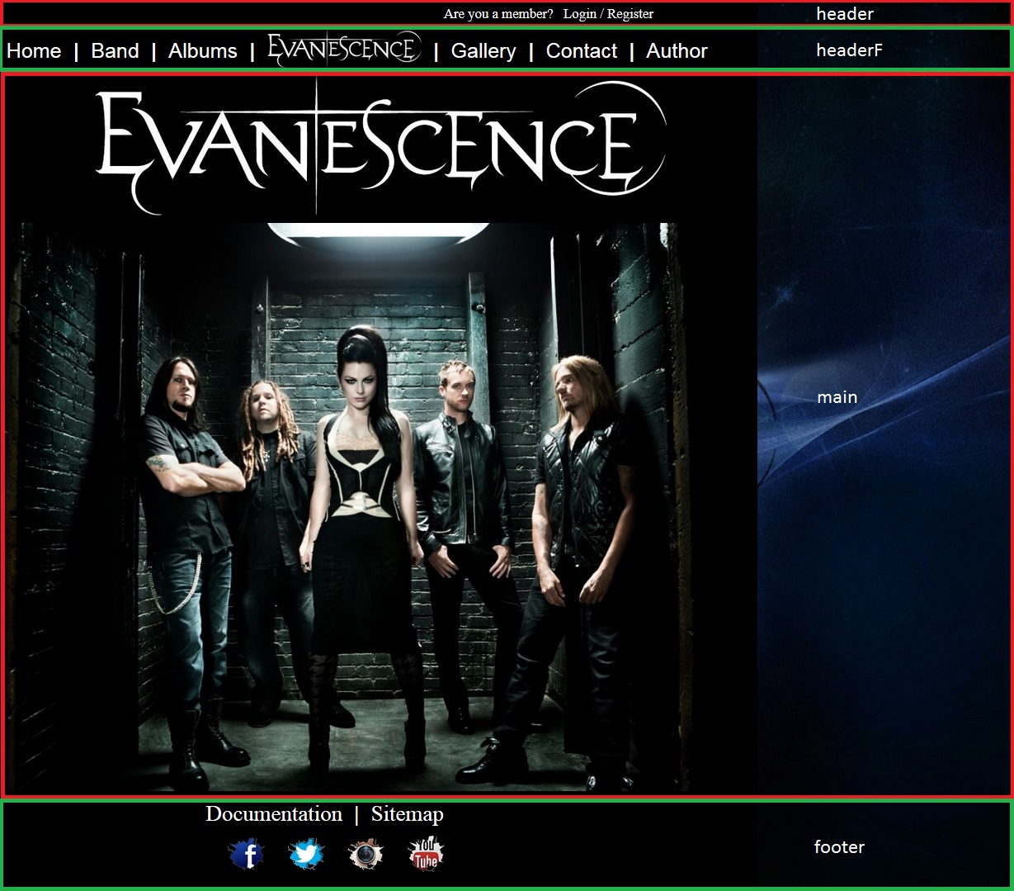

<!DOCTYPE html>

<html>

<head>

</head>

<body>

<div id="omot">

<div id="header">

<div>

</div>

</div>

<div id="headerF">

<div>

</div>

</div>

<div id="main">

<div id="logo">

</div>

<div id="slika">

</div>

</div>

<div id="footer">

<div id=”doc”>

</div>

<div id="footer1">

</div>

</div>

</div>

</body>

</html>

## 1.4. Korišćeni CSS

U folderu css nalaze se dva fajla – vanillabox koji je tudj i nije modifikovan i style koji je moj i nema nista tudjeg.

# 2.0. Organizacija

## 2.1. Organizaciona šema

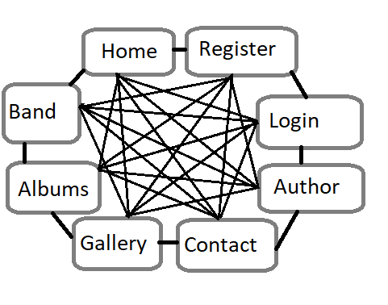

## 2.2. Mapa sajta

<?xml version="1.0" encoding="UTF-8"?>

<urlset xmlns="http://www.sitemaps.org/schemas/sitemap/0.9">

<url>

<loc>http://evanescence.byethost9.com/index.html</loc>

<lastmod>2018-03-03</lastmod>

<changefreq>monthly</changefreq>

<priority>1</priority>

</url>

<url>

<loc>http://evanescence.byethost9.com/login.html</loc>

<lastmod>2018-03-03</lastmod>

<changefreq>monthly</changefreq>

<priority>1</priority>

</url>

<url>

<loc>http://evanescence.byethost9.com/register.html</loc>

<lastmod>2018-03-03</lastmod>

<changefreq>monthly</changefreq>

<priority>1</priority>

</url>

<url>

<loc>http://evanescence.byethost9.com/band.html</loc>

<lastmod>2018-03-03</lastmod>

<changefreq>monthly</changefreq>

<priority>0.9</priority>

</url>

<url>

<loc>http://evanescence.byethost9.com/albums.html</loc>

<lastmod>2018-03-03</lastmod>

<changefreq>monthly</changefreq>

<priority>0.9</priority>

</url>

<url>

<loc>http://evanescence.byethost9.com/gallery.html</loc>

<lastmod>2018-03-03</lastmod>

<changefreq>monthly</changefreq>

<priority>0.9</priority>

</url>

<url>

<loc>http://evanescence.byethost9.com/contact.html</loc>

<lastmod>2018-03-03</lastmod>

<changefreq>monthly</changefreq>

<priority>1</priority>

</url>

<url>

<loc>http://evanescence.byethost9.com/author.html</loc>

<lastmod>2018-03-03</lastmod>

<changefreq>monthly</changefreq>

<priority>0.9</priority>

</url>

</urlset>

## 2.3. Stranice

### 2.3.1. index.html



Pocetna stranica sadrzi dokumentaciju i sitemap.

### 2.3.2. band.html

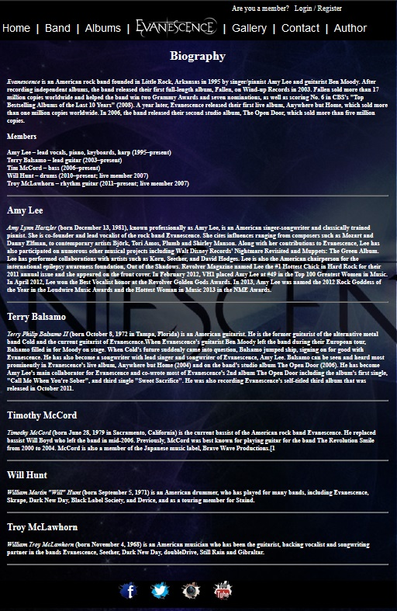

Ima sve funkcionalnosti kao i index.

### 2.3.3. albums.html

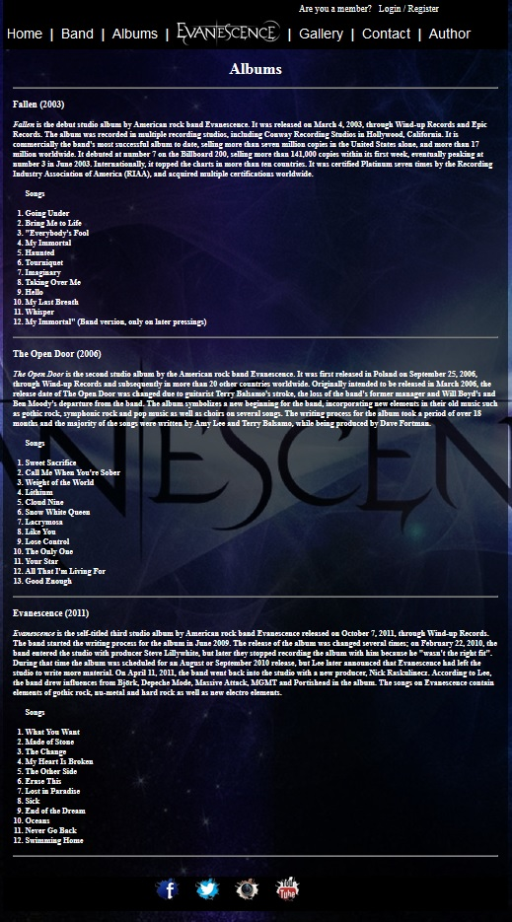

Ima sve funkcionalnosti kao i index.

### 2.3.4. gallery.html

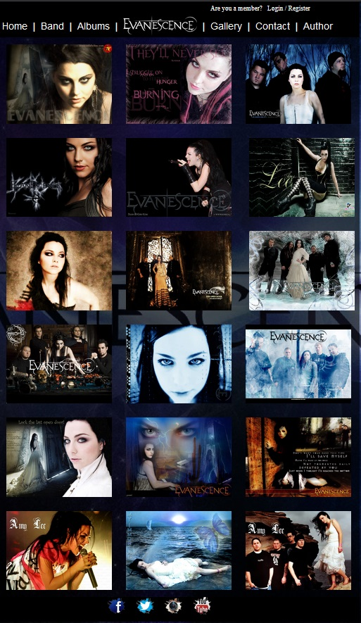

Slike u galeriji se nalaze u eksternom JSON-u i preko AJAX-a se ubacuju u html. Slike se loaduju sa animacijom fadeIn. Prilikom klika na sliku aktivira se JQuery plugin vanillabox. Prilikom prelaska misem preko slika desava se hover efekat.

### 2.3.5. contact.html

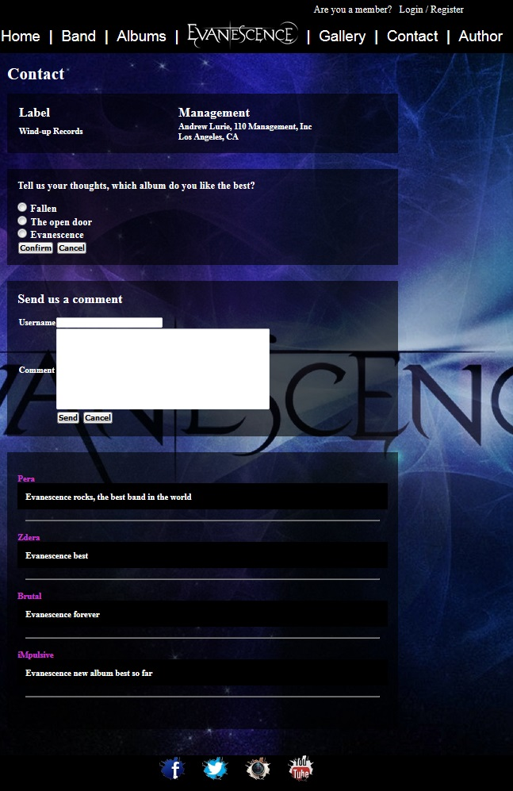

Stranica contact sadrzi anketu, mogucnost da korisnik napise komentar i komentare koji se dinamicki ispisuju iz JSON-a koji se nalazi u JavaScripu.

### 2.3.6. login.html

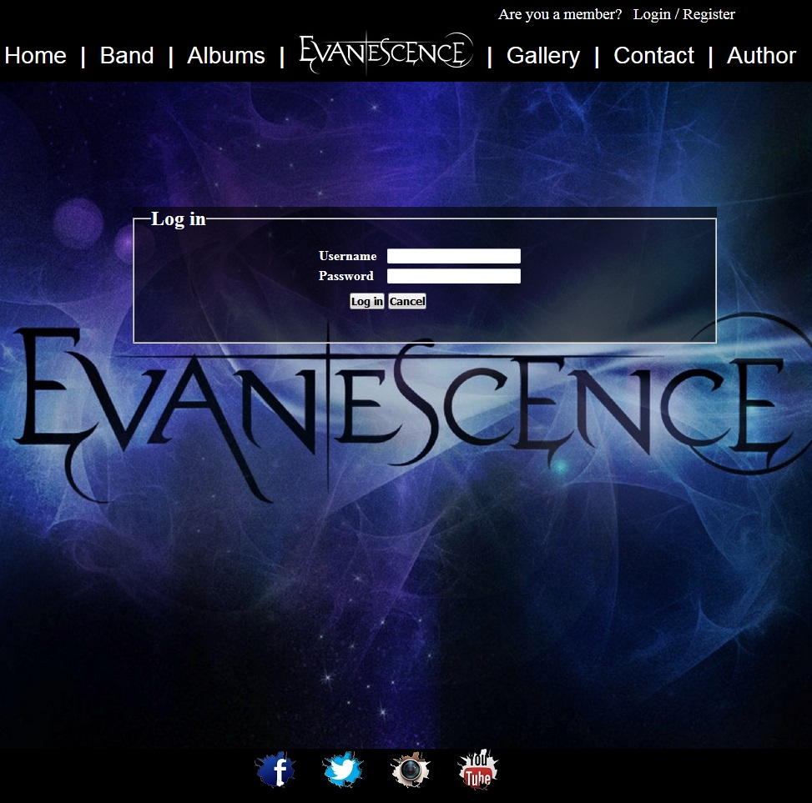

Login stranica sadrzi formu sa regularnim izrazima.

### 2.3.7. register.html

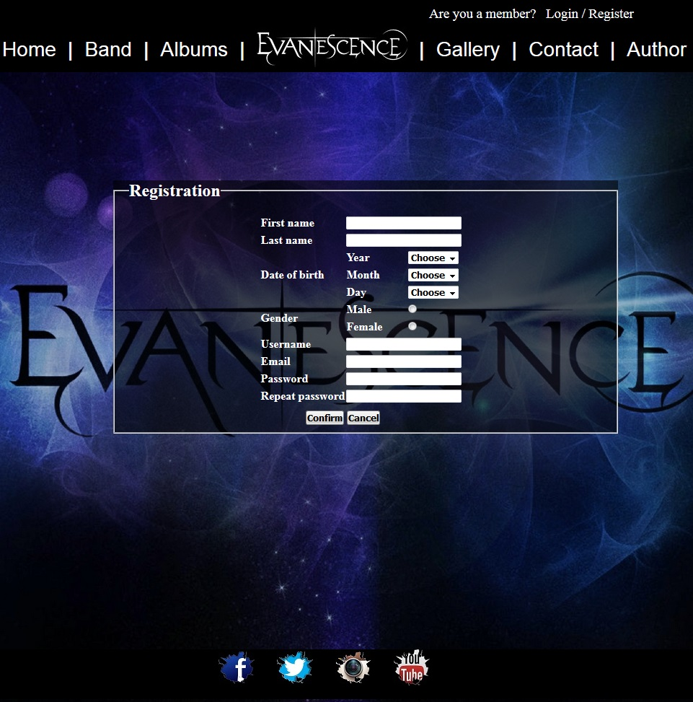

Register stranica sadrzi formu slozeniju od one na login stranici sa kalendarom koji se dinamicki popunjava.

### 2.3.8. author.html

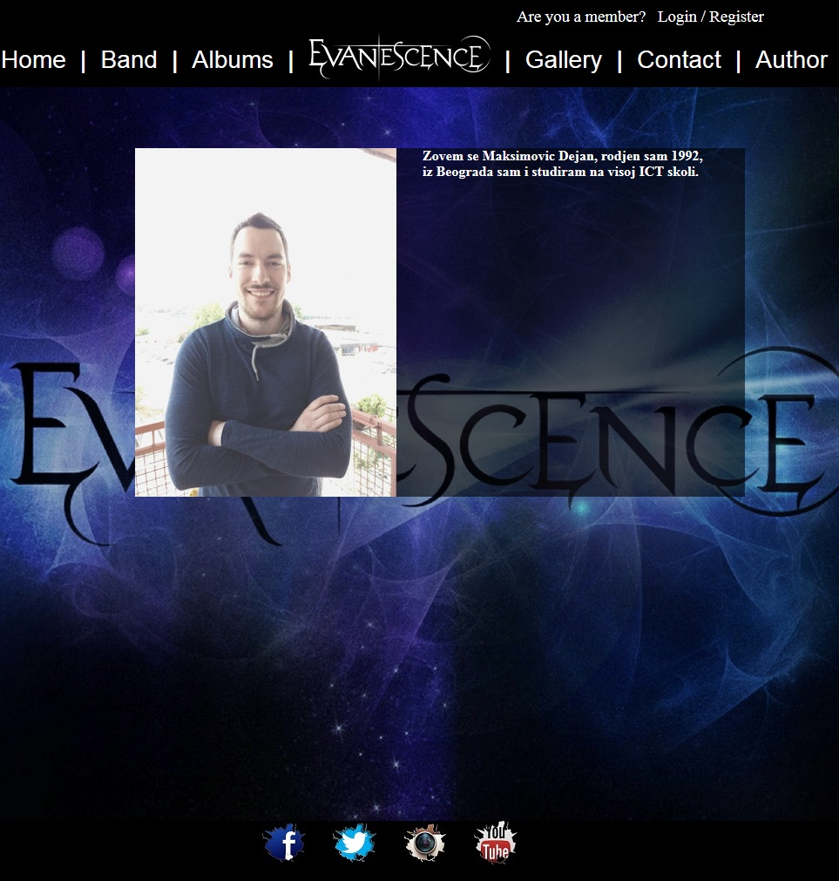

# 3.0. Kodovi

## 3.1. HTML

### 3.1.1. index.html

<!DOCTYPE html>

<html>

<head>

<meta http-equiv="Content-Type" content="text/html; charset=utf-8" >

<meta name="description" content="Index page of music group Evanescence">

<meta name="keywords" content="Evanescence, Amy Lee Terry, Balsamo Tim McCord, Will Hunt, Troy McLawhorn, music group,">

<link rel="stylesheet" href="Evanescence_files/css/style.css" type="text/css">

<title>Evanescence</title>

</head>

<body>

<div id="omot">

<div id="header">

<div>

<ul>

<h3>

<li>Are you a member?&nbsp;&nbsp;</li>

<li><a href="login.html">Login</a></li>

<li>/</li>

<li><a href="register.html">Register</a></li>

</h3>

</ul>

</div>

<!-- search -->

</div>

<div id="headerF">

<div>

<ul>

<h1>

<li><a href="index.html">Home</a></li>

<li>|</li>

<li><a href="band.html">Band</a></li>

<li>|</li>

<li><a href="albums.html">Albums</a></li>

<li>|</li>

<li><img src="Evanescence_files/footer.jpg" alt="footer"/></li>

<li>|</li>

<li><a href="gallery.html">Gallery</a></li>

<li>|</li>

<li><a href="contact.html">Contact</a></li>

<li>|</li>

<li><a href="author.html">Author</a></li>

</h1>

</ul>

</div>

<!-- foot -->

</div>

<div id="main">

<div id="logo">

</div>

<div id="slika">

</div>

</div>

<div id="footer">

<div id="doc">

<h1>

<ul>

<li><a href="Evanescence_files/documentation.PDF">Documentation</a></li>

<li>|</li>

<li><a href="sitemap.xml">Sitemap</a></li>

</ul>

</h1>

</div>

<div id="footer1">

<ul>

<li>

<a href="https://www.facebook.com/Evanescence">

<img src="Evanescence_files/facebook.jpg" alt="facebook"/>

</a>

</li>

<li>&nbsp;

<a href="https://twitter.com/evanescence">

<img src="Evanescence_files/twitter.jpg" alt="twitter"/>

</a>

</li>

<li>&nbsp;

<a href="http://instagram.com/evanescenceofficial">

<img src="Evanescence_files/instagram.jpg" alt="instagram"/>

</a>

</li>

<li>&nbsp;

<a href="https://www.youtube.com/user/EvanescenceVEVO">

<img src="Evanescence_files/youtube.jpg" alt="youtube"/>

</a>

</li>

</ul>

</div>

</div>

</div>

</body>

</html>

### 3.1.2. band.html

<!DOCTYPE html>

<html>

<head>

<meta http-equiv="Content-Type" content="text/html; charset=utf-8" >

<meta name="description" content="Biography">

<meta name="keywords" content="Evanescence, Amy Lee Terry, Balsamo Tim McCord, Will Hunt, Troy McLawhorn, music group,">

<link rel="stylesheet" href="Evanescence_files/css/style.css" type="text/css">

<title>Evanescence</title>

</head>

<body>

<div id="omot">

<div id="header">

<div>

<ul>

<h3>

<li>Are you a member?&nbsp;&nbsp;</li>

<li><a href="login.html">Login</a></li>

<li>/</li>

<li><a href="register.html">Register</a></li>

<br/>

</h3>

</ul>

</div>

<!-- search -->

</div>

<div id="headerF">

<div>

<ul>

<h1>

<li><a href="index.html">Home</a></li>

<li>|</li>

<li><a href="band.html">Band</a></li>

<li>|</li>

<li><a href="albums.html">Albums</a></li>

<li>|</li>

<li><img src="Evanescence_files/footer.jpg" alt="footer"/></li>

<li>|</li>

<li><a href="gallery.html">Gallery</a></li>

<li>|</li>

<li><a href="contact.html">Contact</a></li>

<li>|</li>

<li><a href="author.html">Author</a></li>

</h1>

</ul>

</div>

<!-- foot -->

</div>

<div id="omot1">

<h1>

<p align="center">Biography</p>

</h1>

<br/><br/>

<h4>

<p><cite>Evanescence</cite> is an American rock band founded in Little Rock, Arkansas in 1995 by singer/pianist Amy Lee and guitarist Ben Moody. After recording independent albums, the band released their first full-length album, Fallen, on Wind-up Records in 2003. Fallen sold more than 17 million copies worldwide and helped the band win two Grammy Awards and seven nominations, as well as scoring No. 6 in CBS's "Top Bestselling Albums of the Last 10 Years" (2008). A year later, Evanescence released their first live album, Anywhere but Home, which sold more than one million copies worldwide. In 2006, the band released their second studio album, The Open Door, which sold more than five million copies.

</p><br/>

</h4>

<h3>

<p>Members</p>

</h3>

<br/>

<h4>

<ul>

<li>Amy Lee – lead vocals, piano, keyboards, harp (1995–present)</li>

<li>Terry Balsamo – lead guitar (2003–present)</li>

<li>Tim McCord – bass (2006–present)</li>

<li>Will Hunt – drums (2010–present; live member 2007)</li>

<li>Troy McLawhorn – rhythm guitar (2011–present; live member 2007)</li>

</ul>

</h4>

<br/><hr/><br/>

<h2>

<p>Amy Lee</p>

</h2>

<br/>

<h4>

<cite>Amy Lynn Hartzler</cite> (born December 13, 1981), known professionally as Amy Lee, is an American singer-songwriter and classically trained pianist. She is co-founder and lead vocalist of the rock band Evanescence. She cites influences ranging from composers such as Mozart and Danny Elfman, to contemporary artists Björk, Tori Amos, Plumb and Shirley Manson. Along with her contributions to Evanescence, Lee has also participated on numerous other musical projects including Walt Disney Records' Nightmare Revisited and Muppets: The Green Album. Lee has performed collaborations with artists such as Korn, Seether, and David Hodges. Lee is also the American chairperson for the international epilepsy awareness foundation, Out of the Shadows. Revolver Magazine named Lee the #1 Hottest Chick in Hard Rock for their 2011 annual issue and she appeared on the front cover. In February 2012, VH1 placed Amy Lee at #49 in the Top 100 Greatest Women in Music. In April 2012, Lee won the Best Vocalist honor at the Revolver Golden Gods Awards. In 2013, Amy Lee was named the 2012 Rock Goddess of the Year in the Loudwire Music Awards and the Hottest Woman in Music 2013 in the NME Awards.

</h4>

<br/><hr/><br/>

<h2>

<p>Terry Balsamo</p>

</h2>

<br/>

<h4>

<cite>Terry Philip Balsamo II</cite> (born October 8, 1972 in Tampa, Florida) is an American guitarist. He is the former guitarist of the alternative metal band Cold and the current guitarist of Evanescence.When Evanescence's guitarist Ben Moody left the band during their European tour, Balsamo filled in for Moody on stage. When Cold's future suddenly came into question, Balsamo jumped ship, signing on for good with Evanescence. He has also become a songwriter with lead singer and songwriter of Evanescence, Amy Lee.

Balsamo can be seen and heard most prominently in Evanescence's live album, Anywhere but Home (2004) and on the band's studio album The Open Door (2006). He has become Amy Lee's main collaborator for Evanescence and co-wrote most of Evanescence's 2nd album The Open Door including the album's first single, "Call Me When You're Sober", and third single "Sweet Sacrifice". He was also recording Evanescence's self-titled third album that was released in October 2011.

</h4>

<br/><hr/><br/>

<h2>

<p>Timothy McCord</p>

</h2>

<br/>

<h4>

<cite>Timothy McCord</cite> (born June 28, 1979 in Sacramento, California) is the current bassist of the American rock band Evanescence. He replaced bassist Will Boyd who left the band in mid-2006. Previously, McCord was best known for playing guitar for the band The Revolution Smile from 2000 to 2004. McCord is also a member of the Japanese music label, Brave Wave Productions.[1

</h4>

<br/><hr/><br/>

<h2>

<p>Will Hunt</p>

</h2>

<br/>

<h4>

<cite>William Martin "Will" Hunt</cite> (born September 5, 1971) is an American drummer, who has played for many bands, including Evanescence, Skrape, Dark New Day, Black Label Society, and Device, and as a touring member for Staind.

</h4>

<br/><hr/><br/>

<h2>

<p>Troy McLawhorn</p>

</h2>

<br/>

<h4>

<cite>William Troy McLawhorn</cite> (born November 4, 1968) is an American musician who has been the guitarist, backing vocalist and songwriting partner in the bands Evanescence, Seether, Dark New Day, doubleDrive, Still Rain and Gibraltar.

</h4>

<br/><hr/><br/>

</div>

<div id="footer">

<div id="footer1">

<ul>

<li>

<a href="https://www.facebook.com/Evanescence">

<img src="Evanescence_files/facebook.jpg" alt="facebook"/>

</a>

</li>

<li>&nbsp;

<a href="https://twitter.com/evanescence">

<img src="Evanescence_files/twitter.jpg" alt="twitter"/>

</a>

</li>

<li>&nbsp;

<a href="http://instagram.com/evanescenceofficial">

<img src="Evanescence_files/instagram.jpg" alt="instagram"/>

</a>

</li>

<li>&nbsp;

<a href="https://www.youtube.com/user/EvanescenceVEVO">

<img src="Evanescence_files/youtube.jpg" alt="youtube"/>

</a>

</li>

</ul>

</div>

</div>

</div>

</body>

</html>

### 3.1.3. albums.html

<!DOCTYPE html>

<html>

<head>

<meta http-equiv="Content-Type" content="text/html; charset=utf-8" >

<meta name="description" content="Albums">

<meta name="keywords" content="Evanescence, Amy Lee Terry, Balsamo Tim McCord, Will Hunt, Troy McLawhorn, music group,">

<link rel="stylesheet" href="Evanescence_files/css/style.css" type="text/css">

<title>Evanescence</title>

</head>

<body>

<div id="omot">

<div id="header">

<div>

<ul>

<h3>

<li>Are you a member?&nbsp;&nbsp;</li>

<li><a href="login.html">Login</a></li>

<li>/</li>

<li><a href="register.html">Register</a></li>

<br/>

</h3>

</ul>

</div>

<!-- search -->

</div>

<div id="headerF">

<div>

<ul>

<h1>

<li><a href="index.html">Home</a></li>

<li>|</li>

<li><a href="band.html">Band</a></li>

<li>|</li>

<li><a href="albums.html">Albums</a></li>

<li>|</li>

<li><img src="Evanescence_files/footer.jpg" alt="footer"/></li>

<li>|</li>

<li><a href="gallery.html">Gallery</a></li>

<li>|</li>

<li><a href="contact.html">Contact</a></li>

<li>|</li>

<li><a href="author.html">Author</a></li>

</h1>

</ul>

</div>

<!-- foot -->

</div>

<div id="omot1">

<h1>

<p align="center">Albums</p>

</h1>

<br/><hr/><br/>

<h3>

<p>Fallen (2003)</p>

</h3>

<br/>

<h4>

<p>

<cite>Fallen</cite> is the debut studio album by American rock band Evanescence. It was released on March 4, 2003, through Wind-up Records and Epic Records. The album was recorded in multiple recording studios, including Conway Recording Studios in Hollywood, California. It is commercially the band's most successful album to date, selling more than seven million copies in the United States alone, and more than 17 million worldwide. It debuted at number 7 on the Billboard 200, selling more than 141,000 copies within its first week, eventually peaking at number 3 in June 2003. Internationally, it topped the charts in more than ten countries. It was certified Platinum seven times by the Recording Industry Association of America (RIAA), and acquired multiple certifications worldwide.

</p>

<br/>

<ol>

<p>Songs</p><br/>

<li>Going Under</li>

<li>Bring Me to Life</li>

<li>"Everybody's Fool</li>

<li>My Immortal</li>

<li>Haunted</li>

<li>Tourniquet</li>

<li>Imaginary</li>

<li>Taking Over Me</li>

<li>Hello</li>

<li>My Last Breath</li>

<li>Whisper</li>

<li>My Immortal" (Band version, only on later pressings)</li>

</ol>

</h4>

<br/><hr/><br/>

<h3>

The Open Door (2006)

</h3>

<br/>

<h4>

<p>

<cite>The Open Door</cite> is the second studio album by the American rock band Evanescence. It was first released in Poland on September 25, 2006, through Wind-up Records and subsequently in more than 20 other countries worldwide. Originally intended to be released in March 2006, the release date of The Open Door was changed due to guitarist Terry Balsamo's stroke, the loss of the band's former manager and Will Boyd's and Ben Moody's departure from the band. The album symbolizes a new beginning for the band, incorporating new elements in their old music such as gothic rock, symphonic rock and pop music as well as choirs on several songs. The writing process for the album took a period of over 18 months and the majority of the songs were written by Amy Lee and Terry Balsamo, while being produced by Dave Fortman.

</p>

<br/>

<ol>

<p>Songs</p><br/>

<li>Sweet Sacrifice</li>

<li>Call Me When You're Sober</li>

<li>Weight of the World</li>

<li>Lithium</li>

<li>Cloud Nine</li>

<li>Snow White Queen</li>

<li>Lacrymosa</li>

<li>Like You</li>

<li>Lose Control</li>

<li>The Only One</li>

<li>Your Star</li>

<li>All That I'm Living For</li>

<li>Good Enough</li>

</ol>

</h4>

<br/><hr/><br/>

<h3>

Evanescence (2011)

</h3>

<br/>

<h4>

<p>

<cite>Evanescence</cite> is the self-titled third studio album by American rock band Evanescence released on October 7, 2011, through Wind-up Records. The band started the writing process for the album in June 2009. The release of the album was changed several times; on February 22, 2010, the band entered the studio with producer Steve Lillywhite, but later they stopped recording the album with him because he "wasn't the right fit". During that time the album was scheduled for an August or September 2010 release, but Lee later announced that Evanescence had left the studio to write more material. On April 11, 2011, the band went back into the studio with a new producer, Nick Raskulinecz.

According to Lee, the band drew influences from Björk, Depeche Mode, Massive Attack, MGMT and Portishead in the album. The songs on Evanescence contain elements of gothic rock, nu-metal and hard rock as well as new electro elements.

</p>

<br/>

<ol>

<p>Songs</p><br/>

<li>What You Want</li>

<li>Made of Stone</li>

<li>The Change</li>

<li>My Heart Is Broken</li>

<li>The Other Side</li>

<li>Erase This</li>

<li>Lost in Paradise</li>

<li>Sick</li>

<li>End of the Dream</li>

<li>Oceans</li>

<li>Never Go Back</li>

<li>Swimming Home</li>

</ol>

</h4>

<br/><hr/><br/>

</div>

<div id="footer">

<div id="footer1">

<ul>

<li>

<a href="https://www.facebook.com/Evanescence">

<img src="Evanescence_files/facebook.jpg" alt="facebook"/>

</a>

</li>

<li>&nbsp;

<a href="https://twitter.com/evanescence">

<img src="Evanescence_files/twitter.jpg" alt="twitter"/>

</a>

</li>

<li>&nbsp;

<a href="http://instagram.com/evanescenceofficial">

<img src="Evanescence_files/instagram.jpg" alt="instagram"/>

</a>

</li>

<li>&nbsp;

<a href="https://www.youtube.com/user/EvanescenceVEVO">

<img src="Evanescence_files/youtube.jpg" alt="youtube"/>

</a>

</li>

</ul>

</div>

</div>

</div>

</body>

</html>

### 3.1.4. gallery.html

<!DOCTYPE html>

<html>

<head>

<meta http-equiv="Content-Type" content="text/html; charset=utf-8" >

<meta name="description" content="Gallery">

<meta name="keywords" content="Evanescence, Amy Lee Terry, Balsamo Tim McCord, Will Hunt, Troy McLawhorn, music group,">

<link rel="stylesheet" href="Evanescence_files/css/style.css" type="text/css">

<link rel="stylesheet" href="Evanescence_files/css/vanillabox.css" type="text/css">

<title>Evanescence</title>

</head>

<body>

<div id="omot">

<div id="header">

<div>

<ul>

<h3>

<li>Are you a member?&nbsp;&nbsp;</li>

<li><a href="login.html">Login</a></li>

<li>/</li>

<li><a href="register.html">Register</a></li>

<br/>

</h3>

</ul>

</div>

<!-- search -->

</div>

<div id="headerF">

<div>

<ul>

<h1>

<li><a href="index.html">Home</a></li>

<li>|</li>

<li><a href="band.html">Band</a></li>

<li>|</li>

<li><a href="albums.html">Albums</a></li>

<li>|</li>

<li><img src="Evanescence_files/footer.jpg" alt="footer"/></li>

<li>|</li>

<li><a href="gallery.html">Gallery</a></li>

<li>|</li>

<li><a href="contact.html">Contact</a></li>

<li>|</li>

<li><a href="author.html">Author</a></li>

</h1>

</ul>

</div>

<!-- foot -->

</div>

<div id="omotgallery">

<figure>

</figure>

</div>

<div id="footer">

<div id="footer1">

<ul>

<li>

<a href="https://www.facebook.com/Evanescence">

<img src="Evanescence_files/facebook.jpg" alt="facebook"/>

</a>

</li>

<li>&nbsp;

<a href="https://twitter.com/evanescence">

<img src="Evanescence_files/twitter.jpg" alt="twitter"/>

</a>

</li>

<li>&nbsp;

<a href="http://instagram.com/evanescenceofficial">

<img src="Evanescence_files/instagram.jpg" alt="instagram"/>

</a>

</li>

<li>&nbsp;

<a href="https://www.youtube.com/user/EvanescenceVEVO">

<img src="Evanescence_files/youtube.jpg" alt="youtube"/>

</a>

</li>

</ul>

</div>

</div>

</div>

<script type="text/javascript" src="Evanescence_files/js/jquery/jquery-3.3.1.min.js"></script>

<script type="text/javascript" src="Evanescence_files/js/jquery/jquery.vanillabox.js"></script>

<script type="text/javascript" src="Evanescence_files/js/jsGallery.js"></script>

</body>

</html>

### 3.1.5. contact.html

<!DOCTYPE html>

<html>

<head>

<meta http-equiv="Content-Type" content="text/html; charset=utf-8" >

<meta name="description" content="Contact">

<meta name="keywords" content="Evanescence, Amy Lee Terry, Balsamo Tim McCord, Will Hunt, Troy McLawhorn, music group,">

<link rel="stylesheet" href="Evanescence_files/css/style.css" type="text/css">

<title>Evanescence</title>

</head>

<body>

<div id="omot">

<div id="header">

<div>

<ul>

<h3>

<li>Are you a member?&nbsp;&nbsp;</li>

<li><a href="login.html">Login</a></li>

<li>/</li>

<li><a href="register.html">Register</a></li>

<br/>

</h3>

</ul>

</div>

<!-- search -->

</div>

<div id="headerF">

<div>

<ul>

<h1>

<li><a href="index.html">Home</a></li>

<li>|</li>

<li><a href="band.html">Band</a></li>

<li>|</li>

<li><a href="albums.html">Albums</a></li>

<li>|</li>

<li><img src="Evanescence_files/footer.jpg" alt="footer"/></li>

<li>|</li>

<li><a href="gallery.html">Gallery</a></li>

<li>|</li>

<li><a href="contact.html">Contact</a></li>

<li>|</li>

<li><a href="author.html">Author</a></li>

</h1>

</ul>

</div>

<!-- foot -->

</div>

<div id="omot2">

<h1>Contact</h1>

<br/>

<div class="divcontact">

<table id="contactLabel">

<tr>

<td><h2>Label</h2></td>

<td><h2>Management</h2></td>

</tr>

<tr>

<td><h4>Wind-up Records</h4></td>

<td><h4>Andrew Lurie, 110 Management, Inc<br/>Los Angeles, CA</h4></td>

</tr>

</table>

</div>

<div class="divcontact">

<h3>Tell us your thoughts, which album do you like the best?</h3>

<br/>

<form action="#" method="post" name="formBestAlbum">

<h3><input type="radio" name="rbBestAlbum" value="Fallen"/>&nbsp;Fallen</h3>

<h3><input type="radio" name="rbBestAlbum" value="The open door"/>&nbsp;The open door</h3>

<h3><input type="radio" name="rbBestAlbum" value="Evanescence"/>&nbsp;Evanescence</h3>

<h3><input type="button" value="Confirm" id="btBestAlbum"/>

<input type="reset" value="Cancel"/></h3>

</form>

</div>

<div class="divcontact">

<h2>Send us a comment</h2>

<br/>

<form action="#" method="post">

<table>

<tr>

<td><h4>Username </h4></td>

<td><input type="text" id="tbUsernameContact"/></td>

</tr>

<tr>

<td><h4>Comment </h4></td>

<td>

<textarea id="taTextAreaContact"></textarea>

</td>

</tr>

<tr>

<td></td>

<td><input type="button" value="Send" id="btSendComment"/> <input type="reset" value="Cancel"/></td>

</tr>

</table>

</form>

</div>

<div id="commentContact" class="divcontact">

<div id="searchComment">

<!-- <form action="#" method="post" name="commentForm">

<h3>Search comments <input type="text" id="tbSearchComment"/> <input type="button" id="btnSearchComments" value="OK"/></h3>

</form> -->

<div id="comments"></div>

</div>

</div>

</div>

<div id="footer">

<div id="footer1">

<ul>

<li>

<a href="https://www.facebook.com/Evanescence">

<img src="Evanescence_files/facebook.jpg" alt="facebook"/>

</a>

</li>

<li>&nbsp;

<a href="https://twitter.com/evanescence">

<img src="Evanescence_files/twitter.jpg" alt="twitter"/>

</a>

</li>

<li>&nbsp;

<a href="http://instagram.com/evanescenceofficial">

<img src="Evanescence_files/instagram.jpg" alt="instagram"/>

</a>

</li>

<li>&nbsp;

<a href="https://www.youtube.com/user/EvanescenceVEVO">

<img src="Evanescence_files/youtube.jpg" alt="youtube"/>

</a>

</li>

</ul>

</div>

</div>

</div>

<script type="text/javascript" src="Evanescence_files/js/jquery/jquery-3.3.1.min.js"></script>

<script type="text/javascript" src="Evanescence_files/js/jsContact.js"></script>

</body>

</html>

### 3.1.6. author.html

<!DOCTYPE html>

<html>

<head>

<meta http-equiv="Content-Type" content="text/html; charset=utf-8" >

<meta name="description" content="Author">

<meta name="keywords" content="Evanescence, Amy Lee Terry, Balsamo Tim McCord, Will Hunt, Troy McLawhorn, music group,">

<link rel="stylesheet" href="Evanescence_files/css/style.css" type="text/css">

<title>Evanescence</title>

</head>

<body>

<div id="omot">

<div id="header">

<div>

<ul>

<h3>

<li>Are you a member?&nbsp;&nbsp;</li>

<li><a href="login.html">Login</a></li>

<li>/</li>

<li><a href="register.html">Register</a></li>

<br/>

</h3>

</ul>

</div>

<!-- search -->

</div>

<div id="headerF">

<div>

<ul>

<h1>

<li><a href="index.html">Home</a></li>

<li>|</li>

<li><a href="band.html">Band</a></li>

<li>|</li>

<li><a href="albums.html">Albums</a></li>

<li>|</li>

<li><img src="Evanescence_files/footer.jpg" alt="footer"/></li>

<li>|</li>

<li><a href="gallery.html">Gallery</a></li>

<li>|</li>

<li><a href="contact.html">Contact</a></li>

<li>|</li>

<li><a href="author.html">Author</a></li>

</h1>

</ul>

</div>

<!-- foot -->

</div>

<div id="divauthor">

<div class="divauthor1">

<figure>

<img src="Evanescence_files/author.jpg" alt="author">

</figure>

</div>

<div class="divauthor1">

<h4>&nbsp;Zovem se Maksimovic Dejan, rodjen sam 1992.<br/> &nbsp;iz Beograda sam i studiram na visoj ICT skoli.</h4>

</div>

</div>

<div class="cleaner"></div>

<br/><br/><br/><br/>

<div id="footer">

<div id="footer1">

<ul>

<li>

<a href="https://www.facebook.com/Evanescence">

<img src="Evanescence_files/facebook.jpg" alt="facebook"/>

</a>

</li>

<li>&nbsp;

<a href="https://twitter.com/evanescence">

<img src="Evanescence_files/twitter.jpg" alt="twitter"/>

</a>

</li>

<li>&nbsp;

<a href="http://instagram.com/evanescenceofficial">

<img src="Evanescence_files/instagram.jpg" alt="instagram"/>

</a>

</li>

<li>&nbsp;

<a href="https://www.youtube.com/user/EvanescenceVEVO">

<img src="Evanescence_files/youtube.jpg" alt="youtube"/>

</a>

</li>

</ul>

</div>

</div>

</div>

</body>

</html>

### 3.1.7. login.html

<!DOCTYPE html>

<html>

<head>

<meta http-equiv="Content-Type" content="text/html; charset=utf-8" >

<meta name="description" content="Login page">

<meta name="keywords" content="Evanescence, Amy Lee Terry, Balsamo Tim McCord, Will Hunt, Troy McLawhorn, music group,">

<link rel="stylesheet" href="Evanescence_files/css/style.css" type="text/css">

<title>Evanescence register</title>

</head>

<body>

<div id="omot">

<div id="header">

<div>

<ul>

<h3>

<li>Are you a member?&nbsp;&nbsp;</li>

<li><a href="login.html">Login</a></li>

<li>/</li>

<li><a href="register.html">Register</a></li>

</h3>

</ul>

</div>

<!-- search -->

</div>

<div id="headerF">

<div>

<ul>

<h1>

<li><a href="index.html">Home</a></li>

<li>|</li>

<li><a href="band.html">Band</a></li>

<li>|</li>

<li><a href="albums.html">Albums</a></li>

<li>|</li>

<li><img src="Evanescence_files/footer.jpg" alt="footer"/></li>

<li>|</li>

<li><a href="gallery.html">Gallery</a></li>

<li>|</li>

<li><a href="contact.html">Contact</a></li>

<li>|</li>

<li><a href="author.html">Author</a></li>

</h1>

</ul>

</div>

<!-- foot -->

</div>

<div id="omotlogin">

<div class="divlogin">

<form action="#" method="post">

<fieldset>

<legend><h2>Log in</h2></legend>

<br/>

<table>

<tr>

<td>Username</td>

<td><input type="text" id="tbUsernameLog" name="tbUsernameLog"/><span id="default" class="default"> *</span></td>

</tr>

<tr>

<td>Password</td>

<td><input type="password" id="pswLog" name="pswLog"/><span id="default1" class="default"> *</span></td>

</tr>

<tr class="trButton">

<td align="right"><input type="button" value="Log in" id="submit1"/></td>

<td><input type="reset" value="Cancel" id="resetLog"/></td>

</tr>

</table>

</fieldset>

</form>

</div>

</div>

<div id="footer">

<div id="footer1">

<ul>

<li>

<a href="https://www.facebook.com/Evanescence">

<img src="Evanescence_files/facebook.jpg" alt="facebook"/>

</a>

</li>

<li>&nbsp;

<a href="https://twitter.com/evanescence">

<img src="Evanescence_files/twitter.jpg" alt="twitter"/>

</a>

</li>

<li>&nbsp;

<a href="http://instagram.com/evanescenceofficial">

<img src="Evanescence_files/instagram.jpg" alt="instagram"/>

</a>

</li>

<li>&nbsp;

<a href="https://www.youtube.com/user/EvanescenceVEVO">

<img src="Evanescence_files/youtube.jpg" alt="youtube"/>

</a>

</li>

</ul>

</div>

</div>

</div>

<script type="text/javascript" src="Evanescence_files/js/jsLogin.js"></script>

</body>

</html>

### 3.1.8. register.html

<!DOCTYPE html>

<html>

<head>

<meta http-equiv="Content-Type" content="text/html; charset=utf-8" >

<meta name="description" content="Login page">

<meta name="keywords" content="Evanescence, Amy Lee Terry, Balsamo Tim McCord, Will Hunt, Troy McLawhorn, music group,">

<link rel="stylesheet" href="Evanescence_files/css/style.css" type="text/css">

<title>Evanescence login</title>

</head>

<body>

<div id="omot">

<div id="header">

<div>

<ul>

<h3>

<li>Are you a member?&nbsp;&nbsp;</li>

<li><a href="login.html">Login</a></li>

<li>/</li>

<li><a href="register.html">Register</a></li>

</h3>

</ul>

</div>

<!-- search -->

</div>

<div id="headerF">

<div>

<ul>

<h1>

<li><a href="index.html">Home</a></li>

<li>|</li>

<li><a href="band.html">Band</a></li>

<li>|</li>

<li><a href="albums.html">Albums</a></li>

<li>|</li>

<li><img src="Evanescence_files/footer.jpg" alt="footer"/></li>

<li>|</li>

<li><a href="gallery.html">Gallery</a></li>

<li>|</li>

<li><a href="contact.html">Contact</a></li>

<li>|</li>

<li><a href="author.html">Author</a></li>

</h1>

</ul>

</div>

<!-- foot -->

</div>

<div id="omotlogin">

<div class="divlogin">

<form action="#" method="post" name="regForm">

<fieldset>

<legend><h2>Registration</h2></legend>

<table>

<tr>

<td>First name</td><br/>

<td colspan="3"><input type="text" id="tbFirstName" name="tbFirstName" class="tbWidth"/><span id="default2" class="default"> *</span></td>

</tr>

<tr>

<td>Last name</td>

<td colspan="3"><input type="text" id="tbLastName" name="tbLastName" class="tbWidth"/><span id="default3" class="default"> *</span></td>

</tr>

<tr>

<td rowspan="3">Date of birth</td>

<td>Year</td>

<td>

<select name="ddlYear" id="ddlYear" class="ddlYear">

<option value="year">Choose</option>

</select><span id="default4" class="default"> *</span>

</td>

</tr>

<tr>

<td>Month</td>

<td>

<select name="ddlMonth" id="ddlMonth" class="ddlMonth">

<option value="month">Choose</option>

</select><span id="default5" class="default"> *</span>

</td>

</tr>

<tr>

<td>Day</td>

<td>

<select name="ddlDay" id="ddlDay" class="ddlDay">

<option value="day">Choose</option>

</select><span id="default6" class="default"> *</span>

</td>

</tr>

<tr>

<td rowspan="2">Gender</td>

<td>Male</td>

<td>

<input type="radio" name="rbGender" value="male"/><span id="default7" class="default"> *</span>

</td>

</tr>

<tr>

<td>Female </td>

<td>

<input type="radio" name="rbGender" value="female"/><span id="default8" class="default"> *</span></td>

</td>

</tr>

<tr>

<td>Username</td>

<td colspan="2"><input type="text" name="tbUsernameReg" id="tbUsernameReg" class="tbWidth"/><span id="default9" class="default"> *</span></td>

</tr>

<tr>

<td>Email</td>

<td colspan="2"><input type="email" name="tbEmail" id="tbEmail" class="tbWidth"/><span id="default10" class="default"> *</span></td>

</tr>

<tr>

<td>Password</td>

<td colspan="2"><input type="password" name="pswReg" id="pswReg" class="tbWidth"/><span id="default11" class="default"> *</span></td>

</tr>

<tr>

<td>Repeat password</td>

<td colspan="2"><input type="password" name="pswRegRep" id="pswRegRep" class="tbWidth"/><span id="default12" class="default"> *</span></td>

</tr>

<tr class="trButton">

<td align="right"><input type="button" value="Confirm" id="btConfirm"/></td>

<td><input type="reset" value="Cancel" id="resetReg"/></td>

</tr>

</table>

</fieldset>

</form>

</div>

</div>

<div id="footer">

<div id="footer1">

<ul>

<li>

<a href="https://www.facebook.com/Evanescence">

<img src="Evanescence_files/facebook.jpg" alt="facebook"/>

</a>

</li>

<li>&nbsp;

<a href="https://twitter.com/evanescence">

<img src="Evanescence_files/twitter.jpg" alt="twitter"/>

</a>

</li>

<li>&nbsp;

<a href="http://instagram.com/evanescenceofficial">

<img src="Evanescence_files/instagram.jpg" alt="instagram"/>

</a>

</li>

<li>&nbsp;

<a href="https://www.youtube.com/user/EvanescenceVEVO">

<img src="Evanescence_files/youtube.jpg" alt="youtube"/>

</a>

</li>

</ul>

</div>

</div>

</div>

<script type="text/javascript" src="Evanescence_files/js/jsRegister.js"></script>

</body>

</html>

## 3.2. CSS

* {margin:0px; padding:0px;}

.cleaner

{

clear:both;

}

body {

background-image:url(../pozadina.jpg);

background-size:cover;

background-position:center;

margin:0 auto;

}

a:link, a:visited {

color:inherit;

text-decoration:none;

}

a:active {

color:#999;

}

a:hover {

text-decoration:underline;

}

ol {

margin-left:25px;

}

ul {

list-style-type:none;

}

/* every page */

#omot {

width:1024px;

margin:0 auto;

}

#header {

width:auto;

height:auto;

color:white;

padding-left:600px;

background-color:black;

}

#header li {

display:inline-block;

line-height:200%;

}

#header1 ul li input {vertical-align:middle;}

#headerF {

height:auto;

text-align:center;

color:white;

background-color:black;

}

#headerF li {

display:inline-block;

display:table-cell;

vertical-align:middle;

padding:0px 8px;

font-size:30px;

text-align:center;

}

#footer {

height:auto;

text-align:center;

color:white;

background-color:black;

}

#footer li {

display:inline-block;

display:table-cell;

vertical-align:middle;

padding:0px 8px;

font-size:30px;

text-align:center;

}

#doc h1 ul

{

margin-left:270px;

}

#footer1 {

height:auto;

padding-left:300px;

}

/* home */

#logo {

width:1024px;

height:202px;

background-image:url(../logo.jpg);

background-repeat:no-repeat;

}

#slika {

background-image:url(../slika.jpg);

height:768px;

}

/* band and albums */

#omot1 {

width:984px;

height:auto;

color:white;

padding:20px;

background-color:rgba(000,0,0,0.6);

}

/* gallery */

#omotgallery {

width:auto;

height:auto;

color:white;

background-color:rgba(000,0,0,0.6);

}

.galleryDiv

{

width:300px;

height:225px;

margin:20px;

float:left;

}

.galleryDiv img

{

width:300px;

height:225px;

}

.galleryDiv a{width:300px; height:225px;}

/* contact */

#omot2 {

width:984px;

color:white;

padding:20px;

}

#contactLabel td

{

width:300px;

}

.divcontact {

width:700px;

height:auto;

background-color:rgba(000,0,0,0.6);

color:white;

margin-bottom:30px;

padding:20px;

}

.userComment {

color:#cc33cc;

}

.commentField

{

background-color:black;

padding:15px;

}

#commentContact hr{

margin:0 15px;

}

#searchComment h3

{

text-align:right;

}

#searchComment input

{

min-width:30px;

}

.divcontact textarea

{

width:400px;

height:150px;

resize:none;

}

#divcontact1 {

width:auto;

height:auto;

background-color:rgba(000,0,0,0.6);

color:white;

}

/* author */

#divauthor {

width:700px;

height:368px;

background-color:rgba(000,0,0,0.6);

margin:70px auto 300px;

}

.divauthor1 {

width:auto;

height:auto;

color:white;

float:left;

}

/* login and register */

.divlogin {

margin: 150px auto;

width:700px;

height:auto;

background-color:rgba(000,0,0,0.6);

color:white;

}

.divlogin table {

margin:0 auto;

}

.divlogin table td {

min-width: 80px;

height: 22px;

}

.divlogin table select {

width:70px;

}

.divlogin fieldset {

min-height: 160px;

}

.trButton {

height: 35px;

}

#omotlogin {

width:1024px;

height:650px;

color:white;

margin:0 auto;

}

#omotlogin form legend {

color:white;

margin-left:20px;

}

.default {

visibility:hidden;

}

.red {

color:red;

}

.green {

color:green;

}

/* .tbWidth {

width:250px;

} */

/*#header1 {

padding-left:70px; vertical-align:middle;

} */

/* #omot1 table

{

border:1px solid white;

padding:20px 20px 20px 0px;

}

*/

/* #divauthor2 {

width:700px;

height:auto;

background-color:rgba(000,0,0,0.6);

color:white;

margin:20px auto 100px;

} */

## 3.3. JavaScript i JQuery

### 3.3.1. jsContact.js

//podeliti komentare da se prostiru na vise strana (paginacija) i po mogustvu upisati broj komentara po strani;

//global variables

$(document).ready(function()

{

//dohvatanje podataka iz eksternog json-a

/* $.ajax({

type: 'GET',

url: 'Evanescence_files/json/comments.json',

success: function(data)

{

var ispis = "<br/>";

for(var i in data)

{

ispis+="<div class='userComment'><h4>"+data[i].username+"</h4></div>";

ispis+="<div class='commentField'><h4>"+data[i].comment+"</h4></div><br/><hr><br/>";

}

ispis+="<br/>";

document.querySelector("#comments").innerHTML += ispis;

document.querySelector("#btnSearchComments").addEventListener("click", searchComments);

$("#btSendComment").click(sendComment);

$("#btBestAlbum").click(bestAlbum);

}

}); */

//json comments

var data = [

{

"username" : "Pera",

"comment" : "Evanescence rocks, the best band in the world"

},

{

"username" : "Zdera",

"comment" : "Evanescence best"

},

{

"username" : "Brutal",

"comment" : "Evanescence forever"

},

{

"username" : "iMpulsive",

"comment" : "Evanescence new album best so far"

}

];

var ispis = "<br/>";

for(var i in data)

{

ispis+="<div class='userComment'><h4>"+data[i].username+"</h4></div>";

ispis+="<div class='commentField'><h4>"+data[i].comment+"</h4></div><br/><hr><br/>";

}

ispis+="<br/>";

document.querySelector("#comments").innerHTML += ispis;

//document.querySelector("#btnSearchComments").addEventListener("click", searchComments);

$("#btSendComment").click(sendComment);

$("#btBestAlbum").click(bestAlbum);

}

);

function bestAlbum(){

$("input:radio[name=rbBestAlbum]").each(function(index, current)

{

if(current.checked)

{

var ispis;

ispis = "<h3>"+current.value+"</h3>";

$(".divcontact:eq(1)").append(ispis);

$("form[name=formBestAlbum]").slideUp(2000, "swing");

}

}

);

}

function sendComment()

{

var user = $("#tbUsernameContact").val();

var comment = $("#taTextAreaContact").val();

var userCheck = /^.+$/;

if(userCheck.test(user) && comment != "")

{

$(".divcontact:eq(2)").append("User: "+user+"<br/>"+"Comment: "+comment+"<br/>");

}

}

/* function searchComments()

{

$.ajax({

type: 'GET',

url: 'Evanescence_files/json/comments.json',

success: function(data)

{

var ispis = "<br/>";

var commentValue = document.querySelector("#tbSearchComment").value;

for(var i in data)

{

if(data[i].username.indexOf(commentValue) != -1 || data[i].comment.indexOf(commentValue) != -1)

{

ispis+="<div class='userComment'><h4>"+data[i].username+"</h4></div>";

ispis+="<div class='commentField'><h4>"+data[i].comment+"</h4></div><br/><hr><br/>";

}

}

ispis+="<br/>";

document.querySelector("#comments").innerHTML = ispis;

}

});

}

*/

### 3.3.2. jsGallery.js

$(document).ready(function()

{

var imag = "";

$.ajax({

type:"GET",

url: "Evanescence_files/json/gallery.json",

success:function(data)

{

for(var i = 0; i <data.length; i++)

{

imag += "<div class='galleryDiv'><a href='"+data[i].url+"'><img src='"+data[i].url+"' alt='"+data[i].alt+"'/></a></div>";

}

$("#omotgallery figure").append(imag);

$("#omotgallery figure").append("<div class='cleaner'></div>");

$("figure a").hide();

$("figure a:even").fadeIn(2000);

$("figure a:odd").fadeIn(5000);

$(".galleryDiv a").vanillabox();

$(".galleryDiv a img").hover(

function()

{

$(this).animate({width: "+=20px", height: "+=20px", paddingLeft: "-=10px"});

},

function()

{

$(this).animate({width: "-=20px", height: "-=20px", paddingLeft: "+=10px"});

}

);

}

})

});

### 3.3.4. jsLogin.js

//Global variables

//regular expression

var checkTbUser = /^[\w\d-]{3,30}$/;

var checkPsw = /^.{5,30}$/;

window.onload = function()

{

document.querySelector("#tbUsernameLog").addEventListener("blur", tbUsernameLog);

document.querySelector("#tbUsernameLog").onkeyup = tbUsernameLog;

document.querySelector("#pswLog").addEventListener("blur", pswLog);

document.querySelector("#pswLog").onkeyup = pswLog;

document.querySelector("#submit1").addEventListener("click", submit1);

};

//begining login

//username

function tbUsernameLog()

{

var a = document.querySelector("#tbUsernameLog");

if(!checkTbUser.test(a.value)){

document.querySelector("#default").setAttribute("class", "red");

}

else{

document.querySelector("#default").setAttribute("class", "green");

}

}

//password

function pswLog()

{

var a = document.querySelector("#pswLog");

if(!checkPsw.test(a.value)){

document.querySelector("#default1").setAttribute("class", "red");

}

else{

document.querySelector("#default1").setAttribute("class", "green");

}

}

//submit

function submit1()

{

tbUsernameLog();

pswLog();

}

document.querySelector("#resetLog").onclick = resetingLog;

function resetingLog()

{

document.querySelector("#default").setAttribute("class", "red");

document.querySelector("#default1").setAttribute("class", "red");

}

//end login

### 3.3.5. jsRegister.js

//Global variables

var passwordRep = "";

var ddlDate = new Date();

var ddlMonth = [];

var origYear = false;

var yearNumb;

var origMonth = false;

var monthNumb;

var origDay = false;

var dayNumb;

var userData = new Array();

var userFakeData = new Array();

var gender = document.regForm.rbGender;

//regular expression

var checkTbUser = /^[\w\d-]{3,30}$/;

var checkPsw = /^.{5,30}$/;

var checkTbFirstName = /^([A-Z][a-z]{1,30}\s?){1,4}$/;

var checkTbLastName = /^([A-Z][a-z]{1,30}\s?){1,4}$/;

var checkEmail = /^([A-z\d][\._-]?){3,30}@([a-z]{3,10}\.{1}){1,3}[a-z]{2,4}$/;

window.onload = function()

{

//ddl calendar year

function yearFill()

{

if(origYear == false)

{

for(var i = 1; i < 100; i++)

{

var a = document.createTextNode(ddlDate.getFullYear() - i);

var b = document.createElement("option");

b.value = ddlDate.getFullYear() - i;

b.appendChild(a);

document.querySelector("#ddlYear").appendChild(b);

}

origYear = true;

}

}

yearFill();

var gender1 = document.regForm.rbGender;

for(var i = 0; i < gender1.length; i++)

{

gender[i].addEventListener("change", checkGender);

}

};

//beginning of registration

//firstName

document.querySelector("#tbFirstName").onkeyup = firstNameCheck;

document.querySelector("#tbFirstName").addEventListener("blur", firstNameCheck);

function firstNameCheck()

{

var a = document.querySelector("#tbFirstName");

if(!checkTbFirstName.test(a.value)){

document.querySelector("#default2").setAttribute("class", "red");

}

else{

document.querySelector("#default2").setAttribute("class", "green");

}

};

//lastName

document.querySelector("#tbLastName").onkeyup = lastNameCheck;

document.querySelector("#tbLastName").addEventListener("blur", lastNameCheck);

function lastNameCheck()

{

var a = document.querySelector("#tbLastName");

if(!checkTbLastName.test(a.value)){

document.querySelector("#default3").setAttribute("class", "red");

}

else{

document.querySelector("#default3").setAttribute("class", "green");

}

}

//beginning calendar

//year

document.querySelector("#ddlYear").addEventListener("click", ddlYearCheck);

function ddlYearCheck()

{

yearNumb = document.querySelector("#ddlYear").options[document.querySelector("#ddlYear").selectedIndex].text;

if(yearNumb != "Choose")

{

document.querySelector("#default4").setAttribute("class", "green");

}

else

{

document.querySelector("#default4").setAttribute("class", "red");

}

}

//month

document.querySelector("#ddlMonth").addEventListener("click", ddlMonthCheck);

function ddlMonthCheck()

{

if(document.querySelector("#ddlMonth").options[document.querySelector("#ddlMonth").options.selectedIndex].text != "Choose")

{

document.querySelector("#default5").setAttribute("class", "green");

}

else

{

document.querySelector("#default5").setAttribute("class", "red");

}

}

document.querySelector("#ddlYear").addEventListener("change", function()

{

if(origMonth == true)

{

for(var i = 12; i > 0; i--)

{

document.querySelector("#ddlMonth").remove(i);

}

document.querySelector("#default5").setAttribute("class", "red");

document.querySelector("#default6").setAttribute("class", "red");

origMonth = false;

}

if(origMonth == false && document.querySelector("#ddlYear").options[this.selectedIndex].value != "year")

{

for(var i = 0; i < 12; i++)

{

var months = ["January", "February", "March", "April", "May", "June", "July", "August", "September", "October", "November", "December"];

var a = document.createTextNode(months[i]);

var b = document.createElement("option");

b.value = i;

b.appendChild(a);

document.querySelector("#ddlMonth").appendChild(b);

}

origMonth = true;

}

if(origDay == true)

{

for(i = document.querySelector("#ddlDay").childNodes.length; i > 0; i--)

{

document.querySelector("#ddlDay").remove(i);

}

}

origDay = false;

});

//day

document.querySelector("#ddlDay").addEventListener("click", ddlDayCheck);

function ddlDayCheck()

{

if(document.querySelector("#ddlDay").options[document.querySelector("#ddlDay").options.selectedIndex].text != "Choose")

{

document.querySelector("#default6").setAttribute("class", "green");

}

else

{

document.querySelector("#default6").setAttribute("class", "red");

}

}

document.querySelector("#ddlMonth").addEventListener("change", function()

{

yearNumb = document.querySelector("#ddlYear").options[document.querySelector("#ddlYear").selectedIndex].value;

monthNumb = document.querySelector("#ddlMonth").options[document.querySelector("#ddlMonth").selectedIndex].value;

if(document.querySelector("#ddlDay").childNodes.length > 5)

{

for(var i = document.querySelector("#ddlDay").childNodes.length; i > 0; i--)

{

document.querySelector("#ddlDay").remove(i);

}

document.querySelector("#default6").setAttribute("class", "red");

}

origDay = false;

if(origYear == true && origMonth == true && origDay == false && document.querySelector("#ddlMonth").options[this.selectedIndex].value != "month")

{

if(monthNumb == 0 || monthNumb == 2 || monthNumb == 4 || monthNumb == 6 || monthNumb == 7 || monthNumb == 9|| monthNumb == 11)

{

for(var i = 1; i <= 31; i++)

{

var a = document.createTextNode(i);

var b = document.createElement("option");

b.value = i;

b.appendChild(a);

document.querySelector("#ddlDay").appendChild(b);

}

}

else

{

if(monthNumb == 3 || monthNumb == 5 || monthNumb == 8 || monthNumb == 10)

{

for(var i = 1; i <= 30; i++)

{

var a = document.createTextNode(i);

var b = document.createElement("option");

b.value = i;

b.appendChild(a);

document.querySelector("#ddlDay").appendChild(b);

}

}

else

{

if(yearNumb % 4 == 0)

{

for(var i = 1; i <= 29; i++)

{

var a = document.createTextNode(i);

var b = document.createElement("option");

b.value = i;

b.appendChild(a);

document.querySelector("#ddlDay").appendChild(b);

}

}

else

{

for(var i = 1; i <= 28; i++)

{

var a = document.createTextNode(i);

var b = document.createElement("option");

b.value = i;

b.appendChild(a);

document.querySelector("#ddlDay").appendChild(b);

}

}

}

}

origDay = true;

}

});

//end calendar

//gender

function checkGender()

{

for (var i = 0; i < gender.length; i++)

{

if(gender[i].checked)

{

document.querySelector("#default7").setAttribute("class", "default");

document.querySelector("#default8").setAttribute("class", "default");

document.querySelector("#default"+(7+i)).setAttribute("class", "green")

break;

}

else

{

document.querySelector("#default7").setAttribute("class", "red");

document.querySelector("#default8").setAttribute("class", "red");

}

}

}

//username

document.querySelector("#tbUsernameReg").onkeyup = usernameCheck;

document.querySelector("#tbUsernameReg").addEventListener("blur", usernameCheck);

function usernameCheck()

{

var a = document.querySelector("#tbUsernameReg");

if(!checkTbUser.test(a.value)){

document.querySelector("#default9").setAttribute("class", "red");

}

else{

document.querySelector("#default9").setAttribute("class", "green");

}

}

//email

document.querySelector("#tbEmail").onkeyup = emailCheck;

document.querySelector("#tbEmail").addEventListener("blur", emailCheck);

function emailCheck()

{

var a = document.querySelector("#tbEmail");

if(!checkEmail.test(a.value)){

document.querySelector("#default10").setAttribute("class", "red");

}

else{

document.querySelector("#default10").setAttribute("class", "green");

}

}

//password

document.querySelector("#pswReg").onkeyup = pswRegCheck;

document.querySelector("#pswReg").addEventListener("blur", pswRegCheck);

function pswRegCheck()

{

var a = document.querySelector("#pswReg");

if(!checkPsw.test(a.value)){

document.querySelector("#default11").setAttribute("class", "red");

}

else{

document.querySelector("#default11").setAttribute("class", "green");

passwordRep = a.value;

}

}

//repeat password

document.querySelector("#pswRegRep").onkeyup = pswRegRepCheck;

document.querySelector("#pswRegRep").addEventListener("blur", pswRegRepCheck);

function pswRegRepCheck()

{

var a = document.querySelector("#pswRegRep");

if(a.value != passwordRep){

document.querySelector("#default12").setAttribute("class", "red");

}

else {

if(!checkPsw.test(a.value)){

document.querySelector("#default12").setAttribute("class", "red");

}

else{

document.querySelector("#default12").setAttribute("class", "green");

}

}

}

//end registration

//Beginning data collecting (button)

document.querySelector("#btConfirm").addEventListener("click", function()

{

firstNameCheck();

lastNameCheck();

usernameCheck();

emailCheck();

pswRegCheck();

pswRegRepCheck();

ddlYearCheck();

ddlMonthCheck();

ddlDayCheck();

checkGender();

//first name

if(!checkTbFirstName.test(document.querySelector("#tbFirstName").value))

userFakeData.push("First name");

else

userData.push(document.querySelector("#tbFirstName").value);

//last name

if(!checkTbLastName.test(document.querySelector("#tbLastName").value))

userFakeData.push(" Last name");

else

userData.push(document.querySelector("#tbLastName").value);

//calendar year

if(document.querySelector("#ddlYear").selectedIndex)

userData.push(document.querySelector("#ddlYear").value);

else

userFakeData.push(" Year");

//calendar month

if(document.querySelector("#ddlMonth").selectedIndex)

userData.push(document.querySelector("#ddlMonth").value);

else

userFakeData.push(" Month");

//calendar day

if(document.querySelector("#ddlDay").selectedIndex)

userData.push(document.querySelector("#ddlDay").value);

else

userFakeData.push(" Day");

//gender

for (var i = 0; i < gender.length; i++)

{

if(gender[i].checked)

{

userData.push(gender[i].value);

break;

}

else

{

userFakeData.push(" gender"+[i]);

}

}

//username

if(!checkTbUser.test(document.querySelector("#tbUsernameReg").value))

userFakeData.push(" Username");

else

userData.push(document.querySelector("#tbUsernameReg").value);

//email

if(!checkEmail.test(document.querySelector("#tbEmail").value))

userFakeData.push(" Email");

else

userData.push(document.querySelector("#tbEmail").value);

//password

if(!checkPsw.test(document.querySelector("#pswReg").value))

userFakeData.push(" Password");

else

userData.push(document.querySelector("#pswReg").value);

//password repeat

if(document.querySelector("#pswRegRep").value != passwordRep)

userFakeData.push(" Repeat password");

else

{

if(!checkPsw.test(document.querySelector("#pswRegRep").value))

userFakeData.push(" Repeat password");

else

userData.push(document.querySelector("#pswRegRep").value);

}

//submit

if(userData.length == 10)

{

//document.querySelector("#btConfirm").setAttribute("type", "Submit");

console.log("Uspesno!");

console.log("Real: " +userData);

userData.splice(0, userData.length);

userFakeData.splice(0, userFakeData.length);

console.log("Real Array: " +userData.length);

console.log("Fake Array: " +userFakeData.length);

console.log("\n")

}

else

{

console.log("Neuspesno!");

console.log("Fake: " +userFakeData);

userData.splice(0, userData.length);

userFakeData.splice(0, userFakeData.length);

console.log("Real Array: " +userData.length);

console.log("Fake Array: " +userFakeData.length);

console.log("\n")

}

}

);

//End data collecting (json)

//reset

document.querySelector("#resetReg").onclick = resetingReg;

function resetingReg()

{

document.querySelector("#default2").setAttribute("class", "red");

document.querySelector("#default3").setAttribute("class", "red");

document.querySelector("#default4").setAttribute("class", "red");

document.querySelector("#default5").setAttribute("class", "red");

document.querySelector("#default6").setAttribute("class", "red");

document.querySelector("#default7").setAttribute("class", "red");

document.querySelector("#default8").setAttribute("class", "red");

document.querySelector("#default9").setAttribute("class", "red");

document.querySelector("#default10").setAttribute("class", "red");

document.querySelector("#default11").setAttribute("class", "red");

document.querySelector("#default12").setAttribute("class", "red");

};

//End reset

## 3.4. XML

### 3.4.1. Sitemap.xml

<?xml version="1.0" encoding="UTF-8"?>

<urlset xmlns="http://www.sitemaps.org/schemas/sitemap/0.9">

<url>

<loc>http://evanescence.byethost9.com/index.html</loc>

<lastmod>2018-03-03</lastmod>

<changefreq>monthly</changefreq>

<priority>1</priority>

</url>

<url>

<loc>http://evanescence.byethost9.com/login.html</loc>

<lastmod>2018-03-03</lastmod>

<changefreq>monthly</changefreq>

<priority>1</priority>

</url>

<url>

<loc>http://evanescence.byethost9.com/register.html</loc>

<lastmod>2018-03-03</lastmod>

<changefreq>monthly</changefreq>

<priority>1</priority>

</url>

<url>

<loc>http://evanescence.byethost9.com/band.html</loc>

<lastmod>2018-03-03</lastmod>

<changefreq>monthly</changefreq>

<priority>0.9</priority>

</url>

<url>

<loc>http://evanescence.byethost9.com/albums.html</loc>

<lastmod>2018-03-03</lastmod>

<changefreq>monthly</changefreq>

<priority>0.9</priority>

</url>

<url>

<loc>http://evanescence.byethost9.com/gallery.html</loc>

<lastmod>2018-03-03</lastmod>

<changefreq>monthly</changefreq>

<priority>0.9</priority>

</url>

<url>

<loc>http://evanescence.byethost9.com/contact.html</loc>

<lastmod>2018-03-03</lastmod>

<changefreq>monthly</changefreq>

<priority>1</priority>

</url>

<url>

<loc>http://evanescence.byethost9.com/author.html</loc>

<lastmod>2018-03-03</lastmod>

<changefreq>monthly</changefreq>

<priority>0.9</priority>

</url>

</urlset>

## 3.5. JSON

### 3.5.1. gallery.json

[

{

"url": "Evanescence_files/slike/evanescence1.jpg",

"alt": "Evanescence image 1"

},

{

"url": "Evanescence_files/slike/evanescence2.jpg",

"alt": "Evanescence image 2"

},

{

"url": "Evanescence_files/slike/evanescence3.jpg",

"alt": "Evanescence image 3"

},

{

"url": "Evanescence_files/slike/evanescence4.jpg",

"alt": "Evanescence image 4"

},

{

"url": "Evanescence_files/slike/evanescence5.jpg",

"alt": "Evanescence image 5"

},

{

"url": "Evanescence_files/slike/evanescence6.jpg",

"alt": "Evanescence image 6"

},

{

"url": "Evanescence_files/slike/evanescence7.jpg",

"alt": "Evanescence image 7"

},

{

"url": "Evanescence_files/slike/evanescence8.jpg",

"alt": "Evanescence image 8"

},

{

"url": "Evanescence_files/slike/evanescence9.jpg",

"alt": "Evanescence image 9"

},

{

"url": "Evanescence_files/slike/evanescence10.jpg",

"alt": "Evanescence image 10"

},

{

"url": "Evanescence_files/slike/evanescence11.jpg",

"alt": "Evanescence image 11"

},

{

"url": "Evanescence_files/slike/evanescence12.jpg",

"alt": "Evanescence image 12"

},

{

"url": "Evanescence_files/slike/evanescence13.jpg",

"alt": "Evanescence image 13"

},

{

"url": "Evanescence_files/slike/evanescence14.jpg",

"alt": "Evanescence image 14"

},

{

"url": "Evanescence_files/slike/evanescence15.jpg",

"alt": "Evanescence image 15"

},

{

"url": "Evanescence_files/slike/evanescence16.jpg",

"alt": "Evanescence image 16"

},

{

"url": "Evanescence_files/slike/evanescence17.jpg",

"alt": "Evanescence image 17"

},

{

"url": "Evanescence_files/slike/evanescence18.jpg",

"alt": "Evanescence image 18"

}

]