FSDI 101- Assignment 1
Name: Dejanirra Ramirez Parker
Theme: Pets
Github link: https://github.com/DejanirraMarie04/101Project

My page: 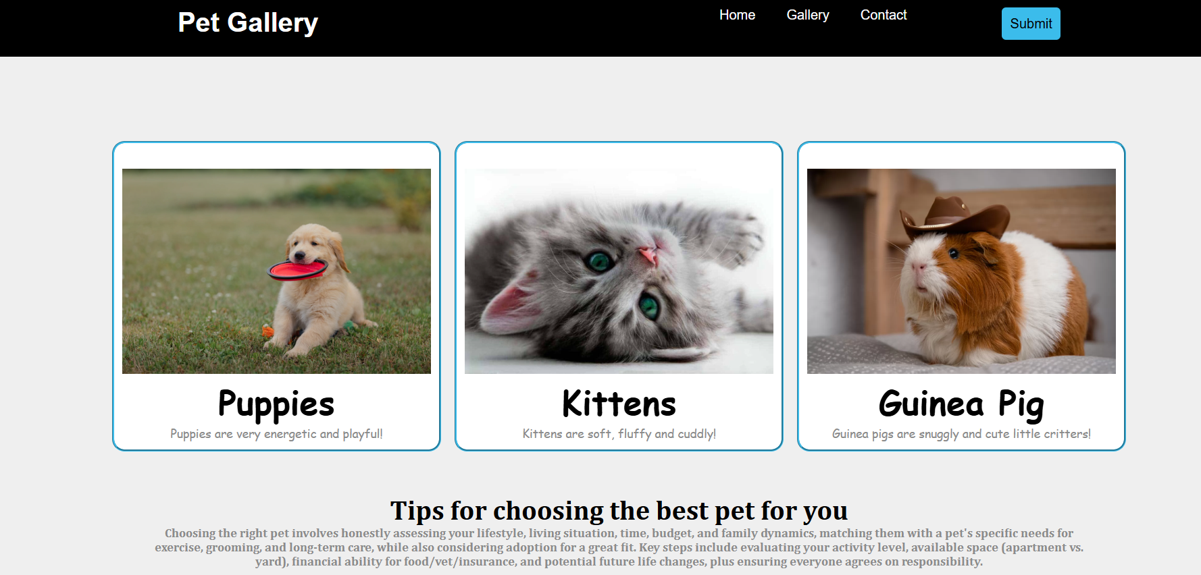

Summary:
- Chose pets for my theme
- Replaced all placeholder texts with new information
- Created new paragraph in flex section

