FSDI 101- Assignment 3
Name: Dejanirra Ramirez Parker
Theme: Pets
Github link: https://github.com/DejanirraMarie04/101Project

My page: 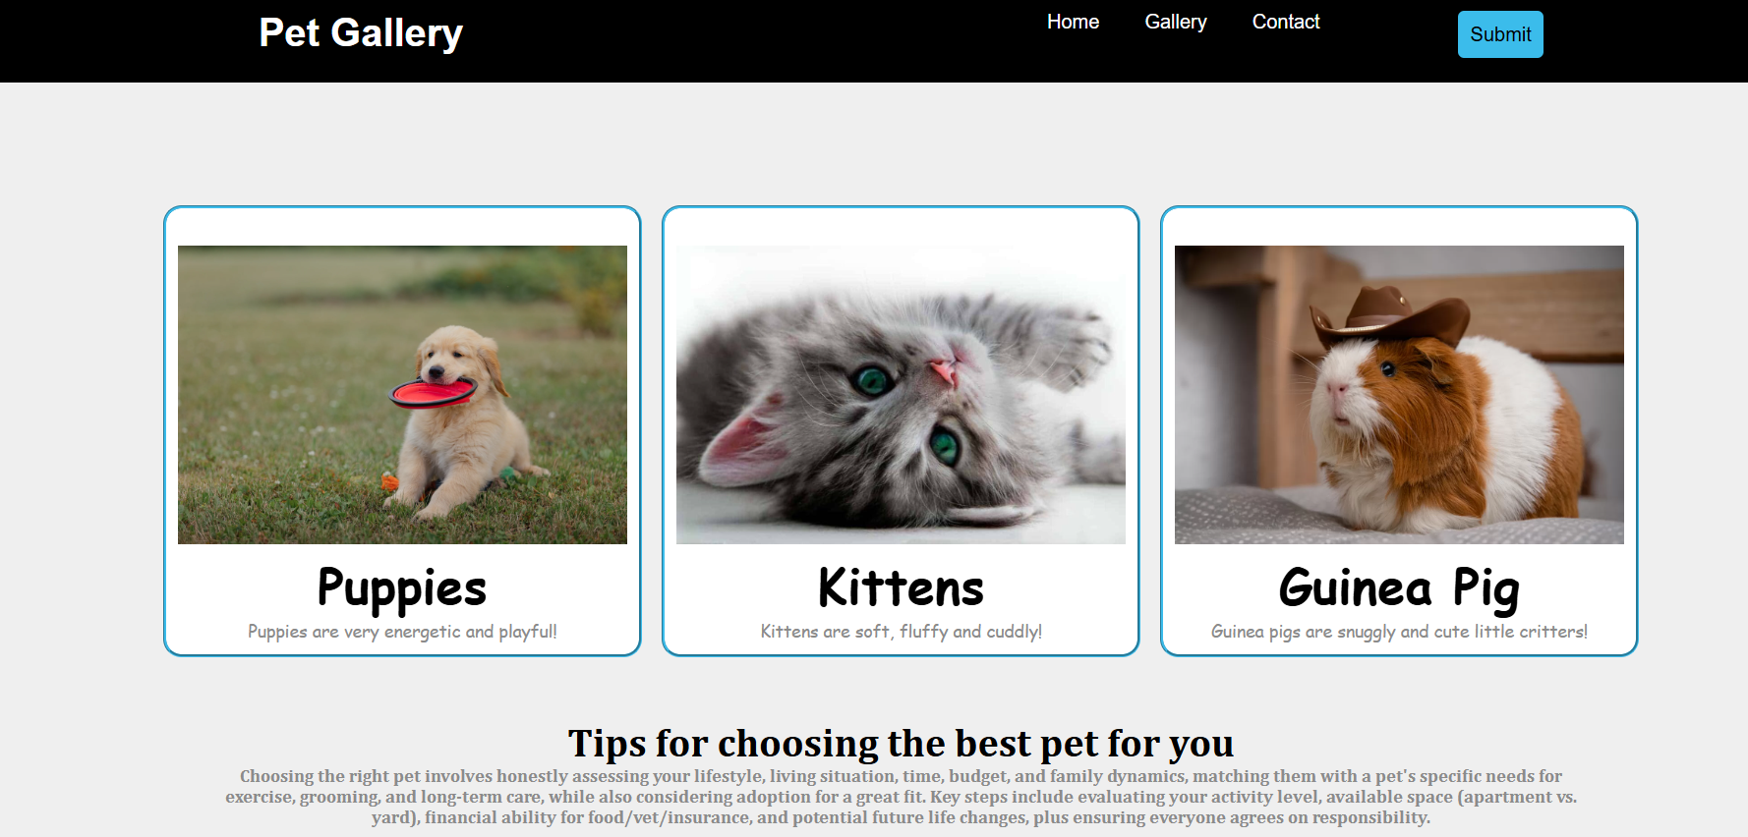

Summary:
- I changed the title of the page.
- I added images from the web.
- I added a groove border to the cards and added some color.
- I changed the font in the cards.
- I added an extra detailed paragraph with a different font.
- I changed the submit button color.

