David Kim

JD Francis

Josua Abe Prawiromaruto

Hash Table versus AVL Tree Report

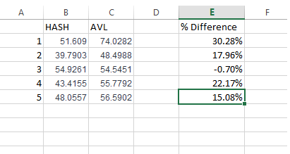

In using the stress test mode, we found that using the Hash Table is almost always a faster, more efficient data structures to serve as an index for large data sets. In the table above, “% Difference” shows how much faster (in seconds) the Hash Table performs the operations by a percentage. However, there is a trial in which the AVL tree was faster than Hash Table. In theory, a Hash Table should be faster than an AVL tree because of the O(1) vs. O(log n) worst case scenarios. However, in practice, because the stress test mode between the different trials and indices (Hash Table or AVL tree) was run once, terminated, then booted up again, the RAM could have been varying depending on the user’s tasks at that time, thus accounting for outlier information such as the one given in Trial 3. The tasks performed for this trial were choosing the data structure, building the index, and searching 4 queries (with multiple mixtures of AND, OR, NOT, DATEGT, and DATELT).