
ADDIS ABABA SCIENCE AND TECHNOLOGY UNIVERSITY
College of Engineering
Department of Electrical and computer Engineering
Internship Report and Project on
“Design and Implementation of an Oracle Database for Managing Failed Electronic Payment Transactions”
By:
Dejen Masresha ID: ETS0388/15
Supervisors:
University supervisor name: Mr. Sileshi Aweke
Industry supervisor name: Ms. Hemen Tekle
Submitted to: Addis Ababa Science and technology University Department of Electrical and Computer Engineering (focus area: Computer Engineering)
September 18, 2026 G.C
Addis Ababa, Ethiopia

Declaration
Me, the undersigned student of the Department of Electrical and Computer Engineering of Addis Ababa Science and Technology University, declare that this internship report entitled “Design and Implementation of an Oracle Database for Managing Failed Electronic Payment Transactions” is my own original work, carried out during my internship at EthSwitch company under the guidance of the university and company supervisors. All sources of material used for this report have been acknowledged.

Name of student | Identification number | Signature
Dejen Masresha | ETS0388/15 | 

This internship report has been submitted for examination with my approval as university supervisors.
Supervisor | Position |   Signature and date
Mr. Sileshi Aweke | University supervisor

Acknowledgement
I would like to thank my university for giving me the opportunity to undertake this internship and gain practical experience. I am deeply grateful to EthSwitch for accepting me as an intern.
I would like to thank the staff and professionals at EthSwitch for their support, cooperation, and willingness to share their knowledge. I am especially thankful to my workplace supervisor, Ms. Helen Tekle and the Database Department for their technical guidance during the internship.
I am also grateful to everyone who supported me while working on the project entitled “Design and Implementation of an Oracle Database for Managing Failed Electronic Payment Transactions.”
Finally, I sincerely thank everyone who contributed directly or indirectly to the successful completion of my internship and this report.

Table of Contents
Declaration 2
Acknowledgement 3
CHAPTER ONE 8
Introduction of the hosting company 8
1.1 Background of EthSwitch 8
1.2 Main Products and Services 8
1.3 Main Customers and End Users 9
1.4 Organization and Workflow 9
CHAPTER TWO 11
Overall internship experience 11
2.1 Section of the Company Where I Worked 11
2.3 Workflow of the Section 11
2.3.1 Understanding the Requirements 11
2.3.2 Preparing the Development Environment 12
2.3.3 Network and Remote Access Configuration 12
2.3.4 Oracle Database Installation and Configuration 12
2.3.5 Database Connectivity 12
2.3.6 Database Development 12
2.3.7 Data Insertion and Testing 13
2.3.8 Failed Transaction Processing 13
2.3.9 Testing and Documentation 13
2.4 Work Pieces and Tasks Executed 13
2.4.1 Company and Technical Orientation 13
2.4.2 Virtual Machine Configuration 14
2.4.3 Solaris Network Configuration 14
2.4.4 MobaXterm Configuration 14
2.4.5 Oracle Database Installation and Configuration 14
2.4.6 Oracle SQL Developer Configuration 14
2.4.7 Oracle User and Schema Management 15
2.4.8 Oracle SQL Development 15
2.6 Procedures and Methods Used 15
2.6.1 Requirement Analysis 15
2.6.2 Step-by-Step Implementation 16
2.7 Challenges Faced During the Internship 16
2.7.1 Virtual Machine Network Problems 16
2.7.2 Solaris Package Repository Problems 17
2.7.3 Database Design and Data Management Challenges 17
2.8 Measures Taken to Overcome Challenges 18
CHAPTER THREE 19
Selected industrial project and its design procedure 19
3.1. Introduction 19
3.2 Problem Statement and Justification 19
3.2.1 Problem Statement 19
3.2.2 Justification 19
3.3 Objective 20
3.3.1 General Objective 20
3.3.2 Specific Objectives 20
3.4 Methodology 20
3.5 Literature Review 22
3.6 Result & Discussion 24
3.6.1 Entities and Attributes 24
3.6.2 Relationships and Cardinality 27
3.6.3 Entity-Relationship Diagram 28
3.6.4 Oracle DDL Scripts 29
CHAPTER FOUR 33
Overall internship achievements and experiences 33
4.1 Introduction 33
4.2 Improvement of Theoretical Knowledge 33
4.3 Improvement of Practical and Technical Skills 33
4.3.1 Virtualization and Operating System Skills 34
4.3.2 Networking Skills 34
4.3.3 Remote Administration Skills 34
4.3.4 Oracle Database Skills 34
4.3.5 Database Design Skills 34
4.4 Understanding of Work Ethics 35
4.5 Personal and Professional Development 35
4.6 Major Achievements During the Internship 36
4.7 Overall Internship Experience 36
4.8 Conclusion 37
CHAPTER FIVE 38
Conclusion & Recommendation 38
5.1 Conclusion 38
5.2 Recommendation 40
5.2.1 Recommendation to EthSwitch 40
5.2.2 Recommendation to the University 40
5.2.3 Recommendation to Future Intern Students 41
5.2.4 Final Recommendation 41
Reference 42

CHAPTER ONE

Introduction of the hosting company

1.1 Background of EthSwitch
EthSwitch is Ethiopia's national payment switch, established to provide an interoperable electronic payment infrastructure that enables different financial institutions and payment service providers to communicate and exchange electronic payment transactions. The organization plays an important role in supporting the development of Ethiopia's digital payment ecosystem by enabling electronic transactions to be processed across participating institutions and payment channels.
The establishment of EthSwitch was motivated by the need for an interoperable national payment infrastructure through which customers of different financial institutions and payment service providers could access electronic payment services more conveniently. Through its switching infrastructure, EthSwitch supports the connection and interoperability of participating institutions by allowing electronic payment transactions to be routed between different participants.
Over time, the organization has expanded its electronic payment services and infrastructure to support different payment channels and financial service providers. Its activities are related to electronic payment switching, clearing and settlement, payment gateway services, dispute management, fraud monitoring, and other payment-related infrastructure services.

1.2 Main Products and Services
EthSwitch provides infrastructure and services that support electronic payment interoperability in Ethiopia. Its services enable participating financial institutions and payment service providers to exchange and process electronic payment transactions through a common switching infrastructure.
The major areas of service include electronic retail payment switching and clearing for channels such as Automated Teller Machines (ATMs), Point-of-Sale (POS) terminals, mobile banking, and internet banking.

1.3 Main Customers and End Users
The main customers and users of EthSwitch's services are organizations participating in Ethiopia's electronic payment ecosystem. These include banks, payment service providers, and other financial institutions that participate in interoperable payment services.
The ultimate users of the electronic payment services are customers who perform financial transactions through different payment channels. For example, customers may use ATMs, POS terminals, mobile banking, internet banking, or other supported electronic payment channels to initiate transactions.
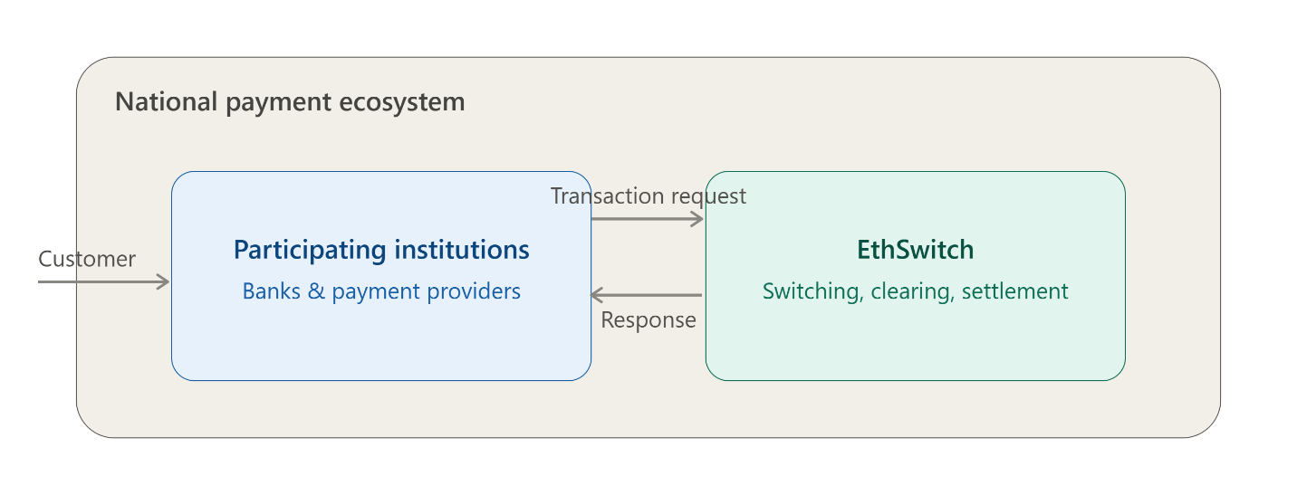
Therefore, EthSwitch operates primarily as an infrastructure and interoperability provider rather than as a conventional retail banking institution. Its services help participating institutions provide interoperable electronic payment services to their customers.

1.4 Organization and Workflow
EthSwitch operates through different functional areas that work together to provide electronic payment infrastructure and related services. The activities of the organization involve technical, operational, financial, security and administrative functions that support the operation of the payment-switching environment.
From a payment-processing perspective, the general workflow begins when a customer initiates an electronic payment transaction through a supported channel such as an ATM, POS terminal, mobile banking, or internet banking. The transaction information is transmitted through the relevant participating institution and reaches the payment-switching infrastructure. The switch processes and routes the transaction information to the appropriate participating institution.
The destination institution processes the transaction and sends a response indicating the result of the transaction. The transaction can be completed successfully or may fail for various operational or technical reasons. Transaction information is subsequently used for activities such as transaction monitoring, clearing, settlement, reporting, dispute management, and other operational requirements.
Here's the step-by-step transaction workflow itself:
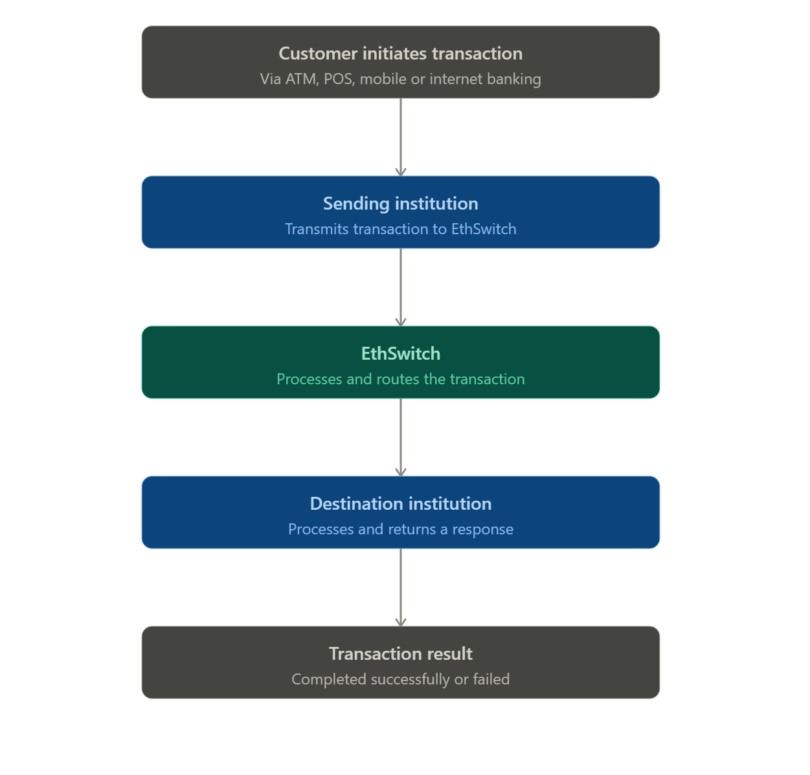

CHAPTER TWO

Overall internship experience

2.1 Section of the Company Where I Worked
During the internship, I worked in the database-related technical area under the guidance of the assigned company advisor. My activities were mainly focused on database development, database administration, SQL programming and database connectivity.
The section provided a practical environment for understanding how database technologies support electronic payment systems. Since electronic payment systems process a large number of transactions, reliable databases are essential for storing, retrieving, updating, monitoring, and analyzing transaction information.
My work therefore focused on developing practical database skills that are relevant to payment transaction processing. The major technology used during the internship was Oracle Database, together with Oracle SQL Developer, MobaXterm, Oracle Solaris and VirtualBox.

2.3 Workflow of the Section
The workflow of the database-related activities followed a progressive process. The work began with understanding the requirements and the working environment and then proceeded toward database implementation, testing and analysis.
The general workflow followed during the internship was:
Understanding Requirements → Preparing Environment → Configuring VM → Configuring Network → Remote Access → Installing Oracle → Connecting SQL Developer → Database Design → Creating Tables → Inserting Data → Querying Data → Identifying Failed Transactions → Testing → Documentation

2.3.1 Understanding the Requirements
The first stage involved understanding the objectives of the internship and the database-related tasks assigned by the company advisor. The requirements were discussed before beginning the technical implementation.

2.3.2 Preparing the Development Environment
The next stage involved preparing the technical environment required for database development and administration.
A virtual machine was created using VirtualBox, and Oracle Solaris was configured as the operating system. The virtual environment provided a controlled platform for installing and working with Oracle Database.

2.3.3 Network and Remote Access Configuration
After configuring the virtual machine, network connectivity was established between the host computer and the Solaris virtual machine.
MobaXterm was configured to provide remote SSH access to the Solaris environment. This made it possible to perform system administration and Oracle-related operations through a remote terminal.
Network connectivity, IP addressing, gateway configuration, and DNS resolution were also checked and troubleshot when necessary.

2.3.4 Oracle Database Installation and Configuration
After preparing the operating system environment, Oracle Database was installed and configured.
The Oracle environment variables and Oracle Database Home were reviewed. The Oracle Listener and Database Configuration Assistant (DBCA) were also studied as part of the database setup.

2.3.5 Database Connectivity
Once Oracle Database was configured, Oracle SQL Developer was used to establish a graphical connection to the database.
The required connection information, including the host address, port, service name, username, and password, was configured and tested.

2.3.6 Database Development
After successful connectivity, database development activities were started.
The database structure was designed according to the requirements of the electronic payment transaction project. Tables, columns, data types, primary keys, foreign keys, and other constraints were considered during the design.

2.3.7 Data Insertion and Testing
Mock electronic payment transaction data was inserted into the database to simulate real transaction records.
The data was then queried and analyzed using SQL. Different transaction statuses were included so that failed transactions could be identified and processed.

2.3.8 Failed Transaction Processing
One of the major tasks was identifying transactions with a status of FAILED from the payment_transaction table.
The failed records were selected using SQL and used to construct and populate the failed_transaction table. This provided practical experience in data filtering, data transformation, and INSERT INTO ... SELECT operations.

2.3.9 Testing and Documentation
The final stage involved testing the database objects, validating the data, correcting errors, and documenting the work performed.
SQL scripts and database operations were reviewed to ensure that the database behaved as expected.

2.4 Work Pieces and Tasks Executed
During the internship, I performed different tasks that progressively increased in complexity.

2.4.1 Company and Technical Orientation
At the beginning of the internship, I was introduced to the company by the company advisor the working environment and the objectives of the internship.
I learned about the importance of databases in electronic payment environments and the responsibilities associated with database-related tasks.

2.4.2 Virtual Machine Configuration
One of my initial technical tasks was configuring a virtual machine using VirtualBox.
The virtual machine was prepared with Oracle Solaris as the guest operating system. I configured by installing the operating system and practiced basic Solaris commands.

2.4.3 Solaris Network Configuration
After installing Solaris, I configured and tested the network connection.
I worked with IP addresses, network interfaces, gateways, and DNS configuration. Network commands were used to determine the status of the interfaces and verify communication between the host computer and the virtual machine.
DNS-related problems were also investigated when hostname resolution failed. The DNS client configuration and name-service configuration were checked and adjusted.
This task improved my understanding of the relationship between operating-system networking and database connectivity.

2.4.4 MobaXterm Configuration
MobaXterm was configured to connect remotely to the Solaris virtual machine.
SSH was used to establish the remote connection. I practiced managing the Solaris system through the MobaXterm terminal and used command-line tools to perform configuration and troubleshooting tasks..

2.4.5 Oracle Database Installation and Configuration
Oracle Database was installed and configured in the prepared environment.
I studied the Oracle Database installation process, Oracle Home, environment variables, listener configuration, and Database Configuration Assistant.
I also learned about software-only installation and the role of response files in automated Oracle installation.

2.4.6 Oracle SQL Developer Configuration
After installing Oracle Database, I configured Oracle SQL Developer to connect to the database.
The database connection parameters were entered and tested. When connection problems occurred, I investigated the listener, network, service name, username, and other connection requirements.

2.4.7 Oracle User and Schema Management
I learned how Oracle users and schemas are created and managed.
I practiced creating database users and assigning appropriate privileges. I also studied the relationship between users, schemas, database objects, roles and privileges.
This helped me understand database access control and the importance of limiting access according to user requirements.

2.4.8 Oracle SQL Development
A significant part of the internship involved learning and practicing Oracle SQL.
I worked with:
- SELECT, INSERT, UPDATE, DELETE
- CREATE TABLE, CREATE USER
- GRANT, COMMIT, ROLLBACK
- WHERE, ORDER BY, GROUP BY, HAVING
Aggregate functions, Joins, Subqueries, Conditional expressions, Views

2.6 Procedures and Methods Used
Several procedures and methods were used throughout the internship to complete the assigned tasks.

2.6.1 Requirement Analysis
Before implementing a database solution, the requirements of each task were first identified and understood. This helped determine which tables, columns, data types, constraints, and SQL operations were required.

2.6.2 Step-by-Step Implementation
Technical tasks were completed progressively rather than attempting to configure the entire system at once.
For example, the database environment was established in the following order:
- Virtual machine creation.
- Solaris installation.
- Network configuration.
- Remote access configuration.
- Oracle installation.
- Oracle configuration.
- SQL Developer connection.
- Database creation.
- Table creation.
- Data insertion.
- Data querying.
- Testing and troubleshooting.
This approach made it easier to identify the source of problems.

2.7 Challenges Faced During the Internship
Several technical challenges were encountered during the internship. These challenges were valuable learning opportunities because they required investigation and problem-solving rather than simply following predefined instructions.

2.7.1 Virtual Machine Network Problems
One challenge was establishing reliable network communication between the Windows host computer and the Solaris virtual machine. Problems related to network configuration, IP addresses, VirtualBox network adapters, and routing affected communication between the systems.
Solution
The network configuration was investigated step by step. The IP configuration, network interface status, routing table, gateway, and connectivity were checked. Different VirtualBox networking configurations were also examined. Connectivity was tested using commands such as ping and Solaris network administration commands.

2.7.2 Solaris Package Repository Problems
During the preparation of the Solaris environment, difficulties were encountered while refreshing and accessing the Solaris package repository.
The package manager experienced problems contacting the Oracle repository. Repository connectivity and transfer errors were encountered during package refresh operations.
Solution
The problem was investigated by checking DNS resolution, repository configuration, network connectivity proxy settings.
The configured publisher and repository origin were examined, and connectivity to the repository was tested separately.
This process improved my ability to troubleshoot problems involving operating-system packages and external repositories.

2.7.3 Database Design and Data Management Challenges
Designing the payment transaction tables required careful consideration of the attributes, data types, constraints, and relationships.
It was also necessary to ensure that mock data was realistic enough to test different transaction scenarios.
Solution
The database was designed incrementally. The required transaction information was identified first, followed by the selection of suitable data types and constraints.
The database was then populated with test data and validated through SQL queries.

2.8 Measures Taken to Overcome Challenges
To overcome the challenges encountered during the internship, I applied several problem-solving approaches.
1. Breaking Problems into Smaller Components
Complex problems were divided into smaller components.
For example, when database connectivity failed, I did not assume that the database itself was the problem. I separately checked:
Network → IP → DNS → Listener → Database Service → SQL Developer
2. Reviewing Configuration Files
When problems were related to system or database configuration, the relevant configuration files and settings were examined.
This included Solaris networking and DNS configuration, Oracle environment configuration, and database connection settings.
3. Testing After Each Change
After making a configuration change, the result was tested before making another change.
This prevented multiple unverified changes from making the problem more difficult to identify.
4. Consulting the Company Advisor
When a problem was beyond my current level of understanding, I discussed it with the company advisor. The advisor provided guidance about the appropriate approach and helped me understand the underlying technical concepts.
5. Practicing Repeatedly
Database concepts and SQL commands were practiced repeatedly using the development database. Repeated practice helped improve my understanding of Oracle SQL and database administration.

CHAPTER THREE

Selected industrial project and its design procedure

3.1. Introduction
This revision uses five (5) core entities, modeled around an inter-bank / national-switch style payment system common in Ethiopia (similar in spirit to how EthSwitch connects multiple banks, mobile-money operators, and channels).

3.2 Problem Statement and Justification

3.2.1 Problem Statement
Electronic payment systems depend on the reliable exchange of transaction information among participating financial institutions and payment service providers. However, not every transaction processed through the switching infrastructure completes successfully. Transactions may fail due to a range of conditions, including insufficient funds, invalid account information, communication failures, system unavailability, transaction timeouts, or invalid transaction data, among other technical and operational causes.
As transaction volumes grow, so does the number of failed transaction records that must be captured and managed. Each failed transaction carries information that is valuable for operational and analytical purposes — including its status, failure reason, payment channel, transaction amount, participating institutions, and date of occurrence. Without a well-structured database to store and organize this information, retrieving specific failed transactions, classifying them by cause, and generating meaningful reports becomes difficult, time-consuming, and prone to inconsistency. This limits the ability of operational personnel to identify recurring failure patterns, investigate specific incidents, and support timely decision-making.

3.2.2 Justification
This project addresses the above problem by designing and implementing an Oracle database prototype specifically for managing failed electronic payment transaction information. The proposed database provides structured storage for transaction records and their associated failure details, enabling failed transactions to be searched, categorized, and summarized in a consistent and efficient manner.
The scope of the project is intentionally limited to the database management aspect of failed payment transactions. It does not aim to build a complete electronic payment switching system, nor does it attempt to directly resolve the underlying technical failures occurring within financial institutions. Rather, by organizing transaction and failure records in a structured way, the system is intended to support easier identification of transaction failures, basic analysis of failure patterns, and the preparation of reports that can assist operational personnel in conducting further investigation.

3.3 Objective

3.3.1 General Objective
To design and implement an Oracle database for managing, categorizing, retrieving, and reporting failed electronic payment transactions.

3.3.2 Specific Objectives
The specific objectives of the project are:
- To identify the main data requirements necessary for recording failed electronic payment transactions.
- To design a relational database model for storing payment transaction and failure information.
- To implement the designed database using Oracle Database.
- To analyze sample failed transaction data based on payment channels, failure reasons, dates, and participating financial institutions.

3.4 Methodology
This project will use a database system development approach to design and implement an Oracle database for managing failed electronic payment transactions. The methodology will focus on understanding the information requirements related to failed transactions, designing a suitable relational database structure, implementing the database using Oracle Database, and testing the proposed database using non-confidential sample data.
The first stage of the project will involve requirements gathering. Information about failed electronic payment transactions will be studied through discussions with the internship supervisor and observation of the payment-related workflow where access is permitted, and review of available non-confidential documentation. The purpose of this stage is to identify the important information that should be stored about failed transactions, such as transaction identification, transaction date and time, payment channel, participating financial institutions, transaction amount, failure reason and transaction status.
The second stage will involve database analysis and design. The identified requirements will be analyzed to determine the main entities, attributes, and relationships required by the proposed database. An Entity-Relationship Diagram (ERD) will be developed to represent the relationships among payment transactions, financial institutions, payment channels, and failure reasons. The database structure will then be converted into relational tables with appropriate primary keys, foreign keys, and integrity constraints.
The third stage will involve database implementation. The designed relational database will be implemented using Oracle Database. Tables, constraints, relationships and other required database objects will be created using Structured Query Language (SQL). Sample non-confidential transaction records will then be inserted into the database to represent different types of failed electronic payment transactions.
The fourth stage will involve query and report development. SQL queries will be developed to retrieve individual failed transactions and generate summarized information. The queries will be used to analyze failed transactions according to failure reason, payment channel, date, transaction amount, and participating financial institution. Database views may also be created to simplify frequently required reports and transaction searches.
The fifth stage will involve database testing. The implemented database will be tested using sample transaction data to determine whether records can be correctly inserted, updated, retrieved and categorized. The relationships and integrity constraints will also be tested to ensure that invalid or inconsistent data is prevented where appropriate.
Finally, the results will be analyzed and discussed. The developed database will be evaluated based on its ability to organize failed transaction information, retrieve specific transactions, categorize failure reasons, and generate useful summary reports. The limitations of the proposed database will also be identified, particularly because the project will use non-confidential sample data and will not directly connect to or modify the production payment-switching environment.

3.5 Literature Review
Electronic payment systems have become an important part of modern financial services. Because they allow financial transactions to be performed electronically through different channels including banking applications, automated teller machines (ATMs), point-of-sale (POS) terminals, mobile payment platforms and other electronic channels. Previous studies have shown that electronic payment systems require security, reliability, availability, integrity and convenience in order to provide dependable services to users. Hancock and Humphrey (1997) explain that payment systems have progressively moved from traditional paper-based methods toward technologically advanced electronic payment systems, increasing the importance of reliable payment infrastructures.
Electronic payment transactions normally involve several processing activities before a transaction is successfully completed. These activities may involve transaction initiation, authorization, communication between participating institutions and recording of the transaction result. Because several components may participate in a single payment process, failures can occur at different stages. Anderson and Bezuidenhoudt (1996) emphasize that reliability is a fundamental requirement of electronic payment systems because payment failures can affect the correct processing and completion of financial transactions.
A failed electronic payment transaction can be described as a transaction that cannot be successfully completed because one or more conditions required for processing are not satisfied. Failure may result from technical problems, communication interruptions, transaction timeouts, system unavailability, invalid transaction information, insufficient funds, duplicate transactions, transaction limits, or problems occurring between interconnected payment systems.
Hassan et al. (2020), in a systematic review of electronic-payment research, identified availability, authorization, integrity, authentication, and confidentiality as important security properties for electronic payment systems. These properties are important when failed transactions are recorded because transaction information must remain accurate and protected from unauthorized modification. Similarly, studies of electronic payment systems emphasize that security and accuracy are essential because financial information is transferred electronically between different parties and systems.
Effective management of failed transactions therefore requires more than simply identifying that a transaction has failed. The failure should be recorded together with relevant information such as the transaction identifier, failure reason, failure date, description, resolution status, resolution date and remarks. Maintaining these details provides a historical record that can support investigation, monitoring, reporting and resolution. A structured database is appropriate for this purpose because it can organize transaction and failure information in related tables and allow authorized users to retrieve and analyze the information efficiently.
Database transaction management is particularly important in financial applications. Oracle Database describes a transaction as a logical and atomic unit of work in which related operations are either committed or rolled back. Oracle also provides mechanisms for concurrency control and data consistency so that multiple users can work with shared data without improperly corrupting it.
Oracle Database provides features that support the development and administration of database applications, including relational data management, SQL, transaction management, concurrency control, security, backup and recovery, and performance management. Oracle's Database 19c documentation also provides facilities for database administration, development, security, connectivity, and performance tuning.
Based on the reviewed literature, reliable electronic payment processing depends on the ability of a payment system to maintain transaction integrity, availability, security, and traceability. However, identifying a failed transaction is only one part of the problem; organizations also need an organized mechanism for recording the causes and current resolution status of those failures. The proposed project addresses this need by designing and implementing an Oracle database for managing failed electronic payment transactions. The proposed database focuses on recording payment transactions and their associated failure information, enabling failed transactions to be identified, stored, monitored, and queried systematically. Thus, the literature supports the importance of the proposed system while the project applies these principles to a practical database solution for failed electronic payment transaction management.

3.6 Result & Discussion

3.6.1 Entities and Attributes
- FINANCIAL_INSTITUTION: a bank, microfinance institution (MFI), or mobile-money operator connected to the system
- PAYMENT_CHANNEL: the channel a transaction was made through (mobile app, USSD, POS, ATM, internet, agent)
- PAYMENT_TRANSACTION: every payment attempt, successful or not, between two accounts
- FAILURE_REASON: a lookup of standard failure causes
- FAILED_TRANSACTION: details recorded only when a transaction fails
1. FINANCIAL_INSTITUTION
Attribute | Data Type (Oracle) | Key / Notes
institution_id | NUMBER | PK
institution_name | VARCHAR2(100) | NOT NULL, e.g. Commercial Bank of Ethiopia
institution_code | VARCHAR2(10) | UNIQUE, e.g. CBE, AWASH, TELEBIRR
institution_type | VARCHAR2(20) | BANK / MFI / MOBILE_MONEY_OPERATOR
status | VARCHAR2(10) | ACTIVE / INACTIVE
created_at | TIMESTAMP | NOT NULL

2. PAYMENT_CHANNEL
Attribute | Data Type (Oracle) | Key / Notes
channel_id | NUMBER | PK
channel_name | VARCHAR2(50) | e.g. Telebirr App, CBE Mobile, USSD
description | VARCHAR2(200)
status | VARCHAR2(10) | ACTIVE / INACTIVE
created_at | TIMESTAMP | NOT NULL

4. FAILURE_REASON
Attribute | Data Type (Oracle) | Key / Notes
reason_id | NUMBER | PK
reason_code | VARCHAR2(15) | UNIQUE, e.g. ERR_TIMEOUT,
reason_name | VARCHAR2(100) | VARCHAR2(100) NOT NULL,
description | VARCHAR2(150) | e.g. Insufficient balance in sender
status | VARCHAR2(20) | DEFAULT 'ACTIVE' NOT NULL,
created_at | TIMESTAMP | NOT NULL

3. PAYMENT_TRANSACTION
Attribute | Data Type (Oracle) | Key / Notes
transaction_id | NUMBER | PK
source_institution_id | NUMBER | FK → FINANCIAL_INSTITUTION
destination_institution_id | NUMBER | FK → FINANCIAL_INSTITUTION
channel_id | NUMBER | FK → PAYMENT_CHANNEL
transaction_date | TIMESTAMP | Default SYSTIMESTAMP
amount | NUMBER(15,2) | > 0
currency | VARCHAR2(5) | Default 'ETB'
transaction_status | VARCHAR2(20) | SUCCESS / FAILED / PENDING /
response_code | VARCHAR2(20)
created_at | TIMESTAMP | NOT NULL

5. FAILED_TRANSACTION
Attribute | Data Type (Oracle) | Key / Notes
failed_txn_id | NUMBER | PK
transaction_id | NUMBER | FK → PAYMENT_TRANSACTION, UNIQUE
reason_id | NUMBER | FK → FAILURE_REASON
failure_timestamp | TIMESTAMP | Default SYSTIMESTAMP
resolution_status | VARCHAR2(20) | DEFAULT 'OPEN' NOT NULL
resolution_date | DATE | Nullable
remarks | VARCHAR2(300) | Free-text notes
created_at | TIMESTAMP | DEFAULT SYSTIMESTAMP

3.6.2 Relationships and Cardinality
Relationship | Cardinality | Description
Financial_institution --- Payment_channel | 1 : M | An institution offers several channels (app, USSD, POS, etc.)
Financial_institution --- Payment_transaction (sender) | 1 : M | A financial institution can send many transactions
Financial_institution --- Payment_transaction(receiver) | 1 : M | A financial institution can receive many transactions
Payment_channel ---Payment_transaction | 1 : M | A channel carries many transactions
Payment_transaction --- Failed_transaction | 1 : 0..1 | A transaction has at most one failure record, created only if it fails
Failure_reason ---Failed_transaction | 1 : M | One reason can explain many failed transactions

3.6.3 Entity-Relationship Diagram
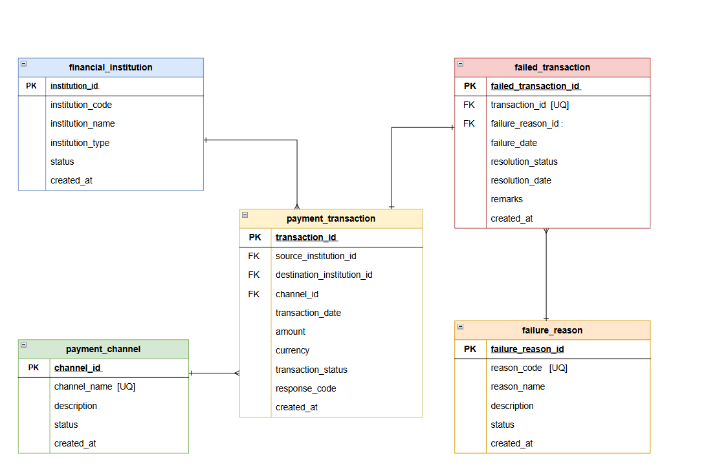
Figure 3.1 Entity -Relationship diagram

3.6.4 Oracle DDL Scripts
CREATE TABLE financial_institution (
institution_id NUMBER(10) NOT NULL,
institution_code VARCHAR2(20) NOT NULL,
institution_name VARCHAR2(100) NOT NULL,
institution_type VARCHAR2(30) NOT NULL,
status VARCHAR2(20) DEFAULT 'ACTIVE' NOT NULL,
created_at TIMESTAMP DEFAULT SYSTIMESTAMP NOT NULL,
CONSTRAINT pk_financial_institution PRIMARY KEY (institution_id),
CONSTRAINT uq_fi_code UNIQUE (institution_code),
CONSTRAINT ck_fi_type CHECK (institution_type IN ( 'BANK', 'MOBILE_MONEY',
'PAYMENT_OPERATOR', 'FINTECH' )),
CONSTRAINT ck_fi_status CHECK (status IN ('ACTIVE', 'INACTIVE'))
);
CREATE TABLE payment_channel (
channel_id NUMBER(10) NOT NULL,
channel_name VARCHAR2(50) NOT NULL,
description VARCHAR2(200),
status VARCHAR2(20) DEFAULT 'ACTIVE' NOT NULL,
created_at TIMESTAMP DEFAULT SYSTIMESTAMP NOT NULL,
CONSTRAINT pk_payment_channel PRIMARY KEY (channel_id),
CONSTRAINT uq_pc_name UNIQUE (channel_name),
CONSTRAINT ck_pc_status CHECK (status IN ('ACTIVE', 'INACTIVE'))
);

CREATE TABLE failure_reason (
failure_reason_id NUMBER(10) NOT NULL,
reason_code VARCHAR2(30) NOT NULL,
reason_name VARCHAR2(100) NOT NULL,
description VARCHAR2(300),
status VARCHAR2(20) DEFAULT 'ACTIVE' NOT NULL,
created_at TIMESTAMP DEFAULT SYSTIMESTAMP NOT NULL,
CONSTRAINT pk_failure_reason PRIMARY KEY (failure_reason_id),
CONSTRAINT uq_fr_code UNIQUE (reason_code),
CONSTRAINT ck_fr_status CHECK (status IN ('ACTIVE', 'INACTIVE'))
);
CREATE TABLE payment_transaction (
transaction_id VARCHAR2(50) NOT NULL,
transaction_date TIMESTAMP DEFAULT SYSTIMESTAMP NOT NULL,
source_institution_id NUMBER(10) NOT NULL,
destination_institution_id NUMBER(10) NOT NULL,
channel_id NUMBER(10) NOT NULL,
amount NUMBER(18,2) NOT NULL,
currency VARCHAR2(10) DEFAULT 'ETB' NOT NULL,
transaction_status VARCHAR2(20) NOT NULL,
response_code VARCHAR2(20),
created_at TIMESTAMP DEFAULT SYSTIMESTAMP NOT NULL,
CONSTRAINT pk_payment_transaction PRIMARY KEY (transaction_id),
CONSTRAINT fk_pt_source_institution FOREIGN KEY (source_institution_id)
REFERENCES financial_institution(institution_id),
CONSTRAINT fk_pt_destination_institution FOREIGN KEY (destination_institution_id)
REFERENCES financial_institution(institution_id),

CONSTRAINT fk_pt_channel FOREIGN KEY (channel_id)
REFERENCES payment_channel(channel_id),
CONSTRAINT ck_pt_amount CHECK (amount > 0),
CONSTRAINT ck_pt_currency CHECK (currency IN ('ETB')),
CONSTRAINT ck_pt_status CHECK ( transaction_status IN
('SUCCESS', 'FAILED', 'PENDING') )
);
CREATE TABLE failed_transaction (
failed_transaction_id NUMBER(15) GENERATED BY DEFAULT AS IDENTITY,
transaction_id VARCHAR2(50) NOT NULL,
failure_reason_id NUMBER(10) NOT NULL,
failure_date TIMESTAMP DEFAULT SYSTIMESTAMP NOT NULL,
resolution_status VARCHAR2(20) DEFAULT 'OPEN' NOT NULL,
resolution_date TIMESTAMP,
remarks VARCHAR2(500),
created_at TIMESTAMP DEFAULT SYSTIMESTAMP NOT NULL,
CONSTRAINT pk_failed_transaction PRIMARY KEY (failed_transaction_id),
CONSTRAINT uq_failed_transaction UNIQUE (transaction_id),
CONSTRAINT fk_ft_transaction FOREIGN KEY (transaction_id)
REFERENCES payment_transaction(transaction_id),
CONSTRAINT fk_ft_failure_reason FOREIGN KEY (failure_reason_id)
REFERENCES failure_reason(failure_reason_id),
CONSTRAINT ck_ft_resolution_status
CHECK ( resolution_status IN
('OPEN', 'INVESTIGATING', 'RESOLVED') )
);

CHAPTER FOUR

Overall internship achievements and experiences

4.1 Introduction
The internship provided me with an important opportunity to connect the theoretical knowledge acquired in my academic studies with practical experience in a professional working environment. During the internship at EthSwitch, I gained knowledge and experience in database management, Oracle Database, SQL programming, virtualization, networking, troubleshooting and electronic payment transaction data management.
The following sections describe the major achievements and benefits I gained from the internship.

4.2 Improvement of Theoretical Knowledge
One of the major benefits of the internship was the improvement and expansion of my theoretical knowledge. Before the internship, most of my database knowledge was obtained through academic courses and practical exercises. The internship allowed me to understand how these concepts are applied in an actual professional environment.
I also expanded my knowledge of Oracle Database. I learned about Oracle Database architecture, Oracle Database installation, Oracle Home, Oracle Listener, Database Configuration Assistant (DBCA), users and schema.
My knowledge of SQL was also significantly improved. I practiced basic SQL statements such as SELECT, INSERT, UPDATE, and DELETE, and progressed to more advanced concepts such as joins, sub-queries, aggregate functions, grouping, views and transaction control using COMMIT and ROLLBACK.

4.3 Improvement of Practical and Technical Skills
The internship significantly improved my practical technical skills. Instead of only studying database concepts theoretically. I gained experience configuring and working with an actual database environment.

4.3.1 Virtualization and Operating System Skills
I gained practical experience using VirtualBox to create and configure a virtual machine. I worked with Oracle Solaris as the operating system for the database environment.

4.3.2 Networking Skills
I also developed practical networking skills while configuring communication between the Windows host computer and the Solaris virtual machine.
I gained experience with IP address configuration, network interfaces, default gateways, DNS configuration, routing concepts, network connectivity testing, SSH connectivity and troubleshooting network problems.

4.3.3 Remote Administration Skills
I gained practical experience using MobaXterm and SSH to remotely access and administer the Solaris virtual machine. This improved my understanding of remote server administration and command-line system management.

4.3.4 Oracle Database Skills
My Oracle Database skills improved considerably during the internship.
I gained practical experience in installing Oracle Database, configuring Oracle Database, creating database users, managing schemas, assigning privileges, creating tables, defining constraints, managing transaction data, executing SQL queries, using SQL Developer, checking Oracle Listener status and troubleshooting database connectivity.

4.3.5 Database Design Skills
The development of the payment transaction database improved my database design skills.
I learned how to identify the information required by a system, determine suitable attributes, select appropriate data types, define keys, apply constraints, and organize information into relational tables.
The failed transaction database project also helped me understand how structured transaction information can support future analytical and intelligent systems.
For example, a collection of failed payment transactions can potentially be analyzed to identify common failure patterns, detect unusual transaction behavior, and support automated decision-making.
I therefore gained an understanding that database management is not isolated from modern technologies. Instead, databases provide an important foundation for AI, analytics, automation, and other Industry 4.0 applications.

4.4 Understanding of Work Ethics
The internship helped me develop a better understanding of professional work ethics.
I learned that working in an organization requires more than technical knowledge. Employees must also demonstrate responsibility, honesty, discipline, confidentiality, respect, punctuality, and professionalism.
Working with payment-related data particularly increased my awareness of the importance of data security and confidentiality. Payment transaction information can be sensitive, and therefore database professionals must handle data carefully and avoid unauthorized access or disclosure.
I learned the importance of protecting confidential information, following organizational procedures, respecting supervisors and colleagues, being punctual and responsible, completing assigned tasks properly, reporting problems honestly and taking responsibility for mistakes and correcting them.

4.5 Personal and Professional Development
In addition to technical knowledge, the internship contributed significantly to my personal development. I became more confident in working with unfamiliar technologies and solving technical problems.
I also improved my ability to learn independently. When I encountered an unfamiliar Oracle command or configuration issue. I learned to investigate the problem, understand the underlying concept, test possible solutions, and verify the result.

4.6 Major Achievements During the Internship
The major achievements I obtained during the internship include:
- Successfully understanding the professional working environment.
- Developing an understanding of the role of databases in electronic payment systems.
- Configuring a virtual machine using VirtualBox.
- Installing and configuring Oracle Solaris.
- Establishing network connectivity for the virtual environment.
- Configuring DNS and troubleshooting network-related problems.
- Establishing remote access using MobaXterm and SSH.
- Installing and configuring Oracle Database.
- Configuring Oracle Database connectivity using SQL Developer.
- Creating and managing Oracle database users and schemas.
- Creating relational database tables and constraints.
- Developing an electronic payment transaction database structure.
- Creating realistic mock payment transaction data.
- Identifying transactions with FAILED status.
- Practicing Oracle SQL from basic to advanced levels.
- Developing database troubleshooting skills.

4.7 Overall Internship Experience
Overall, the internship was a valuable bridge between academic learning and professional practice. It allowed me to experience how database technologies are configured, managed, and applied to practical problems.
The progression from virtual machine configuration to Oracle Database implementation gave me an understanding of the complete technical environment required for database operations. I learned that successful database work depends not only on SQL knowledge but also on operating systems, networking, system administration and troubleshooting.
The Failed Electronic Payment Transaction project was particularly valuable because it provided a practical application of database concepts to a payment-related scenario. Through this project, I gained experience in designing tables, creating mock data, filtering transactions, transferring selected data between tables, validating results, and managing database information.
The internship also improved my professional qualities. I became more comfortable communicating with technical supervisors, asking questions, investigating problems, accepting feedback, and taking responsibility for assigned work.
Most importantly, the internship changed my understanding of database management from a mainly theoretical subject into a practical professional skill. I now have a better understanding of how database systems support real-world applications and how database professionals contribute to the reliability, security, and efficiency of information systems.

4.8 Conclusion
The internship at EthSwitch provided significant benefits in terms of theoretical knowledge, practical technical skills, industrial problem-solving, teamwork, leadership, work ethics, and entrepreneurship.
The experience strengthened my knowledge of Oracle Database, SQL, database design, database administration, networking, virtualization, and electronic payment transaction management.
It also helped me understand the importance of emerging technologies such as artificial intelligence, data analytics, automation, and other Industry 4.0 technologies in the future development of information systems and payment technologies.
The challenges encountered during the internship were not only obstacles but also important learning opportunities. Solving these challenges improved my analytical thinking, troubleshooting ability, patience, and confidence.
Overall, the internship provided a strong foundation for my future professional development in database management, database administration, software and information technology, and related fields.

CHAPTER FIVE

Conclusion & Recommendation

5.1 Conclusion
The internship conducted at EthSwitch was an important opportunity to apply the theoretical knowledge gained through academic studies to a practical professional environment. The internship focused mainly on database management, Oracle Database, SQL programming, database administration, virtualization, networking, and electronic payment transaction data management.
At the beginning of the internship, I was introduced to the organization, the company advisor, the working environment, and the objectives of the internship. This initial orientation helped me understand the importance of professional communication, responsibility, teamwork, and proper workplace conduct.
One of the major areas of practical experience was the preparation of the technical environment. I configured a virtual machine using VirtualBox and worked with Oracle Solaris as the operating system. This helped me understand how virtualized environments can be used to create database development and testing environments. I also gained practical experience in configuring IP addresses, network interfaces, gateways, DNS, and network connectivity.
The configuration of MobaXterm and SSH provided experience in remote system administration. I learned how to connect to the Solaris virtual machine remotely and perform system-level operations through the terminal. During this process, I encountered several networking and DNS-related problems. Solving these problems helped me develop systematic troubleshooting and diagnostic skills.
Another major achievement was gaining practical experience with Oracle Database. I learned how to prepare the Oracle environment, install and configure the database, understand Oracle Database Home and environment variables, configure and check the Oracle Listener, and use Database Configuration Assistant. I also learned how database users, schemas, roles, and privileges are managed.
Oracle SQL Developer was used as the main graphical interface for interacting with the database. Through SQL Developer, I practiced creating database objects, inserting and modifying data, retrieving information, and testing SQL queries. This helped me understand the relationship between a database server and its client applications.
The major practical project during the internship was the development of a database related to Failed Electronic Payment Transactions. The project involved designing a payment_transaction table, selecting suitable attributes and data types, applying database constraints, and inserting realistic mock transaction data. The database was then used to identify transactions with a FAILED transaction status.
A separate failed_transaction table was created based on the failed records obtained from the payment_transaction table. SQL operations were used to select the appropriate records and populate the failed transaction table. I also practiced clearing existing failed transaction records and repopulating the table using current information from the source transaction table. This provided valuable experience in data filtering, data transformation, and data management.
Several challenges were encountered throughout the internship. These included virtual machine networking problems, DNS resolution problems, Solaris package repository connectivity issues, Oracle installation challenges, database connection problems, and differences between Oracle and other database management systems. Rather than treating these challenges only as obstacles, I used them as opportunities to improve my technical problem-solving ability.
In conclusion, the internship successfully achieved its purpose of connecting academic knowledge with practical experience. It strengthened my knowledge of database management and gave me practical exposure to Oracle Database, SQL, Solaris, virtualization, networking, remote administration, and electronic payment transaction data management. The experience has provided a strong foundation for my future career development in database administration, database development, data management, and related information technology fields.

5.2 Recommendation
Based on my internship experience, I would like to provide the following recommendations.

5.2.1 Recommendation to EthSwitch
EthSwitch provides a valuable professional environment for students to gain practical experience in information technology and electronic payment systems. I recommend that the organization continue providing internship opportunities for students because practical exposure helps students understand how the knowledge they acquire in educational institutions is applied in industry.
It would also be beneficial for interns to receive greater exposure to different technical areas related to electronic payment systems, such as database administration, system administration, networking, cybersecurity, data analytics, software development and payment system architecture. Such exposure would provide students with a broader understanding of how different technical components work together.
Finally, I recommend that students continue to receive regular feedback from their company advisors. Regular discussions about progress, challenges and learning objectives can help interns identify areas requiring improvement and gain greater value from their internship.

5.2.2 Recommendation to the University
The university should continue strengthening the connection between academic courses and industrial practice. Database-related courses should provide students with more opportunities to work with enterprise-level database management systems such as Oracle in addition to other commonly used systems. Students should be given practical exercises involving database design, administration, performance, backup and recovery, and troubleshooting.
I also recommend that students receive more practical exposure to technologies surrounding databases, including Linux/Unix systems, virtualization, networking, cloud technologies, cybersecurity, data analytics, and artificial intelligence. Modern database professionals need knowledge beyond SQL alone.

5.2.3 Recommendation to Future Intern Students
Future students undertaking internships in database-related fields should take advantage of the internship as a learning opportunity rather than focusing only on completing assigned tasks.
Students should practice independently, ask questions when they do not understand a concept, document important commands and solutions, and try to understand the reason behind each technical procedure.

5.2.4 Final Recommendation
Finally, I recommend that internship programs continue to emphasize the integration of academic knowledge, practical skills, emerging technologies, and professional development.
The combination of database management, electronic payment systems, data analytics, artificial intelligence, and other Industry 4.0 technologies will continue to create new opportunities in the information technology sector. Therefore, students should continuously update their technical knowledge and develop the ability to learn new technologies independently.
The internship at EthSwitch demonstrated that practical experience is essential for developing competent and confident IT professionals. Continued cooperation between educational institutions and organizations such as EthSwitch can help prepare students with the technical and professional skills required by the industry.

Reference
- Anderson, R. J., & Bezuidenhoudt, S. J. (1996). On the Reliability of Electronic Payment Systems. IEEE Transactions on Software Engineering, 22(5), 294–301.
- Hancock, D., & Humphrey, D. B. (1997). Payment transactions, instruments, and systems: A survey. Journal of Banking & Finance, 21(11–12), 1573–1624.
- Hassan, M. A., Shukur, Z., Hasan, M. K., & Al-Khaleefa, A. S. (2020). A Review on Electronic Payments Security. Symmetry, 12(8), 1344.
- Oracle. Oracle Database 19c: Database Concepts. Oracle Documentation.
- Oracle. Oracle Database 19c: Administration. Oracle Documentation.
- Griffiths, J., & Joyce, M. (2024). The Reliability of Retail Payment Services. Reserve Bank of Australia Bulletin.

