Custometry

Foundation System Design

STATUS  APPROVED |  | OWNER  Architecture |  | LAST UPDATED  July 16, 2026

Authors | Custometry Architecture
Reviewers | Independent cold review · completed
Related docs | system-design.md · ADR-0001 · ADR-0002 · blueprint 0.8.2-draft
Scope | Repository Foundation, contracts, local runtime and acceptance boundaries

1. Executive summary
Custometry is built as a contract-backed modular monolith: a tangible Web shell appears early, then each bounded context replaces a mock adapter with a real vertical slice across API, domain/application, PostgreSQL or immutable artifacts, and browser/runtime proof.
Foundation establishes public-repository governance, DDD boundaries, quality tooling, a download-first Compose topology with an infrastructure Edge and separate edge_to_web/web_to_api networks, local documentation, and a deterministic retail source. It does not claim completed analytics, forecasting, report delivery, universal XLSX, or production deployment.

2. Goals and non-goals
Goals | Non-goals
Reproducible public monorepo and protected delivery | Completed product analytics or forecasting functionality
Explicit DDD ownership and automated boundary gates | Microservices, Kubernetes, or remote workers before a separate ADR
Lightweight download-first local installation and offline core | A huge offline bundle or a false Edge egress-denial claim
UI-first vertical slices with real-boundary proof | Treating Penpot, mocks, or unit tests as complete acceptance

3. Context and problem
Without a shared UI, contract, and verifiable-boundary foundation, the product can fragment into disconnected screens and services. The earlier container approach also exposed risks from a large offline bundle, port conflicts, shared Edge/API adjacency, and overly strong egress claims.
The selected path is UI-first: a shared Experience Platform and versioned contracts precede domain slices. Apps are composition roots, packages own domain/application code and ports, adapters connect from the outside, and application code never reads another context's private tables directly.

4. Target architecture

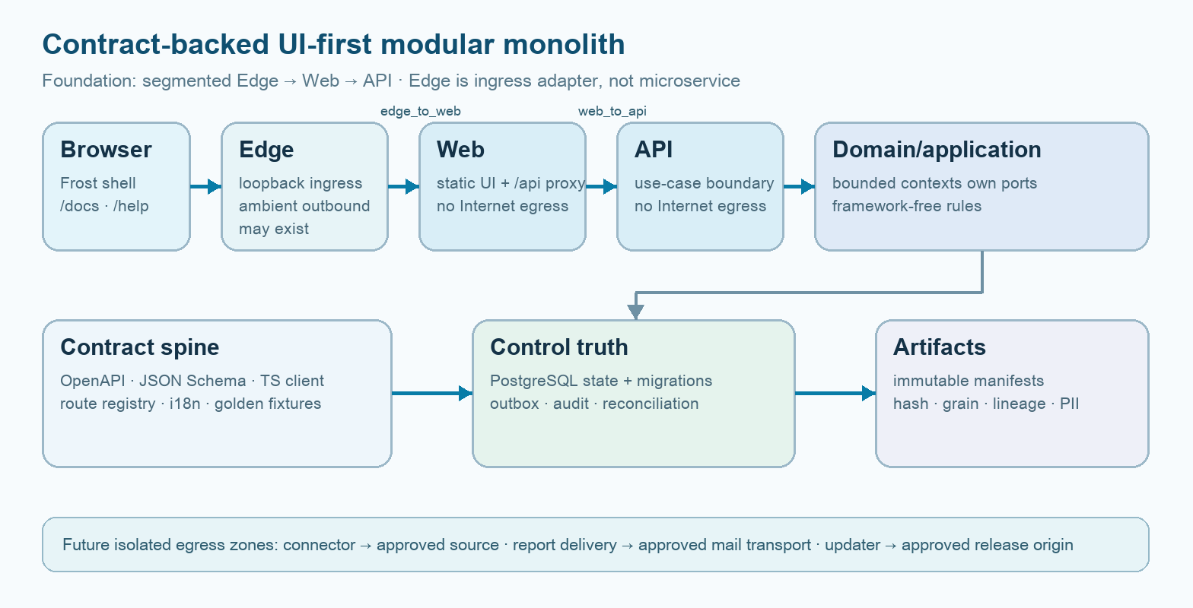
Figure 1. Foundation boundary and dependency direction.

Key components

Component | Responsibility | Primary storage | Failure behavior
Edge / Web / local docs | Infrastructure ingress; split Edge→Web→API; Frost shell, /docs, /help | One immutable Web artifact | No direct Edge→API; explicit degraded state
API composition root | HTTP boundary, use-case wiring, readiness | No private state | Fail closed with stable error code
Domain contexts | Invariants, commands, queries, owned ports | Owned PostgreSQL schema/artifacts | No cross-context private-table fallback
Execution/artifact spine | Outbox, leases, reconciliation, immutable results | PostgreSQL + local manifests | Retry classified; unknown state reconciled
Quality toolchain | Drift, DDD, docs, routes, runtime evidence | Git + generated manifests | Required evidence missing = gate failure

5. Vertical-slice lifecycle
- The route, UI states, DTO/OpenAPI/JSON Schema, and examples are fixed as one versioned contract.
- The boundary validates identity, workspace, authorization, locale-neutral values, and bounded filters before invoking the use case.
- The generated client and mock adapter use the same schemas; a separate product mock model is forbidden.
- The framework-free application use case invokes domain rules and only the outbound ports owned by its context.
- The command/run and outbox intent are committed in one PostgreSQL transaction before the external effect.
- The adapter applies timeouts, retry classes, idempotency identity, and unknown-state reconciliation; the worker uses leases and fencing.
- The terminal state and immutable artifact manifest become visible atomically; UI, audit, metrics, and runbooks reflect the observed result.

6. API and data contracts

Primary execution contract

Field | Type | Required | Description
workspace_id | UUID | Yes | Tenant boundary; authorized before work
definition_ref | Version ref | Yes | Immutable published definition
request_hash | SHA-256 | Yes | Normalized semantic input identity
attempt_id | UUID | Yes | One delivery attempt; never reused
lease_fence | Integer | Long task | Rejects stale worker writes
artifact_ref | Manifest ref | On result | Hash, schema, grain, lineage, PII
trace_id | Opaque ID | Yes | Cross-boundary audit/observability link

Contract guarantees

- Schema, authorization, workspace, and limit validation run before execution; invalid input creates no side effect.
- Repeatable commands use a request hash, idempotency key, attempt identity, and lease/fencing ordering.
- The published definition, input snapshot, code/plugin version, seed, locale/timezone, and artifact hashes are pinned for replay.
- PostgreSQL is the source of truth for control/run state; Valkey is delivery/cache only; bulk data is an immutable artifact, not a control row.
Versioned interfaces and templates live in
docs/contracts/README.md; every change passes compatibility and drift gates.

7. Consistency, idempotency, and replay

Client-facing state changes only after a durable commit. At-least-once delivery may repeat computation but not an external effect; request hash and attempt identity distinguish replay. Partial failure remains observable and is repaired by the reconciler rather than a hidden retry.
Scenario | Expected behavior | Reasoning
Duplicate command/delivery | Return/reuse stable intent; no duplicate effect | Idempotency key + request hash + attempt identity
Required durable write fails | No downstream work; retryable typed failure | State is committed before side effect
Timeout or unknown result | No blind retry; reconcile destination/state | Unknown is explicit and auditable
Definition/config changes mid-run | Pinned version remains authoritative | Replay cannot mix revisions

8. Security and privacy

- Workspace authorization is applied before pagination or aggregation and checked again before sensitive artifact or source access.
- PII is classified and redacted before previews, exports, logs, traces, and samples; raw customer or provider payloads never enter the public repository.
- Secrets arrive as references or files and never enter URLs, image layers, generated artifacts, or diagnostic output.
- Web/API/data runtime remains on internal networks and passes negative egress probes. The secretless, read-only Edge is an infrastructure ingress adapter: edge_to_web is separate from web_to_api, direct Edge→API access is denied, but Compose does not prove absence of ambient Edge egress; production requires firewall/CNI hardening.
- Cleanup, migration, replay, and debugging fail closed by default, remain ownership-bounded and auditable, and require their own proof boundaries.

9. Operational readiness
Signal | SLO or alert | Owner | Launch gate
Application readiness | All owned dependencies ready | Platform | Required
API/browser latency | Measured baseline; no unapproved regression | Web/API | Required per slice
Run failure/retry rate | Typed threshold by workload | Execution | Required per slice
Contract/config drift | Zero unreviewed drift | Architecture | Required
Backup/restore integrity | Fresh disposable restore + hash match | Platform/QA | Required before release
Rollout constraint: local M3 Pro proof first; production promotion additionally requires target firewall/CNI Edge policy, negative outbound/direct-adjacency probes and tested rollback.

10. Alternatives considered

Alternative | Why considered | Why not selected
Microservices first | Independent scaling/deploy | Premature coordination and transaction cost
Backend-first layers | Traditional technical sequencing | Delays workflow validation and usable UI
Large offline bundle | No first-run downloads | Huge artifact, stale caches, poor updates
Broad Edge/Web/API bridge | Simpler connectivity | Creates direct Edge→API adjacency and blurs trust boundaries

11. Open decisions
- OPEN-007: customer_id completeness threshold for customer analytics; owner — Product/Data; recommended form — workspace degraded policy.
- OPEN-008: minimum forecast-target history; owner — Product/ML; the rule depends on frequency, seasonality, and horizon.
- No Foundation decision remains open for the Compose topology: the M3 Pro, single-server target, and ADR-0002 are accepted; target-specific production firewall/CNI implementation remains future Hardening evidence.
- No Foundation decision remains open for ownership or tooling: the DDD map, S00–S06, and mandatory gates are fixed.

12. Decision and next milestones
Adopt Foundation as the shared framework. Next, create the Experience Platform and Local Data Lab, then introduce one real vertical slice at a time with S00–S06 proof; expand targets and capability scope only after local evidence. This document is not a stage plan or prompt pack.
Milestone | Deliverable | Exit criteria
M1 | Repository Foundation | Static gates, thin hooks, cold review
M2 | Experience Platform + Local Data Lab | Real browser and deterministic PostgreSQL proof
M3 | First real vertical slice | S00–S06 evidence across UI/API/data
M4 | Hardening and broader capabilities | Recovery, supply chain, performance and target firewall/CNI Edge proof

Use footnotes for definitions, assumptions, or terms that need precision without interrupting the main narrative.

