Week 2 UI Prototype Report

Excelerate Learning Hub Mobile Application

Team 4 | Mobile App Development with Flutter Virtual Internship

1. Introduction
This report presents the Week 2 development progress of the Excelerate Learning Hub Mobile Application. The primary objective was to transform the wireframes designed in Week 1 into functional user interface prototypes that demonstrate the core learner journey and navigation flow of the application.

2. Project Overview
The Excelerate Learning Hub Mobile Application is designed to:
- Help learners discover opportunities
- Browse educational programs
- Access internship information
- Explore learning pathways
- Engage with the Excelerate ecosystem
The application aims to provide a clean and intuitive mobile experience while maintaining consistency with Excelerate's visual identity.

3. Week 2 Objectives
The objectives achieved during Week 2 include:
✅ Login Screen Development
✅ Home Screen Development
✅ Quick Access Section
✅ Program Listing Screen
✅ Search Functionality
✅ Program Details Screen
✅ Navigation Structure
✅ GitHub Repository Update

4. User Interface Prototype

4.1 Login Screen

Purpose
The Login Screen serves as the application entry point and allows users to access the platform.

Features
- Email field
- Password field
- Login button
- Clean user interface
Figure 1. Login Screen UI Prototype
Login Screen Screenshot

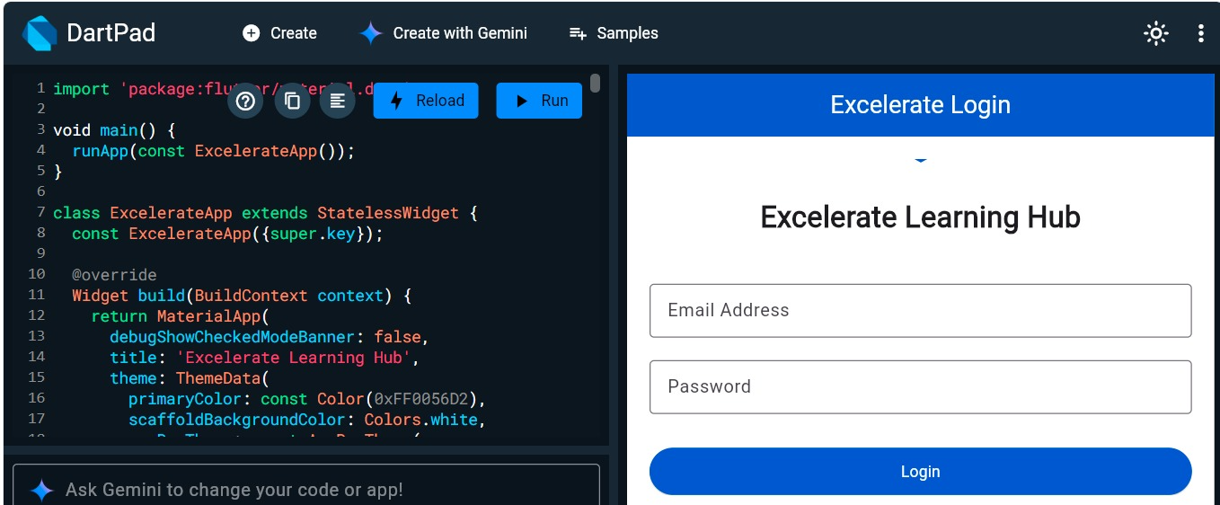

4.2 Home Screen

Purpose
The Home Screen serves as the learner dashboard and central navigation hub.

Features
- Welcome banner
- Featured opportunities
- Dashboard overview
- Navigation menu
Figure 2. Home Screen Dashboard
Home Screen Screenshot
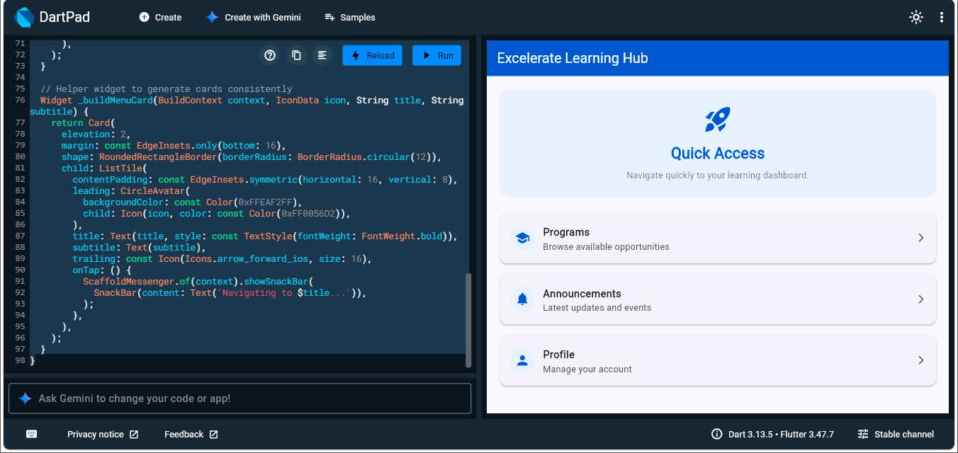

4.3 Quick Access Section

Purpose
The Quick Access section provides direct links to the most frequently used areas of the application.

Features
- Programs shortcut
- Announcements shortcut
- Profile shortcut
Figure 3. Quick Access Navigation Section
The Quick Access section improves navigation efficiency by allowing users to reach important areas of the application with minimal interaction.
Quick Access Screenshot

4.4 Program Listing Screen

Purpose
The Program Listing Screen allows learners to browse available programs and opportunities.

Features
- Program cards
- Program titles
- Program descriptions
- Structured presentation of opportunities

Caption
Figure 4. Program Listing Screen
The Program Listing Screen displays available programs in an organized and user-friendly format, supporting program discovery.
(Insert Program Listing Screenshot Here)

4.5 Search Functionality

Purpose
The search feature allows learners to quickly locate programs using keywords.

Features
- Search input
- Filtered results
- Improved discoverability
Figure 5. Search Function Demonstration
Search Function Screenshot
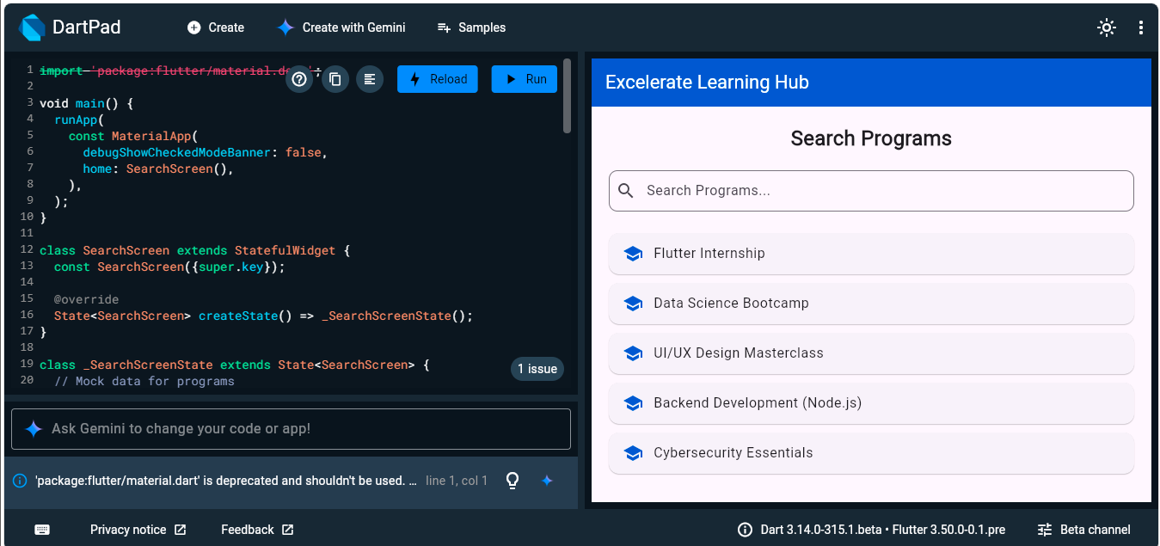
Screenshot output
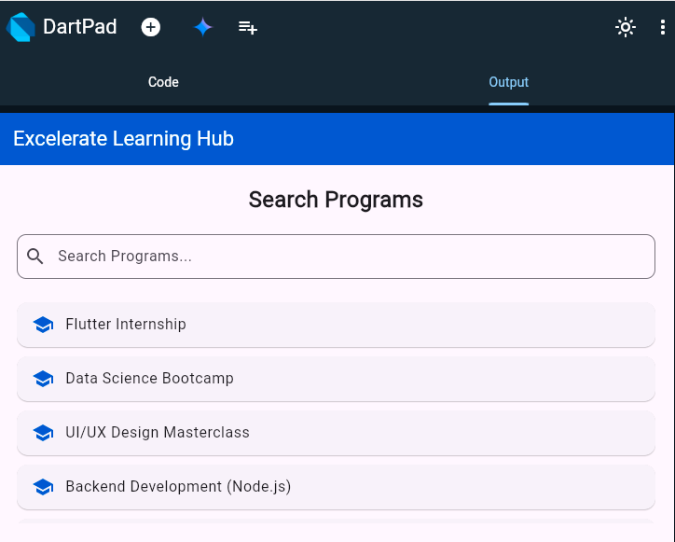
The search functionality helps users efficiently locate programs by filtering results based on keywords entered into the search field.

4.6 Program Details Screen

Purpose
The Program Details Screen provides detailed information about a selected opportunity.

Features
- Description
- Eligibility
- Duration
- Benefits
- Registration option
Figure 6. Program Details Screen
Program Details Screenshot

The Program Details Screen allows learners to review detailed information about a selected program before deciding to register.
(Insert Program Details Screenshot Here)

5. Application Navigation Flow

Figure 7: Navigation Diagram
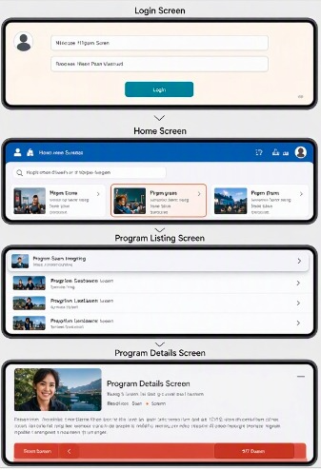
Figure 7. Application Navigation Flow Diagram
The diagram illustrates the primary navigation path within the Excelerate Learning Hub Mobile Application. Users begin at the Login Screen, proceed to the Home Screen, access available opportunities through the Program Listing Screen, and view detailed information through the Program Details Screen. The navigation flow was designed to provide a simple, intuitive, and user-friendly experience that supports quick program discovery and engagement. The application follows a simple and intuitive navigation structure designed to support the learner journey.
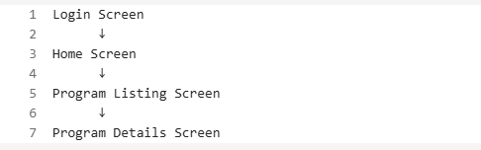.

6. Branding and Design Decisions
The current Excelerate platform demonstrates a modern user experience built around learner engagement, opportunity discovery, and achievement tracking.

Key Branding Elements
- Magenta and pink accent colors
- Rounded cards and buttons
- Dashboard-style layouts
- Clean typography hierarchy
- Progress and achievement visualization
- Opportunity-focused content presentation

Design Inspiration
The prototype design was inspired by the current Excelerate platform experience, including:
- Login interface
- Dashboard cards
- Learning opportunities
- Achievement tracking
- Program exploration workflows
The prototype focuses on demonstrating functionality and navigation while maintaining consistency with modern UI design principles.

7. Technical Implementation

Flutter Concepts Applied
- Scaffold
- AppBar
- Column
- ListView
- Card
- ListTile
- TextField
- ElevatedButton
- Navigation Structure

Features Implemented
- Authentication interface
- Dashboard layout
- Program browsing
- Search functionality
- Program details interface

8. GitHub Repository Documentation
Repository Link:
https://github.com/Deji-Oladiran/excelerate-learning-hub
GitHub documentation includes:
- Source code
- README documentation
- UI screenshots
- Repository structure
- Commit history

9. Challenges Encountered
During development, some platform limitations affected navigation testing and deployment. To ensure successful completion of the prototype, individual screens were developed, tested, documented, and published through GitHub.
These challenges enhanced understanding of UI prototyping, documentation, and version control workflows.

10. Learning Outcomes
By completing Week 2 activities, the following skills were strengthened:
- Flutter UI Design
- Mobile Application Layout Development
- Navigation Planning
- User Experience Design
- GitHub Repository Management
- Technical Documentation
- Version Control Practices

10. Conclusion
Week 2 successfully transformed initial wireframes into functional UI prototypes that demonstrate the core features of the Excelerate Learning Hub Mobile Application. The Login Screen, Home Screen, Quick Access Section, Program Listing Screen, Search Functionality, and Program Details Screen collectively establish a strong foundation for future development.
The application is now prepared for future enhancements such as API integration, dynamic content loading, state management, and advanced user interactions planned for subsequent internship milestones.

Prepared By
Team 4
Excelerate Learning Hub Mobile Application
Mobile App Development with Flutter Virtual Internship
Week 2 Submission

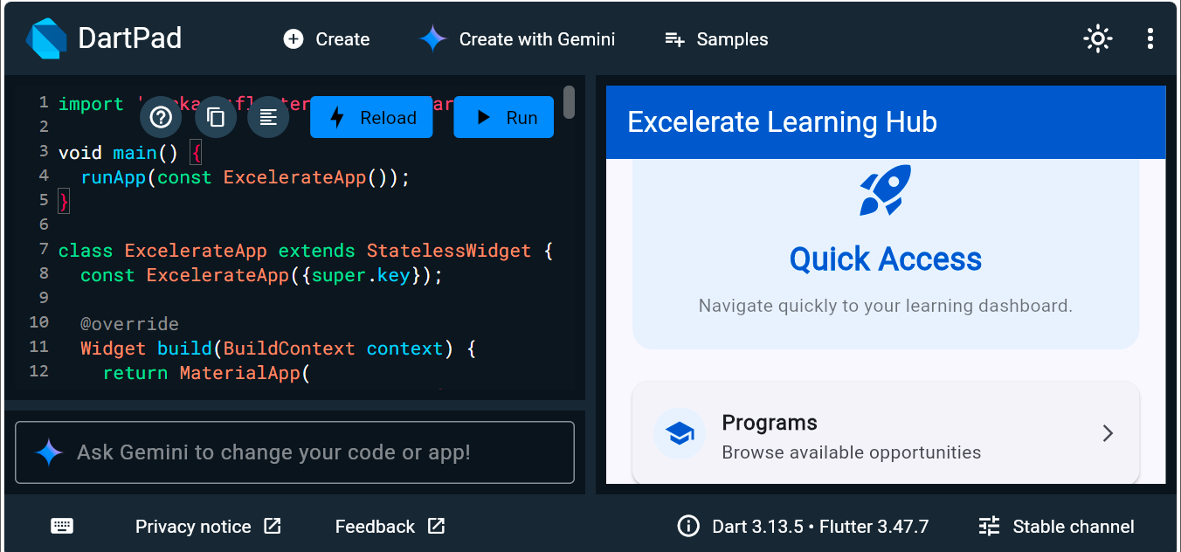

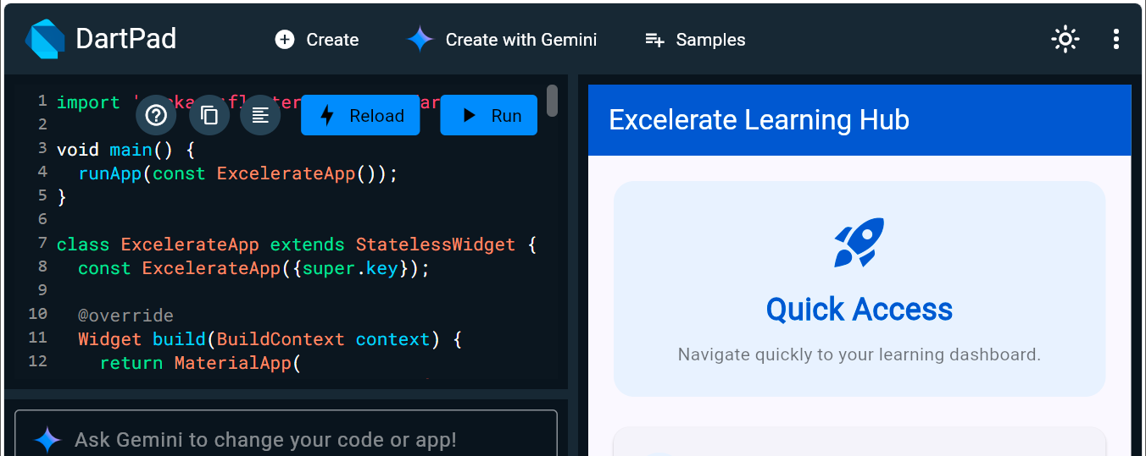
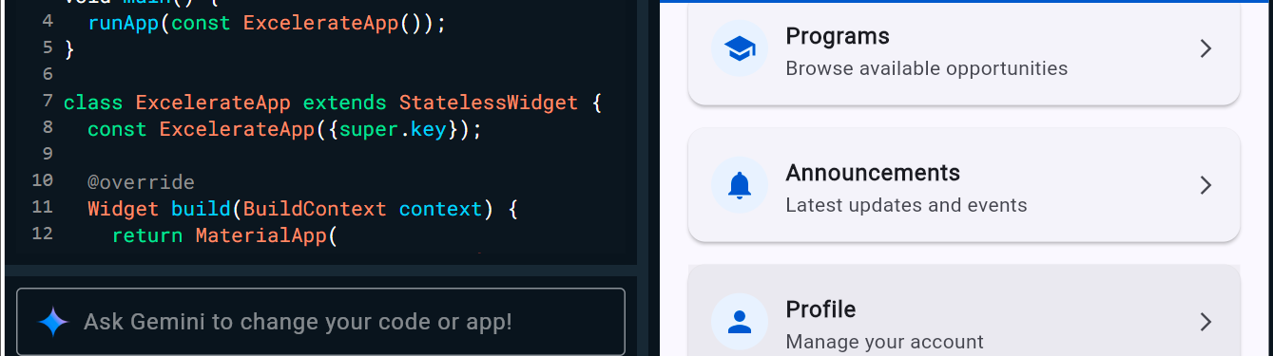

Screenshot Output
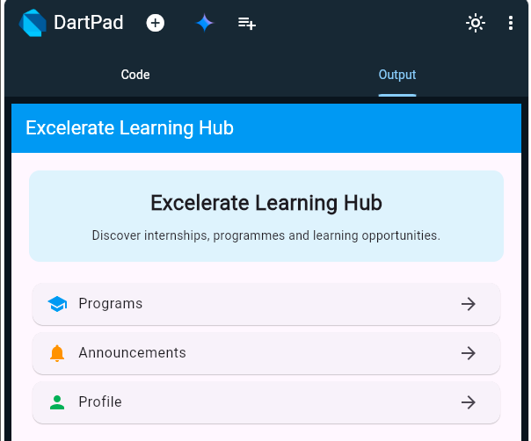

import 'package:flutter/material.dart';

void main() {
runApp(const ExcelerateApp());
}

class ExcelerateApp extends StatelessWidget {
const ExcelerateApp({super.key});

@override
Widget build(BuildContext context) {
return MaterialApp(
debugShowCheckedModeBanner: false,
title: 'Excelerate Learning Hub',
theme: ThemeData(
primaryColor: const Color(0xFF0056D2),
colorScheme: ColorScheme.fromSeed(seedColor: const Color(0xFF0056D2)),
),
home: const QuickAccessScreen(),
);
}
}

class QuickAccessScreen extends StatelessWidget {
const QuickAccessScreen({super.key});

@override
Widget build(BuildContext context) {
const Color excelerateBlue = Color(0xFF0056D2);

return Scaffold(
appBar: AppBar(
backgroundColor: excelerateBlue,
title: const Text('Excelerate Learning Hub', style: TextStyle(color: Colors.white)),
elevation: 0,
),
body: SingleChildScrollView(
padding: const EdgeInsets.all(20),
child: Column(
children: [
Container(
width: double.infinity,
padding: const EdgeInsets.all(24),
decoration: BoxDecoration(
color: const Color(0xFFEAF2FF),
borderRadius: BorderRadius.circular(16),
),
child: const Column(
children: [
Icon(Icons.rocket_launch, size: 48, color: excelerateBlue),
SizedBox(height: 12),
Text(
"Quick Access",
style: TextStyle(fontSize: 24, fontWeight: FontWeight.bold, color: excelerateBlue),
),
SizedBox(height: 8),
Text(
"Navigate quickly to your learning dashboard.",
textAlign: TextAlign.center,
style: TextStyle(color: Colors.black54),
),
],
),
),
const SizedBox(height: 24),
_buildMenuCard(context, Icons.school, "Programs", "Browse available opportunities"),
_buildMenuCard(context, Icons.notifications, "Announcements", "Latest updates and events"),
_buildMenuCard(context, Icons.person, "Profile", "Manage your account"),
],
),
),
);
}

// Helper widget to generate cards consistently
Widget _buildMenuCard(BuildContext context, IconData icon, String title, String subtitle) {
return Card(
elevation: 2,
margin: const EdgeInsets.only(bottom: 16),
shape: RoundedRectangleBorder(borderRadius: BorderRadius.circular(12)),
child: ListTile(
contentPadding: const EdgeInsets.symmetric(horizontal: 16, vertical: 8),
leading: CircleAvatar(
backgroundColor: const Color(0xFFEAF2FF),
child: Icon(icon, color: const Color(0xFF0056D2)),
),
title: Text(title, style: const TextStyle(fontWeight: FontWeight.bold)),
subtitle: Text(subtitle),
trailing: const Icon(Icons.arrow_forward_ios, size: 16),
onTap: () {
ScaffoldMessenger.of(context).showSnackBar(
SnackBar(content: Text('Navigating to $title...')),
);
},
),
);
}
}

Scaffold(
appBar: AppBar(
title: Text("Excelerate Learning Hub"),
),
body: Padding(
padding: EdgeInsets.all(20),
child: Column(
children: [
Text(
"Search Programs",
style: TextStyle(
fontSize: 24,
fontWeight: FontWeight.bold,
),
),
SizedBox(height: 20),
TextField(
decoration: InputDecoration(
hintText: "Search Programs...",
prefixIcon: Icon(Icons.search),
border: OutlineInputBorder(),
),
),
SizedBox(height: 20),
Card(
child: ListTile(
leading: Icon(Icons.school),
title: Text("Flutter Internship"),
),
),
Card(
child: ListTile(
leading: Icon(Icons.school),
title: Text("Data Analytics Program"),
),
),
Card(
child: ListTile(
leading: Icon(Icons.school),
title: Text("Digital Marketing Bootcamp"),
),
),
],
),
),
)

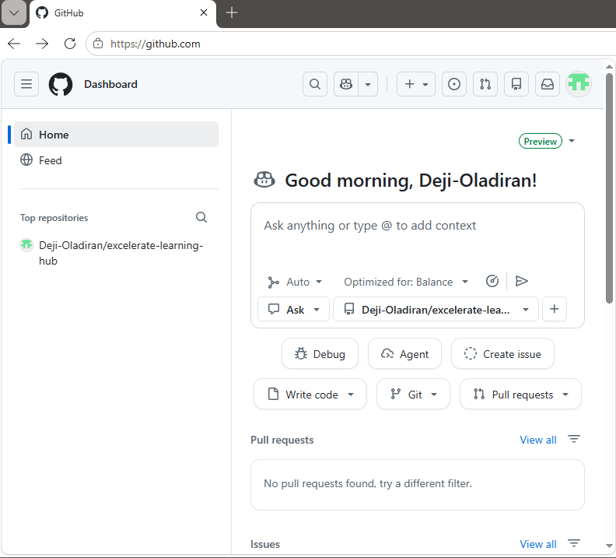

import 'package:flutter/material.dart';

void main() {
runApp(const ExcelerateApp());
}

class ExcelerateApp extends StatelessWidget {
const ExcelerateApp({super.key});

@override
Widget build(BuildContext context) {
return MaterialApp(
debugShowCheckedModeBanner: false,
title: 'Excelerate Learning Hub',
theme: ThemeData(
primaryColor: const Color(0xFF0056D2),
scaffoldBackgroundColor: Colors.white,
appBarTheme: const AppBarTheme(
backgroundColor: Color(0xFF0056D2),
foregroundColor: Colors.white,
centerTitle: true,
),
elevatedButtonTheme: ElevatedButtonThemeData(
style: ElevatedButton.styleFrom(
backgroundColor: const Color(0xFF0056D2),
foregroundColor: Colors.white,
minimumSize: const Size(double.infinity, 50),
),
),
),
home: LoginScreen(),
);
}
}

// ================= LOGIN SCREEN =================

class LoginScreen extends StatelessWidget {
LoginScreen({super.key});

final TextEditingController emailController =
TextEditingController();

final TextEditingController passwordController =
TextEditingController();

@override
Widget build(BuildContext context) {
return Scaffold(
appBar: AppBar(
title: const Text("Excelerate Login"),
),
body: Padding(
padding: const EdgeInsets.all(20),
child: SingleChildScrollView(
child: Column(
mainAxisAlignment:
MainAxisAlignment.center,
children: [
const SizedBox(height: 40),

const Icon(
Icons.school,
size: 90,
color: Color(0xFF0056D2),
),

const SizedBox(height: 20),

const Text(
"Excelerate Learning Hub",
style: TextStyle(
fontSize: 26,
fontWeight: FontWeight.bold,
),
textAlign: TextAlign.center,
),

const SizedBox(height: 40),

TextField(
controller: emailController,
decoration: const InputDecoration(
labelText: "Email Address",
border: OutlineInputBorder(),
),
),

const SizedBox(height: 20),

TextField(
controller: passwordController,
obscureText: true,
decoration: const InputDecoration(
labelText: "Password",
border: OutlineInputBorder(),
),
),

const SizedBox(height: 30),

ElevatedButton(
onPressed: () {
Navigator.push(
context,
MaterialPageRoute(
builder: (_) =>
const HomeScreen(),
),
);
},
child: const Text("Login"),
),
],
),
),
),
);
}
}

// ================= HOME SCREEN =================

class HomeScreen extends StatelessWidget {
const HomeScreen({super.key});

@override
Widget build(BuildContext context) {
return Scaffold(
appBar: AppBar(
title: const Text("Home"),
),
body: Padding(
padding: const EdgeInsets.all(20),
child: Column(
children: [
Container(
width: double.infinity,
padding: const EdgeInsets.all(20),
decoration: BoxDecoration(
color: const Color(0xFFEAF2FF),
borderRadius:
BorderRadius.circular(12),
),
child: const Column(
children: [
Text(
"Welcome to Excelerate",
style: TextStyle(
fontSize: 22,
fontWeight:
FontWeight.bold,
),
),
SizedBox(height: 10),
Text(
"Discover opportunities, internships and learning resources.",
textAlign: TextAlign.center,
),
],
),
),

const SizedBox(height: 25),

Card(
child: ListTile(
leading:
const Icon(Icons.school),
title:
const Text("Programs"),
trailing:
const Icon(Icons.arrow_forward),
onTap: () {
Navigator.push(
context,
MaterialPageRoute(
builder: (_) =>
const ProgramListingScreen(),
),
);
},
),
),

const Card(
child: ListTile(
leading:
Icon(Icons.notifications),
title:
Text("Announcements"),
),
),

const Card(
child: ListTile(
leading: Icon(Icons.person),
title: Text("Profile"),
),
),
],
),
),
);
}
}

// ================= PROGRAM LISTING =================

class ProgramListingScreen extends StatelessWidget {
const ProgramListingScreen(
{super.key});

final List<Map<String, String>>
programs = const [
{
'title':
'Flutter Internship',
'date': 'January 2027',
'description':
'Learn Flutter mobile development and build cross-platform apps.'
},
{
'title':
'Data Analytics Program',
'date': 'February 2027',
'description':
'Learn analytics and data visualization.'
},
{
'title':
'Digital Marketing Bootcamp',
'date': 'March 2027',
'description':
'Build professional digital marketing skills.'
}
];

@override
Widget build(BuildContext context) {
return Scaffold(
appBar: AppBar(
title: const Text("Programs"),
),
body: ListView.builder(
itemCount: programs.length,
itemBuilder: (context, index) {
final program =
programs[index];

return Card(
margin: const EdgeInsets.all(10),
child: ListTile(
leading:
const Icon(Icons.book),
title:
Text(program["title"]!),
subtitle: Text(
"Start Date: ${program["date"]}",
),
trailing:
const Icon(Icons.arrow_forward),
onTap: () {
Navigator.push(
context,
MaterialPageRoute(
builder: (_) =>
ProgramDetailsScreen(
title: program[
"title"]!,
description:
program[
"description"]!,
date:
program["date"]!,
),
),
);
},
),
);
},
),
);
}
}

// ================= PROGRAM DETAILS =================

class ProgramDetailsScreen
extends StatelessWidget {
final String title;
final String description;
final String date;

const ProgramDetailsScreen({
super.key,
required this.title,
required this.description,
required this.date,
});

@override
Widget build(BuildContext context) {
return Scaffold(
appBar: AppBar(
title:
const Text("Program Details"),
),
body: Padding(
padding: const EdgeInsets.all(20),
child: Column(
crossAxisAlignment:
CrossAxisAlignment.start,
children: [
Text(
title,
style: const TextStyle(
fontSize: 24,
fontWeight:
FontWeight.bold,
),
),

const SizedBox(height: 20),

Text(description),

const SizedBox(height: 20),

Text(
"Start Date: $date",
),

const SizedBox(height: 20),

const Text(
"Eligibility:",
style: TextStyle(
fontWeight:
FontWeight.bold,
),
),

const Text(
"Students and Graduates",
),

const SizedBox(height: 20),

const Text(
"Duration: 4 Weeks",
),

const Spacer(),

ElevatedButton(
onPressed: () {},
child:
const Text("Register"),
),
],
),
),
);
}
}
2.

PDF 2: GitHub Repository Evidence
- Repository Link
- Repository Homepage Screenshot
- README Screenshot
- Commit History Screenshot
- Folder Structure Screenshot
- Team Reflection

3. Demo video link

