**Customer Requirements Specification**

**(Lastenheft)**

(TINF19C, SWE I Praxisprojekt 2020/2021)

Project: Modelling Wizard

Customer: Rentschler & Holder

Rotebühlplatz 41

70178 Stuttgart

Supplier: Team 2 (Stefan Banov, Phillip Tran, Simon Jess, Tobias Roth,

Jakob Schmidt, Timo Zaoral)

Rotebühlplatz 41

70178 Stuttgart

|  |  |  |  |
| --- | --- | --- | --- |
| **Version** | **Date** | **Author** | **Comment** |
| 0.1 | 28.10.2020 | Timo Zaoral | created |
| 0.2 | 06.11.2020 | Timo Zaoral | General Überholung nach Review |

#### ****Offene Punkte****

In diesem Abschnitt sollen alle Probleme und offenen Fragen gesammelt werden. Bei einem fertigen Lastenheft sollte er leer sein, aber bei Zwischenversionen kommt diesem Abschnitt besondere Bedeutung zu!

CONTENTS

1. Goal 3

2. Requirements 4

2.1. /R10/ Usability Concept 4

2.2. /R20/ GUI Design 4

2.3. /R30/ CAEX 2.15 & CAEX 3.0 Output 4

2.4. /R40/ Parameter Requirements 4

2.5. /R50/ Mechanical and Hydraulic Interfaces 4

2.6. /R60/ Electric Interface Test 4

2.7. /R70/ User Documentation 4

3. Figures 5

4. References 6

# Goal

An application is to be further developed that allows the creation of a device and the addition of device interfaces (e.g. physical ports) and File attachments [1][2]. A device can be created manually, but also by reading in existing device description files with the aid of the DD2AML converter [3]. The output is an AutomationML-Package that complies with the rules for AML-DDs [4].

In Figure 1 you can see the existing GUI which should be improved by a usability concept.

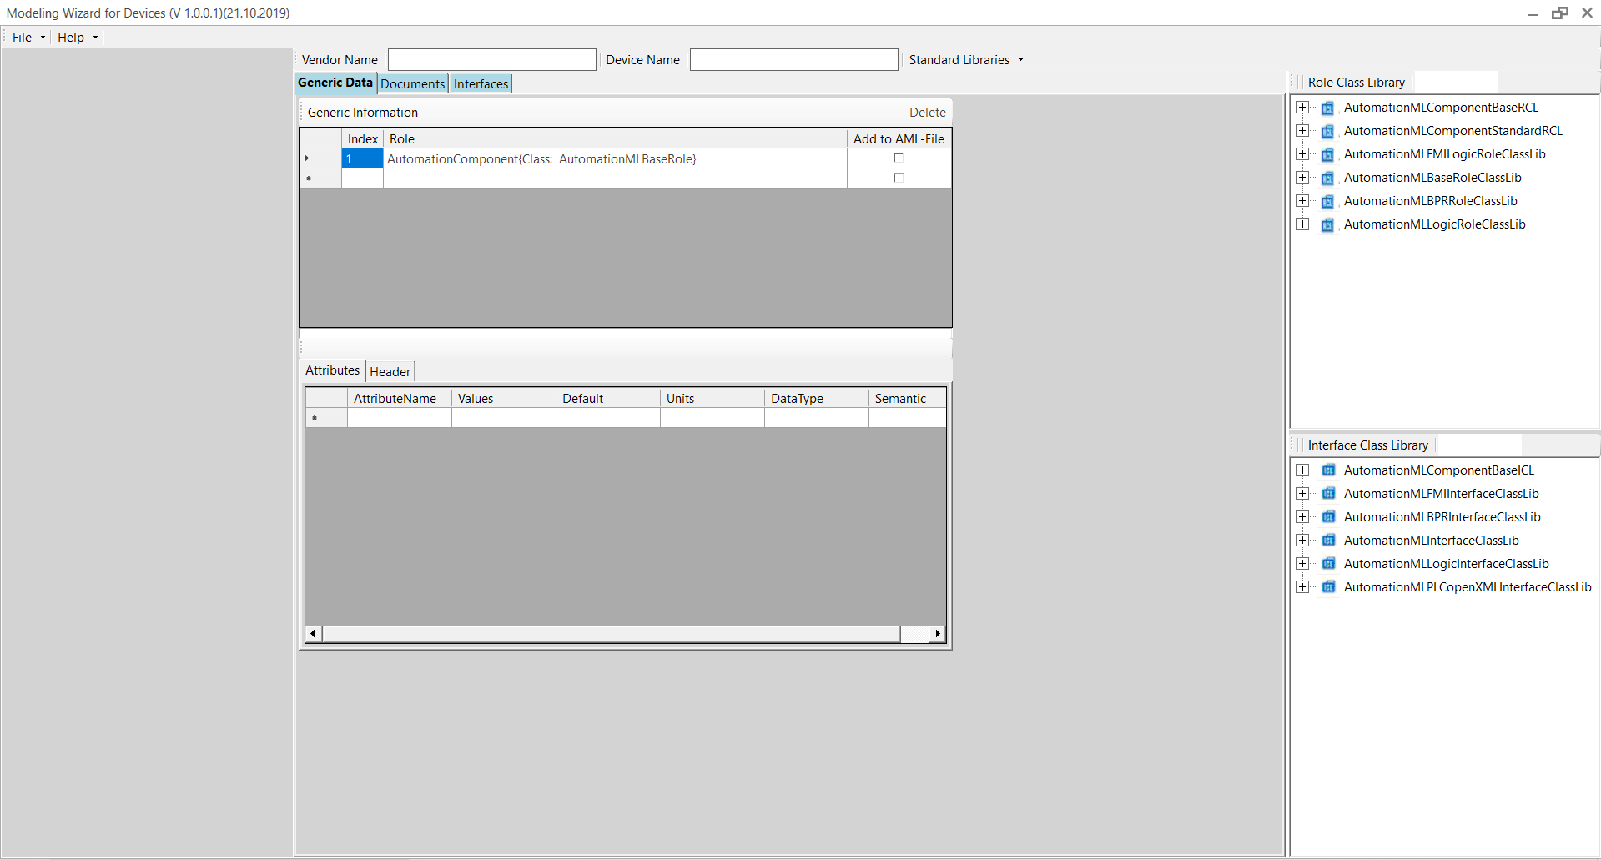

Figure GUI

# Requirements

## /R10/ Usability Concept

For the already existing GUI a new usability concept should be created to make working with this plugin easier.

## /R20/ GUI Design

From the requirements of the usability concept a suitable GUI should be designed.

## /R30/ CAEX 2.15 & CAEX 3.0 Output

For the output from an AML device created with the plugin it should be possible to choose between the output formats CAEX 2.15 and CAEX 3.0.

## /R40/ Parameter Requirements

There shall be input fields for all parameters required by the minimum rules for AML-DDs.

## /R50/ Mechanical and Hydraulic Interfaces

In addition to the electrical interfaces, the other connectors and interfaces of AutomationMLComponentStandardRCL and AutomationMLComponentBaseICL should also be available for selection, e.g. mechanical and hydraulic.

## /R60/ Electric Interface Test

It is to be tested whether the use of the AML interface library can be selected for electrical interfaces.

## /R70/ User Documentation

For a better understanding of how to use the plugin with a new usability concept and new GUI, a user documentation has to be created.

# Figures

Figure 1 GUI 3

# References

[1]<https://github.com/Rajkumarpulaparthi/ModellingWizard>

[2]<https://github.com/tinf17c/ModellingWizard>

[3]<https://github.com/WAntonia/TINF19C_Team_3_DD2AML-Converter>

[4]<https://www.automationml.org/o.red.c/dateien.html?cat=1>