Software Requirements

Specification

**(Pflichtenheft)**

(TINF19C, SWE I Praxisprojekt 2020/2021)

Project: Modelling Wizard

Customer: Rentschler

Rotebühlplatz 41

70178 Stuttgart

Supplier: by Timo Zaoral - Team 2  
 (Stefan Banov, Phillip Tran, Simon Jess, Tobias Roth, Jakob Schmidt, Timo Zaoral)

*Rotebühlplatz 41*

*70178 Stuttgart*

|  |  |  |  |
| --- | --- | --- | --- |
| **Version** | **Date** | **Author** | **Comment** |
| 0.1 | 21.10.2020 | Timo Zaoral | Created |
| 0.2 | 23.10.2020 | Markus Rentschler | Gereviewt: Das SRS sollte in Englisch verfasst und im GitHub-Wiki untergebracht werden! |
| 0.3 | 26.10.2020 | Timo Zaoral | Sprache Englisch, neue Einträge und Bugs ersetzt durch Issue Links |
| 0.4 | 31.10.2020 | Timo Zaoral | Use Cases hinzugefügt |
| 0.5 | 06.11.2020 | Timo Zaoral | Änderungen nach Review |

CONTENTS

1. Goal 4

2. Use Cases 5

2.1. <UC.001> “Create device manually” 5

2.2. <UC.002> “Create Device by import of IODD or GSD” 6

2.3. <UC.003> “Create interface or load interface from Library” 6

2.4. <UC.004> “View device data and device interface data” 6

2.5. <UC.005> “Reloading and editing an AML device description” 7

2.6. <UC.006> “Add Attachments for the Device” 8

2.7. <UC.007> “Format output as CAEX version 2.15 or 3.0” 8

3. Non-functional Requirements 9

3.1. /NF10/ Overview 9

3.2. /NF20/ Load Attributes 10

3.3. /NF30/ Application Load Toolbar 10

3.4. /NF40/Application Load Window Sizing 11

3.5. /NF50/Rename Documents 11

3.6. /NF60/Resizable Rows 11

3.7. /NF70/Header Overview 12

3.8. /NF80/Design of the Button’s 12

3.9. /NF90/Design of the Tab’s 13

3.10. /NF100/Testability of AML device 13

4. Functional Requirements 14

4.1. /F10/ Link to Manual 14

4.2. /F20/ Add Button at Interfaces 14

4.3. /F30/Mechanical and Hydraulic Interfaces 14

4.4. /F40/CAEX 2.15 Output 15

4.5. /F50/CAEX 3.0 Output 15

4.6. /F60/Parameter Requirements 16

4.7. /F70/Delete Empty Fields 16

4.8. /F80/Delete Button 17

5. Bug Fixes 18

5.1. /BUG10/Generic Information Exception 18

5.2. /BUG20/Electrical Interfaces Exception 18

5.3. /BUG30/Generic Information Table Exception 18

6. Figures 19

7. References 20

# Goal

The Goal of this project [1] is to improve the existing software. The software is to be tested for quality defects applying the typical use cases, paying attention to the usability and the "Look&Feel" of the user interface. Based on this, a usability concept will be developed and implemented.

Another point is the support of additional model interfaces and the possibility to use AML interface libraries.

For the file extraction it should be possible to choose between the versions 2.15 and 3.0 of the CAEX output format.

# Use Cases

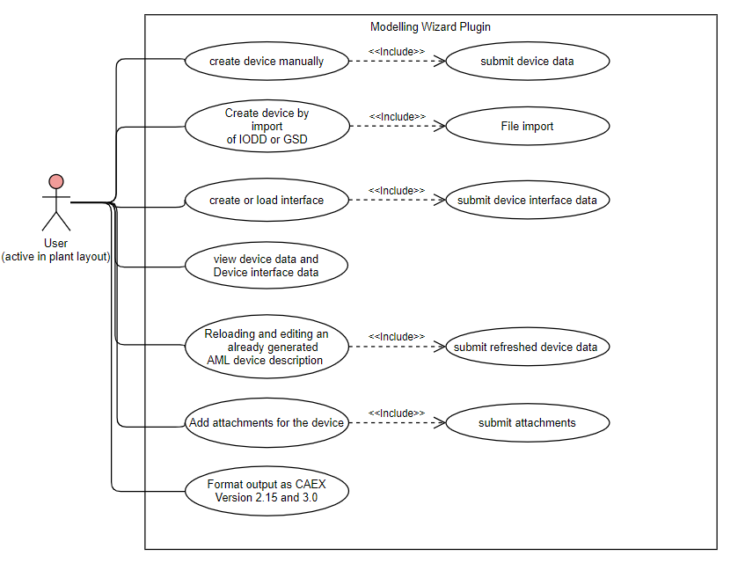

## <UC.001> “Create device manually”

|  |  |
| --- | --- |
| ***Use Case’s Objective:*** | *Creating a device by inserting the data manually into the user interface.* |
| ***System Boundary:*** | *Modelling Wizard for Devices Plugin* |
| ***Precondition:*** | *The user needs to have the specific data for the device.* |
| ***Postcondition on success:*** | *the relevant data is displayed completely and correctly* |
| ***Involved Users:*** | *Each user of the AutomationML-Editor-Application with the Modelling Wizard for Devices Plugin.* |
| ***Triggering Event:*** | *When the user has the need to add a device.* |

## <UC.002> “Create Device by import of IODD or GSD”

|  |  |
| --- | --- |
| ***Use Case’s Objective:*** | *Creating a device by importing an IODD file or a GSD file.* |
| ***System Boundary:*** | *Modelling Wizard for Devices Plugin* |
| ***Precondition:*** | *The user needs to have the specific IODD or GSD file for the device.* |
| ***Postcondition on success:*** | *The file was successfully processed, and the relevant data extracted.* |
| ***Involved Users:*** | *Each user of the AutomationML-Editor-Application with the Modelling Wizard for Devices Plugin.* |
| ***Triggering Event:*** | *When the user has the need to add a device.* |

## <UC.003> “Create interface or load interface from Library”

|  |  |
| --- | --- |
| ***Use Case’s Objective:*** | *Creating a device interface by inserting the data manually into the user interface. Or to add an interface from one of the existing libraries.* |
| ***System Boundary:*** | *Modelling Wizard for Devices Plugin* |
| ***Precondition:*** | *The user needs to have the specific data for the device.* |
| ***Postcondition on success:*** | *The user has submitted the specific data completely and correctly.* |
| ***Involved Users:*** | *Each user of the AutomationML-Editor-Application with the Modelling Wizard for Devices Plugin.* |
| ***Triggering Event:*** | *When the user has the need to add a device interface.* |

## <UC.004> “View device data and device interface data”

|  |  |
| --- | --- |
| ***Use Case’s Objective:*** | *After at least one device was successfully added, the device data should be visible and editable on the user interface.* |
| ***System Boundary:*** | *Modelling Wizard for Devices Plugin* |
| ***Precondition:*** | *The user added a device.* |
| ***Postcondition on success:*** | *The user added at least one device successfully.* |
| ***Involved Users:*** | *Each user of the AutomationML-Editor-Application with the Modelling Wizard for Devices Plugin.* |
| ***Triggering Event:*** | *When the user has the need to view device data and device interface data.* |

## <UC.005> “Reloading and editing an AML device description”

|  |  |
| --- | --- |
| ***Use Cases Objective:*** | *Reloading a device to display and edit the device data on the user interface.* |
| ***System Boundary:*** | *Modelling Wizard for Devices Plugin* |
| ***Precondition:*** | *There is an AMLX-package to reload.* |
| ***Postcondition on success:*** | *The AMLX-package is correct and complete and not damaged in any way.* |
| ***Involved Users:*** | *Each user of the AutomationML-Editor-Application with the Modelling Wizard for Devices Plugin.* |
| ***Triggering Event:*** | *When the user has the need to edit an AML device description.* |

## <UC.006> “Add Attachments for the Device”

|  |  |
| --- | --- |
| ***Use Cases Objective:*** | *It is possible to add an Attachment to the object, such as a Manufacture Icon.* |
| ***System Boundary:*** | *Modelling Wizard for Devices Plugin* |
| ***Precondition:*** | *The user has loaded or added a device.* |
| ***Postcondition on success:*** | *The user has loaded or added at least one device successfully.* |
| ***Involved Users:*** | *Each user of the AutomationML-Editor-Application with the Modelling Wizard for Devices Plugin.* |
| ***Triggering Event:*** | *When the user has the need to add an Attachment on the Device.* |

## <UC.007> “Format output as CAEX version 2.15 or 3.0”

|  |  |
| --- | --- |
| ***Use Cases Objective:*** | *It is possible to output the file in CAEX 2.15 or 3.0.* |
| ***System Boundary:*** | *Modelling Wizard for Devices Plugin* |
| ***Precondition:*** | *The user has loaded or added a device.* |
| ***Postcondition on success:*** | *The user has loaded or added at least one device successfully.* |
| ***Involved Users:*** | *Each user of the AutomationML-Editor-Application with the Modelling Wizard for Devices Plugin.* |
| ***Triggering Event:*** | *When the user has the need to output the file in a newer or older version of CAEX.* |

# Non-functional Requirements

## /NF10/ Overview

The entire space should be used to display the work area more clearly.

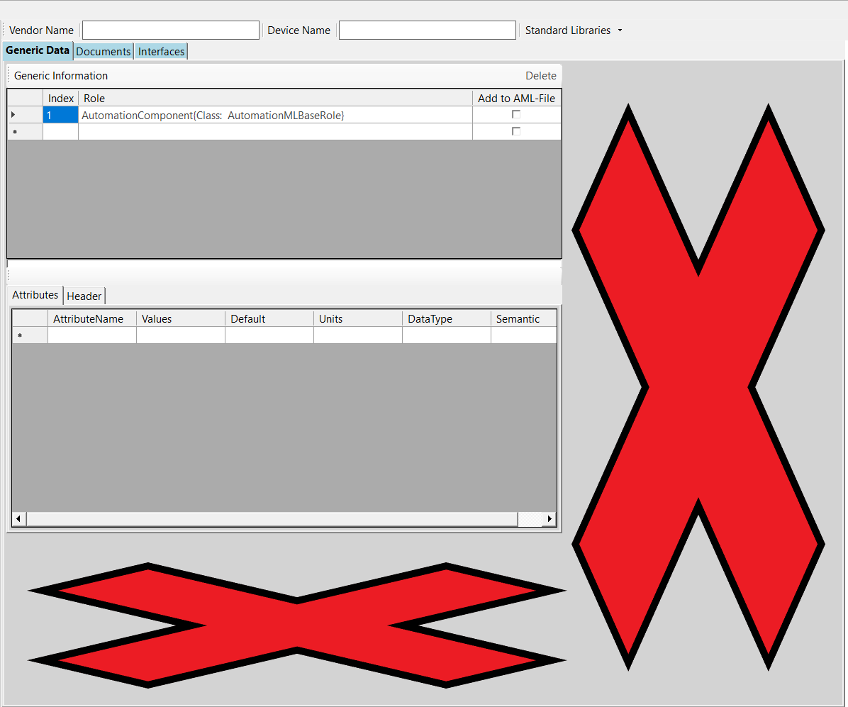

Figure 1 NF10

As shown in Figure 1, the area highlighted with a red cross should also be used.

## /NF20/ Load Attributes

When a file is loaded the attributes of the element should be displayed directly.

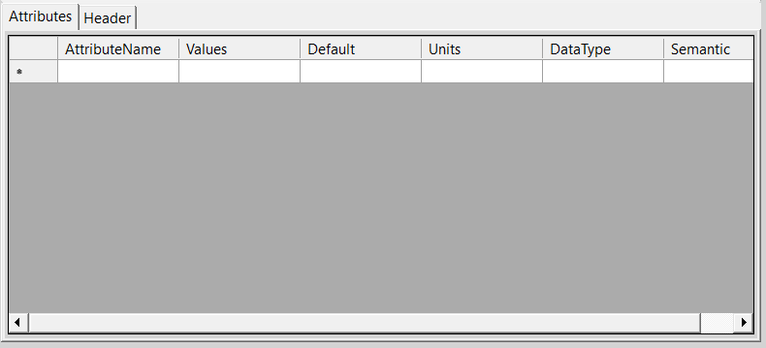

Figure 2 NF20

As you can see in Figure 2, when you load a file, the attributes are not displayed directly and you would have to press 2 clicks to display them.

## /NF30/ Application Load Toolbar

When you open the application for the first time, the right toolbar should not be on the right side as shown in Figure 3. It should be directly visible in the interface.

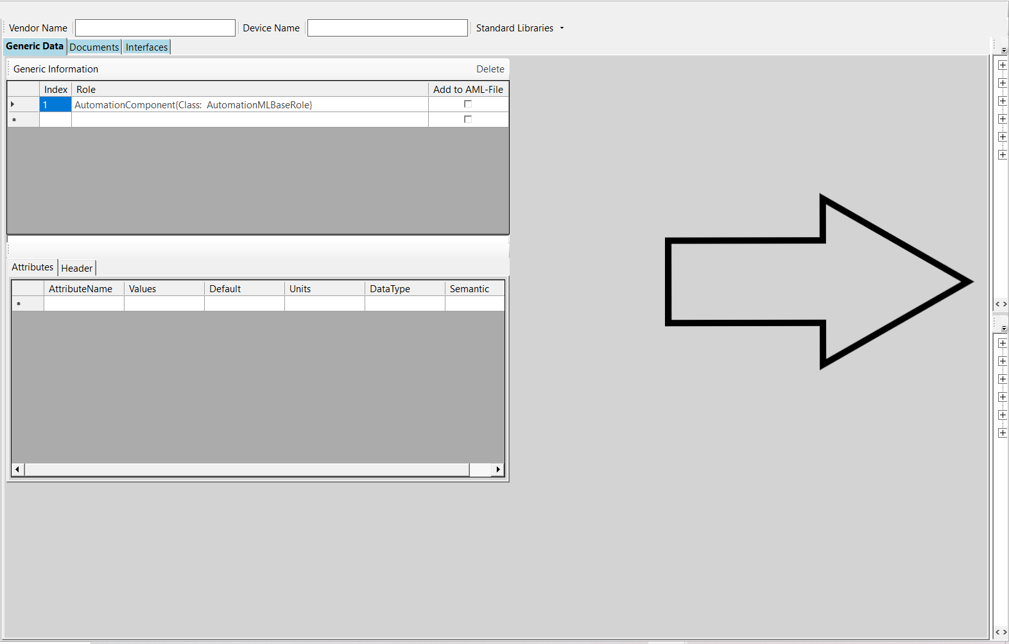

Figure 3 NF30

## /NF40/Application Load Window Sizing

When you start the application for the first time, it will be displayed very small, see Figure 4, but it should be displayed in full screen mode.

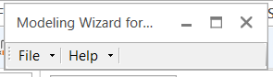

Figure 4 NF40

## /NF50/Rename Documents

The tab Documents from Figure 5 should be renamed to Attachments for better understanding.

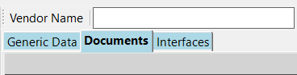

Figure 5 NF50

## /NF60/Resizable Rows

The size of the fields can be adjusted in height, which is unnecessary because line breaks are not possible.

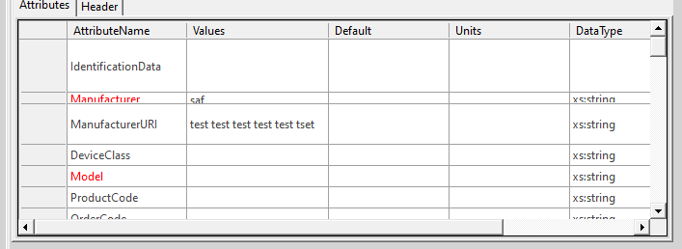

Figure 6 NF60

## /NF70/Header Overview

An unnecessary grey field is displayed in the Header tab. This should be removed.

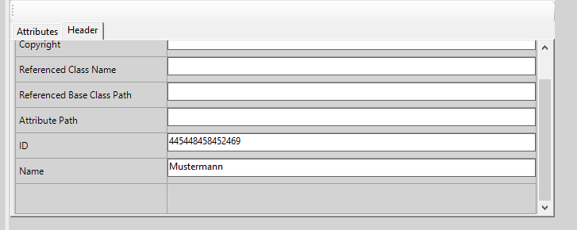

Figure 7 NF70

## /NF80/Design of the Button’s

In general, buttons are very difficult to recognize as such and do not have a uniform style.

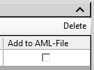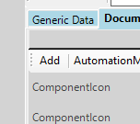

Figure 8 NF80

## /NF90/Design of the Tab’s

As shown in Figure 9, tabs are displayed differently and are not delimited by edges. This should be made uniform.

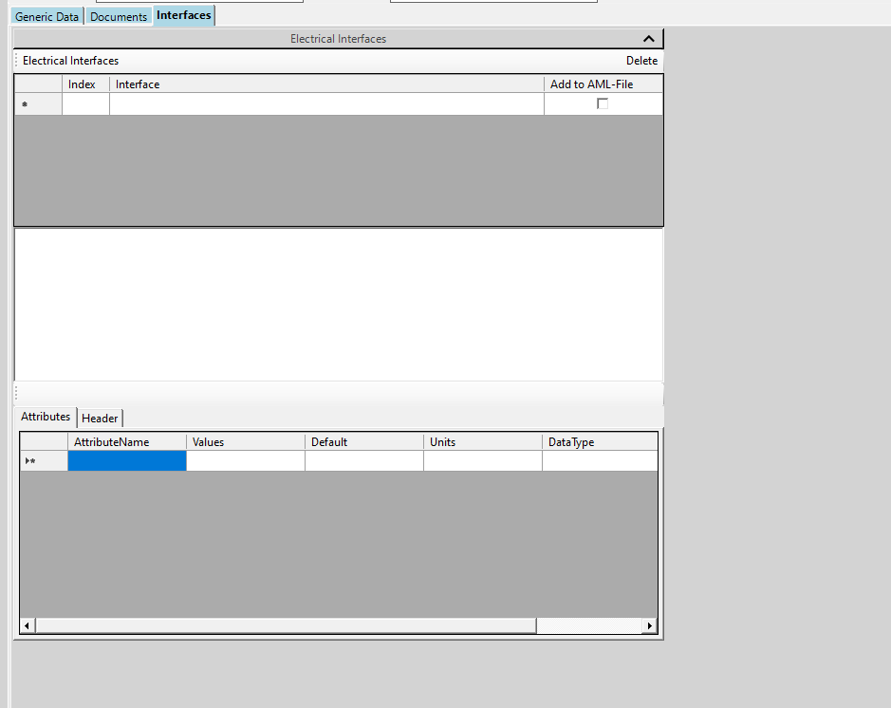

Figure 9 NF90

## /NF100/Testability of AML device

A created AML device should be validated by the AML Component Checker.[5]

# Functional Requirements

## /F10/ Link to Manual

The link under help/manual must be placed on a page that can be reached.

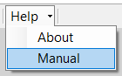

Figure 10 F10

## /F20/ Add Button at Interfaces

The Add button, as in Figure 11 for the interface view, is not necessary. Interfaces should always be added to the AML file by default.

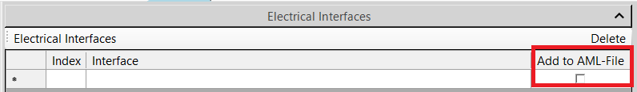

Figure 11 F20

## /F30/Mechanical and Hydraulic Interfaces

For the interfaces, not only electrical interfaces, but also the other connectors and interfaces of AutomationMLComponentStandardRCL and AutomationML-ComponentBaseICL should be available, e.g. mechanical and hydraulic interfaces.

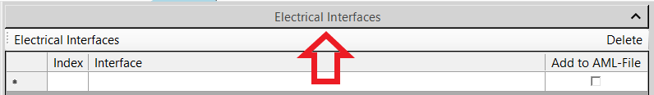

Figure 12 F30_1

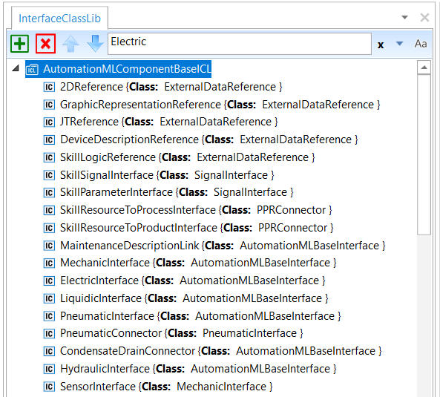

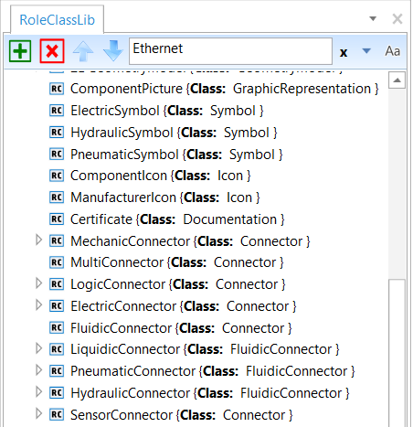

Figure 13 F30_2

## /F40/CAEX 2.15 Output

The selection of CAEX 2.15 as output format should be implemented.

## /F50/CAEX 3.0 Output

The selection of CAEX 3.0 as output format should be implemented.

## /F60/Parameter Requirements

As shown in Figure 14, other mandatory attributes should be highlighted in red. These are those required by the minimum rules for AML-DDs.

The following attributes are mandatory:

Manufacturer

ManufacturerURI

Model

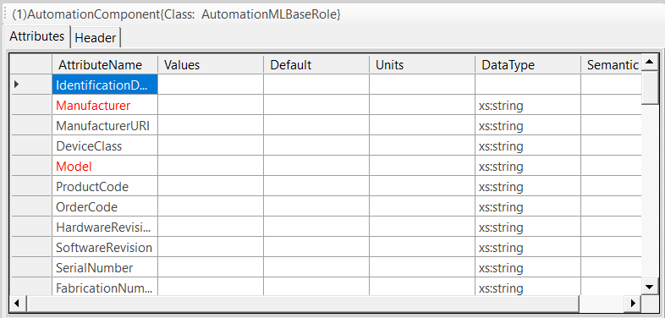

Figure 14 F50

## /F70/Delete Empty Fields

Newly added empty fields remain even though they are empty and can be collected. This should be prevented.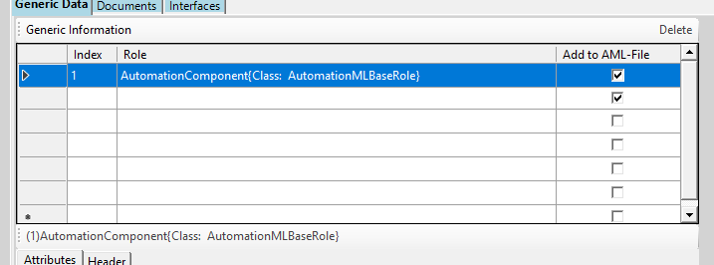

Figure 15 F60

## /F80/Delete Button

The "Delete" button under Generic Data and Interfaces is currently not working. The function to remove elements should be implemented.

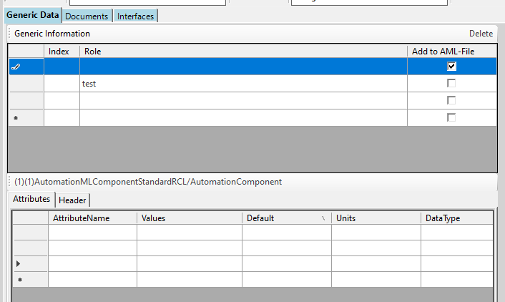

Figure 16 F70

# Bug Fixes

## /BUG10/Generic Information Exception

See the issue tracker in the GitHub project at this link. [2]

## /BUG20/Electrical Interfaces Exception

See the issue tracker in the GitHub project at this link. [3]

## /BUG30/Generic Information Table Exception

See the issue tracker in the GitHub project at this link. [4]

# Figures

Figure 1 NF10 9

Figure 2 NF20 10

Figure 3 NF30 10

Figure 4 NF40 11

Figure 5 NF50 11

Figure 6 NF60 11

Figure 7 NF70 12

Figure 8 NF80 12

Figure 9 NF90 13

Figure 10 F10 14

Figure 11 F20 14

Figure 12 F30_1 14

Figure 13 F30_2 15

Figure 14 F50 16

Figure 15 F60 16

Figure 16 F70 17

# References

[1] <https://github.com/Rajkumarpulaparthi/ModellingWizard>

[2] <https://github.com/DekaAthlos/TINF19C-ModellingWizard/issues/5>

[3] <https://github.com/DekaAthlos/TINF19C-ModellingWizard/issues/6>

[4] <https://github.com/DekaAthlos/TINF19C-ModellingWizard/issues/7>

[5] <https://amlcc.tarakos.de/Identity/Account/Login?ReturnUrl=%2F>