**HW3 – Practical part output:**

**F -** We found out that Spacy counts A LOT on capitalizing when it comes to identifying proper nouns. When we POS-tagged the whole book after lowering SpaCy found 76 proper nouns. Without lowering, it found 5047. For example, in the sentence "IN WHICH PHILEAS FOGG AND PASSEPARTOUT ACCEPT EACH OTHER, THE ONE AS MASTER, THE OTHER AS MAN" (chapter I title) "accept" is tagged as a proper noun if capitalized and as a verb if lowered.

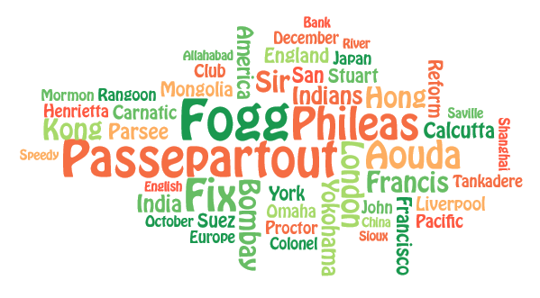**G –** By definition a proper noun is “a specific (i.e., not generic) name for a particular person, place, or thing”. Considering our book choice (Around the world in 80 days) the following cloud of proper nouns definitely corresponds with what we know about the content of the book (includes many countries, cities and references to the 2 main characters):