#Exercise1

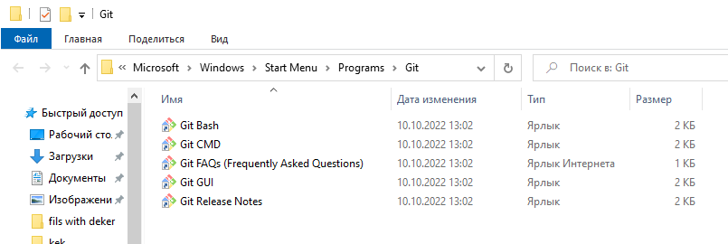

#Exercise2

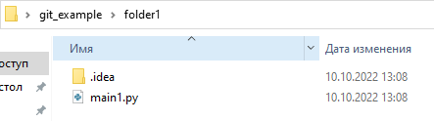

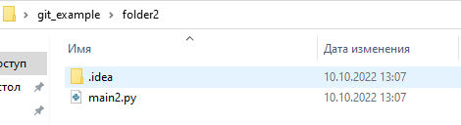

#Exercise3



#Exercise4

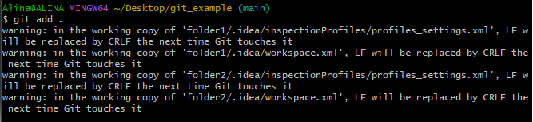

#Exercise5

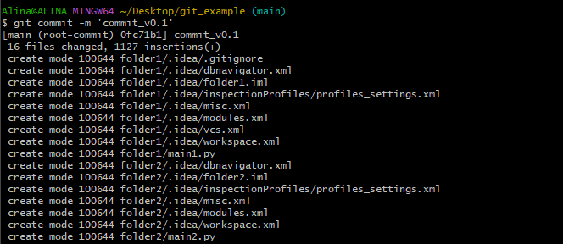

#Exercise6



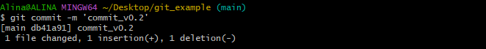

#Exercise7

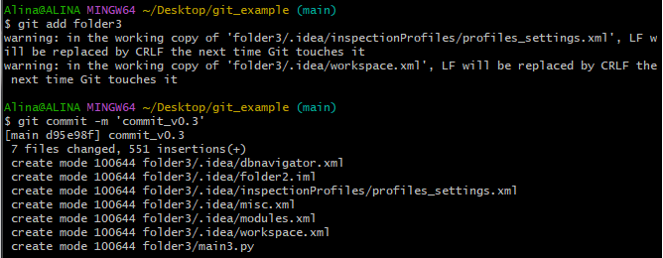

#Exercise8



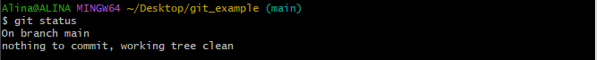

#Exercise9



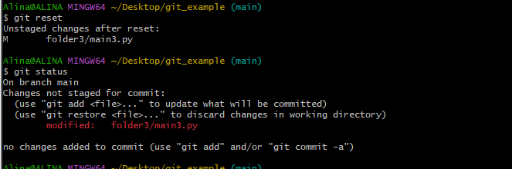

#Exercise10

#Exercise11

#Exercise12