**Midterm Exam Assignment**

Task 1:

I have created a resource group called BlobWebPage and then created a new storage account called storagewebapp123, and then I navigated to the static website blade on the storage account to create a static website. After this step, I created an html file with the simple hello world in it.

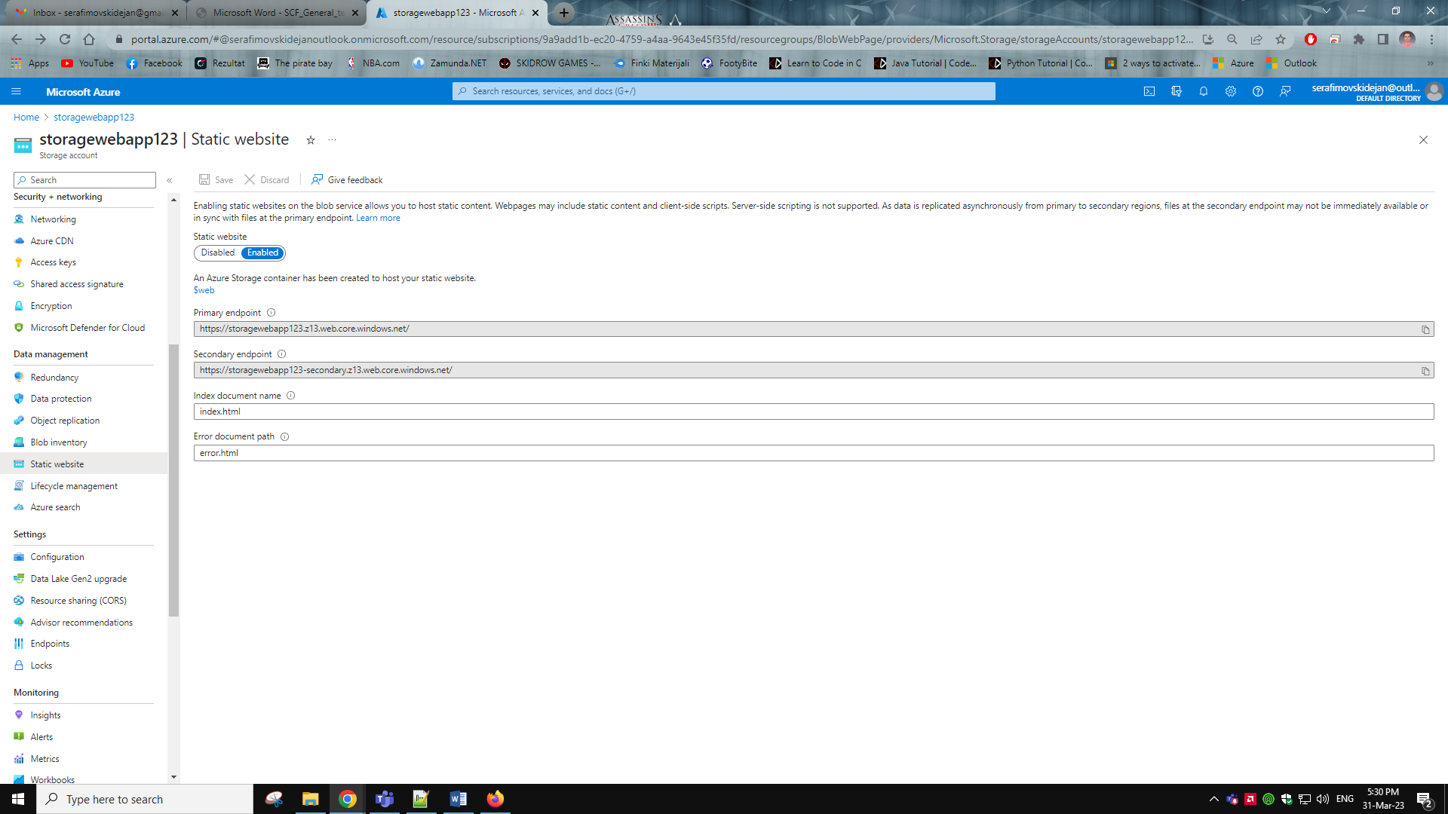

As we can see there is the $web container so we click on it and then press upload to upload our website, after the upload it should look like this.

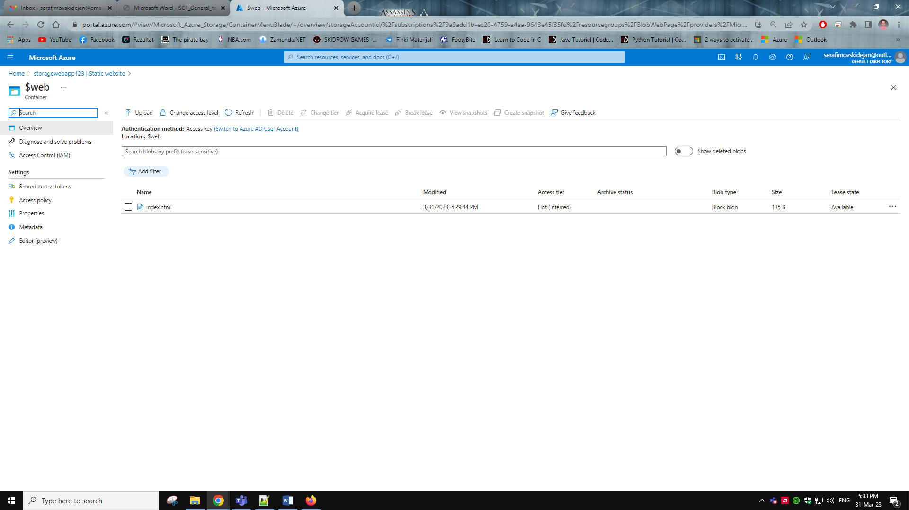

Then we navigate back to the static website blade and copy the primary endpoint address and paste it in a new tab or browser and it will show us the hello world website, as shown below.

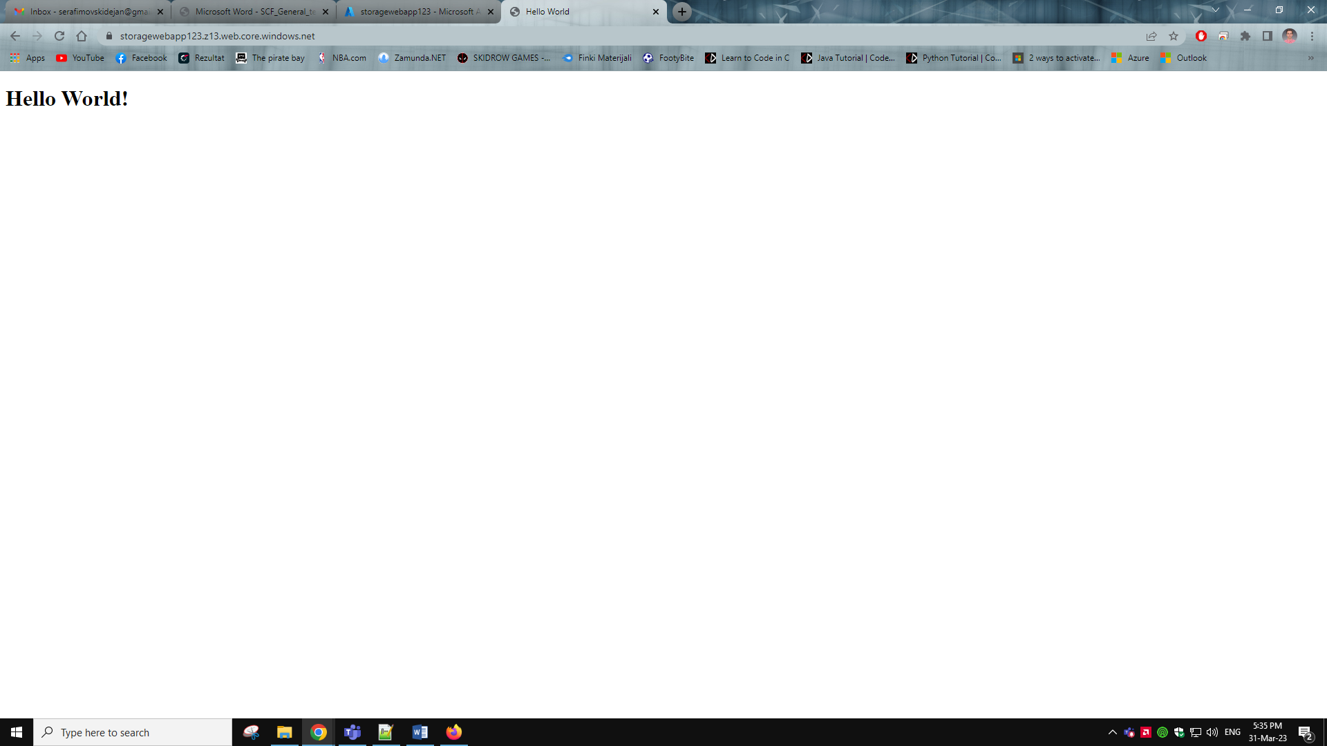

Task 2:

First, we go to the virtual networks resource and create a new virtual network under a new resource group I named it LinuxServer123 and the virtual network name is LinuxServer.

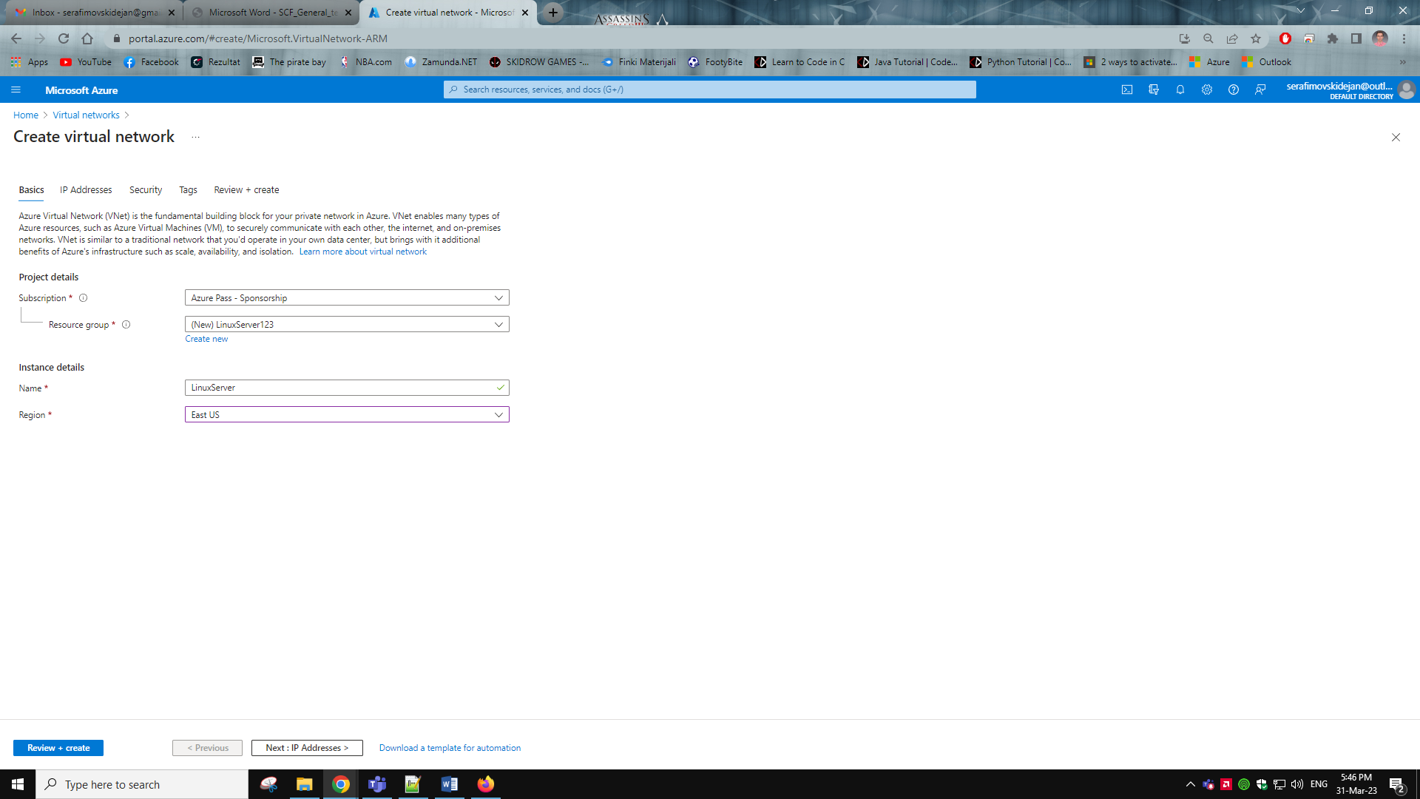

Then we go to the IP Addresses tab and set up the ip address and subnet I have gone with the default ip address which is 10.0.0.0/16 and added a new subnet 10.0.1.0/24 called LinuxWebServer.

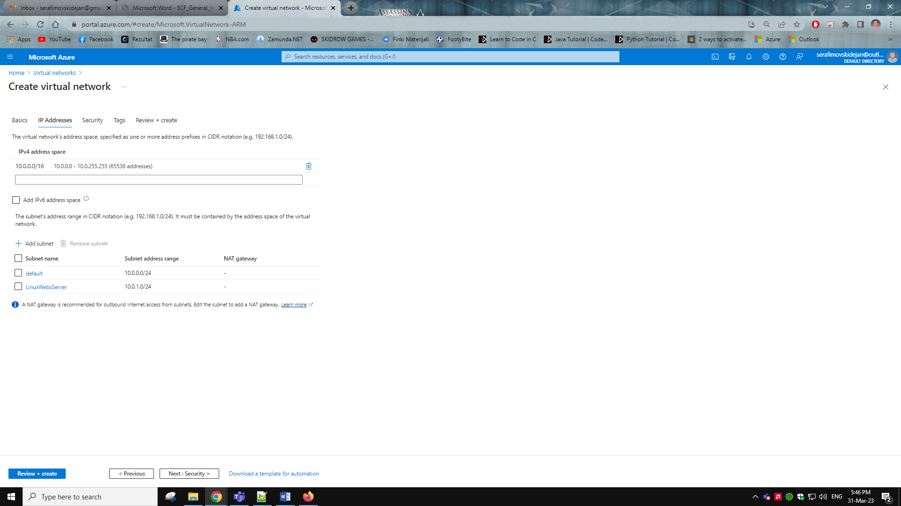

Once the virtual network is created we go to the virtual machines resource. Here we create the VM

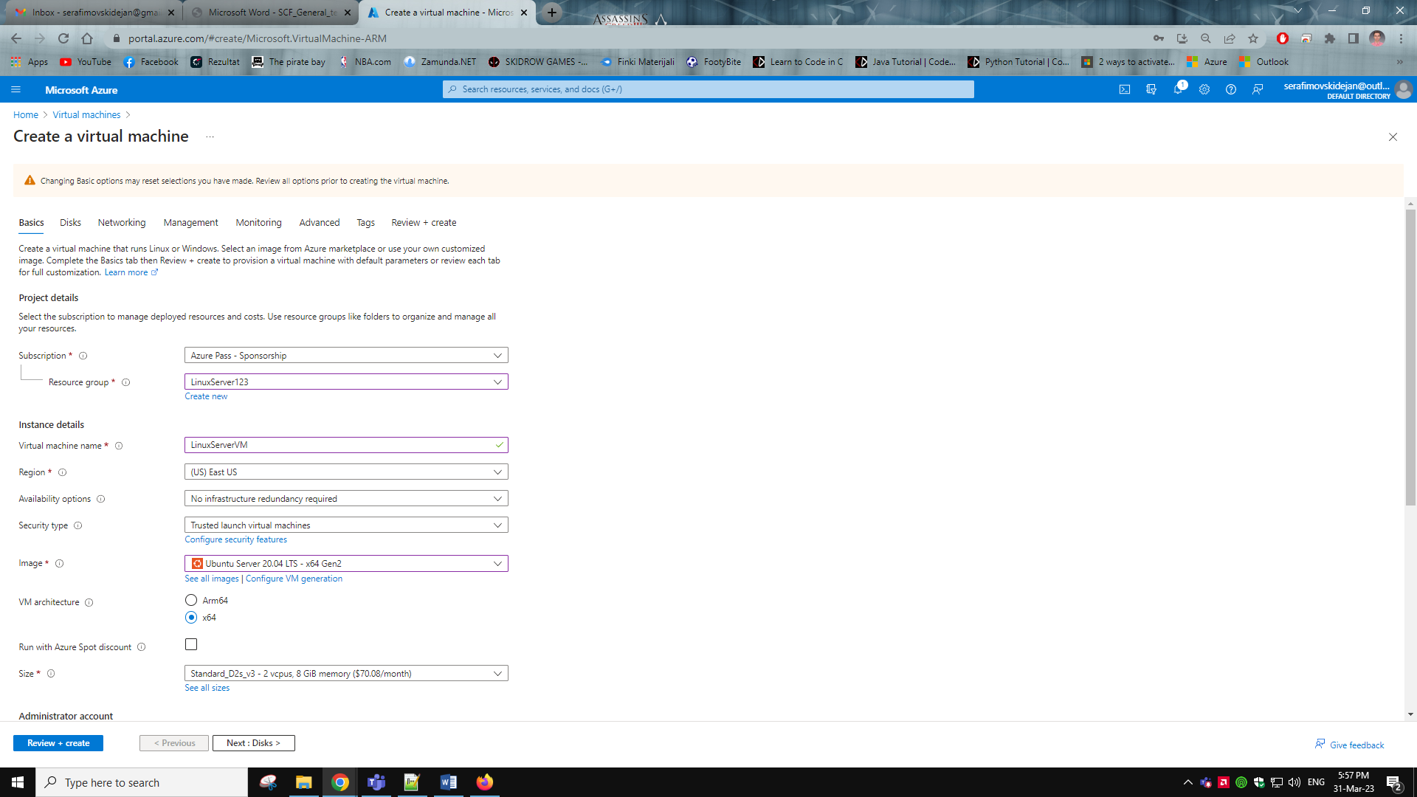

After this we go to the next tab witch is disks we set to premium SSD and we move one to the networking tab in the inbound rules we set only HTTP(80)

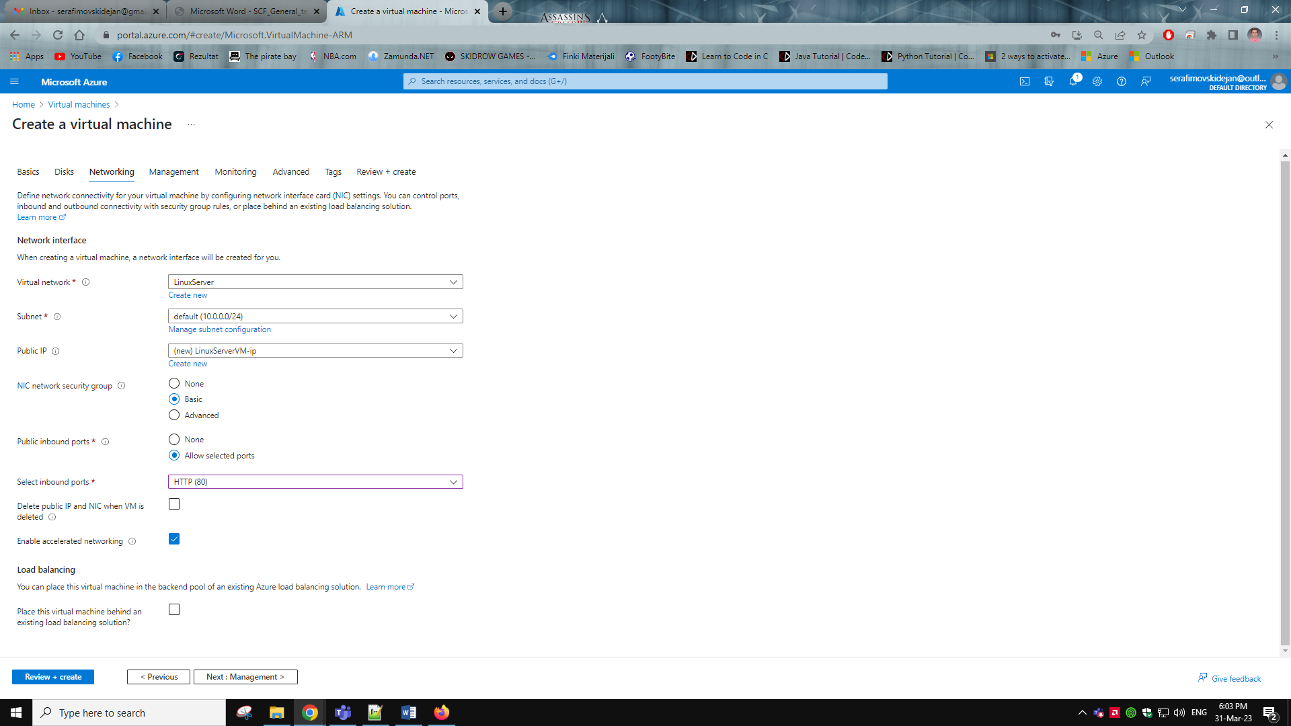

Then we create the VM (this might take a while because Azure ☺)

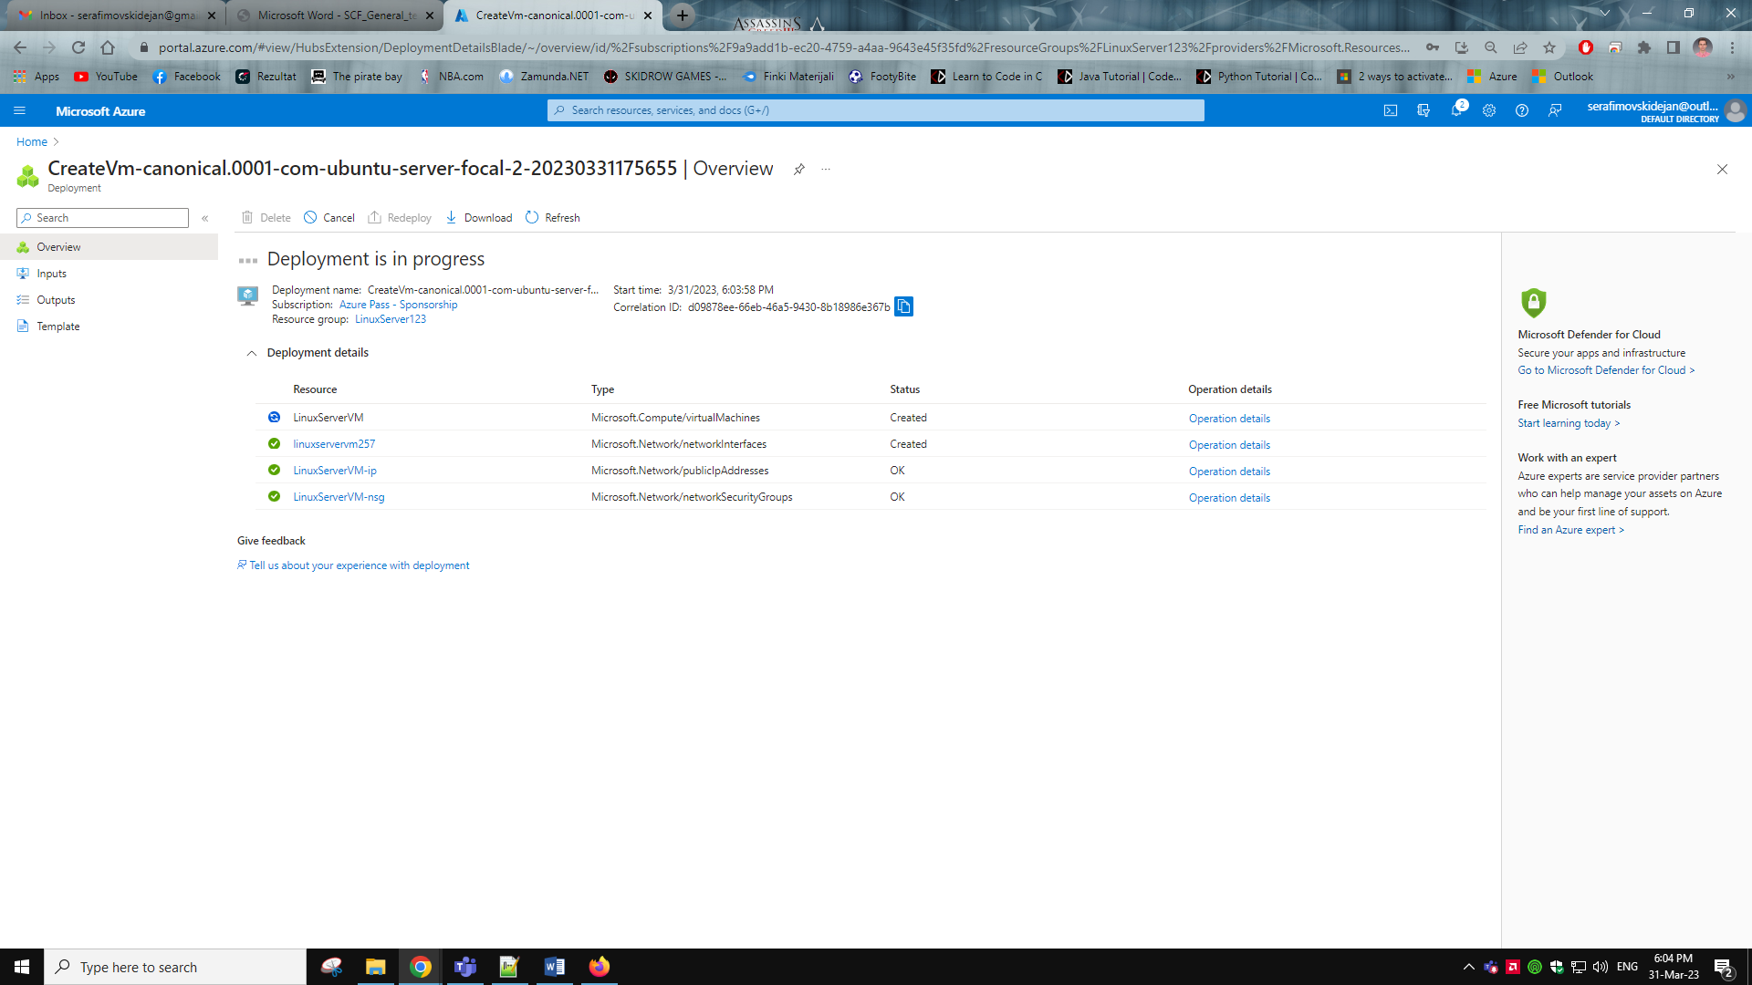

Then on VM we go to the networking blade we select add inbound security rule. I set up the inbound rule so that source Is my ip address and the port range is 3389 so I can use RDP to connect to the vm and protocol TCP with the name as shown. (just covered my ip address with color just to be safe from you guys ☺)

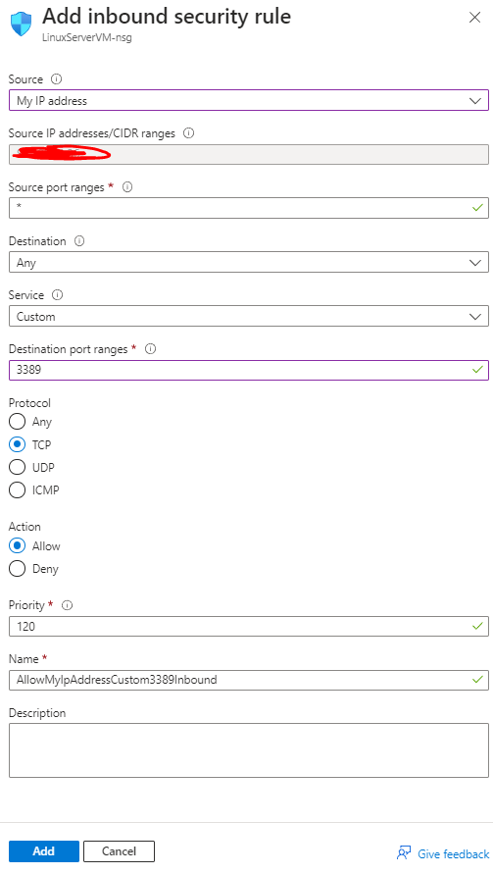

After adding the rule it should look like this. Then I connect to the VM.

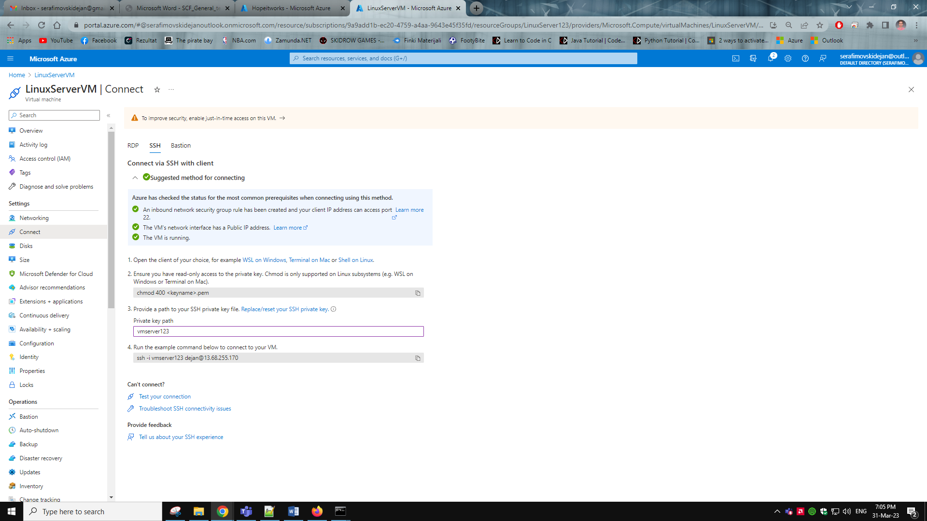

I connected to the VM via command prompt SSH because I had issues connecting via RDP.

I ran the following commands on the VM using cmd.

sudo apt-get update

sudo apt-get install apache2

sudo service apache2 start

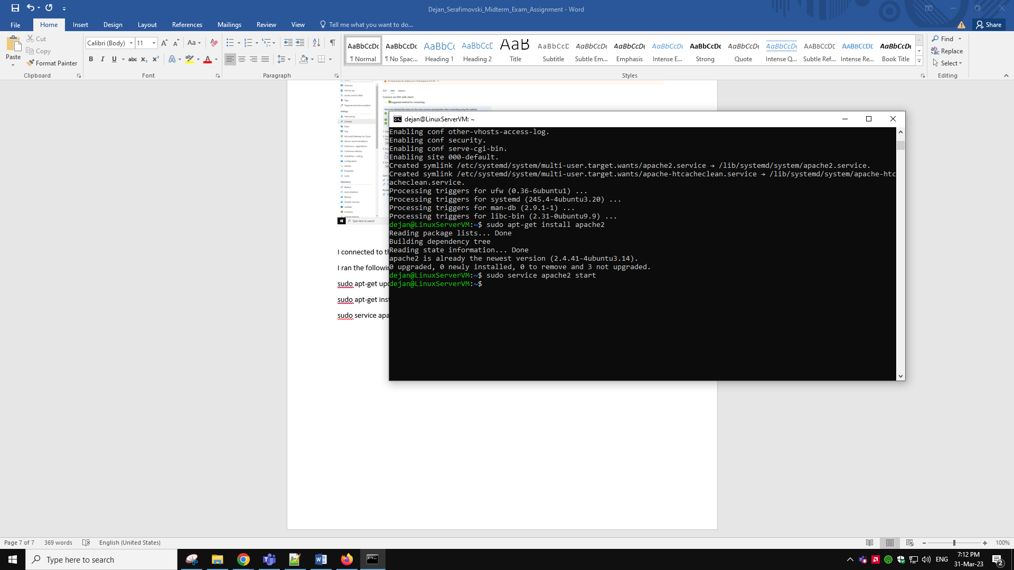

To point out I have issues with that VM so I created a new one because the old one was stuck at updating and wouldn’t even stop or restart I have tried.

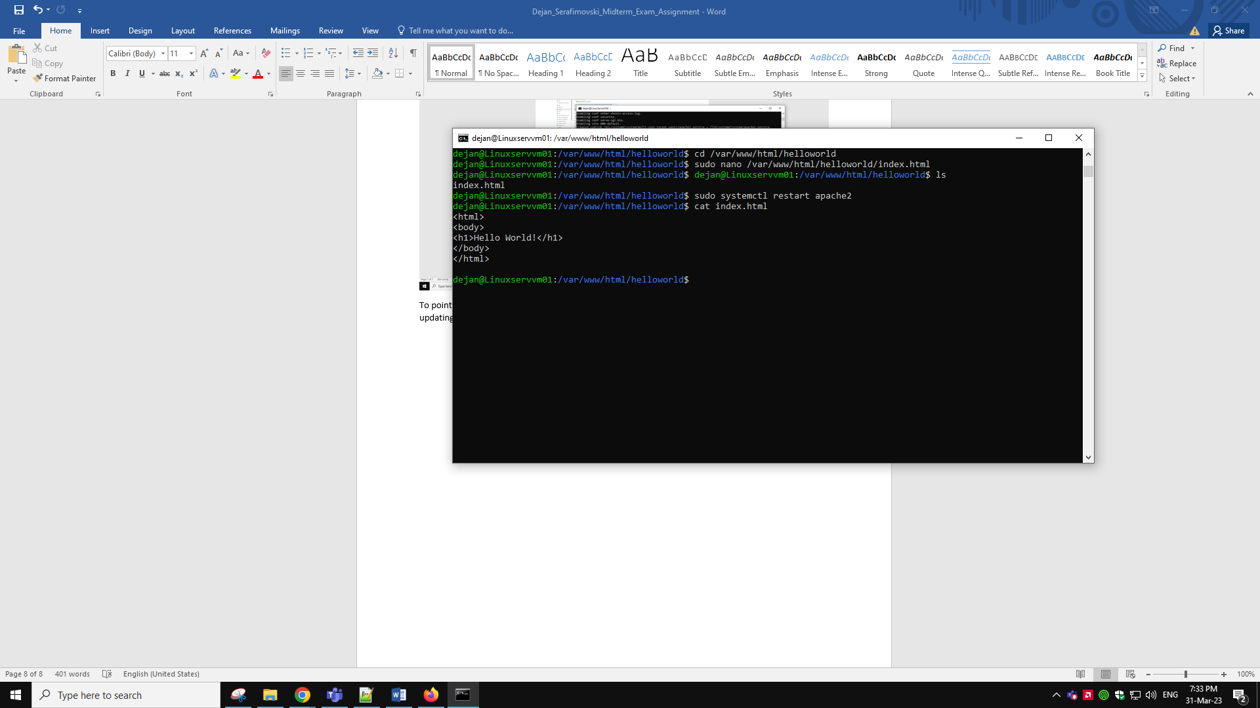

So I did this steps in order to setup the hello world index.html and on the browser it showed us this.

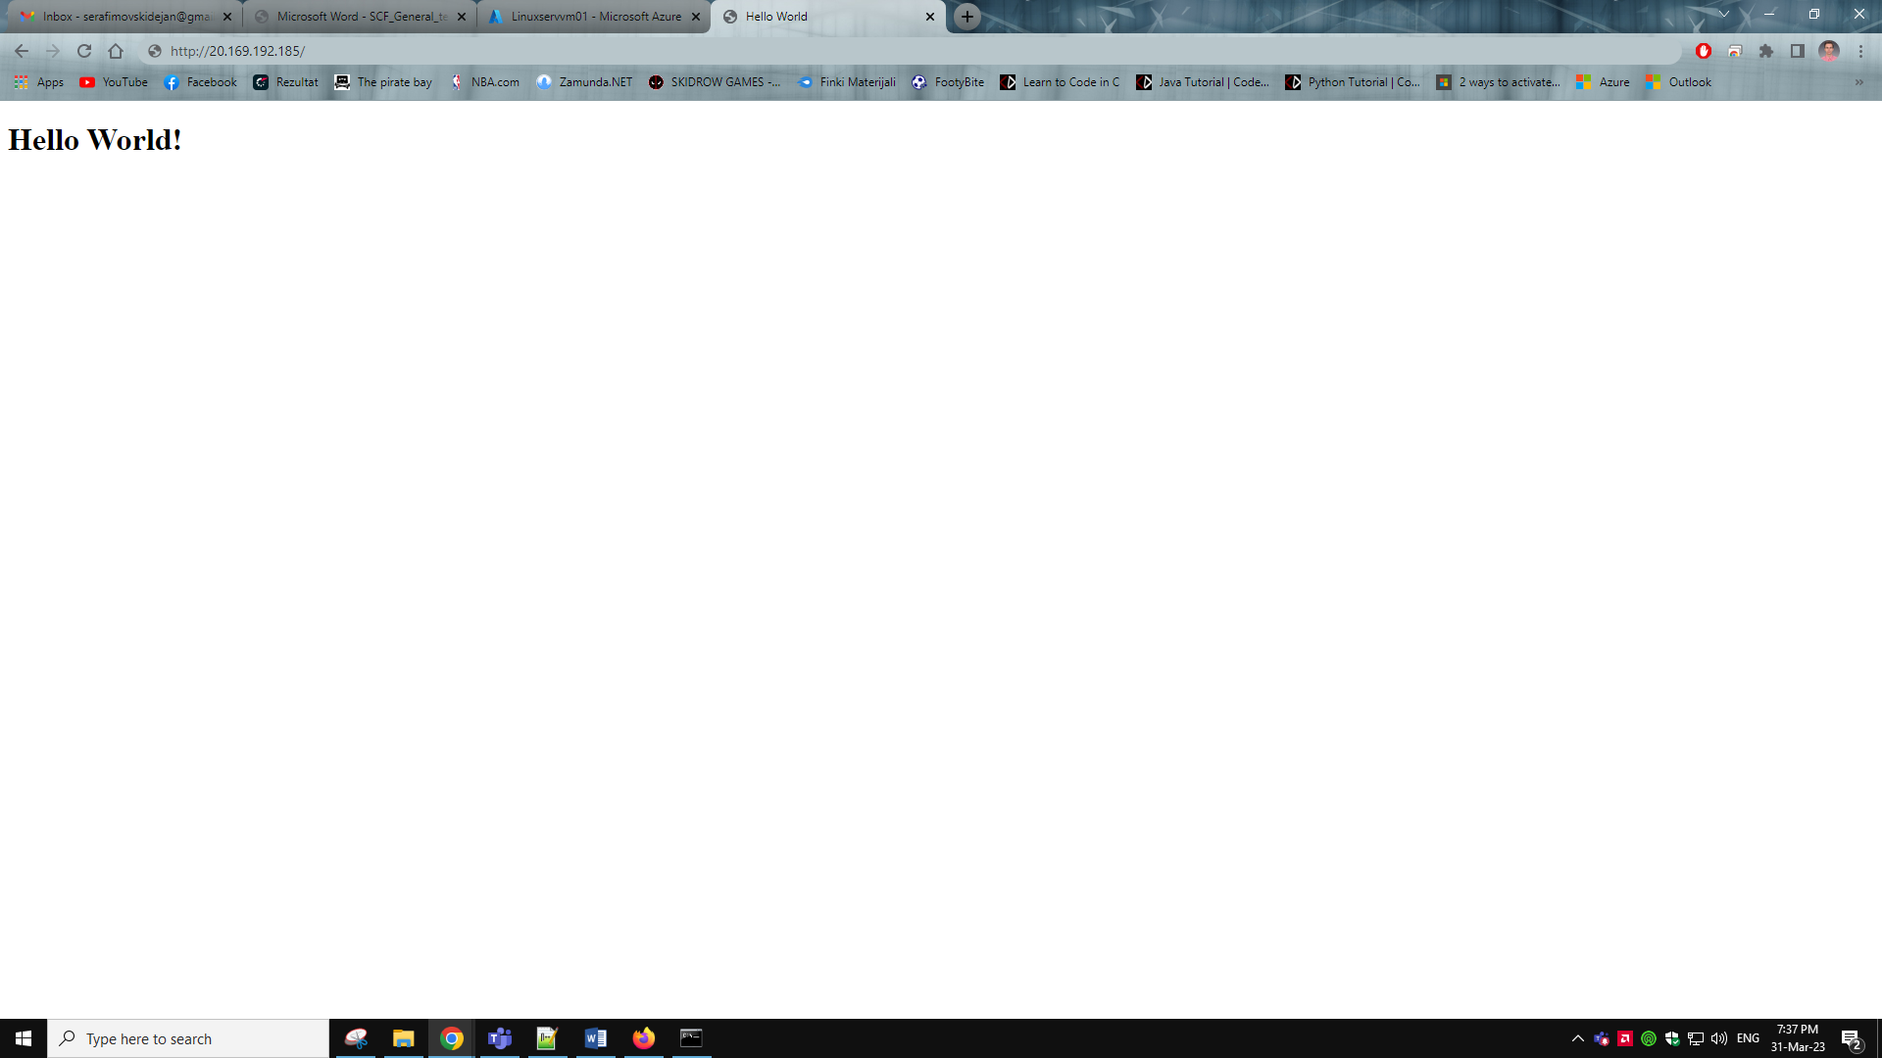

For some reason on my phone it didn’t work.

