Various peculiarities of automated test and measurements in power electronics “python”

|  |  |  |
| --- | --- | --- |
| Tsveti Hranov *Assistant professor, Department of Power Electronics* *Technical University of Sofia* Sofia, Bulgaria chranov@tu-sofia.bg | Anton Dekov  *Student, Department of Power Electronics* *Technical University of Sofia* Sofia, Bulgaria adekov@tu-sofia.bg | Vladimir Dimitrov *Associate professor, Department of Power Electronics* *Technical University of Sofia* Sofia, Bulgaria dimitrov@tu-sofia.bg |

*Abstract*—The paper presents aspects for adoption of the automated test and measurement workflow and algorithms related to the study of power electronic converters. Particularly this is related with some peculiarities of various test bench configurations and how this test-bench configurations affect the speed, performance and accuracy of the carried measurements and produced data. First a test without a device is performed to evaluate the measurement instruments and after that the effect of it has been investigated. The test is based on a virtual instrument (VI), written in Python programming language with various instrument control and data acquisition and processing libraries. The main idea of this VI is to preform efficiency tests of power converters. It is of critical aspect that the researcher is aware of this peculiarities in order to make accurate conclusions on power converter parameters such as efficiency, load and line regulation, reliability and safety of the devices tested.

Keywords—power electronics, automated test and measurement, conversion efficiency, data acquisiton

# Introduction

Automated measurements in power electronic devices have become increasingly common in recent years, driven by advancements in sensor technology, data processing capabilities, and the need for efficient and accurate monitoring and control in various applications. Current state observations yield that many modern power electronic devices, such as inverters, converters, and motor drives, are equipped with built-in sensors and measurement circuits to monitor parameters like voltage, current, temperature, and power. These devices often include microcontrollers or dedicated measurement ICs to process and analyze the measured data in real-time. The integration of power electronic devices with the Internet of Things (IoT) and Industry 4.0 concepts is driving the adoption of automated measurements further. By connecting power electronic devices to cloud-based platforms and data analytics tools, manufacturers can gather valuable insights into device performance, energy consumption, and operational trends across distributed systems. Automation of measurements in power electronics enables real-time monitoring, fault detection, and adaptive control strategies, leading to improved efficiency, reliability, and safety. Automated measurement systems can also facilitate remote monitoring and diagnostics, allowing for predictive maintenance and optimization of system performance. Looking ahead, the future of automated measurements in power electronic devices is likely to be characterized by even greater levels of intelligence, autonomy, and connectivity. This includes advancements in sensor technology (for example wide-bandgap semiconductors, fiber-optic sensors), enhanced data processing capabilities (edge computing, Artificial Intelligence/Machine Learning algorithms, etc.), and seamless integration with emerging technologies such as 5G/6G networks and edge computing infrastructure.

# Goal of the study

The present study is oriented at studying the influence of the automated measurement speed versus the accuracy of the measurements. From engineering perspective it is desired that the measurement cycles be as fast as possible and with absolute accuracy at best. However settling time of the power converters often impose a restrictions on how fast measurements can take place. Yet another restriction is the fluctuation of voltages and currents due to temperature, switching ripple, input and output regulation and electromagnetic interference. Some form of rounding can be implemented to remedy the effects, however the rounding steps, algorithm and approach should be carefully selected in order to acquire the most accurate data. Often neglected by the test personnel is the settling time of the instruments themselves – after all the involved laboratory units such as power supplies, electronic loads, digital multimeters, oscilloscopes do have also some settling time, they do acquire ambient noise and electromagnetic interference, so care should be taken that the automated steps do allow some time their internal parameters and calibration algorithms to settle and perform an accurate measurement of the device under test.

## Testing approach

The current study is carried out in the following systematic approach. First tests are performed only with the measurement and control instruments without an attached power electronic converter. Main takeaway of this study is to identify optimum delay between two measurements and whether there are differences between instruments, vendors and models. Second a full evaluation of the test bench is carried out and conclusions are drawn based on the acquired results between the interaction between instruments and device-under-test. Obtained results would be of interest to both professionals in the field and trainees, students and people looking to get involved in the topic.

## Virtual instruments and software packages

This work is funded by the research and development sector at the Technical University of Sofia, contract № 241ПР00015-03/28.03.2024

The virtual instrument is based on the programming language Python with the following additional libraries: pandas, pyvisa, mathplotlib and for the graphical user interface (GUI) is used the PyQt6 framework. A screenshot of the program in action is shown on figure 1.

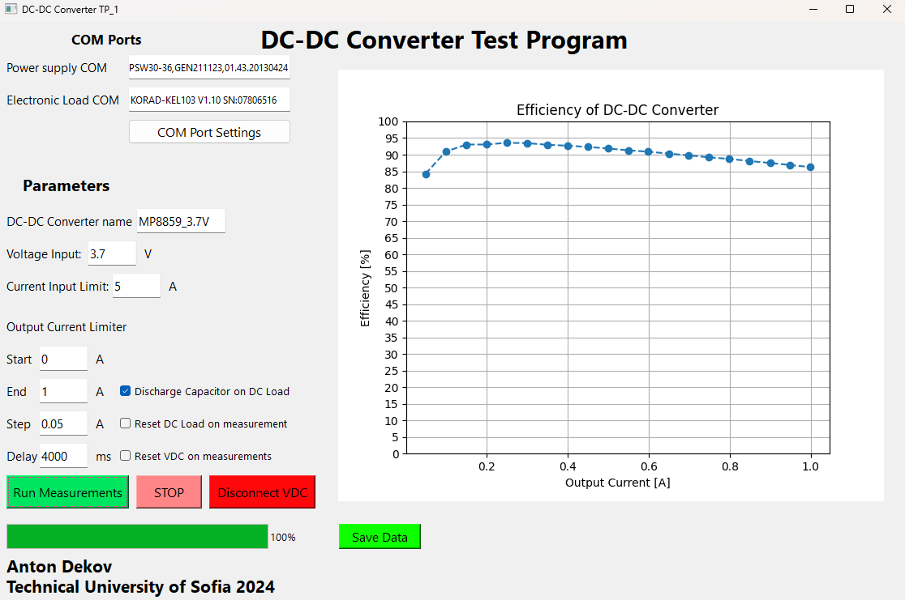

1. Graphical user interface of the program for automated test and measurement

The basic instrument control GUI has the following sections – instrument selection by query from the COM ports (be it real or USB-emulated). Additional assistance is provided programmatically by querying the instruments first with the *IDN? string and placing them in selectable choice combo boxes, as shown on figure 2.

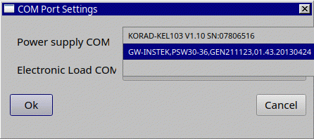

1. Dialog to choose power supply and electronic load, based on their *IDN? queries

Next section is the test parameters definitions. It begins with fields to set the name of the tested converter, input voltage set-up and output current limit. The instrument is primarily designed to take automated load characteristics of a DC-DC converter, so next fields determine a test loop by entering data about the starting current value, step increase and the end threshold current. Also a very important feature is given to allow the user to adjust the time step at which the instruments change their settings. Additional options include a “Reset VDC on Measurements”, which resets the input voltage source after a measurement is acquired, for example when a converter is required to go from 0 to nominal input and observe transients, etc. The option “Reset DC load on measurement” is similar, but resets the output load, this could be used to observe the transient response of the initial output voltage ramp-up. The last option named “Discharge capacitor on DC Load” is used to delay the turn-off of the electronic load until the output capacitors on the converter have been discharged fully, this can be used for safety and performance measures. Finally, a button to start the measurements and a progress bar of the measurement loop is placed below.

As an additional safety and flexibility, “STOP” and “Disconnect VDC” buttons are placed, which can be used to interrupt measurements and take safety measurements if something abruptly goes wrong.

On the right side using the mathplotlib python package an efficiency curve is plotted after the measurements have been completed, allowing the operator to observe the obtained data. By clicking the “Save Data” button, the measurements are exported to an Excel file, where they can be later further processed.

The processing program, running in parallel thread to the GUI has an extensive error handling capabilities and takes necessary steps to guarantee safe operation of the DC/DC converter and instruments. For example if an instrument is not found, the thread provides the operator with a dialog box and a message, that states that the connection has been lost. If the input power supply programmatically doesn’t respond, a message is stated that it should be stopped manually. On aborting of the measurements, both tools are suspended and reset to their default inactive state. All these features make the application very rugged and compliant with general safety precautions.

## Maintaining the Integrity of the Specifications

This work is funded by the research and development sector at the Technical University of Sofia, contract № 241ПР00015-03/28.03.2024

In order to produce accurate results, the operators need to be aware of the peculiarities of both the instruments and device under test. This means that they should be working in steady-state operation, the losses in the wiring and connecting conductors should be minimized as low as possible and protections or limits of the specifications shouldn’t be exceeded.

# Experiments

Several experiments have been conducted in order to demonstrate the peculiarities of the automated test and measurement. First a no device test is conducted to evaluate the settling time effect on the instruments and their influence on the measurements. After that a full set-up measurement is conducted with demonstration of the dependence on the device under test on the settling time of the instruments. The instruments being operated on are electronic-load TENMA 72-13210 and input power supply GwINSTEK PSW30-36 with firmware report string as shown on figure 2. The host operating systems are both Windows 10 and Arch Linux in order to evaluate the open source and cross-platform nature of the software.

## No device under test instrument transient evaluation

The tests of the settling time for the instruments is very important, because it will determine the accuracy of the measurements taken. Usually the desire is to conduct the measurements as fast as possible dictated by the need to test as many devices as possible, but if the instrument is not supporting the nominal parameters, the device under test will also not be able to stabilize its parameters. Thus a standard time based evaluation of the instruments must be conducted in order to determine whether the instrument has sufficient delay to reach its steady state operation.

For the first test a 50 ms delay between the measurements is carried. The results are summarized in table I. The table contains the momentary measurements of the input and output voltages and currents and the additional settings of the measurement’s procedures, such as input supply reset and electronic load reset.

1. Results from 50ms measurement instruments settling time without device under test

|  |  |  |  |  |
| --- | --- | --- | --- | --- |
| 50ms measurements delay | | | | |
| Input Current [A] | Input Voltage [V] | Output Voltage [V] | Output Current [A] | Mode |
| 0,105 | 1,859 | 0 | 0 | No reset |
| 0,071 | 14,966 | 0 | 0 |
| 0 | 14,995 | 0 | 0 |
| 0 | 14,996 | 0 | 0 |
| 0 | 14,998 | 0 | 0 |
| 0,422 | 1,895 | 0 | 0 | VDC Reset |
| 0,356 | 10,775 | 0 | 0 |
| 0,777 | 10,077 | 0 | 0 |
| 0,404 | 11,031 | 0 | 0 |
| 0,448 | 10,807 | 0 | 0 |
| 0,042 | 2,149 | 0 | 0 | Load Reset |
| 0 | 14,992 | 0,0616 | 0 |
| 0 | 14,996 | 0,1133 | 0 |
| 0 | 14,997 | 0,077 | 0 |
| 0 | 14,998 | 0,077 | 0 |
| 0,363 | 2,984 | 0 | 0 | VDC & Load Reset |
| 0,926 | 10,537 | 0 | 0 |
| 0,377 | 10,144 | 0,1606 | 0 |
| 0,682 | 10,098 | 0,1141 | 0 |
| 0,743 | 10,146 | 0,0726 | 0 |

The desired input voltage is defined as 15V and the constant current (CC) threshold setting is 1A. The electronic load is set to achieve constant current setting of 0 to 1A with 0.2A step. As it can be observed, the input power supply doesn’t have enough time to settle down, however if there is no output reset, after a while the output is stabilized (output capacitors are loaded) and the output voltage seems “stable”. However whether the output or load is reset, the devices don’t seem to be able to settle for 50 ms.

In table II are presented the same tests with the same parameters except the measurement interval is defined to be 100 ms. Looking at the numbers it is observed that the devices still don’t have enough time to settle exactly, however regarding the amplitudes, they are nearing the desired parameters.

1. Results from 100ms measurement instruments settling time without device under test

|  |  |  |  |  |
| --- | --- | --- | --- | --- |
| 100ms measurements delay | | | | |
| Input Current [A] | Input Voltage [V] | Output Voltage [V] | Output Current [A] | Mode |
| 0,722 | 12,212 | 0 | 0 | No reset |
| 0 | 14,995 | 0 | 0 |
| 0 | 14,997 | 0 | 0 |
| 0 | 14,998 | 0 | 0 |
| 0 | 14,998 | 0 | 0 |
| 0,684 | 12,357 | 0 | 0 | VDC Reset |
| 0,534 | 14,815 | 0,0017 | 0 |
| 0,474 | 14,753 | 0 | 0 |
| 0,592 | 14,78 | 0 | 0 |
| 0,546 | 14,822 | 0 | 0 |
| 1,14 | 12,071 | 0 | 0 | Load Reset |
| 0 | 14,997 | 0,089 | 0 |
| 0 | 14,997 | 0,1003 | 0 |
| 0 | 14,998 | 0,1033 | 0 |
| 0 | 14,998 | 0,074 | 0 |
| 1,558 | 11,031 | 0 | 0 | VDC & Load Reset |
| 0,442 | 14,75 | 0,1404 | 0 |
| 0,509 | 14,793 | 0,1114 | 0 |
| 0,448 | 14,77 | 0,077 | 0 |
| 0,549 | 14,796 | 0,1175 | 0 |

The conclusion is that 100ms is still insufficient for the measurement to be accurate, regarding this specific instruments.

In table III are summarized the results for 200ms measurement delay, all other settings are the same. Now it can be observed, that the settling delay for the power supply is surpassed by this delay value, however the electronic load still needs more time to settle in the cases where it is reset.

1. Results from 200ms measurement instruments settling time without device under test

|  |  |  |  |  |
| --- | --- | --- | --- | --- |
| 200ms measurements delay | | | | |
| Input Current [A] | Input Voltage [V] | Output Voltage [V] | Output Current [A] | Mode |
| 0 | 14,997 | 0 | 0 | No reset |
| 0 | 14,998 | 0 | 0 |
| 0 | 14,998 | 0 | 0 |
| 0 | 14,999 | 0 | 0 |
| 0 | 14,999 | 0 | 0 |
| 0 | 14,997 | 0 | 0 | VDC Reset |
| 0 | 14,998 | 0 | 0 |
| 0 | 14,998 | 0 | 0 |
| 0 | 14,998 | 0 | 0 |
| 0 | 14,998 | 0 | 0 |
| 0 | 14,998 | 0 | 0 | Load Reset |
| 0 | 14,999 | 0,0305 | 0 |
| 0 | 14,999 | 0,0439 | 0 |
| 0 | 14,999 | 0,0284 | 0 |
| 0 | 14,999 | 0,0284 | 0 |
| 0 | 14,998 | 0 | 0 | VDC & Load Reset |
| 0 | 14,998 | 0,0328 | 0 |
| 0 | 14,998 | 0 | 0 |
| 0 | 14,998 | 0,0278 | 0 |
| 0 | 14,998 | 0,0299 | 0 |

In table IV the measurement delay is increased to half a second. This time the settling time is enough to settle both the electronic load and input power supply unit.

1. Results from 500ms measurement instruments settling time without device under test

|  |  |  |  |  |
| --- | --- | --- | --- | --- |
| 500ms measurements delay | | | | |
| Input Current [A] | Input Voltage [V] | Output Voltage [V] | Output Current [A] | Mode |
| 0 | 14,992 | 0 | 0 | No reset |
| 0 | 14,998 | 0 | 0 |
| 0 | 14,998 | 0 | 0 |
| 0 | 14,998 | 0 | 0 |
| 0 | 14,998 | 0 | 0 |
| 0 | 14,993 | 0 | 0 | VDC Reset |
| 0 | 14,995 | 0 | 0 |
| 0 | 14,995 | 0 | 0 |
| 0 | 14,996 | 0 | 0 |
| 0 | 14,995 | 0 | 0 |
| 0 | 14,991 | 0 | 0 | Load Reset |
| 0 | 14,998 | 0 | 0 |
| 0 | 14,998 | 0 | 0 |
| 0 | 14,999 | 0 | 0 |
| 0 | 14,999 | 0 | 0 |
| 0 | 14,992 | 0 | 0 | VDC & Load Reset |
| 0 | 14,995 | 0 | 0 |
| 0 | 14,995 | 0 | 0 |
| 0 | 14,995 | 0 | 0 |
| 0 | 14,995 | 0 | 0 |

The presented tables show how important is the proper choice of measurement delay time for the automated measurement with real-world data. Results may vary between different manufacturers, models and devices, however the presented effects should be taken into account.

## Transient evaluation with device under test

So far results have been presented without any converter connected to the leads of the instruments. The next iteration is to test the influence of the converter in the measurement loop. Of course the expected result is to observe a further delay in the settling time but other aspects are of interest as well.

In the previous study it was observed that the instruments are settled after 500ms delay, so it makes sense that the investigation should begin from that point forward. In table V are presented the results with a device under test, based on an evaluation board based on chip MP8859 with a measurement delay increased to half a second. The chip is a buck-boost device that particularly is tuned to operate in buck mode, stepping its output voltage down to 5 volts.

1. Results from 500ms measurement delay with device under test

|  |  |  |  |  |
| --- | --- | --- | --- | --- |
| 500ms measurements delay | | | | |
| Input Current [A] | Input Voltage [V] | Output Voltage [V] | Output Current [A] | Mode |
| 0 | 14,997 | 5,0288 | 0 | No reset |
| 0,097 | 14,998 | 5,0372 | 0,2486 |
| 0,184 | 14,998 | 5,0464 | 0,4987 |
| 0,272 | 14,998 | 5,0554 | 0,749 |
| 0,356 | 14,998 | 5,0641 | 0,9985 |
| 0 | 14,997 | 5,0289 | 0 | VDC Reset |
| 0,097 | 14,998 | 5,0371 | 0,2489 |
| 0,184 | 14,997 | 5,0464 | 0,4989 |
| 0,993 | 2,633 | 2,8674 | 0,7546 |
| 0,963 | 2,637 | 2,0596 | 0,9982 |
| 0 | 14,998 | 5,0294 | 0 | Load Reset |
| 0,097 | 14,998 | 5,0371 | 0,2489 |
| 0,184 | 14,998 | 5,0457 | 0,4989 |
| 0,271 | 14,998 | 5,0549 | 0,749 |
| 0,356 | 14,999 | 5,0637 | 0,9985 |
| 0 | 14,998 | 5,0283 | 0 | VDC & Load Reset |
| 0,097 | 14,998 | 5,0366 | 0,2486 |
| 0,184 | 14,998 | 5,0455 | 0,4989 |
| 0,966 | 2,64 | 2,8696 | 0,745 |
| 1,009 | 2,666 | 2,0549 | 1,0043 |

Few things are observed here. Without reset both the converter and the instrument are able to operate in steady-state mode, independently of the maximum load current. If the input source is reset, the setup has sufficient time to enter steady state up to 0.5 A of load current. After that the measurement time must be adjusted to be able to enter steady-state operating mode. If the load is reset and the input source is constant, there is no particular change in the measurements, specifically for this setup. Finally the effects of restarting both instruments is mainly influenced by the inability of the input voltage source to settle above 0.5 A load current.

A plot of the results is displayed on figure 3.

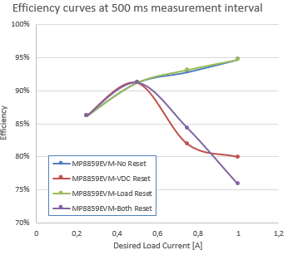

1. Efficiency curves at 500 ms measurement delay with device under test

The thing to observe here is that the curves without input source barely differ. However there is a small difference between the curves for only input source reset and both reset.

For further evaluation the measurement setup is repeated, this time with 750ms delay between the measurements. Results are summarized in table VI.

1. Results from 750ms measurement delay with device under test

|  |  |  |  |  |
| --- | --- | --- | --- | --- |
| 750ms measurements delay | | | | |
| Input Current [A] | Input Voltage [V] | Output Voltage [V] | Output Current [A] | Mode |
| 0 | 14,997 | 5,0288 | 0 | No reset |
| 0,097 | 14,998 | 5,0372 | 0,2486 |
| 0,184 | 14,998 | 5,0464 | 0,4987 |
| 0,272 | 14,998 | 5,0554 | 0,749 |
| 0,357 | 14,998 | 5,0641 | 0,9985 |
| 0 | 14,997 | 5,0289 | 0 | VDC Reset |
| 0,097 | 14,998 | 5,0371 | 0,2489 |
| 0,184 | 14,997 | 5,0464 | 0,4989 |
| 1,004 | 2,633 | 2,8674 | 0,7546 |
| 0,946 | 2,637 | 2,0596 | 0,9982 |
| 0 | 14,998 | 5,0294 | 0 | Load Reset |
| 0,097 | 14,998 | 5,0371 | 0,2489 |
| 0,183 | 14,998 | 5,0457 | 0,4989 |
| 0,27 | 14,998 | 5,0549 | 0,749 |
| 0,356 | 14,999 | 5,0637 | 0,9985 |
| 0 | 14,998 | 5,0283 | 0 | VDC & Load Reset |
| 0,097 | 14,998 | 5,0366 | 0,2486 |
| 0,184 | 14,998 | 5,0455 | 0,4989 |
| 0,969 | 2,64 | 2,8696 | 0,745 |
| 1,016 | 2,666 | 2,0549 | 1,0043 |

Again at no reset and load reset there aren’t significant deviations from the nominal parameters, however at currents greater than 0.5 A the input doesn’t have the time to settle.

The efficiency curves are plotted on figure 4.

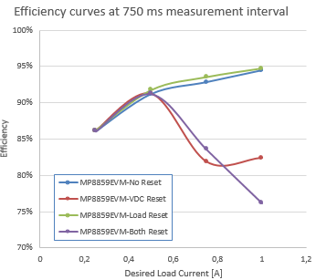

1. Efficiency curves at 750 ms measurement delay with device under test

Results are similar – the restart of the voltage source affects the efficiency curves by lowering the efficiency when the input source has not settled. Notice however, that the overall efficiency has increased a bit from the previous results.

Lastly a measurement with 1 second settling time delay is performed. The results are summarized in table VII.

1. Results from 1 s measurement delay with device under test

|  |  |  |  |  |
| --- | --- | --- | --- | --- |
| 1000 ms measurements delay | | | | |
| Input Current [A] | Input Voltage [V] | Output Voltage [V] | Output Current [A] | Mode |
| 0 | 14,997 | 5,0288 | 0 | No reset |
| 0,097 | 14,998 | 5,0372 | 0,2486 |
| 0,184 | 14,998 | 5,0464 | 0,4987 |
| 0,272 | 14,998 | 5,0554 | 0,749 |
| 0,357 | 14,998 | 5,0641 | 0,9985 |
| 0 | 14,997 | 5,0289 | 0 | VDC Reset |
| 0,097 | 14,998 | 5,0371 | 0,2489 |
| 0,184 | 14,997 | 5,0464 | 0,4989 |
| 1,004 | 2,633 | 2,8674 | 0,7546 |
| 0,946 | 2,637 | 2,0596 | 0,9982 |
| 0 | 14,998 | 5,0294 | 0 | Load Reset |
| 0,097 | 14,998 | 5,0371 | 0,2489 |
| 0,183 | 14,998 | 5,0457 | 0,4989 |
| 0,27 | 14,998 | 5,0549 | 0,749 |
| 0,356 | 14,999 | 5,0637 | 0,9985 |
| 0 | 14,998 | 5,0283 | 0 | VDC & Load Reset |
| 0,097 | 14,998 | 5,0366 | 0,2486 |
| 0,184 | 14,998 | 5,0455 | 0,4989 |
| 0,969 | 2,64 | 2,8696 | 0,745 |
| 1,016 | 2,666 | 2,0549 | 1,0043 |

It seems to overcome the transient process more time should be given to the input source to settle, however if one compares the numbers between the three tables they gradually increase to the nominal value. Plotting the efficiency curves on figure 5 shows the same behavior again with slight increase in the efficiency.

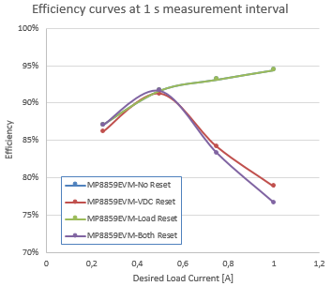

1. Efficiency curves at 1 s measurement delay with device under test

Results indicate that the measurement delay should be greater than 1 second for this particular setup. It has been chosen not to include a measurement with fully settled instrument, because this would be quite specific depending mainly on the device under test. However the presented ideas and measurements would allow trainees, students and professionals to troubleshoot problems with unexpected or undesired results in their automated test and measuremenet data acquisition test benches and setups.

# Conclusion

An adoption of the aspects for automated test and measurement workflow and algorithms related to the study of power electronic converters is presented. An observation is made that some peculiarities of various test bench configurations affect the speed, performance and accuracy of the carried measurements and produced data.

Although automation allows for greater flexibility and superior speed increase this does come with a cost, related with the impossibility to have fast and perfect transient response. This could add a significant error to the measurements and even invalidate them. It was demonstrated that choosing different delay between the automated measurement steps for settling time of both the instruments and the device under test could significantly influence the produced results. It is of critical aspect that the researcher is aware of this peculiarities in order to make accurate conclusions on power converter parameters such as efficiency, load and line regulation, reliability and safety of the devices tested.

Nonetheless, automated measurements play a crucial role in the evolution of power electronic devices towards more efficient, reliable, and adaptive systems, with significant implications for various industries including renewable energy, electric vehicles, industrial automation, and smart grid applications.

##### Acknowledgment

The carried out research is supported and realized in the frames of the project ''Study of power electronic systems with intelligent control'', 241ПР00015-03/28.03.2024, Research and development sector, Technical University of Sofia.

##### References

1. G. Eason, B. Noble, and I. N. Sneddon, “On certain integrals of Lipschitz-Hankel type involving products of Bessel functions,” Phil. Trans. Roy. Soc. London, vol. A247, pp. 529–551, April 1955. *(references)*
2. J. Clerk Maxwell, A Treatise on Electricity and Magnetism, 3rd ed., vol. 2. Oxford: Clarendon, 1892, pp.68–73.
3. I. S. Jacobs and C. P. Bean, “Fine particles, thin films and exchange anisotropy,” in Magnetism, vol. III, G. T. Rado and H. Suhl, Eds. New York: Academic, 1963, pp. 271–350.
4. K. Elissa, “Title of paper if known,” unpublished.
5. R. Nicole, “Title of paper with only first word capitalized,” J. Name Stand. Abbrev., in press.
6. Y. Yorozu, M. Hirano, K. Oka, and Y. Tagawa, “Electron spectroscopy studies on magneto-optical media and plastic substrate interface,” IEEE Transl. J. Magn. Japan, vol. 2, pp. 740–741, August 1987 [Digests 9th Annual Conf. Magnetics Japan, p. 301, 1982].
7. M. Young, The Technical Writer’s Handbook. Mill Valley, CA: University Science, 1989.