Contents
Chapter 1 Introduction
1.1 Project Title ........................................................................................................................1
1.2 Introduction........................................................................................................................1
1.3 Problem Statement ............................................................................................................1
1.4 Objectives ......................................................................................................................…. 2
1.5 Scope and Limitations .....................................................................................................2-3
Chapter 2 Existing System and Feasibility Study
2.1 Literature Review / Existing System Study …….……………………………………………….……………… 4
2.2 Technical Feasibility ……………………………………………………………………………………………….……… 4
2.2.1 Hardware Requirements ….................................................................................. 5
2.2.2 Software Requirements ................................................................................... 5-6
2.3 Operational Feasibility ..................................................................................................…… 6
2.4 Economic Feasibility .....................................................................................................…… 6
2.4.1 COCOMO Model ..............................................................................………………… 7
2.5 Schedule Feasibility ........................................................................................................... 8
2.5.1 Work Breakdown Structure ...............................................................………………. 9
2.5.2 Gant Chart .......................................................................................………………. 10
Chapter 3 Proposed System / System Design
3.1 System Overview ………..................................................................................................… 11
3.2 Functional Modules..................................................................................................... 11-12
3.3 System Design …….........................................................................................................…. 13
3.3.1 Database Design ............................................................................………………... 13
3.3.2 Flow Chart .......................................................................................………………. 14
3.3.3 Use Case Diagram ............................................................................………………. 15
3.3.4 Data Flow Diagram...........................................................................…………. 16-17
3.3.5 Proposed Algorithm ........................................................................………………. 18
3.4 Key Features ………..………………………………………………………………………………………………….…. 18
3.5 Tools and Technologies.………………………………………………………………………………………………. 19
Reference ………………………………………………………………………………………………………………………... 20

List of Tables
Table 2.1: Table for Hardware Requirements …………….………………………………..……………………… 5
Table 2.2: Table for Software Requirements ……………………………………………….………………...… 5-6
Table 2.3: COCOMO parameters …………….………………….……………………………………………………… 7
Table 3.1: Tools and Technology Requirement.…………………………………………………………………. 19
List of Figures
Figure 2.1: Work Breakdown Structure ………………………………………………………………………………. 9
Figure 2.2: Gantt Chart ………………………………………………………………………………………………………10
Figure 3.1: Database Design ….…….….….…….……………………………………………………………………… 13
Figure 3.2: Flow Chart ……………………………………………………………………………………………………… 14
Figure 3.3: Use Case Diagram …………………………………………………………………………………………… 15
Figure 3.4: Data Flow Diagram …….……………………………………………………………………………… 16-17

Chapter 1 Introduction
1.1 Project Title
Smart AI-Based Structural Bug Detection and Prevention System Using Machine Learning and LangGraph
1.2 Introduction
An AI-based system design that reviews the source code and the structure of the software projects and warns developers about the potential structural problems and suggests certain measures to prevent them.
This system is different from most Debugging Tools that only catch syntax errors or crashes after the code runs. This aspects of the system examines how the code is organized: how the modules are dependent on each other, whether there are circular dependencies, coupling and cohesion [1][2], or components that are likely become hard to maintain.
When the system scans a GitHub repository using GitHub OAuth, it runs static analysis and builds a dependency map[3] of the project. It then extracts useful metrics about architectural and design. A machine learning model then predict which part of the system are risky and likely to cause bugs in the future.
In addition, this system also offers multiple subscription tiers such as Free tier and Pro tier, where the advanced feature will be unlocked through paid plans which is support by online payment integration using razorpay[9].
1.3 Problem Statement
Most the existing debugging tools are largely reactive which means they detect problems only after failure occur during testing or deployment phases. Manual architectural reviews are slow or time consuming, costly, and prone to human oversight.
At present there is no comprehensive automated platform that:
- Continuously analyses a software architecture.
- Predicts future structural problems
- Identifying architectural anti patterns.
- Provide clear and explainable, AI-driven recommendations.
- Visualizes of how dependencies evolve over time.
Hence a predictive and intelligent system is required to proactively monitor software design and help maintain quality of the software.
1.4 Objective
The main objective of this project is to design and develop an AI-driven based system that can predict the architectural risk, automatically analyse the structure of the software project and provide explainable recommendations to prevent future defects.
Objectives:
- By performing statistical analysis on complete software repositories, in order to understand module structure, dependencies and design of the system.
- Extracting architectural and complexity metrics such as coupling and cohesion.
- To make a bug predicting model based on machine learning in order to avoid system failure.
- To detect anti-structural patterns like circular dependencies, God files, tight coupling and broken architectural layers.
- To design a LangGraph based reasoning system that identifies and detect risk and suggests actions which are recommended to developers.
- Visualizing project structure and predict risk levels using interactive graph and analytical dashboards.
- To integrate the system with GitHub repositories so that software project can be scanned automatically and generate reports.
1.5 Scope and Limitation
Scope
- Static structural analysis.
- Prediction using Machine-Learning
- AI driven architectural recommendation.
- GitHub repository integration.
- Interactive visualization dashboard.
Limitations
- The system does not analyse program execution or runtime failures.
- Syntax and compilation error are outside of scope for the current implementation.
- Machine learning prediction it depends strongly on the quality and diversity of training data.
- Language specific parser is needed, which limits immediate multiple programming language.
- Automatic code changes are not included in the current implementation.
- Performance may not be guaranteed for extremely large repositories without distributed processing.
- The System cannot remove any defects and it mainly focuses on lowering or reducing architectural risk.

Chapter 2
Existing System and Feasibility Study
2.1 Existing System Study
Existing system
- linters and rule-based scanners[3] these are static analysis tools that primarily identify syntax error and simple bug by examining source code without executing it.
- Runtime debugging tools are design to only work after executing a program.
- Basic code quality platforms and only provide metrics like complexity or duplication but cannot predict future risk.
- Manual architecture review[1] which relies on experienced engineers but they are time consuming, depends on personal judgement, limited scalability due to hidden dependencies.
- Lack of tool support
2.2 Technical Feasibility
The project is technically feasible because of the availability of:
- There are reliable static libraries.
- Machine learning framework is well developed.
- Graph and visualization tools.
- Repository platform APIs.
- AI orchestration frameworks.

    - Hardware Requirements

Components | Developer | User
RAM | Minimum 8 GB | Minimum 4 GB
Processor | Intel i5 / AMD Ryzen 5 or above | Intel i3 / AMD Ryzen 3 or above
Storage | 256 GB SSD or higher | 128 GB free space
GPU | For Machine Learning Training | Not required
Internet | Stable Connection | Stable Connection
Table 2.1: Table for Hardware Requirements

2.2.1 Software Requirements

Category | Software
Operating System | Windows 10 / Windows 11
Frontend | ReactJS
Backend | FastAPI
AI/ML | Python, Scikit-learn, LangGraph, NetworkX
Database | MongoDB, Neo4j
Payment Gateway | Razorpay

Developer

Category | Software
Operating System | Windows 10 / Windows 11
Web Browser | Chrome / Edge / Firefox
Internet | Required

User

Table 2.2: Table for Software Requirements
  - Operational Feasibility
The system is useful for:
- Software developers
- Testing teams
- Operations and deployment teams
- Project managers
Its web-based UI and visual dashboards make it easy to use and require very little training.
  - Economic Feasibility
AI-based structural bug detection system project is economically feasible because:
- Development tools are mostly open source.
- Cloud servers can be scaled on demand.
- Subscription gateway can create revenue.
Cost
- Development time and tools.
- Cloud server.
- Maintenance and updates.
Benefits
- Save Developers time
- It can reduce long term maintenance cost for the companies.
- Improves software quality and reliability
The project uses mostly free tools, needs limited initial cost, and revenue can be earned through paid plans in the future, where the users can also be benefit by avoiding costly future bugs.
    - COCOMO Model
The calculation of the using the formula is as follows:
Effort (E) = a * (KLOC)b
Development Time(D) = c * (Effort)d
Where,
• KLOC = Thousand Lines of Code
• a, b, c, d are constant values for the basic model for different system.
• E = Effort in Person-Months
Table 2.3: COCOMO Parameters
Mode | A | B | C | D
Organic | 2.4 | 1.05 | 2.5 | 0.38
Semi-detached | 3.0 | 1.12 | 2.5 | 0.35
Embedded | 3.6 | 1.2 | 2.5 | 0.35

This project type is a Semi-detached Project, for 1600 lines of code, KLOC 5
Now the basic COCOMO equation of our project is,
Effort Applied (E) = 3.0 * (1.6)^{1.12}
= 5 person-months
Development Time (D) = 2.5 * (5)^{0.35}
= 4.4 months
From the above calculation, the effort is approximately 5 person-months. Since the project is to be completed within a planned duration of 5 months, the development time is approximately 4.4 months. Therefore, the project is considered feasible within the given schedule.
  - Schedule Feasibility
Schedule feasibility evaluates that whether the proposed system can be completed within the academic time frame. The Work Breakdown Structure (WBS) divides the project into clear phases such as design, static analysis implementation, machine learning model development, AI reasoning integration, backend services, frontend visualization, testing and documentation.
A Gantt Chart is use to spread these activities across the project timeline and shows overlapping phases to support iterative development. Extra time is kept for testing and documentation, and the use of open-source tools and reusable libraries, reduces schedule risk.

    - Work Breakdown Structure
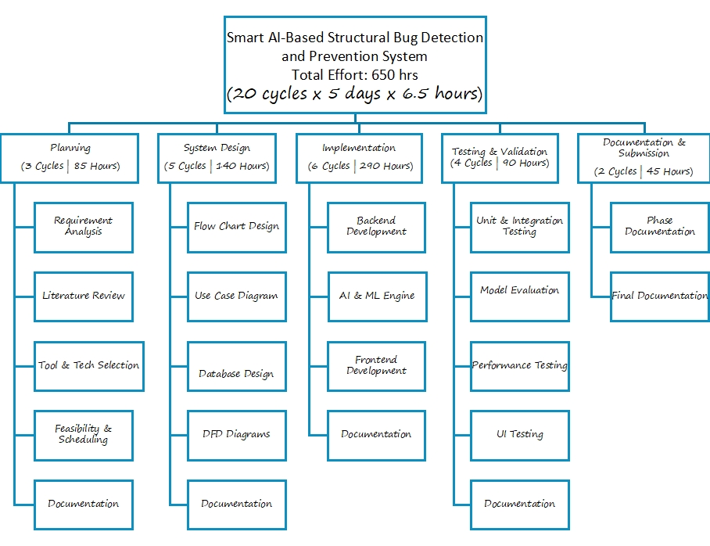
Figure 2.1: Work Breakdown Structure of Smart AI-Based Structural Bug Detection and Prevention System Using Machine Learning and LangGraph

2.5.2 Gantt Chart
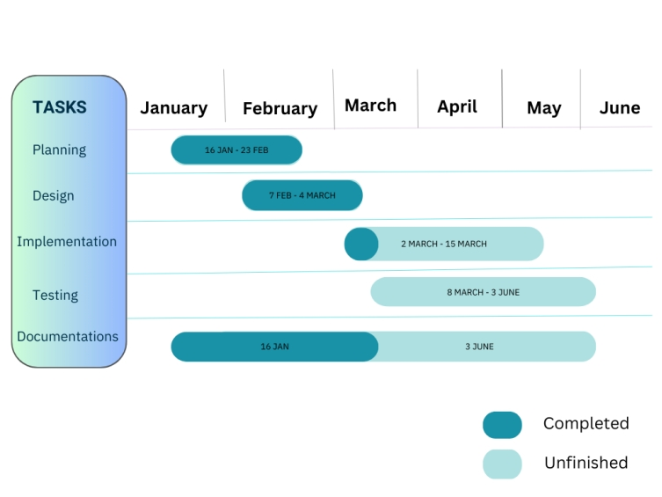
Figure 2.2: Gantt Chart of Smart AI-Based Structural Bug Detection and Prevention System Using Machine Learning and LangGraph

CHAPTER 3
Proposed System /System Design
3.1 System Overview
The proposed system is a web-based intelligent platform that uses machine learning and graph-based analysis to assess the structural quality of software projects and forecast possible architectural risks. Developers can supply a GitHub repository link or upload a project folder using the system. After receiving the repository, the system uses static analysis[3] to look at how the source code is organized and find module dependencies.
In order to extract architectural metrics like module size, coupling, cohesion, fan-in, and fan-out, the analysis engine builds a dependency graph of the project. A machine learning model analyses these features to forecast the likelihood of future structural flaws in various system modules [3].
A LangGraph[8]-based reasoning component evaluates the anticipated risk and offers explanations and preventive suggestions to improve interpretability. The developers receives the results via an interactive web dashboard that displays dependency graphs, risk levels, and recommendations. These are developed using React [4], while backend services responsible for analysis and processing are implemented using FastAPI [5].
MongoDB and Neo4j databases [6][7] are used by the system to store user data, scan results, and dependency information. This system overall helps developers proactively detect structural issues in software architecture and take corrective measures before they lead to major defects.
3.2 Functional Module
The Proposed System is made up of a number of function modules that cooperates to carry out the risk prediction, recommendation generation, and repository analysis.
Modules
- User Authentication:
User login and registration are handled by this module. It saves user data in the database and validates user credentials. Additionally, it controls subscription status and user sessions.
- Project Scanner:
The User can either Upload the project folder or a link to a GitHub repository.
It finds all of the project's modules, packages, classes, and directories by scanning every source file.
- Engine for Static Analysis:
The static analysis engine studies the structure of the source code without executing it. It identifies relationships between modules and detects architectural problems such as tight coupling and circular dependencies.
- Feature Extratcion:
This module transform the raw analysis results into measurable metrics that can be used by the machine learning model.
- Risk Prediction for Machine Learning:
This module checks the evaluated extracted features and calculates the likehood of structural error in each project module using a trained machine learning model.
- AI Reasoning:
This module interprets the prediction results and give and explanation for the risk that had been detected.
- Visualize and Reporting:
This module provides the results to the users through the dashboard and it also provide graph and the risk be download for the future analyse.
- Data Storage Module:
This module stores user information, project scans, and analysis results.
MongoDB is used for storing data and Neo4j stores dependency graph of the software system.

3.3 System Design
3.3.1 Database Design
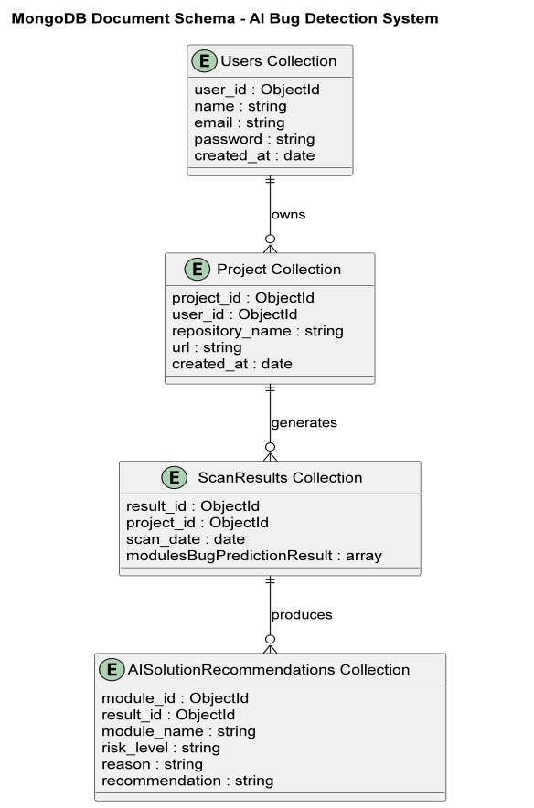

Figure 3.1: Database Design of Smart AI-Based Structural Bug Detection and Prevention System Using Machine Learning and LangGraph

3.3.2 Flowchart
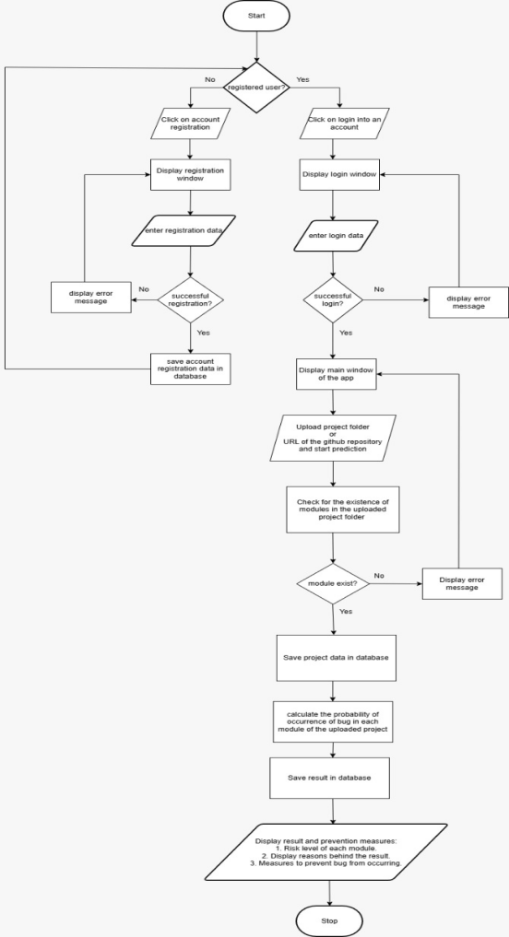
Figure 3.2: Flow Chart of Smart AI-Based Structural Bug Detection and Prevention System Using Machine Learning and LangGraph
3.3.3 Use Case Diagram
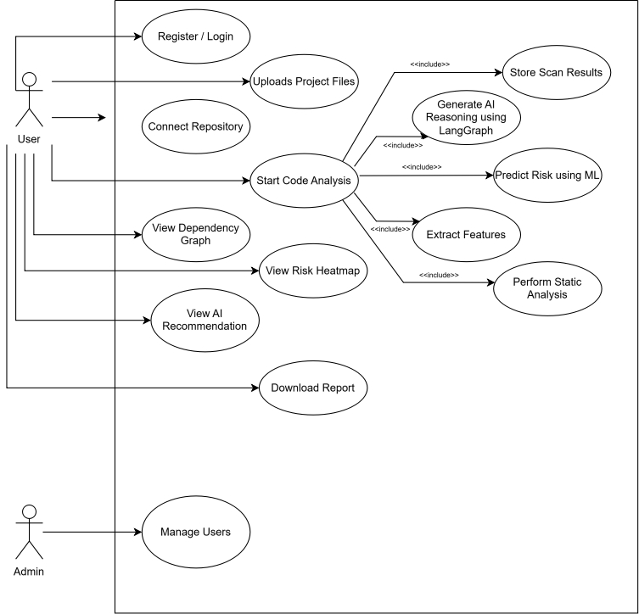

Figure 3.3: Use Case Diagram of Smart AI-Based Structural Bug Detection and Prevention System Using Machine Learning and LangGraph

3.3.4 Data Flow Diagram
1. Level 0
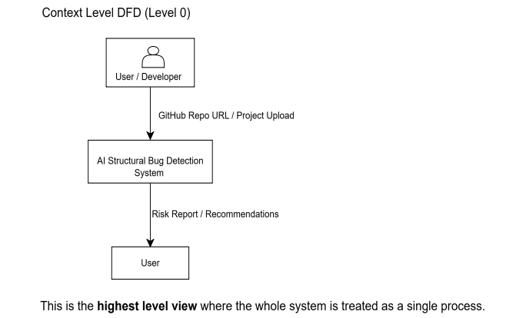

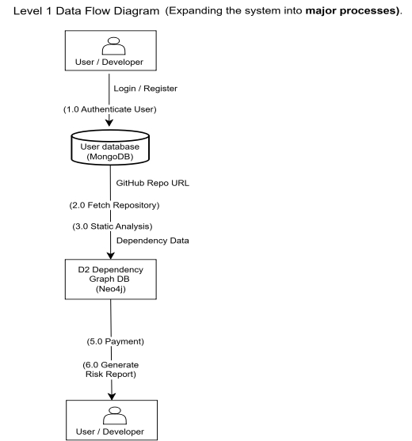
2. Level 1

3. Level 2
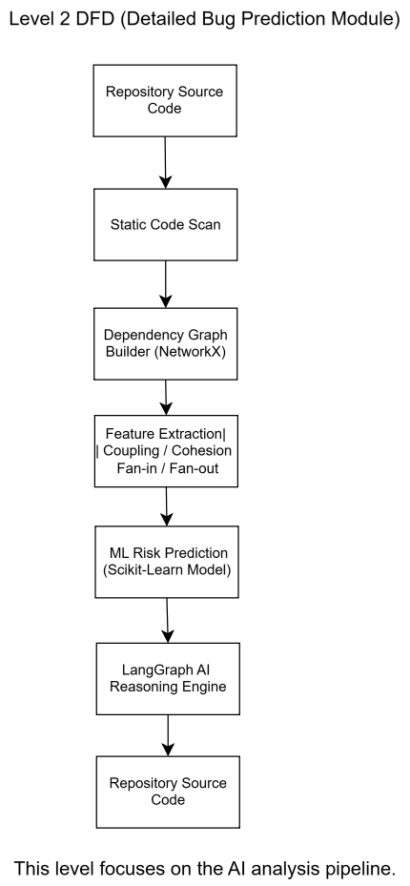
Figure 3.4: Use Case Diagram of Smart AI-Based Structural Bug Detection and Prevention System Using Machine Learning and LangGraph

3.3.5 Proposed Algorithm
Steps and Process
1. Start the system.
2. User logs into the systems.
3. User can upload a project or connects to a GitHub repository.
4. The System scans all source code files.
5. The system identifies modules in the project.
6. Static analysis is performed to detect dependencies between modules.
7. Architectural metrics such as coupling and fan-in/fan-out are calculated.
8. These metrics are sent to the machine learning model.
9. The model predicts the risk level in each module.
10.The LangGraph reasoning engine analyzes the prediction results.
11. The system generates explanations and suggest improvement.
12. The results are then stored in the database.
13. The dashboard displays risk analysis.
14. the user can download the report.
15. End the process.

3.3 Features
- Detection of architectural risk
- Circular dependency identification
- Risk heat maps
- Tracking changes in system structure over time
- AI generated suggestions
- Interactive graphs
- Subscription based access
3.4 Tools and Technologies

Frontend | ReactJS
Backend | FastAPI
AI/ML | Python, Scikit-learn, LangGraph, NetworkX
Database | MongoDB, Neo4j
Payment Gateway | Razorpay

Table 3.1: Tools and Technologies Requirement

References
[1] Gamma, E., Helm, R., Johnson, R., & Vlissides, J. (1994). Design patterns: Elements of reusable object-oriented software. Addison-Wesley.
[2] Fowler, M. (2018). Refactoring: Improving the design of existing code (2nd ed.). Addison-Wesley.
[3] Kruse, R. L. (2021). Static analysis: How and why to analyze your code. Springer.
[4] Meta Platforms, Inc. (n.d.). React: A JavaScript library for building user interfaces. https://react.dev/learn
[5] FastAPI. (n.d.). FastAPI documentation. https://fastapi.tiangolo.com/
[6] MongoDB, Inc. (n.d.). MongoDB documentation. https://www.mongodb.com/docs/
[7] Neo4j, Inc. (n.d.). Neo4j documentation. https://neo4j.com/docs/
[8] LangChain. (n.d.). LangGraph overview. https://docs.langchain.com/oss/python/langgraph/overview
[9] Razorpay. (n.d.). Razorpay documentation. https://razorpay.com/docs/

