Scripting Lab assignment 9: Services in Angular

Name: Dekyi Choezom

Registration Number: 201900170

Sec : B

Create a todo application having following components

1. Todo List Component - Display todo in list format
2. Todo Details Component - Display todo in table format
3. app root (main) component
4. Create a service (TodoService) and share data amongst Todo List & Todo Details Components

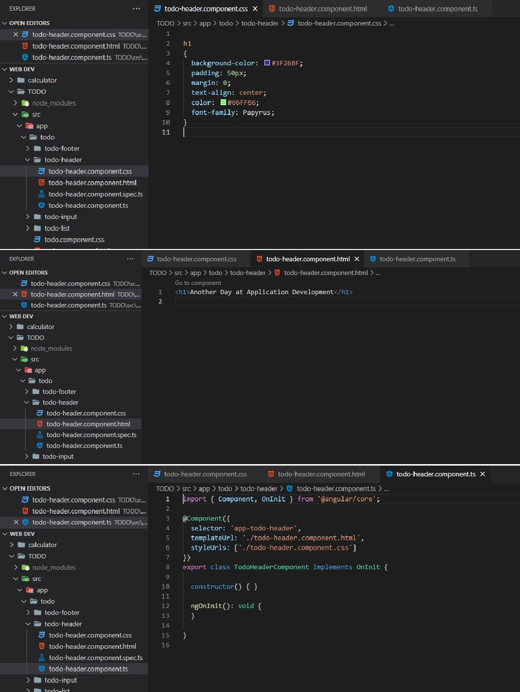

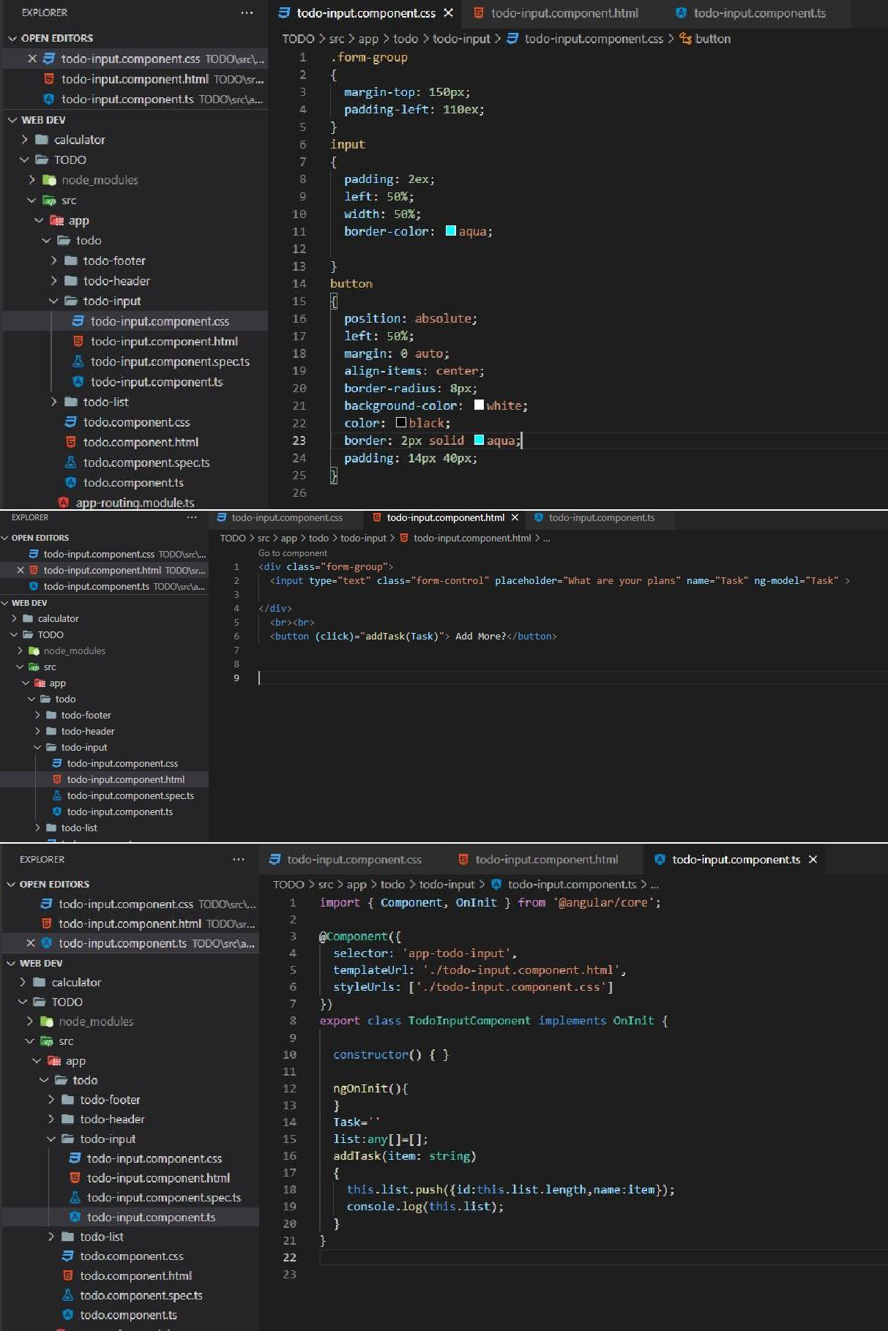

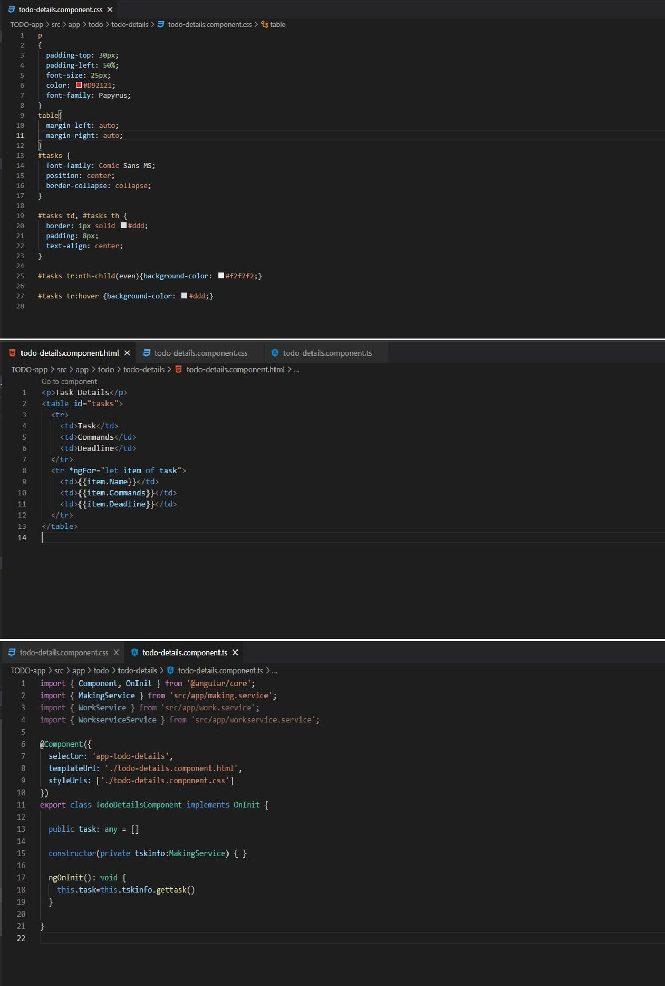

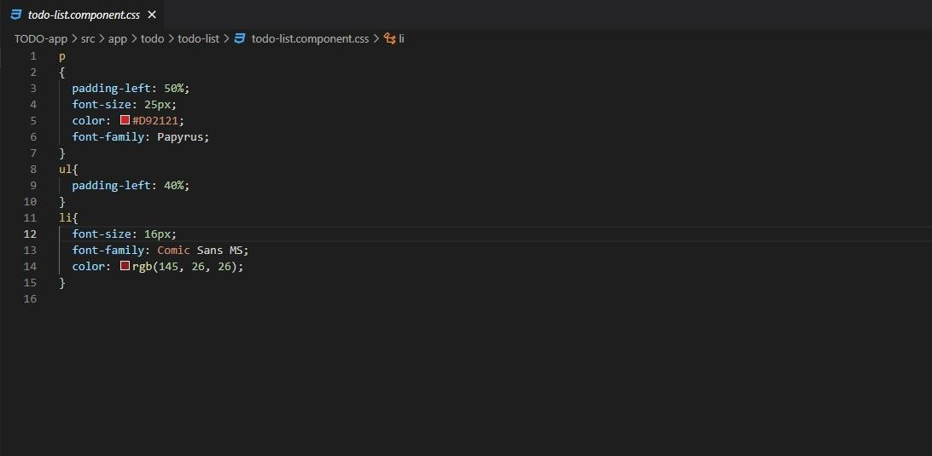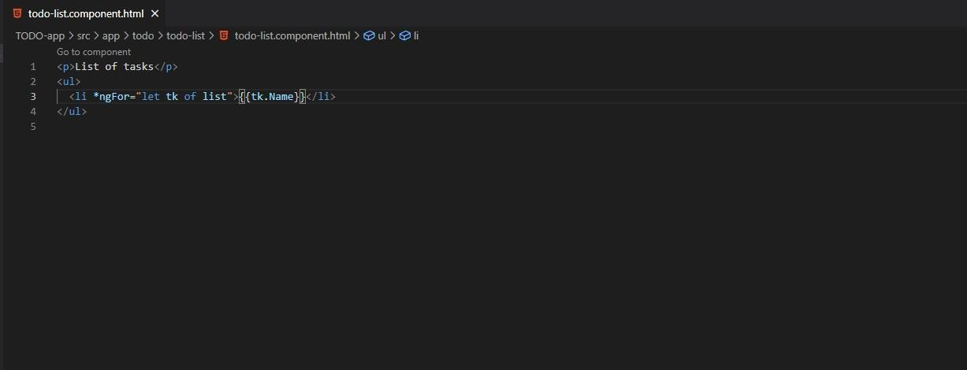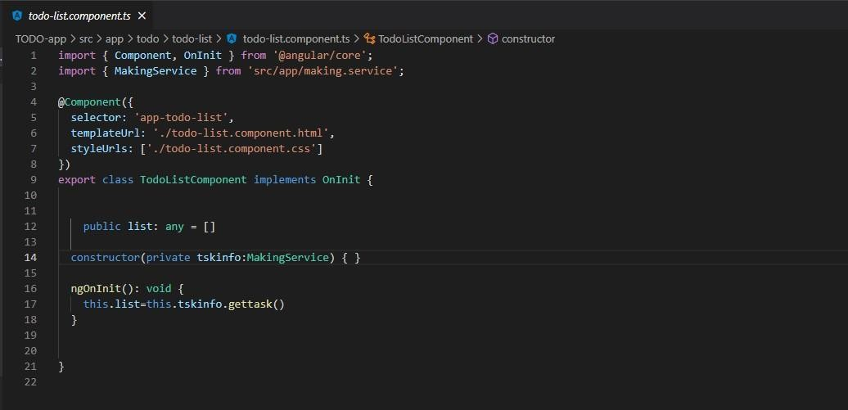

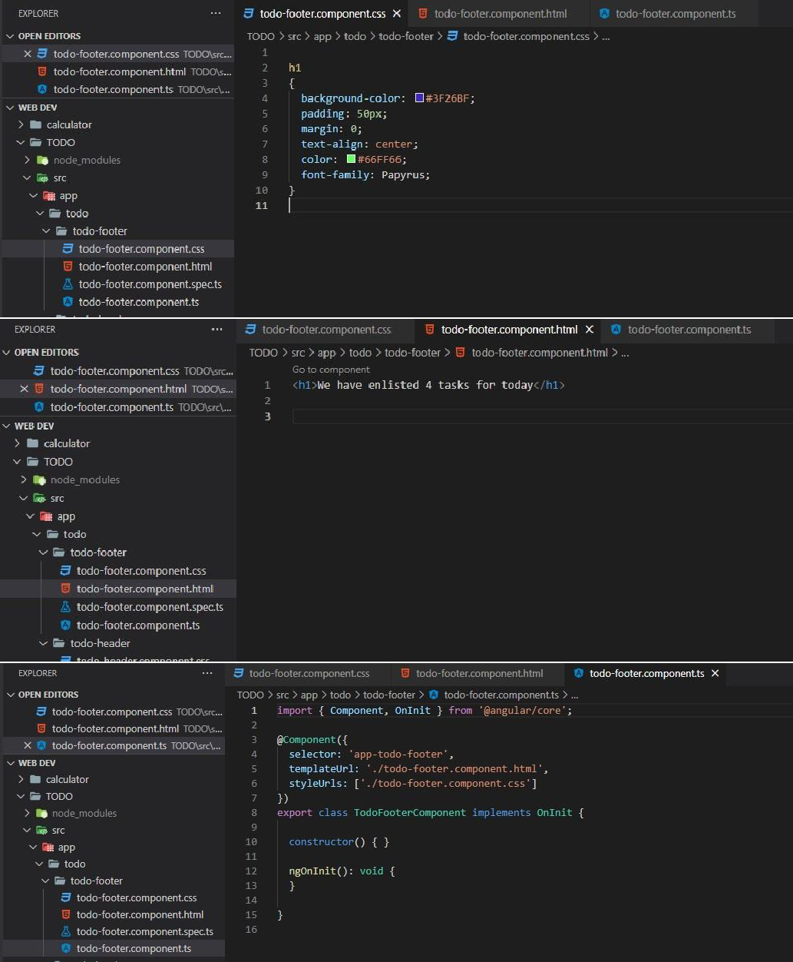

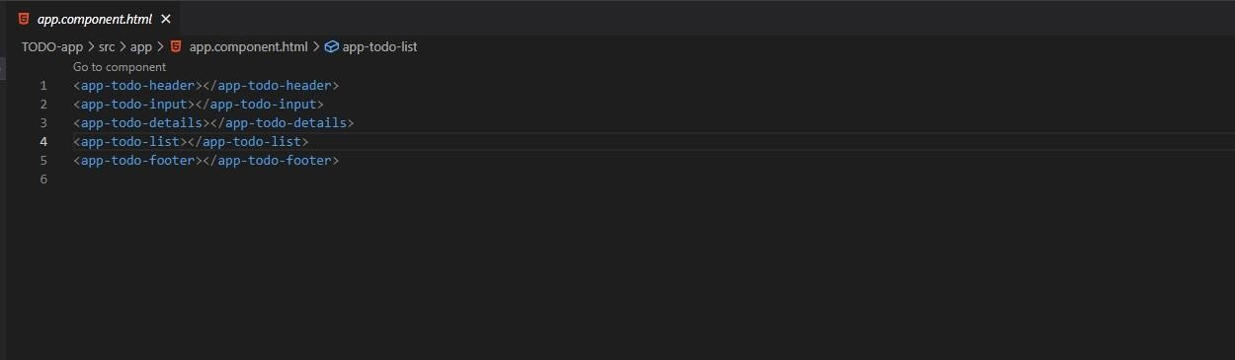

***App Component module file:***

