Kai - Hardware Layout & Wiring Build Sheet
Edge Offline AI Robot - hardware layout, wiring & physical setup only - rev D

TL;DR - as-built state & current status
This document describes the hardware layout and wiring for Kai as it is actually built. All four subsystems below - mic, servos, camera and the speaker chain - are connected and running on the robot. Where the as-built wiring differs from the ideal layout, the difference is recorded in place along with what it costs.
Kai is a four-segment vertical cardboard stack: head (jaw servo at the mouth) -> neck box (pan servo, Arduino Uno, fixed forward-facing Pi Cam NoIR V2) -> body drum (all audio hardware) -> exposed Jetson Orin Nano base (stays visible by design). Two servos only - pan (neck, D9) and jaw (head, D6) - driven by the Uno over PWM, with face-tracking data from the Jetson over Wi-Fi/UDP.
Subsystem | Status | Detail
INMP441 mic -> Jetson | Connected | Wired to 40-pin header on I2S2 (see section 4). Established.
Servos (pan + jaw) | Connected | Pan (D9) and jaw (D6) wired to the Uno.
Camera (Pi NoIR V2) | Connected | CSI ribbon to Jetson base, fixed forward-facing. IMX219-class sensor; it does not pan with the head.
Speaker -> PAM8403 -> 3.5mm -> Jetson | Connected | Chain works end to end: Jetson -> USB sound card (C-Media) -> 3.5mm -> PAM8403 -> speakers. The loose wiring was re-seated; Kai speaks its replies through this path and the jaw is driven from the same audio.
Arduino Uno -> Jetson (USB) | Connected | USB-A to USB-B. CH340 clone - the ch341 driver is not in the Jetson kernel and is loaded from hardware/ch341_build (see 9.2).

1 - Vertical stack overview
Kai is a four-segment vertical stack. The Jetson stays exposed at the base (design requirement, logo/branding visible). The body drum holds the entire audio subsystem. The neck box holds the pan servo, the Arduino Uno and the fixed forward-facing camera. The jaw servo lives up in the head at the mouth linkage.
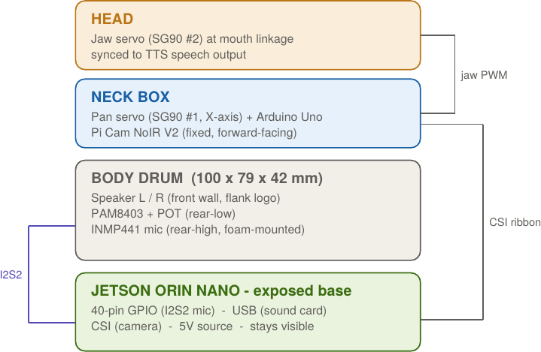

2 - Body drum placement (to scale)
Speakers fire forward through the front wall, flanking the 4-circle logo which stays intact. Mic sits rear-high, foam-mounted, with its own rear port. Amp sits rear-low with a screwdriver access hole for the POT.
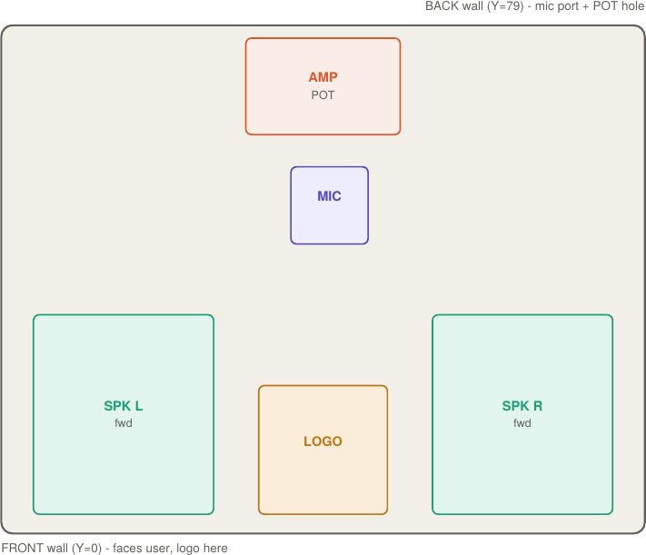
Interior coordinates (mm), origin bottom-front-left. X=width, Y=depth front-to-back, Z=height.
Component | X (L-R) | Y (F-B) | Z (bot-top) | Notes
Speaker L | 5-33 | 0-15 | 0-15 | front-firing, left of logo
Speaker R | 67-95 | 0-15 | 0-15 | front-firing, right of logo
Logo cluster | 40-60 | front face | centered | 4 circles, untouched
INMP441 mic | ~50 | 75-79 | 30-42 | rear/high, foam mount, own port
PAM8403+POT | 40-65 | 74-79 | 0-12 | rear/low, POT trim hole in wall

3 - Full wiring schematic
Five signal domains kept physically separate to control noise. The Uno talks to the Jetson over Wi-Fi/UDP (not a wire) and drives both servos by PWM. The mic is I2S to the 40-pin header; the camera is CSI ribbon; the amp takes analog line-out from a USB sound card on the Jetson.
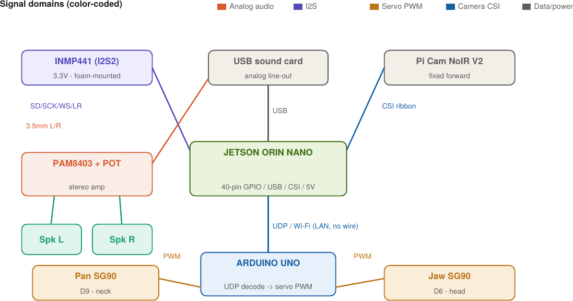

4 - INMP441 to Jetson 40-pin header (I2S2)
Exact mapping per your setup. Note VDD is 3.3V (Pin 1), not 5V - the INMP441 is a 3.3V part and 5V can damage it. L/R is tied to GND, placing the mic on the left channel of the I2S2 stereo stream.
INMP441 pin | Jetson pin | Signal | Wire color (suggest)
VDD | Pin 1 | 3.3V power | red
GND | Pin 6 | Ground | black
SD | Pin 38 | I2S2_SDIN (data in) | green
SCK | Pin 12 | I2S2_SCLK (bit clock) | yellow
WS | Pin 35 | I2S2_FS (frame/word sel) | blue
L/R | Pin 9 | GND = left channel | white

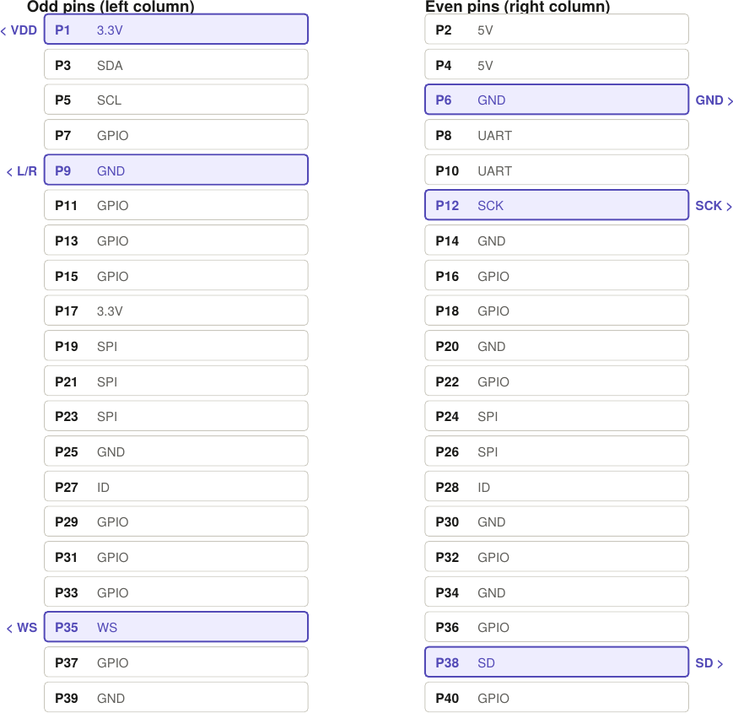
Note: this sheet covers hardware and physical setup only. Enabling the I2S pins in software (device-tree configuration and the capture/record test) is handled separately and is not part of this document.

5 - Arduino Uno servo wiring
Two SG90 servos only. Signal pins are suggestions - match them to your reference firmware's config. SG90 signal is 5V-logic PWM, which the Uno drives directly.
Servo | Uno signal pin | Power | Face param -> motion
Pan (neck) | D9 (PWM) | Uno 5V pin / GND (shared) | X -> head left/right
Jaw (head) | D6 (PWM) | Uno 5V pin / GND (shared) | TTS speaking -> mouth open/close
As built, both servos take 5V from the Uno's onboard 5V pin and the Uno is powered from the Jetson's USB port - so the servos, the board and the CH340 USB chip all share one USB rail. That is why the pan channel is gated to 10 Hz and 8 degrees per command in software: larger or faster commands raise average current and can brown out the CH340, which drops /dev/ttyUSB0 mid-track. If you want faster head motion, give the servos their own 5V supply with grounds commoned to the Uno - do not raise the send rate instead.

6 - Power & ground scheme
Rail / net | Feeds | Rule
5V - audio | PAM8403 + USB sound card | Own run from 5V src. Add 100-470uF bulk + 0.1uF at amp Vcc.
5V - servo | Pan + jaw SG90 | As built: Uno 5V pin, off the Jetson USB rail, shared with the CH340 - which is why pan stays at 10 Hz / 8 deg per command. A separate 5V run is the upgrade path. Never share the amp rail.
3.3V | INMP441 VDD | From Jetson Pin 1 only. Never 5V to the mic.
Ground | All modules | Star ground at the 5V src. No daisy-chaining amp -> servo -> Jetson.
I2S lines | INMP441 -> P12/35/38 | Keep < 30cm, route away from servo PWM and speaker leads.
3.5mm jack | Sound card -> amp | Tip=L, Ring=R, Sleeve=GND. Matches Spk L / Spk R.

7 - Pre-power checklist
☐ INMP441 VDD is on Pin 1 (3.3V), NOT Pin 2/4 (5V). Verify before first power-on.
☐ L/R pin tied to GND (Pin 9). Floating L/R gives silence or noise.
☐ Amp 5V and servo 5V are separate runs from the source; grounds star to one point.
☐ Bulk + bypass caps fitted on PAM8403 Vcc, or USB/servo noise will be audible.
☐ Mic foam/grommet mount in place - decouples speaker vibration through the cardboard.
☐ Speakers fire front (Y=0), mic ports rear (Y=79): the isolation split is intact.
☐ CSI ribbon has a gentle radius (no crease) and runs clear of the pan-servo PWM leads.
☐ 3.5mm plug fully home in the USB sound card - a half-inserted plug gives one channel or a loud hum.
☐ Servo horns mechanically centred at 90 deg before power-on, so travel limits are set in software and not by cardboard.

8 - Acoustic & integration notes
• Mic isolation is the #1 risk. The always-on I2S mic shares the drum with two speakers. Foam/grommet soft-mount decouples structure-borne vibration through the cardboard - this matters more than air-path distance in a cardboard box.
• Two servos only. Pan (neck) and jaw (head). The jaw is up in the head, far from the mic, so jaw-noise-into-mic is broken by distance. Only the speakers remain as an in-drum noise source.
• Camera is fixed forward. It does not pan with the head, so the tracking reference frame stays stable while the head it drives rotates above it.
• Left-channel mic. With L/R->GND the mic data lands on the left channel of the S32_LE stereo stream; take the left channel (or downmix) in the capture code.

9 - Common issues & fixes
What actually goes wrong with Kai, grouped by subsystem, with the cheapest fix first. Most of these present as software faults and are not: a silent robot, a deaf robot and a robot that restarts itself are usually a rail, a plug or a driver.

9.1 - Power, boot and the robot process
Symptom | Likely cause | Fix
Nothing happens at power-on; no lights on the Jetson | Underpowered supply - a phone charger cannot start an Orin Nano | Use the board's own supply. A brownout at boot looks exactly like a dead board.
Board boots but Kai never comes up | face_track.py is launched by an @reboot cron entry running scripts/autostart.sh | Check the process is there before suspecting hardware. If it starts but every reply is silent, the user session is not lingering and PulseAudio never came up: run loginctl enable-linger once, then reboot.
Kai relaunched itself mid-demo and repeated its greeting | The supervisor did its job - the process exited or crashed and autostart.sh brought it back | Not a hardware fault by itself. Read /tmp/face-servo.log for the exit code; rc=139 is a segfault and is usually audio-device contention (see 9.4).
ext4 errors printed on the rootfs at boot | Known: the rootfs partition mounts with recorded errors | Run e2fsck with the filesystem unmounted before trusting the board for a demo, and always shut down properly rather than cutting power.
Dashboard unreachable on port 8081 | Kai is not running, or the board is on another network/IP | Ping the Jetson first. The dashboard is served by face_track.py itself - no page means no process, not a web problem.

9.2 - Servos and the Arduino link
Symptom | Likely cause | Fix
/dev/ttyUSB0 missing; Kai starts with no servos | The ch341 driver for the Uno's CH340 clone is not in the Jetson's kernel | sudo bash hardware/fix_usb.sh. Once only, sudo bash hardware/install_udev.sh for auto-bind on every plug. Kai deliberately runs on without servos rather than failing to start.
Servo buzzes but does not rotate | Faulty SG90, or the 5V rail is sagging under stall current | Sweep it standalone: python3 -m servo.servo_serial --sweep. If it still only buzzes, replace the servo - internally broken units answer electrically and never move.
Head jerks, then the serial link drops mid-track | SG90 current spikes on the shared USB rail brown out the CH340 | Keep the 10 Hz / 8 deg gates in place (section 5). The real fix is a separate 5V servo supply, grounds commoned to the Uno.
Head tracks the wrong way | Horn or mounting is mirrored relative to the camera | Launch with --flip. Do not re-mount the servo to correct direction.
Jaw does not move while Kai speaks | Jaw not wired to D6, or the jaw channel is not enabled | The jaw needs the wire on D6 and --jaw at launch; the flag is ANDed with the jaw setting, so no setting can conjure a servo that is not there.
Servos hum continuously while idle | Something is still sending commands - the firmware detaches after 4 s of silence | A healthy idle robot goes quiet. A continuous hum means a second process is holding the port or the head is fighting a mechanical limit.
Servo strains or the linkage binds at the end of travel | Mechanical range does not match the commanded angle range | Centre the horn at 90 deg mechanically, then bound travel in config/servo.py. Never let the servo push cardboard to find its limit.

9.3 - Microphone (INMP441 on I2S)
Symptom | Likely cause | Fix
Kai does not react to speech; the mic reads as not live | The INMP441 comes up on one boot and not the next - measured across three boots | Press "Find the microphone again" on the dashboard first (~2 s, nothing else interrupted). It re-runs the whole discovery path - I2S route, pulse release, device probe - without a restart.
Mic dead or hot from first power-on | VDD wired to 5V | VDD goes to Pin 1 (3.3V) only. A part that has seen 5V is usually dead - replace it and re-check the pin before powering up again.
Capture is pure silence, or pure noise | L/R left floating | Tie L/R to GND (Pin 9). Data then lands on the left channel, which is the channel the capture code takes.
Kai hears its own speakers, or picks up buzz while speaking | Structure-borne vibration through the cardboard, not air path | Foam/grommet soft-mount the mic; keep it rear-high with its own port and the speakers front-firing. In a cardboard drum this matters more than distance.
Kai hears, but on the wrong microphone | Selection fell back to the USB dongle when the I2S probe timed out | The "find the microphone" reply says which device it landed on. Falling back to the dongle also puts capture on the same card as playback - see the segfault row in 9.4 - so re-seat the I2S wiring rather than living on the fallback.
Intermittent dropouts or clicking in captured audio | I2S run too long, or routed alongside servo PWM and speaker leads | Keep the four I2S wires under 30 cm and physically away from the PWM and speaker runs.

9.4 - Speaker, amp and output
Symptom | Likely cause | Fix
Every reply is silent though the dashboard says it spoke | The C-Media card flipped its profile to S/PDIF, so the sink Kai plays to stops existing | Kai re-asserts the analog profile on every start, so a restart is the quick fix. pactl list short sinks confirms which sink is really there.
Audio dies after a quiet spell; the next reply is clipped at the start | PulseAudio suspend-on-idle. This is not the speaker "powering off" - it is a software idle suspend | The keep-alive in the user default.pa plus the udev rule already fix this. If it returns, check both survived the last rebuild.
Buzz or whine that rises with head movement | Amp and servos sharing a rail, or grounds daisy-chained | Separate 5V runs from the source, star ground at one point, and fit the bulk 100-470uF plus 0.1uF bypass at the amp Vcc.
Distortion or clipping on loud replies | PAM8403 POT set too high, or software volume pushed above 1.0 | Trim the POT through the rear access hole first; only then adjust volume in the Settings tab.
Only one speaker plays | 3.5mm plug not fully seated, or a mono (TS) plug in a TRS jack | Push the plug fully home. Tip = L, ring = R, sleeve = GND, matching Spk L / Spk R.
Kai segfaults exactly as its first audio starts | Playback re-opened the sound card underneath a live capture stream on that same card | Happens when capture has fallen back to the C-Media dongle. Get capture back onto the I2S mic (9.3) so input and output are not on one card.

9.5 - Camera
Symptom | Likely cause | Fix
No camera at boot; the dashboard reports NO CAMERA with a reason | CSI is probed once at boot, and creating the device node needs a root driver bind | sudo bash scripts/camera_bind_retry.sh --now, or --install once to retry at every boot. Kai picks the camera up within about 5 s - no restart needed.
A camera plugged in after boot never appears | Same CSI bind-at-boot limitation | USB webcams genuinely hot-plug; a CSI module does not. Kai running with no camera is a reported state, not a failure.
i2cdetect shows an empty CSI bus | The sensor is only powered for ~10 ms while the driver probes, so an ordinary sweep misses the window | sudo bash scripts/camera_diag.sh probes inside that window and says whether a sensor answers at all - and whether it is the module you think it is. Run it after every hardware swap.
Image is upside down or sideways | Module mounted rotated in the neck box | Use --rotate 0/90/180/270 rather than remounting the camera.
Tracking stutters or drifts after a head move | Ribbon creased, or running beside the pan PWM leads | Give the ribbon a gentle radius and route it clear of the servo leads. The camera is fixed forward by design and must not move with the head.

9.6 - First aid, cheapest first
• 1. Find the microphone again - about 2 s, nothing else interrupted. For anything where Kai cannot hear.
• 2. Restart Kai - about 30 s, the conversation is lost. For anything a setting cannot reach: a wedged capture device, a wake engine that stopped hearing.
• 3. Reboot the Jetson - about 90 s, the whole board goes down. For wedged kernel audio, a wedged camera stack or GPU fragmentation. The dashboard control for this is off by default; consider the rootfs e2fsck (9.1) before making reboots routine.
• Reaching for the bottom of that ladder first is how a five-second problem becomes ninety seconds of dead robot.
Note: this sheet stays hardware-only. Operating Kai, the live settings and the software side of these fixes are documented in docs/operating.md and docs/faq.md.

