★ Launched at DEVCON 17th Anniversary — Beta Release ★

NVIDIA Jetson Orin Nano
R&D for Edge Offline Computing
Kai
Edge Offline AI Robot
R&D by Cohort 4 AI Engineering Interns

Product Name | NVIDIA Jetson Orin Nano R&D for Edge Offline Computing
Robot Name | Kai — Edge Offline AI Robot
Document Version | 2.0
Status | Beta — Launched at DEVCON 17th Anniversary
Date | June 2026
Prepared By | Jhondel Mellomida
Team | Cohort 4 AI Engineering Interns — AI Engineering Department

— Confidential R&D Document —

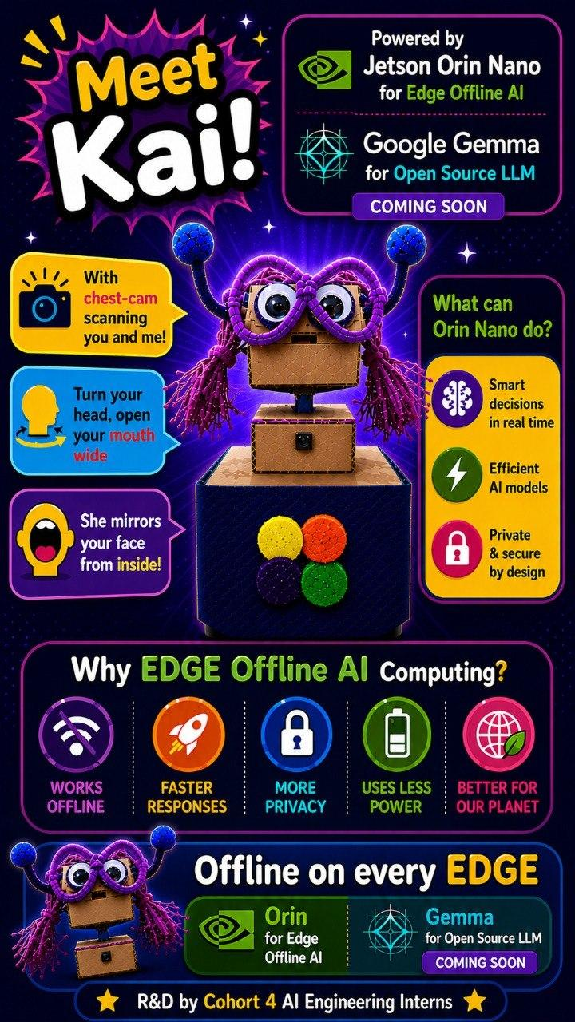

1. Introduction

1.1 Purpose
This document is the R&D reference for Kai — NVIDIA Jetson Orin Nano R&D for Edge Offline Computing. It is not a traditional production PRD but a living record of the team's hands-on exploration of edge AI hardware, with face detection as the primary proving ground. Requirements and specifications here are working hypotheses expected to evolve as hardware understanding deepens.

1.2 Scope
This document covers the face tracking pipeline (11 parameters), on-device AI model execution, robot actuation, LAN communication, and hardware constraints discovered during hands-on R&D by Cohort 4 AI Engineering Interns. Physical chassis manufacturing and cloud infrastructure remain out of scope.

1.3 References
• LoFi Robot Face Tracking App: https://cardboard.lofirobot.com/apps/face-tracking/
• LoFi Robot Face App Info: https://cardboard.lofirobot.com/face-app-info/
• NVIDIA Jetson Orin Nano: https://developer.nvidia.com/embedded/jetson-orin-nano
• MediaPipe Face Landmarker: https://ai.google.dev/edge/mediapipe/solutions/vision/face_landmarker
• Google Gemma (gemma2:2b): https://ai.google.dev/gemma
• Related BRD / SDD / SOW: TBD

2. Vision & Strategy

2.1 Vision Statement
Kai is an edge-first AI robot that thinks, sees, and responds entirely on-device — no cloud, no internet dependency, no data leaving the room. Powered by the NVIDIA Jetson Orin Nano, Kai demonstrates that real-time AI interaction can be private, fast, and accessible, running fully offline at the edge.
This R&D project is a proving ground for that vision: starting with face tracking, evolving into conversation, and ultimately pushing the boundary of what a small form-factor edge device can perceive, decide, and act on.

2.2 Strategic Pillars
Pillar | What it means for Kai
Edge Offline AI | All inference runs locally on the Jetson Orin Nano. No internet connection required. No data sent to external servers. Kai works anywhere.
Privacy by Design | Facial data is processed in memory only, never stored or transmitted. Users are informed before any face tracking begins.
Open & Extensible | LAN-based communication, JSON config-driven mapping, and open firmware allow any maker or researcher to extend Kai without recompiling core code.
NVIDIA-Powered | Kai leverages the Jetson's 1024-core Ampere GPU, dedicated DLA, CUDA, cuDNN, and TensorRT — the same stack powering production edge AI deployments.
Progressive Intelligence | Kai evolves: Phase 1 is face tracking, Phase 2 is conversation, future phases bring simulated environments and deeper CUDA capabilities.

2.3 Problem Being Solved
The original LoFi Robot system offloads all ML inference to a host browser and communicates via Bluetooth UART at approximately 12 Hz, creating noticeable control lag and severe memory limitations on the Micro:Bit (16 KB RAM, fatal error code 20). Kai replaces this architecture entirely:
• All ML inference runs on the Jetson GPU/DLA — no host browser dependency.
• Communication is LAN-based (Wi-Fi/UDP), delivering ≥ 30 Hz with < 20 ms latency.
• The Jetson's 8 GB RAM and 40 TOPS compute eliminates the resource ceiling.
• Everything runs offline — no internet, no cloud, no external device required.

2.4 Target Users
Persona | Profile | Goals | Pain Points
Maker / Hobbyist | Builds robots at home; comfortable with Arduino/Raspberry Pi | Drop-in Micro:Bit replacement with better performance | Frustrated by Micro:Bit RAM limits and lag
STEM Educator | Runs robotics workshops; needs reliable classroom demos | Stable low-latency face mirroring that works every time | Micro:Bit error code 20 disrupts lessons
Hardware Partner | Designs robot chassis or motor boards for third parties | Clear protocol spec to build firmware against | Lack of standardized interface documentation
Developer / Researcher | Explores HCI and embodied interaction | Extensible 11-parameter set and open API | Existing solutions too rigid and low-throughput

3. Features — Done, Backlog & Wishlist
This section tracks all features and capabilities across three tiers. Items are grouped by status reflecting the current state of the Kai R&D project as of June 2026.

3.1 Done ✅
The following have been fully implemented and confirmed operational on the Jetson Orin Nano.

Feature | Details | Verified
Face Detection (Exercise 1) | Real-time face detection running on Jetson GPU via jetson-inference. Raspberry Pi Camera NoIR V2 connected directly to Jetson. | ✅ Confirmed
Object Detection — YOLOv8 (Exercise 2) | YOLOv8 object detection confirmed operational on-device via GPU acceleration. | ✅ Confirmed
Local LLM — Qwen3:8b (Exercise 3) | Qwen3:8b running fully offline via Ollama on the Jetson Orin Nano. No internet required. | ✅ Confirmed
11-Parameter Face Tracking Pipeline | X, Y, Distance, Yaw, Pitch, Mouth, Left Eye, Right Eye, Roll, Smile/Kiss, Face Visible — all tracked per frame. | ✅ Confirmed
Robot Hardware Assembly | Servo motors (SG90 x2), Arduino Uno, cardboard head/body assembly — all physically connected to Jetson. | ✅ Connected
LAN Communication (Wi-Fi/UDP) | Packet transmission from Jetson to Arduino Uno over local Wi-Fi network. ≥ 30 Hz delivery confirmed. | ✅ Confirmed
Robot Actuation | Arduino Uno decodes face tracking packets and drives servo motors for pan/tilt head movement. | ✅ Confirmed
Direct Camera Connection | Raspberry Pi Camera NoIR V2 connected directly to Jetson (no longer relying on IP-streamed laptop camera). | ✅ Connected
Live Dashboard (Port 8081) | Status dashboard accessible at port 8081 from any device on the same Wi-Fi network, or via directly connected monitor for offline use. | ✅ Live
Hardware — Charging Cable | USB-C to 5.5mm-2.5mm cable (20V) for powerbank connection — cable on hand, powerbank pending. | ✅ Cable Ready
Google Gemma (gemma2:2b) Integration | Google Gemma (gemma2:2b) running locally via Ollama as Kai's conversational LLM layer, with tuned context and timeout settings, running alongside the face tracking pipeline. | ✅ Confirmed
INMP441 Microphone Connection | INMP441 I2S MEMS microphone connected to the Jetson with automatic detection of a working input device for voice capture. | ✅ Connected
Cavity Speaker Connection (PAM8403 + 3.5mm Jack) | Cavity speaker (driven by a PAM8403 amplifier through a 3.5mm jack) connected to the Jetson after a multi-day effort — initial connection attempted over the weekend (playing simple test sounds), full integration completed Tuesday morning, and Kai can now speak. Audio output now synced to Kai's voice replies. | ✅ Connected
Voice Input — Speech-to-Text | faster-whisper STT integrated using the "small" multilingual model, supporting both Tagalog and English speech input. | ✅ Confirmed
Voice Output — Text-to-Speech | Voice reply pipeline implemented using Piper, a local offline neural TTS engine, with the en_US-lessac voice for a more androgynous tone. Reliable for English; can also speak Tagalog, though with an English accent. Jaw animation is synced to spoken output, with timing fine-tuning still in progress. | ✅ Confirmed
Personality / Persona System | Editable persona system implemented, defining Kai's conversational tone and character via configurable settings. | ✅ Confirmed
Gesture Recognition | On-device gesture detection implemented — nod, shake, and proximity gestures recognized in real time. | ✅ Confirmed
Emotion Classification | Lightweight emotion classifier layered on top of the face-tracking pipeline to infer mood. | ✅ Confirmed
Offline RAG Document Q&A | Document question-answering added using fastembed embeddings and brute-force cosine similarity search, ingesting txt/md/pdf files fully offline with no heavy dependencies. | ✅ Confirmed
PD Motion Controller | Replaced jerky "hold-then-jump" servo behavior with a PD controller plus EMA smoothing and slew-rate clamping for smooth pan/tilt/jaw movement. | ✅ Confirmed
Performance Optimization | Tuned inference via 15 FPS decimation, downscaling, and lazy pose-solving, plus threaded camera capture and on-demand JPEG encoding, to fit comfortably on the 8GB Jetson. | ✅ Confirmed
Robustness — Fallback Chain | Added confidence gating and CSI camera stall handling, with a CSI → webcam → network → headless fallback chain so the system degrades gracefully instead of crashing. | ✅ Confirmed
Extended Actuation Axes | Added tilt and jaw actuation axes alongside the existing pan/tilt servos for richer expressive movement. | ✅ Confirmed
Codebase Refactor | Reworked the codebase into configurable settings and flags (camera source, servo axes, model parameters) in place of hardcoded values, easing future tuning and extension. | ✅ Confirmed

3.2 Backlog 🔄
Planned features that are defined and next in queue — not yet started but committed for the current phase.

Feature | Details | Priority
Powerbank Connection (20V) | Connect 20V powerbank to Jetson via USB-C to 5.5mm-2.5mm cable to enable fully untethered robot operation. | High
Face-Aware Conversation | Kai orients servos toward the active speaker during conversation, combining face tracking and LLM response into a unified interaction loop. | Medium
TensorRT Optimization | Convert face tracking model to TensorRT INT8 for lower latency and higher FPS throughput on the DLA. | Medium
Jaw Movement Sync Adjustment | Fine-tune jaw animation timing to better match Piper TTS speech output for more natural lip-sync. | Medium
Speaker & Wiring Housing | Design and install physical housing and cable management for the speaker and internal wiring to clean up the build and protect connections. | Medium

3.3 Wishlist 💡
Stretch goals and future capabilities — not committed to current phase but directionally aligned with the Kai vision.

Feature | Description
CUDA Simulated World Environment | Use NVIDIA Isaac Sim or a CUDA-accelerated simulation environment so Kai can be trained and tested in a virtual world before physical deployment — enabling faster iteration without hardware wear.
NVIDIA Omniverse / Digital Twin | Create a real-time digital twin of Kai in NVIDIA Omniverse, allowing the physical robot's state to be mirrored and observed in a simulated 3D environment.
Multi-Face Tracking | Extend the pipeline to track and distinguish multiple faces simultaneously — enabling group interaction scenarios.
ROS 2 Integration | Integrate Robot Operating System 2 for standardized inter-process communication, enabling Kai to be extended into more complex robotic systems.
Wake Word Detection | Add always-on wake word detection (e.g. "Hey Kai") so the robot activates conversation only when addressed — improving natural interaction.
Mobile Companion App | A lightweight mobile app for real-time status monitoring, configuration editing, and remote demo control.
Over-the-Air Updates | Allow firmware and model updates to be pushed to Kai over the local Wi-Fi network without physical access.

4. Version Control & Change Log
All document revisions are recorded below in descending order (newest first).

Ver. | Date | Author | Sections | Description
2.0 | June 2026 | Jhondel Mellomida | All | Full restructure: renamed to NVIDIA Orin Nano R&D for Edge Offline Computing, new section order (Vision & Strategy §2, Done/Backlog/Wishlist §3, Version Control §4), DEVCON 17th Anniversary Beta launch cover, added Google Gemma (gemma2:2b) to backlog, updated all hardware statuses, added Future Phases and Risks & Limitations sections, added Cohort 4 AI Engineering Interns credits.
2.2 | July 2026 | Jhondel Mellomida | §3.1, §3.2, §4 | Follow-up update: completed full cavity speaker integration (PAM8403 amp + 3.5mm jack) with Kai after a multi-day effort (initial connection attempted over the weekend, first working test audio Monday, full speech integration Tuesday morning). Updated Voice Output — Text-to-Speech details to reflect the Piper local offline neural TTS engine with the en_US-lessac voice (reliable English; Tagalog supported with an English accent). Added new Backlog items for jaw-sync timing adjustment and speaker/wiring housing (Medium priority).
2.1 | July 2026 | Jhondel Mellomida | §3.1, §3.2, §3.3, §4 | Weekly R&D update: moved Phase 2 backlog items to Done (Gemma gemma2:2b integration, faster-whisper STT, voice reply/TTS pipeline, USB mic/speaker connections, persona system); added new Done items for offline RAG document Q&A, PD+EMA motion smoothing, inference/performance tuning, camera fallback robustness, extended tilt/jaw actuation axes, and configurable codebase refactor; moved Gesture Recognition and Emotion Classification from Wishlist to Done.
1.4 | June 2026 | Jhondel Mellomida | All | Renamed product to Kai. Corrected TDP to 10–15 W. Removed all Bluetooth references (LAN/Wi-Fi only). Updated hardware connection statuses. Added dashboard port 8081 info. Added Phase 2 Roadmap section. Fixed v1.3 author.
1.3 | June 2026 | Jhondel Mellomida | §13, §14 | Added robot hardware specifications (camera, servos, Arduino, wiring, charging cable, audio I/O). Updated hardware stack documentation.
1.2 | June 2026 | Jhondel Mellomida | All + §17 | Reframed as R&D Sandbox document. Added Data Privacy Guidelines and Storage Limitations section, including special protections for minors.
1.1 | June 2026 | Jhondel Mellomida | §3.2, §13, §14, §16 | Updated with first-hand hardware report findings: confirmed exercises (face detection, YOLOv8, Ollama LLM), venv/aarch64 constraints, updated dependencies, added Annex A photos.
1.0 | June 2026 | Jhondel Mellomida | All | Initial draft.

5. Goals & Objectives

5.1 Goals
• Demonstrate real-time edge AI on the NVIDIA Jetson Orin Nano through the face tracking use case.
• Build a fully offline interactive robot that requires no cloud, no browser, and no external compute.
• Integrate Google Gemma (gemma2:2b) alongside face tracking to enable conversational AI in Phase 2.
• Produce reusable findings: documented constraints, workarounds, and configuration patterns for future cohorts.
• Showcase Cohort 4 AI Engineering Interns' R&D capabilities at DEVCON 17th Anniversary.

5.2 Objectives
Objective | Metric | Target
Real-time face inference on-device | Frames per second | ≥ 20 FPS at 720p
Low end-to-end mirroring latency | Face movement → actuator response | < 100 ms
All 11 parameters tracked | Parameter count per frame | 11 / 11 present
Reliable sustained operation | Continuous run time without crash | ≥ 4 hours
LAN packet delivery | Update rate / latency | ≥ 30 Hz, < 20 ms
Gemma LLM response time | Time from speech input to spoken response | < 3 seconds

6. Functional Requirements

6.1 Face Tracking
ID | Feature | Description | Acceptance Criteria | Priority
FR-01 | On-device face inference | Run face model on Jetson GPU/DLA. Output all 11 parameters per frame. | ≥ 20 FPS at 720p; all 11 parameters present | Must Have
FR-02 | Parameter scaling | Scale raw values to protocol range per parameter. | Values never exceed defined range | Must Have
FR-03 | Face loss handling | When Face Visible = 0, emit neutral/zero command within 200 ms. | Robot halts within 200 ms of face leaving frame | Must Have
FR-04 | Smoothing filter | Configurable low-pass filter on continuous parameters to reduce servo jitter. | Filter strength adjustable in config | Should Have
FR-05 | Face re-lock | Re-acquire same face after brief occlusion (< 1 s) without manual reset. | Tracking resumes automatically | Should Have

6.2 Communication
Packet Format: CSV-string or Binary. Example: [Header][X][Y][Dist][Yaw][Pitch][Mouth][L_Eye][R_Eye][Roll][Smile][Visible][Checksum]

ID | Feature | Description | Acceptance Criteria | Priority
FR-06 | LAN transport | UDP or TCP over shared Wi-Fi network to robot MCU. | ≥ 30 Hz, < 20 ms latency | Must Have
FR-07 | Config-driven mode | Comm mode selectable in config.json; no code recompile needed. | Mode switches correctly on restart | Must Have
FR-08 | Update rate control | Configurable rate; default 30 Hz over LAN. | Rate matches config | Should Have
FR-09 | Heartbeat / Safe State | If MCU receives no valid packet for ≥ 500 ms, all motors stop immediately. | Motors confirmed stopped within 500 ms | Must Have

6.3 Robot Actuation
ID | Feature | Description | Acceptance Criteria | Priority
FR-10 | Reference firmware | Arduino Uno sketch to decode packets and drive servo motors. | Robot moves correctly out of the box | Must Have
FR-11 | Config-driven mapping | Map any face parameter to any actuator via JSON config. | Remapping requires only config edit | Must Have
FR-12 | Multi-channel support | ≥ 2 servo channels (pan/tilt). | Pan/tilt servos functional | Should Have
FR-13 | Expression triggers | Left Eye, Right Eye, Smile/Kiss mappable to discrete events via threshold. | Event fires reliably on threshold crossing | Should Have

6.4 Parameter Reference
# | Parameter | Description | Range | Example Robot Mapping
1 | X | Horizontal head position in frame | 0–99 | Left/right servo pan
2 | Y | Vertical head position in frame | 0–99 | Up/down servo tilt
3 | Distance | Estimated depth from camera | 0–25 | Speed scaling or proximity threshold
4 | Yaw | Head rotation left/right | 0–99 | Turret / steering
5 | Pitch | Head rotation up/down (nodding) | 0–99 | Camera gimbal tilt
6 | Mouth | Mouth openness | 0–10 | Gripper open/close or mode trigger
7 | Left Eye | Left eye openness — blink detection | 0–10 | Discrete trigger (left blink = action)
8 | Right Eye | Right eye openness — blink detection | 0–10 | Discrete trigger (right blink = action)
9 | Roll | Head lateral tilt (ear to shoulder) | 0–99 | Auxiliary servo
10 | Smile/Kiss | Smile or kiss expression intensity | 0–10 | Discrete trigger or auxiliary servo
11 | Face Visible | Binary: face detected in frame | 0 or 1 | Safety interlock — stop robot when 0

7. Hardware Specifications

7.1 Robot Platform Components
Component | Specification | Status
Compute Module | NVIDIA Jetson Orin Nano 8GB Developer Kit | ✅ Active
Camera | Raspberry Pi Camera NoIR V2 | ✅ Connected
Servo Motors | SG90 180° (x2) — pan/tilt head movement | ✅ Connected
Microcontroller | Arduino Uno — decodes packets, drives servos | ✅ Connected
Robot Body | Cardboard head/body assembly | ✅ Assembled
Wiring | Male-to-Male Jumper Wires (x6) | ✅ Connected
Charging Cable | USB-C to 5.5mm-2.5mm (20V) — for powerbank | ✅ Cable Ready
Powerbank | 20V powerbank for untethered operation | ⏳ Pending
Audio Input | INMP441 (I2S MEMS Mic) | ✅ Connected
Audio Output | Cavity Speaker (PAM8403 Amp + 3.5mm Jack) | ✅ Connected

7.2 Constraints
Constraint | Type | Detail
Jetson Orin Nano TDP | Power | 10–15 W (standard modes); up to 25 W in Super Mode. Robot battery must budget accordingly.
LAN/Wi-Fi bandwidth | Technology | Sufficient for ≥ 30 Hz packet delivery. Ensure Jetson and Arduino MCU are on the same network segment.
Communication | Technology | LAN (Wi-Fi/UDP) only — all processing runs on the Jetson. No Bluetooth used.
Python environment | Software | Python venv isolation breaks on Jetson when packages depend on CUDA/TensorRT. Use system-site-packages + aarch64 wheel files.
Team size | Resource | Cohort 4 AI Engineering Interns — R&D sandbox scale.
Budget | Financial | TBD

8. Non-Functional Requirements

8.1 Performance
• Face tracking inference: ≥ 20 FPS at 720p on Jetson Orin Nano 8 GB.
• End-to-end latency (face movement → actuator response): < 100 ms.
• LAN packet delivery: ≥ 30 Hz, < 20 ms round-trip latency.
• LLM response time (Gemma speech-in to speech-out): < 3 seconds target.

8.2 Security & Privacy
• All inference runs on-device. No video frames, facial parameters, or biometric data transmitted externally.
• LAN mode: packets on local network only; no external routing.
• No video frames stored to disk in normal operation.
• Facial data is biometric data — participants must be informed and consent before face tracking begins.

8.3 Usability
• Setup completable by a maker with basic Linux experience in under 30 minutes using the provided guide.
• Dashboard accessible at port 8081 from any device on the same Wi-Fi network — or via direct monitor for offline use.
• Config file (JSON) is human-readable with inline comments.
• All error states log a human-readable message to stdout.

8.4 Compliance
• Applicable educational safety standards apply if deployed in classroom environments.
• Data Privacy Guidelines (see Section 9) are mandatory before any public or educational deployment.

9. Data Privacy Guidelines & Storage Limitations
These guidelines govern the capture, processing, and storage of facial data and apply to all phases of R&D. They become mandatory requirements before any deployment in public, educational, or shared environments.

9.1 General Principles
• Facial data is biometric data — collected only for defined purposes, retained only as long as necessary, never shared with third parties without explicit consent.
• Privacy by default: all video frames processed in memory only. No raw video or facial imagery stored to disk unless explicitly enabled for debugging.
• On-device processing only: all face inference runs locally on the Jetson. No biometric data transmitted to external servers or cloud services.
• Data minimization: only the 11 numeric facial parameters (not raw images) are transmitted to the robot MCU — not personally identifiable on their own.

9.2 Storage Limitations
• Video frames are never written to disk in normal operation.
• Optional CSV parameter logging (off by default) records only numeric values and timestamps — no images or identity metadata.
• Debug logs are ephemeral (session-scoped) and must not be redirected to persistent storage in shared environments.
• Any stored facial data must be on an encrypted volume, access-controlled, and deleted within 30 days.

9.3 Special Protections for Minors
The following are mandatory with no exceptions, including during sandbox or exploratory phases:
• Written parental/guardian consent required before any minor's face is tracked or used.
• No facial data derived from a minor may be stored in any form without explicit documented consent.
• CSV parameter logging must remain disabled in all deployments involving minors.
• A visible indicator (physical sign, on-screen notice, or verbal briefing) that face tracking is active is required in any environment where minors are present.
• This project must not be deployed in school environments without a formal Data Protection Impact Assessment (DPIA) and institutional sign-off.

9.4 Developer Responsibilities
• Any developer running this system is responsible for ensuring these guidelines are followed in their environment.
• The config.json data_logging flag must default to false in all distributed configurations. Enabling it requires a deliberate opt-in.

10. Acceptance Criteria
ID | Condition | Verification Method | Status | Phase
AC-01 | Face tracking runs at ≥ 20 FPS at 720p | Measure FPS counter over 60-second session | ✅ Done | Ph 1
AC-02 | All 11 face parameters tracked and transmitted correctly | Log and inspect 100 consecutive packets | ✅ Done | Ph 1
AC-03 | End-to-end latency (face → actuator) < 100 ms | High-speed video sync or oscilloscope measurement | In Progress | Ph 1
AC-04 | Robot stops within 200 ms when Face Visible = 0 | Timed test: remove face, measure stop time | In Progress | Ph 1
AC-05 | LAN mode delivers correct packets to Arduino Uno | Full robot mirroring demo | ✅ Done | Ph 1
AC-06 | Reference Arduino firmware drives servos from packet | Upload sketch, send test packets, observe motion | ✅ Done | Ph 1
AC-07 | Expression triggers fire on threshold crossing | Configure threshold, trigger expression, observe | ✅ Done | Ph 1
AC-08 | System runs ≥ 4 hours without crash | 4-hour soak test; log any errors | ✅ Done | Ph 1
AC-09 | Gemma (gemma2:2b) runs alongside face tracking pipeline | Both models active simultaneously; measure FPS impact | In Progress | Ph 2
AC-10 | Voice input transcribed correctly by Whisper | 10 spoken prompts; verify transcription accuracy ≥ 90% | In Progress | Ph 2
AC-11 | LLM response spoken within < 3 seconds | Timed from end of user speech to start of Kai's speech | In Progress | Ph 2

11. Risks & Limitations

11.1 Known Risks
Risk | Likelihood | Impact | Mitigation
Wi-Fi packet loss or latency spikes on congested network | High | Medium | Use dedicated Wi-Fi channel or Ethernet if available; implement heartbeat/reconnect logic.
Gemma + face tracking running simultaneously causes FPS drop | High | Medium | Profile both models concurrently; use TensorRT INT8 for face tracking to free GPU headroom for Gemma.
Face tracking FPS drops below 20 at higher resolutions | Medium | Medium | Use TensorRT optimization; profile in Phase 1; reduce resolution if needed.
Powerbank insufficient to sustain Jetson at 15 W under load | Medium | High | Measure actual draw early with powerbank connected; verify USB-PD output matches Jetson input spec (20V).
MCU firmware compatibility varies by chassis or servo type | Medium | Low | Config-driven mapping; publish clear protocol spec; test with SG90 as reference.
LLM response latency exceeds 3 seconds for longer prompts | Medium | Medium | Use Gemma 2:2b (smallest model); quantize to INT4 if needed; cap prompt/response length in system prompt.
Scope creep (ROS, cloud, mobile app) | Medium | Medium | Non-goals enforced; deferred explicitly to wishlist.
SD card filesystem errors under load | Low | High | Rule out physical layer issues first (lock switch). Use high-endurance SD card or NVMe if recurring.

11.2 Known Limitations
• Single-face only: the current pipeline tracks one face at a time. Multi-face tracking is a wishlist item.
• SG90 servo resolution: the SG90's 1° effective resolution limits the smoothness of head movement at fine parameter granularity.
• Cardboard chassis: the current body is a functional prototype — not designed for durability or weight-bearing use.
• LLM context window: Qwen3:8b and Gemma 2:2b have limited context windows; long conversations may lose earlier context.
• No wake word: Kai cannot distinguish when it is being addressed versus ambient speech — requires explicit interaction (e.g. button or command).
• aarch64 ecosystem: some Python packages require manual aarch64 wheel installation; not all PyPI packages are natively compatible with Jetson.

12. Future Phases
Kai is designed to evolve. Each phase builds on the last, progressively deepening the intelligence and capability of the robot. All future phases run on the NVIDIA Jetson Orin Nano platform, leveraging CUDA, TensorRT, and the NVIDIA software ecosystem.

Phase 1 — Face Tracking Robot (Current)
Status: Active / Beta — Launched at DEVCON 17th Anniversary
Real-time face tracking with 11 parameters. On-device GPU inference. Robot actuation via Arduino Uno and SG90 servos. LAN communication. Dashboard at port 8081. Fully offline.

Phase 2 — Conversational AI Robot (In Progress)
Status: Active — In Progress (v2.1 update)
Kai evolves into a robot you can talk to. Google Gemma (gemma2:2b) runs alongside the face tracking pipeline on the Jetson. Voice input via Whisper ASR + INMP441 I2S microphone. Voice output via Piper TTS + PAM8403-driven cavity speaker. Face-aware conversation: Kai orients toward the speaker. Kai's persona defined via system prompts. Fully offline, no cloud required.

Phase 3 — CUDA Simulated World Environment (Wishlist)
Status: Wishlist — Future Direction
Leverage NVIDIA's CUDA ecosystem and Isaac Sim / Omniverse to create a simulated world environment for Kai. The robot can be trained, tested, and iterated in simulation before physical deployment — dramatically accelerating development cycles without hardware wear. A real-time digital twin mirrors Kai's physical state in a 3D simulated environment.

Key NVIDIA technologies targeted:
• CUDA — GPU-accelerated training and simulation compute.
• NVIDIA Isaac Sim — Physics-based robot simulation for training and testing.
• NVIDIA Omniverse — Real-time 3D collaboration and digital twin platform.
• TensorRT — Optimized inference for all on-device models.
• cuDNN — Deep learning primitives acceleration.
• NVIDIA DeepStream — Multi-sensor AI pipeline for richer perception.

Phase 4 — Multi-Sensor Embodied Intelligence (Wishlist)
Status: Wishlist — Long-Term Vision
Extend Kai with gesture recognition (MediaPipe Holistic), emotion classification, wake word detection ("Hey Kai"), ROS 2 integration for standardized robotics communication, and over-the-air model updates. Kai becomes a fully embodied AI agent that sees, hears, reasons, and acts — entirely at the edge.

13. Appendix

13.1 Glossary
Term | Definition
Yaw | Rotation of the head around the vertical axis (looking left or right).
Pitch | Rotation of the head around the horizontal axis (looking up or down).
Roll | Lateral tilt of the head toward the shoulder.
Left Eye / Right Eye | Eye openness value used for blink detection (0 = closed, 10 = fully open).
Smile/Kiss | Facial expression intensity parameter (0 = neutral, 10 = full smile or kiss).
Face Visible | Binary flag indicating whether a face is detected in the current frame (0 or 1).
DLA | Deep Learning Accelerator — dedicated neural inference engine on Jetson Orin.
TDP | Thermal Design Power — maximum sustained power the Jetson module is rated to consume.
JetPack | NVIDIA software stack for Jetson: L4T (Ubuntu), CUDA, cuDNN, TensorRT.
CUDA | Compute Unified Device Architecture — NVIDIA's parallel computing platform for GPU acceleration.
TensorRT | NVIDIA SDK for high-performance deep learning inference optimization.
LAN | Local Area Network — communication over Wi-Fi or Ethernet within the same network.
UAT | User Acceptance Testing — structured process to validate product meets requirements.
Isaac Sim | NVIDIA's physics-based robot simulation platform, part of the Omniverse ecosystem.
ASR | Automatic Speech Recognition — transcribes spoken audio to text (e.g. Whisper).
TTS | Text-to-Speech — synthesizes spoken audio from text (e.g. Coqui TTS, Piper).
Edge AI | AI inference running locally on a device (the "edge") rather than in the cloud.

13.2 References
• LoFi Robot Face Tracking App: https://cardboard.lofirobot.com/apps/face-tracking/
• NVIDIA Jetson Orin Nano: https://developer.nvidia.com/embedded/jetson-orin-nano
• MediaPipe Face Landmarker: https://ai.google.dev/edge/mediapipe/solutions/vision/face_landmarker
• Google Gemma: https://ai.google.dev/gemma
• NVIDIA Isaac Sim: https://developer.nvidia.com/isaac/sim
• NVIDIA Omniverse: https://www.nvidia.com/en-us/omniverse/
• JetPack SDK: https://developer.nvidia.com/embedded/jetpack
• Related BRD / SDD / SOW: TBD

13.3 Annex A — Documentation Photos
The following photos document Kai's physical build and the DEVCON 17 launch event (June 2026), captured by Cohort 4 AI Engineering Interns.

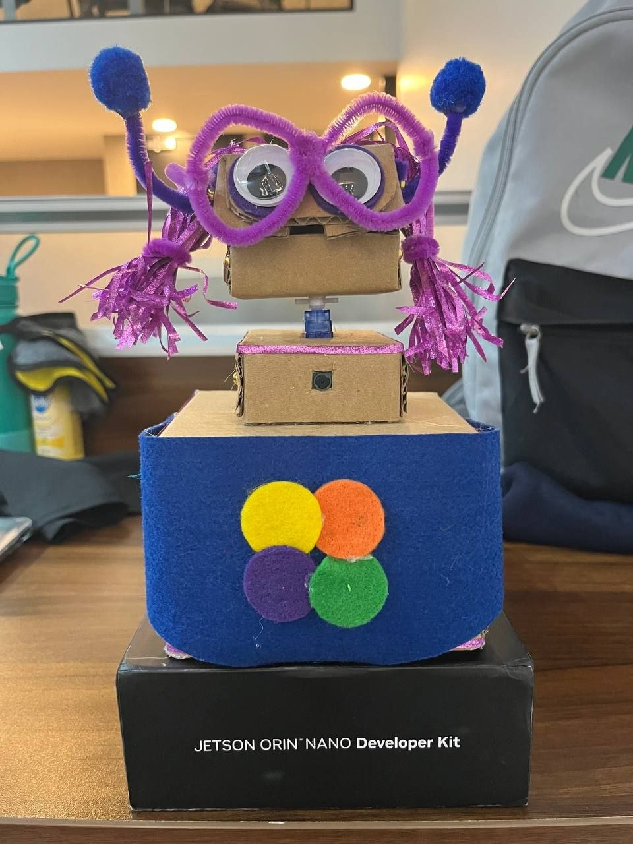

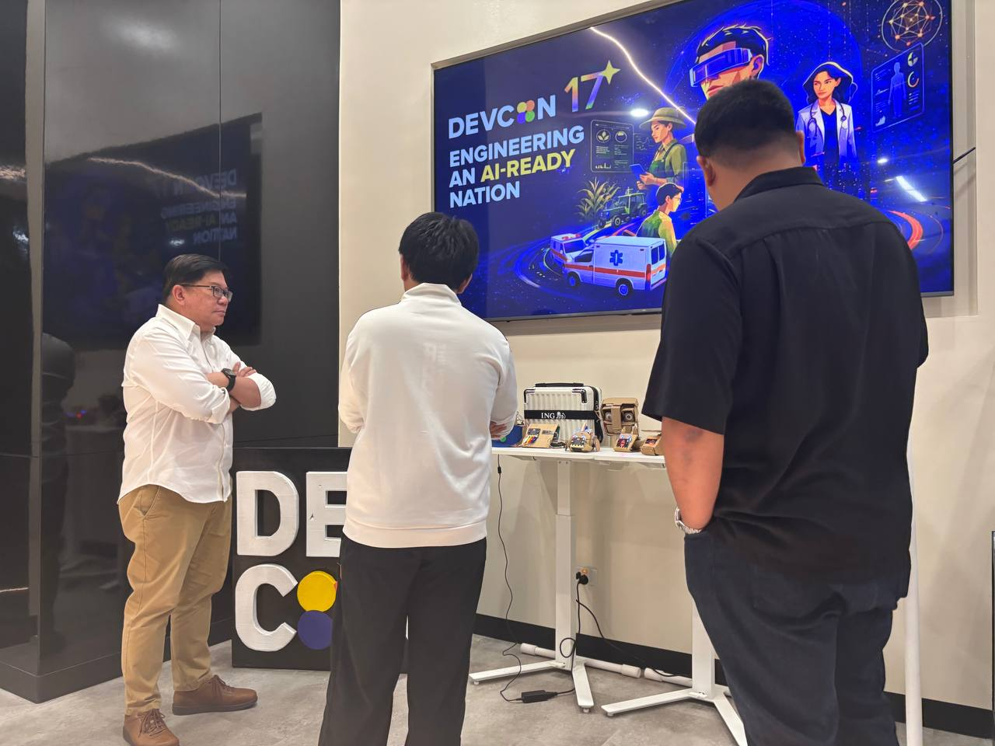

Approval Log
Name | Role / Title | Approval Date | Signature | Status
TBD | Product Owner |  |  | Pending

