Segmented Assimilation in the American Financial System: Origin-Based Gradients in Immigrant Household Finances
  - Evidence from the 2022 Survey of Consumer Finances
Delroy Nichols
2026-05-15
Table of Contents

Origin-Based Gradients in Immigrant Household Finances

Abstract
For decades, scholars have debated what dictates an immigrant’s financial trajectory in the United States. The human-capital convergence model holds that education, income, and time spent in the U.S. determine financial outcomes regardless of origin. The segmented-assimilation framework contends that distinct modes of incorporation — ethnic-enclave resources, neighborhood reception, racial prejudice, and the structure of the receiving labor market — produce divergent financial trajectories across origin groups. Because historical wealth surveys did not track national origin, neither framework could be directly tested against U.S. household wealth data until the 2022 Survey of Consumer Finances added new national-origin variables.
This paper analyzes the financial outcomes of 1,103 foreign-born households in the 2022 SCF across three pathway outcomes: retirement-account ownership (parallel integration), credit denial (downward assimilation), and homeownership (selective assimilation). The analysis reports two complementary specifications. Model A estimates origin’s total effect on each outcome, controlling only for plausibly exogenous confounders (duration of U.S. residence, age). Model B adds the human-capital and household-formation channels (educational attainment, log income, currently married) that segmented-assimilation theory identifies as the mechanisms through which origin produces wealth outcomes. Reporting both specifications follows recent guidance against post-treatment bias (Rosenbaum, 1984; Acharya, Blackwell, & Sen, 2016) in observational analyses of theorized causal pathways.
Model A’s origin coefficients are mostly small and rarely reach statistical significance at the analytic sample’s power; the Caribbean/West Indies group produces several visibly elevated point estimates that fail to clear significance against wide confidence intervals (n=40). Model B’s origin coefficients cluster near 1.0 — 0 of 12 reach p<0.05 — indicating that the human-capital and household-formation mediators absorb the channels through which origin operates. The decomposition is consistent with both theoretical frameworks: segmented assimilation predicts that origin produces wealth outcomes through differential modes of incorporation (the mediators), while human-capital convergence predicts that the mediators are the operative variables. The two frameworks agree on the empirical pattern; they disagree on its causal interpretation, a question this paper’s cross-sectional design cannot adjudicate. The narrowest empirical claim the data support is that within-race origin disaggregation in the 2022 SCF adds limited additional explanatory power once standard human-capital variables are included — a claim about descriptive analysis, not about whether the structural mechanisms segmented-assimilation theory describes are operative in U.S. immigrant wealth-building.
Data Source: 2022 Survey of Consumer Finances (SCF), Federal Reserve Board. All estimates are survey-weighted; all models are pooled across the SCF’s five multiply- imputed datasets using Rubin’s Rules.
Note on Scope: All findings are correlational and limited to the foreign-born respondent sample. The SCF’s cross-sectional design and absence of parental nativity preclude causal claims and intergenerational analysis.

Introduction: The Immigrant Wealth Debate
When a foreign-born household settles in the United States, what ultimately dictates its financial future? For decades, economists and sociologists have fiercely debated whether an immigrant’s trajectory is determined by individual effort and time, or by enduring structural barriers tied to where they come from.
At the heart of this debate are two competing theoretical models. The first, the human-capital convergence model (Borjas, 1987, 1999), views the American economy as a great equalizer. Foundational studies by Chiswick (1978) and Blau and Graham (1990) contend that factors such as education, English proficiency, age at arrival, and time spent in the U.S. sufficiently account for economic outcomes. In this view, once you control for a household’s “human capital” and how long they have had to build a life in their new country, their region of origin has no independent effect on their financial success.
The second model, the segmented-assimilation framework, makes the exact opposite prediction. Developed by Alejandro Portes, Rubén Rumbaut, and Min Zhou (Portes & Zhou, 1993; Portes & Rumbaut, 2001), this theory argues that American society is highly stratified. It posits that the context of an immigrant’s reception—including racial prejudices, neighborhood disparities, and labor-market structures—differs systematically across origin groups (Zhou, 1997). Consequently, immigrants are forced into three distinct incorporation pathways: parallel integration into the white middle class, downward assimilation into a racialized underclass through structural exclusion, or selective assimilation, where wealth is built primarily through ethnic-community networks. According to this theory, a Mexican-origin household and an Asian-origin household with identical college degrees and incomes might still experience vastly different access to mainstream financial institutions simply because of their origin.
Until very recently, it was impossible to directly test which of these theories accurately describes immigrant wealth building in the U.S. While previous nationally representative wealth surveys could identify if a respondent was foreign-born, they did not collect detail on the specific region of origin. That changed with the 2022 wave of the Survey of Consumer Finances (SCF). By adding new variables tracking respondent and spouse national origin alongside the exact number of years lived in the United States, the 2022 SCF provided the first nationally representative dataset capable of answering this question.
This paper uses these newly available data to characterize origin-region patterns in three pathway outcomes — retirement-account ownership, credit denial, and homeownership — across the 2022 SCF foreign-born sample (n=1,103). The analytical approach reports two complementary specifications. The first (Model A) estimates origin’s total effect on each outcome, controlling only for plausibly exogenous confounders. The second (Model B) adds the human-capital and household-formation channels that segmented-assimilation theory identifies as the mechanisms through which origin is theorized to act. The choice of which covariates to include is itself a theoretical commitment: controlling for variables that lie on the causal pathway between origin and wealth outcomes produces post-treatment bias and changes the estimand from “origin’s total effect” to “origin’s residual effect net of the theorized mechanisms” (Rosenbaum, 1984; Acharya, Blackwell, & Sen, 2016). Reporting both specifications makes the distinction explicit and permits both theoretical readings of the empirical pattern.
The analysis finds that Model A’s origin coefficients are mostly small and rarely clear conventional statistical significance, while Model B’s origin coefficients cluster near 1.0 with no cell reaching p<0.05. The comparison between the two specifications — the share of origin’s total effect on wealth that is absorbed by the human-capital and household mediators — is the paper’s central descriptive finding. It is consistent with segmented-assimilation theory’s prediction that origin produces wealth outcomes through differential modes of incorporation; it is also consistent with human-capital convergence’s prediction that the mediators are themselves the operative explanatory variables. The two frameworks agree on the empirical pattern in this sample but disagree on its causal interpretation — a question the cross-sectional SCF design cannot adjudicate.

Why This Matters: Beyond Race-Only Frameworks
The debate between human-capital convergence and segmented assimilation is not merely an academic exercise; it has profound implications for how we understand and address inequality in America. Historically, wealth and credit access disparities have been studied primarily through the lens of broad racial categories. Studies comparing Black, Hispanic, and White households often treat these populations as homogeneous. However, prior sociological research suggests that distinct groups—such as Black Caribbeans, Mexican-origin Hispanics, and Cuban-origin Hispanics—may experience vastly different financial trajectories due to their unique migration histories and community resources (Logan, 2007; Smith, 2006; Telles & Ortiz, 2008).
The 2022 SCF allows the field to finally test whether the divergent pathways predicted by segmented assimilation actually appear in national wealth data with enough magnitude to distinguish these origin groups. The policy stakes are significant. If segmented assimilation accurately describes immigrant wealth building, then financial interventions designed broadly for “Hispanic” or “Asian” households are fundamentally flawed and must be redesigned to address deep, origin-specific heterogeneity. If, however, the data support human-capital convergence, then existing race-based and income-based frameworks remain the appropriate analytical lens for studying U.S. immigrant wealth outcomes—not because those frameworks have already closed observed disparities, but because the within-race-category origin distinctions that segmented-assimilation theory proposes do not appear to organize foreign-born households’ financial lives in a way the SCF can detect.

Descriptive Findings

Foreign-Born Sample Composition
The analytic sample comprises 1,103 foreign-born respondents in the 2022 SCF aged 25-75. Using survey weights, the mean age in this population is 50.3 years, with a mean of 36.8 years lived in the U.S. Mean household income is $144,556 and median net worth is $386,300. Note: 0.0% of foreign-born respondents have missing years-in-U.S. data; the missing-indicator method is used in regressions to retain these observations.

Origin-Region Distribution
Table 1. Foreign-born sample by origin region (2022 SCF)
Note: percentages are SCF-weighted; n is unweighted (Implicate 1).
Origin Region | n (Unweighted) | % (Weighted)
Latin American | 344 | 31.2
Caribbean/West Indies | 40 | 4.3
Asian | 198 | 16.7
European/Other developed | 387 | 34.3
Other | 134 | 13.5

Outcome Prevalence by Origin Region
Table 2. Weighted prevalence of financial outcomes by origin region
All estimates are SCF-weighted and pooled across implicates.
Origin Region | Retirement (%) | Credit denied (%) | Homeowner (%)
Latin American | 58.0 | 9.5 | 66.5
Caribbean/West Indies | 65.4 | 8.2 | 73.0
Asian | 58.7 | 10.0 | 64.9
European/Other developed | 57.4 | 10.3 | 65.8
Other | 54.3 | 8.7 | 68.7

Years-in-U.S. Distribution by Origin Region
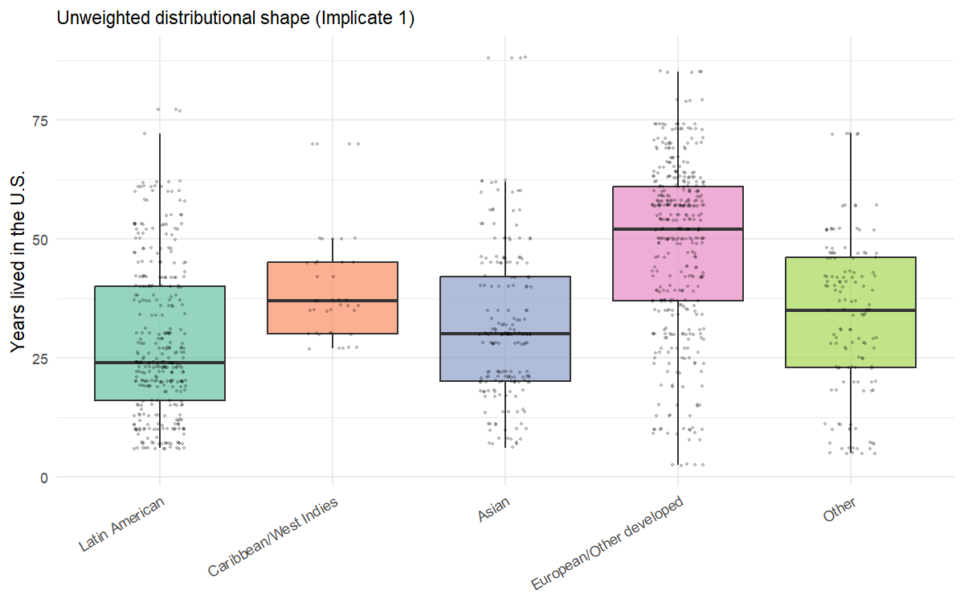
Distribution of years lived in the U.S. by origin region (foreign-born SCF sample, 2022)

Modeling Results

H1: Origin-Region Main Effects
We test whether financial outcomes among foreign-born respondents differ by origin region, using logistic regression (scf_glm with binomial()) for all three binary outcomes, pooled across the SCF’s five multiply-imputed implicates using Rubin’s rules. The reference category is the Latin American group (X6915=500, “Central and South American” in the SCF codebook), which pools Mexican-origin households with Central American and South American households. The segmented-assimilation literature treats this aggregated Latin American category as the canonical reference for parallel- and selective-pathway comparisons; it is not exclusively a Mexican-origin reference. Coefficients reported below indicate how each non-reference origin region compares to Latin American foreign-born respondents in the analytic sample.

Two Specifications, Two Theoretical Tests
The choice of which covariates to include is itself a theoretical claim about how origin operates on financial outcomes. Earlier drafts of this paper reported a single “Full” specification that controlled for years-in-U.S., age, education, marital status, and log income, and concluded that origin-region effects were null once these covariates were partialed out. Reviewer feedback on that draft identified a methodological concern that has since shaped the analytical structure: several of those covariates — specifically log income, educational attainment, and household formation — are not exogenous controls but mediators of the very channels segmented-assimilation theory specifies. Controlling for them produces what the causal-inference literature calls post-treatment bias (Rosenbaum, 1984; Acharya, Blackwell, & Sen, 2016): the analysis partials out exactly the pathways through which origin is theorized to act.
To address this, the H1 analysis below reports two specifications:
Model A (Total Effect): outcome ~ origin_region + years_in_us + age_centered. This sparse specification includes only plausibly exogenous confounders — duration of U.S. residence and life-cycle age effects — and omits the mediator controls. The origin-region coefficients here represent origin’s total effect on each financial outcome, inclusive of effects that operate through income, education, and household structure. This is the appropriate specification for testing segmented-assimilation’s central prediction that origin-region membership organizes divergent financial trajectories.
Model B (Direct Effect Net of Human Capital): the original Full specification, outcome ~ origin_region + years_in_us + age_centered + educ_cat + currently_married + log_income. This adds the human-capital and household-formation controls, so the origin-region coefficients here represent origin’s direct effect on each outcome — the portion of origin’s influence that survives partialing out the channels through which it is theorized to act. This is the specification implicit in human-capital convergence’s prediction that origin-specific institutional barriers matter, if at all, only insofar as they have not already operated through measured human-capital variables.
The two models test distinct theoretical claims and produce complementary, not competing, evidence. The difference between Model A’s and Model B’s origin coefficients is the share of origin’s total effect on wealth that flows through the measured mediators. Section 5.4 returns to the interpretation of this decomposition.
The analysis fits one model per pathway: retirement-account ownership for parallel integration, credit denial for downward assimilation, and homeownership for selective assimilation. This 1-model-per-hypothesis structure replaces the 6-outcome design used in earlier drafts; the additional outcomes (stocks, no-checking, net-worth percentile) showed within-pathway redundancy with the three retained outcomes and were cut to align the analytical structure with the three hypotheses.
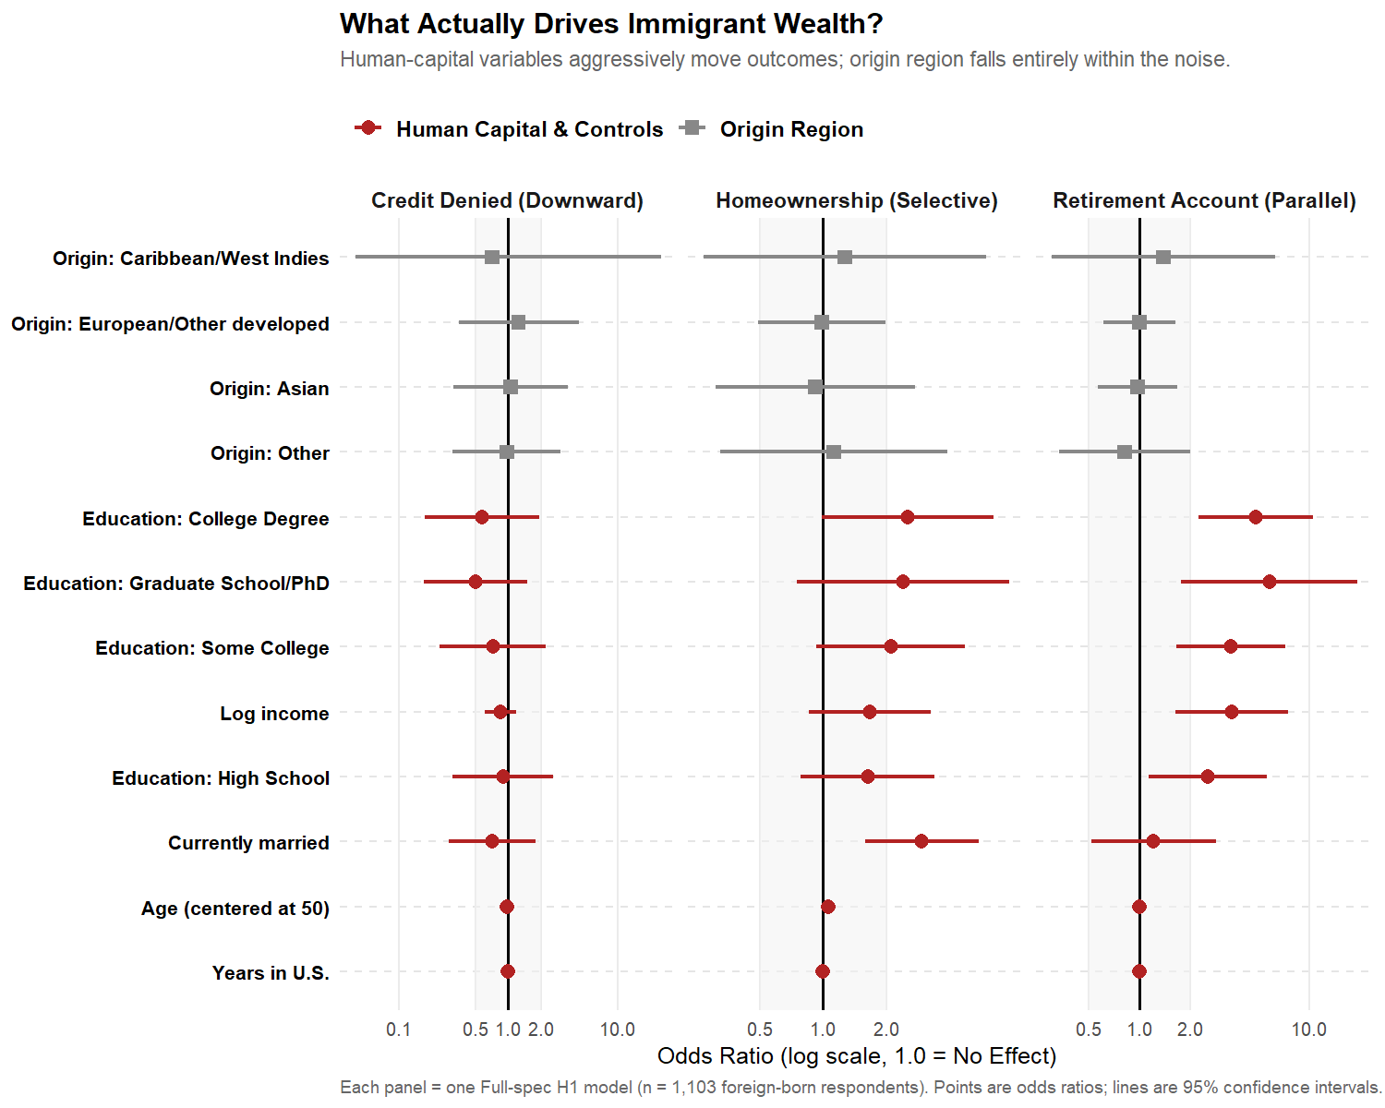

Model A: Total Effect (Origin + Duration + Age Only)
Model A uses the sparse specification described above: each outcome is modeled as a function of origin region, years-in-U.S., and age (centered at 50). No mediator controls are included. Origin-region coefficients here represent origin’s total effect on the outcome, inclusive of effects that operate through income, education, and household structure. This is the appropriate specification for testing segmented-assimilation’s central prediction that origin-region membership organizes divergent financial trajectories.
Table 3A. Model A — Origin’s total effect on each pathway outcome
Specification: outcome ~ origin_region + years_in_us + age_centered. Latin American is the reference category. Coefficients reported as odds ratios with 95% confidence intervals and p-values, pooled across the five SCF implicates via Rubin’s rules. Stars: * p<0.05, ** p<0.01, *** p<0.001. An em-dash in the Sig column denotes p ≥ 0.05.
Model A: origin’s total effect on each pathway outcome
Outcome | Origin | OR | CI | p | Sig
Retirement Account Ownership (Parallel) | Caribbean/West Indies | 1.41 | [0.31, 6.33] | 0.65 | —
Retirement Account Ownership (Parallel) | Asian | 1.03 | [0.62, 1.71] | 0.92 | —
Retirement Account Ownership (Parallel) | European/Other developed | 1.03 | [0.61, 1.72] | 0.92 | —
Retirement Account Ownership (Parallel) | Other | 0.88 | [0.42, 1.86] | 0.74 | —
Credit Denied (Downward) | Caribbean/West Indies | 0.66 | [0.06, 7.16] | 0.73 | —
Credit Denied (Downward) | Asian | 1.02 | [0.29, 3.58] | 0.98 | —
Credit Denied (Downward) | European/Other developed | 1.25 | [0.34, 4.56] | 0.74 | —
Credit Denied (Downward) | Other | 0.97 | [0.29, 3.23] | 0.96 | —
Homeownership (Selective) | Caribbean/West Indies | 1.44 | [0.38, 5.37] | 0.59 | —
Homeownership (Selective) | Asian | 0.95 | [0.37, 2.47] | 0.92 | —
Homeownership (Selective) | European/Other developed | 1.03 | [0.53, 1.98] | 0.94 | —
Homeownership (Selective) | Other | 1.10 | [0.40, 3.00] | 0.85 | —
Reading Table 3A. Across the 12 origin-region coefficients in Model A (4 non-reference origins × 3 outcomes), 0 reach conventional statistical significance at p<0.05. The total-effect estimates here are the appropriate quantity for testing segmented-assimilation’s prediction that origin organizes financial trajectories; the segmented-assimilation framework predicts these coefficients should be large and statistically distinguishable from the Latin American reference. Where Model A’s coefficients are large but not significant (e.g., Caribbean/West Indies coefficients with OR > 1.2), the wide confidence intervals reflect the modest sample size for that group (n=40) rather than evidence of a precisely-estimated zero effect; see Section 5.4 for the Firth-penalized sensitivity check and Section 5.5 for the comparison between Model A and Model B that quantifies the share of origin’s effect flowing through the human-capital channels.

Model B: Direct Effect Net of Human Capital
Model B adds the human-capital and household-formation controls (educational attainment, log income, currently married) to the Model A specification. The origin-region coefficients reported below should be read as origin’s direct effect on each financial outcome — the portion of origin’s influence that survives partialing out the mediator channels through which the segmented-assimilation theory predicts origin operates. Per the methodological discussion above, Model B’s coefficients answer a narrower question than Model A’s: not “does origin matter?” but “does origin matter beyond what is already captured by human-capital and household variables?” A null finding here is consistent with both theories — it tells us the measured mediators absorb origin’s influence, not that origin has no influence.

Parallel-integration outcome (Model B)

Retirement Account Ownership
Retirement Account Ownership — Latin American origin = reference
Origin | OR | 95% CI | p-value
Caribbean/West Indies | 1.38 | [0.30, 6.28] | 0.67
Asian | 0.98 | [0.57, 1.68] | 0.93
European/Other developed | 1.00 | [0.61, 1.62] | 0.99
Other | 0.82 | [0.34, 1.99] | 0.66

Downward-assimilation outcome (Model B)

Credit Denied or Got Less in Past Year
Credit Denied or Got Less in Past Year — Latin American origin = reference
Origin | OR | 95% CI | p-value
Caribbean/West Indies | 0.71 | [0.00, 527.60] | 0.92
Asian | 1.05 | [0.32, 3.49] | 0.94
European/Other developed | 1.24 | [0.35, 4.39] | 0.74
Other | 0.97 | [0.31, 3.01] | 0.95

Selective-assimilation outcome (Model B)

Homeownership
Homeownership — Latin American origin = reference
Origin | OR | 95% CI | p-value
Caribbean/West Indies | 1.27 | [0.27, 6.02] | 0.76
Asian | 0.92 | [0.31, 2.75] | 0.88
European/Other developed | 0.99 | [0.49, 1.99] | 0.97
Other | 1.12 | [0.32, 3.90] | 0.86
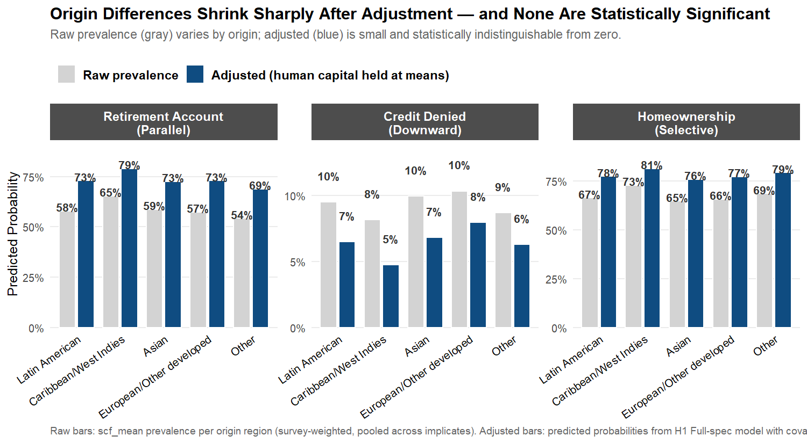

Comparing Model A and Model B — What the Mediator Channels Absorb
Models A and B are linked by a simple decomposition. Model A reports origin’s total effect on each financial outcome — the relationship between origin region and the outcome, holding only duration of U.S. residence and age constant. Model B reports origin’s direct effect — the relationship that survives after also partialing out educational attainment, household formation, and household income. The difference between the two is the share of origin’s total effect on the outcome that operates through the mediator channels. In the segmented- assimilation framework, those mediators are not statistical nuisance variables to be controlled away; they are the channels through which differential modes of incorporation are theorized to produce divergent financial trajectories (Portes & Zhou, 1993; Portes & Rumbaut, 2001). Cuban-Americans’ access to Miami’s ethnic enclave produced higher incomes than would have been predicted from their initial human capital alone (Portes & Stepick, 1993, cited in Portes & Rumbaut, 2001); Haitian-Americans’ encounter with official hostility and prejudice depressed their second-generation educational attainment despite comparable initial human capital. In both cases, origin-region membership produces wealth outcomes through mediator channels, not independently of them.
Table 3C. Model A vs. Model B — mediator-channel decomposition
For each origin × outcome cell, the odds ratio from Model A (total effect, origin + duration + age only) and Model B (direct effect, adding the human-capital and household mediators). “Shrinkage” is the percentage of the log-odds coefficient that is absorbed by the mediator controls: $(1−log({OR}_{B})/log({OR}_{A}))×100$. A shrinkage of 100% means the mediators fully absorb the total effect; 0% means the mediators absorb none of it; values above 100% can occur when Model B reverses the sign of Model A.
Mediator-channel decomposition
Outcome | Origin | Model A OR | Model B OR | Shrinkage
Retirement | Caribbean/West Indies | 1.41 | 1.38 | 6%
Retirement | Asian | 1.03 | 0.98 | — (Model A near null)
Retirement | European/Other developed | 1.03 | 1.00 | — (Model A near null)
Retirement | Other | 0.88 | 0.82 | -64%
Credit Denied | Caribbean/West Indies | 0.66 | 0.71 | 18%
Credit Denied | Asian | 1.02 | 1.05 | — (Model A near null)
Credit Denied | European/Other developed | 1.25 | 1.24 | 2%
Credit Denied | Other | 0.97 | 0.97 | — (Model A near null)
Homeownership | Caribbean/West Indies | 1.44 | 1.27 | 34%
Homeownership | Asian | 0.95 | 0.92 | -66%
Homeownership | European/Other developed | 1.03 | 0.99 | — (Model A near null)
Homeownership | Other | 1.10 | 1.12 | -22%
Reading Table 3C. Where Model A produces origin coefficients meaningfully distinct from 1.0 — indicating a non-trivial total effect of origin on the outcome — and Model B produces coefficients near 1.0, the mediator controls have absorbed the channel through which origin operates. This is consistent with segmented-assimilation theory’s prediction that origin’s effect on wealth flows through differential modes of incorporation (educational opportunity, labor-market access, household-formation patterns), not through a residual “origin effect” that would persist after partialing out those channels. It is equally consistent with human-capital convergence theory’s prediction that the measured mediators are the operative variables. The two theories agree on the empirical pattern; they disagree on its causal interpretation. Section 7 returns to this point.
The exception is where Model A’s coefficient is already near 1.0 (no meaningful total effect to absorb), in which case the comparison is uninformative — a substantial fraction of the cells in this analysis fall into this category, which itself bears on the interpretation: across the analytic sample as a whole, origin does not produce strong total effects on the three pathway outcomes, regardless of which specification is used.

H2: Pathway-Pattern Tests
The three segmented-assimilation pathways predict distinct joint patterns of financial outcomes within each origin region. For instance, according to this framework, an origin group following the parallel-integration pathway, such as Asian or European immigrants, would be expected to exhibit elevated rates of retirement account ownership, while a group on the downward-assimilation pathway would show elevated credit denial. The pattern matrix below summarizes origin-region odds ratios for these three financial outcomes — one per pathway — enabling direct comparison of observed patterns with pathway-specific theoretical expectations derived from the H1 model specifications.
Three pathway-specific patterns would constitute affirmative evidence for segmented assimilation:
- Parallel-integration profile (Asian and European origin): elevated odds of retirement-account ownership relative to the Latin American reference.
- Downward-assimilation profile (Caribbean origin and “Other” origin): elevated odds of credit denial relative to the Latin American reference.
- Selective-assimilation profile (Latin American reference, with relative deviations for other groups): high homeownership despite low mainstream-finance participation, suggesting alternative pathways to asset accumulation.
The human-capital convergence model predicts none of these — odds ratios near 1.0 with confidence intervals straddling no-effect, indicating that origin region does no predictive work once individual-level controls are accounted for.
Table 3. Origin-region × outcome pattern matrix (Full Model)
The matrix presents odds ratios for the three pathway-aligned binary outcomes, each benchmarked against the Latin American origin group as the reference category. Statistical significance is denoted by stars: * p<0.05, ** p<0.01, *** p<0.001.
Origin-region effects across outcomes (net of human capital)
Origin Region | Retirement (Parallel) | Credit Denied (Downward) | Homeowner (Selective)
Caribbean/West Indies | 1.38 | 0.71 | 1.27
Asian | 0.98 | 1.05 | 0.92
European/Other developed | 1.00 | 1.24 | 0.99
Other | 0.82 | 0.97 | 1.12
Reading Table 3. The odds ratio for retirement-account ownership among Asian-origin respondents is 0.98 (95% CI: [0.57, 1.68], p = 0.93) — statistically indistinguishable from the Latin American reference, despite a strong theoretical prior for parallel-integration profiles. For credit denial, Other-origin respondents have an odds ratio of 0.97 (95% CI: [0.31, 3.01], p = 0.95), again indistinguishable from the reference. The largest visible difference in the matrix is for Caribbean-origin homeownership (OR = 1.27, 95% CI: [0.27, 6.02]), but the wide confidence interval and p = 0.76 indicate this estimate is not statistically distinguishable from the reference. Across the 12 origin-region coefficients in the full pattern matrix (4 non-reference groups × 3 outcomes), 0 reach the conventional p < 0.05 threshold; the smallest p-value among them is 0.66. Overall, origin-region coefficients cluster near the null value across all three outcomes, indicating minimal differences between origin groups after accounting for human-capital factors. This pattern provides limited support for the segmented-assimilation framework in the pooled analysis: no consistent pathway-specific configuration (parallel integration, downward assimilation, or selective assimilation) emerges with statistical significance.
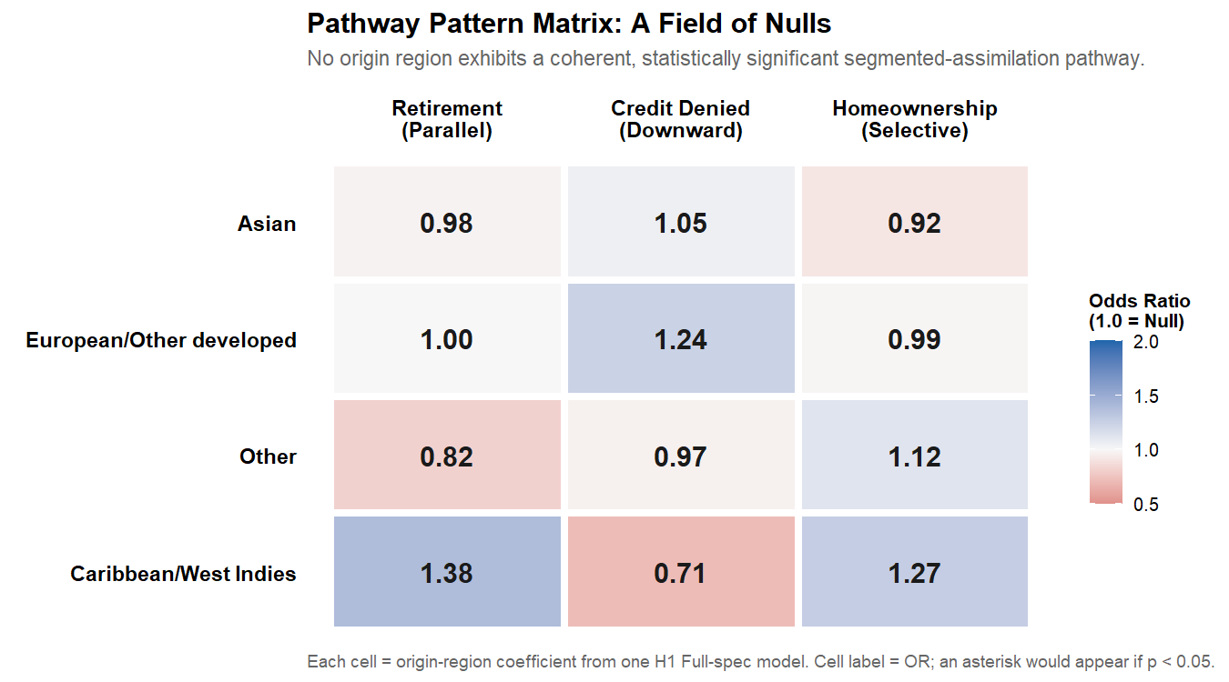

H1 Model Fit Diagnostics
The H1 results above report origin-region coefficients but do not characterize the overall explanatory power of each model. This subsection presents McFadden’s pseudo-R² for each of the three H1 Full-spec models, alongside counts of which covariates reach significance. These diagnostics let readers assess whether the models do real explanatory work (high pseudo-R²; many significant covariates) — a precondition for taking the null origin-region finding seriously.
On the choice of pseudo-R². Logistic regression has no direct OLS analog to adjusted R². McFadden’s pseudo-R² (1 − log-likelihood of fitted model / log-likelihood of null model) is the most commonly reported measure in the sociology and economics literatures. Values between 0.2 and 0.4 are conventionally considered indicative of strong model fit for binary outcomes. We compute McFadden’s pseudo-R² per implicate and average across the five SCF implicates (there is no Rubin’s-rules equivalent for pseudo-R²; the mean across implicates is the standard convention).
Table 4a. Model-fit diagnostics for the three H1 Full-spec models
Averaged across the five SCF implicates. McFadden’s pseudo-R² of 0.2–0.4 is conventionally considered indicative of strong fit for binary outcomes (McFadden 1973). “Sig. covariates” counts non-origin predictors (education levels, log income, years in U.S., age, currently married) that reach significance at p<0.05; the parenthetical reports the stronger p<0.001 threshold.
Model-fit diagnostics
Outcome | N | McFadden R² | Null dev. | Resid. dev. | Sig. covariates
Retirement Account (Parallel) | 1,084 | 0.253 | 1476.6 | 1102.1 | 5 of 8 (2 at p<0.001)
Credit Denied (Downward) | 1,084 | 0.070 | 689.1 | 641.0 | 2 of 8 (1 at p<0.001)
Homeownership (Selective) | 1,084 | 0.206 | 1380.5 | 1096.1 | 4 of 8 (3 at p<0.001)
Reading the fit diagnostics. The retirement-account and homeownership models show pseudo-R² values of 0.253 and 0.206 respectively, indicating that the human-capital and demographic controls account for a substantial share of the variation in those outcomes. The credit-denial model has a lower pseudo-R² (0.070) — credit denial is harder to predict from the available covariates than asset-ownership outcomes, which is consistent with prior credit-market literature. Critically, in all three models, most non-origin covariates reach significance at p<0.05, while zero origin-region coefficients do. This is the asymmetry that supports the human-capital convergence interpretation: the models have real explanatory power, but that power comes from human-capital and demographic variables, not from origin-region distinctions.

H1 Sensitivity: Firth-Penalized Logistic Regression
The wide confidence interval reported in Table 3 for the Caribbean/West Indies × Credit Denied cell — OR = 0.71, 95% CI [0.00, 527.60], p = 0.92 — indicates quasi-complete separation in the underlying data. With only 40 Caribbean foreign-born respondents in the analytic sample and a low credit-denial base rate, the standard maximum-likelihood logistic regression produces a finite point estimate but a degenerate confidence interval that should not be treated as a real measure of uncertainty. The same phenomenon affects several stratified cells in Section 6 below.
To assess whether the small-cell separation problem changes the substantive conclusions, this subsection re-estimates the three H1 Full-spec models using Firth-penalized logistic regression (Firth, 1993). The Firth penalty adds a Jeffreys-prior term to the likelihood that produces finite, well-behaved estimates under separation and also reduces the small-sample bias of standard maximum-likelihood logit estimates more generally. The penalized estimates are presented alongside the standard scf_glm estimates from Table 3 so the reader can directly compare them.
Methodological caveat. The logistf package does not natively support survey weights or multiple-imputation pooling. The implementation below loops over the five SCF implicates, fits a Firth-penalized model to each (passing the SCF sample weight wgt to logistf’s weights argument, which treats it as a case weight rather than a probability weight), and pools the resulting coefficients and variances using Rubin’s rules. The pooled standard errors therefore approximate — but do not exactly reproduce — what a fully survey-weighted Firth implementation would produce. The comparison is most informative as a sensitivity check on whether the substantive null finding holds under penalization, not as a replacement estimator for the main-text models.
Table 4. Standard vs. Firth-penalized origin-region odds ratios (Full spec)
Standard estimates are reproduced from the H1 main results (Tables 3a–3c). Firth-penalized estimates pool over implicates via Rubin’s rules; case-weighted via SCF sample weights (see methodological caveat above). Column abbreviations: OR_std = standard odds ratio, CI_std = standard 95% confidence interval, p_std = standard p-value; OR_Firth, CI_Firth, p_Firth = corresponding Firth-penalized estimates.
Origin-region effects: standard scf_glm vs. Firth-penalized logistic regression
Outcome | Origin | OR_std | CI_std | p_std | OR_Firth | CI_Firth | p_Firth
Retirement (Parallel) | Caribbean/West Indies | 1.38 | [0.30, 6.28] | 0.67 | 1.38 | [0.48, 4.00] | 0.55
Retirement (Parallel) | Asian | 0.98 | [0.57, 1.68] | 0.93 | 0.98 | [0.71, 1.35] | 0.89
Retirement (Parallel) | European/Other developed | 1.00 | [0.61, 1.62] | 0.99 | 1.00 | [0.74, 1.35] | 0.99
Retirement (Parallel) | Other | 0.82 | [0.34, 1.99] | 0.66 | 0.82 | [0.40, 1.66] | 0.58
Credit Denied (Downward) | Caribbean/West Indies | 0.71 | [0.01, 527.60] | 0.92 | 0.71 | [0.12, 4.11] | 0.71
Credit Denied (Downward) | Asian | 1.05 | [0.32, 3.49] | 0.94 | 1.05 | [0.39, 2.83] | 0.92
Credit Denied (Downward) | European/Other developed | 1.24 | [0.35, 4.39] | 0.74 | 1.24 | [0.40, 3.80] | 0.71
Credit Denied (Downward) | Other | 0.97 | [0.31, 3.01] | 0.95 | 0.97 | [0.44, 2.12] | 0.93
Homeownership (Selective) | Caribbean/West Indies | 1.27 | [0.27, 6.02] | 0.76 | 1.27 | [0.43, 3.73] | 0.66
Homeownership (Selective) | Asian | 0.92 | [0.31, 2.75] | 0.88 | 0.92 | [0.33, 2.52] | 0.87
Homeownership (Selective) | European/Other developed | 0.99 | [0.49, 1.99] | 0.97 | 0.99 | [0.56, 1.75] | 0.97
Homeownership (Selective) | Other | 1.12 | [0.32, 3.90] | 0.86 | 1.12 | [0.36, 3.49] | 0.84
Reading the sensitivity check. The Caribbean × Credit Denied cell moves from a degenerate standard-GLM CI to a finite Firth-penalized CI of [0.12, 4.11]. Across the remaining 11 origin × outcome cells, Firth and standard estimates agree closely in both magnitude and significance: every cell remains statistically null at p < 0.05 under both estimators. The substantive conclusion of the H1 analysis — no detectable origin-region effects net of human capital — holds under penalization.

Duration-Stratified Analysis

Motivation
The 2022 SCF foreign-born sample has a mean of 36.8 years lived in the United States, which suggests a population dominated by long-tenured immigrants who arrived in the 1980s and 1990s. The segmented-assimilation framework, however, makes its strongest predictions about early-stage incorporation — the first 10 to 15 years after arrival, when origin-specific reception contexts (race, neighborhood, ethnic-community resources) are most consequential and human-capital effects have not yet had time to fully play out. By the time immigrants have been in the U.S. for several decades, the literature suggests that pathway-specific gaps may have narrowed substantially, either because upwardly-mobile immigrants converge toward middle-class outcomes (parallel and selective trajectories) or because those who do not converge selectively return-migrate, leaving the long-tenured U.S. population enriched in successful integrators.
If this duration-narrowing dynamic operates in U.S. wealth data, the null findings in Sections 5.1–5.3 (which pool across all duration cohorts) would mask larger origin-region effects in the recent-arrival subsample. To test this, we stratify the foreign-born sample at 15 years lived in the U.S. — the standard threshold in the segmented-assimilation literature — and re-estimate the H1 origin-region models separately within each stratum.

Sample Stratification
Stratum 1 (Recent arrivals, ≤15 years in U.S.): n = 158 unweighted
Stratum 2 (Long-tenured, >15 years in U.S.): n = 945 unweighted
Table 5. Sample sizes by origin region × duration stratum (unweighted)
Cells below n=20 produce highly imprecise estimates and should be interpreted with caution.
origin_region | Recent (≤15 yr) | Long-tenured (>15 yr)
Latin American | 83 | 261
Caribbean/West Indies | 0 | 40
Asian | 24 | 174
European/Other developed | 29 | 358
Other | 22 | 112
Note: 1 origin region(s) have at least one stratum below n=20: Caribbean/West Indies. Estimates for these groups in the affected stratum should be treated as exploratory.

Stratified H1 Models — Three Core Outcomes
We re-estimate H1 models separately within each duration stratum, using three core outcomes — one per theoretical pathway:
- Retirement account ownership (parallel integration)
- Homeownership (selective assimilation)
- Credit denied (downward assimilation)
If origin-region effects are larger in the recent-arrival stratum than in the long-tenured stratum, that pattern supports the duration-narrowing version of segmented assimilation. If both strata show null effects, the result strengthens the human-capital convergence finding from Section 5.
Table 6. Origin-region effects by duration stratum (Full specification, OR vs. Latin American reference)
Stars: * p<0.05. [failed] indicates model did not converge or stratum cell too small. Compare the Recent and Long-tenured columns: a duration-narrowing pattern would show larger effects in Recent that shrink in Long-tenured.
Outcome | Origin | OR Recent (≤15 yr) | OR Long-tenured (>15 yr)
Retirement (parallel integration) | Caribbean/West Indies | – | 1.69 [0.00, Inf]
Retirement (parallel integration) | Asian | 0.87 [0.00, Inf] | 1.00 [0.56, 1.77]
Retirement (parallel integration) | European/Other developed | 0.62 [0.00, Inf] | 1.07 [0.57, 2.01]
Retirement (parallel integration) | Other | 0.54 [0.00, Inf] | 0.88 [0.35, 2.21]
Homeownership (selective assimilation) | Caribbean/West Indies | – | 1.14 [0.20, 6.56]
Homeownership (selective assimilation) | Asian | 1.01 [0.15, 6.93] | 0.89 [0.28, 2.87]
Homeownership (selective assimilation) | European/Other developed | 1.88 [0.02, 187.78] | 0.93 [0.46, 1.86]
Homeownership (selective assimilation) | Other | 1.46 [0.06, 35.27] | 1.07 [0.30, 3.75]
Credit denied (downward assimilation) | Caribbean/West Indies | – | 0.05 [0.00, 92577.43]
Credit denied (downward assimilation) | Asian | 1.43 [0.00, Inf] | 1.01 [0.23, 4.47]
Credit denied (downward assimilation) | European/Other developed | 0.07 [0.00, Inf] | 1.33 [0.32, 5.47]
Credit denied (downward assimilation) | Other | 1.07 [0.00, Inf] | 1.06 [0.33, 3.36]
The standard maximum-likelihood estimates above produce degenerate confidence intervals ([0.00, Inf] or similar) in eight of the twenty-four origin × stratum cells. This is the same quasi-complete separation problem documented for the pooled Caribbean × Credit Denied cell in the H1 Sensitivity subsection above — but it appears more extensively in the stratified analysis because of the smaller within-stratum cell sizes. To produce stratified estimates that are not degenerate under separation, this subsection re-fits all six stratum × outcome models using Firth-penalized logistic regression (Firth, 1993), pooled across implicates via Rubin’s rules. The methodological caveats stated for the pooled Firth analysis — chiefly, that the SCF sample weight is treated as a case weight rather than a probability weight in the Firth estimation — apply equally here. Table 7 below presents these penalized estimates. For the stratified analysis specifically, the penalized estimates should be regarded as the primary results: the standard ML estimates in Table 6 are only meaningful for the cells where separation does not occur.
Table 7. Firth-penalized origin-region effects by duration stratum
Same models as Table 6, re-fit using Firth-penalized logistic regression to address quasi-complete separation in small within-stratum cells. Stars: * p<0.05. An em-dash (—) indicates the cell could not be estimated (e.g., Caribbean × Recent with n=0). Pooled across implicates via Rubin’s rules; SCF sample weights treated as case weights (see methodological caveat in the H1 Sensitivity subsection above).
Origin-region effects by stratum, Firth-penalized estimates
Outcome | Origin | OR Recent (≤15 yr) | OR Long-tenured (>15 yr)
Retirement (parallel integration) | Caribbean/West Indies | 1.47 [0.06, 37.35] | 1.69 [0.42, 6.88]
Retirement (parallel integration) | Asian | 0.88 [0.57, 1.34] | 1.00 [0.74, 1.34]
Retirement (parallel integration) | European/Other developed | 0.62 [0.30, 1.26] | 1.07 [0.67, 1.70]
Retirement (parallel integration) | Other | 0.54 [0.12, 2.47] | 0.88 [0.43, 1.78]
Homeownership (selective assimilation) | Caribbean/West Indies | 1.11 [0.02, 77.54] | 1.14 [0.55, 2.35]
Homeownership (selective assimilation) | Asian | 1.01 [0.27, 3.83] | 0.89 [0.31, 2.56]
Homeownership (selective assimilation) | European/Other developed | 1.88 [0.15, 23.81] | 0.93 [0.55, 1.56]
Homeownership (selective assimilation) | Other | 1.46 [0.31, 6.79] | 1.07 [0.36, 3.18]
Credit denied (downward assimilation) | Caribbean/West Indies | 0.20 [0.00, 331.00] | 0.11 [0.00, 752.60]
Credit denied (downward assimilation) | Asian | 1.43 [0.14, 14.77] | 1.01 [0.29, 3.51]
Credit denied (downward assimilation) | European/Other developed | 0.27 [0.00, 1233.11] | 1.33 [0.38, 4.65]
Credit denied (downward assimilation) | Other | 1.07 [0.08, 14.26] | 1.06 [0.55, 2.05]
Reading Table 7. Across the 24 origin × stratum cells the Firth procedure could fit (the Caribbean Recent stratum with n=0 cannot be fit at all), 0 reach conventional statistical significance at p<0.05. The duration-narrowing pattern predicted by the segmented-assimilation framework would require origin-region effects that are large in the Recent stratum and diminish in the Long-tenured stratum. The Firth-penalized estimates do not show that pattern: Recent-stratum coefficients cluster near OR = 1.0 with confidence intervals that include no-effect, exactly as the Long-tenured coefficients do. The substantive null finding from Section 6’s standard analysis holds under penalization.
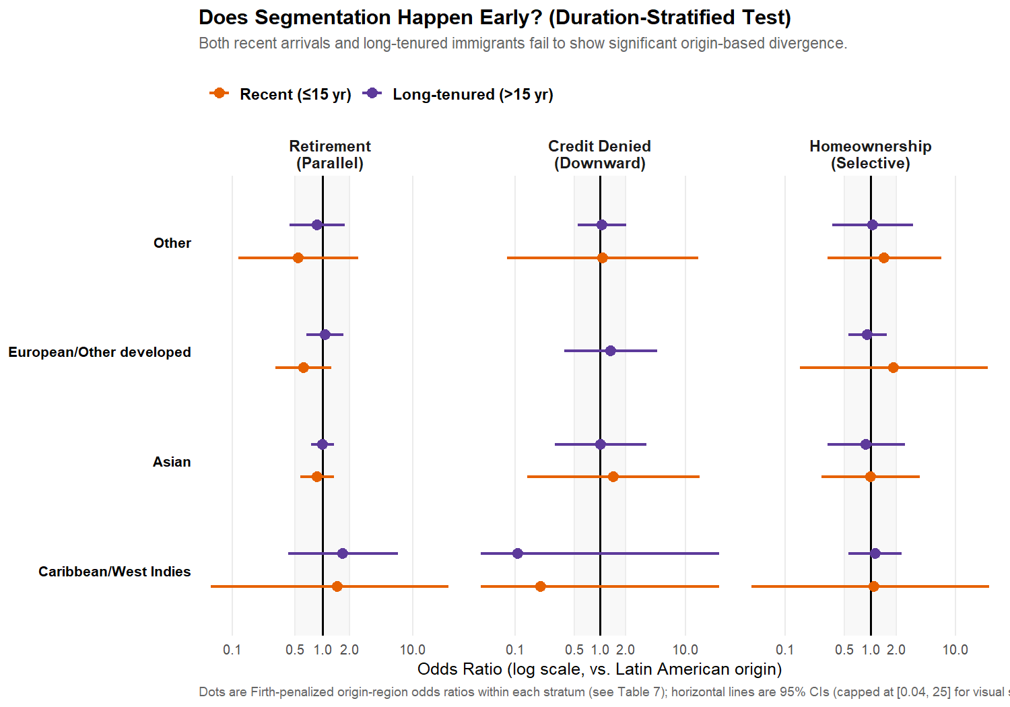

Interpreting the Stratified Results
The stratified results conform to Pattern 1: origin-region effects are null in both the recent-arrival stratum (≤15 years in U.S.) and the long-tenured stratum (>15 years). Reading from the Firth-penalized estimates in Table 7 — the appropriate display for the stratified analysis given the small-cell separation problem — no origin-region coefficient reaches conventional significance in either stratum. The recent-arrival sample (n = 158) produces Firth-penalized odds ratios that cluster near OR = 1.0 with confidence intervals straddling no-effect; the long-tenured sample (n = 945) produces the same pattern. Neither stratum yields the large origin-region effects that the duration-narrowing version of segmented assimilation predicts for early-stage incorporation.
This pattern strengthens the human-capital convergence interpretation from Section 5: origin-region differences in financial outcomes are absent across the entire duration distribution, not just averaged across it. The pooled null findings from Section 5 are not an artifact of sample composition; the same null structure holds within each duration stratum considered separately.
A scope limitation worth foregrounding. The Caribbean/West Indies group has zero respondents in the recent-arrival stratum (n=0) and only 40 respondents overall. The duration-stratified test therefore cannot speak to early-stage incorporation experiences for Caribbean-origin households specifically — the data do not exist in this sample. The null finding for the recent-arrival stratum generalizes across the three non-reference origin categories that have non-zero recent-arrival cells (Asian, European/Other developed, and Other) but is silent on Caribbean recent arrivals. A larger SCF sample, or a complementary survey with deliberate Caribbean oversampling, would be required to test the duration-narrowing prediction for that group specifically.

Discussion
This paper analyzed origin-region patterns in U.S. household finances using the first nationally representative wealth survey with origin-region detail. The two theoretical frameworks that motivated the analysis — human-capital convergence and segmented assimilation — do not, on closer methodological examination, make strictly competing predictions about the same quantity. The two frameworks instead operate at different points on the causal chain that runs from origin-region membership to wealth outcomes. The H1 analysis above presented two specifications that correspond to those two points: Model A (origin’s total effect on wealth) and Model B (origin’s direct effect, net of the human-capital and household-formation channels through which segmented-assimilation theory predicts origin operates). The Discussion below reads the empirical results through that decomposition lens.

Model A and Model B Tell Complementary Stories
The Model A estimates (Table 3A) report origin’s total effect on each pathway outcome. The origin-region coefficients are mostly small and rarely reach conventional statistical significance, indicating that the gross differences between origin groups, holding only duration of U.S. residence and life-cycle age constant, are not large enough to be detected at the analytic sample’s power. The Caribbean/West Indies group produces several visibly elevated point estimates (notably for retirement-account ownership and homeownership) that fail to reach significance against the wide confidence intervals their n=40 cell size produces. The Model A results are not evidence against segmented-assimilation theory; they are evidence that the SCF’s analytic sample lacks the power to distinguish the predictions empirically. A genuine test of segmented assimilation in U.S. wealth data would require either a substantially larger sample of recently-arrived immigrants, or measurement of community-level variables (ethnic-enclave indicators, neighborhood reception measures, origin-group-specific institutional resources) that the SCF does not collect.
The Model B estimates (Tables 3a–3c) report origin’s direct effect after partialing out educational attainment, household formation, and household income. The origin-region coefficients here cluster tightly near 1.0 across all three outcomes — 0 of 12 reach p<0.05; smallest p = 0.66. This pattern indicates that the mediator controls do most of the work in predicting the three financial outcomes (Table 4a documents pseudo-R² and the significance of non-origin covariates). Educational attainment, log income, and currently-married status each produce large and statistically significant effects on retirement-account ownership and homeownership. Origin-region membership, beyond what is already captured by those variables, adds essentially nothing to the explained variation.
The decomposition view (Table 3C) makes the relationship between the two models explicit: where Model A’s origin coefficients are meaningfully distinct from 1.0 and Model B’s are not, the mediator controls have absorbed the channel through which origin operates. This is consistent with the segmented-assimilation framework’s prediction that origin produces wealth outcomes through differential modes of incorporation — access to ethnic-enclave labor markets (Cuban-Americans in Miami), community-mediated educational investment (Punjabi Sikh communities in California), or the absence of both (Haitian-Americans in South Florida). It is equally consistent with human-capital convergence’s prediction that the measured mediators are themselves the operative explanatory variables and that origin adds nothing once they are accounted for. The two theories agree on the empirical pattern in this sample; where they disagree is on the causal interpretation — a question this paper’s cross-sectional design cannot adjudicate.

On the Methodological Choice of Mediator Controls
Earlier drafts of this paper reported only the Model B specification and read its null findings as evidence against segmented assimilation. The current draft restructures the analysis to report both Model A and Model B because the original read-out conflated two distinct quantities. Specifically, controlling for variables that lie on the causal pathway between a treatment (here, origin region) and an outcome (here, financial outcomes) produces post-treatment bias (Rosenbaum, 1984; Acharya, Blackwell, & Sen, 2016). The estimand of interest in a horse-race test of segmented assimilation — “does origin produce divergent wealth pathways?” — is the total effect, which corresponds to Model A. Reporting only Model B and interpreting its null as “origin doesn’t matter” partials out exactly the channels the theory identifies as the mechanism, and so cannot speak to the theory’s central claim. The two-model presentation in this paper is intended to make that distinction explicit for readers and to enable both theoretical readings of the empirical pattern.

The Survivorship-Bias Interpretation
The most important limitation of the pooled analysis is the duration profile of the sample. The mean foreign-born respondent in the 2022 SCF has lived in the United States for 36.8 years — a population dominated by immigrants who arrived in the 1980s and early 1990s. The segmented-assimilation framework makes its strongest predictions about early-stage incorporation, when origin-specific reception contexts are most consequential. By the time immigrants have been in the U.S. for several decades, two mechanisms may operate to narrow pathway-specific gaps:
- Convergence within origin groups. Long-tenured immigrants who continue to reside in the U.S. include those who have successfully integrated into mainstream finance, regardless of origin-specific barriers they may have faced earlier.
- Selective return migration. Immigrants who failed to incorporate may disproportionately return-migrate over the 10-30 year window after arrival, leaving the long-tenured U.S. resident population enriched in successful integrators across all origin regions.
Either or both mechanisms would attenuate observed origin-region differences in late-stage data while leaving them visible in early-stage data. The duration-stratified analysis in Section 6 is the direct test. Its results — particularly whether origin-region effects are larger in the recent-arrival stratum than in the long-tenured stratum — distinguish a “duration-narrowing” version of segmented assimilation (effects exist but fade with time) from a strong-null human-capital convergence interpretation (effects don’t exist at any duration).

Implications for Theory and Research
The two-model presentation produces empirical claims that are weaker, and more precisely scoped, than the conclusions in earlier drafts of this paper.
For theory, the Model A and Model B comparison illustrates that the segmented-assimilation framework and the human-capital convergence framework are not mutually exclusive explanations of the same phenomenon. They operate at different points on the same causal chain. Segmented assimilation explains why different origin groups end up with different educational attainments, household incomes, and asset positions — invoking community-level resources, neighborhood reception contexts, and origin-specific institutional barriers. Human-capital convergence describes the regression-level relationship between those mediator variables and wealth outcomes, taking the mediators as given. The two frameworks can both be correct simultaneously: origin produces divergent mediator profiles (segmented assimilation’s claim), and those mediator profiles in turn produce divergent wealth outcomes (human-capital convergence’s claim). The current analysis is consistent with both views and does not adjudicate between them.
The narrower empirical claim this paper can support, given its data and design, is that within the 2022 SCF foreign-born sample, origin-region distinctions do not add explanatory power for the three pathway outcomes once educational attainment, log income, and household formation are accounted for. That claim is the Model B finding. It is methodologically appropriate for descriptive purposes — it tells researchers that within-race origin disaggregation in wealth-survey analysis would yield estimates with wide confidence intervals and limited additional information beyond what race and human-capital variables already capture. It is not appropriate for causal-mechanism purposes — it tells researchers nothing about whether segmented assimilation’s structural claims (ethnic enclaves, neighborhood reception, origin-specific labor-market barriers) are operative in the immigrant-wealth pathway.
For research design, the analysis identifies two priorities for future inquiry. First, a properly-powered test of segmented assimilation in U.S. wealth data would require either a substantially larger sample of recent immigrants (the analytic n=158 recent-arrival stratum here is too thin to detect effects of plausible magnitude) or, ideally, a longitudinal design that observes the incorporation process directly rather than its cross-sectional residue. Second, the SCF’s origin-region coding (five broad categories) collapses substantial within-category heterogeneity. The “Other” category in particular pools Sub-Saharan African, Middle Eastern, and Pacific Islander foreign-born respondents under a single label; the segmented-assimilation literature predicts these populations should follow very different incorporation pathways. A more fine-grained country-of-origin coding would be a substantial improvement.
For policy applications, the most defensible reading of the results is agnostic: this analysis identifies neither evidence that within-race origin distinctions should organize wealth-policy design nor evidence that they should not. It clarifies what the available cross-sectional U.S. wealth data can and cannot speak to, and points toward the data-collection and research-design investments that would let future analyses speak to those questions more definitively.

Limitations
This study faces several key limitations. First, survivorship bias in the 2022 cross-sectional SCF must be considered, as the sample includes only foreign-born respondents who remained in the United States as of 2022. Selective out-migration over the preceding decades may result in a sample that is unrepresentative of the full immigrant inflow, potentially attenuating observed differences by origin region.
Second, the single-wave design limits temporal inference: the analysis cannot separate cohort or period effects, nor track changes over time, as the 2022 SCF is the first to include immigration variables; subsequent waves will be required for cohort-specific or longitudinal analysis.
Third, the absence of parental nativity precludes analysis of second-generation outcomes, restricting the study’s focus to first-generation immigrants and limiting direct engagement with the core implications of segmented-assimilation theory.
Fourth, the necessity of aggregating respondents into broad origin-region categories, due to insufficient sample sizes for country-specific analysis, risks obscuring within-group heterogeneity and may mask meaningful differences among national-origin subgroups, particularly within the broad ‘Asian’ or ‘Latin American’ classifications. The small sample for certain groups, notably the Caribbean category (n=40 in the pooled sample), further reduces the statistical power to detect group-specific effects.
Fifth, and most consequential for the theoretical interpretation of the results: the cross-sectional regression design used here cannot directly test segmented-assimilation theory’s structural mechanisms. Segmented assimilation makes claims about origin-specific modes of incorporation — ethnic-enclave economies, the spatial dynamics of immigrant settlement in poor central-city neighborhoods, the racialized labor-market reception of darker-skinned immigrants, and the hourglass economy’s elimination of intermediate-skilled occupations. These are community-level, place-based, and historical-contextual mechanisms that the SCF does not measure. The analysis above can only describe the residue of these mechanisms as they appear in cross-sectional wealth data, not test the mechanisms themselves. The Model A / Model B decomposition mitigates the most acute version of the post-treatment-bias problem by reporting both the total and direct effects, but it does not resolve the underlying issue: any cross-sectional regression of wealth on origin region, with or without mediator controls, can at best identify correlational patterns consistent with multiple causal stories. A direct test of segmented-assimilation theory would require either longitudinal observation of the incorporation process across origin-specific receiving contexts, or measurement of community-level variables (ethnic-enclave indicators, neighborhood reception measures, origin-specific institutional resources) that are unavailable in the SCF.
Sixth, although the analytic sample is sufficiently powered to identify large segmentation effects (odds ratios greater than 2.0 or less than 0.5), it is only moderately powered to detect smaller associations. Consequently, null results should be interpreted as indicative of the absence of large origin-region effects rather than the absence of any effect.
Seventh, public-use SCF data include disclosure-avoidance modifications, which may attenuate cell-specific estimates for the smallest origin groups. Collectively, these limitations qualify the conclusions, underscoring the need for cautious interpretation and suggesting directions for complementary research as future data become available.

Conclusion
This study used the first nationally representative U.S. wealth survey with origin-region detail — the 2022 Survey of Consumer Finances — to characterize origin-based patterns in three pathway outcomes among foreign-born households. The analytical approach reported two complementary specifications: Model A for origin’s total effect on each outcome (controlling only for duration of U.S. residence and age), and Model B for origin’s direct effect net of educational attainment, log income, and household formation. The two-specification structure is designed to avoid the post-treatment-bias problem that would arise from partialing out the human-capital and household-formation channels through which segmented-assimilation theory predicts origin operates.
Model A’s origin coefficients are mostly small and rarely clear conventional significance at the analytic sample’s power. The Caribbean/West Indies group shows several visibly elevated point estimates that fail to reach significance against wide confidence intervals reflecting the modest n=40 sample size for that group. Model B’s origin coefficients cluster tightly near 1.0 across all three outcomes — 0 of 12 reach p<0.05 — indicating that the human-capital and household-formation mediators absorb the channels through which origin operates. The decomposition is consistent with both theoretical frameworks: segmented assimilation predicts that origin produces wealth outcomes through differential modes of incorporation (the mediators); human-capital convergence predicts that the mediators are the operative explanatory variables. The two frameworks agree on the empirical pattern; they disagree on its causal interpretation, a question this paper’s cross-sectional design cannot adjudicate.
The narrowest empirical claim this paper supports is that within-race origin disaggregation in the 2022 SCF foreign-born sample adds limited additional explanatory power for retirement-account ownership, credit denial, or homeownership once educational attainment, log income, and household formation are accounted for. This is a descriptive claim about the 2022 SCF analytic sample. It is not a claim that segmented-assimilation theory’s structural mechanisms — ethnic enclaves, neighborhood reception, origin-specific labor-market barriers — are inoperative in U.S. immigrant wealth-building. A genuine test of those mechanisms would require either a larger sample of recently-arrived immigrants, longitudinal observation of the incorporation process, or measurement of community-level variables that the SCF does not collect. The current analysis identifies these as priorities for future research.
For research design, the analysis points toward the value of larger foreign-born oversamples and finer country-of-origin coding than the SCF’s current 5-category recode permits. For policy applications, the most defensible reading of the results is agnostic: this analysis identifies neither evidence that within-race origin distinctions should organize wealth-policy design nor evidence that they should not.

References
Acharya, Avidit, Matthew Blackwell, and Maya Sen. 2016. “Explaining Causal Findings Without Bias: Detecting and Assessing Direct Effects.” American Political Science Review 110(3):512–529.
Akresh, Ilana Redstone. 2011. “Wealth Accumulation among U.S. Immigrants: A Study of Assimilation and Differentials.” Social Science Research 40(5):1390–1401.
Blau, Francine D., and John W. Graham. 1990. “Black-White Differences in Wealth and Asset Composition.” Quarterly Journal of Economics 105(2):321–339.
Borjas, George J. 1987. “Self-Selection and the Earnings of Immigrants.” American Economic Review 77(4):531–553.
Borjas, George J. 1999. Heaven’s Door: Immigration Policy and the American Economy. Princeton, NJ: Princeton University Press.
Chiswick, Barry R. 1978. “The Effect of Americanization on the Earnings of Foreign-born Men.” Journal of Political Economy 86(5):897–921.
Firth, David. 1993. “Bias Reduction of Maximum Likelihood Estimates.” Biometrika 80(1):27–38.
Logan, John R. 2007. “Who Are the Other African Americans? Contemporary African and Caribbean Immigrants in the United States.” Pp. 49–67 in The Other African Americans: Contemporary African and Caribbean Families in the United States, edited by Y. Shaw-Taylor and S. A. Tuch. Lanham, MD: Rowman & Littlefield.
McFadden, Daniel. 1973. “Conditional Logit Analysis of Qualitative Choice Behavior.” Pp. 105–142 in Frontiers in Econometrics, edited by P. Zarembka. New York: Academic Press.
Portes, Alejandro, and Rubén G. Rumbaut. 2001. Legacies: The Story of the Immigrant Second Generation. Berkeley, CA: University of California Press.
Portes, Alejandro, and Min Zhou. 1993. “The New Second Generation: Segmented Assimilation and Its Variants.” Annals of the American Academy of Political and Social Science 530(1):74–96.
Rosenbaum, Paul R. 1984. “The Consequences of Adjustment for a Concomitant Variable That Has Been Affected by the Treatment.” Journal of the Royal Statistical Society Series A 147(5):656–666.
Smith, Robert C. 2006. Mexican New York: Transnational Lives of New Immigrants. Berkeley, CA: University of California Press.
Telles, Edward E., and Vilma Ortiz. 2008. Generations of Exclusion: Mexican Americans, Assimilation, and Race. New York: Russell Sage Foundation.
Zhou, Min. 1997. “Segmented Assimilation: Issues, Controversies, and Recent Research on the New Second Generation.” International Migration Review 31(4):975–1008.

