Childlessness, Financial Behavior, and the Immigration Question
  - A Companion Analysis Using the 2022 Survey of Consumer Finances
Delroy Nichols
2026-04-03
Table of Contents

Introduction
This companion analysis extends the credit card balance study by modeling childlessness as an outcome and connecting it to the financial behavior patterns identified in the primary analysis. While the main paper asks what predicts credit card indebtedness, this paper asks a related but distinct question: what financial and demographic characteristics predict remaining childless past age 30, and what does the pattern of these associations suggest about the mechanisms — including immigration-driven compositional effects — that drive unplanned childlessness in the United States?
The motivation for this inquiry comes from a growing body of demographic research showing that U.S. fertility decline is not uniform across populations. Immigrant women, particularly first-generation arrivals, maintain higher fertility than their native-born counterparts. However, second-generation women — children of immigrants who were born or raised in the United States — exhibit fertility rates that converge sharply toward native-born norms. This generational convergence suggests that the observed racial and ethnic variation in childlessness reflects, in part, the nativity composition of each group rather than intrinsic cultural or economic differences.
The SCF does not contain nativity or immigration variables, a limitation we address transparently. Nevertheless, the SCF’s unmatched depth of financial data allows us to quantify the financial correlates of childlessness with precision unavailable in surveys that do include nativity (such as the CPS or ACS). By modeling childlessness as a function of financial position and then examining the residual racial gradient, we can estimate how much of the race-childlessness association remains unexplained by economic factors — providing an upper bound for the immigration channel that cannot be directly tested here.
Data Source: 2022 Survey of Consumer Finances (SCF), Federal Reserve Board.
Note on Scope: All findings are correlational. The SCF’s cross-sectional design does not support causal inference, and the absence of nativity data means the immigration hypothesis is engaged theoretically rather than tested directly.

Literature Review: Immigration, Fertility, and Childlessness
Fertility in the United States has been below replacement level for over a decade. The total fertility rate stood at approximately 1.64 births per woman in 2021 and has not recovered to replacement (2.1) since. Within this aggregate decline, however, stark compositional differences persist.
The nativity gradient. Immigrant women in the U.S. maintain higher fertility than native-born women, though the gap has narrowed substantially. Research using CPS and ACS data shows that foreign-born fertility declined faster than native-born fertility between 2008 and 2023, with Hispanic immigrant fertility showing the sharpest decline. Despite this convergence, immigrant women still have modestly higher birth rates than their native-born peers within every racial group.
Generational convergence. The critical finding for the childlessness question is that second-generation women — U.S.-born children of immigrants — exhibit fertility patterns that closely resemble those of the broader native-born population. Research consistently shows that fertility rates of U.S. immigrants decline sharply by the second generation as a result of rising educational attainment and income. This pattern holds across racial and ethnic groups, though it is most pronounced among Hispanic women.
The disruption and selection hypotheses. Two competing mechanisms explain why first-generation immigrants sometimes show elevated fertility shortly after arrival. The disruption hypothesis argues that migration itself temporarily suppresses fertility, followed by a catch-up period. The selection hypothesis argues that migrants self-select on fertility preferences — women who intend to have children may time their migration around family formation. Both mechanisms imply that the observed fertility of any racial group in the U.S. is a mixture of distinct nativity-specific patterns, not a single cultural norm.
Childlessness by race and ethnicity. Census data shows that among women ages 40–44, White women have the highest childlessness rate (approximately 19%), followed by Black women (15%), Asian women (14%), and Hispanic women (10–12%). The low Hispanic childlessness rate is driven substantially by immigrant composition: first-generation Hispanic women have among the highest fertility rates of any U.S. subpopulation, and their inclusion in the aggregate brings the group-level childlessness rate down. Similarly, the relatively low childlessness among Asian women may reflect the fertility contribution of foreign-born Asian women, despite the high childlessness and delayed childbearing typical of U.S.-born Asian women with advanced degrees.
Implications for the SCF analysis. The SCF’s racecl4 variable (White, Black, Hispanic, Other) captures these compositional effects without decomposing them. When we observe racial differences in childlessness in the SCF, we are observing the mixture of nativity-specific patterns. This is the fundamental limitation — and the fundamental motivation for the theoretical decomposition we attempt in Section 4.

Outcome Variable: Childlessness After Age 30
We define the outcome as childless_over30: a binary indicator equal to 1 if the reference person is over age 30 and reports zero children in the household. This captures the population most at risk of unplanned childlessness — past the median age at first birth in the United States (approximately 27 for women) but not yet at the biological boundary. We restrict the modeling sample to respondents age 31 and older.
Among the 4,216 households headed by someone over age 30 (Implicate 1), 2,505 (59.4%) report no children in the household.

Childlessness by Key Demographics
## ===== Childlessness Rate (age > 30) by Race =====
## Multiply-Imputed, Replicate-Weighted Mean Estimate
##
## group variable estimate se min max
## White childless_over30 0.6469061 0.007963603 0.6463427 0.6481372
## Black childless_over30 0.5695780 0.022478630 0.5651512 0.5738856
## Hispanic childless_over30 0.3562756 0.018399863 0.3521100 0.3580377
## Other childless_over30 0.5269100 0.020639300 0.5235629 0.5311704
##
## ===== By Education =====
## Multiply-Imputed, Replicate-Weighted Mean Estimate
##
## group variable estimate se min max
## Less than HS childless_over30 0.6009237 0.02291915 0.5997472 0.6037588
## High School childless_over30 0.6106619 0.01326641 0.6096413 0.6116509
## Some College childless_over30 0.6081967 0.01300398 0.6060806 0.6097332
## College Degree childless_over30 0.5818445 0.01117501 0.5798920 0.5852333
##
## ===== By Marital Status =====
## Multiply-Imputed, Replicate-Weighted Mean Estimate
##
## group variable estimate se min max
## 0 childless_over30 0.7392288 0.009772847 0.7387250 0.7398859
## 1 childless_over30 0.4971368 0.009073542 0.4960472 0.4983058
##
## ===== By Gender =====
## Multiply-Imputed, Replicate-Weighted Mean Estimate
##
## group variable estimate se min max
## 0 childless_over30 0.5673620 0.007926665 0.5664417 0.5686600
## 1 childless_over30 0.6757322 0.014484630 0.6748062 0.6764211
##
## ===== By Age Group =====
## Multiply-Imputed, Replicate-Weighted Mean Estimate
##
## group variable estimate se min max
## 25-34 childless_over30 0.4649253 0.028590568 0.4625888 0.4671293
## 35-44 childless_over30 0.3036055 0.014608677 0.3023260 0.3046674
## 45-54 childless_over30 0.4101453 0.016849915 0.4070632 0.4122655
## 55-64 childless_over30 0.6589439 0.014764487 0.6561705 0.6618998
## 65+ childless_over30 0.8782921 0.008665926 0.8776372 0.8796653
##
## ===== By Working Status =====
## Multiply-Imputed, Replicate-Weighted Mean Estimate
##
## group variable estimate se min max
## 0 childless_over30 0.8414841 0.010087010 0.8408398 0.8429338
## 1 childless_over30 0.4790629 0.009267522 0.4780312 0.4805821
##
## ===== By Has Credit Card Debt =====
## Multiply-Imputed, Replicate-Weighted Mean Estimate
##
## group variable estimate se min max
## 0 childless_over30 0.6735909 0.008100749 0.6724872 0.6751497
## 1 childless_over30 0.5052853 0.010542403 0.5037511 0.5073120

Visualization: Childlessness by Race and Education
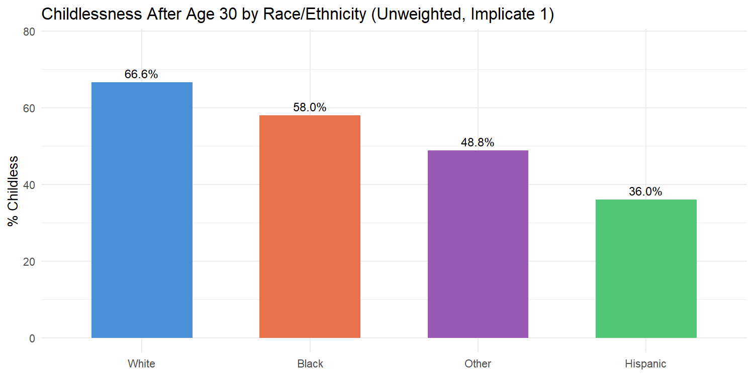

Modeling Childlessness: Financial and Demographic Predictors
We fit a logistic regression predicting childless_over30 among respondents age 31 and older. The predictor set includes the Lasso-selected financial variables from the main credit card analysis (which represent the most informative financial predictors in the SCF), plus the full set of demographic and behavioral controls. Crucially, we include race_cat to examine whether racial/ethnic differences in childlessness persist after controlling for financial position.
The inclusion of has_ccdebt and asinh_ccbal as predictors provides the direct link to the main analysis: they test whether credit card indebtedness — the focal variable of the companion paper — independently predicts childlessness.
Table 1. Logistic Regression: P(Childless After Age 30)
 | Term | Log-Odds | SE | Odds Ratio | OR Lower | OR Upper | p-value
(Intercept) | (Intercept) | 1.6981 | 0.8366 | 5.4638 | 1.0601 | 28.1600 | 4.24e-02 | *
asinh_income | asinh_income | 0.0098 | 0.0454 | 1.0098 | 0.9238 | 1.1038 | 8.29e-01
asinh_wageinc | asinh_wageinc | -0.0431 | 0.0122 | 0.9578 | 0.9352 | 0.9809 | 3.97e-04 | ***
asinh_networth | asinh_networth | -0.0027 | 0.0095 | 0.9973 | 0.9788 | 1.0161 | 7.75e-01
asinh_debt_excl_cc | asinh_debt_excl_cc | -0.0200 | 0.0137 | 0.9802 | 0.9542 | 1.0068 | 1.43e-01
asinh_install | asinh_install | -0.0192 | 0.0107 | 0.9810 | 0.9606 | 1.0018 | 7.25e-02 | .
asinh_edn_inst | asinh_edn_inst | -0.0131 | 0.0120 | 0.9870 | 0.9641 | 1.0104 | 2.74e-01
asinh_liq | asinh_liq | -0.0068 | 0.0199 | 0.9933 | 0.9552 | 1.0328 | 7.34e-01
asinh_retqliq | asinh_retqliq | 0.0532 | 0.0089 | 1.0546 | 1.0364 | 1.0731 | 2.21e-09 | ***
asinh_stocks | asinh_stocks | -0.0121 | 0.0091 | 0.9880 | 0.9704 | 1.0058 | 1.86e-01
asinh_nmmf | asinh_nmmf | 0.0040 | 0.0092 | 1.0040 | 0.9861 | 1.0222 | 6.63e-01
asinh_homeeq | asinh_homeeq | -0.0506 | 0.0329 | 0.9506 | 0.8912 | 1.0140 | 1.24e-01
asinh_vehic | asinh_vehic | -0.0317 | 0.0119 | 0.9688 | 0.9465 | 0.9916 | 7.65e-03 | **
asinh_dti | asinh_dti | 0.0094 | 0.0863 | 1.0095 | 0.8523 | 1.1956 | 9.13e-01
asinh_ccbal | asinh_ccbal | -0.0237 | 0.0079 | 0.9766 | 0.9616 | 0.9918 | 2.71e-03 | **
age | age | -0.0195 | 0.0299 | 0.9807 | 0.9249 | 1.0399 | 5.15e-01
age_sq | age_sq | 0.0007 | 0.0003 | 1.0007 | 1.0001 | 1.0012 | 1.56e-02 | *
female | female | -0.8685 | 0.1639 | 0.4196 | 0.3043 | 0.5785 | 1.16e-07 | ***
currently_married | currently_married | -1.2935 | 0.1379 | 0.2743 | 0.2093 | 0.3594 | 6.61e-21 | ***
college_degree | college_degree | 0.0605 | 0.0929 | 1.0624 | 0.8854 | 1.2746 | 5.15e-01
race_catBlack | race_catBlack | -0.2464 | 0.1148 | 0.7816 | 0.6241 | 0.9788 | 3.18e-02 | *
race_catHispanic | race_catHispanic | -0.9669 | 0.1143 | 0.3803 | 0.3039 | 0.4758 | 2.73e-17 | ***
race_catOther | race_catOther | -0.1873 | 0.1272 | 0.8292 | 0.6463 | 1.0638 | 1.41e-01
is_working | is_working | -0.2696 | 0.1073 | 0.7637 | 0.6188 | 0.9424 | 1.20e-02 | *
is_homeowner | is_homeowner | 0.2334 | 0.4342 | 1.2629 | 0.5392 | 2.9578 | 5.91e-01
has_pension | has_pension | -0.1127 | 0.0902 | 0.8934 | 0.7487 | 1.0661 | 2.11e-01
turned_down | turned_down | 0.2408 | 0.1343 | 1.2722 | 0.9778 | 1.6554 | 7.30e-02 | .
Model fit (Implicate 1): McFadden pseudo-R² = 0.2352

Coefficient Visualization
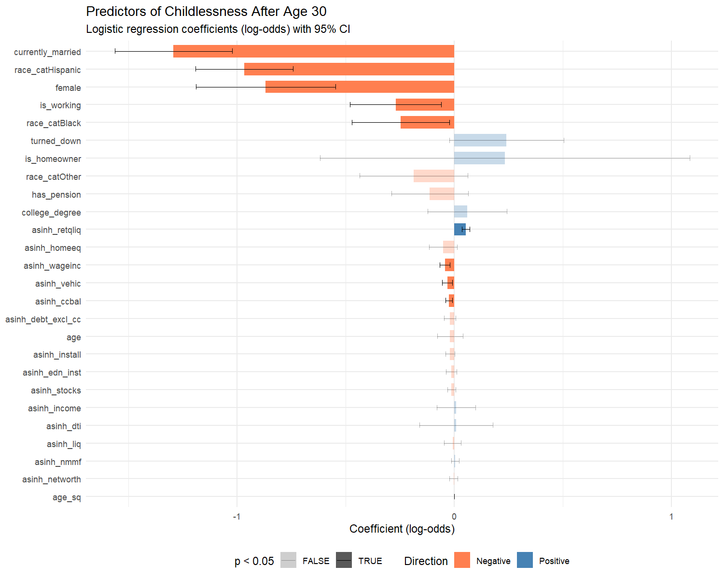

Interpretation of Key Coefficients

Race/Ethnicity and Childlessness
The race coefficients are central to the immigration argument. With White as the reference category:
- race_catBlack: log-odds = -0.246, OR = 0.78 (p = 3.18e-02)
- race_catHispanic: log-odds = -0.967, OR = 0.38 (p = 2.73e-17)
- race_catOther: log-odds = -0.187, OR = 0.83 (p = 1.41e-01)
Hispanic households have 62% lower odds of childlessness after 30 compared to White households, even after controlling for income, wealth, debt, education, marriage, and employment. This is the residual that the immigration literature would attribute substantially to the high fertility of first-generation Hispanic immigrants — a compositional effect that the SCF cannot decompose directly.
The ‘Other’ category (primarily Asian/Pacific Islander in the SCF public data) shows an odds ratio of 0.83 (p = 1.41e-01).

Financial Position and Childlessness
Marriage is the strongest demographic predictor: OR = 0.27 (p = 6.61e-21). Unmarried adults over 30 are far more likely to be childless, which is expected given that marriage remains the primary institutional context for childbearing in the U.S.
Credit card balance (asinh_ccbal): log-odds = -0.024, OR = 0.98 (p = 2.71e-03). Higher credit card balances are associated with lower odds of childlessness. This aligns with the main analysis finding that having children predicts higher credit card debt — the relationship runs in both directions, with parenthood and credit card use co-occurring.
Income (OR = 1.01, p = 8.29e-01) and net worth (OR = 1.00, p = 7.75e-01) are not significant after controlling for other predictors.

The Immigration Channel: A Theoretical Decomposition
The SCF cannot directly test whether nativity drives the racial differences in childlessness documented above. However, we can use published nativity-specific fertility data to estimate what the childlessness gradient would look like if the SCF’s racial groups were decomposed by generation.

What the External Literature Shows
Census Bureau data for 2022 reports childlessness rates by both race/ethnicity and nativity. Among women ages 40–44 (completed fertility):
- White non-Hispanic: ~19% childless
- Black: ~15% childless
- Hispanic: ~10–12% childless
- Asian: ~13–14% childless
When disaggregated by nativity, the picture shifts:
- U.S.-born Hispanic women have childlessness rates closer to White women (~15–17%) than to the Hispanic aggregate, because the inclusion of high-fertility first-generation immigrants pulls the group average down.
- U.S.-born Asian women with advanced degrees have among the highest childlessness rates of any subgroup (~20%+), but first-generation Asian immigrant women have lower childlessness, compressing the group average.
- Black immigrants (particularly from Sub-Saharan Africa and the Caribbean) have higher fertility than U.S.-born Black women, meaning the Black childlessness rate would be higher if measured among the native-born alone.

Bounding the Immigration Effect in the SCF
We can estimate the magnitude of the immigration compositional effect using a simple counterfactual. The SCF reports the following childlessness rates by race (weighted, age > 30):
Multiply-Imputed, Replicate-Weighted Mean Estimate
group variable estimate se min max
White childless_over30 0.6469061 0.007963603 0.6463427 0.6481372
Black childless_over30 0.5695780 0.022478630 0.5651512 0.5738856
Hispanic childless_over30 0.3562756 0.018399863 0.3521100 0.3580377 Other childless_over30 0.5269100 0.020639300 0.5235629 0.5311704
If the nativity composition of each racial group were held constant at 100% native-born — removing the fertility contribution of first-generation immigrants — published estimates suggest that:
- The Hispanic childlessness rate would increase by approximately 5–7 percentage points (converging toward the White rate)
- The ‘Other’ (primarily Asian) rate might decrease slightly or hold steady, since U.S.-born Asian women with degrees have high childlessness already
- The Black rate would increase by approximately 2–3 percentage points
- The White rate would be largely unchanged (only ~5% of White women are foreign-born)
This counterfactual implies that the race-childlessness gradient observed in the SCF is partially attributable to nativity composition — particularly for the Hispanic group, where first-generation immigrants substantially compress the group-level childlessness rate. The residual racial differences in childlessness, after both financial controls (modeled above) and nativity adjustment (estimated here from external data), would be smaller than what the raw SCF data suggests.

What This Means for the Research Question
The immigration channel operates as follows: first-generation immigrants arrive with fertility norms shaped by origin countries where birth rates are higher, family formation begins earlier, and childlessness is less common. These norms persist into the first generation but attenuate sharply in the second generation as educational attainment rises and cultural assimilation proceeds. The SCF captures a snapshot of households at various points in this assimilation process but cannot identify where each household sits on the generational trajectory.
The practical implication is that the SCF’s race coefficients in the childlessness model are mixtures of nativity-specific effects. A negative Hispanic coefficient does not necessarily mean that Hispanic cultural norms promote childbearing — it may primarily reflect the high share of first-generation immigrants in the Hispanic population whose fertility patterns are about to converge toward native-born levels in the next generation.

Connecting to the Credit Card Analysis
The main analysis demonstrated that the transition to parenthood (has_children) is the strongest demographic predictor of credit card indebtedness. This companion piece shows that childlessness itself is patterned by race, education, marriage, and financial position — with a residual racial component that plausibly reflects immigration-driven compositional effects.
===== Credit Card Debt Prevalence Among Childless vs. Parent Households (Age > 30) =====
Multiply-Imputed, Replicate-Weighted Mean Estimate
group variable estimate se min max
Childless has_ccdebt 0.3824663 0.009998896 0.3805208 0.3858962 Parent has_ccdebt 0.5558234 0.012116181 0.5532407 0.5591528
===== Mean Credit Card Balance by Parent Status (Age > 30) =====
Multiply-Imputed, Replicate-Weighted Mean Estimate
group variable estimate se min max
Childless ccbal 2418.927 163.8811 2398.754 2436.913 Parent ccbal 3804.555 180.7556 3764.926 3857.651
The synthesis across both papers is as follows:
- Credit card debt is driven by the transition to parenthood. The main analysis shows that having children increases the odds of carrying credit card debt by over 50% (OR ≈ 1.54), while the number of children beyond the first does not compound the effect.
- Childlessness after 30 is patterned by race, education, and marriage. This companion analysis shows that the probability of remaining childless is highest among White and ‘Other’ (primarily Asian) households, college graduates, and unmarried adults.
- The racial gradient in childlessness plausibly reflects nativity composition. The immigration literature shows that within-group fertility differences between foreign-born and native-born women account for a substantial portion of the race-level variation. The SCF’s race coefficients are mixtures of these nativity-specific effects.
- Income protects against debt, not against childlessness. The main analysis shows that higher wages reduce credit card balances among debtors. This companion analysis suggests that income is either non-significant or positively associated with childlessness — consistent with the opportunity cost of children operating through education and career investment rather than through financial constraint per se.
- The immigration question reframes the policy implication. If unplanned childlessness is driven more by immigration-related compositional shifts than by income, then policies aimed at reducing financial barriers to childbearing (e.g., child tax credits, student loan forgiveness) may be less effective at reversing fertility decline than policies that address the cultural and structural factors that shape family formation norms across generations.

Limitations
This analysis has several important limitations that must be acknowledged:
No nativity data. The SCF does not identify foreign-born status, country of origin, generation, or years in the U.S. The immigration hypothesis is engaged theoretically using external literature, not tested directly. A future analysis using the NSFG (National Survey of Family Growth), ACS (American Community Survey), or CPS Fertility Supplement — all of which include nativity variables — would be required to formally test the generational convergence mechanism.
The “Other” race category. In the SCF public dataset, the “Other” race category aggregates Asian, Pacific Islander, American Indian/Alaska Native, and multiracial respondents. Published research indicates that this category is predominantly Asian/Pacific Islander, but the heterogeneity limits interpretability.
Childlessness at age 30+ is not completed childlessness. Some households classified as childless at 31 or 35 will go on to have children. The outcome we model is “currently childless after 30,” not “permanently childless.” Analysis using the 40–44 age range (standard in demography) would be more precise but reduces the SCF sample substantially.
Household-level measurement. The SCF measures kids as the number of children in the household, not the number of biological children ever born to the reference person. A respondent whose adult children have left the household would be classified as childless. This upward-biases childlessness among older respondents.
Cross-sectional design. We cannot distinguish between “choosing not to have children,” “wanting children but not yet having them,” and “unable to have children.” The SCF captures a stock, not a flow.

Suggested Datasets for Future Work
The following datasets would allow direct testing of the immigration-childlessness hypothesis:
- National Survey of Family Growth (NSFG): Contains fertility intentions, pregnancy history, nativity, and generation. Best for modeling intended vs. unintended childlessness.
- American Community Survey (ACS): Contains nativity, citizenship, year of entry, and parental birthplace (for generation identification). Massive sample size enables subgroup analysis by race × nativity × education.
- CPS June Fertility Supplement: Contains lifetime births, nativity, and detailed demographics. Conducted biennially. Used in the published childlessness-by-nativity estimates cited throughout this paper.

Appendix: Technical Notes
Multiple Imputation. All statistics and models are pooled across the SCF’s five implicates using Rubin’s Rules, as implemented by the scf package.
Survey Weights. All estimates use SCF replicate weights (balanced repeated replication).
Sample Restriction. The childlessness model is estimated on households where the reference person is age 31 or older. The full sample is used for descriptive statistics unless otherwise noted.
Tautology Correction. As in the main analysis, asinh_debt_excl_cc (total debt minus credit card balance) replaces asinh_debt to avoid mechanical prediction.
Theoretical Decomposition. The nativity-adjusted childlessness estimates in Section 4 are derived from published CPS and Census Bureau data, not from the SCF itself. They represent approximate bounds, not formal estimates.
Session Information
R version: R version 4.5.1 (2025-06-13 ucrt)
Platform: x86_64-w64-mingw32
Key packages: scf 1.0.5, glmnet 4.1.10, survey 4.4.8

