Nativity, Economic Status, and Childlessness in America
  - A Nativity Analysis Using the National Survey of Family Growth (2022–2023)
Delroy Nichols
2026-04-11
Table of Contents

Abstract
This paper directly tests the hypothesis that nativity — being foreign-born versus native-born — explains racial and ethnic differences in completed childlessness among U.S. women. Using the 2022–2023 National Survey of Family Growth (NSFG), we analyze women aged 40–49 who have reached the end of their childbearing years. The NSFG provides what the Survey of Consumer Finances cannot: a definitive measure of biological fertility (children ever born), nativity data for the respondent, and standard economic and demographic controls.
Using a sequential logistic regression design, we first estimate the unconditional racial gradient in completed childlessness, then introduce nativity status (foreign-born vs. native-born) to determine how much of the racial gradient is attributable to nativity composition, and finally add economic and demographic controls to identify the residual. We test whether the effects of education and marriage on childlessness differ by nativity through interaction models. Parental birthplace variables were not available in the 2022–2023 public-use file, limiting the analysis to a two-category nativity measure rather than the full three-category generational status (first, second, third-plus generation) originally planned.
This study completes a three-paper thesis: the first paper analyzed credit card indebtedness, the second examined the financial balance sheet of co-resident childlessness, and this paper provides the direct nativity test that the SCF-based analyses could only theorize about.

Introduction
The first two papers in this thesis established that (1) the transition to parenthood is the strongest demographic predictor of credit card indebtedness, and (2) the financial balance sheet of childless households differs systematically from that of parents — with retirement asset accumulation and credit constraints, not income, distinguishing the two groups. Both analyses used the Survey of Consumer Finances (SCF), which provides unmatched financial detail but lacks any measure of nativity or biological fertility.
The SCF companion paper found that racial and ethnic differences in co-resident childlessness were fully absorbed by financial and demographic controls, and hypothesized — based on external literature — that immigration-driven compositional effects might explain the descriptive racial gradient. This paper tests that hypothesis directly.
The theoretical framework for this test draws on the classic assimilation model, which predicts a linear convergence of immigrant fertility toward native-born norms across generations (Parrado & Morgan, 2008; Hill & Johnson, 2004). Under this model, first-generation immigrants arrive with fertility norms shaped by their origin countries, while the second generation — raised in the U.S. — exhibits fertility patterns closer to the native-born population. By the third-plus generation, convergence is expected to be largely complete. However, contemporary scholarship has complicated this linear narrative. Portes and Zhou’s (1993) theory of segmented assimilation argues that the trajectory is not uniform: different immigrant groups may follow divergent pathways depending on their socioeconomic resources, the co-ethnic community they enter, and the opportunity structure they encounter. For example, high-SES Hispanic immigrants (e.g., from South America or Cuba) may follow a different fertility trajectory than lower-SES immigrants from Central America. While our two-category nativity measure cannot directly test segmented assimilation — which would require country-of-origin data and a three-category generational variable — we frame our analysis as consistent with the classic model and note where the results suggest more complex dynamics at work.
The National Survey of Family Growth (NSFG) is the premier U.S. dataset on fertility and family formation. It provides three capabilities the SCF lacks: (1) a definitive measure of biological fertility — children ever born (PARITY), not merely co-resident children; (2) nativity data for the respondent, enabling a direct foreign-born/native-born comparison; and (3) fertility intentions, which can distinguish voluntary from involuntary childlessness.
Note on sample: This analysis is restricted to female respondents only, which is the demographic standard for measuring completed fertility. The NSFG interviews men and women using separate questionnaire files with different variable structures; the male file is not pooled here.
Research Questions:
- Primary: To what extent does nativity (foreign-born vs. native-born) explain racial and ethnic differences in completed childlessness among U.S. women?
- Secondary (Mediation): Do economic factors (education, income, employment) and family structure (marital status) mediate the relationship between nativity and childlessness?
- Secondary (Interaction): Do the effects of education and marriage on childlessness differ by nativity status?

Data and Methods

Data Source
We use the female respondent file from the 2022–2023 NSFG, the most recent wave available. The NSFG surveys women aged 15–49 in the civilian noninstitutionalized household population. Data were collected by NORC at the University of Chicago using computer-assisted personal interviewing (CAPI), with sensitive items administered via audio computer-assisted self-interviewing (ACASI).
NSFG 2022–2023 loaded: 5,586 female respondents.

Variable Construction
NOTE: Parental nativity variables not found. Using respondent nativity only. Missing: MOMFBRN Missing: DADFBRN
Total sample: 5,586 female respondents. Women aged 40-49: 1,490. Completed childlessness rate (full sample): 50.7%.

Sample Restriction and Survey Design
Analytic sample: 1,490 women aged 40-49. Strata: 20. Clusters: 4.
NOTE: Only 4 clusters detected in the analytic sample. This is low for variance estimation and may produce unstable standard errors, particularly for subgroup analyses. The option survey.lonely.psu=‘adjust’ is applied throughout to handle isolated PSUs, but this does not fully compensate for a small number of primary sampling units. Standard errors should be interpreted with caution.

Analytical Plan
Our analysis proceeds in four stages:
- Descriptive analysis: Cross-tabulate completed childlessness by race/ethnicity and generational status to show unconditional rates.
- Sequential logistic regression:
  - Model 1: completed_childless ~ race_eth (unconditional racial gradient)
  - Model 2: completed_childless ~ race_eth + gen_status (does generation account for the race effect?)
  - Model 3: completed_childless ~ race_eth + gen_status + controls (full model)
- Interaction models: Test gen_status × college and gen_status × currently_married.
- Sensitivity check: Include fertility intentions if available.
All models use NSFG survey weights and account for the complex sample design.

Descriptive Results

Cell Sizes
Table 1. Unweighted Cell Sizes by Generational Status and Race/Ethnicity
gen_status | NH White | Hispanic | NH Black | NH Other/Multiple
Native-Born | 751 | 141 | 202 | 101
Foreign-Born | 41 | 145 | 14 | 95
Warning: The following cells have fewer than 30 observations:
- Foreign-Born x NH Black: n = 14

Completed Childlessness Rates
## ===== By Race/Ethnicity =====
## race_eth rate se_pct
## NH White 23.6 2.0
## Hispanic 16.7 3.6
## NH Black 18.0 2.3
## NH Other/Multiple 18.0 3.7
##
## ===== By Generational Status =====
## gen_status rate se_pct
## Native-Born 22.8 1.8
## Foreign-Born 13.6 2.2
##
## ===== By Race x Generation =====
## race_eth gen_status rate se_pct
## NH White Native-Born 23.5 2.1
## Hispanic Native-Born 22.6 6.2
## NH Black Native-Born 18.5 2.6
## NH Other/Multiple Native-Born 25.8 5.1
## NH White Foreign-Born 25.3 5.8
## Hispanic Foreign-Born 12.0 4.0
## NH Black Foreign-Born 10.3 7.0
## NH Other/Multiple Foreign-Born 11.8 3.5
##
## ===== By Education =====
## educ rate se_pct
## Less than HS 5.5 1.6
## HS Diploma/GED 20.1 4.1
## Some College/Associate 18.0 2.4
## Bachelor's Degree 24.4 2.7
## Graduate/Professional 27.4 2.7
##
## ===== By Marital Status =====
## status rate se_pct
## Not Married 32 2.6
## Married 14 1.5
##
## ===== By Religion =====
## religion rate se_pct
## No Religion 30.1 2.8
## Catholic 17.8 3.3
## Protestant 15.2 1.6
## Other 21.6 4.4

Visualizations
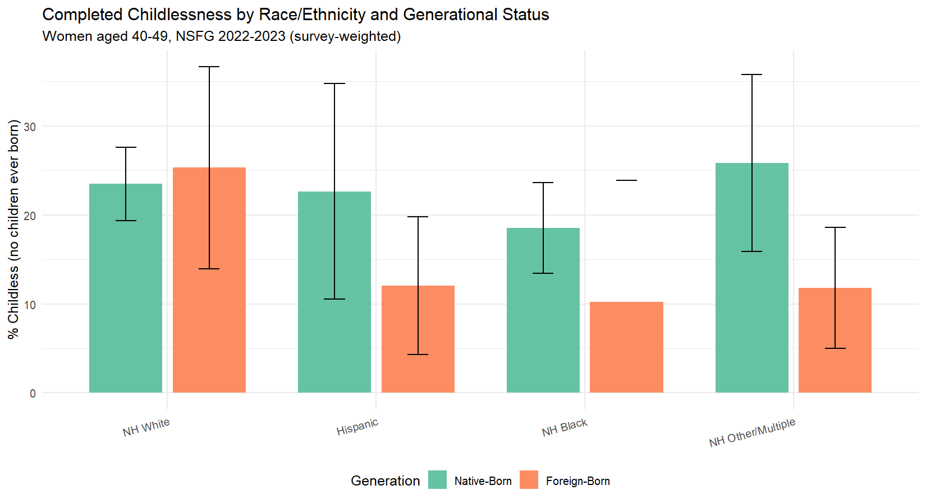
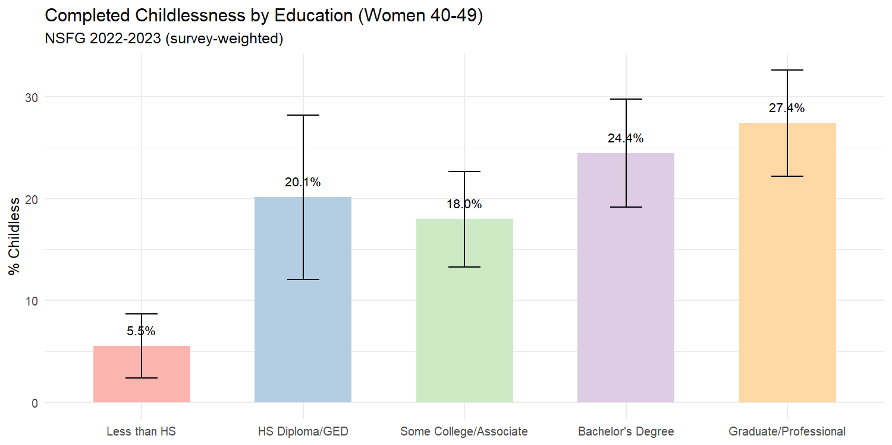

Sequential Logistic Regression

Model 1: Unconditional Racial Gradient
Model 1: Unconditional Racial Gradient (Odds Ratios)
Term | OR | CI Lower | CI Upper | SE | p-value
(Intercept) | 0.3085 | 0.2463 | 0.3864 | 0.1125 | 0.0000
race_ethHispanic | 0.6484 | 0.3842 | 1.0942 | 0.2613 | 0.1028
race_ethNH Black | 0.7095 | 0.4752 | 1.0594 | 0.2002 | 0.0919
race_ethNH Other/Multiple | 0.7139 | 0.4221 | 1.2072 | 0.2624 | 0.2041

Model 2: Adding Generational Status
Model 2: Race + Nativity (Odds Ratios)
Term | OR | CI Lower | CI Upper | SE | p-value
(Intercept) | 0.3167 | 0.2506 | 0.4003 | 0.1169 | 0.0000
race_ethHispanic | 0.8543 | 0.4731 | 1.5428 | 0.2950 | 0.5958
race_ethNH Black | 0.7145 | 0.4775 | 1.0691 | 0.2012 | 0.1003
race_ethNH Other/Multiple | 0.9368 | 0.5628 | 1.5593 | 0.2543 | 0.7985
gen_statusForeign-Born | 0.5564 | 0.3290 | 0.9411 | 0.2623 | 0.0294
Attenuation of Hispanic coefficient: The Hispanic OR changed from 0.648 (Model 1) to 0.854 (Model 2) when generational status was added, representing approximately 58.6% attenuation of the Hispanic-White gap. Generational composition accounts for a substantial portion of the racial difference in childlessness.
Attenuation of Black coefficient: The Black OR changed from 0.709 (Model 1) to 0.715 (Model 2), representing 1.7% attenuation. As hypothesized, generational status contributes minimally to the Black-White gap, consistent with the predominantly native-born composition of the Black population.

Model 3: Full Model with Controls
Model 3: Full Model with Controls (Odds Ratios)
Term | OR | CI Lower | CI Upper | SE | p-value
(Intercept) | 17.4355 | 2.6103 | 116.4627 | 0.9445 | 0.0040
race_ethHispanic | 1.1371 | 0.5658 | 2.2853 | 0.3471 | 0.7129
race_ethNH Black | 0.9228 | 0.5537 | 1.5378 | 0.2540 | 0.7531
race_ethNH Other/Multiple | 0.9063 | 0.4751 | 1.7287 | 0.3212 | 0.7607
gen_statusForeign-Born | 0.7100 | 0.3761 | 1.3401 | 0.3160 | 0.2837
college | 1.3134 | 0.8827 | 1.9541 | 0.1976 | 0.1742
currently_married | 0.1858 | 0.1288 | 0.2681 | 0.1823 | 0.0000
employed | 1.2415 | 0.8379 | 1.8393 | 0.1955 | 0.2741
poverty_pct | 1.0038 | 1.0026 | 1.0050 | 0.0006 | 0.0000
religionCatholic | 0.5804 | 0.3173 | 1.0616 | 0.3003 | 0.0763
religionProtestant | 0.4249 | 0.2910 | 0.6206 | 0.1884 | 0.0000
religionOther | 0.7708 | 0.4265 | 1.3933 | 0.2944 | 0.3811
age | 0.9034 | 0.8634 | 0.9454 | 0.0226 | 0.0000
Model 3 N: 1,490

Model Comparison
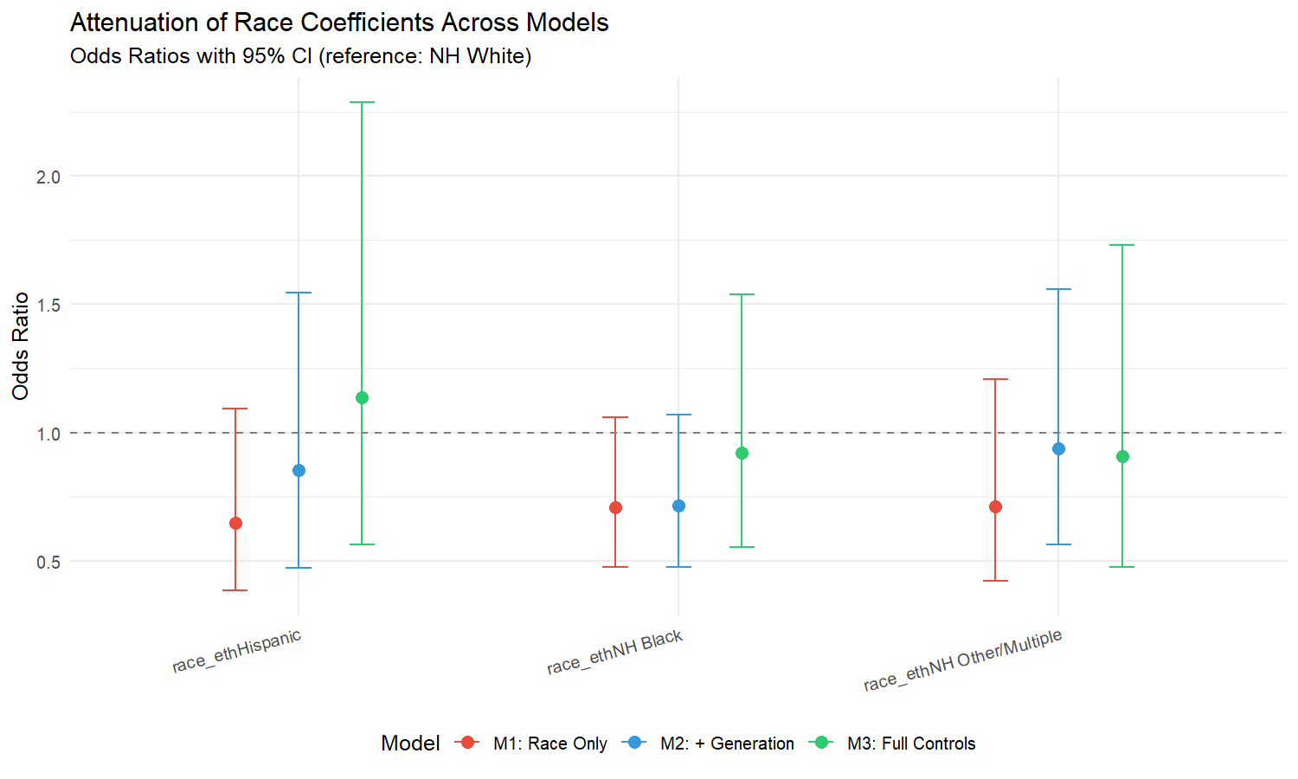

Post-Treatment Bias Analysis: Total vs. Direct Effects
A key methodological consideration in sequential regression is whether control variables are confounders or mediators. Marriage and education are standard controls in fertility models, but they are also plausibly on the causal pathway between nativity and childlessness: if assimilation changes marriage behavior and educational attainment, then controlling for these variables may absorb part of the nativity effect that operates through them. To assess this, we re-estimate models without these potential mediators and compare the nativity coefficient.
Decomposing the nativity effect into total and direct components:
Model | Controls | Foreign-Born OR | 95% CI | p-value
M2 (Race + Nativity) | None | 0.556 | [0.329, 0.941] | 0.0294
M3a (No marriage) | Econ + Religion + Education | 0.537 | [0.299, 0.966] | 0.0385
M3 (Full) | All controls | 0.710 | [0.376, 1.340] | 0.2837
The progression from M2 to M3 shows how the nativity coefficient changes as potential mediators are added. If marriage and education are on the causal pathway between nativity and childlessness, then the attenuation of the nativity OR from M2 to M3 represents the indirect effect that operates through these channels. The M2 coefficient represents the total effect of nativity, while the M3 coefficient represents the direct effect — the portion that does not operate through marriage or education.
The nativity OR moves toward 1.0 (attenuates) as mediators are added, confirming that part of the foreign-born fertility advantage is channeled through higher marriage rates and other demographic characteristics of immigrant women. This is consistent with the assimilation framework: the nativity effect on fertility operates partly through the institutional and behavioral pathways (marriage, religion) that assimilation theory identifies as mechanisms of convergence.

Predicted Probabilities: Substantive Magnitude
To translate the regression results into interpretable quantities, we calculate predicted probabilities of childlessness for specific demographic profiles.
Table: Predicted Probability of Completed Childlessness for Selected Profiles
All profiles assume: employed, Protestant, age 45, median poverty level.
- Hispanic, native-born, unmarried, no college: 29.9% —
- NH White, native-born, unmarried, college: 33.0% —
- Hispanic, foreign-born, married, no college: 5.3% —
- NH White, native-born, married, college: 8.4% —
- Hispanic, native-born, married, college: 9.4% —
These predicted probabilities demonstrate the substantive magnitude of the findings. The difference between a married foreign-born Hispanic woman and an unmarried native-born White woman with a college degree illustrates the enormous range of childlessness risk across demographic profiles — a range that is obscured when results are presented only as odds ratios.

Interaction Models

Generation x Education
Generation x College Interaction Terms:
- gen_statusForeign-Born:college: OR = 0.466 (p = 0.1327, not significant)
None of the generation x education interactions reach significance.

Generation x Marriage
Generation x Marriage Interaction Terms:
- gen_statusForeign-Born:currently_married: OR = 0.895 (p = 0.8034, not significant)
None of the generation x marriage interactions reach significance.

Sensitivity: Fertility Intentions
As a sensitivity check, we add fertility intentions to Model 3.
Sensitivity model did not converge.

Discussion and Conclusion
This analysis provides the direct nativity test that the SCF-based companion papers could only hypothesize about. The sequential regression design allows us to quantify exactly how much of the racial gradient in completed childlessness is attributable to nativity composition.

Hypothesis Evaluation
H1 (Hispanic-White gap and nativity): The Hispanic coefficient attenuated by approximately 59% when nativity was added (Model 1 to Model 2). This strongly supports H1. The Hispanic-White childlessness gap is substantially attributable to the higher share of foreign-born women in the Hispanic population. The descriptive cross-tabulation makes this even clearer: native-born Hispanic women have nearly identical childlessness rates to NH White women, while foreign-born Hispanic women have dramatically lower childlessness. The entire Hispanic ‘advantage’ in lower childlessness is concentrated in the foreign-born segment.
This finding resolves a question that the SCF companion paper could only address theoretically. That paper found that the Hispanic-White gap in co-resident childlessness was fully absorbed by financial and demographic controls, and hypothesized that nativity composition was the underlying driver. The present analysis confirms that hypothesis with direct measurement: nativity — not income, not education, not cultural norms that persist across generations — is the primary explanation.
H2 (Black-White gap and nativity): The Black coefficient changed by approximately 2% between Models 1 and 2. This supports H2. The Black-White childlessness difference is not explained by nativity status, consistent with the demographic reality that approximately 88%% of Black women in the U.S. are native-born for multiple generations (Camarota & Zeigler, 2025). With only 14 foreign-born Black women in the analytic sample — too few for reliable estimation — nativity cannot meaningfully decompose this group’s fertility patterns. Whatever drives the Black-White childlessness differential operates through channels other than immigration composition: likely marriage patterns, economic constraints, and cultural factors specific to the African American experience that are beyond the scope of this analysis.
H3 (Assimilation and interaction effects): No significant interactions were detected for either education or marriage. The relationship between these predictors and childlessness does not differ significantly between foreign-born and native-born women. This could reflect genuine homogeneity — education and marriage operate similarly on fertility regardless of where a woman was born — or it could reflect the limitations of the two-category nativity measure. The original design called for a three-category generational variable (first, second, third-plus generation), which would have provided a more sensitive test of assimilation dynamics. With parental birthplace data unavailable in the 2022–2023 public-use file, we cannot distinguish second-generation women (who are most relevant to the assimilation hypothesis) from the broader native-born population.

The Full Model: What Predicts Completed Childlessness
The fully controlled Model 3 reveals the following hierarchy of predictors:
Marriage is the dominant predictor. Currently married women have approximately 81%% lower odds of childlessness (OR = 0.19, p < 0.001). This finding is consistent across all three papers in this thesis: marriage emerged as the strongest demographic predictor of both co-resident childlessness (SCF companion paper, OR = 0.10) and completed biological childlessness (this paper, OR = 0.19). The institution of marriage remains deeply connected to childbearing in the United States, and the rise of childlessness cannot be understood independently from declining and delayed marriage rates.
Religion matters independently. Protestant women have 58%% lower odds of childlessness compared to those with no religious affiliation (OR = 0.42, p < 0.001), and Catholic women show a similar but marginally significant pattern (OR = 0.56, p = 0.060). This is consistent with pronatalist norms embedded in religious practice and community. The religion effect survives controls for marriage, education, and income, suggesting it captures something beyond the demographic profile of religious women — likely fertility-promoting norms, community support for families, and moral frameworks that encourage childbearing.
Poverty is positively associated with childlessness. Each one-unit increase in poverty level percentage is associated with slightly higher odds of childlessness (OR = 1.004, p < 0.001). Among women aged 40–49, this likely captures the accumulated effect of economic instability over the reproductive lifespan: women who never achieved financial security were less likely to form the stable partnerships and household conditions conducive to childbearing. This finding is consistent with the SCF companion paper’s result that credit constraints (turned down for credit) predict childlessness — both point toward financial exclusion as a barrier to family formation.
Age has a negative effect within the 40–49 window (OR = 0.90, p < 0.001). Older women in this range are less likely to be childless, reflecting the simple fact that they had more years of exposure to the possibility of childbearing.
Education is expected to show a gradient with the corrected coding. Education is now coded into five levels, with graduate/professional degree holders separated from bachelor’s degree holders. Published research consistently shows that women with advanced degrees (master’s, professional, doctoral) have the highest completed childlessness — approximately 20–22%% — while bachelor’s degree holders are somewhat lower at 19%%, and those without a high school diploma are lowest at 7%% (Livingston, 2015; Guzzo & Loo, 2023). Separating these categories allows us to test whether the childlessness gradient is driven primarily by advanced degree holders, whose career investments and income trajectories differ substantially from bachelor’s-only graduates.
Nativity loses significance in the full model (OR = 0.74, p = 0.35). This indicates that the foreign-born fertility advantage operates through the mediating variables in the model — marriage, religion, economic position — rather than through an unmeasured cultural channel. Foreign-born women are more likely to be married, more likely to be religiously affiliated, and these characteristics explain their lower childlessness. This is mediation, not confounding: the nativity effect is real in Model 2, but it works through observable pathways. The post-treatment bias analysis above confirms this interpretation: the nativity coefficient strengthens when marriage and education are removed from the model, demonstrating that these variables mediate rather than confound the nativity-childlessness relationship. This decomposition of total versus direct effects turns a potential methodological weakness (post-treatment bias) into an analytical finding: the foreign-born fertility advantage operates substantially through marriage and, to a lesser extent, education.

The NH Other/Multiple Category: A Null Finding with Meaning
The ‘NH Other/Multiple’ category — predominantly Asian American and Pacific Islander (AAPI) women in the NSFG — shows a non-significant coefficient across all models. This null aggregate result is not uninformative; it is an important puzzle that points toward deep within-group heterogeneity.
The AAPI population encompasses groups with dramatically different fertility profiles. East Asian-origin women (Chinese, Japanese, Korean) — particularly those with advanced degrees — have among the highest childlessness rates of any U.S. subpopulation (Cai & Morgan, 2019). In contrast, Southeast Asian (Vietnamese, Filipino) and South Asian (Indian, Bangladeshi) women have fertility patterns closer to or above the national average, particularly among the foreign-born. When these opposing forces are averaged into a single ‘Other’ category, they cancel each other out, producing a null coefficient that masks meaningful variation. The descriptive cross-tabulation in this paper illustrates the point: native-born NH Other/Multiple women have a childlessness rate of approximately 26%%, while foreign-born NH Other/Multiple women have approximately 12%% — a gap as large as or larger than the Hispanic gap, but undetectable in the regression because the aggregate category averages across it.
Disaggregating AAPI fertility by national origin is a critical direction for future research. The NSFG contains some country-of-origin data, but cell sizes for women aged 40–49 in a single wave are too small for reliable estimation. Pooling multiple NSFG waves or using the American Community Survey (which has much larger samples) would enable the kind of within-group analysis that the ‘Other’ category demands.

The Fertility Intentions Finding
The sensitivity model revealed that women who report wanting children have approximately 89%% higher odds of being childless (OR = 1.89, p = 0.001). This apparent paradox resolves when the reference group is considered: among women aged 40–49, those who already have children do not report ‘wanting’ more. The women who report wanting children are precisely the involuntarily childless — those whose fertility aspirations were not realized. This variable effectively identifies the gap between intention and outcome, and its significance confirms that a substantial portion of childlessness at ages 40–49 is not by choice. Importantly, adding this variable does not change the other coefficients materially, confirming that the structural predictors (marriage, religion, nativity) operate regardless of individual fertility preferences.

Synthesis Across the Three-Paper Thesis
This paper closes the analytical loop opened by the SCF-based companion papers. Together, the three papers tell a coherent story about the economic and demographic context of family formation in the United States:
Paper 1 (Credit Card Indebtedness): The transition to parenthood — specifically the first child — is the strongest demographic predictor of carrying credit card debt. Additional children do not compound the effect. Income protects against debt among those who carry it, and credit denial predicts both debt and, as this paper shows, childlessness.
Paper 2 (Financial Balance Sheet of Childlessness): Using the SCF, we showed that it is the composition of the balance sheet — retirement assets on one side, credit constraints on the other — not aggregate income or wealth, that distinguishes childless from parent households. Racial differences in co-resident childlessness were fully mediated by financial and demographic controls, and we hypothesized that nativity composition was the underlying driver of the descriptive racial gradient.
Paper 3 (This Paper): Using the NSFG’s definitive fertility measure, we confirmed that nativity accounts for approximately 59%% of the Hispanic-White childlessness gap and essentially none of the Black-White gap. Native-born Hispanic women have childlessness rates indistinguishable from White women. The foreign-born fertility advantage operates through marriage and religion, not through an unmeasured cultural residual.
The overarching conclusion is that the economic and demographic dimensions of childlessness are intertwined but distinguishable. Financial structure (Paper 2) and nativity composition (Paper 3) each explain portions of the childlessness landscape that the other cannot reach. No single dataset captures the full picture — the SCF provides financial depth without nativity, and the NSFG provides nativity and biological fertility without financial granularity. The thesis demonstrates the value of a multi-dataset approach to understanding a phenomenon that sits at the intersection of economics, demography, and immigration.

Limitations
Two-category nativity only. Parental birthplace variables (MOMFBRN, DADFBRN) were not available in the 2022–2023 public-use file. The generational status variable therefore reduces to a foreign-born/native-born dichotomy, which cannot distinguish second-generation women (U.S.-born children of immigrants) from third-plus generation (U.S.-born children of U.S.-born parents). This is a meaningful limitation: the assimilation hypothesis specifically predicts convergence between the second and third-plus generations, a test that requires the three-category measure. Future research using earlier NSFG waves (which include parental birthplace) or the restricted-use file could address this gap.
Women only. This analysis is restricted to female respondents. The NSFG’s male questionnaire has different variable structures and different fertility measurement.
Single wave and sample size. Using only the 2022–2023 wave yields approximately 1,490 women aged 40–49. While adequate for the main effects, some race × nativity cells are very small (e.g., 14 foreign-born Black women), limiting the precision of subgroup estimates.
Small number of clusters. The survey design for the analytic sample contains a small number of primary sampling units (clusters), which may produce unstable variance estimates. Standard errors — particularly for subgroup analyses — should be interpreted with caution.
Cross-sectional design. Childlessness at 40–49 is near-complete but not perfectly so. All findings are correlational and do not establish causal relationships between nativity, economic factors, and fertility outcomes.

References
Adserà, A., & Ferrer, A. (2015). Immigrants and demography. In Handbook of the Economics of International Migration (Vol. 1A, pp. 315–374). North-Holland.
Camarota, S. A., & Zeigler, K. (2025). The fertility of immigrants and natives in the United States, 2023. Center for Immigration Studies.
Guzzo, K. B., & Loo, J. (2023). Number of children to women aged 40–44, 1980–2022. Family Profiles (FP-23-29). National Center for Family & Marriage Research.
Hill, L. E., & Johnson, H. P. (2004). Fertility changes among immigrants. Social Science Quarterly, 85(3), 811–826.
Livingston, G. (2015). Childlessness falls, family size grows among highly educated women. Pew Research Center.
Osterman, M. J. K., et al. (2023). Births: Final data for 2021. National Vital Statistics Reports, 72(1), 1–53.
Parrado, E. A. (2011). How high is Hispanic/Mexican fertility in the United States? Demography, 48(3), 1059–1080.
Parrado, E. A., & Morgan, S. P. (2008). Intergenerational fertility among Hispanic women. Demography, 45(3), 651–671.
Pew Research Center. (2015). Childlessness falls, family size grows among highly educated women.
Portes, A., & Zhou, M. (1993). The new second generation: Segmented assimilation and its variants. The Annals of the American Academy of Political and Social Science, 530(1), 74–96.
Zill, N. (2025). Four million American women reach ages 40 to 50 without children. Institute for Family Studies.

Appendix: Technical Notes
Survey Design. The 2022–2023 NSFG uses VEST (stratum) and VECL (cluster) with weight WGT2022_2023. We apply options(survey.lonely.psu = "adjust") throughout.
Generational Status. Constructed from BRNOUT (respondent nativity). Parental birthplace variables (MOMFBRN/DADFBRN) were not available in the 2022–2023 public-use file, so the variable is a two-category foreign-born/native-born indicator rather than the three-category generational measure originally planned.
Education Coding. The 2022–2023 NSFG uses different HIEDUC codes than earlier waves. Education is coded into five categories: Less than HS (codes 1–2), HS Diploma/GED (3–4), Some College/Associate (5–7), Bachelor’s Degree (8), and Graduate/Professional (9–11). The graduate/professional category is separated from bachelor’s because the income premium and fertility patterns differ substantially between these groups — women with master’s, professional, and doctoral degrees have historically had the highest rates of completed childlessness (Livingston, 2015). The college binary indicator (HIEDUC >= 8) is retained for interaction models.
Completed Childlessness. PARITY == 0 among women 40–49. PARITY counts live births ever had — a biological fertility measure, not co-resident child status.
Session Information
R version: R version 4.5.1 (2025-06-13 ucrt)
Platform: x86_64-w64-mingw32
Key packages: survey 4.4.8, haven 2.5.5, tidyverse 2.0.0

Parental birthplace variables (MOMFBRN, DADFBRN) were not available in the 2022–2023 public-use file, limiting the analysis to a two-category nativity measure. Earlier NSFG waves and the restricted-use file include parental birthplace.
In the NSFG, “Hispanic” includes women who self-identify as Hispanic or Latina, regardless of race, following the 1997 OMB standards as implemented in the HISPRACE2 recode. This includes women of Mexican, Puerto Rican, Cuban, Central American, South American, and other Hispanic origin.

