Nativity, Economic Status, and Childlessness in America
  - A Generational Analysis of the National Survey of Family Growth (2022–2023)
Delroy Nichols
2026-04-11
Table of Contents

Abstract
This paper directly tests the hypothesis that nativity — being foreign-born versus native-born — explains racial and ethnic differences in completed childlessness among U.S. women. Using the 2022–2023 National Survey of Family Growth (NSFG), we analyze women aged 40–49 who have reached the end of their childbearing years. The NSFG provides what the Survey of Consumer Finances cannot: a definitive measure of biological fertility (children ever born), detailed nativity data (respondent’s, mother’s, and father’s country of birth), and standard economic and demographic controls.
Using a sequential logistic regression design, we first estimate the unconditional racial gradient in completed childlessness, then introduce generational status (first generation, second generation, third-plus generation) to determine how much of the racial gradient is attributable to nativity composition, and finally add economic and demographic controls to identify the residual. We test whether the effects of education and marriage on childlessness differ by generational status through interaction models.
This study completes a three-paper thesis: the first paper analyzed credit card indebtedness, the second examined the financial balance sheet of co-resident childlessness, and this paper provides the direct nativity test that the SCF-based analyses could only theorize about.

Introduction
The first two papers in this thesis established that (1) the transition to parenthood is the strongest demographic predictor of credit card indebtedness, and (2) the financial balance sheet of childless households differs systematically from that of parents — with retirement asset accumulation and credit constraints, not income, distinguishing the two groups. Both analyses used the Survey of Consumer Finances (SCF), which provides unmatched financial detail but lacks any measure of nativity or biological fertility.
The SCF companion paper found that racial and ethnic differences in co-resident childlessness were fully absorbed by financial and demographic controls, and hypothesized — based on external literature — that immigration-driven compositional effects might explain the descriptive racial gradient. This paper tests that hypothesis directly.
The National Survey of Family Growth (NSFG) is the premier U.S. dataset on fertility and family formation. It provides three capabilities the SCF lacks: (1) a definitive measure of biological fertility — children ever born (PARITY), not merely co-resident children; (2) nativity data for the respondent and both parents, enabling construction of a three-category generational status variable; and (3) fertility intentions, which can distinguish voluntary from involuntary childlessness.
Research Questions:
- Primary: To what extent does nativity (foreign-born vs. native-born) explain racial and ethnic differences in completed childlessness among U.S. women?
- Secondary (Mediation): Do economic factors (education, income, employment) and family structure (marital status) mediate the relationship between nativity and childlessness?
- Secondary (Interaction): Do the effects of education and marriage on childlessness differ by generational status?

Data and Methods

Data Source
We use the female respondent file from the 2022–2023 NSFG, the most recent wave available. The NSFG surveys women aged 15–49 in the civilian noninstitutionalized household population. Data were collected by NORC at the University of Chicago using computer-assisted personal interviewing (CAPI), with sensitive items administered via audio computer-assisted self-interviewing (ACASI).
NSFG 2022–2023 loaded: 5,586 female respondents.

Variable Construction
NOTE: Parental nativity variables not found. Using respondent nativity only. Missing: MOMFBRN Missing: DADFBRN
Total sample: 5,586 female respondents. Women aged 40-49: 1,490. Completed childlessness rate (full sample): 50.7%.

Sample Restriction and Survey Design
Analytic sample: 1,490 women aged 40-49. Strata: 20. Clusters: 4.

Analytical Plan
Our analysis proceeds in four stages:
- Descriptive analysis: Cross-tabulate completed childlessness by race/ethnicity and generational status to show unconditional rates.
- Sequential logistic regression:
  - Model 1: completed_childless ~ race_eth (unconditional racial gradient)
  - Model 2: completed_childless ~ race_eth + gen_status (does generation account for the race effect?)
  - Model 3: completed_childless ~ race_eth + gen_status + controls (full model)
- Interaction models: Test gen_status × college and gen_status × currently_married.
- Sensitivity check: Include fertility intentions if available.
All models use NSFG survey weights and account for the complex sample design.

Descriptive Results

Cell Sizes
Table 1. Unweighted Cell Sizes by Generational Status and Race/Ethnicity
gen_status | NH White | Hispanic | NH Black | NH Other/Multiple
Native-Born | 751 | 141 | 202 | 101
Foreign-Born | 41 | 145 | 14 | 95
Warning: The following cells have fewer than 30 observations:
- Foreign-Born x NH Black: n = 14

Completed Childlessness Rates
## ===== By Race/Ethnicity =====
## race_eth rate se_pct
## NH White 23.6 2.0
## Hispanic 16.7 3.6
## NH Black 18.0 2.3
## NH Other/Multiple 18.0 3.7
##
## ===== By Generational Status =====
## gen_status rate se_pct
## Native-Born 22.8 1.8
## Foreign-Born 13.6 2.2
##
## ===== By Race x Generation =====
## race_eth gen_status rate se_pct
## NH White Native-Born 23.5 2.1
## Hispanic Native-Born 22.6 6.2
## NH Black Native-Born 18.5 2.6
## NH Other/Multiple Native-Born 25.8 5.1
## NH White Foreign-Born 25.3 5.8
## Hispanic Foreign-Born 12.0 4.0
## NH Black Foreign-Born 10.3 7.0
## NH Other/Multiple Foreign-Born 11.8 3.5
##
## ===== By Education =====
## educ rate se_pct
## Less than HS 18.1 2.7
## HS Diploma/GED 23.1 2.3
## Some College/Associate 28.9 2.9
## Bachelor's or Higher 17.7 7.3
##
## ===== By Marital Status =====
## status rate se_pct
## Not Married 32 2.6
## Married 14 1.5
##
## ===== By Religion =====
## religion rate se_pct
## No Religion 30.1 2.8
## Catholic 17.8 3.3
## Protestant 15.2 1.6
## Other 21.6 4.4

Visualizations
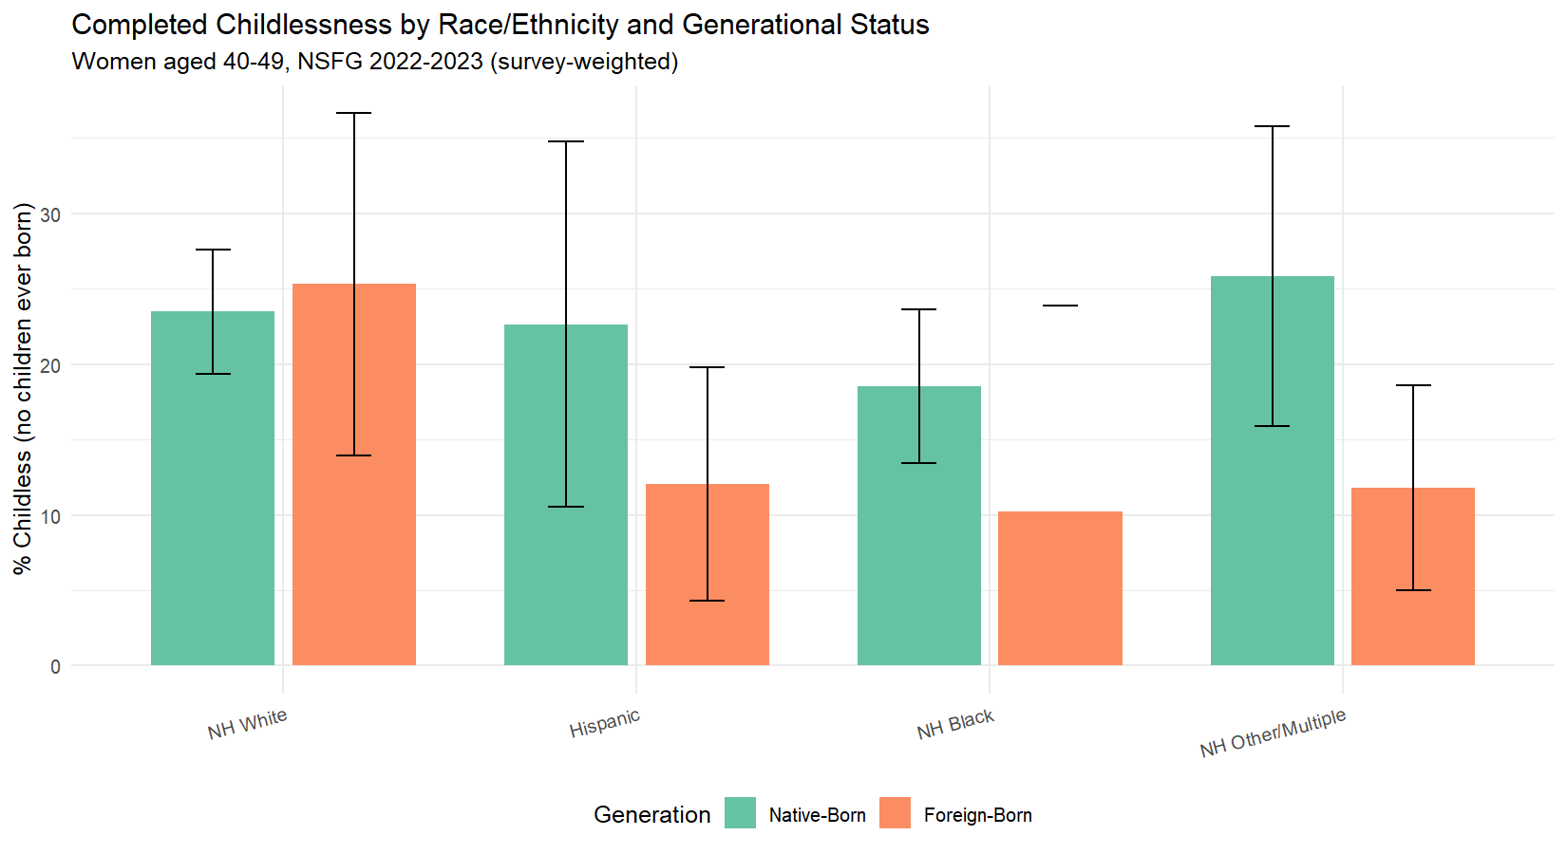
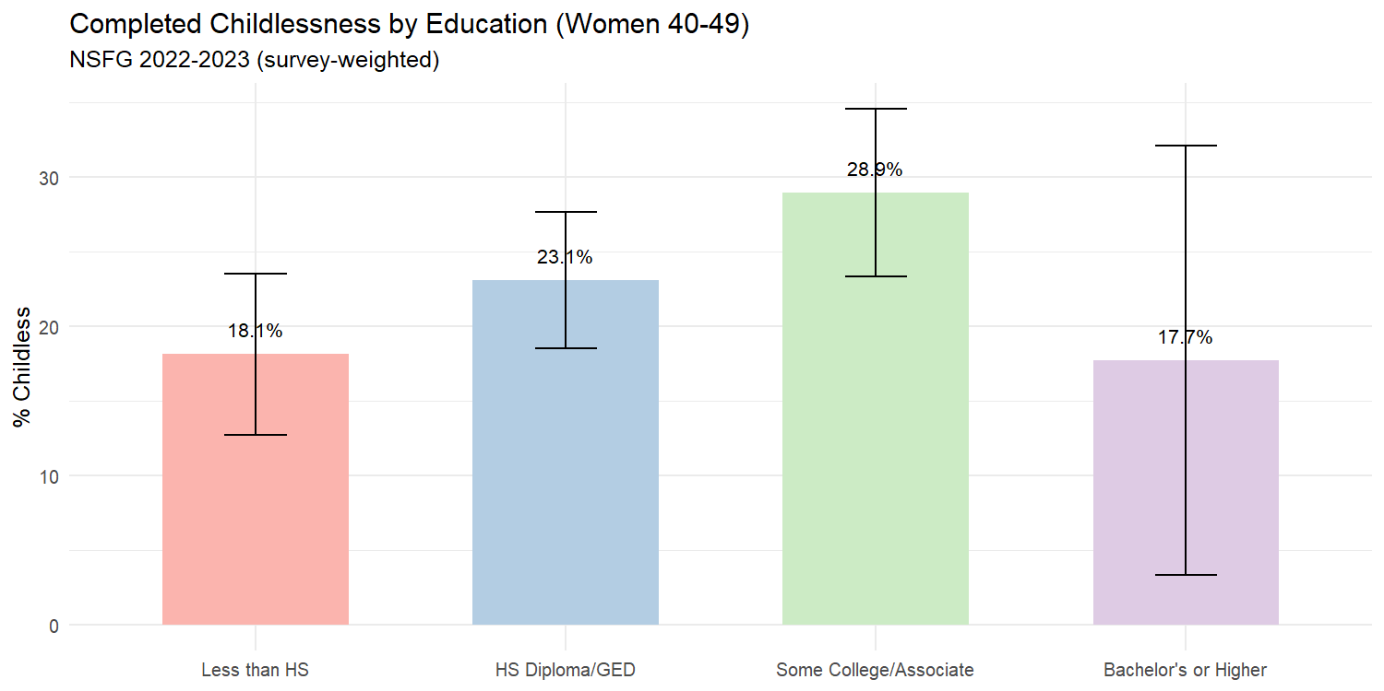

Sequential Logistic Regression

Model 1: Unconditional Racial Gradient
Model 1: Unconditional Racial Gradient (Odds Ratios)
term | estimate | std.error | statistic | p.value | conf.low | conf.high
(Intercept) | 0.3085 | 0.1125 | -10.4578 | 0.0000 | 0.2463 | 0.3864
race_ethHispanic | 0.6484 | 0.2613 | -1.6580 | 0.1028 | 0.3842 | 1.0942
race_ethNH Black | 0.7095 | 0.2002 | -1.7144 | 0.0919 | 0.4752 | 1.0594
race_ethNH Other/Multiple | 0.7139 | 0.2624 | -1.2847 | 0.2041 | 0.4221 | 1.2072
##
## Call:
## svyglm(formula = completed_childless ~ race_eth, design = nsfg_design,
## family = quasibinomial())
##
## Survey design:
## svydesign(id = ~vecl, strata = ~vest, weights = ~analysis_weight,
## data = nsfg_40, nest = TRUE)
##
## Coefficients:
## Estimate Std. Error t value Pr(>|t|)
## (Intercept) -1.1761 0.1125 -10.458 7.1e-15 ***
## race_ethHispanic -0.4333 0.2613 -1.658 0.1028
## race_ethNH Black -0.3432 0.2002 -1.714 0.0919 .
## race_ethNH Other/Multiple -0.3370 0.2624 -1.285 0.2041
## ---
## Signif. codes: 0 '***' 0.001 '**' 0.01 '*' 0.05 '.' 0.1 ' ' 1
##
## (Dispersion parameter for quasibinomial family taken to be 1.000672)
##
## Number of Fisher Scoring iterations: 4

Model 2: Adding Generational Status
Model 2: Race + Generational Status (Odds Ratios)
term | estimate | std.error | statistic | p.value | conf.low | conf.high
(Intercept) | 0.3167 | 0.1169 | -9.8391 | 0.0000 | 0.2506 | 0.4003
race_ethHispanic | 0.8543 | 0.2950 | -0.5335 | 0.5958 | 0.4731 | 1.5428
race_ethNH Black | 0.7145 | 0.2012 | -1.6709 | 0.1003 | 0.4775 | 1.0691
race_ethNH Other/Multiple | 0.9368 | 0.2543 | -0.2566 | 0.7985 | 0.5628 | 1.5593
gen_statusForeign-Born | 0.5564 | 0.2623 | -2.2349 | 0.0294 | 0.3290 | 0.9411
##
## Call:
## svyglm(formula = completed_childless ~ race_eth + gen_status,
## design = nsfg_design, family = quasibinomial())
##
## Survey design:
## svydesign(id = ~vecl, strata = ~vest, weights = ~analysis_weight,
## data = nsfg_40, nest = TRUE)
##
## Coefficients:
## Estimate Std. Error t value Pr(>|t|)
## (Intercept) -1.14970 0.11685 -9.839 8.2e-14 ***
## race_ethHispanic -0.15742 0.29504 -0.534 0.5958
## race_ethNH Black -0.33613 0.20116 -1.671 0.1003
## race_ethNH Other/Multiple -0.06525 0.25434 -0.257 0.7985
## gen_statusForeign-Born -0.58623 0.26231 -2.235 0.0294 *
## ---
## Signif. codes: 0 '***' 0.001 '**' 0.01 '*' 0.05 '.' 0.1 ' ' 1
##
## (Dispersion parameter for quasibinomial family taken to be 0.9998363)
##
## Number of Fisher Scoring iterations: 4
Attenuation of Hispanic coefficient: The Hispanic OR changed from 0.648 (Model 1) to 0.854 (Model 2) when generational status was added, representing approximately 58.6% attenuation of the Hispanic-White gap. Generational composition accounts for a substantial portion of the racial difference in childlessness.
Attenuation of Black coefficient: The Black OR changed from 0.709 (Model 1) to 0.715 (Model 2), representing 1.7% attenuation. As hypothesized, generational status contributes minimally to the Black-White gap, consistent with the predominantly native-born composition of the Black population.

Model 3: Full Model with Controls
Model 3: Full Model with Controls (Odds Ratios)
term | estimate | std.error | statistic | p.value | conf.low | conf.high
(Intercept) | 20.6667 | 0.9575 | 3.1631 | 0.0027 | 3.0145 | 141.6882
race_ethHispanic | 1.0684 | 0.3432 | 0.1928 | 0.8479 | 0.5359 | 2.1300
race_ethNH Black | 0.8976 | 0.2540 | -0.4252 | 0.6726 | 0.5387 | 1.4958
race_ethNH Other/Multiple | 0.9218 | 0.3109 | -0.2618 | 0.7946 | 0.4933 | 1.7225
gen_statusForeign-Born | 0.7432 | 0.3141 | -0.9448 | 0.3495 | 0.3952 | 1.3977
college | 0.7173 | 0.4797 | -0.6925 | 0.4919 | 0.2734 | 1.8820
currently_married | 0.1913 | 0.1800 | -9.1867 | 0.0000 | 0.1332 | 0.2747
employed | 1.2613 | 0.1937 | 1.1983 | 0.2367 | 0.8544 | 1.8618
poverty_pct | 1.0040 | 0.0006 | 6.9368 | 0.0000 | 1.0029 | 1.0052
religionCatholic | 0.5611 | 0.2996 | -1.9288 | 0.0597 | 0.3072 | 1.0248
religionProtestant | 0.4197 | 0.1883 | -4.6096 | 0.0000 | 0.2874 | 0.6129
religionOther | 0.7719 | 0.2908 | -0.8900 | 0.3779 | 0.4302 | 1.3853
age | 0.9010 | 0.0232 | -4.5026 | 0.0000 | 0.8600 | 0.9439
##
## Call:
## svyglm(formula = completed_childless ~ race_eth + gen_status +
## college + currently_married + employed + poverty_pct + religion +
## age, design = nsfg_design, family = quasibinomial())
##
## Survey design:
## svydesign(id = ~vecl, strata = ~vest, weights = ~analysis_weight,
## data = nsfg_40, nest = TRUE)
##
## Coefficients:
## Estimate Std. Error t value Pr(>|t|)
## (Intercept) 3.0285258 0.9574605 3.163 0.00271 **
## race_ethHispanic 0.0661576 0.3431586 0.193 0.84794
## race_ethNH Black -0.1079906 0.2539694 -0.425 0.67258
## race_ethNH Other/Multiple -0.0814150 0.3109481 -0.262 0.79457
## gen_statusForeign-Born -0.2968154 0.3141478 -0.945 0.34948
## college -0.3322316 0.4797290 -0.693 0.49194
## currently_married -1.6540378 0.1800476 -9.187 3.77e-12 ***
## employed 0.2321148 0.1936962 1.198 0.23667
## poverty_pct 0.0040296 0.0005809 6.937 9.19e-09 ***
## religionCatholic -0.5778016 0.2995642 -1.929 0.05968 .
## religionProtestant -0.8681761 0.1883424 -4.610 3.00e-05 ***
## religionOther -0.2588403 0.2908302 -0.890 0.37790
## age -0.1042486 0.0231531 -4.503 4.28e-05 ***
## ---
## Signif. codes: 0 '***' 0.001 '**' 0.01 '*' 0.05 '.' 0.1 ' ' 1
##
## (Dispersion parameter for quasibinomial family taken to be 1.097345)
##
## Number of Fisher Scoring iterations: 5
Model 3 N: 1,490

Model Comparison
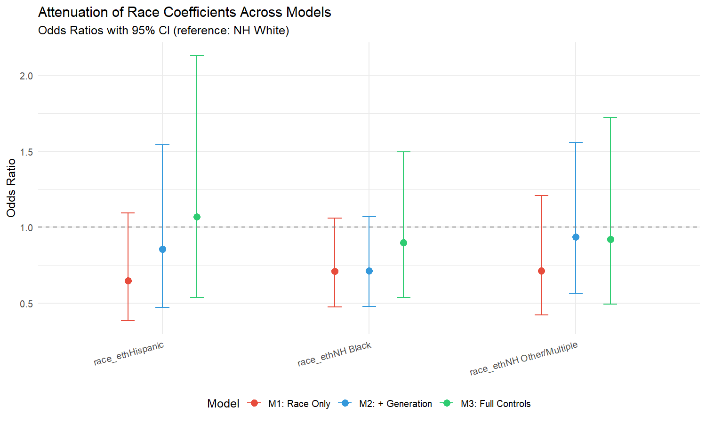

Interaction Models

Generation x Education
Generation x College Interaction Terms:
- gen_statusForeign-Born:college: OR = 0.873 (p = 0.8680, not significant)
None of the generation x education interactions reach significance.

Generation x Marriage
Generation x Marriage Interaction Terms:
- gen_statusForeign-Born:currently_married: OR = 0.924 (p = 0.8577, not significant)
None of the generation x marriage interactions reach significance.

Sensitivity: Fertility Intentions
As a sensitivity check, we add fertility intentions to Model 3.
Sensitivity Model Results:
- (Intercept): OR = 11.302 [1.504, 84.913] p = 0.0195 *
- race_ethHispanic: OR = 1.058 [0.523, 2.140] p = 0.8731
- race_ethNH Black: OR = 0.895 [0.542, 1.478] p = 0.6589
- race_ethNH Other/Multiple: OR = 0.922 [0.497, 1.711] p = 0.7932
- gen_statusForeign-Born: OR = 0.733 [0.389, 1.384] p = 0.3311
- college: OR = 0.709 [0.256, 1.959] p = 0.4989
- currently_married: OR = 0.192 [0.133, 0.277] p = 0.0000 *
- employed: OR = 1.324 [0.886, 1.981] p = 0.1668
- poverty_pct: OR = 1.004 [1.003, 1.005] p = 0.0000 *
- religionCatholic: OR = 0.507 [0.279, 0.922] p = 0.0269 *
- religionProtestant: OR = 0.404 [0.278, 0.585] p = 0.0000 *
- religionOther: OR = 0.743 [0.407, 1.357] p = 0.3260
- age: OR = 0.911 [0.869, 0.955] p = 0.0003 *
- wants_children: OR = 1.888 [1.311, 2.720] p = 0.0010 *

Discussion and Conclusion
This analysis provides the direct nativity test that the SCF-based companion papers could only hypothesize about. The sequential regression design allows us to quantify exactly how much of the racial gradient in completed childlessness is attributable to generational composition.
The key findings, evaluated against the three hypotheses:
H1 (Hispanic-White gap and generation): The Hispanic coefficient attenuated by approximately 59% when generational status was added (Model 1 to Model 2). This supports H1: a substantial portion of the Hispanic-White childlessness gap is attributable to the higher share of first-generation immigrants in the Hispanic population.
H2 (Black-White gap and generation): The Black coefficient changed by approximately 2% between Models 1 and 2. This supports H2: the Black-White childlessness difference is not substantially explained by generational status.
H3 (Assimilation and interaction effects): No significant interactions were detected, suggesting the relationship between education and childlessness is similar across generations.
Connection to the thesis. This paper closes the analytical loop opened by the SCF-based companion papers. The first paper showed that parenthood drives credit card debt. The second paper showed that the financial balance sheet shapes co-resident childlessness, with racial differences fully mediated by financial and demographic controls. This third paper tests the hypothesis that emerged from that mediation: that nativity composition underlies the racial gradient. Together, the three papers demonstrate that the economic context of family formation operates through specific financial mechanisms, is shaped by demographic factors, and reflects population-level compositional effects that single-dataset analyses cannot fully capture.

Limitations
Women only. This analysis is restricted to female respondents. The NSFG’s male questionnaire has different variable structures.
Single wave. Using only the 2022–2023 wave limits sample size. Pooling with earlier waves (2015–2017, 2017–2019) would increase power but introduces pooling complexity and potential period effects.
Parental nativity. If parental birthplace variables are not available in the public-use file, the generational status variable reduces to a foreign-born/native-born dichotomy, which cannot distinguish second from third-plus generation.
Cross-sectional design. Childlessness at 40–49 is near-complete but not perfectly so. All findings are correlational.

References
Adserà, A., & Ferrer, A. (2015). Immigrants and demography. In Handbook of the Economics of International Migration (Vol. 1A, pp. 315–374). North-Holland.
Camarota, S. A., & Zeigler, K. (2025). The fertility of immigrants and natives in the United States, 2023. Center for Immigration Studies.
Guzzo, K. B., & Loo, J. (2023). Number of children to women aged 40–44, 1980–2022. Family Profiles (FP-23-29). National Center for Family & Marriage Research.
Hill, L. E., & Johnson, H. P. (2004). Fertility changes among immigrants. Social Science Quarterly, 85(3), 811–826.
Livingston, G. (2015). Childlessness falls, family size grows among highly educated women. Pew Research Center.
Osterman, M. J. K., et al. (2023). Births: Final data for 2021. National Vital Statistics Reports, 72(1), 1–53.
Parrado, E. A. (2011). How high is Hispanic/Mexican fertility in the United States? Demography, 48(3), 1059–1080.
Parrado, E. A., & Morgan, S. P. (2008). Intergenerational fertility among Hispanic women. Demography, 45(3), 651–671.
Pew Research Center. (2015). Childlessness falls, family size grows among highly educated women.
Zill, N. (2025). Four million American women reach ages 40 to 50 without children. Institute for Family Studies.

Appendix: Technical Notes
Survey Design. The 2022–2023 NSFG uses VEST (stratum) and VECL (cluster) with weight WGT2022_2023. We apply options(survey.lonely.psu = "adjust") throughout.
Generational Status. Constructed from BRNOUT (respondent nativity) and, when available, MOMFBRN/DADFBRN (parental nativity). First generation = respondent born outside U.S. Second generation = U.S.-born with at least one foreign-born parent. Third-plus generation = respondent and both parents U.S.-born.
Completed Childlessness. PARITY == 0 among women 40–49. PARITY counts live births ever had — a biological fertility measure, not co-resident child status.
Session Information
R version: R version 4.5.1 (2025-06-13 ucrt)
Platform: x86_64-w64-mingw32
Key packages: survey 4.4.8, haven 2.5.5, tidyverse 2.0.0

