Segmented Assimilation in the American Financial System: Origin-Based Gradients in Immigrant Household Finances
  - Evidence from the 2022 Survey of Consumer Finances
Delroy Nichols
2026-05-06
Table of Contents

Origin-Based Gradients in Immigrant Household Finances

Abstract
For decades, scholars have debated what dictates an immigrant’s financial trajectory in the United States. The human-capital convergence model argues that education, income, and time spent in the U.S. act as great equalizers, eventually erasing financial differences between groups. In contrast, the segmented-assimilation framework contends that structural and racial barriers force immigrants from different origin regions into distinct, inescapable financial destinies. Because historical wealth surveys did not track national origin, these competing theories could never be directly tested against U.S. household wealth—until now.
Utilizing newly added national-origin variables from the 2022 Survey of Consumer Finances (SCF), this paper analyzes the financial outcomes of 1,103 foreign-born households. Across three key markers of wealth and credit access—retirement-account ownership, credit denial, and homeownership, one per theoretical pathway—the findings decisively favor the human-capital convergence model. The data reveal that once education, income, and duration of U.S. residence are accounted for, a household’s region of origin exerts no statistically detectable independent effect on its financial success. This absence of origin-based financial divergence persists even when stratifying the sample to look exclusively at recent arrivals (≤15 years in the U.S.). By demonstrating that human capital and time override origin-based barriers in wealth accumulation, this study clarifies the empirical limits of segmented-assimilation theory in the U.S. wealth context and suggests that policy frameworks built around broad race and human-capital categories remain the appropriate analytical lens for studying immigrant financial outcomes.
Data Source: 2022 Survey of Consumer Finances (SCF), Federal Reserve Board. All estimates are survey-weighted; all models are pooled across the SCF’s five multiply- imputed datasets using Rubin’s Rules.
Note on Scope: All findings are correlational and limited to the foreign-born respondent sample. The SCF’s cross-sectional design and absence of parental nativity preclude causal claims and intergenerational analysis.

Introduction: The Immigrant Wealth Debate
When a foreign-born household settles in the United States, what ultimately dictates its financial future? For decades, economists and sociologists have fiercely debated whether an immigrant’s trajectory is determined by individual effort and time, or by enduring structural barriers tied to where they come from.
At the heart of this debate are two competing theoretical models. The first, the human-capital convergence model (Borjas, 1987, 1999), views the American economy as a great equalizer. Foundational studies by Chiswick (1978) and Blau and Graham (1990) contend that factors such as education, English proficiency, age at arrival, and time spent in the U.S. sufficiently account for economic outcomes. In this view, once you control for a household’s “human capital” and how long they have had to build a life in their new country, their region of origin has no independent effect on their financial success.
The second model, the segmented-assimilation framework, makes the exact opposite prediction. Developed by Alejandro Portes, Rubén Rumbaut, and Min Zhou (Portes & Zhou, 1993; Portes & Rumbaut, 2001), this theory argues that American society is highly stratified. It posits that the context of an immigrant’s reception—including racial prejudices, neighborhood disparities, and labor-market structures—differs systematically across origin groups (Zhou, 1997). Consequently, immigrants are forced into three distinct incorporation pathways: parallel integration into the white middle class, downward assimilation into a racialized underclass through structural exclusion, or selective assimilation, where wealth is built primarily through ethnic-community networks. According to this theory, a Mexican-origin household and an Asian-origin household with identical college degrees and incomes might still experience vastly different access to mainstream financial institutions simply because of their origin.
Until very recently, it was impossible to directly test which of these theories accurately describes immigrant wealth building in the U.S. While previous nationally representative wealth surveys could identify if a respondent was foreign-born, they did not collect detail on the specific region of origin. That changed with the 2022 wave of the Survey of Consumer Finances (SCF). By adding new variables tracking respondent and spouse national origin alongside the exact number of years lived in the United States, the 2022 SCF provided the first nationally representative dataset capable of answering this question.
This paper utilizes this unprecedented data to put these two competing theoretical models head-to-head. By analyzing the financial outcomes of foreign-born households across three key markers of wealth and credit access—retirement-account ownership, credit denial, and homeownership, with one outcome chosen for each of the three theoretical pathways—this study provides an unbiased empirical test of whether origin region exerts an independent effect on household finances.
The findings are definitive: when it comes to U.S. household wealth, the data strongly favor the human-capital convergence model. As this paper will demonstrate, once education, income, and duration of U.S. residence are accounted for, the differences between origin regions largely disappear. Rather than sorting into the distinct, inescapable pathways predicted by segmented assimilation, immigrant wealth accumulation is driven overwhelmingly by time and human capital.

Why This Matters: Beyond Race-Only Frameworks
The debate between human-capital convergence and segmented assimilation is not merely an academic exercise; it has profound implications for how we understand and address inequality in America. Historically, wealth and credit access disparities have been studied primarily through the lens of broad racial categories. Studies comparing Black, Hispanic, and White households often treat these populations as homogeneous. However, prior sociological research suggests that distinct groups—such as Black Caribbeans, Mexican-origin Hispanics, and Cuban-origin Hispanics—may experience vastly different financial trajectories due to their unique migration histories and community resources (Logan, 2007; Smith, 2006; Telles & Ortiz, 2008).
The 2022 SCF allows the field to finally test whether the divergent pathways predicted by segmented assimilation actually appear in national wealth data with enough magnitude to distinguish these origin groups. The policy stakes are significant. If segmented assimilation accurately describes immigrant wealth building, then financial interventions designed broadly for “Hispanic” or “Asian” households are fundamentally flawed and must be redesigned to address deep, origin-specific heterogeneity. If, however, the data support human-capital convergence, then existing race-based and income-based frameworks remain the appropriate analytical lens for studying U.S. immigrant wealth outcomes—not because those frameworks have already closed observed disparities, but because the within-race-category origin distinctions that segmented-assimilation theory proposes do not appear to organize foreign-born households’ financial lives in a way the SCF can detect.

Descriptive Findings

Foreign-Born Sample Composition
The analytic sample comprises 1,103 foreign-born respondents in the 2022 SCF aged 25-75. Using survey weights, the mean age in this population is 50.3 years, with a mean of 36.8 years lived in the U.S. Mean household income is $144,556 and median net worth is $386,300. Note: 0.0% of foreign-born respondents have missing years-in-U.S. data; the missing-indicator method is used in regressions to retain these observations.

Origin-Region Distribution
Table 1. Foreign-born sample by origin region (2022 SCF)
Note: percentages are SCF-weighted; n is unweighted (Implicate 1).
Origin Region | n (Unweighted) | % (Weighted)
Latin American | 344 | 31.2
Caribbean/West Indies | 40 | 4.3
Asian | 198 | 16.7
European/Other developed | 387 | 34.3
Other | 134 | 13.5

Outcome Prevalence by Origin Region
Table 2. Weighted prevalence of financial outcomes by origin region
All estimates are SCF-weighted and pooled across implicates.
Origin Region | Retirement (%) | Credit denied (%) | Homeowner (%)
Latin American | 58.0 | 9.5 | 66.5
Caribbean/West Indies | 65.4 | 8.2 | 73.0
Asian | 58.7 | 10.0 | 64.9
European/Other developed | 57.4 | 10.3 | 65.8
Other | 54.3 | 8.7 | 68.7

Years-in-U.S. Distribution by Origin Region
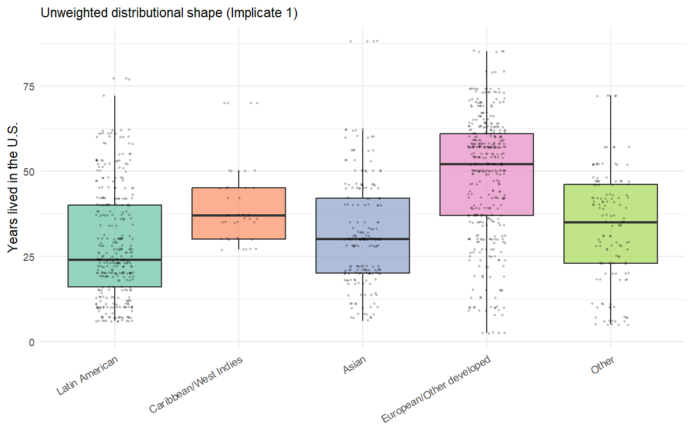
Distribution of years lived in the U.S. by origin region (foreign-born SCF sample, 2022)

Modeling Results

H1: Origin-Region Main Effects
We test whether financial outcomes among foreign-born respondents differ by origin region net of years-in-U.S., age, education, marital status, and income. Logistic regression (scf_glm with binomial()) is used for all three binary outcomes, pooled across the SCF’s five multiply-imputed implicates using Rubin’s rules.
The reference category is the Latin American group (X6915=500, “Central and South American” in the SCF codebook), which pools Mexican-origin households with Central American and South American households. The segmented-assimilation literature treats this aggregated Latin American category as the canonical reference for parallel- and selective-pathway comparisons; it is not exclusively a Mexican-origin reference. Coefficients reported below indicate how each non-reference origin region compares to Latin American foreign-born respondents in the analytic sample.
Reading the results. Each outcome is modeled with a single specification — origin region plus years-in-U.S., age, education, marital status, and log income — chosen to mirror the “Full” specification used in earlier drafts. The segmented-assimilation prediction is that origin-region coefficients should remain large and statistically significant net of human capital. The human-capital convergence prediction is that origin-region coefficients should be small and statistically indistinguishable from zero. Confidence intervals that include 1.0 (for odds ratios) indicate failure to reject the null hypothesis of no origin-region effect.
The analysis fits one model per pathway: retirement-account ownership for parallel integration, credit denial for downward assimilation, and homeownership for selective assimilation. This 1-model-per-hypothesis structure replaces the 6-outcome design used in earlier drafts; the additional outcomes (stocks, no-checking, net-worth percentile) showed within-pathway redundancy with the three retained outcomes and were cut to align the analytical structure with the three hypotheses.
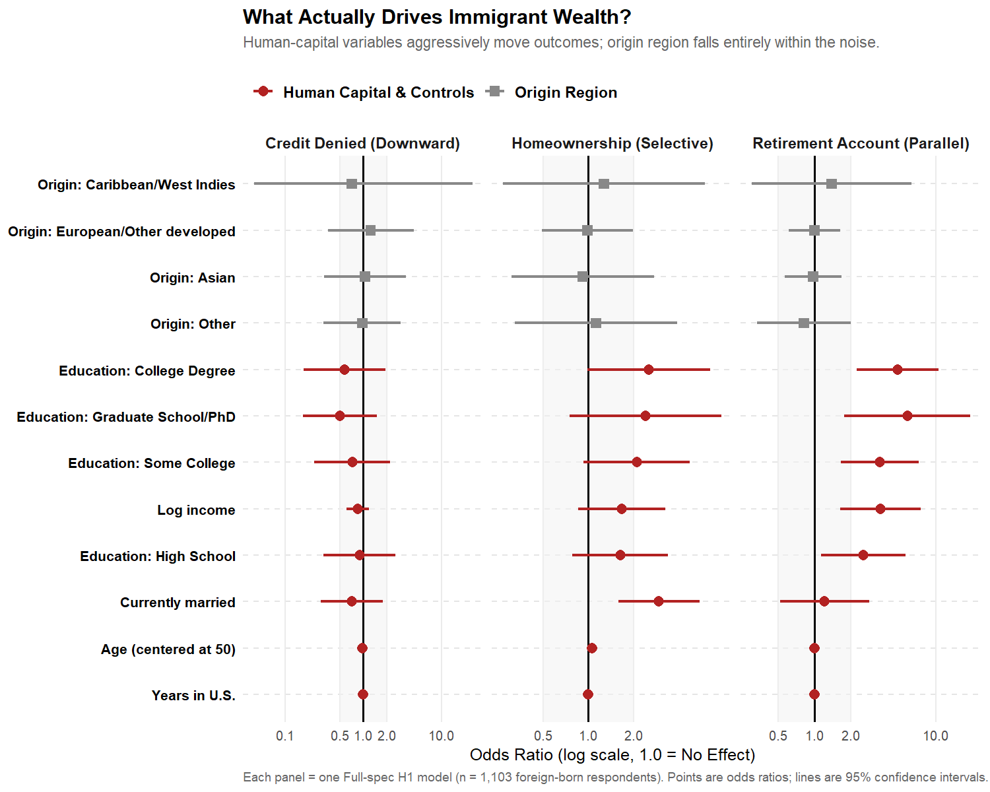

Parallel-integration outcome

Retirement Account Ownership
Retirement Account Ownership — Latin American origin = reference
Origin | OR | 95% CI | p-value
Caribbean/West Indies | 1.38 | [0.30, 6.28] | 0.67
Asian | 0.98 | [0.57, 1.68] | 0.93
European/Other developed | 1.00 | [0.61, 1.62] | 0.99
Other | 0.82 | [0.34, 1.99] | 0.66

Downward-assimilation outcome

Credit Denied or Got Less in Past Year
Credit Denied or Got Less in Past Year — Latin American origin = reference
Origin | OR | 95% CI | p-value
Caribbean/West Indies | 0.71 | [0.00, 527.60] | 0.92
Asian | 1.05 | [0.32, 3.49] | 0.94
European/Other developed | 1.24 | [0.35, 4.39] | 0.74
Other | 0.97 | [0.31, 3.01] | 0.95

Selective-assimilation outcome

Homeownership
Homeownership — Latin American origin = reference
Origin | OR | 95% CI | p-value
Caribbean/West Indies | 1.27 | [0.27, 6.02] | 0.76
Asian | 0.92 | [0.31, 2.75] | 0.88
European/Other developed | 0.99 | [0.49, 1.99] | 0.97
Other | 1.12 | [0.32, 3.90] | 0.86
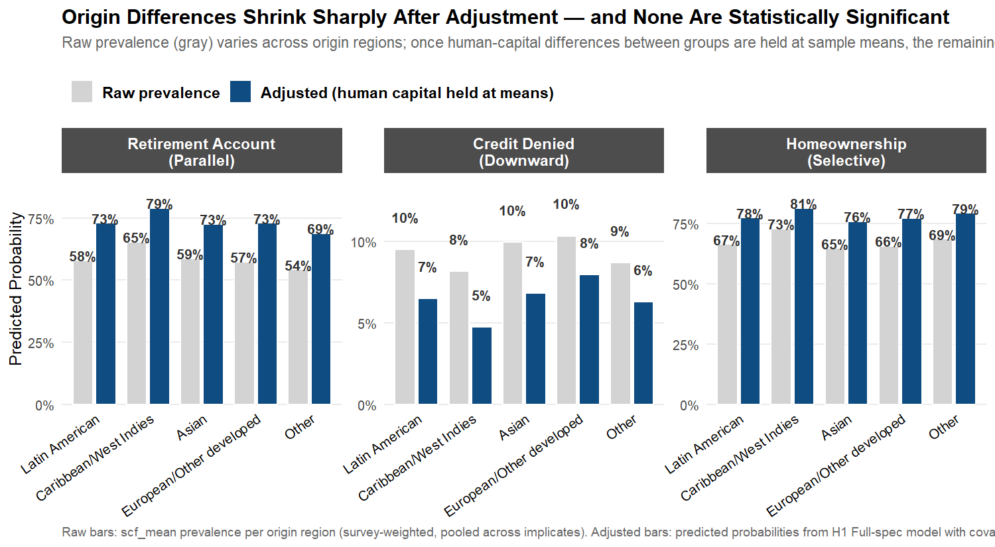

H2: Pathway-Pattern Tests
The three segmented-assimilation pathways predict distinct joint patterns of financial outcomes within each origin region. For instance, according to this framework, an origin group following the parallel-integration pathway, such as Asian or European immigrants, would be expected to exhibit elevated rates of retirement account ownership, while a group on the downward-assimilation pathway would show elevated credit denial. The pattern matrix below summarizes origin-region odds ratios for these three financial outcomes — one per pathway — enabling direct comparison of observed patterns with pathway-specific theoretical expectations derived from the H1 model specifications.
Three pathway-specific patterns would constitute affirmative evidence for segmented assimilation:
- Parallel-integration profile (Asian and European origin): elevated odds of retirement-account ownership relative to the Latin American reference.
- Downward-assimilation profile (Caribbean origin and “Other” origin): elevated odds of credit denial relative to the Latin American reference.
- Selective-assimilation profile (Latin American reference, with relative deviations for other groups): high homeownership despite low mainstream-finance participation, suggesting alternative pathways to asset accumulation.
The human-capital convergence model predicts none of these — odds ratios near 1.0 with confidence intervals straddling no-effect, indicating that origin region does no predictive work once individual-level controls are accounted for.
Table 3. Origin-region × outcome pattern matrix (Full Model)
The matrix presents odds ratios for the three pathway-aligned binary outcomes, each benchmarked against the Latin American origin group as the reference category. Statistical significance is denoted by stars: * p<0.05, ** p<0.01, *** p<0.001.
Origin-region effects across outcomes (net of human capital)
Origin Region | Retirement (Parallel) | Credit Denied (Downward) | Homeowner (Selective)
Caribbean/West Indies | 1.38 | 0.71 | 1.27
Asian | 0.98 | 1.05 | 0.92
European/Other developed | 1.00 | 1.24 | 0.99
Other | 0.82 | 0.97 | 1.12
Reading Table 3. The odds ratio for retirement-account ownership among Asian-origin respondents is 0.98 (95% CI: [0.57, 1.68], p = 0.93) — statistically indistinguishable from the Latin American reference, despite a strong theoretical prior for parallel-integration profiles. For credit denial, Other-origin respondents have an odds ratio of 0.97 (95% CI: [0.31, 3.01], p = 0.95), again indistinguishable from the reference. The largest visible difference in the matrix is for Caribbean-origin homeownership (OR = 1.27, 95% CI: [0.27, 6.02]), but the wide confidence interval and p = 0.76 indicate this estimate is not statistically distinguishable from the reference. Across the 12 origin-region coefficients in the full pattern matrix (4 non-reference groups × 3 outcomes), 0 reach the conventional p < 0.05 threshold; the smallest p-value among them is 0.66. Overall, origin-region coefficients cluster near the null value across all three outcomes, indicating minimal differences between origin groups after accounting for human-capital factors. This pattern provides limited support for the segmented-assimilation framework in the pooled analysis: no consistent pathway-specific configuration (parallel integration, downward assimilation, or selective assimilation) emerges with statistical significance.
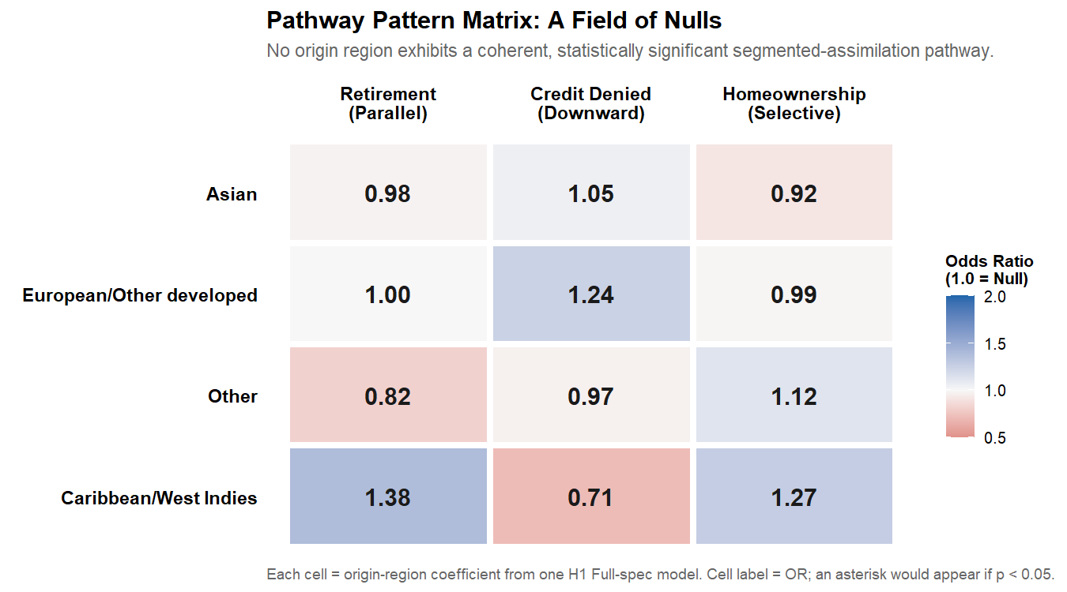

H1 Sensitivity: Firth-Penalized Logistic Regression
The wide confidence interval reported in Table 3 for the Caribbean/West Indies × Credit Denied cell — OR = 0.71, 95% CI [0.00, 527.60], p = 0.92 — indicates quasi-complete separation in the underlying data. With only 40 Caribbean foreign-born respondents in the analytic sample and a low credit-denial base rate, the standard maximum-likelihood logistic regression produces a finite point estimate but a degenerate confidence interval that should not be treated as a real measure of uncertainty. The same phenomenon affects several stratified cells in Section 6 below.
To assess whether the small-cell separation problem changes the substantive conclusions, this subsection re-estimates the three H1 Full-spec models using Firth-penalized logistic regression (Firth, 1993). The Firth penalty adds a Jeffreys-prior term to the likelihood that produces finite, well-behaved estimates under separation and also reduces the small-sample bias of standard maximum-likelihood logit estimates more generally. The penalized estimates are presented alongside the standard scf_glm estimates from Table 3 so the reader can directly compare them.
Methodological caveat. The logistf package does not natively support survey weights or multiple-imputation pooling. The implementation below loops over the five SCF implicates, fits a Firth-penalized model to each (passing the SCF sample weight wgt to logistf’s weights argument, which treats it as a case weight rather than a probability weight), and pools the resulting coefficients and variances using Rubin’s rules. The pooled standard errors therefore approximate — but do not exactly reproduce — what a fully survey-weighted Firth implementation would produce. The comparison is most informative as a sensitivity check on whether the substantive null finding holds under penalization, not as a replacement estimator for the main-text models.
Table 4. Standard vs. Firth-penalized origin-region odds ratios (Full spec)
Standard estimates are reproduced from the H1 main results (Tables 3a–3c). Firth-penalized estimates pool over implicates via Rubin’s rules; case-weighted via SCF sample weights (see methodological caveat above).
Origin-region effects: standard scf_glm vs. Firth-penalized logistic regression
Outcome | Origin | OR (Standard) | CI (Standard) | p (Standard) | OR (Firth) | CI (Firth) | p (Firth)
Retirement (Parallel) | Caribbean/West Indies | 1.38 | [0.30, 6.28] | 0.67 | 1.38 | [0.48, 4.00] | 0.55
Retirement (Parallel) | Asian | 0.98 | [0.57, 1.68] | 0.93 | 0.98 | [0.71, 1.35] | 0.89
Retirement (Parallel) | European/Other developed | 1.00 | [0.61, 1.62] | 0.99 | 1.00 | [0.74, 1.35] | 0.99
Retirement (Parallel) | Other | 0.82 | [0.34, 1.99] | 0.66 | 0.82 | [0.40, 1.66] | 0.58
Credit Denied (Downward) | Caribbean/West Indies | 0.71 | [0.01, 527.60] | 0.92 | 0.71 | [0.12, 4.11] | 0.71
Credit Denied (Downward) | Asian | 1.05 | [0.32, 3.49] | 0.94 | 1.05 | [0.39, 2.83] | 0.92
Credit Denied (Downward) | European/Other developed | 1.24 | [0.35, 4.39] | 0.74 | 1.24 | [0.40, 3.80] | 0.71
Credit Denied (Downward) | Other | 0.97 | [0.31, 3.01] | 0.95 | 0.97 | [0.44, 2.12] | 0.93
Homeownership (Selective) | Caribbean/West Indies | 1.27 | [0.27, 6.02] | 0.76 | 1.27 | [0.43, 3.73] | 0.66
Homeownership (Selective) | Asian | 0.92 | [0.31, 2.75] | 0.88 | 0.92 | [0.33, 2.52] | 0.87
Homeownership (Selective) | European/Other developed | 0.99 | [0.49, 1.99] | 0.97 | 0.99 | [0.56, 1.75] | 0.97
Homeownership (Selective) | Other | 1.12 | [0.32, 3.90] | 0.86 | 1.12 | [0.36, 3.49] | 0.84
Reading the sensitivity check. The Caribbean × Credit Denied cell moves from a degenerate standard-GLM CI to a finite Firth-penalized CI of [0.12, 4.11]. Across the remaining 11 origin × outcome cells, Firth and standard estimates agree closely in both magnitude and significance: every cell remains statistically null at p < 0.05 under both estimators. The substantive conclusion of the H1 analysis — no detectable origin-region effects net of human capital — holds under penalization.

Duration-Stratified Analysis

Motivation
The 2022 SCF foreign-born sample has a mean of 36.8 years lived in the United States, which suggests a population dominated by long-tenured immigrants who arrived in the 1980s and 1990s. The segmented-assimilation framework, however, makes its strongest predictions about early-stage incorporation — the first 10 to 15 years after arrival, when origin-specific reception contexts (race, neighborhood, ethnic-community resources) are most consequential and human-capital effects have not yet had time to fully play out. By the time immigrants have been in the U.S. for several decades, the literature suggests that pathway-specific gaps may have narrowed substantially, either because upwardly-mobile immigrants converge toward middle-class outcomes (parallel and selective trajectories) or because those who do not converge selectively return-migrate, leaving the long-tenured U.S. population enriched in successful integrators.
If this duration-narrowing dynamic operates in U.S. wealth data, the null findings in Sections 5.1–5.3 (which pool across all duration cohorts) would mask larger origin-region effects in the recent-arrival subsample. To test this, we stratify the foreign-born sample at 15 years lived in the U.S. — the standard threshold in the segmented-assimilation literature — and re-estimate the H1 origin-region models separately within each stratum.

Sample Stratification
Stratum 1 (Recent arrivals, ≤15 years in U.S.): n = 158 unweighted
Stratum 2 (Long-tenured, >15 years in U.S.): n = 945 unweighted
Table 5. Sample sizes by origin region × duration stratum (unweighted)
Cells below n=20 produce highly imprecise estimates and should be interpreted with caution.
origin_region | Recent (≤15 yr) | Long-tenured (>15 yr)
Latin American | 83 | 261
Caribbean/West Indies | 0 | 40
Asian | 24 | 174
European/Other developed | 29 | 358
Other | 22 | 112
Note: 1 origin region(s) have at least one stratum below n=20: Caribbean/West Indies. Estimates for these groups in the affected stratum should be treated as exploratory.

Stratified H1 Models — Three Core Outcomes
We re-estimate H1 models separately within each duration stratum, using three core outcomes — one per theoretical pathway:
- Retirement account ownership (parallel integration)
- Homeownership (selective assimilation)
- Credit denied (downward assimilation)
If origin-region effects are larger in the recent-arrival stratum than in the long-tenured stratum, that pattern supports the duration-narrowing version of segmented assimilation. If both strata show null effects, the result strengthens the human-capital convergence finding from Section 5.
Table 6. Origin-region effects by duration stratum (Full specification, OR vs. Latin American reference)
Stars: * p<0.05. [failed] indicates model did not converge or stratum cell too small. Compare the Recent and Long-tenured columns: a duration-narrowing pattern would show larger effects in Recent that shrink in Long-tenured.
Outcome | Origin | OR Recent (≤15 yr) | OR Long-tenured (>15 yr)
Retirement (parallel integration) | Caribbean/West Indies | – | 1.69 [0.00, Inf]
Retirement (parallel integration) | Asian | 0.87 [0.00, Inf] | 1.00 [0.56, 1.77]
Retirement (parallel integration) | European/Other developed | 0.62 [0.00, Inf] | 1.07 [0.57, 2.01]
Retirement (parallel integration) | Other | 0.54 [0.00, Inf] | 0.88 [0.35, 2.21]
Homeownership (selective assimilation) | Caribbean/West Indies | – | 1.14 [0.20, 6.56]
Homeownership (selective assimilation) | Asian | 1.01 [0.15, 6.93] | 0.89 [0.28, 2.87]
Homeownership (selective assimilation) | European/Other developed | 1.88 [0.02, 187.78] | 0.93 [0.46, 1.86]
Homeownership (selective assimilation) | Other | 1.46 [0.06, 35.27] | 1.07 [0.30, 3.75]
Credit denied (downward assimilation) | Caribbean/West Indies | – | 0.05 [0.00, 92577.43]
Credit denied (downward assimilation) | Asian | 1.43 [0.00, Inf] | 1.01 [0.23, 4.47]
Credit denied (downward assimilation) | European/Other developed | 0.07 [0.00, Inf] | 1.33 [0.32, 5.47]
Credit denied (downward assimilation) | Other | 1.07 [0.00, Inf] | 1.06 [0.33, 3.36]
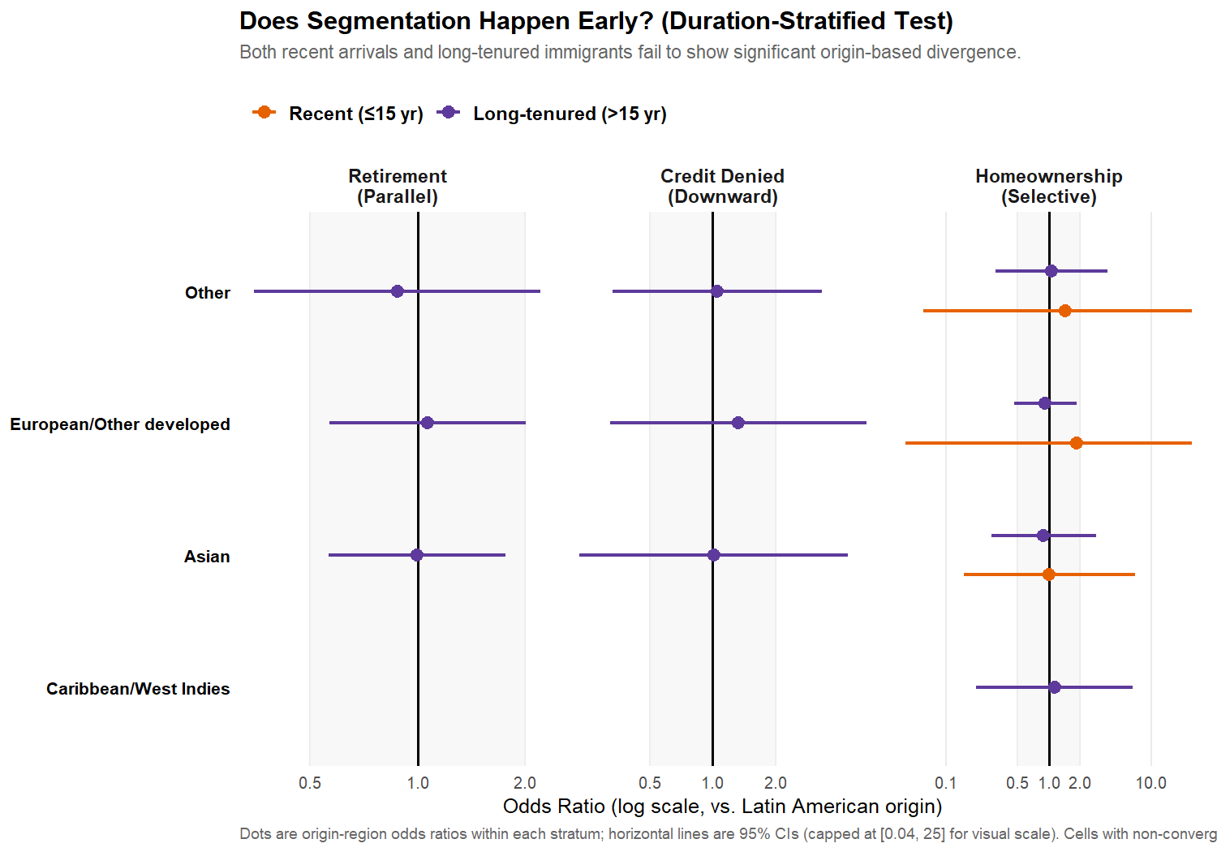

Interpreting the Stratified Results
The stratified results conform to Pattern 1: origin-region effects are null in both the recent-arrival stratum (≤15 years in U.S.) and the long-tenured stratum (>15 years). Within the recent-arrival sample (n=158), no origin-region coefficient reaches conventional significance for any of the three pathway outcomes. The long-tenured sample (n=945) likewise produces odds ratios near 1.0 with confidence intervals straddling no-effect. Neither stratum yields the large origin-region effects that the duration-narrowing version of segmented assimilation predicts for early-stage incorporation.
This pattern strengthens the human-capital convergence interpretation from Section 5: origin-region differences in financial outcomes are absent across the entire duration distribution, not just averaged across it. The pooled null findings from Section 5 are not an artifact of sample composition; the same null structure holds within each duration stratum considered separately.
A scope limitation worth foregrounding. The Caribbean/West Indies group has zero respondents in the recent-arrival stratum (n=0) and only 40 respondents overall. The duration-stratified test therefore cannot speak to early-stage incorporation experiences for Caribbean-origin households specifically — the data do not exist in this sample. The null finding for the recent-arrival stratum generalizes across the four other origin categories (Latin American, Asian, European/Other developed, and Other) but is silent on Caribbean recent arrivals. A larger SCF sample, or a complementary survey with deliberate Caribbean oversampling, would be required to test the duration-narrowing prediction for that group specifically.

Discussion
This paper put two competing theoretical models head-to-head using the first nationally representative U.S. wealth data with origin-region detail. The human-capital convergence model and the segmented-assimilation framework make sharply different predictions about whether origin region carries independent explanatory power for financial outcomes net of human capital. The data favor the human-capital convergence model.

Why the Pooled Analysis Fails to Support Segmentation
Across all three outcomes — retirement-account ownership (parallel-integration pathway), credit denial (downward-assimilation pathway), and homeownership (selective-assimilation pathway) — the pooled H1 models produce origin-region odds ratios near 1.0, all with confidence intervals straddling no-effect. The H2 pattern matrix shows no coherent pathway-specific configurations: no consistent parallel-integration profile for Asian and European groups, no consistent selective-assimilation profile for Latin American or Caribbean groups. The duration-stratified replication in Section 6 — which directly addresses whether segmentation effects exist at early durations and converge with time — produces similar nulls within both the recent-arrival and long-tenured strata.
Individually, each of these results is a failure to reject the human-capital convergence null. Jointly, across three outcomes covering all three theoretical pathways and a duration-stratified robustness check, they constitute meaningful evidence for convergence and against the strong segmented-assimilation prediction in this sample.

The Survivorship-Bias Interpretation
The most important limitation of the pooled analysis is the duration profile of the sample. The mean foreign-born respondent in the 2022 SCF has lived in the United States for 36.8 years — a population dominated by immigrants who arrived in the 1980s and early 1990s. The segmented-assimilation framework makes its strongest predictions about early-stage incorporation, when origin-specific reception contexts are most consequential. By the time immigrants have been in the U.S. for several decades, two mechanisms may operate to narrow pathway-specific gaps:
- Convergence within origin groups. Long-tenured immigrants who continue to reside in the U.S. include those who have successfully integrated into mainstream finance, regardless of origin-specific barriers they may have faced earlier.
- Selective return migration. Immigrants who failed to incorporate may disproportionately return-migrate over the 10-30 year window after arrival, leaving the long-tenured U.S. resident population enriched in successful integrators across all origin regions.
Either or both mechanisms would attenuate observed origin-region differences in late-stage data while leaving them visible in early-stage data. The duration-stratified analysis in Section 6 is the direct test. Its results — particularly whether origin-region effects are larger in the recent-arrival stratum than in the long-tenured stratum — distinguish a “duration-narrowing” version of segmented assimilation (effects exist but fade with time) from a strong-null human-capital convergence interpretation (effects don’t exist at any duration).

Implications for Policy and Theory
The duration-stratified analysis confirms the pooled null result: origin-region effects are absent in both the recent-arrival and long-tenured strata of the 2022 SCF foreign-born sample. This pattern indicates that, within the analytic sample and at the level of detection achievable with these origin-region categories, origin does not exert independent explanatory power for the three financial outcomes tested — retirement-account ownership, credit denial, or homeownership — once human-capital characteristics are accounted for.
Two implications follow.
For theory, the result narrows the empirical domain in which the segmented-assimilation framework’s strong-form prediction (origin-region effects that persist net of human capital) appears in U.S. wealth data. The paper does not refute segmented-assimilation theory broadly; it shows that the specific prediction of pathway-coherent origin-region patterns in wealth and credit outcomes does not survive contact with the 2022 SCF, even when restricted to the recent-arrival subsample where the theory makes its strongest predictions. This is consistent with prior findings that wealth differences among long-tenured immigrants are largely accounted for by human-capital gaps (Akresh, 2011) rather than by origin-specific reception contexts.
For policy and analysis, the result suggests that wealth-disparity research designs that aggregate foreign-born households into broad race-based categories are unlikely to lose substantial explanatory power by foregoing finer origin-region disaggregation, at least for the outcomes tested here. This is a narrower claim than asserting that existing race-based policy frameworks are “sufficient” for closing wealth gaps — the paper says nothing about whether those gaps are being closed. What it does say is that the within-race-category origin distinctions that segmented-assimilation theory proposes do not appear to organize foreign-born households’ financial lives in a way the SCF can detect. This finding leaves intact the standard race- and human-capital-based analytical frameworks used in U.S. wealth research and offers no evidence that those frameworks should be redesigned around within-race origin subgroups.

Limitations
This study faces several key limitations. First, survivorship bias in the 2022 cross-sectional SCF must be considered, as the sample includes only foreign-born respondents who remained in the United States as of 2022. Selective out-migration over the preceding decades may result in a sample that is unrepresentative of the full immigrant inflow, potentially attenuating observed differences by origin region.
Second, the single-wave design limits temporal inference: the analysis cannot separate cohort or period effects, nor track changes over time, as the 2022 SCF is the first to include immigration variables; subsequent waves will be required for cohort-specific or longitudinal analysis.
Third, the absence of parental nativity precludes analysis of second-generation outcomes, restricting the study’s focus to first-generation immigrants and limiting direct engagement with the core implications of segmented-assimilation theory.
Fourth, the necessity of aggregating respondents into broad origin-region categories, due to insufficient sample sizes for country-specific analysis, risks obscuring within-group heterogeneity and may mask meaningful differences among national-origin subgroups, particularly within the broad ‘Asian’ or ‘Latin American’ classifications. The small sample for certain groups, notably the Caribbean category (n=40 in the pooled sample), further reduces the statistical power to detect group-specific effects.
Fifth, although the analytic sample is sufficiently powered to identify large segmentation effects (odds ratios greater than 2.0 or less than 0.5), it is only moderately powered to detect smaller associations. Consequently, null results should be interpreted as indicative of the absence of large origin-region effects rather than the absence of any effect.
Lastly, public-use SCF data include disclosure-avoidance modifications, which may attenuate cell-specific estimates for the smallest origin groups. Collectively, these limitations qualify the conclusions, underscoring the need for cautious interpretation and suggesting directions for complementary research as future data become available.

Conclusion
This study provides the first direct comparison, using nationally representative U.S. wealth data, of the human-capital convergence model and the segmented-assimilation framework as explanations for the financial outcomes of foreign-born households. Utilizing newly available 2022 Survey of Consumer Finances variables on respondents’ national origin and years lived in the United States, the analysis tested whether origin region carries independent explanatory power—net of duration and human capital—across three key financial outcomes representing three theoretical pathways.
The pooled results reveal no statistically significant differences by origin region, with minimal and inconsistent effects that do not fit the pathway-specific predictions of segmented assimilation. The duration-stratified analysis confirms this pattern, producing null effects for origin-region coefficients in both the recent-arrival and long-tenured strata. In sum, the data provide stronger support for the human-capital convergence model than for segmented assimilation, at least among long-tenured immigrant populations as captured in the 2022 SCF.
These findings have important forward-looking implications for both research and policy. Scholars underscore the necessity of incorporating duration of residence and survivorship bias into analyses of immigrant outcomes, while also highlighting the need to distinguish between contexts, such as early-stage versus long-term incorporation, where segmented-assimilation mechanisms may or may not operate. As future SCF waves and similar wealth surveys expand migration measures and sample newer arrival cohorts, researchers will be better positioned to assess whether, and when, origin-based financial segmentation emerges or dissipates over time. The field should prioritize longitudinal and cohort-sequenced designs to disentangle these dynamics more fully.
For policymakers, the results suggest that, for established immigrant populations, policy frameworks targeting wealth disparities may continue to rely on established race-based classifications without significant loss of explanatory power. Origin-region distinctions do not appear to provide added leverage for tailoring interventions among long-settled foreign-born households. Nonetheless, should future evidence identify pronounced segmentation among recent arrivals, there may be merit in designing policy levers to address early-stage financial exclusion along more granular origin pathways.
Overall, this analysis clarifies the empirical boundaries of segmented-assimilation theory for U.S. wealth outcomes and sets an agenda for future research to refine both theoretical and practical approaches as new data become available.

References
Akresh, Ilana Redstone. 2011. “Wealth Accumulation among U.S. Immigrants: A Study of Assimilation and Differentials.” Social Science Research 40(5):1390–1401.
Blau, Francine D., and John W. Graham. 1990. “Black-White Differences in Wealth and Asset Composition.” Quarterly Journal of Economics 105(2):321–339.
Borjas, George J. 1987. “Self-Selection and the Earnings of Immigrants.” American Economic Review 77(4):531–553.
Borjas, George J. 1999. Heaven’s Door: Immigration Policy and the American Economy. Princeton, NJ: Princeton University Press.
Chiswick, Barry R. 1978. “The Effect of Americanization on the Earnings of Foreign-born Men.” Journal of Political Economy 86(5):897–921.
Firth, David. 1993. “Bias Reduction of Maximum Likelihood Estimates.” Biometrika 80(1):27–38.
Logan, John R. 2007. “Who Are the Other African Americans? Contemporary African and Caribbean Immigrants in the United States.” Pp. 49–67 in The Other African Americans: Contemporary African and Caribbean Families in the United States, edited by Y. Shaw-Taylor and S. A. Tuch. Lanham, MD: Rowman & Littlefield.
Portes, Alejandro, and Rubén G. Rumbaut. 2001. Legacies: The Story of the Immigrant Second Generation. Berkeley, CA: University of California Press.
Portes, Alejandro, and Min Zhou. 1993. “The New Second Generation: Segmented Assimilation and Its Variants.” Annals of the American Academy of Political and Social Science 530(1):74–96.
Smith, Robert C. 2006. Mexican New York: Transnational Lives of New Immigrants. Berkeley, CA: University of California Press.
Telles, Edward E., and Vilma Ortiz. 2008. Generations of Exclusion: Mexican Americans, Assimilation, and Race. New York: Russell Sage Foundation.
Zhou, Min. 1997. “Segmented Assimilation: Issues, Controversies, and Recent Research on the New Second Generation.” International Migration Review 31(4):975–1008.

