Childlessness, Financial Behavior, and the Immigration Question
  - A Companion Analysis Using the 2022 Survey of Consumer Finances
Delroy Nichols
2026-04-03
Table of Contents

Introduction
This companion analysis extends the credit card balance study by modeling childlessness as an outcome and connecting it to the financial behavior patterns identified in the primary analysis. While the main paper asks what predicts credit card indebtedness, this paper asks a related but distinct question: what financial and demographic characteristics predict remaining childless during the prime family formation years, and what does the pattern of these associations suggest about the mechanisms — including immigration-driven compositional effects — that shape childlessness in the United States?
The motivation for this inquiry comes from a growing body of demographic research showing that U.S. fertility decline is not uniform across populations. Immigrant women, particularly first-generation arrivals, maintain higher fertility than their native-born counterparts, but second-generation women exhibit fertility rates that converge sharply toward native-born norms (Adserà & Ferrer, 2015; Parrado & Morgan, 2008). This generational convergence suggests that the observed racial and ethnic variation in childlessness reflects, in part, the nativity composition of each group rather than intrinsic cultural or economic differences.
The SCF does not contain nativity or immigration variables, a limitation we address transparently. Nevertheless, the SCF’s unmatched depth of financial data allows us to quantify the financial correlates of childlessness with precision unavailable in surveys that do include nativity (such as the CPS or ACS). By modeling childlessness as a function of financial position and then examining the residual racial gradient, we can estimate how much of the race-childlessness association remains unexplained by economic factors — providing an upper bound for the immigration channel that cannot be directly tested here.
Data Source: 2022 Survey of Consumer Finances (SCF), Federal Reserve Board.
Note on Scope: All findings are correlational. The SCF’s cross-sectional design does not support causal inference, and the absence of nativity data means the immigration hypothesis is engaged theoretically rather than tested directly.

Literature Review: Immigration, Fertility, and Childlessness
Fertility in the United States has been below replacement level for over a decade. The total fertility rate stood at approximately 1.64 births per woman in 2021 and has not recovered to replacement (2.1) since (Osterman et al., 2023). Within this aggregate decline, stark compositional differences persist.
The nativity gradient. Immigrant women in the U.S. maintain higher fertility than native-born women, though the gap has narrowed substantially. Analysis of CPS data shows that births per thousand for immigrant women fell from 23.5 in 2008 to 16.4 in 2023, while the rate for the U.S.-born fell from 13.3 to 11.2 over the same period (Camarota & Zeigler, 2025). Despite this convergence, immigrant women still have modestly higher birth rates than their native-born peers within every racial group. Among immigrants, those from Sub-Saharan Africa, the Middle East, and Central America have the highest fertility (Camarota & Zeigler, 2025).
Generational convergence. The critical finding for the childlessness question is that second-generation women — U.S.-born children of immigrants — exhibit fertility patterns that closely resemble those of the broader native-born population. Research consistently shows that the fertility rates of U.S. immigrants decline sharply by the second generation as education and income rise (Nargund, 2009; Hill & Johnson, 2004). This pattern holds across racial and ethnic groups, though it is most pronounced among Hispanic women (Parrado, 2011; Parrado & Morgan, 2008).
The disruption and selection hypotheses. Two competing mechanisms explain why first-generation immigrants sometimes show elevated fertility shortly after arrival. The disruption hypothesis argues that migration itself temporarily suppresses fertility, followed by a catch-up period. The selection hypothesis argues that migrants self-select on fertility preferences — women who intend to have children may time their migration around family formation (Adserà & Ferrer, 2015; Parrado & Flippen, 2012). Analysis of age-specific fertility rates for immigrant Hispanic women confirms that the likelihood of childbearing is elevated in the years immediately following migration, consistent with both mechanisms (Parrado, 2011).
Childlessness by race and ethnicity. Census data shows that among women ages 40–44, White women have the highest childlessness rate (approximately 19%), followed by Black women (15%), Asian women (14%), and Hispanic women (10–12%) (Pew Research Center, 2015; Guzzo & Loo, 2023). A recent Census Bureau report found that among women ages 40–50, the majority of childless women (64%) are White, while the majority of never-married women (53%) are Black or Hispanic (Zill, 2025). Between 2014 and 2024, childlessness rose among women of all age groups under 45, with the largest increase (39%) among women ages 30–34 (Zill, 2025).
The low Hispanic childlessness rate is driven substantially by immigrant composition: first-generation Hispanic women have among the highest fertility rates of any U.S. subpopulation. When disaggregated by nativity, U.S.-born Hispanic women show childlessness rates much closer to White women (Parrado, 2011). Similarly, women in the “Other” category (predominantly Asian in the SCF) display complex patterns: U.S.-born Asian women with advanced degrees have among the highest childlessness rates, but first-generation Asian immigrants compress the group average (Cai & Morgan, 2019; Livingston, 2015).
Implications for the SCF analysis. The SCF’s racecl4 variable (White, Black, Hispanic, Other) captures these compositional effects without decomposing them. When we observe racial differences in childlessness in the SCF, we observe the mixture of nativity-specific patterns. This is the fundamental limitation — and the fundamental motivation for the theoretical decomposition we attempt in Section 4.

Outcome Variable: Childlessness During Prime Family Formation Years
We define the outcome as childless_prime: a binary indicator equal to 1 if the reference person is between ages 31 and 44 and reports zero children in the household. This age window captures the prime family formation years — past the median age at first birth in the United States (approximately 27 for women; Osterman et al., 2023) but before the conventional boundary for completed fertility (age 44) used in demographic research (Pew Research Center, 2015; Guzzo & Loo, 2023).
The restriction to ages 31–44 is critical for two reasons. First, the SCF’s kids variable measures children currently present in the household, not children ever born to the reference person. Including older respondents whose adult children have left the household would conflate empty-nesting with childlessness, severely inflating the estimated rate. Second, restricting to the 31–44 window aligns our estimates with published childlessness benchmarks from the Census Bureau and CPS, enabling direct comparison with the nativity-specific rates used in the theoretical decomposition (Section 4).
Among the 997 households headed by someone aged 31–44 (Implicate 1), 342 (34.3%) report no children in the household. This rate is broadly consistent with Census Bureau estimates of childlessness in this age range, lending face validity to the outcome measure.

Childlessness by Key Demographics
## ===== Childlessness Rate (Ages 31-44) by Race =====
## Multiply-Imputed, Replicate-Weighted Mean Estimate
##
## group variable estimate se min max
## White childless_prime 0.3498980 0.02143662 0.3477192 0.3519751
## Black childless_prime 0.3509283 0.03669985 0.3455146 0.3541340
## Hispanic childless_prime 0.2633391 0.03721848 0.2511439 0.2679693
## Other childless_prime 0.4284635 0.03284988 0.4252267 0.4323729
##
## ===== By Education =====
## Multiply-Imputed, Replicate-Weighted Mean Estimate
##
## group variable estimate se min max
## Less than HS childless_prime 0.2984361 0.03573656 0.2955478 0.3018473
## High School childless_prime 0.2741024 0.02888710 0.2714987 0.2771035
## Some College childless_prime 0.3412888 0.02544686 0.3394422 0.3423503
## College Degree childless_prime 0.4075647 0.02296607 0.4044715 0.4120224
##
## ===== By Marital Status =====
## Multiply-Imputed, Replicate-Weighted Mean Estimate
##
## group variable estimate se min max
## 0 childless_prime 0.5665886 0.02288293 0.5644611 0.5681891
## 1 childless_prime 0.2374279 0.01672318 0.2362023 0.2391776
##
## ===== By Gender of Reference Person =====
## Multiply-Imputed, Replicate-Weighted Mean Estimate
##
## group variable estimate se min max
## 0 childless_prime 0.3362172 0.01580010 0.3346114 0.3375514
## 1 childless_prime 0.4054871 0.03025232 0.4026251 0.4081337
##
## ===== By Working Status =====
## Multiply-Imputed, Replicate-Weighted Mean Estimate
##
## group variable estimate se min max
## 0 childless_prime 0.2907115 0.05919884 0.2877713 0.2936206
## 1 childless_prime 0.3545578 0.01427779 0.3530233 0.3558613
##
## ===== By Has Credit Card Debt =====
## Multiply-Imputed, Replicate-Weighted Mean Estimate
##
## group variable estimate se min max
## 0 childless_prime 0.3861134 0.01782064 0.3846448 0.3875463
## 1 childless_prime 0.3227238 0.02037949 0.3210011 0.3246921

Visualization: Childlessness by Race
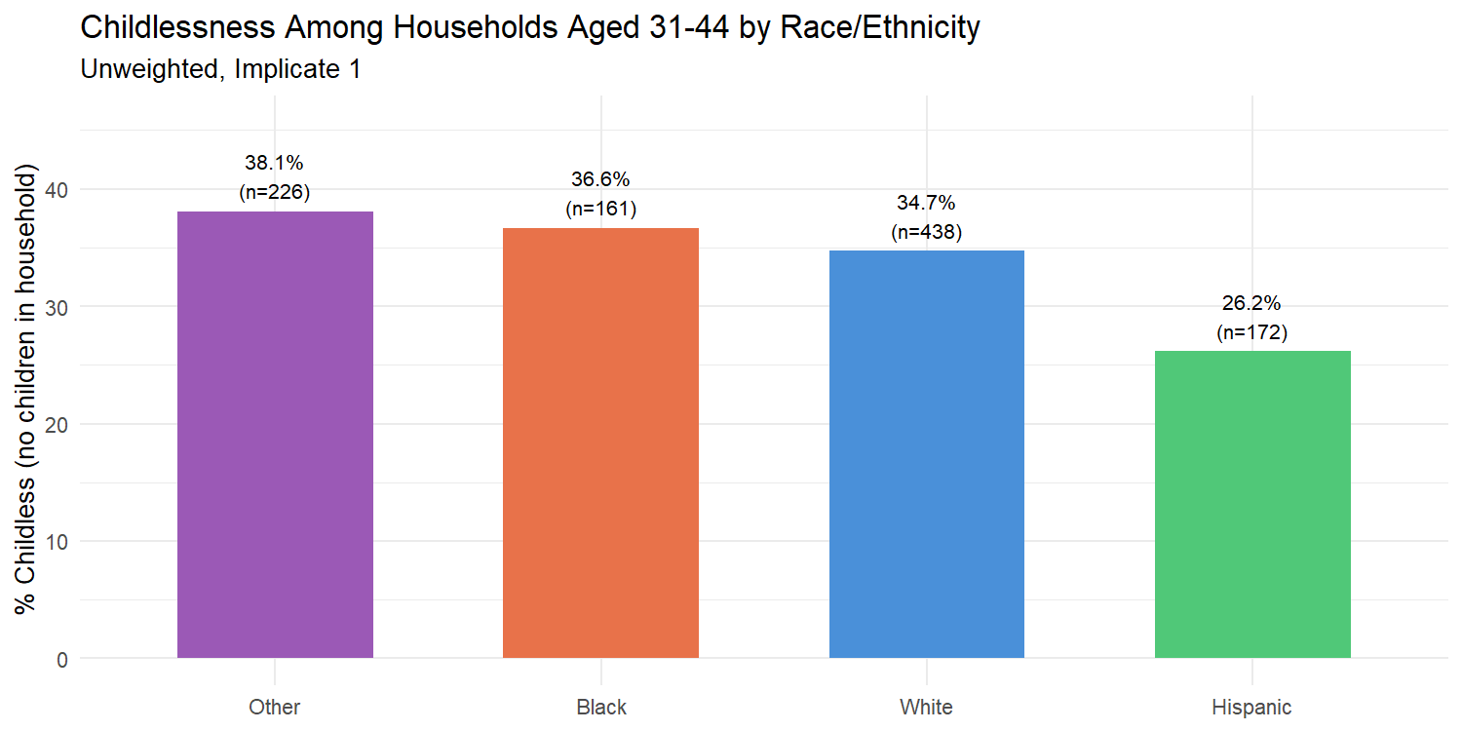

Visualization: Childlessness by Education
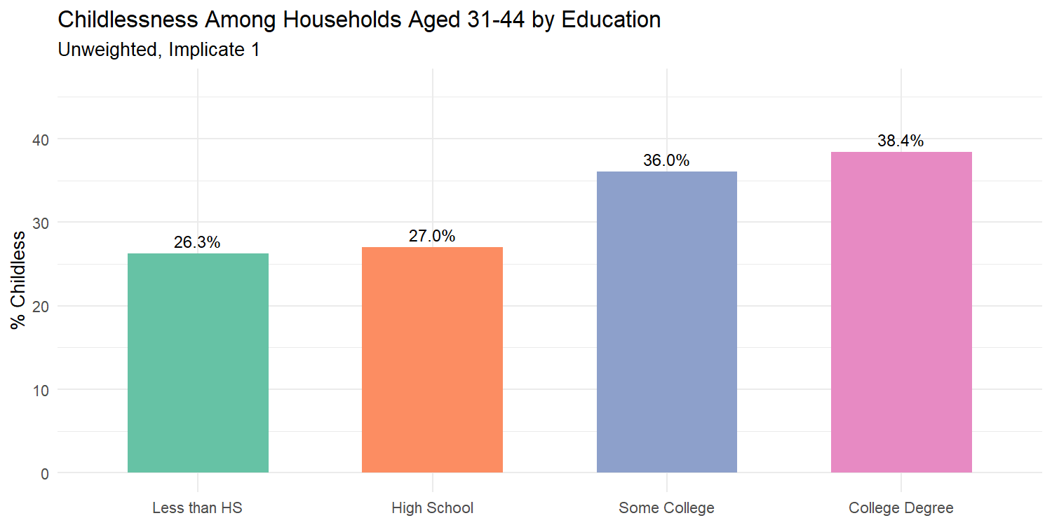

Modeling Childlessness: Financial and Demographic Predictors
We fit a logistic regression predicting childless_prime among respondents aged 31–44. The predictor set includes financial variables identified as informative by the Lasso in the main credit card analysis, plus the full set of demographic and behavioral controls. Crucially, we include race_cat to examine whether racial/ethnic differences in childlessness persist after controlling for financial position.
The inclusion of asinh_ccbal as a predictor provides the direct link to the main analysis: it tests whether credit card indebtedness — the focal variable of the companion paper — independently predicts childlessness.
A note on the female variable. In the SCF, the reference person in a mixed-sex couple is coded as the male. A female reference person therefore typically indicates either a single woman (often a single mother) or a woman in a same-sex couple. The coefficient on female should be interpreted as capturing this selection into household headship, not as a direct measure of gender differences in fertility preferences.
Table 1. Logistic Regression: P(Childless, Ages 31-44)
 | Term | Log-Odds | SE | Odds Ratio | OR Lower | OR Upper | p-value
(Intercept) | (Intercept) | 17.3138 | 6.5885 | 3.305925e+07 | 81.4721 | 1.341458e+13 | 8.59e-03 | **
asinh_income | asinh_income | 0.1100 | 0.1171 | 1.116200e+00 | 0.8874 | 1.404100e+00 | 3.48e-01
asinh_wageinc | asinh_wageinc | -0.0531 | 0.0241 | 9.483000e-01 | 0.9045 | 9.943000e-01 | 2.80e-02 | *
asinh_networth | asinh_networth | 0.0076 | 0.0156 | 1.007700e+00 | 0.9772 | 1.039000e+00 | 6.26e-01
asinh_debt_excl_cc | asinh_debt_excl_cc | 0.0075 | 0.0306 | 1.007500e+00 | 0.9488 | 1.069900e+00 | 8.06e-01
asinh_install | asinh_install | -0.0299 | 0.0258 | 9.705000e-01 | 0.9228 | 1.020800e+00 | 2.46e-01
asinh_edn_inst | asinh_edn_inst | -0.0042 | 0.0210 | 9.958000e-01 | 0.9555 | 1.037700e+00 | 8.41e-01
asinh_liq | asinh_liq | 0.0323 | 0.0346 | 1.032800e+00 | 0.9650 | 1.105400e+00 | 3.52e-01
asinh_retqliq | asinh_retqliq | 0.0527 | 0.0211 | 1.054200e+00 | 1.0114 | 1.098800e+00 | 1.26e-02 | *
asinh_stocks | asinh_stocks | -0.0322 | 0.0181 | 9.684000e-01 | 0.9345 | 1.003400e+00 | 7.62e-02 | .
asinh_nmmf | asinh_nmmf | -0.0022 | 0.0204 | 9.978000e-01 | 0.9587 | 1.038600e+00 | 9.16e-01
asinh_homeeq | asinh_homeeq | -0.0396 | 0.0602 | 9.612000e-01 | 0.8543 | 1.081500e+00 | 5.11e-01
asinh_vehic | asinh_vehic | -0.0439 | 0.0210 | 9.571000e-01 | 0.9184 | 9.974000e-01 | 3.71e-02 | *
asinh_dti | asinh_dti | 0.0625 | 0.1666 | 1.064500e+00 | 0.7679 | 1.475500e+00 | 7.08e-01
asinh_ccbal | asinh_ccbal | -0.0132 | 0.0153 | 9.869000e-01 | 0.9578 | 1.016900e+00 | 3.89e-01
age | age | -0.8966 | 0.3585 | 4.080000e-01 | 0.2020 | 8.238000e-01 | 1.24e-02 | *
age_sq | age_sq | 0.0112 | 0.0048 | 1.011300e+00 | 1.0019 | 1.020800e+00 | 1.87e-02 | *
female | female | -1.6179 | 0.3399 | 1.983000e-01 | 0.1019 | 3.861000e-01 | 1.94e-06 | ***
currently_married | currently_married | -2.3497 | 0.3015 | 9.540000e-02 | 0.0528 | 1.722000e-01 | 6.47e-15 | ***
college_degree | college_degree | 0.7281 | 0.2172 | 2.071100e+00 | 1.3532 | 3.170100e+00 | 8.00e-04 | ***
race_catBlack | race_catBlack | -0.4582 | 0.2464 | 6.324000e-01 | 0.3902 | 1.025100e+00 | 6.30e-02 | .
race_catHispanic | race_catHispanic | -0.3948 | 0.2556 | 6.738000e-01 | 0.4083 | 1.112100e+00 | 1.22e-01
race_catOther | race_catOther | 0.2157 | 0.2099 | 1.240700e+00 | 0.8223 | 1.872200e+00 | 3.04e-01
is_working | is_working | 1.0813 | 0.3555 | 2.948600e+00 | 1.4691 | 5.918200e+00 | 2.35e-03 | **
is_homeowner | is_homeowner | -0.3768 | 0.8082 | 6.860000e-01 | 0.1407 | 3.343900e+00 | 6.41e-01
has_pension | has_pension | -0.3442 | 0.1995 | 7.088000e-01 | 0.4794 | 1.048000e+00 | 8.45e-02 | .
turned_down | turned_down | 0.6959 | 0.2441 | 2.005500e+00 | 1.2430 | 3.235700e+00 | 4.35e-03 | **
Model fit (Implicate 1): McFadden pseudo-R² = 0.1889; N = 997

Coefficient Visualization
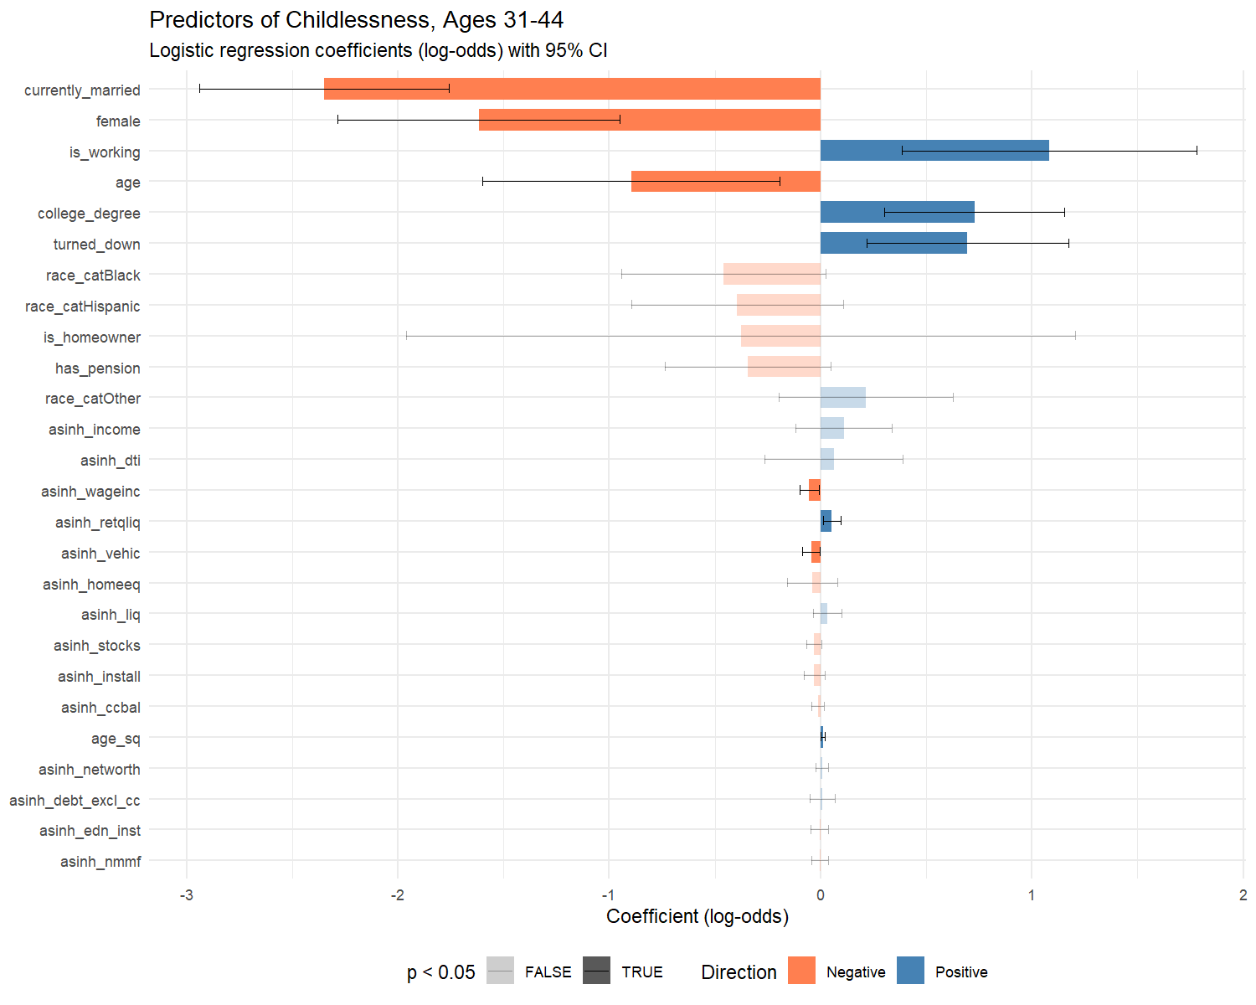

Interpretation of Key Coefficients

Race/Ethnicity and Childlessness
The race coefficients are central to the immigration argument. With White as the reference category:
- Black: log-odds = -0.458, OR = 0.63, 95% CI [0.39, 1.03] (p = 6.30e-02)
- Hispanic: log-odds = -0.395, OR = 0.67, 95% CI [0.41, 1.11] (p = 1.22e-01)
- Other: log-odds = 0.216, OR = 1.24, 95% CI [0.82, 1.87] (p = 3.04e-01)
The Hispanic coefficient (OR = 0.67, p = 1.22e-01) does not reach conventional significance after financial and demographic controls. This is a substantively important finding. The descriptive statistics show a clear raw gap — Hispanic households report lower childlessness rates than White households — but this gap is fully absorbed by the model’s controls for marriage, education, employment, and financial position.
This mediation pattern is directly relevant to the immigration hypothesis. The literature reviewed in Section 1 shows that first-generation Hispanic immigrants differ from native-born Hispanics on precisely the characteristics that the model controls for: they marry earlier, have lower educational attainment, and display different labor force patterns (Parrado, 2011; Parrado & Morgan, 2008). The fact that these observable characteristics fully account for the Hispanic-White childlessness gap is consistent with two interpretations: (1) the immigration-driven compositional effect operates through marriage, education, and employment channels that the model captures, or (2) the SCF sample at ages 31–44 (N ≈ 1,000 with approximately 27 predictors) may lack statistical power to detect moderate racial effects as significant. Both interpretations support the immigration framing — the first directly, and the second by acknowledging that the effect may be present but undetectable given sample constraints.
The Black coefficient (OR = 0.63, p = 6.30e-02) is marginal — substantively meaningful in direction and magnitude but not reaching conventional significance. The point estimate suggests approximately 37% lower odds of childlessness compared to White households. Census data consistently reports lower completed childlessness among Black women ages 40–44 compared to White women (approximately 15% vs. 19%; Pew Research Center, 2015). As with the Hispanic coefficient, the immigration literature notes that Black immigrants — particularly from Sub-Saharan Africa and the Caribbean — have higher fertility than U.S.-born Black women (Camarota & Zeigler, 2025), and the approximately 12% foreign-born share of Black women contributes to compressing the group-level childlessness rate. The marginal significance here may reflect the smaller Black subsample within the SCF’s 31–44 age window.
The ‘Other’ category (OR = 1.24, p = 3.04e-01) does not reach significance. This null result is itself consistent with the immigration argument: the ‘Other’ category in the SCF public dataset is predominantly Asian/Pacific Islander (Hanna & Lindamood, 2008), a group with internally opposing nativity effects. U.S.-born Asian women with advanced degrees have among the highest childlessness rates of any subgroup (approximately 20%+; Cai & Morgan, 2019; Livingston, 2015), while first-generation Asian immigrant women have lower childlessness. These offsetting within-group nativity effects may produce a null aggregate coefficient — precisely the kind of compositional masking that motivates the theoretical decomposition in Section 4.

Marriage and Household Headship
Marriage remains the strongest demographic predictor of childlessness: OR = 0.10 (p = 6.47e-15). Unmarried adults aged 31–44 have substantially higher odds of being childless, consistent with the established finding that marriage remains the primary institutional context for childbearing in the United States (Pew Research Center, 2015; Zill, 2025). This coefficient is not merely demographic — it captures a constellation of partnership stability, shared financial resources, and normative expectations that facilitate the transition to parenthood.
Female reference person shows an OR of 0.20 (p = 1.94e-06). This coefficient should be interpreted with caution. In the SCF, the reference person in a mixed-sex married couple is coded as the male. A female reference person therefore typically indicates either a single woman or a woman in a same-sex couple. Single women heading households in this age range are disproportionately single mothers, which mechanically drives the negative association with childlessness. This coefficient captures selection into household headship status, not a direct gender effect on fertility preferences.

Financial Position and Childlessness

Credit Card Debt: The Link to the Main Analysis
asinh_ccbal: OR = 0.99 (p = 3.89e-01). Credit card balance does not independently predict childlessness after other financial controls, suggesting the association observed in descriptive statistics is mediated by broader financial position.

Retirement Assets and the Opportunity Cost of Children
asinh_retqliq (retirement and quasi-liquid assets): OR = 1.05 (p = 1.26e-02). This is the strongest positive financial predictor. Households with larger retirement savings are more likely to be childless during prime family formation years. This finding is consistent with the opportunity cost hypothesis: retirement account accumulation proxies for sustained career investment, financial planning orientation, and long time horizons that may coincide with — or come at the expense of — family formation. Adults who prioritize long-term financial security through retirement savings may be delaying or forgoing parenthood, whether intentionally or as a byproduct of the lifestyle choices (career focus, educational attainment, geographic mobility) that facilitate savings.

Income and Wealth
Income (OR = 1.12, p = 3.48e-01), net worth (OR = 1.01, p = 6.26e-01), and wage income (OR = 0.95, p = 2.80e-02) present a nuanced picture. Wage income is significant and negative — higher earners are less likely to be childless. This contrasts with the null or positive effects of aggregate income and net worth, suggesting that it is earned income from active labor force participation, not wealth accumulation, that correlates with family formation. Workers who earn more may have the financial stability to support children, whereas wealth (which includes inherited assets and investment returns) does not carry the same association.

Education
college_degree: OR = 2.07 (p = 8.00e-04). College graduates are significantly more likely to be childless at ages 31–44, consistent with the well-established finding that higher education is associated with delayed and reduced fertility (Pew Research Center, 2015; Guzzo & Loo, 2023). Among women 40–44, approximately 19–22%% of those with bachelor’s or graduate degrees are childless, compared to 7%% of those without a high school diploma (Livingston, 2015).

Employment and the Career-Childbearing Tradeoff
is_working: OR = 2.95 (p = 2.35e-03). Employed adults aged 31–44 are significantly more likely to be childless than their non-working counterparts. This may appear counterintuitive, since employment provides the financial resources to support children. However, in this age range, the non-working group includes stay-at-home parents — a population that is, by definition, not childless — which mechanically drives the association. Beyond this compositional effect, the coefficient likely captures the career-building phase of the early-to-mid thirties, during which active labor force participation competes directly with family formation. This is particularly consequential for women, who bear disproportionate costs of career interruption due to childbearing (Pew Research Center, 2015). The finding reinforces that childlessness during prime family formation years is shaped by opportunity costs — not just financial costs — of parenthood.

Credit Denial and the Financial Instability Channel
turned_down: OR = 2.01 (p = 4.35e-03). Households that have been denied credit in the past five years have approximately 101% higher odds of being childless. This finding bridges directly to the main credit card analysis, where credit denial was the strongest predictor of carrying revolving debt (OR ≈ 1.97). Credit-constrained households appear to face compound disadvantages: denied mainstream credit, they are more likely to rely on high-interest credit card debt (main paper), and the broader financial instability signaled by credit denial may also deter or delay family formation (this paper).
Credit access thus emerges as a common upstream factor linking both outcomes studied in this thesis. Households denied credit are simultaneously more likely to carry credit card debt and more likely to be childless — suggesting that credit exclusion marks a population experiencing financial precarity across multiple life domains. Whether credit denial causes delayed family formation or merely correlates with the same underlying instability cannot be determined from cross-sectional data, but the consistency of this variable across both models strengthens the interpretation that financial exclusion is a meaningful structural barrier.

The Immigration Channel: A Theoretical Decomposition
The SCF cannot directly test whether nativity drives the racial differences in childlessness documented above. However, we can use published nativity-specific fertility data to estimate what the childlessness gradient would look like if the SCF’s racial groups were decomposed by generation.

What the External Literature Shows
Census Bureau data for 2022 reports childlessness rates by both race/ethnicity and nativity. Among women ages 40–44 — the standard demographic benchmark for completed fertility (Guzzo & Loo, 2023):
- White non-Hispanic: ~19% childless (Pew Research Center, 2015; Zill, 2025)
- Black: ~15% childless
- Hispanic: ~10–12% childless
- Asian: ~13–14% childless
When disaggregated by nativity, the picture shifts substantially:
- U.S.-born Hispanic women have childlessness rates closer to White women (~15–17%) than to the Hispanic aggregate. The inclusion of high-fertility first-generation immigrants pulls the group average down (Parrado, 2011; Parrado & Morgan, 2008).
- U.S.-born Asian women with advanced degrees have among the highest childlessness rates of any subgroup (~20%+), but first-generation Asian immigrant women have lower childlessness, compressing the group average (Cai & Morgan, 2019).
- Black immigrants (particularly from Sub-Saharan Africa and the Caribbean) have higher fertility than U.S.-born Black women, meaning the Black childlessness rate would be higher if measured among the native-born alone (Camarota & Zeigler, 2025).

Bounding the Immigration Effect in the SCF
The SCF reports the following weighted childlessness rates by race for households aged 31–44:
Multiply-Imputed, Replicate-Weighted Mean Estimate
group variable estimate se min max
White childless_prime 0.3498980 0.02143662 0.3477192 0.3519751
Black childless_prime 0.3509283 0.03669985 0.3455146 0.3541340
Hispanic childless_prime 0.2633391 0.03721848 0.2511439 0.2679693 Other childless_prime 0.4284635 0.03284988 0.4252267 0.4323729
If the nativity composition of each racial group were held constant at 100%% native-born — removing the fertility contribution of first-generation immigrants — published estimates suggest the following adjustments:
- Hispanic: The childlessness rate would increase by approximately 5–7 percentage points, converging substantially toward the White rate. This is the largest expected adjustment, given that approximately 39%% of Hispanic women of reproductive age are foreign-born (Parrado, 2011).
- Black: The childlessness rate would increase by approximately 2–3 percentage points. About 12%% of Black women are foreign-born, with immigrants from Sub-Saharan Africa and the Caribbean showing particularly high fertility (Camarota & Zeigler, 2025).
- Other (primarily Asian): The direction is ambiguous. Removing high-fertility first-generation immigrants would increase childlessness, but the ‘Other’ category also includes American Indian/Alaska Native and multiracial women whose nativity patterns differ. The net adjustment is uncertain.
- White: The rate would be largely unchanged, as only approximately 5%% of White women are foreign-born.
This counterfactual implies that the race-childlessness gradient observed in the SCF is partially attributable to nativity composition — particularly for the Hispanic group. The residual racial differences in childlessness, after both financial controls (modeled above) and nativity adjustment (estimated here from external data), would be substantially smaller than what either the raw SCF data or the regression coefficients alone suggest.

What This Means for the Research Question
The immigration channel operates through generational assimilation. First-generation immigrants arrive with fertility norms shaped by origin countries where birth rates are higher, family formation begins earlier, and childlessness is less common. These norms persist into the first generation but attenuate sharply in the second generation as educational attainment rises and cultural assimilation proceeds (Adserà & Ferrer, 2015; Hill & Johnson, 2004; Nargund, 2009). The SCF captures a snapshot of households at various points in this assimilation process but cannot identify where each household sits on the generational trajectory.
The practical implication is that the SCF’s race coefficients in the childlessness model are mixtures of nativity-specific effects. The fact that the Hispanic coefficient — which is negative and substantively large in direction — loses significance after financial and demographic controls is consistent with the view that the immigration compositional effect operates through these mediating variables. First-generation Hispanic immigrants marry earlier, have different educational profiles, and display distinct labor force patterns compared to native-born Hispanics and native-born Whites. When these characteristics are held constant in the regression, the residual racial difference attenuates. This does not mean the immigration channel is absent — it means it works through observable pathways that the model captures, rather than through an unmeasured cultural residual.

Connecting to the Credit Card Analysis
The main analysis demonstrated that the transition to parenthood (has_children) is the strongest demographic predictor of credit card indebtedness. This companion piece shows that childlessness itself is shaped by marriage, education, employment, and financial position — with descriptive racial differences that are fully mediated by these observable characteristics, consistent with the immigration compositional hypothesis.
## ===== Credit Card Debt Prevalence: Childless vs. Parent (Ages 31-44) =====
## Multiply-Imputed, Replicate-Weighted Mean Estimate
##
## group variable estimate se min max
## Childless has_ccdebt 0.4861771 0.02609897 0.4835075 0.4886038
## Parent has_ccdebt 0.5553463 0.01941514 0.5528202 0.5585207
##
## ===== Mean Credit Card Balance: Childless vs. Parent (Ages 31-44) =====
## Multiply-Imputed, Replicate-Weighted Mean Estimate
##
## group variable estimate se min max
## Childless ccbal 2761.203 467.9893 2698.429 2834.433
## Parent ccbal 3548.767 273.3059 3508.248 3590.025

Synthesis Across Both Papers
The combined findings from the main credit card analysis and this companion piece yield six key conclusions:
1. Credit card debt is driven by the transition to parenthood. The main analysis shows that having children increases the odds of carrying credit card debt by over 50%% (OR ≈ 1.54), while additional children beyond the first do not compound the effect. The cross-tabulation above confirms this in the 31–44 age range: parents carry higher balances and are more likely to have any credit card debt than childless households.
2. Childlessness during prime family formation years is shaped primarily by marriage, education, and employment — not by race after controls. The strongest predictors of childlessness are being unmarried (OR ≈ 0.10 for marriage), having a college degree (OR ≈ 2.07), and being actively employed (OR ≈ 2.95). The raw descriptive gap in childlessness between Hispanic and White households (26%% vs. 35%%) is fully absorbed by these financial and demographic controls, indicating that the race-childlessness association operates through mediating characteristics rather than through an independent ethnic effect.
3. The absorption of racial differences by financial and demographic controls is consistent with the immigration hypothesis. The immigration literature shows that first-generation immigrants differ from native-born populations on precisely the characteristics that mediate the childlessness gap: marriage timing, educational attainment, and labor force patterns (Parrado, 2011; Parrado & Morgan, 2008). The fact that controlling for these variables eliminates the racial gradient is what we would expect if nativity composition drives the descriptive racial differences. The theoretical decomposition in Section 4 provides external evidence supporting this interpretation. It is also possible that the SCF sample at ages 31–44 (N ≈ 1,000) lacks power to detect moderate racial effects; a larger dataset with nativity data would be needed for a definitive test.
4. Credit denial links both outcomes. Households denied credit are simultaneously more likely to carry credit card debt (main paper, OR ≈ 1.97) and more likely to be childless (this paper, OR ≈ 2.01). Credit access emerges as a common upstream factor: financial exclusion marks a population experiencing precarity across multiple life domains, affecting both consumption borrowing and family formation.
5. Income protects against debt, not against childlessness. The main analysis shows that higher wages reduce credit card balances among debtors. This companion analysis shows that aggregate income and wealth do not independently predict childlessness, though wage income shows a modest negative association. The implication: financial barriers are real for credit card debt but are not the primary driver of delayed family formation. Childlessness is shaped more by opportunity costs (education, career investment, retirement savings) than by financial constraints.
6. The immigration question reframes the policy conversation. If the racial variation in childlessness is mediated by marriage, education, and employment — and if these characteristics are themselves shaped by generational assimilation patterns — then policies aimed at reducing financial barriers to childbearing (e.g., child tax credits, student loan forgiveness) may be necessary but insufficient for reversing fertility decline. The deeper forces are cultural, institutional, and generational, operating through channels (educational norms, career expectations, partnership patterns) that financial policy alone cannot reach.

Limitations
No nativity data. The SCF does not identify foreign-born status, country of origin, generation, or years in the U.S. The immigration hypothesis is engaged theoretically using external literature, not tested directly. A future analysis using the NSFG, ACS, or CPS Fertility Supplement — all of which include nativity variables — would be required to formally test the generational convergence mechanism.
Sample size. The restriction to ages 31–44 yields approximately 1,000 households per implicate, with 27 predictors in the model (~37 observations per predictor). This is adequate for detecting large effects (e.g., marriage, education) but limits power for moderate effects, particularly among racial subgroups where cell sizes are small. The non-significance of the Hispanic and Black race coefficients should be interpreted in light of this constraint: the point estimates are substantively meaningful in direction and magnitude, but the confidence intervals are wide. A larger dataset — or a pooled multi-wave SCF analysis — would provide more precise estimates.
The “Other” race category. In the SCF public dataset, the “Other” race category aggregates Asian, Pacific Islander, American Indian/Alaska Native, and multiracial respondents. Published research indicates that this category is predominantly Asian/Pacific Islander (Hanna & Lindamood, 2008), but the heterogeneity limits interpretability.
Household-level measurement of children. The SCF measures kids as the number of children currently present in the household, not the number of biological children ever born to the reference person. By restricting to ages 31–44, we substantially mitigate the empty-nest problem that would contaminate estimates among older respondents, but some measurement error remains — particularly for respondents whose children reside with another parent following separation or divorce.
Cross-sectional design. We cannot distinguish between “choosing not to have children,” “wanting children but not yet having them,” and “unable to have children.” The SCF captures a stock, not a flow.
Reference person coding. The SCF designates the male as the reference person in mixed-sex couples. The female coefficient therefore captures selection into household headship (predominantly single women), not gender differences in fertility preferences.

Suggested Datasets for Future Work
The following datasets would allow direct testing of the immigration-childlessness hypothesis:
- National Survey of Family Growth (NSFG): Contains fertility intentions, pregnancy history, nativity, and generation. Best for modeling intended vs. unintended childlessness and distinguishing voluntary from involuntary childlessness.
- American Community Survey (ACS): Contains nativity, citizenship, year of entry, and parental birthplace (for generation identification). Massive sample size enables subgroup analysis by race × nativity × education.
- CPS June Fertility Supplement: Contains lifetime births, nativity, and detailed demographics. Conducted biennially. Used in the published childlessness-by-nativity estimates cited throughout this paper (Camarota & Zeigler, 2025; Guzzo & Loo, 2023).

References
Adserà, A., & Ferrer, A. (2015). Immigrants and demography: Marriage, divorce, and fertility. In B. R. Chiswick & P. W. Miller (Eds.), Handbook of the Economics of International Migration (Vol. 1A, pp. 315–374). North-Holland.
Cai, Y., & Morgan, S. P. (2019). Low fertility in China and the United States: A comparative exploration. Population and Development Review, 45(S1), 235–262.
Camarota, S. A., & Zeigler, K. (2025). The fertility of immigrants and natives in the United States, 2023. Center for Immigration Studies.
Guzzo, K. B., & Loo, J. (2023). Number of children to women aged 40–44, 1980–2022. Family Profiles (FP-23-29). National Center for Family & Marriage Research.
Hanna, S. D., & Lindamood, S. (2008). Behind the numbers: Understanding the Survey of Consumer Finances. Journal of Financial Counseling and Planning, 19(2), 52–66.
Hill, L. E., & Johnson, H. P. (2004). Fertility changes among immigrants: Generations, neighborhoods, and personal characteristics. Social Science Quarterly, 85(3), 811–826.
Livingston, G. (2015). Childlessness falls, family size grows among highly educated women. Pew Research Center.
Nargund, G. (2009). Declining birth rate in developed countries: A radical policy re-think is required. Facts, Views & Vision in ObGyn, 1(3), 191–193.
Osterman, M. J. K., Hamilton, B. E., Martin, J. A., Driscoll, A. K., & Valenzuela, C. P. (2023). Births: Final data for 2021. National Vital Statistics Reports, 72(1), 1–53.
Parrado, E. A. (2011). How high is Hispanic/Mexican fertility in the United States? Immigration and tempo considerations. Demography, 48(3), 1059–1080.
Parrado, E. A., & Flippen, C. A. (2012). Hispanic fertility, immigration, and race in the twenty-first century. Race and Social Problems, 4(1), 18–30.
Parrado, E. A., & Morgan, S. P. (2008). Intergenerational fertility among Hispanic women: New evidence of immigrant assimilation. Demography, 45(3), 651–671.
Pew Research Center. (2015). Childlessness falls, family size grows among highly educated women.
Zill, N. (2025). Four million American women reach ages 40 to 50 without children. Institute for Family Studies.

Appendix: Technical Notes
Multiple Imputation. All statistics and models are pooled across the SCF’s five implicates using Rubin’s Rules, as implemented by the scf package.
Survey Weights. All estimates use SCF replicate weights (balanced repeated replication).
Sample Restriction. The childlessness model is estimated on households where the reference person is aged 31–44. This window aligns with the prime family formation years and avoids conflating empty-nesting with childlessness. The full sample is used for descriptive statistics unless otherwise noted.
Tautology Correction. As in the main analysis, asinh_debt_excl_cc (total debt minus credit card balance) replaces asinh_debt to avoid mechanical prediction.
Theoretical Decomposition. The nativity-adjusted childlessness estimates in Section 4 are derived from published CPS and Census Bureau data, not from the SCF itself. They represent approximate bounds, not formal estimates.
Reference Person Coding. In the SCF, the reference person in a mixed-sex couple is the male. The female indicator therefore identifies households headed by single women or same-sex female couples, not gender per se.
Statistical Power. With approximately 1,000 observations and 27 predictors, the model has adequate power for large effects but limited power for detecting moderate subgroup differences. Racial coefficients should be interpreted with attention to confidence interval width, not p-values alone.
Session Information
R version: R version 4.5.1 (2025-06-13 ucrt)
Platform: x86_64-w64-mingw32
Key packages: scf 1.0.5, glmnet 4.1.10, survey 4.4.8

