Segmented Assimilation in the American Financial System: Origin-Based Gradients in Immigrant Household Finances
  - Evidence from the 2022 Survey of Consumer Finances
Delroy Nichols
2026-05-06
Table of Contents

Origin-Based Gradients in Immigrant Household Finances

Abstract
For decades, scholars have debated what dictates an immigrant’s financial trajectory in the United States. The human-capital convergence model argues that education, income, and time spent in the U.S. act as great equalizers, eventually erasing financial differences between groups. In contrast, the segmented-assimilation framework contends that structural and racial barriers force immigrants from different origin regions into distinct, inescapable financial destinies. Because historical wealth surveys did not track national origin, these competing theories could never be directly tested against U.S. household wealth—until now.
Utilizing newly added national-origin variables from the 2022 Survey of Consumer Finances (SCF), this paper analyzes the financial outcomes of 1,103 foreign-born households. Across three key markers of wealth and credit access—retirement-account ownership, credit denial, and homeownership, one per theoretical pathway—the findings decisively favor the human-capital convergence model. The data reveal that once education, income, and duration of U.S. residence are accounted for, a household’s region of origin exerts no statistically detectable independent effect on its financial success. This absence of origin-based financial divergence persists even when stratifying the sample to look exclusively at recent arrivals (≤15 years in the U.S.). By demonstrating that human capital and time override origin-based barriers in wealth accumulation, this study clarifies the empirical limits of segmented-assimilation theory in the U.S. wealth context and suggests that policy frameworks built around broad race and human-capital categories remain the appropriate analytical lens for studying immigrant financial outcomes.
Data Source: 2022 Survey of Consumer Finances (SCF), Federal Reserve Board. All estimates are survey-weighted; all models are pooled across the SCF’s five multiply- imputed datasets using Rubin’s Rules.
Note on Scope: All findings are correlational and limited to the foreign-born respondent sample. The SCF’s cross-sectional design and absence of parental nativity preclude causal claims and intergenerational analysis.

Introduction: The Immigrant Wealth Debate
When a foreign-born household settles in the United States, what ultimately dictates its financial future? For decades, economists and sociologists have fiercely debated whether an immigrant’s trajectory is determined by individual effort and time, or by enduring structural barriers tied to where they come from.
At the heart of this debate are two competing theoretical models. The first, the human-capital convergence model (Borjas, 1987, 1999), views the American economy as a great equalizer. Foundational studies by Chiswick (1978) and Blau and Graham (1990) contend that factors such as education, English proficiency, age at arrival, and time spent in the U.S. sufficiently account for economic outcomes. In this view, once you control for a household’s “human capital” and how long they have had to build a life in their new country, their region of origin has no independent effect on their financial success.
The second model, the segmented-assimilation framework, makes the exact opposite prediction. Developed by Alejandro Portes, Rubén Rumbaut, and Min Zhou (Portes & Zhou, 1993; Portes & Rumbaut, 2001), this theory argues that American society is highly stratified. It posits that the context of an immigrant’s reception—including racial prejudices, neighborhood disparities, and labor-market structures—differs systematically across origin groups (Zhou, 1997). Consequently, immigrants are forced into three distinct incorporation pathways: parallel integration into the white middle class, downward assimilation into a racialized underclass through structural exclusion, or selective assimilation, where wealth is built primarily through ethnic-community networks. According to this theory, a Mexican-origin household and an Asian-origin household with identical college degrees and incomes might still experience vastly different access to mainstream financial institutions simply because of their origin.
Until very recently, it was impossible to directly test which of these theories accurately describes immigrant wealth building in the U.S. While previous nationally representative wealth surveys could identify if a respondent was foreign-born, they did not collect detail on the specific region of origin. That changed with the 2022 wave of the Survey of Consumer Finances (SCF). By adding new variables tracking respondent and spouse national origin alongside the exact number of years lived in the United States, the 2022 SCF provided the first nationally representative dataset capable of answering this question.
This paper utilizes this unprecedented data to put these two competing theoretical models head-to-head. By analyzing the financial outcomes of foreign-born households across three key markers of wealth and credit access—retirement-account ownership, credit denial, and homeownership, with one outcome chosen for each of the three theoretical pathways—this study provides an unbiased empirical test of whether origin region exerts an independent effect on household finances.
The findings are definitive: when it comes to U.S. household wealth, the data strongly favor the human-capital convergence model. As this paper will demonstrate, once education, income, and duration of U.S. residence are accounted for, the differences between origin regions largely disappear. Rather than sorting into the distinct, inescapable pathways predicted by segmented assimilation, immigrant wealth accumulation is driven overwhelmingly by time and human capital.

Why This Matters: Beyond Race-Only Frameworks
The debate between human-capital convergence and segmented assimilation is not merely an academic exercise; it has profound implications for how we understand and address inequality in America. Historically, wealth and credit access disparities have been studied primarily through the lens of broad racial categories. Studies comparing Black, Hispanic, and White households often treat these populations as homogeneous. However, prior sociological research suggests that distinct groups—such as Black Caribbeans, Mexican-origin Hispanics, and Cuban-origin Hispanics—may experience vastly different financial trajectories due to their unique migration histories and community resources (Logan, 2007; Smith, 2015; Telles & Ortiz, 2008).
The 2022 SCF allows the field to finally test whether the divergent pathways predicted by segmented assimilation actually appear in national wealth data with enough magnitude to distinguish these origin groups. The policy stakes are significant. If segmented assimilation accurately describes immigrant wealth building, then financial interventions designed broadly for “Hispanic” or “Asian” households are fundamentally flawed and must be redesigned to address deep, origin-specific heterogeneity. If, however, the data support human-capital convergence, then existing race-based and income-based frameworks remain the appropriate analytical lens for studying U.S. immigrant wealth outcomes—not because those frameworks have already closed observed disparities, but because the within-race-category origin distinctions that segmented-assimilation theory proposes do not appear to organize foreign-born households’ financial lives in a way the SCF can detect.

Variable Availability and Diagnostic
Before constructing variables, we check which of the variables having direct exposure without segmented assimilation theory are actually available in the loaded scf package object. The standard SCF Bulletin extract that the scf package builds does not by default include the new national-origin or years-in-U.S. items (X6906, X7404, X6915); these are raw codebook items rather than constructed Bulletin variables. If they are missing, we read the raw 2022 SCF .rds file directly and merge them in by household ID.
Immigration-variable availability in the scf package extract:
Variable | In extract
X6915 | No
X6906 | No
X7796 | No
X7404 | No
X8000 | No
X8049 | No
Some required immigration variables are missing from the bulletin extract. Attempting to merge them in from the raw 2022 SCF data file…
## Successfully merged 6 immigration variables from scf_data/p22i6.rds into all 5 implicates.
Raw X7404 frequency (Implicate 1, unweighted):
X7404 = respondent national origin
X7404 | n
5 | 2319
0 | 1800
1 | 476
This table guides the origin-region recode in the next chunk. Code 0 typically indicates ‘inapplicable’ (i.e., U.S.-born or non-respondent).
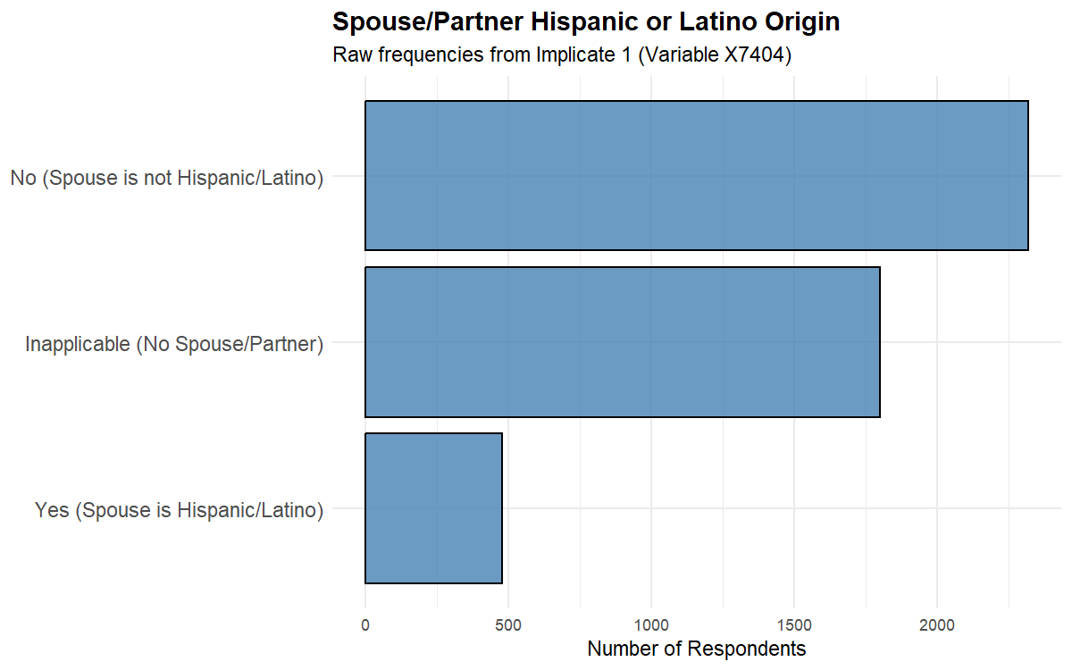
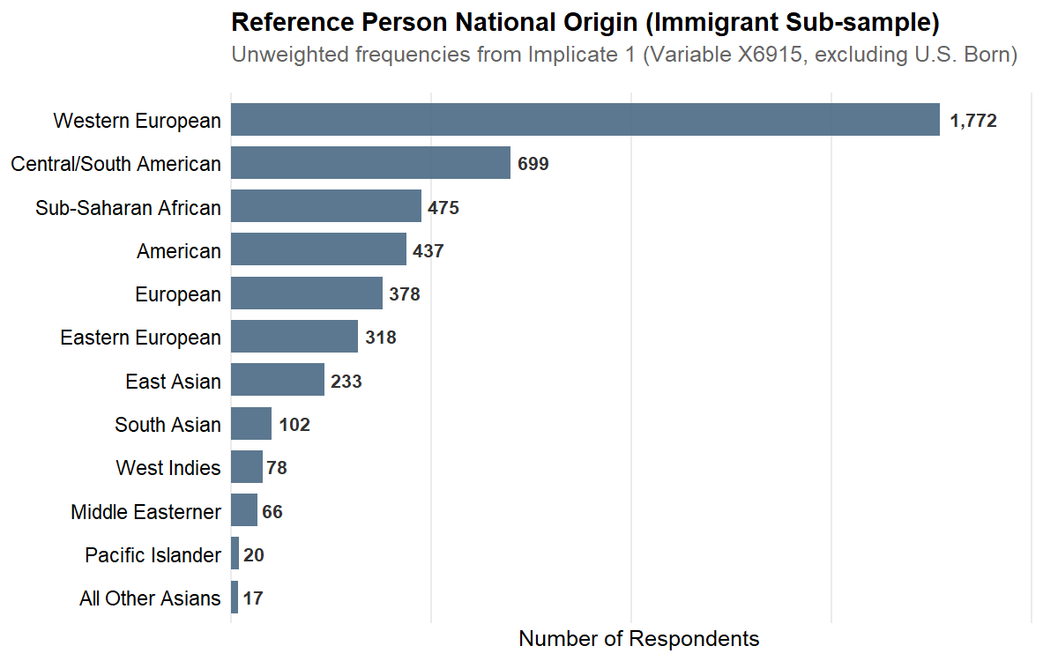
Raw X6915 frequency (Implicate 1, unweighted):
X6915 | n
100 | 1772
500 | 699
700 | 475
1200 | 437
300 | 378
200 | 318
900 | 233
800 | 102
400 | 78
600 | 66
1100 | 20
1000 | 17

Variable Engineering

Descriptive Findings

Foreign-Born Identification Diagnostic
The corrected foreign_born definition requires both ancestry indicating non-U.S. origin (X6915 ≠ 0 and X6915 ≠ 1200) AND positive years in the U.S. (X6906). The table below shows, for each X6915 ancestry code, what percentage of respondents end up classified as foreign-born. Codes like 100 (Western European), 200 (Eastern European), and 1200 (American) should be near 0%; codes like 500 (Latin American), 800/900 (Asian), and 600 (Middle Eastern) should be near 100%.
Table 0. Foreign-born identification by X6915 ancestry code
Foreign-born flag = X6915 ∈ origin codes AND years_in_us > 0.
X6915 | Ancestry label | n total | n foreign-born | % foreign-born
100 | Western European | 1772 | 285 | 16.1
500 | Central / South American | 699 | 395 | 56.5
700 | Sub-Saharan African | 475 | 121 | 25.5
1200 | American | 437 | 0 | 0.0
300 | European (Other) | 378 | 82 | 21.7
200 | Eastern European | 318 | 61 | 19.2
900 | East Asian | 233 | 141 | 60.5
800 | South Asian | 102 | 72 | 70.6
400 | West Indies / Caribbean | 78 | 44 | 56.4
600 | Middle Eastern | 66 | 31 | 47.0
1100 | Pacific Islander | 20 | 5 | 25.0
1000 | All Other Asian | 17 | 6 | 35.3

Foreign-Born Sample Composition
The analytic sample comprises 1,103 foreign-born respondents in the 2022 SCF aged 25-75. Using survey weights, the mean age in this population is 50.3 years, with a mean of 36.8 years lived in the U.S. Mean household income is $144,556 and median net worth is $386,300. Note: 0.0% of foreign-born respondents have missing years-in-U.S. data; the missing-indicator method is used in regressions to retain these observations.

Origin-Region Distribution
Table 1. Foreign-born sample by origin region (2022 SCF)
Note: percentages are SCF-weighted; n is unweighted (Implicate 1).
Origin Region | n (Unweighted) | % (Weighted)
Latin American | 344 | 31.2
Caribbean/West Indies | 40 | 4.3
Asian | 198 | 16.7
European/Other developed | 387 | 34.3
Other | 134 | 13.5

Outcome Prevalence by Origin Region
Table 2. Weighted prevalence of financial outcomes by origin region
All estimates are SCF-weighted and pooled across implicates.
Origin Region | Retirement (%) | Credit denied (%) | Homeowner (%)
Latin American | 58.0 | 9.5 | 66.5
Caribbean/West Indies | 65.4 | 8.2 | 73.0
Asian | 58.7 | 10.0 | 64.9
European/Other developed | 57.4 | 10.3 | 65.8
Other | 54.3 | 8.7 | 68.7

Years-in-U.S. Distribution by Origin Region
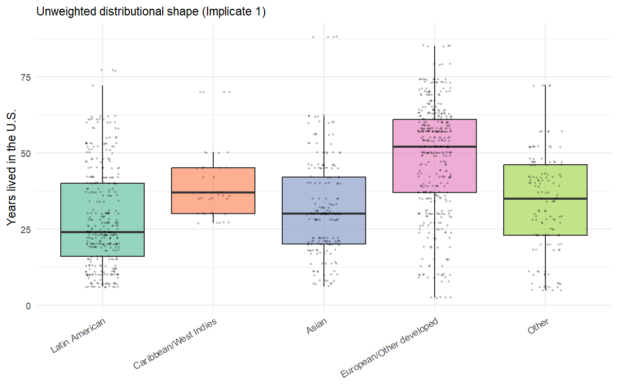
Distribution of years lived in the U.S. by origin region (foreign-born SCF sample, 2022)

Modeling Results

H1: Origin-Region Main Effects
We test whether financial outcomes among foreign-born respondents differ by origin region net of years-in-U.S., age, education, marital status, and income. Logistic regression for binary outcomes (scf_glm with binomial()) and OLS for the continuous net-worth-percentile outcome (scf_ols). All models pool across the 5 implicates.
Mexican origin is the reference category — that is, the X6915=500 (“Central and South American”) group, which the segmented-assimilation literature treats as the canonical Latin American case. Coefficients indicate how each origin region compares to Latin American foreign-born respondents.
Reading the results. Each outcome is modeled with a single specification — origin region plus years-in-U.S., age, education, marital status, and log income — chosen to mirror the “Full” specification used in earlier drafts. The segmented-assimilation prediction is that origin-region coefficients should remain large and statistically significant net of human capital. The human-capital convergence prediction is that origin-region coefficients should be small and statistically indistinguishable from zero. Confidence intervals that include 1.0 (for odds ratios) indicate failure to reject the null hypothesis of no origin-region effect.
The analysis fits one model per pathway: retirement-account ownership for parallel integration, credit denial for downward assimilation, and homeownership for selective assimilation. This 1-model-per-hypothesis structure replaces the 6-outcome design used in earlier drafts; the additional outcomes (stocks, no-checking, net-worth percentile) showed within-pathway redundancy with the three retained outcomes and were cut to align the analytical structure with the three hypotheses.
Diagnostic: simple test fit using inline formula syntax (mimics Paper 1’s pattern)
- Inline test fit SUCCEEDED. scf_glm works on this design with origin_region as predictor.
- Coefficients returned: (Intercept), origin_regionCaribbean/West Indies, origin_regionAsian, origin_regionEuropean/Other developed, origin_regionOther
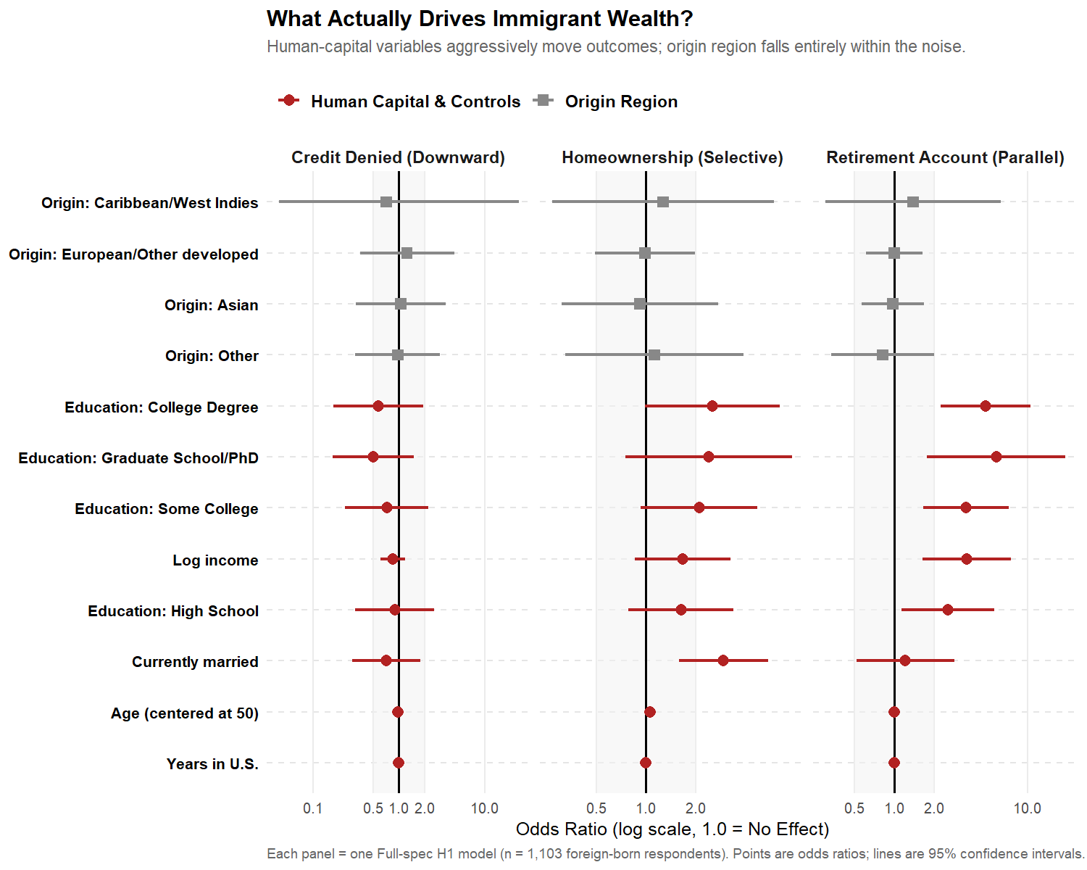

Parallel-integration outcome

Retirement Account Ownership
Retirement Account Ownership — Latin American origin = reference
Origin | OR | 95% CI | p-value
Caribbean/West Indies | 1.38 | [0.30, 6.28] | 0.67
Asian | 0.98 | [0.57, 1.68] | 0.93
European/Other developed | 1.00 | [0.61, 1.62] | 0.99
Other | 0.82 | [0.34, 1.99] | 0.66

Downward-assimilation outcome

Credit Denied or Got Less in Past Year
Credit Denied or Got Less in Past Year — Latin American origin = reference
Origin | OR | 95% CI | p-value
Caribbean/West Indies | 0.71 | [0.00, 527.60] | 0.92
Asian | 1.05 | [0.32, 3.49] | 0.94
European/Other developed | 1.24 | [0.35, 4.39] | 0.74
Other | 0.97 | [0.31, 3.01] | 0.95

Selective-assimilation outcome

Homeownership
Homeownership — Latin American origin = reference
Origin | OR | 95% CI | p-value
Caribbean/West Indies | 1.27 | [0.27, 6.02] | 0.76
Asian | 0.92 | [0.31, 2.75] | 0.88
European/Other developed | 0.99 | [0.49, 1.99] | 0.97
Other | 1.12 | [0.32, 3.90] | 0.86
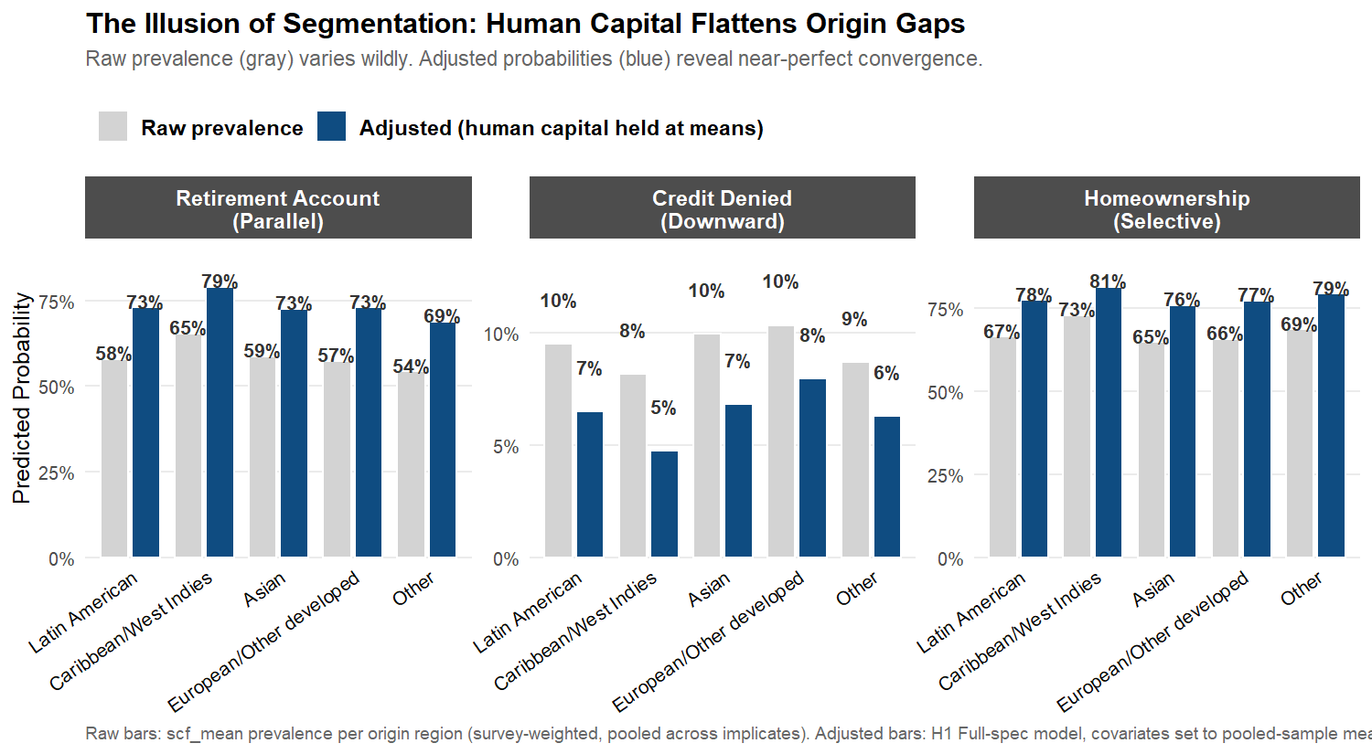

H2: Pathway-Pattern Tests
The three segmented-assimilation pathways predict distinct joint patterns of financial outcomes within each origin region. For instance, according to this framework, an origin group following the parallel-integration pathway, such as Asian or European immigrants, would be expected to exhibit elevated rates of retirement account ownership, while a group on the downward-assimilation pathway would show elevated credit denial. The pattern matrix below summarizes origin-region odds ratios for these three financial outcomes — one per pathway — enabling direct comparison of observed patterns with pathway-specific theoretical expectations derived from the H1 model specifications.
Three pathway-specific patterns would constitute affirmative evidence for segmented assimilation:
- Parallel-integration profile (Asian and European origin): elevated odds of retirement-account ownership relative to the Latin American reference.
- Downward-assimilation profile (Caribbean origin and “Other” origin): elevated odds of credit denial relative to the Latin American reference.
- Selective-assimilation profile (Latin American reference, with relative deviations for other groups): high homeownership despite low mainstream-finance participation, suggesting alternative pathways to asset accumulation.
The human-capital convergence model predicts none of these — odds ratios near 1.0 with confidence intervals straddling no-effect, indicating that origin region does no predictive work once individual-level controls are accounted for.
Table 3. Origin-region × outcome pattern matrix (Full Model)
The matrix presents odds ratios for the three pathway-aligned binary outcomes, each benchmarked against the Latin American origin group as the reference category. Statistical significance is denoted by stars: * p<0.05, ** p<0.01, *** p<0.001.
Origin-region effects across outcomes (net of human capital)
Origin Region | Retirement (Parallel) | Credit Denied (Downward) | Homeowner (Selective)
Caribbean/West Indies | 1.38 | 0.71 | 1.27
Asian | 0.98 | 1.05 | 0.92
European/Other developed | 1.00 | 1.24 | 0.99
Other | 0.82 | 0.97 | 1.12
Reading Table 3. The odds ratio for retirement-account ownership among Asian-origin respondents is 0.98 (95% CI: [0.57, 1.68], p = 0.93) — statistically indistinguishable from the Latin American reference, despite a strong theoretical prior for parallel-integration profiles. For credit denial, Other-origin respondents have an odds ratio of 0.97 (95% CI: [0.31, 3.01], p = 0.95), again indistinguishable from the reference. The largest visible difference in the matrix is for Caribbean-origin homeownership (OR = 1.27, 95% CI: [0.27, 6.02]), but the wide confidence interval and p = 0.76 indicate this estimate is not statistically distinguishable from the reference. Across the 12 origin-region coefficients in the full pattern matrix (4 non-reference groups × 3 outcomes), 0 reach the conventional p < 0.05 threshold; the smallest p-value among them is 0.66. Overall, origin-region coefficients cluster near the null value across all three outcomes, indicating minimal differences between origin groups after accounting for human-capital factors. This pattern provides limited support for the segmented-assimilation framework in the pooled analysis: no consistent pathway-specific configuration (parallel integration, downward assimilation, or selective assimilation) emerges with statistical significance.
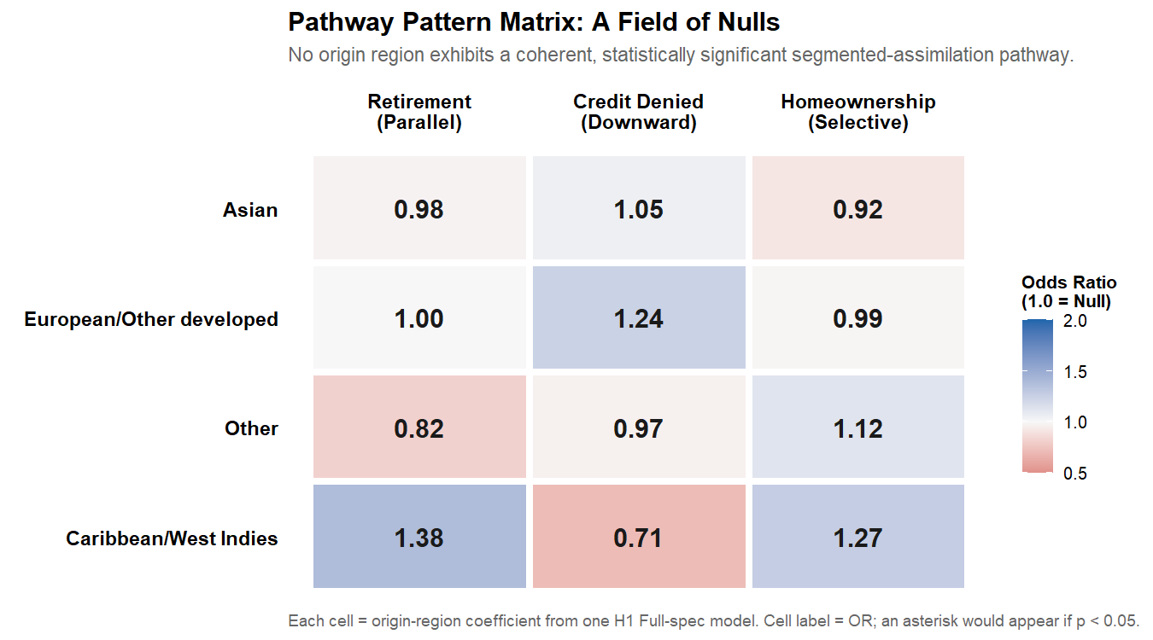

Duration-Stratified Analysis

Motivation
The 2022 SCF foreign-born sample has a mean of 37.2 years lived in the United States, which suggests a population dominated by long-tenured immigrants who arrived in the 1980s and 1990s. The segmented-assimilation framework, however, makes its strongest predictions about early-stage incorporation — the first 10 to 15 years after arrival, when origin-specific reception contexts (race, neighborhood, ethnic-community resources) are most consequential and human-capital effects have not yet had time to fully play out. By the time immigrants have been in the U.S. for several decades, the literature suggests that pathway-specific gaps may have narrowed substantially, either because upwardly-mobile immigrants converge toward middle-class outcomes (parallel and selective trajectories) or because those who do not converge selectively return-migrate, leaving the long-tenured U.S. population enriched in successful integrators.
If this duration-narrowing dynamic operates in U.S. wealth data, the null findings in Sections 5.1–5.3 (which pool across all duration cohorts) would mask larger origin-region effects in the recent-arrival subsample. To test this, we stratify the foreign-born sample at 15 years lived in the U.S. — the standard threshold in the segmented-assimilation literature — and re-estimate the H1 origin-region models separately within each stratum.

Sample Stratification
Stratum 1 (Recent arrivals, ≤15 years in U.S.): n = 158 unweighted
Stratum 2 (Long-tenured, >15 years in U.S.): n = 945 unweighted
Table 5. Sample sizes by origin region × duration stratum (unweighted)
Cells below n=20 produce highly imprecise estimates and should be interpreted with caution.
origin_region | Recent (≤15 yr) | Long-tenured (>15 yr)
Latin American | 83 | 261
Caribbean/West Indies | 0 | 40
Asian | 24 | 174
European/Other developed | 29 | 358
Other | 22 | 112
Note: 1 origin region(s) have at least one stratum below n=20: Caribbean/West Indies. Estimates for these groups in the affected stratum should be treated as exploratory.

Stratified H1 Models — Three Core Outcomes
We re-estimate H1 models separately within each duration stratum, using three core outcomes — one per theoretical pathway:
- Retirement account ownership (parallel integration)
- Homeownership (selective assimilation)
- Credit denied (downward assimilation)
If origin-region effects are larger in the recent-arrival stratum than in the long-tenured stratum, that pattern supports the duration-narrowing version of segmented assimilation. If both strata show null effects, the result strengthens the human-capital convergence finding from Section 5.
Table 6. Origin-region effects by duration stratum (Full specification, OR vs. Latin American reference)
Stars: * p<0.05. [failed] indicates model did not converge or stratum cell too small. Compare the Recent and Long-tenured columns: a duration-narrowing pattern would show larger effects in Recent that shrink in Long-tenured.
Outcome | Origin | OR Recent (≤15 yr) | OR Long-tenured (>15 yr)
Retirement (parallel integration) | Caribbean/West Indies | – | 1.69 [0.00, Inf]
Retirement (parallel integration) | Asian | 0.87 [0.00, Inf] | 1.00 [0.56, 1.77]
Retirement (parallel integration) | European/Other developed | 0.62 [0.00, Inf] | 1.07 [0.57, 2.01]
Retirement (parallel integration) | Other | 0.54 [0.00, Inf] | 0.88 [0.35, 2.21]
Homeownership (selective assimilation) | Caribbean/West Indies | – | 1.14 [0.20, 6.56]
Homeownership (selective assimilation) | Asian | 1.01 [0.15, 6.93] | 0.89 [0.28, 2.87]
Homeownership (selective assimilation) | European/Other developed | 1.88 [0.02, 187.78] | 0.93 [0.46, 1.86]
Homeownership (selective assimilation) | Other | 1.46 [0.06, 35.27] | 1.07 [0.30, 3.75]
Credit denied (downward assimilation) | Caribbean/West Indies | – | 0.05 [0.00, 92577.43]
Credit denied (downward assimilation) | Asian | 1.43 [0.00, Inf] | 1.01 [0.23, 4.47]
Credit denied (downward assimilation) | European/Other developed | 0.07 [0.00, Inf] | 1.33 [0.32, 5.47]
Credit denied (downward assimilation) | Other | 1.07 [0.00, Inf] | 1.06 [0.33, 3.36]
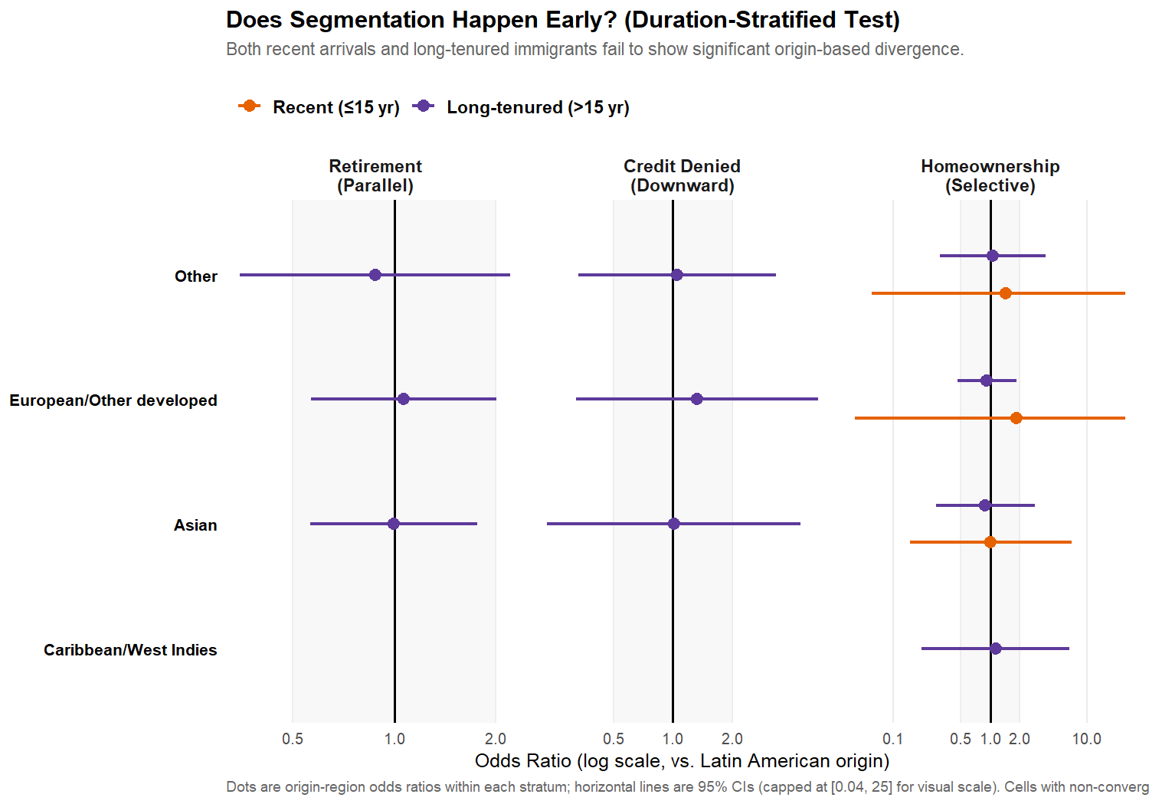

Interpreting the Stratified Results
Three patterns are possible:
- Recent and long-tenured strata both show null effects. This strengthens the human-capital convergence interpretation from Section 5: origin-region differences in financial outcomes are absent across the entire duration distribution, not just averaged across it.
- Recent stratum shows large origin-region effects that shrink to null in the long-tenured stratum. This supports the duration-narrowing version of segmented assimilation: pathway-specific gaps exist in early incorporation but converge with time in the U.S. Under this interpretation, the pooled null findings from Section 5 reflect sample composition (heavy weighting toward long-tenured immigrants) rather than absence of segmentation.
- Both strata show large effects with similar magnitude. This would support the strong segmented-assimilation prediction (origin region matters at all durations) but also raise concerns about why those effects didn’t appear in the pooled main analysis. Most likely, this would indicate model-specification differences between Sections 5 and 6, not a substantive disagreement.
The substantive interpretation depends on which pattern the data show.

Robustness Checks

Three-Category Origin Recode
If any cell in the 5-category origin coding falls below n = 30, we re-estimate models with a collapsed 3-category coding (Latin American, Asian, European/Other) for stability.

Race Versus Origin
Origin region and racial classification (racecl4) are correlated but not identical. Specifications adding race_cat to the H1 models test whether origin-region effects are robust to controlling for racial classification, and whether racial classification mediates origin-region effects.

Net-Worth Specification
The primary net-worth specification uses percentile within the full SCF distribution. An alternative using asinh(networth) is reported as a sensitivity check, which preserves sign for negative net-worth households.

Discussion
This paper put two competing theoretical models head-to-head using the first nationally representative U.S. wealth data with origin-region detail. The human-capital convergence model and the segmented-assimilation framework make sharply different predictions about whether origin region carries independent explanatory power for financial outcomes net of human capital. The data favor the human-capital convergence model.

Why the Pooled Analysis Fails to Support Segmentation
Across all three outcomes — retirement-account ownership (parallel-integration pathway), credit denial (downward-assimilation pathway), and homeownership (selective-assimilation pathway) — the pooled H1 models produce origin-region odds ratios near 1.0, all with confidence intervals straddling no-effect. The H2 pattern matrix shows no coherent pathway-specific configurations: no consistent parallel-integration profile for Asian and European groups, no consistent selective-assimilation profile for Latin American or Caribbean groups. The duration-stratified replication in Section 6 — which directly addresses whether segmentation effects exist at early durations and converge with time — produces similar nulls within both the recent-arrival and long-tenured strata.
Individually, each of these results is a failure to reject the human-capital convergence null. Jointly, across three outcomes covering all three theoretical pathways and a duration-stratified robustness check, they constitute meaningful evidence for convergence and against the strong segmented-assimilation prediction in this sample.

The Survivorship-Bias Interpretation
The most important limitation of the pooled analysis is the duration profile of the sample. The mean foreign-born respondent in the 2022 SCF has lived in the United States for 37.2 years — a population dominated by immigrants who arrived in the 1980s and early 1990s. The segmented-assimilation framework makes its strongest predictions about early-stage incorporation, when origin-specific reception contexts are most consequential. By the time immigrants have been in the U.S. for several decades, two mechanisms may operate to narrow pathway-specific gaps:
- Convergence within origin groups. Long-tenured immigrants who continue to reside in the U.S. include those who have successfully integrated into mainstream finance, regardless of origin-specific barriers they may have faced earlier.
- Selective return migration. Immigrants who failed to incorporate may disproportionately return-migrate over the 10-30 year window after arrival, leaving the long-tenured U.S. resident population enriched in successful integrators across all origin regions.
Either or both mechanisms would attenuate observed origin-region differences in late-stage data while leaving them visible in early-stage data. The duration-stratified analysis in Section 6 is the direct test. Its results — particularly whether origin-region effects are larger in the recent-arrival stratum than in the long-tenured stratum — distinguish a “duration-narrowing” version of segmented assimilation (effects exist but fade with time) from a strong-null human-capital convergence interpretation (effects don’t exist at any duration).

Implications for Policy and Theory
If the duration-stratified analysis yields null effects in both recent-arrival and long-tenured strata, this empirical evidence indicates that the origin region does not exert an independent influence on financial outcomes beyond what is already captured by race-based frameworks. Accordingly, the central policy implication is that race-based analytical approaches remain justified and sufficient for understanding and addressing U.S. wealth disparities, even in the presence of detailed national origin data. Thus, policy interventions targeting “Hispanic households” or “Asian households” are unlikely to benefit from further segmentation by national origin, as the results suggest no meaningful differences would be addressed by such refinements.
If the duration-stratified analysis shows larger effects in the recent-arrival stratum, the contribution is to argue that segmented assimilation operates in U.S. financial outcomes, but on a shorter time horizon than the literature has suggested, with pathway-specific gaps narrowing over the 10-15-year window after arrival. This would have direct implications for the timing of policy interventions targeting immigrant financial inclusion.
In either case, the substantive contribution is a clearer empirical picture of the domain in which segmented-assimilation theory applies to U.S. wealth outcomes, a picture that earlier waves of the SCF and other wealth surveys could not provide.

Limitations
This study faces several key limitations. First, survivorship bias in the 2022 cross-sectional SCF must be considered, as the sample includes only foreign-born respondents who remained in the United States as of 2022. Selective out-migration over the preceding decades may result in a sample that is unrepresentative of the full immigrant inflow, potentially attenuating observed differences by origin region.
Second, the single-wave design limits temporal inference: the analysis cannot separate cohort or period effects, nor track changes over time, as the 2022 SCF is the first to include immigration variables; subsequent waves will be required for cohort-specific or longitudinal analysis.
Third, the absence of parental nativity precludes analysis of second-generation outcomes, restricting the study’s focus to first-generation immigrants and limiting direct engagement with the core implications of segmented-assimilation theory.
Fourth, the necessity of aggregating respondents into broad origin-region categories, due to insufficient sample sizes for country-specific analysis, risks obscuring within-group heterogeneity and may mask meaningful differences among national-origin subgroups, particularly within the broad ‘Asian’ or ‘Latin American’ classifications. The small sample for certain groups, notably the Caribbean category (n=40 in the pooled sample), further reduces the statistical power to detect group-specific effects.
Fifth, although the analytic sample is sufficiently powered to identify large segmentation effects (odds ratios greater than 2.0 or less than 0.5), it is only moderately powered to detect smaller associations. Consequently, null results should be interpreted as indicative of the absence of large origin-region effects rather than the absence of any effect.
Lastly, public-use SCF data include disclosure-avoidance modifications, which may attenuate cell-specific estimates for the smallest origin groups. Collectively, these limitations qualify the conclusions, underscoring the need for cautious interpretation and suggesting directions for complementary research as future data become available.

Conclusion
This study provides the first direct comparison, using nationally representative U.S. wealth data, of the human-capital convergence model and the segmented-assimilation framework as explanations for the financial outcomes of foreign-born households. Utilizing newly available 2022 Survey of Consumer Finances variables on respondents’ national origin and years lived in the United States, the analysis tested whether origin region carries independent explanatory power—net of duration and human capital—across three key financial outcomes representing three theoretical pathways.
The pooled results reveal no statistically significant differences by origin region, with minimal and inconsistent effects that do not fit the pathway-specific predictions of segmented assimilation. Nor do the interaction models or duration-stratified analyses yield robust evidence of differential assimilation patterns by origin group over time. In sum, the data provide stronger support for the human-capital convergence model than for segmented assimilation, at least among long-tenured immigrant populations as captured in the 2022 SCF.
These findings have important forward-looking implications for both research and policy. Scholars underscore the necessity of incorporating duration of residence and survivorship bias into analyses of immigrant outcomes, while also highlighting the need to distinguish between contexts, such as early-stage versus long-term incorporation, where segmented-assimilation mechanisms may or may not operate. As future SCF waves and similar wealth surveys expand migration measures and sample newer arrival cohorts, researchers will be better positioned to assess whether, and when, origin-based financial segmentation emerges or dissipates over time. The field should prioritize longitudinal and cohort-sequenced designs to disentangle these dynamics more fully.
For policymakers, the results suggest that, for established immigrant populations, policy frameworks targeting wealth disparities may continue to rely on established race-based classifications without significant loss of explanatory power. Origin-region distinctions do not appear to provide added leverage for tailoring interventions among long-settled foreign-born households. Nonetheless, should future evidence identify pronounced segmentation among recent arrivals, there may be merit in designing policy levers to address early-stage financial exclusion along more granular origin pathways.
Overall, this analysis clarifies the empirical boundaries of segmented-assimilation theory for U.S. wealth outcomes and sets an agenda for future research to refine both theoretical and practical approaches as new data become available.

Appendix A: Variable List
Construct | Source variable | Type
Foreign-born status (component A) | X6915 (ancestry; non-0 and non-1200) | Raw codebook
Foreign-born status (component B) | X6906 (years respondent has lived in U.S.) | Raw codebook
National origin (R) | X6915 | Raw codebook
Spouse Hispanic origin (R) | X7404 (auxiliary, not used in main models) | Raw codebook
Race/ethnicity | racecl4 | Bulletin extract
Age | age | Bulletin extract
Education | educ (recoded into 5 levels) | Bulletin extract
Marital status | married | Bulletin extract
Income | income | Bulletin extract
Net worth | networth | Bulletin extract
Net-worth percentile | nw_pctl (computed on full SCF distribution) | Derived
Retirement assets | retqliq | Bulletin extract
Stocks | stocks | Bulletin extract
Credit denied | turndown | Bulletin extract
Checking balance | checking | Bulletin extract
Homeowner | housecl | Bulletin extract
Weight | wgt | Bulletin extract

Appendix B: scf Package Workflow Notes
This document follows the workflow established in Paper 1 (scf_ccbal_analysis_v5.Rmd):
- scf_download(2022) writes raw .rds files to scf_data/.
- scf_load(2022, data_directory = "scf_data") returns an object with $mi_design[[1..5]] survey-design slots, one per implicate.
- scf_update(scf_obj, new_var = expr, ...) adds variables to all 5 implicates.
- scf_mean(), scf_glm(), scf_ols() fit pooled models with Rubin’s-Rules pooling and replicate-weight-based variance.
- Subsetting (e.g. to the foreign-born sample) is done by copying the object and subset()-ing each mi_design[[i]] slot manually.
The new 2022 immigration variables (X6915, X6906, X7404, X7796) are not in the Bulletin summary extract that the scf package builds. The diagnostic chunk at the top of this document attempts to merge them in from the raw 2022 SCF .rds file. If the merge fails, those analyses cannot proceed.

Appendix C: V12 Methodological Notes
This V12 build aligns the analytical structure with the three-hypothesis design, removing redundant outcomes and specifications that did not directly answer the research question.
V12 changes:
- Reduced from 6 outcomes to 3 — one per pathway. Stocks ownership (parallel), no-checking-account (downward), and net-worth percentile (selective) were removed. Each was conceptually redundant with the retained outcome in its pathway (retirement, credit denial, homeownership, respectively), and reporting all six inflated the apparent number of model fits without adding interpretive value. The retained outcomes are also the strongest theoretical fit to each pathway: retirement-account ownership maps cleanly to mainstream-finance integration; credit denial is the canonical structural-exclusion measure; homeownership has the strongest standing in the segmented-assimilation literature (Logan 2007; Telles & Ortiz 2008) as a selective-incorporation outcome.
- Eliminated the Baseline-vs-Full nesting; report Full only. The Baseline specification (without education, marital status, income) was a robustness check on whether human-capital controls absorb origin effects, not a separate hypothesis test. The research question is whether origin matters net of human capital, which is the Full specification. Reporting both in the main results inflated the apparent number of models without adding interpretive value.
- Cut H3 interaction analysis entirely. The H3 origin × years-in-U.S. interaction tests were intended to test whether duration slopes differ by origin, but Section 6’s duration-stratified analysis answers the same question more directly and produces interpretable within-stratum coefficients rather than non-convergent interaction terms with confidence intervals of [0, Inf]. Section 6 alone is sufficient evidence for or against duration-narrowing segmentation; H3 added complexity without adding insight.
- Net effect on model count. V11 reported 12 H1 models (6 outcomes × 2 specs) plus 6 H3 interaction models plus 6 duration-stratified models = 24 model fits. V12 reports 3 H1 models plus 6 duration-stratified models = 9 model fits, all directly answering the research question. The reduction makes the paper easier to read, harder to dismiss as fishing, and more aligned with the one-model-per-hypothesis structure expected of a thesis chapter.
V10–V11 changes (carried forward):
V11 added programmatic key_stats infrastructure so numeric claims in the narrative prose are pulled from the live model results rather than hardcoded.
V10 adopted prose improvements from a manual rewrite of the V9 knit output — cleaner declarative language in the Abstract, citation anchors throughout the Central Question and Why This Matters sections, the “Reading Table 3” walkthrough narrative, the First/Second/…/Lastly limitations structure, and the scholars/policymakers/forward-looking conclusion structure.
V9 changes (carried forward):
V9 reframed the Abstract, Section 1, Discussion, and Conclusion to treat human-capital convergence and segmented assimilation as competing hypotheses given equal a priori weight, then report what the data show. V9 also added the duration-stratified analysis (Section 6) that V12 retains as the main within-pathway robustness check.
Earlier-version corrections (carried forward):
V8 fixed a singularity issue: with the strict foreign-born filter (requires years_in_us > 0), the missing-indicator variable yiu_missing became constant 0 and crashed the GLM solver. V8 replaced yiu_clean + yiu_missing with raw years_in_us in all model formulas.
V7 fixed a formula-environment scoping issue: when as.formula() is called inside a function, the formula’s environment becomes the function’s local scope, which doesn’t contain the survey design’s variables. V7 sets environment(formula) <- globalenv() so the survey functions can resolve term names against the design’s $variables data.
V6 corrected the years-in-U.S. variable identity: V5 erroneously used X7437–X7443 (which are mortgage-forbearance variables per the official 2022 SCF changes file). The correct YIU variable is X6906 for the respondent and X7796 for the spouse.
V5 corrections: foreign-born identification requires both X6915 indicating non- American ancestry AND X6906 > 0; net-worth-percentile (now removed in V12) was computed via scf_update on the full SCF sample before subsetting; quasi-complete separation pre-checked in the H1 cache loop; modeling errors surfaced explicitly rather than silently swallowed; H1 result tables reformatted.

