The Financial Balance Sheet of Childlessness
  - An Analysis of Household Wealth, Debt, and Credit Constraints in the 2022 Survey of Consumer Finances
Delroy Nichols
2026-04-03
Table of Contents

Abstract
This paper examines the financial correlates of childlessness among prime-age U.S. households. While demographic research has extensively studied the social and cultural drivers of fertility decline, the detailed financial circumstances of childless households — particularly their assets, debts, and access to credit — remain less well understood. Using replicate-weighted, multiply-imputed data from the 2022 Survey of Consumer Finances (SCF), we analyze households headed by individuals aged 31–44 and define childlessness as having no co-resident children, a measure that captures a household’s current living arrangement rather than biological fertility history.
Our logistic regression models reveal that, beyond powerful demographic predictors like marital status and education, specific financial variables are strongly associated with childlessness. Holding higher levels of retirement assets is positively associated with childlessness, consistent with an opportunity cost framework in which long-term savings and family formation compete for household resources. Conversely, households that have experienced credit denial are more likely to be childless, suggesting that financial exclusion and the instability it signals may constitute a barrier to family formation. Income and net worth, by contrast, are not significant predictors after other financial characteristics are controlled.
This study repositions the economic dimension of childlessness beyond simple income measures, demonstrating that the composition of the household balance sheet — what a household owns, what it owes, and whether it can access credit — matters more than aggregate financial resources for understanding the economic context of family formation.

Introduction
The rise of childlessness is a defining demographic trend of the 21st century. The U.S. total fertility rate has fallen below replacement and continued to decline through 2023 (Osterman et al., 2023; Camarota & Zeigler, 2025). A vast body of work has explored the demographic and social drivers of this trend, from educational attainment and marital patterns to shifting cultural norms and, more recently, immigration-related compositional effects (Parrado & Morgan, 2008; Adserà & Ferrer, 2015; Zill, 2025). Yet the economic dimension is often simplified to measures of income or employment status, collapsing the richness of household finances into a single axis.
This paper argues for a more comprehensive financial perspective. A household’s decision-making, opportunities, and constraints are shaped not just by income flows but by its entire balance sheet: what it owns (assets), what it owes (debts), and whether it can access credit. A household with $80,000 in retirement savings, $15,000 in student loans, and a recent credit denial inhabits a fundamentally different economic reality than one with $80,000 in income — even though both might appear similar on a single financial measure.
Using the unparalleled financial detail of the Survey of Consumer Finances (SCF), this paper asks: What are the financial correlates of co-resident childlessness among prime-age U.S. households? We move beyond income to investigate how different forms of wealth (retirement vs. liquid assets), debt (installment loans vs. credit card balances), and credit access are associated with the likelihood of a household having no children present. By centering the analysis on the SCF’s core strength — granular financial data — we provide a descriptive but deeply nuanced portrait of the economic trade-offs and circumstances linked to household structure during the prime family formation years.
This paper serves as a companion to a primary analysis of credit card indebtedness using the same dataset, in which the transition to parenthood was identified as the strongest demographic predictor of carrying revolving credit card debt. The present analysis inverts that question: given what we know about the financial burdens of parenthood, what does the financial profile of childless households look like?

Data and Methods

Data Source
We use the 2022 Survey of Consumer Finances (SCF), a triennial cross-sectional survey of U.S. households conducted by the Federal Reserve Board in cooperation with NORC at the University of Chicago. The SCF employs a dual-frame design combining area-probability sampling with a list-based oversample of wealthy households drawn from IRS records. The resulting dataset is the most detailed publicly available source of information on household balance sheets, income, pensions, and credit experiences in the United States (Bricker et al., 2023).
The SCF addresses item nonresponse through multiple imputation, providing five complete implicates of the dataset. All analyses account for this structure using Rubin’s Rules, as implemented by the scf R package (Cohen, 2025). Survey replicate weights (balanced repeated replication) are used throughout to produce design-consistent variance estimates.

Sample
We restrict the analysis to households where the reference person is aged 31–44. This window captures the prime family formation years — past the median age at first birth in the United States (approximately 27; Osterman et al., 2023) but before the conventional boundary for completed fertility (age 44) used in demographic research (Guzzo & Loo, 2023). The restriction yields approximately 1,000 households per implicate.

Outcome Variable
The primary outcome, childless_prime, is an indicator equal to 1 if the reference person is aged 31–44 and reports zero children currently residing in the household.
It is critical to underscore the precise nature of this variable. It is a measure of co-resident child status, not biological fertility. This measure will systematically misclassify non-custodial parents — primarily fathers whose children reside with another parent — as childless. It may also misclassify parents whose children live with grandparents or other relatives. This misclassification is non-trivial and is likely correlated with key predictors including race, marital status, and income.
However, this measure is the only indicator of child status available in the SCF. The primary justification for using the SCF despite this limitation is its status as the gold standard for household financial data. No other survey provides comparable granularity on assets, liabilities, income sources, and credit experiences. The trade-off is explicit: we sacrifice precision in the fertility measure to gain depth in the financial measures, and we interpret all findings accordingly as pertaining to co-resident childlessness, not biological childlessness.

Predictor Variables
Our key financial predictors, summarized below, are grouped by balance sheet category. All continuous financial variables are transformed using the inverse hyperbolic sine (asinh), which accommodates zeros and negative values while approximating a log transformation for large values.
Assets: retirement and quasi-liquid assets (asinh_retqliq), liquid transaction accounts (asinh_liq), directly held stocks (asinh_stocks), pooled investment funds (asinh_nmmf), home equity (asinh_homeeq), vehicle value (asinh_vehic).
Debts: installment debt (asinh_install), education debt (asinh_edn_inst), non-credit-card debt (asinh_debt_excl_cc), credit card balance (asinh_ccbal), debt-to-income ratio (asinh_dti).
Credit access: a binary indicator for having been turned down for credit in the past five years (turned_down).
Income: total household income (asinh_income), wage income (asinh_wageinc), net worth (asinh_networth).
Demographic controls: age and age-squared (to capture nonlinear lifecycle effects), marital status, college degree, race/ethnicity, gender of reference person, employment status, homeownership, and pension access.
A note on the female variable. In the SCF, the reference person in a mixed-sex couple is coded as the male. A female reference person therefore typically indicates a single woman (often a single mother) or a woman in a same-sex couple. This variable functions as a control for household structure, not a direct measure of gender differences in fertility.
A note on the “Other” race category. The SCF public dataset aggregates Asian, Pacific Islander, American Indian/Alaska Native, and multiracial respondents into a single “Other” category. Published research indicates this group is predominantly Asian/Pacific Islander (Hanna & Lindamood, 2008), but the internal heterogeneity is substantial. We retain this category in the model for completeness but urge caution in interpreting its coefficient. The opposing fertility patterns of U.S.-born Asian women (high childlessness) and first-generation Asian immigrants (lower childlessness) may produce attenuated or null aggregate effects that mask meaningful within-group variation (Cai & Morgan, 2019).

Descriptive Results
The analysis sample comprises approximately 997 households per implicate. Among these, 34.3% report no co-resident children. This rate is broadly consistent with Census Bureau estimates of childlessness for women in this age range (Guzzo & Loo, 2023), though it likely overstates biological childlessness due to the non-custodial parent misclassification discussed above.

Co-Resident Childlessness by Demographics
## ===== By Race/Ethnicity =====
## Multiply-Imputed, Replicate-Weighted Mean Estimate
##
## group variable estimate se min max
## White childless_prime 0.3498980 0.02143662 0.3477192 0.3519751
## Black childless_prime 0.3509283 0.03669985 0.3455146 0.3541340
## Hispanic childless_prime 0.2633391 0.03721848 0.2511439 0.2679693
## Other childless_prime 0.4284635 0.03284988 0.4252267 0.4323729
##
## ===== By Education =====
## Multiply-Imputed, Replicate-Weighted Mean Estimate
##
## group variable estimate se min max
## Less than HS childless_prime 0.2984361 0.03573656 0.2955478 0.3018473
## High School childless_prime 0.2741024 0.02888710 0.2714987 0.2771035
## Some College childless_prime 0.3412888 0.02544686 0.3394422 0.3423503
## College Degree childless_prime 0.4075647 0.02296607 0.4044715 0.4120224
##
## ===== By Marital Status =====
## Multiply-Imputed, Replicate-Weighted Mean Estimate
##
## group variable estimate se min max
## 0 childless_prime 0.5665886 0.02288293 0.5644611 0.5681891
## 1 childless_prime 0.2374279 0.01672318 0.2362023 0.2391776
##
## ===== By Credit Denial Experience =====
## Multiply-Imputed, Replicate-Weighted Mean Estimate
##
## group variable estimate se min max
## 0 childless_prime 0.3377808 0.01454740 0.3357907 0.3394162
## 1 childless_prime 0.4442268 0.04480882 0.4428682 0.4455963

Visualizations
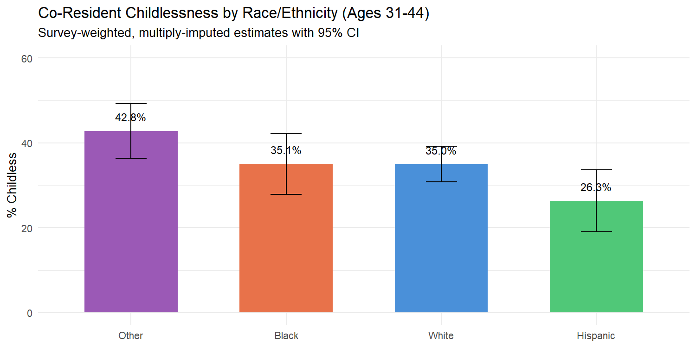
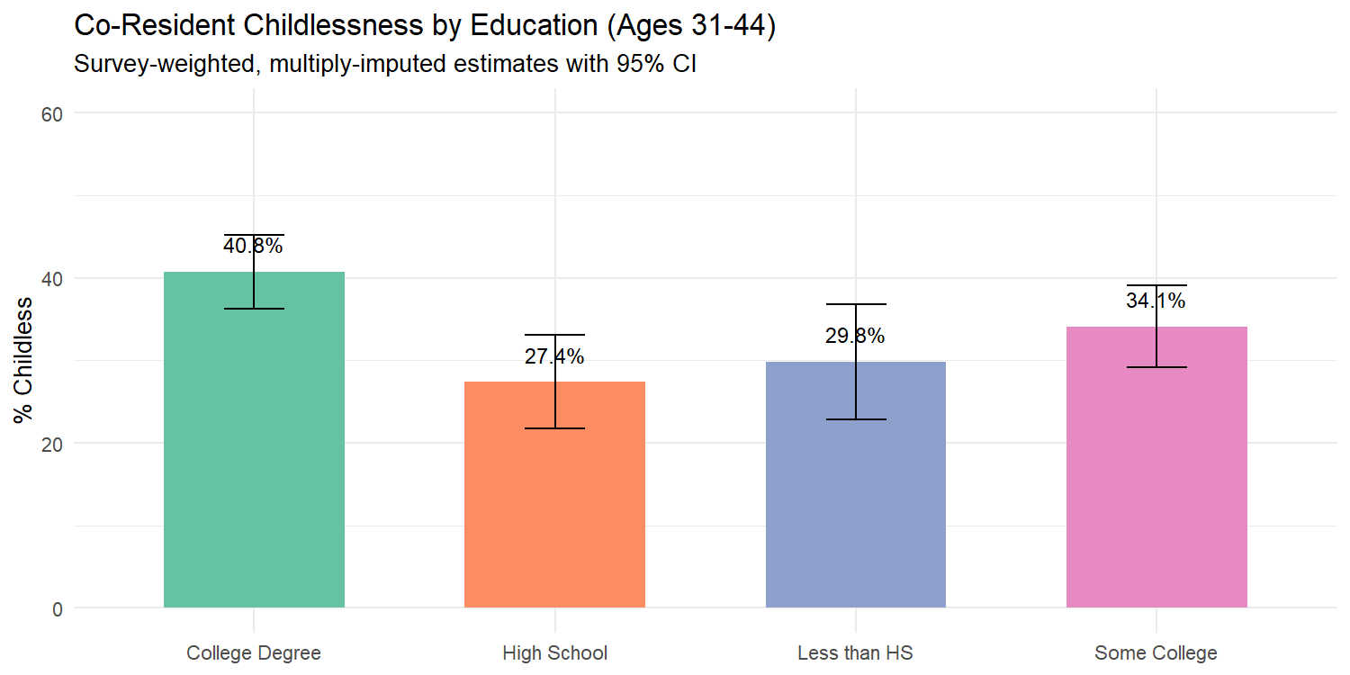

Regression Results
Table 1. Logistic Regression: P(Co-Resident Childless, Ages 31-44)
 | Term | Log-Odds | SE | Odds Ratio | OR 2.5% | OR 97.5% | p-value
(Intercept) | (Intercept) | 17.3138 | 6.5885 | 3.305925e+07 | 81.4721 | 1.341458e+13 | 8.59e-03 | **
asinh_retqliq | asinh_retqliq | 0.0527 | 0.0211 | 1.054200e+00 | 1.0114 | 1.098800e+00 | 1.26e-02 | *
asinh_liq | asinh_liq | 0.0323 | 0.0346 | 1.032800e+00 | 0.9650 | 1.105400e+00 | 3.52e-01
asinh_stocks | asinh_stocks | -0.0322 | 0.0181 | 9.684000e-01 | 0.9345 | 1.003400e+00 | 7.62e-02 | .
asinh_nmmf | asinh_nmmf | -0.0022 | 0.0204 | 9.978000e-01 | 0.9587 | 1.038600e+00 | 9.16e-01
asinh_homeeq | asinh_homeeq | -0.0396 | 0.0602 | 9.612000e-01 | 0.8543 | 1.081500e+00 | 5.11e-01
asinh_vehic | asinh_vehic | -0.0439 | 0.0210 | 9.571000e-01 | 0.9184 | 9.974000e-01 | 3.71e-02 | *
asinh_install | asinh_install | -0.0299 | 0.0258 | 9.705000e-01 | 0.9228 | 1.020800e+00 | 2.46e-01
asinh_edn_inst | asinh_edn_inst | -0.0042 | 0.0210 | 9.958000e-01 | 0.9555 | 1.037700e+00 | 8.41e-01
asinh_debt_excl_cc | asinh_debt_excl_cc | 0.0075 | 0.0306 | 1.007500e+00 | 0.9488 | 1.069900e+00 | 8.06e-01
asinh_ccbal | asinh_ccbal | -0.0132 | 0.0153 | 9.869000e-01 | 0.9578 | 1.016900e+00 | 3.89e-01
asinh_dti | asinh_dti | 0.0625 | 0.1666 | 1.064500e+00 | 0.7679 | 1.475500e+00 | 7.08e-01
asinh_income | asinh_income | 0.1100 | 0.1171 | 1.116200e+00 | 0.8874 | 1.404100e+00 | 3.48e-01
asinh_wageinc | asinh_wageinc | -0.0531 | 0.0241 | 9.483000e-01 | 0.9045 | 9.943000e-01 | 2.80e-02 | *
asinh_networth | asinh_networth | 0.0076 | 0.0156 | 1.007700e+00 | 0.9772 | 1.039000e+00 | 6.26e-01
turned_down | turned_down | 0.6959 | 0.2441 | 2.005500e+00 | 1.2430 | 3.235700e+00 | 4.35e-03 | **
age | age | -0.8966 | 0.3585 | 4.080000e-01 | 0.2020 | 8.238000e-01 | 1.24e-02 | *
age_sq | age_sq | 0.0112 | 0.0048 | 1.011300e+00 | 1.0019 | 1.020800e+00 | 1.87e-02 | *
female | female | -1.6179 | 0.3399 | 1.983000e-01 | 0.1019 | 3.861000e-01 | 1.94e-06 | ***
currently_married | currently_married | -2.3497 | 0.3015 | 9.540000e-02 | 0.0528 | 1.722000e-01 | 6.47e-15 | ***
college_degree | college_degree | 0.7281 | 0.2172 | 2.071100e+00 | 1.3532 | 3.170100e+00 | 8.00e-04 | ***
race_catBlack | race_catBlack | -0.4582 | 0.2464 | 6.324000e-01 | 0.3902 | 1.025100e+00 | 6.30e-02 | .
race_catHispanic | race_catHispanic | -0.3948 | 0.2556 | 6.738000e-01 | 0.4083 | 1.112100e+00 | 1.22e-01
race_catOther | race_catOther | 0.2157 | 0.2099 | 1.240700e+00 | 0.8223 | 1.872200e+00 | 3.04e-01
is_working | is_working | 1.0813 | 0.3555 | 2.948600e+00 | 1.4691 | 5.918200e+00 | 2.35e-03 | **
is_homeowner | is_homeowner | -0.3768 | 0.8082 | 6.860000e-01 | 0.1407 | 3.343900e+00 | 6.41e-01
has_pension | has_pension | -0.3442 | 0.1995 | 7.088000e-01 | 0.4794 | 1.048000e+00 | 8.45e-02 | .
Model fit (Implicate 1): McFadden pseudo-R² = 0.1889; N = 997; Predictors = 24

Coefficient Visualization
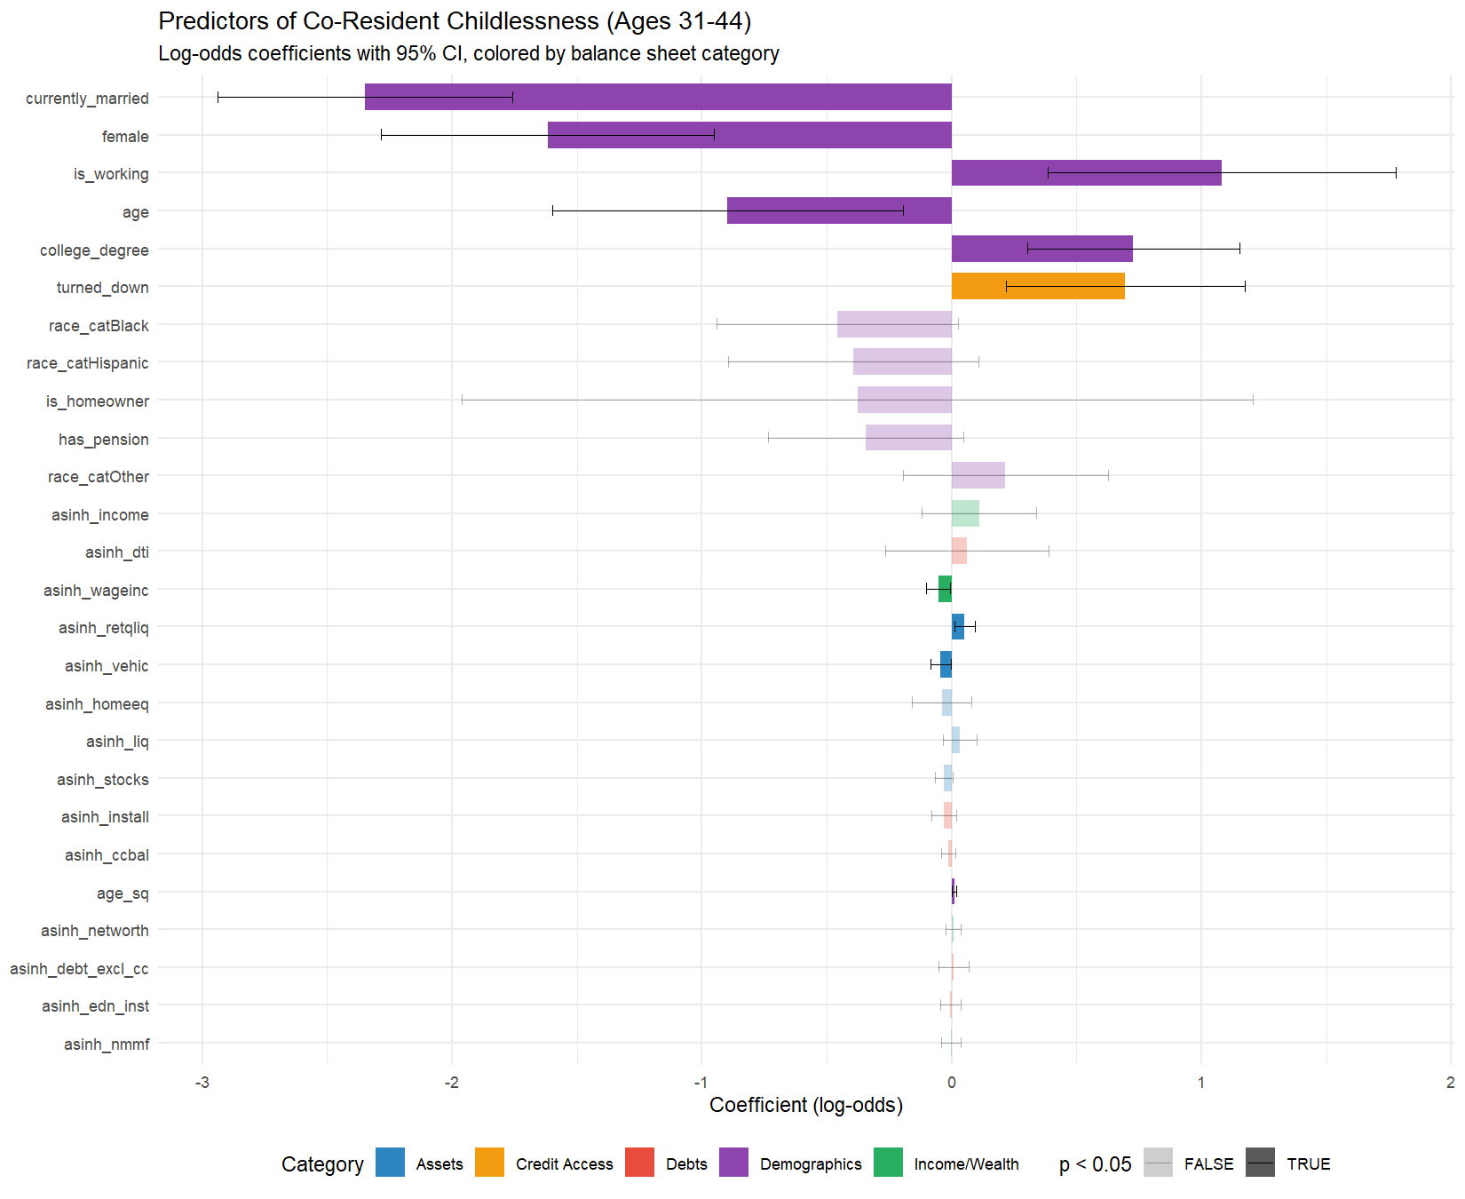

Interpretation

The Balance Sheet Findings

Retirement Assets and the Opportunity Cost of Children
The value of retirement and quasi-liquid assets (asinh_retqliq) is the strongest financial predictor of childlessness: OR = 1.05 (p = 1.26e-02). Households with larger retirement savings are significantly more likely to be childless during the prime family formation years.
This finding lends clear support to an opportunity cost framework. Retirement account accumulation reflects sustained career investment, long time horizons, and a financial planning orientation that may coincide with — or come at the expense of — family formation. The cost of raising a child through age 18 is estimated at $237,000 to $310,000 in 2022 dollars (Lino et al., 2020), and the career interruptions associated with parenthood (particularly for women) reduce lifetime earnings and retirement savings. Households that have prioritized or been able to accumulate more retirement wealth are, on this evidence, less likely to have children present — suggesting a genuine trade-off between investing in financial assets for the future and bearing the immense cost of raising children in the present.
Importantly, this is not a simple income effect. As we show below, aggregate income and net worth are not significant predictors of childlessness. The specificity of the retirement asset finding — that it is the composition of wealth, not its level, that matters — is the core contribution of this analysis.

Credit Constraints and Financial Exclusion
Having been turned down for credit in the past five years (turned_down) is significantly associated with childlessness: OR = 2.01 (p = 4.35e-03). Households that have experienced credit denial are approximately 101% more likely to be childless.
The interpretation of this coefficient requires care regarding causal direction. Two plausible mechanisms are consistent with this association:
Financial exclusion as a barrier to family formation. Credit-constrained households may face material barriers to the consumption demands of parenthood — housing, vehicles, childcare — that require access to credit. If these households cannot borrow to smooth the lumpy expenses associated with having a child, they may delay or forgo parenthood. On this reading, credit denial signals a broader financial precarity that deters family formation.
Parenthood as a strain on creditworthiness. Alternatively, the presence of children strains a household’s liquidity and makes it more vulnerable to financial shocks, which may damage creditworthiness and lead to credit denial. On this reading, parents are more likely to have been turned down because child-related expenses exhausted their financial buffer.
The cross-sectional design of the SCF cannot distinguish between these mechanisms. However, this finding bridges directly to the companion analysis of credit card debt, where credit denial was the strongest predictor of carrying revolving balances (OR ≈ 1.97). Credit access thus emerges as a common upstream factor linking both childlessness and credit card indebtedness — marking a population experiencing financial precarity across multiple life domains.

Income, Wealth, and the Null Finding
Total household income (OR = 1.12, p = 3.48e-01) and net worth (OR = 1.01, p = 6.26e-01) are not significant predictors of childlessness after controlling for the composition of the balance sheet. This null finding is itself a substantive result. It indicates that the economic context of childlessness is not about how much a household has in aggregate, but about how that wealth is allocated and whether the household faces credit constraints. A high-income household that has channeled resources into retirement accounts and a low-income household that has been denied credit occupy opposite ends of the financial spectrum, yet both are more likely to be childless than their demographic peers.
Wage income (asinh_wageinc) is the one income-adjacent variable that reaches significance (OR = 0.95, p = 2.80e-02), with higher wages associated with lower childlessness. This may reflect financial stability enabling family formation, or it may capture the mechanical relationship between non-employment and parenthood (discussed below under structural controls). The distinction between wage income (significant) and total income (non-significant) suggests that it is earned income from active labor force participation, not investment returns or transfers, that correlates with having children present.

Credit Card Balances: The Link to the Companion Analysis
Credit card balance (asinh_ccbal): OR = 0.99 (p = 3.89e-01). Credit card balances do not independently predict childlessness after other financial variables are controlled. The companion analysis showed that the transition to parenthood is the strongest demographic predictor of carrying credit card debt (OR ≈ 1.54). The present analysis confirms the reverse direction: credit card debt does not appear to cause childlessness — rather, parenthood drives credit card use. Once we control for the broader financial structure of the household, the credit card balance carries no additional predictive power for childlessness.

Demographic Controls

Expected Demographic Patterns
Marriage is overwhelmingly the strongest predictor: OR = 0.10 (p = 6.47e-15). Unmarried adults aged 31–44 have dramatically higher odds of co-resident childlessness. Marriage remains the primary institutional context for childbearing in the United States, and this coefficient captures the combined effect of partnership stability, shared financial resources, and normative expectations (Pew Research Center, 2015; Zill, 2025).
College degree: OR = 2.07 (p = 8.00e-04). College graduates are significantly more likely to be childless, consistent with extensive demographic research showing that higher education delays and reduces fertility (Livingston, 2015; Guzzo & Loo, 2023). Among women aged 40–44, approximately 19–22%% of degree holders are childless compared to 7%% of those without a high school diploma (Livingston, 2015).

Structural Controls
Female reference person (OR = 0.20, p = 1.94e-06) and employment (OR = 2.95, p = 2.35e-03) are both significant but should be interpreted as structural controls rather than substantive predictors of fertility preferences. The female coefficient is driven by the SCF’s reference person coding: female-headed households in this age range are disproportionately single mothers, producing a mechanical negative association with childlessness. The employment coefficient captures the compositional fact that the non-working population aged 31–44 includes stay-at-home parents, who are by definition not childless. These variables are included to control for household structure; they should not be read as evidence of gender or employment effects on fertility decisions.

Racial and Ethnic Categories
With White households as the reference category, the coefficients for racial and ethnic groups are as follows:
- Black: OR = 0.63, 95% CI [0.39, 1.03] (p = 6.30e-02)
- Hispanic: OR = 0.67, 95% CI [0.41, 1.11] (p = 1.22e-01)
- Other: OR = 1.24, 95% CI [0.82, 1.87] (p = 3.04e-01)
In the fully controlled model, none of the racial coefficients reach conventional statistical significance. Given the moderate sample size relative to the number of predictors (N ≈ %s with %d predictors, yielding approximately %d observations per predictor), this model is likely underpowered to precisely estimate racial differences. The confidence intervals are wide enough to encompass both substantively meaningful effects and true nulls.
997 24 42We do not interpret these non-significant coefficients as evidence for or against any specific theory — including theories of immigrant assimilation or cultural differences in fertility norms. The financial and demographic controls in the model account for a substantial portion of the unconditional racial variance in co-resident childlessness, but whether the remaining variance reflects nativity composition, unmeasured cultural factors, differential non-custodial parenthood rates, or simply sampling variability cannot be determined from these data. Unpacking the source of racial and ethnic differences in childlessness requires a dataset with direct measures of nativity and biological fertility history, which the SCF lacks.
The ‘Other’ category merits particular caution (OR = 1.24, p = 3.04e-01). As noted in the Methods section, this group aggregates Asian, Pacific Islander, American Indian/Alaska Native, and multiracial respondents. The internal heterogeneity of this category — particularly the opposing nativity-specific fertility patterns within the Asian subpopulation (Cai & Morgan, 2019) — means that its aggregate coefficient is difficult to interpret substantively. We report it for completeness but do not draw inferences from it.

Connection to the Companion Analysis
The primary analysis in this thesis examined credit card indebtedness, finding that the transition to parenthood is the strongest demographic predictor of carrying revolving credit card debt. This companion piece inverts the question and finds complementary results.
## ===== Credit Card Debt Prevalence: Childless vs. Parent (Ages 31-44) =====
## Multiply-Imputed, Replicate-Weighted Mean Estimate
##
## group variable estimate se min max
## Childless has_ccdebt 0.4861771 0.02609897 0.4835075 0.4886038
## Parent has_ccdebt 0.5553463 0.01941514 0.5528202 0.5585207
##
## ===== Mean Credit Card Balance: Childless vs. Parent (Ages 31-44) =====
## Multiply-Imputed, Replicate-Weighted Mean Estimate
##
## group variable estimate se min max
## Childless ccbal 2761.203 467.9893 2698.429 2834.433
## Parent ccbal 3548.767 273.3059 3508.248 3590.025
The cross-tabulation confirms the expected pattern: parents aged 31–44 carry higher credit card balances and are more likely to have any revolving debt than childless households. Combined with the regression findings from both papers, the synthesis is:
Parenthood drives credit card debt; the balance sheet shapes childlessness. The main paper shows that having children increases the odds of carrying credit card debt by over 50%%, while additional children beyond the first do not compound the effect. This companion paper shows that childlessness is predicted not by income or total wealth, but by the composition of the balance sheet — retirement assets on one side, credit constraints on the other. The economic story of family formation is richer than a single income number can capture.
Credit denial links both outcomes. Households denied credit are simultaneously more likely to carry revolving credit card debt (main paper) and more likely to be childless (this paper). Financial exclusion marks a population experiencing precarity across multiple domains.
Income protects against debt, not against childlessness. Higher wages reduce credit card balances among debtors (main paper) but do not reduce childlessness (this paper). The implication for policy is that income support may alleviate the debt burden of existing parents but is unlikely, on its own, to shift fertility patterns.

Robustness: Interaction Effects
As a robustness check, we test whether the association between education and childlessness, and between marriage and childlessness, varies by race/ethnicity. If the financial and demographic predictors operate differently across racial groups — as immigration-related assimilation theories would predict — we would expect significant interaction terms.

Race × Education Interactions
- college_degree:race_catBlack: log-odds = 0.796 (p = 1.31e-01, not significant)
- college_degree:race_catHispanic: log-odds = 0.537 (p = 4.57e-01, not significant)
- college_degree:race_catOther: log-odds = 0.883 (p = 2.99e-02, significant)
One or more of the race × education interactions reach significance at the 0.05 level.

Race × Marriage Interactions
- currently_married:race_catBlack: log-odds = 0.309 (p = 5.98e-01, not significant)
- currently_married:race_catHispanic: log-odds = -0.474 (p = 3.72e-01, not significant)
- currently_married:race_catOther: log-odds = -0.002 (p = 9.96e-01, not significant)
None of the race × marriage interactions reach significance.
These interaction tests should be interpreted with caution given the sample size. The 31–44 age restriction yields approximately 1,000 observations, and adding interaction terms further reduces the effective sample size within each cell. Non-significant interactions may reflect insufficient power rather than true homogeneity of effects across racial groups.

Discussion and Conclusion
This analysis demonstrates that a household’s financial balance sheet is intricately linked to its co-resident childlessness status during the prime family formation years. The key contribution is that the economic context of childlessness is richer than simple measures of income or wealth can capture.
The strong positive association between retirement assets and childlessness, combined with the positive association between credit denial and childlessness, paints a picture of competing financial pressures operating at opposite ends of the economic spectrum. At the upper end, households investing in long-term financial security face opportunity costs that may delay or preclude family formation. At the lower end, households denied access to credit face material barriers and financial instability that may produce the same outcome through a different mechanism. In between, aggregate income and wealth do not distinguish childless households from parents — it is the structure of the balance sheet, not its total, that matters.
The non-significant racial coefficients in the fully controlled model are notable but should be interpreted conservatively. The descriptive statistics show clear differences in co-resident childlessness rates by race and ethnicity, with Hispanic households showing the lowest rates and “Other” (primarily Asian) households showing the highest. These differences could reflect nativity composition, differential rates of non-custodial parenthood, cultural variation in family formation norms, or other factors that the SCF cannot isolate. Other scholars have argued persuasively that immigration-driven compositional effects play a substantial role in racial fertility differentials (Parrado & Morgan, 2008; Adserà & Ferrer, 2015; Camarota & Zeigler, 2025). Testing this hypothesis directly requires a dataset that combines detailed fertility history with nativity data — a task for which the National Survey of Family Growth (NSFG), American Community Survey (ACS), or CPS Fertility Supplement would be better suited.
Nonetheless, this paper makes a valuable contribution by centering the role of wealth composition, debt structure, and credit access in the study of household formation. The findings suggest that policies aimed at easing the financial burden of child-rearing should consider not only income support but also mechanisms to improve household liquidity, access to credit, and the ability to save for both retirement and child-related expenses simultaneously. The framing of children as a “financial trade-off” against retirement savings is not merely metaphorical — the data confirm it is a measurable feature of the American household balance sheet.

Limitations
Co-resident child status, not biological fertility. The SCF’s kids variable measures children currently present in the household. Non-custodial parents (primarily fathers), parents whose children live with other relatives, and other scenarios of parent-child separation are misclassified as childless. This error is likely correlated with race, income, and marital status, and could bias coefficients in unpredictable ways. For example, if non-custodial fatherhood is more prevalent among Black or lower-income households, their childlessness rate will be artificially inflated.
Sample size and statistical power. With approximately 1,000 observations and 24 predictors (~42 observations per predictor), the model has adequate power for large effects (e.g., marriage, education) but limited power for moderate effects, particularly among racial subgroups with smaller cell sizes.
No nativity data. The SCF does not identify foreign-born status, country of origin, generation, or years in the U.S. The role of immigration in shaping racial fertility differentials cannot be tested directly.
Cross-sectional design. We cannot distinguish between voluntary childlessness, involuntary childlessness, and intended-but-not-yet-realized parenthood. All findings are correlational.
The “Other” race category. This group aggregates Asian, Pacific Islander, American Indian/Alaska Native, and multiracial respondents. Its internal heterogeneity severely limits interpretability.
Reference person coding. The SCF codes the male as reference person in mixed-sex couples. The female coefficient captures household structure, not gender.

References
Adserà, A., & Ferrer, A. (2015). Immigrants and demography: Marriage, divorce, and fertility. In B. R. Chiswick & P. W. Miller (Eds.), Handbook of the Economics of International Migration (Vol. 1A, pp. 315–374). North-Holland.
Bricker, J., et al. (2023). Changes in U.S. family finances from 2019 to 2022: Evidence from the Survey of Consumer Finances. Federal Reserve Bulletin.
Cai, Y., & Morgan, S. P. (2019). Low fertility in China and the United States. Population and Development Review, 45(S1), 235–262.
Camarota, S. A., & Zeigler, K. (2025). The fertility of immigrants and natives in the United States, 2023. Center for Immigration Studies.
Cohen, G. (2025). scf: Analyzing the Survey of Consumer Finances. R package version 1.0.5.
Guzzo, K. B., & Loo, J. (2023). Number of children to women aged 40–44, 1980–2022. Family Profiles (FP-23-29). National Center for Family & Marriage Research.
Hanna, S. D., & Lindamood, S. (2008). Behind the numbers: Understanding the Survey of Consumer Finances. Journal of Financial Counseling and Planning, 19(2), 52–66.
Lino, M., Kuczynski, K., Rodriguez, N., & Schap, T. (2020). Expenditures on children by families, 2015. U.S. Department of Agriculture, Miscellaneous Report No. 1528-2015.
Livingston, G. (2015). Childlessness falls, family size grows among highly educated women. Pew Research Center.
Osterman, M. J. K., Hamilton, B. E., Martin, J. A., Driscoll, A. K., & Valenzuela, C. P. (2023). Births: Final data for 2021. National Vital Statistics Reports, 72(1), 1–53.
Parrado, E. A., & Morgan, S. P. (2008). Intergenerational fertility among Hispanic women: New evidence of immigrant assimilation. Demography, 45(3), 651–671.
Pew Research Center. (2015). Childlessness falls, family size grows among highly educated women.
Zill, N. (2025). Four million American women reach ages 40 to 50 without children. Institute for Family Studies.

Appendix: Technical Notes
Multiple Imputation. All statistics and models are pooled across the SCF’s five implicates using Rubin’s Rules.
Survey Weights. All estimates — including figures — use SCF replicate weights (balanced repeated replication). No unweighted estimates are reported.
Sample Restriction. Ages 31–44. This window aligns with the prime family formation years and avoids conflating empty-nesting with childlessness.
Tautology Correction. asinh_debt_excl_cc (total debt minus credit card balance) replaces asinh_debt to avoid mechanical prediction, consistent with the companion analysis.
Statistical Power. With ~1,000 observations and 24 predictors, the model is adequately powered for large effects but may miss moderate subgroup differences. Confidence intervals, not p-values alone, should guide interpretation of non-significant coefficients.
Session Information
R version: R version 4.5.1 (2025-06-13 ucrt)
Platform: x86_64-w64-mingw32
Key packages: scf 1.0.5, glmnet 4.1.10, survey 4.4.8

