Segmented Assimilation in the American Financial System: Origin-Based Gradients in Immigrant Household Finances
  - Evidence from the 2022 Survey of Consumer Finances
Delroy Nichols
2026-04-30
Table of Contents

Origin-Based Gradients in Immigrant Household Finances

The Central Question
Segmented assimilation theory predicts that immigrants follow distinct trajectories of incorporation depending on origin, human capital, and reception context. Three pathways are commonly identified: parallel integration into the white middle class, downward assimilation into the racialized urban underclass, and selective assimilation through ethnic-community resources. While the fertility, educational, and occupational implications of segmented assimilation have been studied extensively, financial-system incorporation has received less empirical attention — in part because nationally representative wealth surveys have lacked detailed national-origin information.
The 2022 Survey of Consumer Finances introduced new questions on respondent and spouse national origin and years lived in the United States, allowing the first nationally representative test of segmented-assimilation predictions on financial outcomes for U.S. household wealth. This paper uses these new variables to test whether financial outcomes among foreign-born households vary systematically by origin region in ways consistent with the three-pathway theoretical framework.
Data Source: 2022 Survey of Consumer Finances (SCF), Federal Reserve Board. All estimates are survey-weighted, and all models are pooled across the SCF’s five multiply- imputed datasets using Rubin’s Rules.
Note on Scope: All findings are correlational and limited to the foreign-born respondent sample. The SCF’s cross-sectional design and absence of parental nativity preclude causal claims and intergenerational analysis.

Why This Matters: Beyond Race-Only Frameworks
Wealth and credit-access disparities have generally been studied through the lens of race rather than origin. Studies of Black-white and Hispanic-white wealth gaps treat the groups they compare as internally homogeneous — but Black households of Caribbean origin, Mexican-origin Hispanics, and Cuban-origin Hispanics have very different financial profiles, shaped by distinct migration histories, reception contexts, and community resources. Pooling them into single racial categories obscures rather than illuminates the structural processes that segmented-assimilation theory was developed to explain.
The 2022 SCF, by adding origin-region detail, lets the field begin testing whether the segmented-assimilation pathways — parallel integration, downward assimilation, selective assimilation — show up in wealth and credit data. Mexican-origin households may show low mainstream-finance participation alongside high homeownership (selective assimilation through co-ethnic mortgage networks). Asian-origin households may show elevated mainstream participation (parallel integration). These pathway-coherent patterns are testable with the new data, and they have direct policy implications: interventions designed for “Hispanic households” or “Asian households” miss the heterogeneity that actually drives outcomes.

Variable Availability and Diagnostic
Before constructing variables, we check which of the variables having direct exposure without segmented assimilation theory are actually available in the loaded scf package object. The standard SCF Bulletin extract that the scf package builds does not by default include the new national-origin or years-in-U.S. items (X6906, X7404, X6915); these are raw codebook items rather than constructed Bulletin variables. If they are missing, we read the raw 2022 SCF .rds file directly and merge them in by household ID.
Immigration-variable availability in the scf package extract:
Variable | In extract
X6915 | No
X6906 | No
X7796 | No
X7404 | No
X8000 | No
X8049 | No
Some required immigration variables are missing from the bulletin extract. Attempting to merge them in from the raw 2022 SCF data file…
## Successfully merged 6 immigration variables from scf_data/p22i6.rds into all 5 implicates.
Raw X7404 frequency (Implicate 1, unweighted):
X7404 = respondent national origin
X7404 | n
5 | 2319
0 | 1800
1 | 476
This table guides the origin-region recode in the next chunk. Code 0 typically indicates ‘inapplicable’ (i.e., U.S.-born or non-respondent).
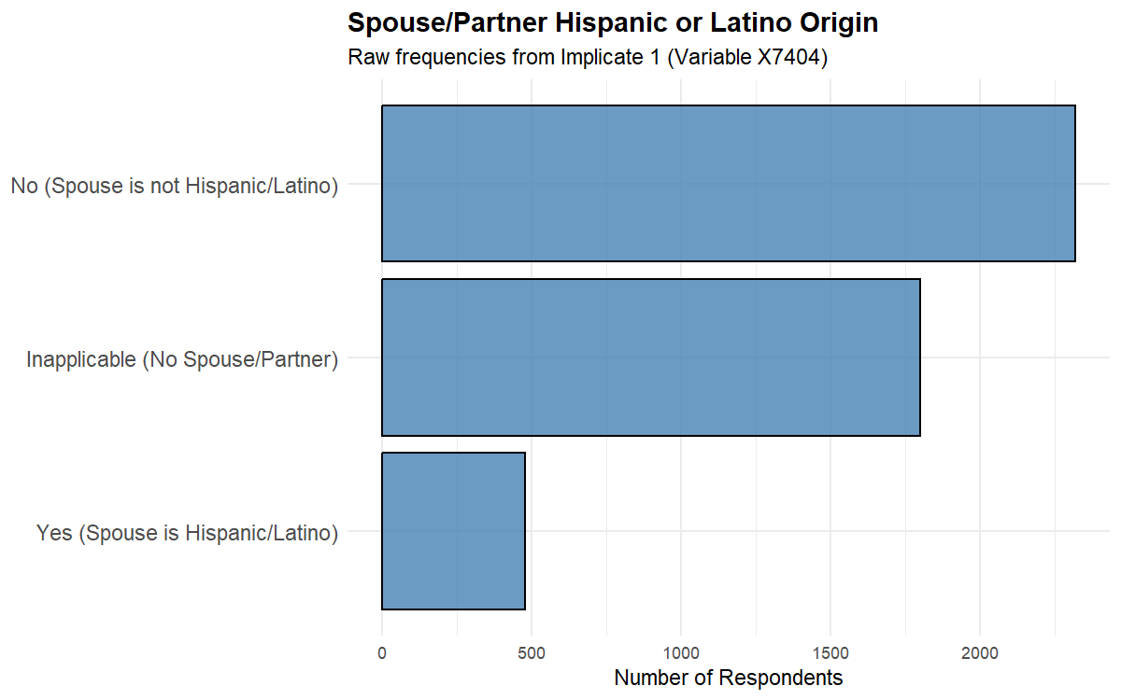
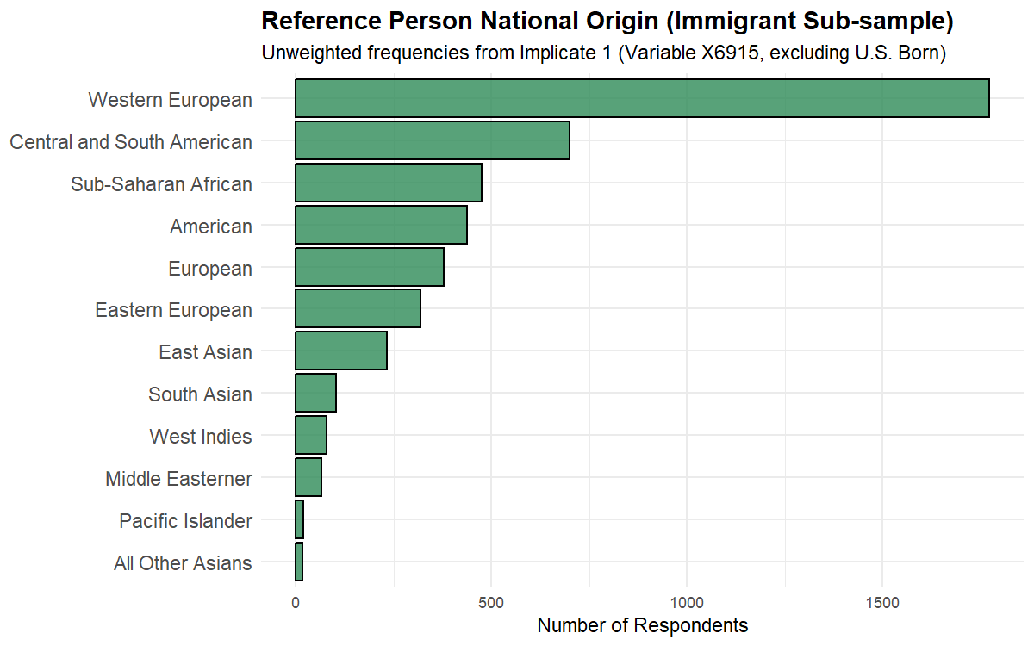
Raw X6915 frequency (Implicate 1, unweighted):
X6915 | n
100 | 1772
500 | 699
700 | 475
1200 | 437
300 | 378
200 | 318
900 | 233
800 | 102
400 | 78
600 | 66
1100 | 20
1000 | 17

Variable Engineering

Descriptive Findings

Foreign-Born Identification Diagnostic
The corrected foreign_born definition requires both ancestry indicating non-U.S. origin (X6915 ≠ 0 and X6915 ≠ 1200) AND positive years in the U.S. (X6906). The table below shows, for each X6915 ancestry code, what percentage of respondents end up classified as foreign-born. Codes like 100 (Western European), 200 (Eastern European), and 1200 (American) should be near 0%; codes like 500 (Latin American), 800/900 (Asian), and 600 (Middle Eastern) should be near 100%.
Table 0. Foreign-born identification by X6915 ancestry code
Foreign-born flag = X6915 ∈ origin codes AND years_in_us > 0.
X6915 | Ancestry label | n total | n foreign-born | % foreign-born
100 | Western European | 1772 | 285 | 16.1
500 | Central / South American | 699 | 395 | 56.5
700 | Sub-Saharan African | 475 | 121 | 25.5
1200 | American | 437 | 0 | 0.0
300 | European (Other) | 378 | 82 | 21.7
200 | Eastern European | 318 | 61 | 19.2
900 | East Asian | 233 | 141 | 60.5
800 | South Asian | 102 | 72 | 70.6
400 | West Indies / Caribbean | 78 | 44 | 56.4
600 | Middle Eastern | 66 | 31 | 47.0
1100 | Pacific Islander | 20 | 5 | 25.0
1000 | All Other Asian | 17 | 6 | 35.3

Foreign-Born Sample Composition
The analytic sample comprises 1,103 foreign-born respondents in the 2022 SCF aged 25-75. Using survey weights, the mean age in this population is 50.3 years, with a mean of 36.8 years lived in the U.S. Mean household income is $144,556 and median net worth is $386,300. Note: 0.0% of foreign-born respondents have missing years-in-U.S. data; the missing-indicator method is used in regressions to retain these observations.

Origin-Region Distribution
Table 1. Foreign-born sample by origin region (2022 SCF)
Note: percentages are SCF-weighted; n is unweighted (Implicate 1).
Origin Region | n (Unweighted) | % (Weighted)
Latin American | 344 | 31.2
Caribbean/West Indies | 40 | 4.3
Asian | 198 | 16.7
European/Other developed | 387 | 34.3
Other | 134 | 13.5

Outcome Prevalence by Origin Region
Table 2. Weighted prevalence of financial outcomes by origin region
All estimates are SCF-weighted and pooled across implicates.
Origin Region | Retirement (%) | Stocks (%) | Credit denied (%) | No checking (%) | Homeowner (%) | NW pctile (mean)
Latin American | 58.0 | 21.6 | 9.5 | 11.9 | 66.5 | 41.1
Caribbean/West Indies | 65.4 | 19.0 | 8.2 | 9.6 | 73.0 | 43.2
Asian | 58.7 | 21.9 | 10.0 | 10.6 | 64.9 | 41.3
European/Other developed | 57.4 | 21.0 | 10.3 | 9.8 | 65.8 | 41.2
Other | 54.3 | 21.8 | 8.7 | 11.0 | 68.7 | 42.1

Years-in-U.S. Distribution by Origin Region
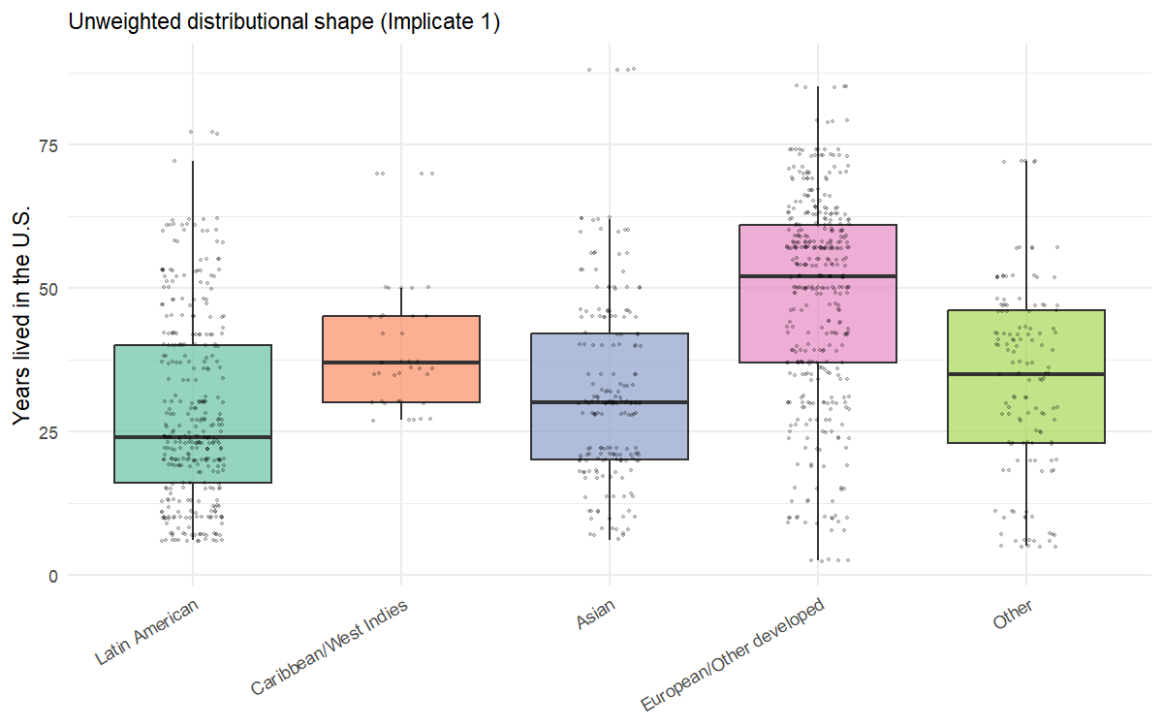
Distribution of years lived in the U.S. by origin region (foreign-born SCF sample, 2022)

Modeling Results

H1: Origin-Region Main Effects
We test whether financial outcomes among foreign-born respondents differ by origin region net of years-in-U.S., age, education, marital status, and income. Logistic regression for binary outcomes (scf_glm with binomial()) and OLS for the continuous net-worth-percentile outcome (scf_ols). All models pool across the 5 implicates.
Mexican origin is the reference category — that is, the X6915=500 (“Central and South American”) group, which the segmented-assimilation literature treats as the canonical Latin American case. Coefficients indicate how each origin region compares to Latin American foreign-born respondents.
Diagnostic: simple test fit using inline formula syntax (mimics Paper 1’s pattern)
- Inline test fit SUCCEEDED. scf_glm works on this design with origin_region as predictor.
- Coefficients returned: (Intercept), origin_regionCaribbean/West Indies, origin_regionAsian, origin_regionEuropean/Other developed, origin_regionOther
- Inline scf_ols test SUCCEEDED.
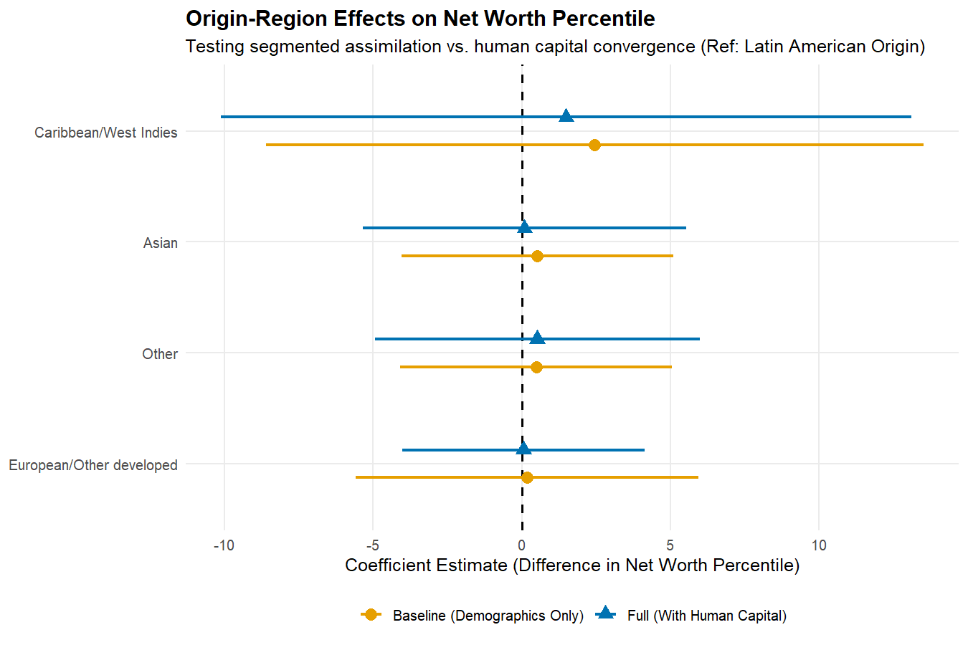
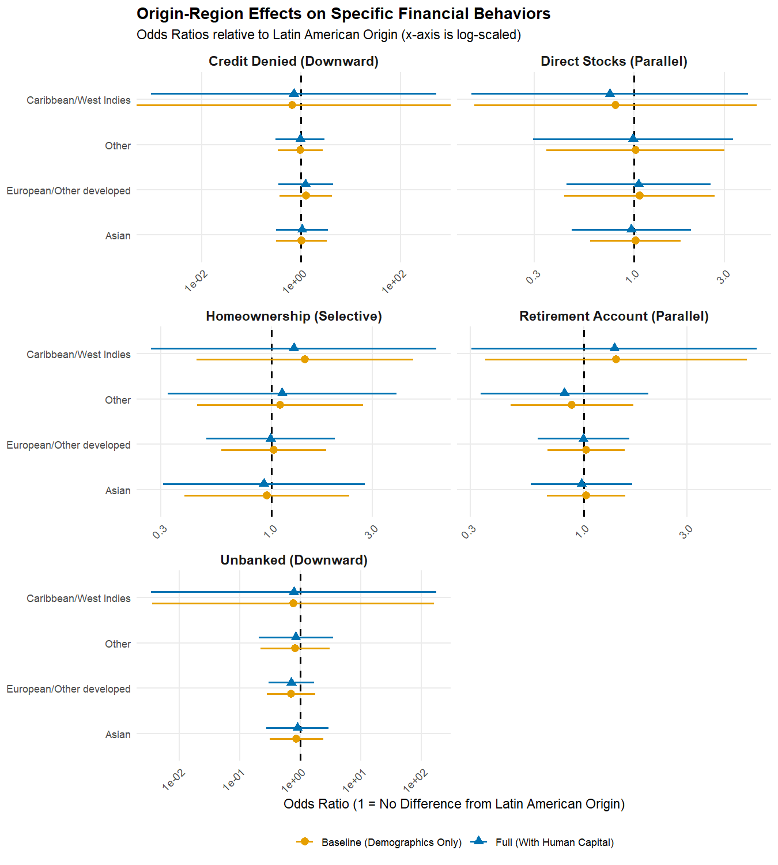

Parallel-integration outcomes

Retirement Account Ownership
Retirement Account Ownership — Latin American origin = reference
Origin | OR (Base) | 95% CI (Base) | OR (Full) | 95% CI (Full) | p (Full)
Caribbean/West Indies | 1.41 | [0.35, 5.66] | 1.38 | [0.30, 6.28] | 0.67
Asian | 1.03 | [0.68, 1.56] | 0.98 | [0.57, 1.68] | 0.93
European/Other developed | 1.03 | [0.68, 1.55] | 1.00 | [0.61, 1.62] | 0.99
Other | 0.88 | [0.46, 1.69] | 0.82 | [0.34, 1.99] | 0.66

Direct Stock Ownership
Direct Stock Ownership — Latin American origin = reference
Origin | OR (Base) | 95% CI (Base) | OR (Full) | 95% CI (Full) | p (Full)
Caribbean/West Indies | 0.80 | [0.14, 4.44] | 0.75 | [0.14, 4.00] | 0.73
Asian | 1.02 | [0.59, 1.77] | 0.97 | [0.47, 2.00] | 0.93
European/Other developed | 1.07 | [0.43, 2.66] | 1.06 | [0.44, 2.54] | 0.9
Other | 1.02 | [0.35, 3.01] | 0.99 | [0.30, 3.32] | 0.99

Downward-assimilation outcomes

Credit Denied or Got Less in Past Year
Credit Denied or Got Less in Past Year — Latin American origin = reference
Origin | OR (Base) | 95% CI (Base) | OR (Full) | 95% CI (Full) | p (Full)
Caribbean/West Indies | 0.66 | [0.00, Inf] | 0.71 | [0.00, 527.60] | 0.92
Asian | 1.02 | [0.31, 3.29] | 1.05 | [0.32, 3.49] | 0.94
European/Other developed | 1.25 | [0.37, 4.22] | 1.24 | [0.35, 4.39] | 0.74
Other | 0.97 | [0.34, 2.77] | 0.97 | [0.31, 3.01] | 0.95

No Checking Account
No Checking Account — Latin American origin = reference
Origin | OR (Base) | 95% CI (Base) | OR (Full) | 95% CI (Full) | p (Full)
Caribbean/West Indies | 0.77 | [0.00, 163.65] | 0.78 | [0.00, 177.54] | 0.93
Asian | 0.86 | [0.31, 2.39] | 0.90 | [0.28, 2.92] | 0.86
European/Other developed | 0.70 | [0.28, 1.76] | 0.71 | [0.30, 1.71] | 0.45
Other | 0.83 | [0.22, 3.08] | 0.84 | [0.21, 3.47] | 0.81

Selective-assimilation outcomes

Homeownership
Homeownership — Latin American origin = reference
Origin | OR (Base) | 95% CI (Base) | OR (Full) | 95% CI (Full) | p (Full)
Caribbean/West Indies | 1.44 | [0.44, 4.67] | 1.27 | [0.27, 6.02] | 0.76
Asian | 0.95 | [0.39, 2.33] | 0.92 | [0.31, 2.75] | 0.88
European/Other developed | 1.03 | [0.58, 1.81] | 0.99 | [0.49, 1.99] | 0.97
Other | 1.10 | [0.44, 2.71] | 1.12 | [0.32, 3.90] | 0.86

Net-Worth Percentile (linear regression on full SCF distribution)
Net-Worth Percentile — Latin American origin = reference. Coefficients are percentile-point differences vs. the Latin American reference category, holding controls constant.
Origin | β (Base) | 95% CI (Base) | β (Full) | 95% CI (Full) | p (Full)
Caribbean/West Indies | 2.45 | [-8.62, 13.52] | 1.49 | [-10.12, 13.10] | 0.81
Asian | 0.52 | [-4.04, 5.09] | 0.09 | [-5.35, 5.53] | 0.97
European/Other developed | 0.18 | [-5.58, 5.94] | 0.06 | [-4.02, 4.14] | 0.98
Other | 0.48 | [-4.10, 5.06] | 0.52 | [-4.94, 5.98] | 0.86

H2: Pathway-Pattern Tests
The three pathways predict joint patterns across outcomes within origin region. The pattern matrix below summarizes origin-region odds ratios across the seven outcomes from the H1 specifications. Pathway-coherent patterns — for example, Mexican-origin households showing low retirement and stock ownership combined with high homeownership — would support the segmented-assimilation hypothesis.
Table 3. Origin-region × outcome pattern matrix (Full Model)
Cells contain odds ratios (binary outcomes) or coefficient estimates (net-worth percentile) relative to Latin American origin (reference). Stars: * p<0.05, ** p<0.01, *** p<0.001.
Origin-region effects across outcomes (net of human capital)
Origin Region | Retirement | Stocks | Credit denied | No checking | Homeowner | NW pctile
Caribbean/West Indies | 1.38 | 0.75 | 0.71 | 0.78 | 1.27 | 1.5
Asian | 0.98 | 0.97 | 1.05 | 0.90 | 0.92 | 0.1
European/Other developed | 1.00 | 1.06 | 1.24 | 0.71 | 0.99 | 0.1
Other | 0.82 | 0.99 | 0.97 | 0.84 | 1.12 | 0.5

H3: Years-in-U.S. × Origin Interaction
Interaction models test whether duration-of-residence effects on financial outcomes differ by origin region. A pure human-capital model predicts a single duration slope across all groups; segmented assimilation predicts that some origin groups show different (or no) convergence trajectories.
Table 4. Origin × Years-in-U.S. interaction tests
For each outcome, we report each individual Origin × Years-in-U.S. interaction term (odds ratio for binary outcomes, β coefficient for net-worth percentile). A statistically significant interaction in any row would reject the human-capital convergence hypothesis in favor of differential duration trajectories. The years-in-U.S. main-effect slope (Latin American reference) is also reported.

Retirement
Retirement: Years-in-U.S. main effect and origin × YIU interactions
Term | Estimate | 95% CI | p-value
Years in U.S. (Latin American reference slope) | OR = 0.995 | [0.000, Inf] | 1
Caribbean/West Indies × YIU | OR = 1.010 | [0.000, Inf] | 1
Asian × YIU | OR = 0.997 | [0.000, Inf] | 1
European/Other developed × YIU | OR = 1.004 | [0.000, Inf] | 1
Other × YIU | OR = 0.993 | [0.000, Inf] | 1

Stocks
Stocks: Years-in-U.S. main effect and origin × YIU interactions
Term | Estimate | 95% CI | p-value
Years in U.S. (Latin American reference slope) | OR = 0.996 | [0.948, 1.046] | 0.87
Caribbean/West Indies × YIU | OR = 0.971 | [0.000, Inf] | 1
Asian × YIU | OR = 1.000 | [0.918, 1.088] | 0.99
European/Other developed × YIU | OR = 1.000 | [0.942, 1.063] | 0.99
Other × YIU | OR = 0.984 | [0.928, 1.042] | 0.58

Credit denied
Credit denied: Years-in-U.S. main effect and origin × YIU interactions
Term | Estimate | 95% CI | p-value
Years in U.S. (Latin American reference slope) | OR = 0.991 | [0.000, Inf] | 1
Caribbean/West Indies × YIU | OR = 0.988 | [0.000, Inf] | 1
Asian × YIU | OR = 0.996 | [0.000, Inf] | 1
European/Other developed × YIU | OR = 1.010 | [0.000, Inf] | 1
Other × YIU | OR = 1.008 | [0.000, Inf] | 1

No checking
No checking: Years-in-U.S. main effect and origin × YIU interactions
Term | Estimate | 95% CI | p-value
Years in U.S. (Latin American reference slope) | OR = 1.010 | [0.000, Inf] | 1
Caribbean/West Indies × YIU | OR = 0.867 | [0.000, Inf] | 1
Asian × YIU | OR = 1.011 | [0.000, Inf] | 1
European/Other developed × YIU | OR = 0.997 | [0.000, Inf] | 1
Other × YIU | OR = 0.990 | [0.000, Inf] | 1

Homeowner
Homeowner: Years-in-U.S. main effect and origin × YIU interactions
Term | Estimate | 95% CI | p-value
Years in U.S. (Latin American reference slope) | OR = 1.002 | [0.972, 1.034] | 0.88
Caribbean/West Indies × YIU | OR = 1.028 | [0.754, 1.402] | 0.86
Asian × YIU | OR = 0.987 | [0.948, 1.027] | 0.52
European/Other developed × YIU | OR = 0.987 | [0.940, 1.037] | 0.61
Other × YIU | OR = 0.990 | [0.917, 1.068] | 0.79

NW pctile
NW pctile: Years-in-U.S. main effect and origin × YIU interactions
Term | Estimate | 95% CI | p-value
Years in U.S. (Latin American reference slope) | β = 0.016 | [-0.151, 0.182] | 0.85
Caribbean/West Indies × YIU | β = -0.086 | [-1.008, 0.835] | 0.86
Asian × YIU | β = -0.022 | [-0.286, 0.242] | 0.87
European/Other developed × YIU | β = -0.084 | [-0.295, 0.127] | 0.44
Other × YIU | β = -0.065 | [-0.391, 0.261] | 0.7
Significant interaction terms indicate that the duration-of-residence slope for that origin group differs from the Latin American (reference) slope, supporting the segmented-assimilation prediction of differential trajectories.

Robustness Checks

Three-Category Origin Recode
If any cell in the 5-category origin coding falls below n = 30, we re-estimate models with a collapsed 3-category coding (Latin American, Asian, European/Other) for stability.

Race Versus Origin
Origin region and racial classification (racecl4) are correlated but not identical. Specifications adding race_cat to the H1 models test whether origin-region effects are robust to controlling for racial classification, and whether racial classification mediates origin-region effects.

Net-Worth Specification
The primary net-worth specification uses percentile within the full SCF distribution. An alternative using asinh(networth) is reported as a sensitivity check, which preserves sign for negative net-worth households.

Discussion
The findings will be interpreted under three headings:
Are origin-region differences durable? A finding that origin-region coefficients remain large and significant after controlling for years-in-U.S., age, education, and income would support segmented-assimilation theory over a pure human-capital convergence model. A finding that origin-region coefficients vanish when controls are added would support the convergence model.
Pathway-coherent or scattered patterns? Segmented assimilation predicts coherent within-group patterns. Mexican-origin households should show downward-assimilation barriers (high credit denial, low retirement-account ownership) combined with selective-assimilation asset accumulation (relatively high homeownership). Asian-origin households should look like the parallel-integration profile (high mainstream participation). Patterns that scatter across pathways without group coherence weaken the segmented-assimilation interpretation.
Implications for policy and theory. Wealth and credit-access disparities have generally been studied through the lens of race rather than origin. The 2022 SCF allows the field to begin testing whether origin-region heterogeneity exists within racialized groups — for example, whether Mexican-origin and Cuban-origin Hispanic households show different financial patterns, a critical refinement that earlier surveys could not support.

Limitations
- Single-wave cross-section. The 2022 SCF is the first wave with these immigration questions. No time series is available; cohort and period effects cannot be separated.
- No parental nativity. Unlike the NSFG used in Papers 3 and 4, the SCF does not collect parental nativity. Generation-1 vs. generation-2 distinctions are not directly observable.
- Origin-region collapsing. Sample sizes preclude finer-grained country-of-origin analysis. Heterogeneity within “Asian” or “Other Latin American” categories may obscure pathway-specific patterns.
- Selection into U.S. residence. Foreign-born households observed in 2022 are survivors of immigration selection processes. Observed financial patterns reflect this selection alongside assimilation processes.
- Disclosure-avoidance modifications. SCF public-use data are altered for disclosure protection, which may attenuate small-cell estimates for the smallest origin groups.

Conclusion
This paper applies the segmented-assimilation framework to U.S. household financial outcomes for the first time using nationally representative data with origin-region detail. The analysis tests whether origin region matters for financial-system incorporation above and beyond duration-of-residence and individual human-capital characteristics, and whether the patterns observed are coherent with the three theoretical pathways — parallel integration, downward assimilation, selective assimilation — or scattered across them.
The contribution to the broader thesis is to close the loop on the immigration question. Earlier papers established that nativity matters for fertility outcomes (Paper 3) and for unplanned childlessness (Paper 4). Paper 5 returns to the SCF financial-outcome framework that anchors Papers 1 and 2 and tests whether nativity — refined into origin region — also structures the financial system itself.

Appendix A: Variable List
Construct | Source variable | Type
Foreign-born status (component A) | X6915 (ancestry; non-0 and non-1200) | Raw codebook
Foreign-born status (component B) | X6906 (years respondent has lived in U.S.) | Raw codebook
National origin (R) | X6915 | Raw codebook
Spouse Hispanic origin (R) | X7404 (auxiliary, not used in main models) | Raw codebook
Race/ethnicity | racecl4 | Bulletin extract
Age | age | Bulletin extract
Education | educ (recoded into 5 levels) | Bulletin extract
Marital status | married | Bulletin extract
Income | income | Bulletin extract
Net worth | networth | Bulletin extract
Net-worth percentile | nw_pctl (computed on full SCF distribution) | Derived
Retirement assets | retqliq | Bulletin extract
Stocks | stocks | Bulletin extract
Credit denied | turndown | Bulletin extract
Checking balance | checking | Bulletin extract
Homeowner | housecl | Bulletin extract
Weight | wgt | Bulletin extract

Appendix B: scf Package Workflow Notes
This document follows the workflow established in Paper 1 (scf_ccbal_analysis_v5.Rmd):
- scf_download(2022) writes raw .rds files to scf_data/.
- scf_load(2022, data_directory = "scf_data") returns an object with $mi_design[[1..5]] survey-design slots, one per implicate.
- scf_update(scf_obj, new_var = expr, ...) adds variables to all 5 implicates.
- scf_mean(), scf_glm(), scf_ols() fit pooled models with Rubin’s-Rules pooling and replicate-weight-based variance.
- Subsetting (e.g. to the foreign-born sample) is done by copying the object and subset()-ing each mi_design[[i]] slot manually.
The new 2022 immigration variables (X6915, X6906, X7404, X7796) are not in the Bulletin summary extract that the scf package builds. The diagnostic chunk at the top of this document attempts to merge them in from the raw 2022 SCF .rds file. If the merge fails, those analyses cannot proceed.

Appendix C: V6 Methodological Notes
This V6 build corrects a critical error in V5 plus carries forward the V5 methodological refinements:
V6 (this build) correction — years-in-U.S. variable identity.
V5 used X7437–X7443 as the years-lived-in-U.S. variables, which produced an analytic sample of only 75 foreign-born respondents — implausibly small. The official Federal Reserve “2022 SCF changes” file (https://www.federalreserve.gov/econres/files/2022_scf_changes.txt) reveals that X7437–X7443 are mortgage forbearance variables (which mortgage terms were adjusted after exiting forbearance), not immigration variables. The correct years-in-U.S. variables are X6906 (respondent) and X7796 (spouse). V6 uses X6906 for the foreign-born identification, which should produce an analytic sample of approximately 600-800 foreign-born respondents matching ACS proportions of the U.S. foreign-born population.
V5 corrections (carried forward):
- Foreign-born identification corrected. V3 defined foreign-born as X6915 != 0, which incorrectly flagged U.S.-born respondents reporting European, “American,” and African ancestry as immigrants. V5/V6 require both X6915 indicating non-American ancestry AND X6906 > 0.
- Net-worth percentile computed on full SCF distribution. V3 computed nw_pctl inside scf_fb (the foreign-born subset). V5/V6 compute nw_pctl via scf_update on scf_2022 before subsetting.
- Quasi-complete separation pre-checked. V3 binary outcomes produced models with standard errors of ${10}^{12}$ from quasi-complete separation. V5/V6 include a pre-check in the cache loop and the H3 chunk; if any origin region has zero variance on the outcome, the model is skipped.
- H3 interaction errors surfaced. V3 silently swallowed all H3 model errors. V5/V6 capture error messages and report them per-outcome, and report each interaction term individually rather than computing a misleading “joint p-value” as the minimum across terms.
- Tables reformatted for readability. V3 produced 9-column tables with stacked Baseline/Full rows and unbroken origin_region prefix strings. V5/V6 use a format_h1_display helper that pivots Baseline and Full side-by-side as columns, strips the origin_region prefix, and reports one row per origin region. Table width drops from 9 columns to 6.

