Credit Card Balance and Household Behavior in the United States
  - A Two-Part Model with Lasso Variable Selection Using the 2022 Survey of Consumer Finances
Delroy Nichols
2026-03-29
Table of Contents

Introduction
Research Question: What financial and demographic characteristics most strongly predict credit card balance levels among U.S. households, and what do these associations suggest about the behavioral and causal mechanisms — including relationship formation, willingness to start families, and labor market participation — that govern household indebtedness?
Analytic Strategy: We employ a two-part modeling approach. Part 1 uses logistic regression to model the probability of carrying any credit card debt (ccbal > 0). Part 2 uses OLS regression to model the magnitude of credit card balances, conditional on carrying any debt. Before fitting either model, we use Lasso regression on a broad set of continuous SCF variables to identify the most influential predictors, retaining only those whose coefficients survive penalization across a majority of implicates.
Data Source: 2022 Survey of Consumer Finances (SCF), Federal Reserve Board. The SCF uses a dual-frame design combining area-probability sampling with a list-based oversample of wealthy households. All analyses account for the five-implicate multiple imputation structure and use replicate weights. Inferential statistics are pooled across all five implicates using Rubin’s Rules.
Note on Scope: All findings reported here are correlational. The cross-sectional design of the SCF does not support causal inference. We discuss plausible mechanisms but acknowledge that reverse causality, confounding, and selection effects are present throughout.

Outcome Variable: Credit Card Balance

Raw Distribution Diagnostics
The 2022 SCF contains 4,595 household records per implicate. Of these, 2,853 (62.1%) report a credit card balance of zero, while 1,742 (37.9%) carry a positive balance.
Among all households, the unweighted mean balance is $2,515 with a standard deviation of $7,853. The distribution is severely right-skewed (skewness = 6.68, kurtosis = 68.32). Among the 37.9% of households carrying any balance, the mean is $6,635 (median $2,520), with a maximum of $139,000.

Distribution Visualizations
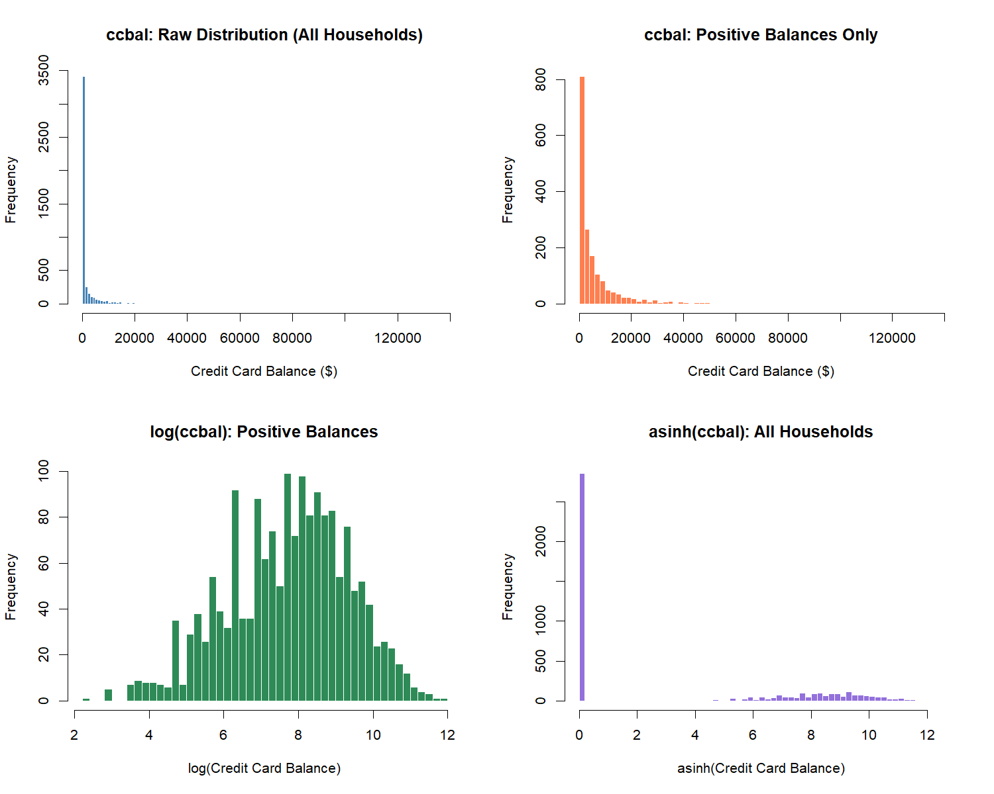

Transformation Decision
The distribution of ccbal exhibits two defining features: a large mass at zero (roughly 62.1% of households carry no credit card balance) and extreme right skew among positive values. This structure motivates a two-part modeling approach.
For Part 1 (logistic regression), the outcome is the binary indicator has_ccdebt (1 if ccbal > 0). For Part 2 (OLS regression), the outcome is log(ccbal) conditional on carrying any debt, which normalizes the heavy right tail. For the Lasso variable selection step, we use asinh(ccbal) on the full sample. The inverse hyperbolic sine handles zeros naturally and approximates log(2x) for large values, making it suitable for an initial screening pass that includes both debtors and non-debtors.

Predictor Variables
We engineer a broad set of continuous and categorical variables from the SCF extract dataset. A key decision is the treatment of total debt. Because ccbal is a component of the SCF’s aggregate debt variable, including total debt as a predictor would introduce a mechanical (tautological) relationship. We therefore construct debt_excl_cc (total debt minus credit card balance) to preserve the signal from non-credit-card liabilities without circularity.
The Lasso screening considers 31 continuous predictors. An additional 9 binary and categorical predictors enter the final models unpenalized as theoretically motivated controls.

Lasso Variable Selection
We run Lasso regression via glmnet with asinh(ccbal) as the outcome and the full set of 31 continuous predictors. Because the SCF uses multiple imputation, we run the Lasso on each of the five implicates separately and retain variables that survive penalization in at least 3 of 5 implicates (majority rule). This ensures that variable selection is robust to imputation variation.
Across the five implicates, the Lasso retained between 15 and 17 variables at lambda.1se. Applying the majority rule (survival in at least 3 of 5 implicates), 17 variables were selected for inclusion in the final models. Of these, 13 survived in all five implicates.
Variables surviving Lasso selection: asinh_bond, asinh_debt_excl_cc, asinh_dti, asinh_edn_inst, asinh_install, asinh_liq, asinh_mrthel, asinh_nmmf, asinh_othloc, asinh_resdbt, asinh_stocks, asinh_wageinc, kids, asinh_checking, asinh_income, asinh_networth, asinh_vehic
Note: asinh_vehic survived in exactly 3 of 5 implicates, the minimum threshold. The 3/5 majority rule is a researcher decision; results are not sensitive to reasonable alternatives (e.g., 4/5).

Lasso Coefficient Visualization
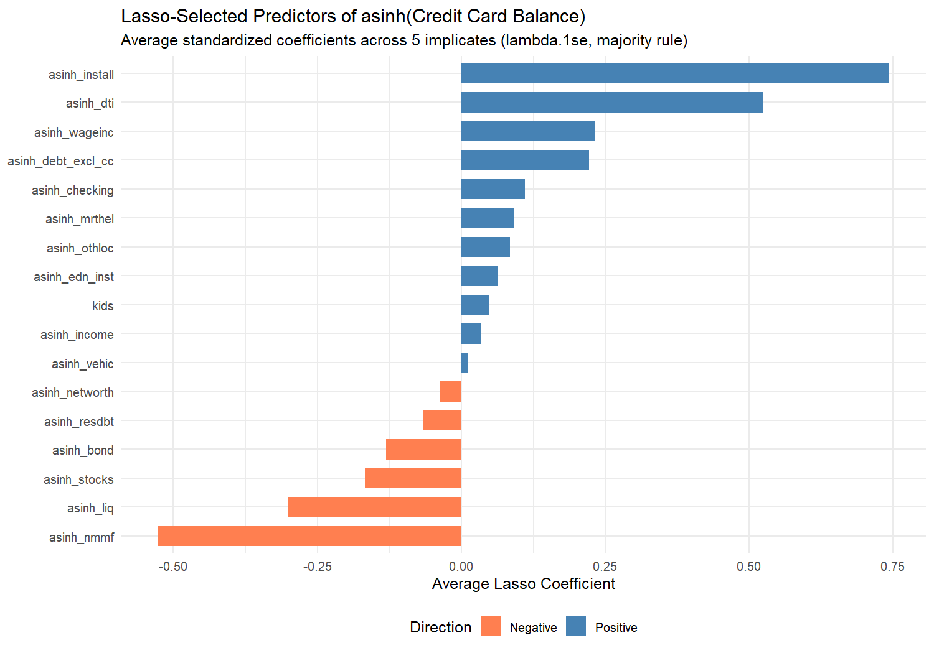
Table 1. Average Lasso Coefficients for Selected Predictors
Variable | Mean Coefficient | SD Across Implicates | Implicates Retained
asinh_install | 0.7439 | 0.0227 | 5
asinh_nmmf | -0.5276 | 0.0153 | 5
asinh_dti | 0.5254 | 0.0205 | 5
asinh_liq | -0.3009 | 0.0533 | 5
asinh_wageinc | 0.2333 | 0.0154 | 5
asinh_debt_excl_cc | 0.2225 | 0.0203 | 5
asinh_stocks | -0.1671 | 0.0185 | 5
asinh_bond | -0.1307 | 0.0247 | 5
asinh_checking | 0.1111 | 0.0318 | 4
asinh_mrthel | 0.0922 | 0.0158 | 5
asinh_othloc | 0.0850 | 0.0222 | 5
asinh_resdbt | -0.0671 | 0.0387 | 5
asinh_edn_inst | 0.0637 | 0.0176 | 5
kids | 0.0476 | 0.0077 | 5
asinh_networth | -0.0372 | 0.0222 | 4
asinh_income | 0.0338 | 0.0252 | 4
asinh_vehic | 0.0128 | 0.0088 | 3

Univariate Statistics

Credit Card Balance: Weighted Estimates
## Multiply-Imputed, Replicate-Weighted Mean Estimate
##
## variable estimate se min max
## ccbal 2767.986 121.0167 2740.803 2799.071
## Multiply-Imputed, Replicate-Weighted Mean Estimate
##
## group variable estimate se min max
## 0 ccbal 2150.649 172.1373 2134.640 2163.403
## 1 ccbal 3225.160 156.5334 3175.368 3269.392
## Multiply-Imputed, Replicate-Weighted Mean Estimate
##
## group variable estimate se min max
## 0 ccbal 2888.923 124.5942 2857.429 2928.669
## 1 ccbal 2455.025 255.5885 2431.100 2486.883
## Multiply-Imputed, Replicate-Weighted Mean Estimate
##
## group variable estimate se min max
## Less than HS ccbal 1496.270 334.1191 1479.819 1519.385
## High School ccbal 2301.266 164.3792 2267.489 2331.957
## Some College ccbal 3163.191 233.4667 3128.246 3191.653
## College Degree ccbal 3067.279 217.4229 3003.076 3114.921
## Multiply-Imputed, Replicate-Weighted Mean Estimate
##
## group variable estimate se min max
## White ccbal 2924.146 169.2922 2896.426 2943.604
## Black ccbal 2453.663 234.6755 2377.714 2576.787
## Hispanic ccbal 2317.569 217.1020 2291.596 2358.966
## Other ccbal 2557.178 267.8708 2518.284 2586.221
## Multiply-Imputed, Replicate-Weighted Mean Estimate
##
## group variable estimate se min max
## 18-24 ccbal 664.489 130.0121 649.961 689.1381
## 25-34 ccbal 2356.914 296.4665 2322.799 2416.4382
## 35-44 ccbal 3350.608 288.0760 3297.358 3387.0578
## 45-54 ccbal 3795.149 301.3882 3708.249 3911.4962
## 55-64 ccbal 3337.365 275.0102 3303.712 3362.3459
## 65+ ccbal 2008.410 237.7266 1979.650 2037.7963
## Multiply-Imputed, Replicate-Weighted Mean Estimate
##
## group variable estimate se min max
## 0 ccbal 2232.206 143.4845 2213.756 2249.821
## 1 ccbal 3608.408 175.8851 3565.304 3661.418
## Multiply-Imputed, Replicate-Weighted Mean Estimate
##
## group variable estimate se min max
## 0 ccbal 1569.792 148.7977 1536.394 1587.294
## 1 ccbal 3261.813 161.6847 3216.845 3301.628
## Multiply-Imputed, Replicate-Weighted Mean Estimate
##
## group variable estimate se min max
## 0 ccbal 2578.464 129.5913 2553.158 2613.155
## 1 ccbal 4452.096 488.9023 4411.345 4507.983

Prevalence of Credit Card Debt
## Multiply-Imputed, Replicate-Weighted Mean Estimate
##
## variable estimate se min max
## has_ccdebt 0.4522272 0.009755585 0.4501642 0.4551503
## Multiply-Imputed, Replicate-Weighted Mean Estimate
##
## group variable estimate se min max
## 0 has_ccdebt 0.4263822 0.01222587 0.4243260 0.4296706
## 1 has_ccdebt 0.4713673 0.01225992 0.4680617 0.4741518
## Multiply-Imputed, Replicate-Weighted Mean Estimate
##
## group variable estimate se min max
## Less than HS has_ccdebt 0.3408664 0.02180491 0.3385457 0.3424714
## High School has_ccdebt 0.4833815 0.01465548 0.4804082 0.4855977
## Some College has_ccdebt 0.5076535 0.01409139 0.5064834 0.5102121
## College Degree has_ccdebt 0.4218866 0.01459048 0.4172659 0.4256203
## Multiply-Imputed, Replicate-Weighted Mean Estimate
##
## group variable estimate se min max
## White has_ccdebt 0.4218539 0.01101429 0.4195253 0.4257106
## Black has_ccdebt 0.5632997 0.02291581 0.5551795 0.5686210
## Hispanic has_ccdebt 0.5578940 0.02562115 0.5531260 0.5613359
## Other has_ccdebt 0.4329153 0.02270661 0.4289794 0.4366085
## Multiply-Imputed, Replicate-Weighted Mean Estimate
##
## group variable estimate se min max
## 18-24 has_ccdebt 0.4107222 0.04605129 0.4067558 0.4133289
## 25-34 has_ccdebt 0.5070813 0.02338007 0.5047454 0.5087880
## 35-44 has_ccdebt 0.5259061 0.01877300 0.5234331 0.5290401
## 45-54 has_ccdebt 0.5699713 0.01797954 0.5663620 0.5756623
## 55-64 has_ccdebt 0.4432015 0.01654951 0.4415219 0.4458446
## 65+ has_ccdebt 0.3214669 0.01225475 0.3193070 0.3268730
## Multiply-Imputed, Replicate-Weighted Mean Estimate
##
## group variable estimate se min max
## 0 has_ccdebt 0.3897269 0.01120408 0.3877207 0.3928992
## 1 has_ccdebt 0.5502616 0.01253523 0.5478494 0.5532330
## Multiply-Imputed, Replicate-Weighted Mean Estimate
##
## group variable estimate se min max
## 0 has_ccdebt 0.4281616 0.009974434 0.4260088 0.4311213
## 1 has_ccdebt 0.6660838 0.023476561 0.6646745 0.6677505

Bivariate Associations
##
## ===== asinh_ccbal ~ currently_married =====
## term estimate std.error t.value p.value
## (Intercept) (Intercept) 3.4870045 0.1012389 34.443316 5.521526e-234
## currently_married currently_married 0.5420685 0.1258018 4.308907 1.707939e-05
## stars
## (Intercept) ***
## currently_married ***
##
##
## ===== asinh_ccbal ~ female =====
## term estimate std.error t.value p.value stars
## (Intercept) (Intercept) 3.7526749 0.09531281 39.372198 2.240629e-215 ***
## female female 0.1642269 0.14594662 1.125253 2.605478e-01
##
##
## ===== asinh_ccbal ~ college_degree =====
## term estimate std.error t.value p.value stars
## (Intercept) (Intercept) 3.921119 0.08260034 47.470971 0.0000000 ***
## college_degree college_degree -0.305835 0.12707155 -2.406794 0.0163236 *
##
##
## ===== asinh_ccbal ~ has_children =====
## term estimate std.error t.value p.value stars
## (Intercept) (Intercept) 3.242899 0.09238116 35.10347 3.487047e-241 ***
## has_children has_children 1.426936 0.11689959 12.20651 3.387196e-34 ***
##
##
## ===== asinh_ccbal ~ is_working =====
## term estimate std.error t.value p.value stars
## (Intercept) (Intercept) 2.596806 0.1098046 23.64933 4.333636e-117 ***
## is_working is_working 1.696855 0.1406061 12.06815 1.973998e-33 ***
##
##
## ===== asinh_ccbal ~ turned_down =====
## term estimate std.error t.value p.value stars
## (Intercept) (Intercept) 3.597667 0.08517968 42.236212 4.465159e-270 ***
## turned_down turned_down 1.984897 0.22550797 8.801893 1.348017e-18 ***
##
##
## ===== asinh_ccbal ~ fear_denial =====
## term estimate std.error t.value p.value stars
## (Intercept) (Intercept) 3.7233009 0.09016215 41.295610 8.112683e-254 ***
## fear_denial fear_denial 0.5821001 0.19428524 2.996111 2.786865e-03 **
##
##
## ===== asinh_ccbal ~ is_homeowner =====
## term estimate std.error t.value p.value stars
## (Intercept) (Intercept) 3.6837773 0.1286262 28.639406 3.390609e-177 ***
## is_homeowner is_homeowner 0.1735968 0.1379075 1.258792 2.084335e-01

Two-Part Regression Models

Final Predictor Set
The final predictor set combines the 17 Lasso-selected continuous variables with the 9 categorical/binary predictors. The categorical variables enter the model unpenalized because they represent theoretically motivated controls that should be included regardless of Lasso selection.
Total predictors: 26 (17 from Lasso + 9 categorical)
- asinh_bond
- asinh_debt_excl_cc
- asinh_dti
- asinh_edn_inst
- asinh_install
- asinh_liq
- asinh_mrthel
- asinh_nmmf
- asinh_othloc
- asinh_resdbt
- asinh_stocks
- asinh_wageinc
- kids
- asinh_checking
- asinh_income
- asinh_networth
- asinh_vehic
- female
- currently_married
- has_children
- college_degree
- is_working
- is_homeowner
- has_pension
- turned_down
- fear_denial

Part 1: Logistic Regression — P(Carries Any Credit Card Debt)
Table 2. Logistic Regression: Probability of Carrying Any Credit Card Debt
Outcome: has_ccdebt (1 = ccbal > 0). Coefficients are log-odds; odds ratios shown.
Table 2. Logistic Regression Results (Part 1)
 | Term | Log-Odds | SE | Odds Ratio | OR Lower | OR Upper | p-value
(Intercept) | (Intercept) | -1.5092 | 0.4485 | 0.2211 | 0.0918 | 0.5326 | 7.66e-04 | ***
asinh_bond | asinh_bond | -0.0858 | 0.0436 | 0.9178 | 0.8427 | 0.9997 | 4.91e-02 | *
asinh_debt_excl_cc | asinh_debt_excl_cc | 0.0326 | 0.0139 | 1.0331 | 1.0053 | 1.0617 | 1.91e-02 | *
asinh_dti | asinh_dti | 0.2822 | 0.0764 | 1.3260 | 1.1416 | 1.5404 | 2.22e-04 | ***
asinh_edn_inst | asinh_edn_inst | 0.0126 | 0.0102 | 1.0127 | 0.9926 | 1.0331 | 2.18e-01
asinh_install | asinh_install | 0.0466 | 0.0111 | 1.0478 | 1.0252 | 1.0708 | 2.66e-05 | ***
asinh_liq | asinh_liq | -0.1158 | 0.0226 | 0.8906 | 0.8521 | 0.9309 | 2.90e-07 | ***
asinh_mrthel | asinh_mrthel | 0.0069 | 0.0115 | 1.0070 | 0.9846 | 1.0299 | 5.45e-01
asinh_nmmf | asinh_nmmf | -0.0695 | 0.0103 | 0.9329 | 0.9142 | 0.9520 | 1.76e-11 | ***
asinh_othloc | asinh_othloc | 0.0506 | 0.0285 | 1.0519 | 0.9947 | 1.1124 | 7.63e-02 | .
asinh_resdbt | asinh_resdbt | -0.0400 | 0.0139 | 0.9608 | 0.9349 | 0.9873 | 4.03e-03 | **
asinh_stocks | asinh_stocks | -0.0294 | 0.0083 | 0.9711 | 0.9555 | 0.9869 | 3.77e-04 | ***
asinh_wageinc | asinh_wageinc | 0.0092 | 0.0102 | 1.0093 | 0.9894 | 1.0296 | 3.64e-01
kids | kids | -0.1109 | 0.0444 | 0.8950 | 0.8204 | 0.9764 | 1.25e-02 | *
asinh_checking | asinh_checking | 0.0622 | 0.0170 | 1.0642 | 1.0293 | 1.1003 | 2.51e-04 | ***
asinh_income | asinh_income | 0.0513 | 0.0389 | 1.0526 | 0.9753 | 1.1361 | 1.87e-01
asinh_networth | asinh_networth | -0.0060 | 0.0088 | 0.9940 | 0.9771 | 1.0112 | 4.94e-01
asinh_vehic | asinh_vehic | 0.0062 | 0.0095 | 1.0062 | 0.9875 | 1.0252 | 5.19e-01
female | female | 0.3595 | 0.1035 | 1.4326 | 1.1696 | 1.7548 | 5.13e-04 | ***
currently_married | currently_married | 0.1624 | 0.0953 | 1.1763 | 0.9759 | 1.4180 | 8.85e-02 | .
has_children | has_children | 0.4329 | 0.1042 | 1.5417 | 1.2569 | 1.8910 | 3.27e-05 | ***
college_degree | college_degree | -0.2216 | 0.0674 | 0.8012 | 0.7021 | 0.9143 | 1.01e-03 | **
is_working | is_working | 0.3100 | 0.1120 | 1.3635 | 1.0947 | 1.6983 | 5.65e-03 | **
is_homeowner | is_homeowner | -0.1413 | 0.1252 | 0.8682 | 0.6792 | 1.1097 | 2.59e-01
has_pension | has_pension | 0.3462 | 0.0713 | 1.4137 | 1.2294 | 1.6257 | 1.19e-06 | ***
turned_down | turned_down | 0.6795 | 0.1268 | 1.9729 | 1.5386 | 2.5297 | 8.46e-08 | ***
fear_denial | fear_denial | -0.1576 | 0.1209 | 0.8542 | 0.6739 | 1.0826 | 1.92e-01
Model fit (Implicate 1): McFadden pseudo-R² = 0.1354; Null deviance = 6333.0; Residual deviance = 5475.3

Part 2: OLS Regression — log(ccbal), Conditional on ccbal > 0
Table 3. OLS Regression Results (Part 2: log(ccbal) | ccbal > 0)
 | Term | Estimate | SE | t-value | p-value
(Intercept) | (Intercept) | 4.6120 | 0.9517 | 4.8460 | 1.27e-06 | ***
asinh_bond | asinh_bond | -0.1273 | 0.0731 | -1.7420 | 8.38e-02 | ^
asinh_debt_excl_cc | asinh_debt_excl_cc | -0.0084 | 0.0136 | -0.6163 | 5.38e-01
asinh_dti | asinh_dti | 0.3082 | 0.1104 | 2.7931 | 5.28e-03 | **
asinh_edn_inst | asinh_edn_inst | -0.0188 | 0.0074 | -2.5363 | 1.12e-02 | *
asinh_install | asinh_install | 0.0393 | 0.0107 | 3.6596 | 2.62e-04 | ***
asinh_liq | asinh_liq | 0.0339 | 0.0228 | 1.4885 | 1.39e-01
asinh_mrthel | asinh_mrthel | 0.0259 | 0.0146 | 1.7719 | 7.65e-02 | ^
asinh_nmmf | asinh_nmmf | 0.0089 | 0.0129 | 0.6914 | 4.89e-01
asinh_othloc | asinh_othloc | 0.0457 | 0.0197 | 2.3211 | 2.03e-02 | *
asinh_resdbt | asinh_resdbt | 0.0423 | 0.0204 | 2.0760 | 3.82e-02 | *
asinh_stocks | asinh_stocks | 0.0415 | 0.0092 | 4.5323 | 5.91e-06 | ***
asinh_wageinc | asinh_wageinc | -0.0248 | 0.0092 | -2.7116 | 7.81e-03 | **
kids | kids | -0.0235 | 0.0429 | -0.5478 | 5.84e-01
asinh_checking | asinh_checking | 0.0160 | 0.0151 | 1.0595 | 2.90e-01
asinh_income | asinh_income | 0.1577 | 0.0910 | 1.7338 | 8.30e-02 | ^
asinh_networth | asinh_networth | -0.0162 | 0.0068 | -2.3839 | 1.72e-02 | *
asinh_vehic | asinh_vehic | 0.0415 | 0.0110 | 3.7591 | 1.72e-04 | ***
female | female | 0.0459 | 0.1101 | 0.4172 | 6.77e-01
currently_married | currently_married | 0.0100 | 0.1026 | 0.0971 | 9.23e-01
has_children | has_children | 0.0002 | 0.1047 | 0.0018 | 9.99e-01
college_degree | college_degree | -0.0972 | 0.0830 | -1.1708 | 2.42e-01
is_working | is_working | 0.0287 | 0.0974 | 0.2942 | 7.69e-01
is_homeowner | is_homeowner | -0.0430 | 0.1237 | -0.3476 | 7.28e-01
has_pension | has_pension | 0.2303 | 0.0714 | 3.2257 | 1.34e-03 | **
turned_down | turned_down | 0.0625 | 0.0905 | 0.6908 | 4.90e-01
fear_denial | fear_denial | -0.0755 | 0.1099 | -0.6870 | 4.92e-01
Model fit (Implicate 1): Weighted R² = -0.3154; N (used) = 1,742

Coefficient Comparison
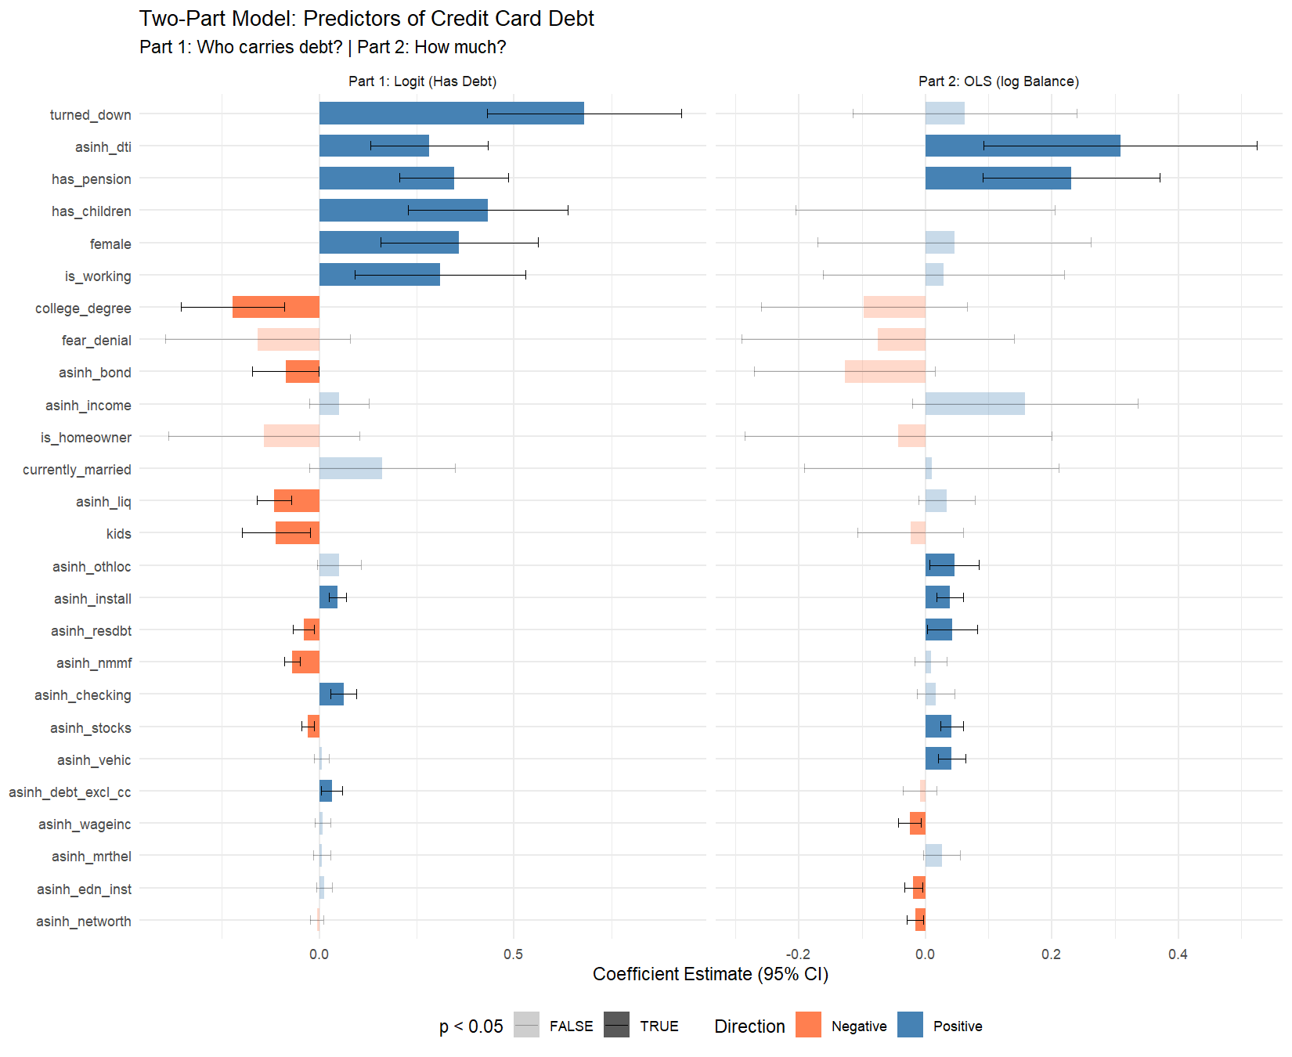

Interpretation: What the Coefficients Suggest
The two-part model separates two distinct behavioral questions about credit card debt in the United States. Part 1 asks who takes on any credit card debt at all, and Part 2 asks, among those who carry a balance, what predicts higher or lower amounts. The following interpretation is grounded in the estimated coefficients and connects them to plausible behavioral mechanisms.

Marriage and Partnership
The logit coefficient on currently_married is 0.162 (OR = 1.18, p = 0.088), and the OLS coefficient is 0.010 (p = 0.923). Neither coefficient reaches conventional significance. Marriage does not independently predict either the probability or the magnitude of credit card debt once financial characteristics, education, labor force status, and credit access are controlled.
This is a substantively important null finding. The bivariate association between marriage and credit card balances (which is positive and significant in the univariate statistics above) is fully mediated by the financial and demographic variables in the model. Married households carry more credit card debt not because of marriage per se, but because marriage is correlated with income, homeownership, pension access, and other characteristics that independently predict credit use. For researchers interested in the relationship between financial stress and marital stability, this suggests that credit card debt should be understood as a function of the household’s broader financial position, not as a distinctive feature of married life.

Children, Family Formation, and the kids/has_children Distinction
The binary indicator has_children has a logit coefficient of 0.433 (OR = 1.54, p < 0.001) and an OLS coefficient of 0.000 (p = 0.999). Households with any children are significantly more likely to carry credit card debt — the odds are 54% higher than for childless households — but among those who carry debt, the presence of children does not predict balance levels.
The continuous variable kids (number of children) shows the opposite sign in the logit: -0.111 (p = 0.013). This apparent contradiction is a suppression effect. Having any children increases the probability of debt (captured by has_children), but conditional on already having children, each additional child is associated with slightly lower odds of carrying credit card debt. This may reflect lifecycle selection: larger families tend to be older, more financially established households that have moved beyond the acute expense shock of the first child. Alternatively, families choosing to have many children may be more financially conservative or may have access to economies of scale in child-rearing.
The implication for family formation is clear in Part 1: the transition from zero to one child is the financially consequential event for credit card indebtedness, not the subsequent expansion of family size. Young adults deciding whether to start a family face a genuine debt threshold that the data confirms at the national level.

Labor Force Participation and Earnings
Employment (is_working) has a logit coefficient of 0.310 (OR = 1.36, p = 0.006) and an OLS coefficient of 0.029 (p = 0.769). Working households are significantly more likely to carry any credit card debt, but employment does not predict higher balances among debtors. This pattern suggests that employment operates primarily through the credit access channel: working households qualify for credit cards and use them, but their income also provides capacity to keep balances manageable.
Wage income (asinh_wageinc) has a logit coefficient of 0.009 (p = 0.364) and an OLS coefficient of -0.025 (p = 0.008). The negative OLS coefficient is the key finding here: among debtors, higher wage income is associated with lower credit card balances. This supports the interpretation that earnings provide debt-repayment capacity rather than fueling additional consumption on credit.

Credit Access and Financial Exclusion
Having been turned down for credit (turned_down) has a logit coefficient of 0.680 (OR = 1.97, p < 0.001) and an OLS coefficient of 0.063 (p = 0.490). Households denied credit in the past five years have 97% higher odds of carrying a credit card balance. However, credit denial does not predict balance levels among those who carry debt. This suggests that credit cards function as a last-resort borrowing channel for credit-constrained households: denied other forms of credit, these households lean on existing credit card lines, but the amounts they carry are governed by their credit limits and financial circumstances rather than the denial experience itself.
The anticipatory measure — fear_denial — has a logit coefficient of -0.158 (p = 0.192) and an OLS coefficient of -0.075 (p = 0.492). Neither reaches conventional significance. This is itself informative: the behavioral effect on credit card indebtedness is driven by the actual experience of being turned down for credit, not by the anticipation of rejection. Anticipated financial exclusion, while psychologically meaningful, does not independently predict credit card behavior once actual denial is controlled.

Wealth, Assets, and Financial Cushions
The Lasso retained several asset-side variables:
- asinh_liq: Logit = -0.116 (*), OLS = 0.034 (ns)
- asinh_checking: Logit = 0.062 (*), OLS = 0.016 (ns)
- asinh_stocks: Logit = -0.029 (*), OLS = 0.041 (*)
- asinh_nmmf: Logit = -0.069 (*), OLS = 0.009 (ns)
- asinh_bond: Logit = -0.086 (*), OLS = -0.127 (ns)
The pattern across asset variables is asymmetric between the two models. In the logit, liquid assets (asinh_liq, asinh_nmmf, asinh_stocks) carry negative coefficients — households with more liquid wealth are less likely to carry any credit card debt, consistent with savings serving as a substitute for revolving credit. In the OLS, however, some of these same variables show positive or non-significant coefficients, suggesting that among debtors, the level of assets does not consistently predict lower balances. This asymmetry implies that the primary role of liquid wealth is as a threshold effect: it determines whether a household needs to use credit cards at all, but once a household is carrying a balance, other factors (income, debt-to-income ratio, installment obligations) matter more for the amount.

Connecting to Broader Trends
The coefficients estimated in this analysis provide a quantified, nationally representative snapshot of the financial behaviors that connect to broader sociological trends. The two-part structure reveals that the predictors of having credit card debt are not identical to the predictors of how much debt one carries.
The most striking finding for the family formation question is the sharp asymmetry around children: the first child is the inflection point for credit card indebtedness, but subsequent children do not compound the effect. Combined with the null result on marriage, this suggests that credit card debt is driven by lifecycle transitions and financial constraints, not by partnership status itself. For young adults weighing the costs of family formation, the data confirms that the transition to parenthood — not marriage — is the event most strongly associated with revolving debt.
For labor market policy, the negative relationship between wages and balance levels among debtors points to a straightforward mechanism: higher earnings help people pay down existing debt. Programs that increase wages or reduce income volatility may be more effective at reducing credit card burdens than programs that expand credit access, which the data suggests primarily increase the prevalence of debt without reducing its severity.

Appendix: Technical Notes
Multiple Imputation. All statistics and models are pooled across the SCF’s five implicates using Rubin’s Rules, as implemented by the scf package. No results are reported from a single implicate. Model fit statistics (pseudo-R², R²) are reported from Implicate 1 for reference; these may vary slightly across implicates.
Survey Weights. All estimates use the SCF replicate weights (balanced repeated replication) to account for the complex survey design, including oversampling of wealthy households.
Lasso Implementation. Lasso was run via glmnet with 10-fold cross-validation on each implicate separately. We used lambda.1se (the most regularized model within one standard error of the minimum CV error) for parsimony. The majority rule (variable survives in >= 3 of 5 implicates) ensures robustness to imputation variation.
Tautology Correction. Total household debt (debt) includes credit card balances as a component. To avoid a mechanically inflated coefficient, we constructed debt_excl_cc = max(debt - ccbal, 0) and used its asinh transform in place of asinh_debt throughout the Lasso and regression models.
Two-Part Model. Part 1 is a logistic regression on the binary indicator has_ccdebt. Part 2 is OLS on log(ccbal) conditional on ccbal > 0. This approach is standard for semicontinuous outcomes with a large mass at zero and a continuous positive tail (Duan et al., 1983; Manning et al., 1987).
Suppression Effect: kids vs. has_children. Both the continuous count of children and the binary indicator are included in the model. The opposite-signed coefficients are a classical suppression pattern: the binary indicator captures the extensive margin (any children vs. none), while the continuous count captures the intensive margin conditional on the binary. This is analogous to a two-part specification within the predictor set itself.
Session Information
R version: R version 4.5.1 (2025-06-13 ucrt)
Platform: x86_64-w64-mingw32
Key packages: scf 1.0.5, glmnet 4.1.10, survey 4.4.8

