Credit Card Balance and Household Behavior in the United States
  - A Two-Part Model with Lasso Variable Selection Using the 2022 Survey of Consumer Finances
Delroy Nichols
2026-04-12
Table of Contents

The Cost of Starting a Family: What Drives Credit Card Debt in America

The Central Question
Nearly half of American households carry a credit card balance. But credit card debt is not distributed randomly — it clusters around specific life circumstances. This analysis asks a simple question with significant practical implications: What financial and demographic characteristics most strongly predict who carries credit card debt, and among those who do, what predicts how much?
The answer, as we will show, centers on a finding with direct relevance for young adults, financial counselors, and policy makers: the single most consequential event for credit card indebtedness is the transition to parenthood. Having a first child increases the odds of carrying credit card debt by 54%. By contrast, marriage — often assumed to be a major financial transition — has no independent effect on credit card debt after accounting for the financial characteristics that accompany it. Additional children beyond the first do not further increase debt. And among those who already carry balances, higher wages are the strongest factor associated with lower balances, suggesting that earnings provide repayment capacity that credit access alone cannot.
These findings emerge from a two-part analysis of the 2022 Survey of Consumer Finances (SCF), the most detailed publicly available dataset on U.S. household balance sheets. We use machine learning (Lasso regression) to identify the most important predictors from over 30 financial variables, then fit a logistic model for who carries debt and an OLS model for how much they carry. The two-part structure is essential because the factors that push a household into debt are not the same factors that determine the size of the balance.
Data Source: 2022 Survey of Consumer Finances (SCF), Federal Reserve Board. All estimates are survey-weighted, and all models are pooled across the SCF’s five multiply- imputed datasets using Rubin’s Rules.
Note on Scope: All findings are correlational. The SCF’s cross-sectional design does not support causal claims, and we interpret results accordingly.

How Credit Card Debt Is Distributed

The Basic Landscape
Before modeling, we need to understand the shape of the problem. Credit card debt in America is not normally distributed — it is a two-part phenomenon. The majority of households carry no balance at all, and among those who do, a small number carry very large amounts.
The 2022 SCF contains 4,595 household records per implicate. Of these, 2,853 (62.1%) report a credit card balance of zero, while 1,742 (37.9%) carry a positive balance.
Among all households, the unweighted mean balance is $2,515 with a standard deviation of $7,853. The distribution is severely right-skewed (skewness = 6.68, kurtosis = 68.32). Among the 37.9% of households carrying any balance, the mean is $6,635 (median $2,520), with a maximum of $139,000.

Distribution Visualizations
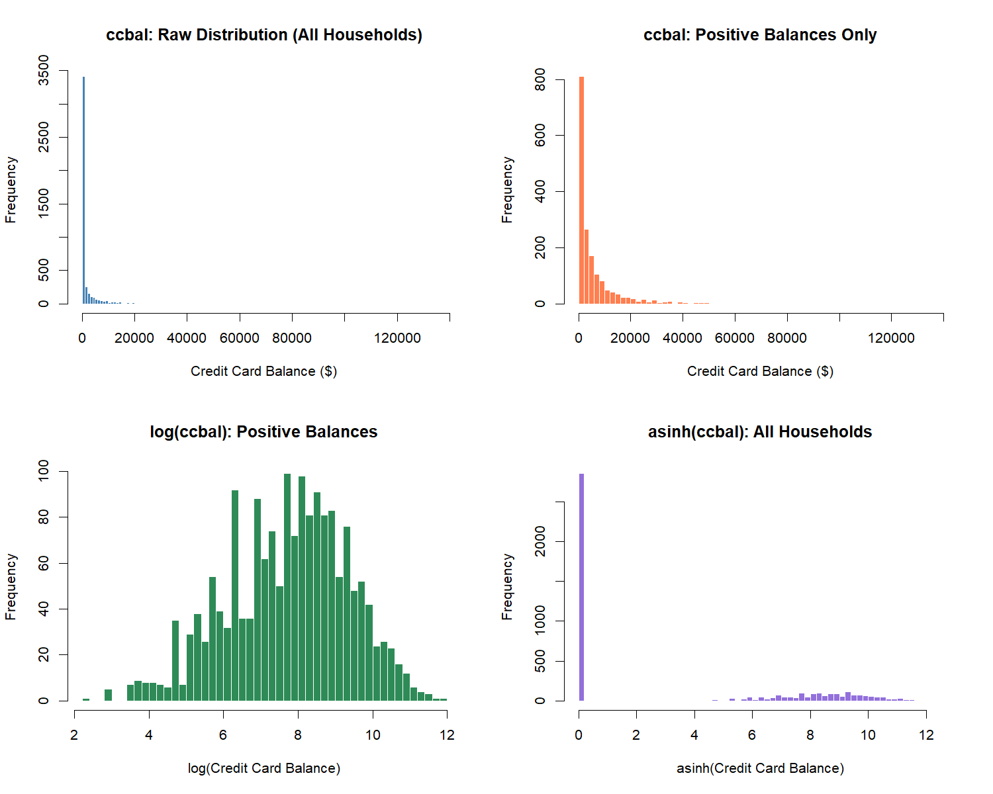

Transformation Decision
The distribution of ccbal exhibits two defining features: a large mass at zero (roughly 62.1% of households carry no credit card balance) and extreme right skew among positive values. This structure motivates a two-part modeling approach.
For Part 1 (logistic regression), the outcome is the binary indicator has_ccdebt (1 if ccbal > 0). For Part 2 (OLS regression), the outcome is log(ccbal) conditional on carrying any debt, which normalizes the heavy right tail. For the Lasso variable selection step, we use asinh(ccbal) on the full sample. The inverse hyperbolic sine handles zeros naturally and approximates log(2x) for large values, making it suitable for an initial screening pass that includes both debtors and non-debtors.

Predictor Variables
We engineer a broad set of continuous and categorical variables from the SCF extract dataset. A key decision is the treatment of total debt. Because ccbal is a component of the SCF’s aggregate debt variable, including total debt as a predictor would introduce a mechanical (tautological) relationship. We therefore construct debt_excl_cc (total debt minus credit card balance) to preserve the signal from non-credit-card liabilities without circularity.
The Lasso screening considers 31 continuous predictors. An additional 9 binary and categorical predictors enter the final models unpenalized as theoretically motivated controls.

Lasso Variable Selection
We run Lasso regression via glmnet with asinh(ccbal) as the outcome and the full set of 31 continuous predictors. Because the SCF uses multiple imputation, we run the Lasso on each of the five implicates separately and retain variables that survive penalization in at least 3 of 5 implicates (majority rule). This ensures that variable selection is robust to imputation variation.
Across the five implicates, the Lasso retained between 15 and 17 variables at lambda.1se. Applying the majority rule (survival in at least 3 of 5 implicates), 17 variables were selected for inclusion in the final models. Of these, 13 survived in all five implicates.
Variables surviving Lasso selection: asinh_bond, asinh_debt_excl_cc, asinh_dti, asinh_edn_inst, asinh_install, asinh_liq, asinh_mrthel, asinh_nmmf, asinh_othloc, asinh_resdbt, asinh_stocks, asinh_wageinc, kids, asinh_checking, asinh_income, asinh_networth, asinh_vehic
Note: asinh_vehic survived in exactly 3 of 5 implicates, the minimum threshold. The 3/5 majority rule is a researcher decision; results are not sensitive to reasonable alternatives (e.g., 4/5).

Lasso Coefficient Visualization
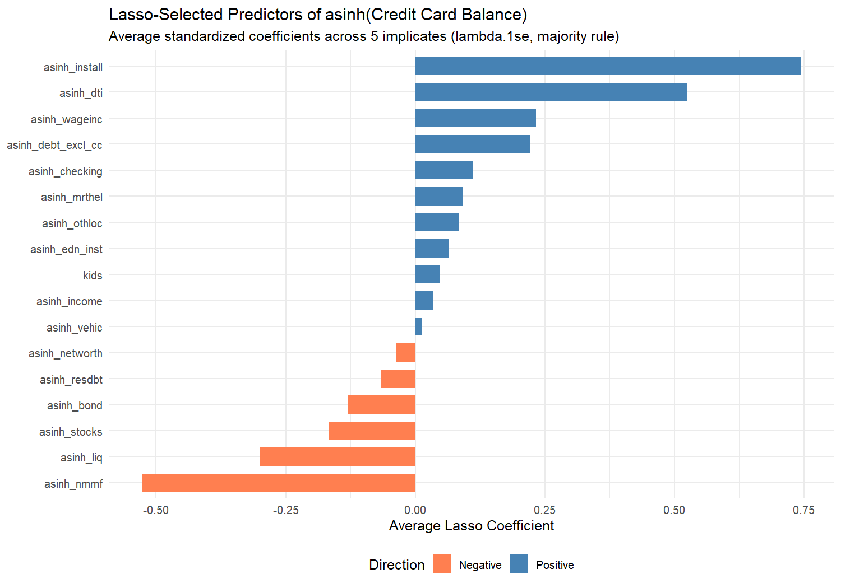
Table 1. Average Lasso Coefficients for Selected Predictors
Variable | Mean Coefficient | SD Across Implicates | Implicates Retained
asinh_install | 0.7439 | 0.0227 | 5
asinh_nmmf | -0.5276 | 0.0153 | 5
asinh_dti | 0.5254 | 0.0205 | 5
asinh_liq | -0.3009 | 0.0533 | 5
asinh_wageinc | 0.2333 | 0.0154 | 5
asinh_debt_excl_cc | 0.2225 | 0.0203 | 5
asinh_stocks | -0.1671 | 0.0185 | 5
asinh_bond | -0.1307 | 0.0247 | 5
asinh_checking | 0.1111 | 0.0318 | 4
asinh_mrthel | 0.0922 | 0.0158 | 5
asinh_othloc | 0.0850 | 0.0222 | 5
asinh_resdbt | -0.0671 | 0.0387 | 5
asinh_edn_inst | 0.0637 | 0.0176 | 5
kids | 0.0476 | 0.0077 | 5
asinh_networth | -0.0372 | 0.0222 | 4
asinh_income | 0.0338 | 0.0252 | 4
asinh_vehic | 0.0128 | 0.0088 | 3

Who Carries Credit Card Debt? Descriptive Patterns
Before turning to the multivariate models, we examine how credit card debt varies across key demographic groups. These descriptive patterns motivate the regression analysis and provide the context for interpreting the model coefficients.
Across all U.S. households, the weighted average credit card balance is approximately $2,768. About 45.2% of households carry any credit card balance at all.
The parenthood divide. Households with children carry a weighted average balance of $%s, compared to $%s for childless households. More importantly, %.1f%% of parents carry some credit card debt, versus %.1f%% of childless households. This gap — roughly 16 percentage points — is one of the largest demographic differences in credit card prevalence and motivates the central finding of this analysis.
3,608 2,232 55 39Credit denial is a red flag. Among households that have been turned down for credit in the past five years, 66.6% carry a credit card balance — compared to 42.8% of those never denied. Their average balances are also substantially higher ($4,452 vs. $2,578). Credit denial marks a population that is both more likely to carry revolving debt and more likely to carry larger amounts.
The age curve peaks in middle adulthood. Credit card balances are lowest among the youngest households (18–24: $664 average) and rise through middle age (45–54: $3,795), before declining in retirement. This lifecycle pattern reflects the accumulation of financial obligations — mortgages, children, career expenses — that peak in the 40s and 50s.
Race and ethnicity. Black and Hispanic households are more likely to carry credit card debt (56.3% and 55.8% respectively, vs. 42.2% for White households), but White households carry the highest average balances ($2,924). This pattern suggests that minority households enter credit card debt more frequently but may have lower credit limits or more constrained borrowing capacity.
These descriptive patterns are informative but potentially misleading — many of these characteristics are correlated with each other. A working married homeowner with a college degree and children is a very different household than a single renter without children. The multivariate models that follow disentangle these overlapping effects.

Prevalence of Credit Card Debt by Group
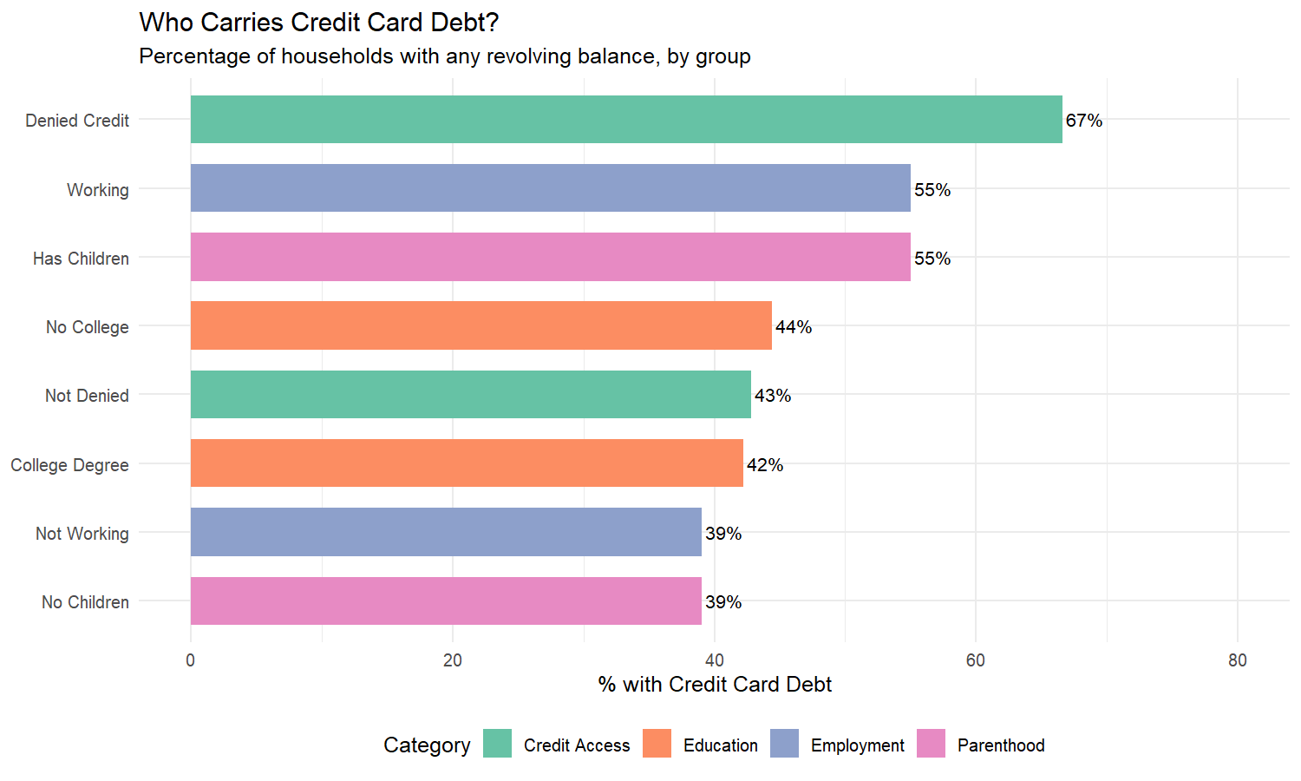

Bivariate Associations
The descriptive patterns above suggest that parenthood, credit access, and employment are strongly associated with credit card debt. But these variables are correlated — parents are more likely to be married, employed, and to own homes. To isolate the independent contribution of each factor, we turn to a two-part regression model.

The Two-Part Model: Who Carries Debt, and How Much?

Why Two Separate Models?
Credit card debt is a two-stage phenomenon. First, a household must enter revolving debt — by carrying a balance rather than paying in full. Second, conditional on carrying a balance, the household accumulates a specific amount. The factors that push someone into debt are not necessarily the same factors that determine how deep they go. We therefore estimate two separate models: a logistic regression for who carries any debt (Part 1), and an OLS regression for the dollar amount among debtors (Part 2).

Variable Selection: Letting the Data Speak
Rather than choosing predictors based on theory alone, we first use Lasso regression — a machine learning technique that penalizes weak predictors and retains only those with genuine explanatory power — to screen over 30 financial variables from the SCF. To ensure robustness, we run the Lasso on each of the SCF’s five multiply-imputed datasets separately and retain only variables that survive in at least three of five (majority rule). This data-driven selection is then combined with theoretically motivated demographic controls (marital status, parenthood, education, employment, race, gender, homeownership, pension access, and credit denial experience).
Total predictors: 26 (17 from Lasso + 9 categorical)
- asinh_bond
- asinh_debt_excl_cc
- asinh_dti
- asinh_edn_inst
- asinh_install
- asinh_liq
- asinh_mrthel
- asinh_nmmf
- asinh_othloc
- asinh_resdbt
- asinh_stocks
- asinh_wageinc
- kids
- asinh_checking
- asinh_income
- asinh_networth
- asinh_vehic
- female
- currently_married
- has_children
- college_degree
- is_working
- is_homeowner
- has_pension
- turned_down
- fear_denial

Part 1: Who Carries Any Credit Card Debt?
The logistic regression answers the extensive margin question: what predicts whether a household carries any revolving credit card balance? The table below shows odds ratios, where values above 1.0 indicate higher odds of carrying debt and values below 1.0 indicate lower odds.
Table 2. Logistic Regression Results (Part 1)
 | Term | Log-Odds | SE | Odds Ratio | OR Lower | OR Upper | p-value
(Intercept) | (Intercept) | -1.5092 | 0.4485 | 0.2211 | 0.0918 | 0.5326 | 7.66e-04 | ***
asinh_bond | asinh_bond | -0.0858 | 0.0436 | 0.9178 | 0.8427 | 0.9997 | 4.91e-02 | *
asinh_debt_excl_cc | asinh_debt_excl_cc | 0.0326 | 0.0139 | 1.0331 | 1.0053 | 1.0617 | 1.91e-02 | *
asinh_dti | asinh_dti | 0.2822 | 0.0764 | 1.3260 | 1.1416 | 1.5404 | 2.22e-04 | ***
asinh_edn_inst | asinh_edn_inst | 0.0126 | 0.0102 | 1.0127 | 0.9926 | 1.0331 | 2.18e-01
asinh_install | asinh_install | 0.0466 | 0.0111 | 1.0478 | 1.0252 | 1.0708 | 2.66e-05 | ***
asinh_liq | asinh_liq | -0.1158 | 0.0226 | 0.8906 | 0.8521 | 0.9309 | 2.90e-07 | ***
asinh_mrthel | asinh_mrthel | 0.0069 | 0.0115 | 1.0070 | 0.9846 | 1.0299 | 5.45e-01
asinh_nmmf | asinh_nmmf | -0.0695 | 0.0103 | 0.9329 | 0.9142 | 0.9520 | 1.76e-11 | ***
asinh_othloc | asinh_othloc | 0.0506 | 0.0285 | 1.0519 | 0.9947 | 1.1124 | 7.63e-02 | .
asinh_resdbt | asinh_resdbt | -0.0400 | 0.0139 | 0.9608 | 0.9349 | 0.9873 | 4.03e-03 | **
asinh_stocks | asinh_stocks | -0.0294 | 0.0083 | 0.9711 | 0.9555 | 0.9869 | 3.77e-04 | ***
asinh_wageinc | asinh_wageinc | 0.0092 | 0.0102 | 1.0093 | 0.9894 | 1.0296 | 3.64e-01
kids | kids | -0.1109 | 0.0444 | 0.8950 | 0.8204 | 0.9764 | 1.25e-02 | *
asinh_checking | asinh_checking | 0.0622 | 0.0170 | 1.0642 | 1.0293 | 1.1003 | 2.51e-04 | ***
asinh_income | asinh_income | 0.0513 | 0.0389 | 1.0526 | 0.9753 | 1.1361 | 1.87e-01
asinh_networth | asinh_networth | -0.0060 | 0.0088 | 0.9940 | 0.9771 | 1.0112 | 4.94e-01
asinh_vehic | asinh_vehic | 0.0062 | 0.0095 | 1.0062 | 0.9875 | 1.0252 | 5.19e-01
female | female | 0.3595 | 0.1035 | 1.4326 | 1.1696 | 1.7548 | 5.13e-04 | ***
currently_married | currently_married | 0.1624 | 0.0953 | 1.1763 | 0.9759 | 1.4180 | 8.85e-02 | .
has_children | has_children | 0.4329 | 0.1042 | 1.5417 | 1.2569 | 1.8910 | 3.27e-05 | ***
college_degree | college_degree | -0.2216 | 0.0674 | 0.8012 | 0.7021 | 0.9143 | 1.01e-03 | **
is_working | is_working | 0.3100 | 0.1120 | 1.3635 | 1.0947 | 1.6983 | 5.65e-03 | **
is_homeowner | is_homeowner | -0.1413 | 0.1252 | 0.8682 | 0.6792 | 1.1097 | 2.59e-01
has_pension | has_pension | 0.3462 | 0.0713 | 1.4137 | 1.2294 | 1.6257 | 1.19e-06 | ***
turned_down | turned_down | 0.6795 | 0.1268 | 1.9729 | 1.5386 | 2.5297 | 8.46e-08 | ***
fear_denial | fear_denial | -0.1576 | 0.1209 | 0.8542 | 0.6739 | 1.0826 | 1.92e-01
Model fit (Implicate 1): McFadden pseudo-R² = 0.1354; Null deviance = 6333.0; Residual deviance = 5475.3

Part 2: Among Debtors, What Predicts Higher Balances?
The OLS regression answers the intensive margin question: among the roughly 45% of households that carry a balance, what predicts how much they owe? The outcome is the natural log of the credit card balance, and the sample is restricted to households with positive balances.
Table 3. OLS Regression Results (Part 2: log(ccbal) | ccbal > 0)
 | Term | Estimate | SE | t-value | p-value
(Intercept) | (Intercept) | 4.6120 | 0.9517 | 4.8460 | 1.27e-06 | ***
asinh_bond | asinh_bond | -0.1273 | 0.0731 | -1.7420 | 8.38e-02 | ^
asinh_debt_excl_cc | asinh_debt_excl_cc | -0.0084 | 0.0136 | -0.6163 | 5.38e-01
asinh_dti | asinh_dti | 0.3082 | 0.1104 | 2.7931 | 5.28e-03 | **
asinh_edn_inst | asinh_edn_inst | -0.0188 | 0.0074 | -2.5363 | 1.12e-02 | *
asinh_install | asinh_install | 0.0393 | 0.0107 | 3.6596 | 2.62e-04 | ***
asinh_liq | asinh_liq | 0.0339 | 0.0228 | 1.4885 | 1.39e-01
asinh_mrthel | asinh_mrthel | 0.0259 | 0.0146 | 1.7719 | 7.65e-02 | ^
asinh_nmmf | asinh_nmmf | 0.0089 | 0.0129 | 0.6914 | 4.89e-01
asinh_othloc | asinh_othloc | 0.0457 | 0.0197 | 2.3211 | 2.03e-02 | *
asinh_resdbt | asinh_resdbt | 0.0423 | 0.0204 | 2.0760 | 3.82e-02 | *
asinh_stocks | asinh_stocks | 0.0415 | 0.0092 | 4.5323 | 5.91e-06 | ***
asinh_wageinc | asinh_wageinc | -0.0248 | 0.0092 | -2.7116 | 7.81e-03 | **
kids | kids | -0.0235 | 0.0429 | -0.5478 | 5.84e-01
asinh_checking | asinh_checking | 0.0160 | 0.0151 | 1.0595 | 2.90e-01
asinh_income | asinh_income | 0.1577 | 0.0910 | 1.7338 | 8.30e-02 | ^
asinh_networth | asinh_networth | -0.0162 | 0.0068 | -2.3839 | 1.72e-02 | *
asinh_vehic | asinh_vehic | 0.0415 | 0.0110 | 3.7591 | 1.72e-04 | ***
female | female | 0.0459 | 0.1101 | 0.4172 | 6.77e-01
currently_married | currently_married | 0.0100 | 0.1026 | 0.0971 | 9.23e-01
has_children | has_children | 0.0002 | 0.1047 | 0.0018 | 9.99e-01
college_degree | college_degree | -0.0972 | 0.0830 | -1.1708 | 2.42e-01
is_working | is_working | 0.0287 | 0.0974 | 0.2942 | 7.69e-01
is_homeowner | is_homeowner | -0.0430 | 0.1237 | -0.3476 | 7.28e-01
has_pension | has_pension | 0.2303 | 0.0714 | 3.2257 | 1.34e-03 | **
turned_down | turned_down | 0.0625 | 0.0905 | 0.6908 | 4.90e-01
fear_denial | fear_denial | -0.0755 | 0.1099 | -0.6870 | 4.92e-01
Weighted R² (Implicate 1): -0.3154
Model fit (Implicate 1): Weighted R² = -0.3154; N (debtors) = 1,742

Coefficient Comparison
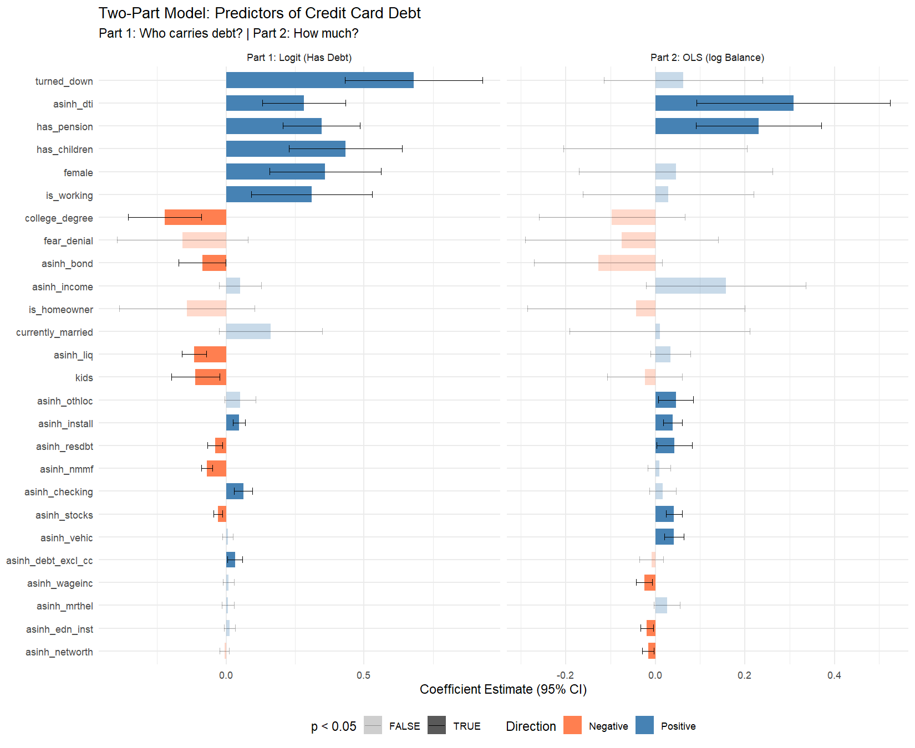

What the Data Tells Us: Five Key Findings
The two-part model separates two distinct questions — who takes on credit card debt, and how much they carry — revealing that the answers are not the same. The following findings are ordered by their practical significance.

Finding 1: The First Child Is the Financial Tipping Point
The single most striking result concerns parenthood. Having any children increases the odds of carrying credit card debt by 54% (OR = 1.54, p < 0.001). This is the largest demographic effect in the model — larger than employment, education, race, or marriage.
But here is the nuance: among households that already carry debt, the presence of children does not predict higher balances (OLS p = 0.999). And each additional child beyond the first is actually associated with lower odds of carrying debt (OR = 0.90, p = 0.013). This suppression effect suggests that the first child is the financially consequential event. Larger families tend to be older, more established households that have moved past the acute expense shock of a new baby.
The takeaway for young adults: The transition from zero to one child is the moment when credit card debt becomes significantly more likely. Financial planning for parenthood should focus on this transition — building an emergency fund, reducing existing debt, and anticipating the lumpy expenses (medical bills, childcare, equipment) that accompany a first child.

Finding 2: Marriage Does Not Independently Predict Credit Card Debt
Marriage has no significant independent effect on credit card debt. The odds ratio is 1.18 (p = 0.088) — and the OLS coefficient among debtors is essentially zero (p = 0.923).
This is a substantively important null finding. In the descriptive statistics, married households carry higher average balances. But that association disappears entirely once we control for income, homeownership, pension access, and other financial characteristics. Married households carry more debt not because of marriage itself, but because marriage is correlated with higher income, homeownership, and greater access to credit.
The takeaway: For researchers and counselors interested in the relationship between financial stress and marriage, credit card debt should be understood as a function of the household’s broader financial position, not as a distinctive feature of married life.

Finding 3: Credit Denial Is the Strongest Predictor of Revolving Debt
Households that have been denied credit in the past five years have 97% higher odds of carrying a credit card balance (OR = 1.97, p < 0.001). This is the single largest coefficient in the logistic model. However, among those who carry debt, credit denial does not predict higher balances (OLS p = 0.490).
This pattern suggests that credit cards function as a last resort for financially excluded households. Denied other forms of credit (auto loans, personal loans, home equity lines), these households lean on their existing credit card lines. The amounts they carry are then governed by their credit limits and income, not by the denial experience itself.
The takeaway: Credit denial is a powerful signal of financial vulnerability. A household that has been turned down for credit is nearly twice as likely to be revolving credit card debt. For financial counselors, a recent credit denial should trigger a conversation about debt management strategies.

Finding 4: Higher Wages Help People Pay Down Debt
Among debtors, higher wage income is associated with significantly lower credit card balances (OLS coefficient = -0.025, p = 0.008). This is one of the few variables that reaches significance in the Part 2 model.
The interpretation is straightforward: earnings provide debt-repayment capacity. Workers who earn more can pay down their balances faster. This contrasts with total household income, which is not significant — suggesting that it is earned income from labor, not investment returns or transfers, that drives repayment behavior.
The takeaway for policy: Programs that increase wages or reduce income volatility may be more effective at reducing credit card debt burdens than programs that expand credit access. Expanding access increases the prevalence of debt (more people can borrow) but does not reduce its severity (how much they owe). Wage growth addresses severity directly.

Finding 5: Liquid Savings Protect Against Entering Debt
Households with more liquid assets are significantly less likely to carry any credit card debt. Liquid savings (OR = 0.89), stock holdings (OR = 0.97), and mutual fund balances (OR = 0.93) all carry significant negative coefficients in the logistic model.
However, among those who carry debt, asset levels do not consistently predict lower balances. This asymmetry reveals a threshold effect: liquid savings determine whether a household needs to use credit cards as a borrowing tool. If an unexpected expense arises, a household with savings can absorb it; a household without savings reaches for the credit card. But once a household is carrying a balance, other factors — debt-to-income ratio, installment obligations, income — matter more for the amount.
The takeaway: Emergency savings are the first line of defense against credit card debt. Even a modest liquid savings buffer can prevent the entry into revolving debt that becomes difficult to escape.

Conclusion
This analysis reveals that credit card debt in America is not a monolithic phenomenon — it is a two-stage process driven by different forces at each stage. The factors that push a household into revolving debt (parenthood, credit denial, lack of liquid savings) are largely distinct from the factors that determine how much debt they carry (wages, debt-to-income ratio, installment obligations).
The central finding — that the first child is the single most consequential event for credit card indebtedness — has direct implications for financial counselors, policy makers, and young adults themselves. The transition to parenthood increases the odds of carrying credit card debt by 54%, but marriage does not. Additional children beyond the first do not compound the effect. This means the financial preparation conversation should center on the first pregnancy, not on the wedding.
For policy, the data points in two directions. First, expanding credit access without addressing underlying financial vulnerability will increase the prevalence of credit card debt without reducing its severity. Second, wage growth is the most effective lever for reducing balances among those who already carry debt — higher earners pay down faster. Programs that combine income support with financial literacy at the transition to parenthood may be the most targeted intervention available.

Appendix: Technical Notes
Multiple Imputation. All statistics and models are pooled across the SCF’s five implicates using Rubin’s Rules, as implemented by the scf package. No results are reported from a single implicate. Model fit statistics (pseudo-R², R²) are reported from Implicate 1 for reference; these may vary slightly across implicates.
Survey Weights. All estimates use the SCF replicate weights (balanced repeated replication) to account for the complex survey design, including oversampling of wealthy households.
Lasso Implementation. Lasso was run via glmnet with 10-fold cross-validation on each implicate separately. We used lambda.1se (the most regularized model within one standard error of the minimum CV error) for parsimony. The majority rule (variable survives in >= 3 of 5 implicates) ensures robustness to imputation variation.
Tautology Correction. Total household debt (debt) includes credit card balances as a component. To avoid a mechanically inflated coefficient, we constructed debt_excl_cc = max(debt - ccbal, 0) and used its asinh transform in place of asinh_debt throughout the Lasso and regression models.
Two-Part Model. Part 1 is a logistic regression on the binary indicator has_ccdebt. Part 2 is OLS on log(ccbal) conditional on ccbal > 0. This approach is standard for semicontinuous outcomes with a large mass at zero and a continuous positive tail (Duan et al., 1983; Manning et al., 1987).
Suppression Effect: kids vs. has_children. Both the continuous count of children and the binary indicator are included in the model. The opposite-signed coefficients are a classical suppression pattern: the binary indicator captures the extensive margin (any children vs. none), while the continuous count captures the intensive margin conditional on the binary. This is analogous to a two-part specification within the predictor set itself.

