itle: “Credit Card Balance and Household Behavior in the United States”
ubtitle: “A Two-Part Model with Lasso Variable Selection Using the 2022 Survey of Consumer Finances”
uthor: “Delroy Nichols”
ate: “2026-03-29”
utput:
word_document:
toc: true
toc_depth: 3

Introduction
Research Question: What financial and demographic characteristics most strongly predict credit card balance levels among U.S. households, and what do these associations suggest about the behavioral and causal mechanisms — including relationship formation, willingness to start families, and labor market participation — that govern household indebtedness?
Analytic Strategy: We employ a two-part modeling approach. Part 1 uses logistic regression to model the probability of carrying any credit card debt (ccbal > 0). Part 2 uses OLS regression to model the magnitude of credit card balances, conditional on carrying any debt. Before fitting either model, we use Lasso regression on a broad set of continuous SCF variables to identify the most influential predictors, retaining only those whose coefficients survive penalization across a majority of implicates.
Data Source: 2022 Survey of Consumer Finances (SCF), Federal Reserve Board. The SCF uses a dual-frame design combining area-probability sampling with a list-based oversample of wealthy households. All analyses account for the five-implicate multiple imputation structure and use replicate weights. Inferential statistics are pooled across all five implicates using Rubin’s Rules.
Note on Scope: All findings reported here are correlational. The cross-sectional design of the SCF does not support causal inference. We discuss plausible mechanisms but acknowledge that reverse causality, confounding, and selection effects are present throughout.

Package Loading
required_packages <- c(
"tidyverse", "haven", "survey", "labelled",
"psych", "ggplot2", "scales", "scf",
"glmnet", "Matrix", "broom", "knitr",
"moments", "car"
)
for (pkg in required_packages) {
if (!require(pkg, character.only = TRUE, quietly = TRUE)) {
install.packages(pkg, repos = "http://cran.us.r-project.org")
library(pkg, character.only = TRUE)
}
}
cat("All packages loaded.\n")
## All packages loaded.

Data Download and Load
dir.create("scf_data", showWarnings = FALSE, recursive = TRUE)
original_wd <- getwd()
setwd("scf_data")
if (!file.exists("scf2022.rds")) {
cat("Downloading 2022 SCF data (this may take a few minutes)...\n")
tryCatch({
scf_download(2022)
cat("2022 download complete.\n")
}, error = function(e) {
cat("Error downloading 2022 data:", conditionMessage(e), "\n")
})
} else {
cat("scf2022.rds already exists — skipping download.\n")
}
## scf2022.rds already exists — skipping download.
setwd(original_wd)
cat("Download step complete.\n")
## Download step complete.
scf_2022 <- scf_load(2022, data_directory = "scf_data")
cat("2022 SCF loaded successfully.\n")
## 2022 SCF loaded successfully.

Outcome Variable: Credit Card Balance (ccbal)
We examine the distribution of ccbal to determine the most appropriate modeling approach.

Raw Distribution Diagnostics
imp1 <- scf_2022$mi_design[[1]]$variables
cat("===== ccbal: Raw Distribution Summary (Implicate 1) =====\n")
## ===== ccbal: Raw Distribution Summary (Implicate 1) =====
cat("N total: ", nrow(imp1), "\n")
## N total: 4595
cat("N zero: ", sum(imp1$ccbal == 0), "\n")
## N zero: 2853
cat("Pct zero: ", round(100 * mean(imp1$ccbal == 0), 1), "%\n")
## Pct zero: 62.1 %
cat("N positive: ", sum(imp1$ccbal > 0), "\n")
## N positive: 1742
cat("Pct positive: ", round(100 * mean(imp1$ccbal > 0), 1), "%\n\n")
## Pct positive: 37.9 %
cat("--- Among ALL households ---\n")
## --- Among ALL households ---
cat("Mean: $", formatC(mean(imp1$ccbal), format = "f", big.mark = ",", digits = 0), "\n")
## Mean: $ 2,515
cat("Median: $", formatC(median(imp1$ccbal), format = "f", big.mark = ",", digits = 0), "\n")
## Median: $ 0
cat("SD: $", formatC(sd(imp1$ccbal), format = "f", big.mark = ",", digits = 0), "\n")
## SD: $ 7,853
cat("Skewness: ", round(moments::skewness(imp1$ccbal), 2), "\n")
## Skewness: 6.68
cat("Kurtosis: ", round(moments::kurtosis(imp1$ccbal), 2), "\n\n")
## Kurtosis: 68.32
pos <- imp1$ccbal[imp1$ccbal > 0]
cat("--- Among households WITH credit card debt ---\n")
## --- Among households WITH credit card debt ---
cat("Mean: $", formatC(mean(pos), format = "f", big.mark = ",", digits = 0), "\n")
## Mean: $ 6,635
cat("Median: $", formatC(median(pos), format = "f", big.mark = ",", digits = 0), "\n")
## Median: $ 2,520
cat("SD: $", formatC(sd(pos), format = "f", big.mark = ",", digits = 0), "\n")
## SD: $ 11,636
cat("Skewness: ", round(moments::skewness(pos), 2), "\n")
## Skewness: 4.33
cat("Kurtosis: ", round(moments::kurtosis(pos), 2), "\n")
## Kurtosis: 30.51
cat("Max: $", formatC(max(pos), format = "f", big.mark = ",", digits = 0), "\n")
## Max: $ 139,000

Distribution Visualizations
par(mfrow = c(2, 2))
hist(imp1$ccbal, breaks = 100, main = "ccbal: Raw Distribution (All)",
xlab = "Credit Card Balance ($)", col = "steelblue", border = "white")
hist(pos, breaks = 80, main = "ccbal: Positive Balances Only",
xlab = "Credit Card Balance ($)", col = "coral", border = "white")
hist(log(pos), breaks = 60, main = "log(ccbal): Positive Balances",
xlab = "log(Credit Card Balance)", col = "seagreen", border = "white")
hist(asinh(imp1$ccbal), breaks = 60, main = "asinh(ccbal): All Households",
xlab = "asinh(Credit Card Balance)", col = "mediumpurple", border = "white")
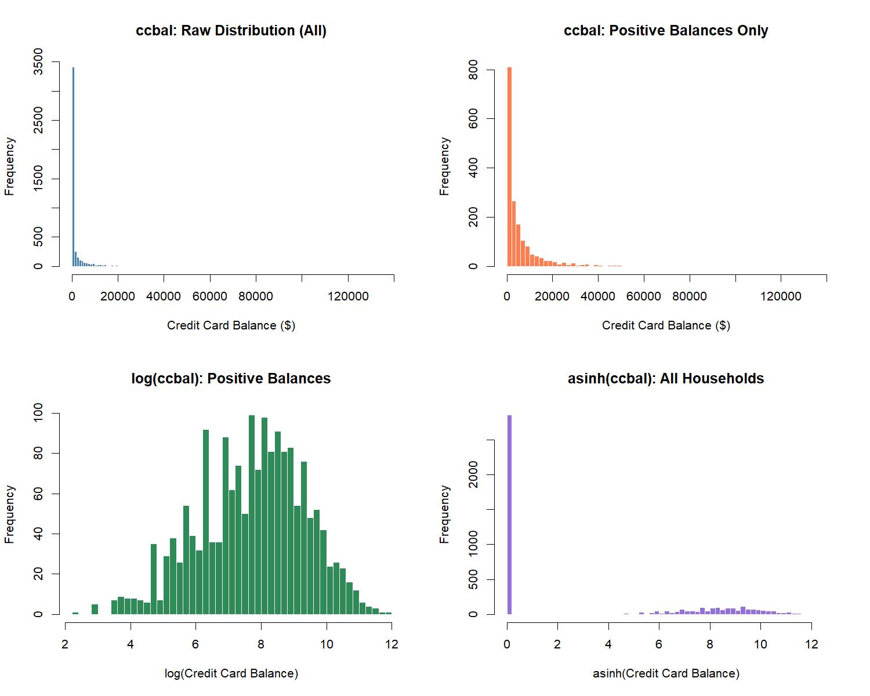
par(mfrow = c(1, 1))

Transformation Decision
The distribution of ccbal exhibits two defining features: a large mass at zero (roughly 62% of households carry no credit card balance) and extreme right skew among positive values (skewness > 4, kurtosis > 30). This structure motivates a two-part modeling approach.
For Part 1 (logistic regression), the outcome is the binary indicator has_ccdebt (1 if ccbal > 0). For Part 2 (OLS regression), the outcome is log(ccbal) conditional on carrying any debt, which normalizes the heavy right tail. For the Lasso variable selection step, we use asinh(ccbal) on the full sample. The inverse hyperbolic sine handles zeros naturally and approximates log(2x) for large values, making it suitable for an initial screening pass that includes both debtors and non-debtors.

Create Outcome Variables
scf_2022 <- scf_update(scf_2022,
has_ccdebt = as.integer(ccbal > 0),
log_ccbal = ifelse(ccbal > 0, log(ccbal), NA),
asinh_ccbal = asinh(ccbal)
)
cat("Outcome variables created: has_ccdebt, log_ccbal, asinh_ccbal\n")
## Outcome variables created: has_ccdebt, log_ccbal, asinh_ccbal

Predictor Variables: Wide Net and Wrangling
We engineer a broad set of continuous and categorical variables from the SCF extract dataset. A key decision here is the treatment of total debt (debt). Because ccbal is a component of debt, including asinh_debt as a predictor would introduce a mechanical (tautological) relationship — total debt predicts credit card debt partly because it contains credit card debt. We therefore construct debt_excl_cc (total debt minus credit card balance) to preserve the signal from non-credit-card liabilities without the circularity.

Variable Engineering
scf_2022 <- scf_update(scf_2022,
# ---- Demographics ----
female = as.integer(hhsex == 2),
currently_married = as.integer(married == 1),
has_children = as.integer(kids > 0),
college_degree = as.integer(edcl == 4),
educ_cat = factor(edcl,
levels = 1:4,
labels = c("Less than HS", "High School", "Some College", "College Degree")
),
race_cat = factor(racecl4,
levels = 1:4,
labels = c("White", "Black", "Hispanic", "Other")
),
age_group = cut(age,
breaks = c(18, 24, 34, 44, 54, 64, Inf),
labels = c("18-24", "25-34", "35-44", "45-54", "55-64", "65+"),
right = TRUE, include.lowest = TRUE
),
age_sq = age^2,
# ---- Income and wealth (asinh for zeros/negatives) ----
asinh_income = asinh(income),
asinh_networth = asinh(networth),
asinh_wageinc = asinh(wageinc),
# ---- Debt variables (asinh) ----
# debt_excl_cc removes the tautological component
debt_excl_cc = pmax(debt - ccbal, 0),
asinh_debt_excl_cc = asinh(pmax(debt - ccbal, 0)),
asinh_install = asinh(install),
asinh_edn_inst = asinh(edn_inst),
asinh_nh_mort = asinh(nh_mort),
asinh_mrthel = asinh(mrthel),
asinh_othloc = asinh(othloc),
asinh_resdbt = asinh(resdbt),
# ---- Asset variables (asinh) ----
asinh_asset = asinh(asset),
asinh_fin = asinh(fin),
asinh_nfin = asinh(nfin),
asinh_liq = asinh(liq),
asinh_retqliq = asinh(retqliq),
asinh_cashli = asinh(cashli),
asinh_stocks = asinh(stocks),
asinh_bond = asinh(bond),
asinh_nmmf = asinh(nmmf),
asinh_vehic = asinh(vehic),
asinh_houses = asinh(houses),
asinh_homeeq = asinh(homeeq),
asinh_bus = asinh(bus),
asinh_equity = asinh(equity),
asinh_saving = asinh(saving),
asinh_checking = asinh(checking),
# ---- Ratios ----
asinh_dti = asinh(ifelse(income > 0, debt / income, 0)),
# ---- Counts ----
nvehic_raw = nvehic,
# ---- Labor / credit access indicators ----
is_working = as.integer(lf == 1),
is_homeowner = as.integer(housecl == 1),
has_pension = as.integer(anypen == 1),
turned_down = as.integer(turndown == 1),
fear_denial = as.integer(feardenial == 1)
)
cat("All predictor variables engineered across implicates.\n")
## All predictor variables engineered across implicates.

Define Predictor Sets
# Full continuous predictor set for Lasso (wide net)
# NOTE: asinh_debt_excl_cc replaces asinh_debt to avoid tautology
continuous_predictors <- c(
"age", "age_sq",
"asinh_income", "asinh_wageinc", "asinh_networth",
"asinh_debt_excl_cc", "asinh_install", "asinh_edn_inst",
"asinh_nh_mort", "asinh_mrthel", "asinh_othloc", "asinh_resdbt",
"asinh_asset", "asinh_fin", "asinh_nfin",
"asinh_liq", "asinh_retqliq", "asinh_cashli",
"asinh_stocks", "asinh_bond", "asinh_nmmf",
"asinh_vehic", "asinh_houses", "asinh_homeeq",
"asinh_bus", "asinh_equity", "asinh_saving", "asinh_checking",
"asinh_dti", "nvehic_raw", "kids"
)
# Categorical / binary predictors (enter final models directly, not penalized by Lasso)
categorical_predictors <- c(
"female", "currently_married", "has_children",
"college_degree", "is_working", "is_homeowner",
"has_pension", "turned_down", "fear_denial"
)
cat("Continuous predictors for Lasso: ", length(continuous_predictors), "\n")
## Continuous predictors for Lasso: 31
cat("Binary/categorical predictors: ", length(categorical_predictors), "\n")
## Binary/categorical predictors: 9

Lasso Variable Selection
We run Lasso regression via glmnet with asinh(ccbal) as the outcome and the full set of continuous predictors. The Lasso shrinks uninformative coefficients to zero, retaining only variables with genuine predictive signal.
Because the SCF uses multiple imputation, we run the Lasso on each of the five implicates separately and retain variables that survive penalization in at least 3 of 5 implicates (majority rule). This ensures that variable selection is robust to imputation variation.
library(glmnet)
lasso_selected <- list()
lasso_coefs <- list()
for (i in 1:5) {
cat("--- Implicate", i, "---\n")
df_i <- scf_2022$mi_design[[i]]$variables
wt_i <- df_i$wgt
# Build predictor matrix (continuous only)
available <- continuous_predictors[continuous_predictors %in% names(df_i)]
X <- as.matrix(df_i[, available, drop = FALSE])
y <- df_i$asinh_ccbal
# Remove rows with NA
complete <- complete.cases(X, y, wt_i)
X <- X[complete, , drop = FALSE]
y <- y[complete]
w <- wt_i[complete]
w <- w / mean(w)
# Standardize
X_scaled <- scale(X)
# Cross-validated Lasso
set.seed(123)
cv_fit <- cv.glmnet(X_scaled, y, weights = w, alpha = 1,
nfolds = 10, type.measure = "mse")
# Coefficients at lambda.1se (parsimonious)
coef_1se <- coef(cv_fit, s = "lambda.1se")
coef_df <- as.data.frame(as.matrix(coef_1se))
coef_df$variable <- rownames(coef_df)
names(coef_df)[1] <- "coefficient"
nonzero <- coef_df %>%
filter(variable != "(Intercept)", coefficient != 0) %>%
arrange(desc(abs(coefficient)))
lasso_selected[[i]] <- nonzero$variable
lasso_coefs[[i]] <- nonzero
cat(" lambda.1se =", round(cv_fit$lambda.1se, 4), "\n")
cat(" Variables retained:", nrow(nonzero), "of", length(available), "\n\n")
}
## --- Implicate 1 ---
## lambda.1se = 0.0919
## Variables retained: 16 of 31
##
## --- Implicate 2 ---
## lambda.1se = 0.0837
## Variables retained: 16 of 31
##
## --- Implicate 3 ---
## lambda.1se = 0.0766
## Variables retained: 17 of 31
##
## --- Implicate 4 ---
## lambda.1se = 0.0774
## Variables retained: 17 of 31
##
## --- Implicate 5 ---
## lambda.1se = 0.1102
## Variables retained: 15 of 31
# Majority rule: keep variables surviving in >= 3 of 5 implicates
all_vars <- unlist(lasso_selected)
var_counts <- sort(table(all_vars), decreasing = TRUE)
cat("===== Lasso Survival Across Implicates =====\n")
## ===== Lasso Survival Across Implicates =====
print(var_counts)
## all_vars
## asinh_bond asinh_debt_excl_cc asinh_dti asinh_edn_inst
## 5 5 5 5
## asinh_install asinh_liq asinh_mrthel asinh_nmmf
## 5 5 5 5
## asinh_othloc asinh_resdbt asinh_stocks asinh_wageinc
## 5 5 5 5
## kids asinh_checking asinh_income asinh_networth
## 5 4 4 4
## asinh_vehic asinh_saving
## 3 1
lasso_survivors <- names(var_counts[var_counts >= 3])
cat("\n===== Variables Surviving Majority Rule (>= 3/5) =====\n")
##
## ===== Variables Surviving Majority Rule (>= 3/5) =====
cat(paste(lasso_survivors, collapse = ", "), "\n")
## asinh_bond, asinh_debt_excl_cc, asinh_dti, asinh_edn_inst, asinh_install, asinh_liq, asinh_mrthel, asinh_nmmf, asinh_othloc, asinh_resdbt, asinh_stocks, asinh_wageinc, kids, asinh_checking, asinh_income, asinh_networth, asinh_vehic
cat("Total retained:", length(lasso_survivors), "\n")
## Total retained: 17

Lasso Coefficient Visualization
avg_coefs <- bind_rows(lasso_coefs, .id = "implicate") %>%
filter(variable %in% lasso_survivors) %>%
group_by(variable) %>%
summarise(
mean_coef = mean(coefficient),
sd_coef = sd(coefficient),
n_implicates = n(),
.groups = "drop"
) %>%
arrange(desc(abs(mean_coef)))
cat("\n===== Average Lasso Coefficients (Standardized, Across Implicates) =====\n")
##
## ===== Average Lasso Coefficients (Standardized, Across Implicates) =====
print(avg_coefs, n = 50)
## # A tibble: 17 × 4
## variable mean_coef sd_coef n_implicates
## <chr> <dbl> <dbl> <int>
## 1 asinh_install 0.744 0.0227 5
## 2 asinh_nmmf -0.528 0.0153 5
## 3 asinh_dti 0.525 0.0205 5
## 4 asinh_liq -0.301 0.0533 5
## 5 asinh_wageinc 0.233 0.0154 5
## 6 asinh_debt_excl_cc 0.222 0.0203 5
## 7 asinh_stocks -0.167 0.0185 5
## 8 asinh_bond -0.131 0.0247 5
## 9 asinh_checking 0.111 0.0318 4
## 10 asinh_mrthel 0.0922 0.0158 5
## 11 asinh_othloc 0.0850 0.0222 5
## 12 asinh_resdbt -0.0671 0.0387 5
## 13 asinh_edn_inst 0.0637 0.0176 5
## 14 kids 0.0476 0.00769 5
## 15 asinh_networth -0.0372 0.0222 4
## 16 asinh_income 0.0338 0.0252 4
## 17 asinh_vehic 0.0128 0.00877 3
ggplot(avg_coefs, aes(x = reorder(variable, mean_coef), y = mean_coef)) +
geom_col(aes(fill = mean_coef > 0), width = 0.7) +
scale_fill_manual(values = c("TRUE" = "steelblue", "FALSE" = "coral"),
labels = c("Negative", "Positive"), name = "Direction") +
coord_flip() +
labs(
title = "Lasso-Selected Predictors of asinh(Credit Card Balance)",
subtitle = "Average standardized coefficients across 5 implicates (lambda.1se, majority rule)",
x = NULL, y = "Average Lasso Coefficient"
) +
theme_minimal(base_size = 12) +
theme(legend.position = "bottom")
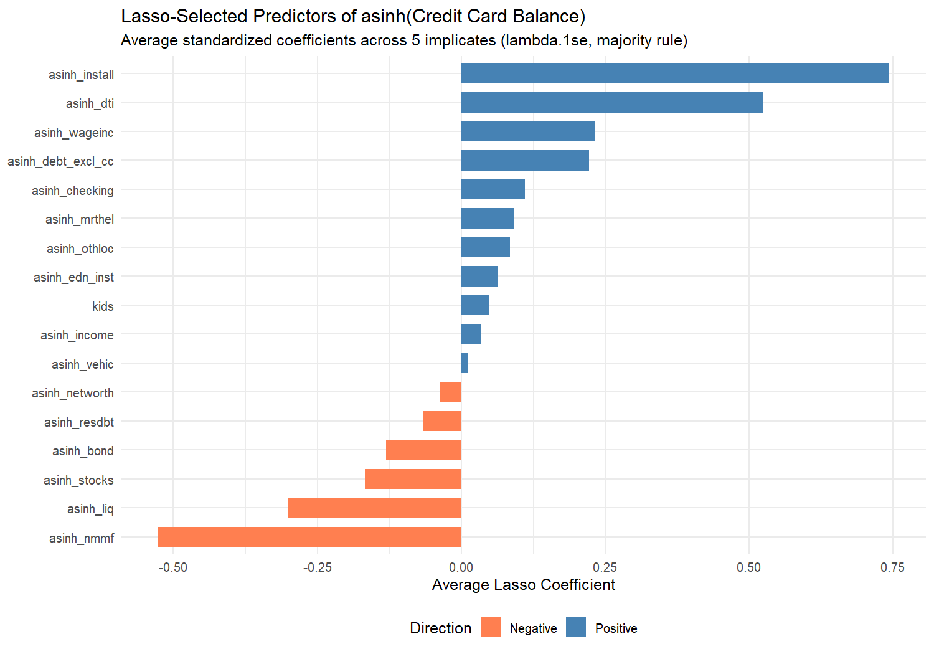
The Lasso winnowed 31 continuous predictors down to 17 variables that carry genuine predictive signal for credit card balances. Variables shrunk to zero across most implicates are considered noise or redundant. We carry the surviving variables forward into the two-part model alongside the categorical predictors.

Univariate Statistics
Before modeling, we examine the marginal distributions of ccbal using proper survey-weighted estimates pooled across all five implicates.

Credit Card Balance: Weighted Estimates
cat("===== Weighted Mean: ccbal (Overall) =====\n")
## ===== Weighted Mean: ccbal (Overall) =====
print(scf_mean(scf_2022, ~ccbal))
## Multiply-Imputed, Replicate-Weighted Mean Estimate
##
## variable estimate se min max
## ccbal 2767.986 121.0167 2740.803 2799.071
cat("\n===== By Marital Status =====\n")
##
## ===== By Marital Status =====
print(scf_mean(scf_2022, ~ccbal, by = ~currently_married))
## Multiply-Imputed, Replicate-Weighted Mean Estimate
##
## group variable estimate se min max
## 0 ccbal 2150.649 172.1373 2134.640 2163.403
## 1 ccbal 3225.160 156.5334 3175.368 3269.392
cat("\n===== By Gender =====\n")
##
## ===== By Gender =====
print(scf_mean(scf_2022, ~ccbal, by = ~female))
## Multiply-Imputed, Replicate-Weighted Mean Estimate
##
## group variable estimate se min max
## 0 ccbal 2888.923 124.5942 2857.429 2928.669
## 1 ccbal 2455.025 255.5885 2431.100 2486.883
cat("\n===== By Education =====\n")
##
## ===== By Education =====
print(scf_mean(scf_2022, ~ccbal, by = ~educ_cat))
## Multiply-Imputed, Replicate-Weighted Mean Estimate
##
## group variable estimate se min max
## Less than HS ccbal 1496.270 334.1191 1479.819 1519.385
## High School ccbal 2301.266 164.3792 2267.489 2331.957
## Some College ccbal 3163.191 233.4667 3128.246 3191.653
## College Degree ccbal 3067.279 217.4229 3003.076 3114.921
cat("\n===== By Race =====\n")
##
## ===== By Race =====
print(scf_mean(scf_2022, ~ccbal, by = ~race_cat))
## Multiply-Imputed, Replicate-Weighted Mean Estimate
##
## group variable estimate se min max
## White ccbal 2924.146 169.2922 2896.426 2943.604
## Black ccbal 2453.663 234.6755 2377.714 2576.787
## Hispanic ccbal 2317.569 217.1020 2291.596 2358.966
## Other ccbal 2557.178 267.8708 2518.284 2586.221
cat("\n===== By Age Group =====\n")
##
## ===== By Age Group =====
print(scf_mean(scf_2022, ~ccbal, by = ~age_group))
## Multiply-Imputed, Replicate-Weighted Mean Estimate
##
## group variable estimate se min max
## 18-24 ccbal 664.489 130.0121 649.961 689.1381
## 25-34 ccbal 2356.914 296.4665 2322.799 2416.4382
## 35-44 ccbal 3350.608 288.0760 3297.358 3387.0578
## 45-54 ccbal 3795.149 301.3882 3708.249 3911.4962
## 55-64 ccbal 3337.365 275.0102 3303.712 3362.3459
## 65+ ccbal 2008.410 237.7266 1979.650 2037.7963
cat("\n===== By Has Children =====\n")
##
## ===== By Has Children =====
print(scf_mean(scf_2022, ~ccbal, by = ~has_children))
## Multiply-Imputed, Replicate-Weighted Mean Estimate
##
## group variable estimate se min max
## 0 ccbal 2232.206 143.4845 2213.756 2249.821
## 1 ccbal 3608.408 175.8851 3565.304 3661.418
cat("\n===== By Working Status =====\n")
##
## ===== By Working Status =====
print(scf_mean(scf_2022, ~ccbal, by = ~is_working))
## Multiply-Imputed, Replicate-Weighted Mean Estimate
##
## group variable estimate se min max
## 0 ccbal 1569.792 148.7977 1536.394 1587.294
## 1 ccbal 3261.813 161.6847 3216.845 3301.628
cat("\n===== By Turned Down for Credit =====\n")
##
## ===== By Turned Down for Credit =====
print(scf_mean(scf_2022, ~ccbal, by = ~turned_down))
## Multiply-Imputed, Replicate-Weighted Mean Estimate
##
## group variable estimate se min max
## 0 ccbal 2578.464 129.5913 2553.158 2613.155
## 1 ccbal 4452.096 488.9023 4411.345 4507.983

Prevalence of Credit Card Debt
cat("===== Weighted Prevalence: Carries Any CC Debt =====\n")
## ===== Weighted Prevalence: Carries Any CC Debt =====
print(scf_mean(scf_2022, ~has_ccdebt))
## Multiply-Imputed, Replicate-Weighted Mean Estimate
##
## variable estimate se min max
## has_ccdebt 0.4522272 0.009755585 0.4501642 0.4551503
cat("\n===== By Marital Status =====\n")
##
## ===== By Marital Status =====
print(scf_mean(scf_2022, ~has_ccdebt, by = ~currently_married))
## Multiply-Imputed, Replicate-Weighted Mean Estimate
##
## group variable estimate se min max
## 0 has_ccdebt 0.4263822 0.01222587 0.4243260 0.4296706
## 1 has_ccdebt 0.4713673 0.01225992 0.4680617 0.4741518
cat("\n===== By Education =====\n")
##
## ===== By Education =====
print(scf_mean(scf_2022, ~has_ccdebt, by = ~educ_cat))
## Multiply-Imputed, Replicate-Weighted Mean Estimate
##
## group variable estimate se min max
## Less than HS has_ccdebt 0.3408664 0.02180491 0.3385457 0.3424714
## High School has_ccdebt 0.4833815 0.01465548 0.4804082 0.4855977
## Some College has_ccdebt 0.5076535 0.01409139 0.5064834 0.5102121
## College Degree has_ccdebt 0.4218866 0.01459048 0.4172659 0.4256203
cat("\n===== By Race =====\n")
##
## ===== By Race =====
print(scf_mean(scf_2022, ~has_ccdebt, by = ~race_cat))
## Multiply-Imputed, Replicate-Weighted Mean Estimate
##
## group variable estimate se min max
## White has_ccdebt 0.4218539 0.01101429 0.4195253 0.4257106
## Black has_ccdebt 0.5632997 0.02291581 0.5551795 0.5686210
## Hispanic has_ccdebt 0.5578940 0.02562115 0.5531260 0.5613359
## Other has_ccdebt 0.4329153 0.02270661 0.4289794 0.4366085
cat("\n===== By Age Group =====\n")
##
## ===== By Age Group =====
print(scf_mean(scf_2022, ~has_ccdebt, by = ~age_group))
## Multiply-Imputed, Replicate-Weighted Mean Estimate
##
## group variable estimate se min max
## 18-24 has_ccdebt 0.4107222 0.04605129 0.4067558 0.4133289
## 25-34 has_ccdebt 0.5070813 0.02338007 0.5047454 0.5087880
## 35-44 has_ccdebt 0.5259061 0.01877300 0.5234331 0.5290401
## 45-54 has_ccdebt 0.5699713 0.01797954 0.5663620 0.5756623
## 55-64 has_ccdebt 0.4432015 0.01654951 0.4415219 0.4458446
## 65+ has_ccdebt 0.3214669 0.01225475 0.3193070 0.3268730
cat("\n===== By Has Children =====\n")
##
## ===== By Has Children =====
print(scf_mean(scf_2022, ~has_ccdebt, by = ~has_children))
## Multiply-Imputed, Replicate-Weighted Mean Estimate
##
## group variable estimate se min max
## 0 has_ccdebt 0.3897269 0.01120408 0.3877207 0.3928992
## 1 has_ccdebt 0.5502616 0.01253523 0.5478494 0.5532330
cat("\n===== By Turned Down for Credit =====\n")
##
## ===== By Turned Down for Credit =====
print(scf_mean(scf_2022, ~has_ccdebt, by = ~turned_down))
## Multiply-Imputed, Replicate-Weighted Mean Estimate
##
## group variable estimate se min max
## 0 has_ccdebt 0.4281616 0.009974434 0.4260088 0.4311213
## 1 has_ccdebt 0.6660838 0.023476561 0.6646745 0.6677505

Bivariate Associations
We estimate simple bivariate regressions of asinh(ccbal) on each key grouping variable. Each coefficient represents a survey-weighted, MI-pooled association.
cat("===== asinh_ccbal ~ currently_married =====\n")
## ===== asinh_ccbal ~ currently_married =====
print(scf_ols(scf_2022, asinh_ccbal ~ currently_married)$results)
## term estimate std.error t.value p.value
## (Intercept) (Intercept) 3.4870045 0.1012389 34.443316 5.521526e-234
## currently_married currently_married 0.5420685 0.1258018 4.308907 1.707939e-05
## stars
## (Intercept) ***
## currently_married ***
cat("\n===== asinh_ccbal ~ female =====\n")
##
## ===== asinh_ccbal ~ female =====
print(scf_ols(scf_2022, asinh_ccbal ~ female)$results)
## term estimate std.error t.value p.value stars
## (Intercept) (Intercept) 3.7526749 0.09531281 39.372198 2.240629e-215 ***
## female female 0.1642269 0.14594662 1.125253 2.605478e-01
cat("\n===== asinh_ccbal ~ college_degree =====\n")
##
## ===== asinh_ccbal ~ college_degree =====
print(scf_ols(scf_2022, asinh_ccbal ~ college_degree)$results)
## term estimate std.error t.value p.value stars
## (Intercept) (Intercept) 3.921119 0.08260034 47.470971 0.0000000 ***
## college_degree college_degree -0.305835 0.12707155 -2.406794 0.0163236 *
cat("\n===== asinh_ccbal ~ has_children =====\n")
##
## ===== asinh_ccbal ~ has_children =====
print(scf_ols(scf_2022, asinh_ccbal ~ has_children)$results)
## term estimate std.error t.value p.value stars
## (Intercept) (Intercept) 3.242899 0.09238116 35.10347 3.487047e-241 ***
## has_children has_children 1.426936 0.11689959 12.20651 3.387196e-34 ***
cat("\n===== asinh_ccbal ~ is_working =====\n")
##
## ===== asinh_ccbal ~ is_working =====
print(scf_ols(scf_2022, asinh_ccbal ~ is_working)$results)
## term estimate std.error t.value p.value stars
## (Intercept) (Intercept) 2.596806 0.1098046 23.64933 4.333636e-117 ***
## is_working is_working 1.696855 0.1406061 12.06815 1.973998e-33 ***
cat("\n===== asinh_ccbal ~ turned_down =====\n")
##
## ===== asinh_ccbal ~ turned_down =====
print(scf_ols(scf_2022, asinh_ccbal ~ turned_down)$results)
## term estimate std.error t.value p.value stars
## (Intercept) (Intercept) 3.597667 0.08517968 42.236212 4.465159e-270 ***
## turned_down turned_down 1.984897 0.22550797 8.801893 1.348017e-18 ***
cat("\n===== asinh_ccbal ~ fear_denial =====\n")
##
## ===== asinh_ccbal ~ fear_denial =====
print(scf_ols(scf_2022, asinh_ccbal ~ fear_denial)$results)
## term estimate std.error t.value p.value stars
## (Intercept) (Intercept) 3.7233009 0.09016215 41.295610 8.112683e-254 ***
## fear_denial fear_denial 0.5821001 0.19428524 2.996111 2.786865e-03 **
cat("\n===== asinh_ccbal ~ is_homeowner =====\n")
##
## ===== asinh_ccbal ~ is_homeowner =====
print(scf_ols(scf_2022, asinh_ccbal ~ is_homeowner)$results)
## term estimate std.error t.value p.value stars
## (Intercept) (Intercept) 3.6837773 0.1286262 28.639406 3.390609e-177 ***
## is_homeowner is_homeowner 0.1735968 0.1379075 1.258792 2.084335e-01

Two-Part Regression Models

Build Final Predictor Set
The final predictor set combines the Lasso-selected continuous variables with the full set of categorical/binary predictors. The categorical variables enter the model unpenalized because they represent theoretically motivated controls (demographics, labor force status, credit access experience) that should be included regardless of Lasso selection.
lasso_final <- setdiff(lasso_survivors,
c("asinh_ccbal", "ccbal", "has_ccdebt", "log_ccbal"))
all_predictors <- unique(c(lasso_final, categorical_predictors))
cat("Final predictor set for both models:\n")
## Final predictor set for both models:
cat(paste(all_predictors, collapse = "\n"), "\n")
## asinh_bond
## asinh_debt_excl_cc
## asinh_dti
## asinh_edn_inst
## asinh_install
## asinh_liq
## asinh_mrthel
## asinh_nmmf
## asinh_othloc
## asinh_resdbt
## asinh_stocks
## asinh_wageinc
## kids
## asinh_checking
## asinh_income
## asinh_networth
## asinh_vehic
## female
## currently_married
## has_children
## college_degree
## is_working
## is_homeowner
## has_pension
## turned_down
## fear_denial
cat("\nTotal predictors:", length(all_predictors), "\n")
##
## Total predictors: 26

Part 1: Logistic Regression — P(Carries Any Credit Card Debt)
logit_formula <- as.formula(
paste("has_ccdebt ~", paste(all_predictors, collapse = " + "))
)
cat("===== Part 1: Logistic Regression (Log-Odds) =====\n")
## ===== Part 1: Logistic Regression (Log-Odds) =====
cat("Outcome: has_ccdebt (1 = carries any credit card balance)\n\n")
## Outcome: has_ccdebt (1 = carries any credit card balance)
logit_model <- scf_glm(scf_2022, logit_formula, family=binomial())
print(logit_model$results)
## term estimate std.error z.value
## (Intercept) (Intercept) -1.509195346 0.448540824 -3.3646778
## asinh_bond asinh_bond -0.085756732 0.043577069 -1.9679325
## asinh_debt_excl_cc asinh_debt_excl_cc 0.032574267 0.013904662 2.3426867
## asinh_dti asinh_dti 0.282200283 0.076434525 3.6920525
## asinh_edn_inst asinh_edn_inst 0.012574743 0.010214896 1.2310202
## asinh_install asinh_install 0.046649992 0.011105921 4.2004614
## asinh_liq asinh_liq -0.115816107 0.022578327 -5.1295255
## asinh_mrthel asinh_mrthel 0.006949582 0.011468855 0.6059526
## asinh_nmmf asinh_nmmf -0.069482013 0.010332862 -6.7243726
## asinh_othloc asinh_othloc 0.050604538 0.028544791 1.7728117
## asinh_resdbt asinh_resdbt -0.040012636 0.013915355 -2.8754305
## asinh_stocks asinh_stocks -0.029367800 0.008259946 -3.5554470
## asinh_wageinc asinh_wageinc 0.009214991 0.010161147 0.9068849
## kids kids -0.110904509 0.044407707 -2.4974158
## asinh_checking asinh_checking 0.062237205 0.016999132 3.6611991
## asinh_income asinh_income 0.051294423 0.038909676 1.3182948
## asinh_networth asinh_networth -0.005986562 0.008753173 -0.6839304
## asinh_vehic asinh_vehic 0.006157196 0.009540683 0.6453622
## female female 0.359521606 0.103486175 3.4741027
## currently_married currently_married 0.162390626 0.095321371 1.7036119
## has_children has_children 0.432861005 0.104202107 4.1540523
## college_degree college_degree -0.221642266 0.067390544 -3.2889224
## is_working is_working 0.310024167 0.112031824 2.7672866
## is_homeowner is_homeowner -0.141349276 0.125228014 -1.1287353
## has_pension has_pension 0.346234661 0.071279516 4.8574216
## turned_down turned_down 0.679500463 0.126842807 5.3570279
## fear_denial fear_denial -0.157600895 0.120922604 -1.3033204
## p.value stars
## (Intercept) 7.663310e-04 ***
## asinh_bond 4.907580e-02 *
## asinh_debt_excl_cc 1.914545e-02 *
## asinh_dti 2.224515e-04 ***
## asinh_edn_inst 2.183153e-01
## asinh_install 2.663716e-05 ***
## asinh_liq 2.904734e-07 ***
## asinh_mrthel 5.445463e-01
## asinh_nmmf 1.763506e-11 ***
## asinh_othloc 7.625992e-02 .
## asinh_resdbt 4.034769e-03 **
## asinh_stocks 3.773370e-04 ***
## asinh_wageinc 3.644677e-01
## kids 1.251022e-02 *
## asinh_checking 2.510376e-04 ***
## asinh_income 1.874050e-01
## asinh_networth 4.940191e-01
## asinh_vehic 5.186925e-01
## female 5.125647e-04 ***
## currently_married 8.845361e-02 .
## has_children 3.266384e-05 ***
## college_degree 1.005718e-03 **
## is_working 5.652503e-03 **
## is_homeowner 2.590095e-01
## has_pension 1.189242e-06 ***
## turned_down 8.460204e-08 ***
## fear_denial 1.924654e-01
cat("\n===== Part 1: Odds Ratios (Exponentiated) =====\n")
##
## ===== Part 1: Odds Ratios (Exponentiated) =====
logit_or <- scf_glm(scf_2022, logit_formula, family=binomial())
print(logit_or$results)
## term estimate std.error z.value
## (Intercept) (Intercept) -1.509195346 0.448540824 -3.3646778
## asinh_bond asinh_bond -0.085756732 0.043577069 -1.9679325
## asinh_debt_excl_cc asinh_debt_excl_cc 0.032574267 0.013904662 2.3426867
## asinh_dti asinh_dti 0.282200283 0.076434525 3.6920525
## asinh_edn_inst asinh_edn_inst 0.012574743 0.010214896 1.2310202
## asinh_install asinh_install 0.046649992 0.011105921 4.2004614
## asinh_liq asinh_liq -0.115816107 0.022578327 -5.1295255
## asinh_mrthel asinh_mrthel 0.006949582 0.011468855 0.6059526
## asinh_nmmf asinh_nmmf -0.069482013 0.010332862 -6.7243726
## asinh_othloc asinh_othloc 0.050604538 0.028544791 1.7728117
## asinh_resdbt asinh_resdbt -0.040012636 0.013915355 -2.8754305
## asinh_stocks asinh_stocks -0.029367800 0.008259946 -3.5554470
## asinh_wageinc asinh_wageinc 0.009214991 0.010161147 0.9068849
## kids kids -0.110904509 0.044407707 -2.4974158
## asinh_checking asinh_checking 0.062237205 0.016999132 3.6611991
## asinh_income asinh_income 0.051294423 0.038909676 1.3182948
## asinh_networth asinh_networth -0.005986562 0.008753173 -0.6839304
## asinh_vehic asinh_vehic 0.006157196 0.009540683 0.6453622
## female female 0.359521606 0.103486175 3.4741027
## currently_married currently_married 0.162390626 0.095321371 1.7036119
## has_children has_children 0.432861005 0.104202107 4.1540523
## college_degree college_degree -0.221642266 0.067390544 -3.2889224
## is_working is_working 0.310024167 0.112031824 2.7672866
## is_homeowner is_homeowner -0.141349276 0.125228014 -1.1287353
## has_pension has_pension 0.346234661 0.071279516 4.8574216
## turned_down turned_down 0.679500463 0.126842807 5.3570279
## fear_denial fear_denial -0.157600895 0.120922604 -1.3033204
## p.value stars
## (Intercept) 7.663310e-04 ***
## asinh_bond 4.907580e-02 *
## asinh_debt_excl_cc 1.914545e-02 *
## asinh_dti 2.224515e-04 ***
## asinh_edn_inst 2.183153e-01
## asinh_install 2.663716e-05 ***
## asinh_liq 2.904734e-07 ***
## asinh_mrthel 5.445463e-01
## asinh_nmmf 1.763506e-11 ***
## asinh_othloc 7.625992e-02 .
## asinh_resdbt 4.034769e-03 **
## asinh_stocks 3.773370e-04 ***
## asinh_wageinc 3.644677e-01
## kids 1.251022e-02 *
## asinh_checking 2.510376e-04 ***
## asinh_income 1.874050e-01
## asinh_networth 4.940191e-01
## asinh_vehic 5.186925e-01
## female 5.125647e-04 ***
## currently_married 8.845361e-02 .
## has_children 3.266384e-05 ***
## college_degree 1.005718e-03 **
## is_working 5.652503e-03 **
## is_homeowner 2.590095e-01
## has_pension 1.189242e-06 ***
## turned_down 8.460204e-08 ***
## fear_denial 1.924654e-01

Part 2: OLS Regression — log(ccbal), Conditional on ccbal > 0
scf_debtors <- scf_2022
for (i in 1:5) {
idx <- scf_2022$mi_design[[i]]$variables$ccbal > 0
scf_debtors$mi_design[[i]] <- subset(scf_2022$mi_design[[i]], idx)
}
cat("Subsetting to households with ccbal > 0:\n")
## Subsetting to households with ccbal > 0:
for (i in 1:5) {
cat(" Implicate", i, ":", nrow(scf_debtors$mi_design[[i]]$variables), "debtors\n")
}
## Implicate 1 : 1742 debtors
## Implicate 2 : 1742 debtors
## Implicate 3 : 1736 debtors
## Implicate 4 : 1737 debtors
## Implicate 5 : 1737 debtors
ols_formula <- as.formula(
paste("log_ccbal ~", paste(all_predictors, collapse = " + "))
)
cat("\n===== Part 2: OLS Regression =====\n")
##
## ===== Part 2: OLS Regression =====
cat("Outcome: log(ccbal), conditional on ccbal > 0\n\n")
## Outcome: log(ccbal), conditional on ccbal > 0
ols_model <- scf_ols(scf_debtors, ols_formula)
print(ols_model$results)
## term estimate std.error t.value
## (Intercept) (Intercept) 4.6119942488 0.951720389 4.845955072
## asinh_bond asinh_bond -0.1273136431 0.073085912 -1.741972431
## asinh_debt_excl_cc asinh_debt_excl_cc -0.0084000786 0.013630950 -0.616250426
## asinh_dti asinh_dti 0.3082400984 0.110358251 2.793086103
## asinh_edn_inst asinh_edn_inst -0.0188179293 0.007419467 -2.536291372
## asinh_install asinh_install 0.0392667301 0.010729887 3.659566137
## asinh_liq asinh_liq 0.0339323498 0.022795723 1.488540168
## asinh_mrthel asinh_mrthel 0.0259038762 0.014618993 1.771933047
## asinh_nmmf asinh_nmmf 0.0089254904 0.012908791 0.691427284
## asinh_othloc asinh_othloc 0.0457464139 0.019708517 2.321149513
## asinh_resdbt asinh_resdbt 0.0423336137 0.020392390 2.075951599
## asinh_stocks asinh_stocks 0.0414860784 0.009153388 4.532319666
## asinh_wageinc asinh_wageinc -0.0248167884 0.009152090 -2.711597956
## kids kids -0.0234724433 0.042851337 -0.547764549
## asinh_checking asinh_checking 0.0160264386 0.015126007 1.059528691
## asinh_income asinh_income 0.1577141210 0.090966930 1.733752271
## asinh_networth asinh_networth -0.0161576382 0.006777894 -2.383873064
## asinh_vehic asinh_vehic 0.0414825622 0.011035168 3.759123802
## female female 0.0459287123 0.110091120 0.417188166
## currently_married currently_married 0.0099694233 0.102639071 0.097130880
## has_children has_children 0.0001912422 0.104671125 0.001827077
## college_degree college_degree -0.0971587331 0.082982768 -1.170830229
## is_working is_working 0.0286582812 0.097411091 0.294199366
## is_homeowner is_homeowner -0.0429978317 0.123691094 -0.347622696
## has_pension has_pension 0.2302937073 0.071393736 3.225685056
## turned_down turned_down 0.0625379619 0.090534932 0.690760576
## fear_denial fear_denial -0.0754923908 0.109892539 -0.686965569
## p.value stars
## (Intercept) 1.274904e-06 ***
## asinh_bond 8.375161e-02 ^
## asinh_debt_excl_cc 5.377557e-01
## asinh_dti 5.276258e-03 **
## asinh_edn_inst 1.121444e-02 *
## asinh_install 2.624658e-04 ***
## asinh_liq 1.386988e-01
## asinh_mrthel 7.653947e-02 ^
## asinh_nmmf 4.893019e-01
## asinh_othloc 2.030418e-02 *
## asinh_resdbt 3.820595e-02 *
## asinh_stocks 5.911471e-06 ***
## asinh_wageinc 7.812237e-03 **
## kids 5.838617e-01
## asinh_checking 2.898758e-01
## asinh_income 8.298184e-02 ^
## asinh_networth 1.720293e-02 *
## asinh_vehic 1.722008e-04 ***
## female 6.765899e-01
## currently_married 9.226228e-01
## has_children 9.985424e-01
## college_degree 2.416729e-01
## is_working 7.686897e-01
## is_homeowner 7.281893e-01
## has_pension 1.343155e-03 **
## turned_down 4.897186e-01
## fear_denial 4.921150e-01

Coefficient Comparison Visualization
logit_df <- logit_model$results %>%
filter(term != "(Intercept)") %>%
mutate(model = "Part 1: Logit (Has Debt)")
ols_df <- ols_model$results %>%
filter(term != "(Intercept)") %>%
mutate(model = "Part 2: OLS (log Balance)")
combined <- bind_rows(logit_df, ols_df) %>%
mutate(
significant = p.value < 0.05,
direction = ifelse(estimate > 0, "Positive", "Negative")
)
ggplot(combined, aes(x = reorder(term, abs(estimate)), y = estimate,
fill = direction, alpha = significant)) +
geom_col(width = 0.7) +
geom_errorbar(aes(ymin = estimate - 1.96 * std.error,
ymax = estimate + 1.96 * std.error),
width = 0.3, linewidth = 0.4) +
facet_wrap(~model, scales = "free_x") +
scale_fill_manual(values = c("Positive" = "steelblue", "Negative" = "coral")) +
scale_alpha_manual(values = c("TRUE" = 1.0, "FALSE" = 0.3)) +
coord_flip() +
labs(
title = "Two-Part Model: Predictors of Credit Card Debt",
subtitle = "Part 1: Who carries debt? | Part 2: How much?",
x = NULL, y = "Coefficient Estimate (95% CI)",
fill = "Direction", alpha = "p < 0.05"
) +
theme_minimal(base_size = 11) +
theme(legend.position = "bottom")
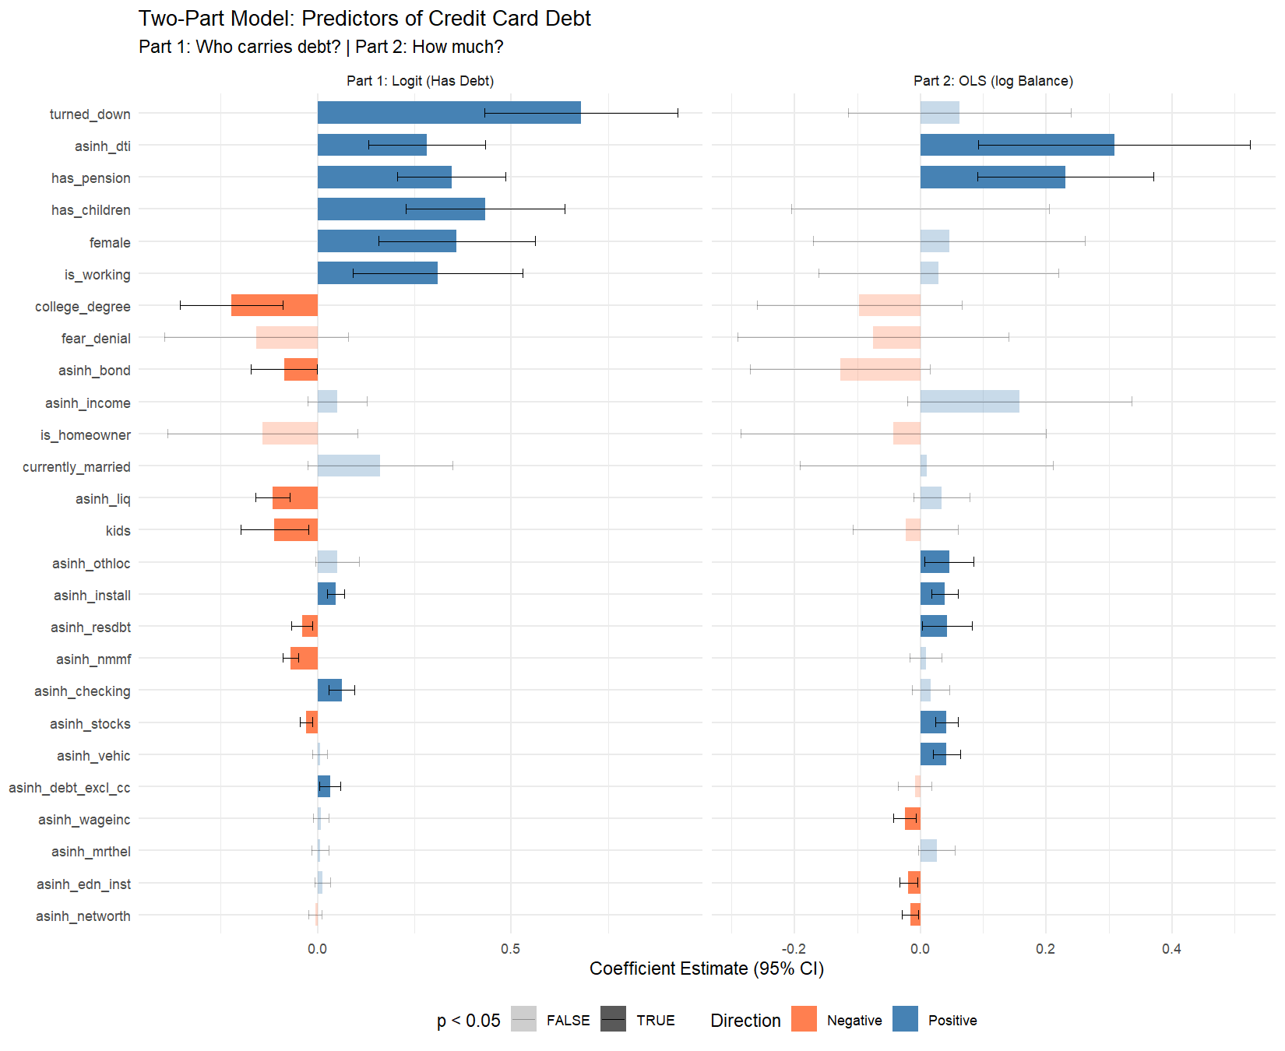

Interpretation: What the Data Suggests
The two-part model separates two distinct behavioral questions about credit card debt in the United States. Part 1 asks who takes on any credit card debt at all, and Part 2 asks, among those who carry a balance, what predicts higher or lower amounts. The following interpretation is grounded in the actual coefficients estimated above and connects them to plausible behavioral mechanisms.

Marriage, Partnership, and Credit Card Debt
In the logistic model, the coefficient on currently_married is 0.162 (p = 0.0885). This coefficient is not statistically significant, suggesting that marriage status does not independently predict the probability of carrying credit card debt once other financial and demographic characteristics are accounted for.
In the OLS model (Part 2), the coefficient on currently_married is 0.010 (p = 0.9226). This coefficient is not statistically significant, indicating that marriage does not predict the magnitude of credit card balances among those who carry debt.
These patterns matter for relationship health. Financial stress — and credit card debt in particular, given its high interest rates and discretionary nature — is among the strongest predictors of relationship conflict and divorce. The coefficients here quantify the nationally representative association between partnership and this specific form of indebtedness.

Children, Family Formation, and Debt
The logit coefficient on has_children is 0.433 (p = 0.0000). Households with children are significantly more likely to carry credit card debt. This is consistent with the well-documented cost-of-children channel: childcare, education, healthcare, clothing, and food expenses can push household spending beyond what income covers, leading to revolving credit use.
In Part 2, the coefficient is 0.000 (p = 0.9985). Among debtors, the presence of children does not significantly predict the magnitude of credit card balances.
This has direct implications for willingness to start families. If young households observe that parenthood is associated with credit card debt accumulation, this may contribute to the well-documented trend of delayed family formation, particularly among college-educated women.

Labor Force Participation and Earnings
The coefficient on is_working in the logit is 0.310 (p = 0.0057) and in the OLS is 0.029 (p = 0.7687). This pattern — employment increasing the probability of having debt but not increasing (or reducing) balance levels — suggests that employment primarily operates through the credit access channel. Working households qualify for credit cards and use them, but their income also provides capacity to manage balances.
Wage income (asinh_wageinc) has a logit coefficient of 0.009 (p = 0.3645) and an OLS coefficient of -0.025 (p = 0.0078). The negative OLS coefficient is important: among debtors, higher wage income is associated with lower credit card balances. This supports the interpretation that earnings provide capacity to pay down revolving debt rather than fuel additional spending.

Credit Access and Financial Exclusion
The coefficient on turned_down is 0.680 (p = 0.0000) in the logit and 0.063 (p = 0.4897) in the OLS. Households that have been turned down for credit in the past five years are significantly more likely to carry credit card debt. This suggests that credit cards serve as a last-resort borrowing channel for credit-constrained households — precisely the population least equipped to manage high-interest revolving debt.
The coefficient on fear_denial is -0.158 (p = 0.1925) in the logit and -0.075 (p = 0.4921) in the OLS.

Wealth, Assets, and the Role of Financial Cushions
The Lasso retained several asset-side variables, allowing us to examine whether financial cushions reduce reliance on credit card borrowing.
- asinh_liq: Logit = -0.116 (*), OLS = 0.034 (ns)
- asinh_checking: Logit = 0.062 (*), OLS = 0.016 (ns)
- asinh_stocks: Logit = -0.029 (), OLS = 0.041 ()
- asinh_nmmf: Logit = -0.069 (*), OLS = 0.009 (ns)
Negative coefficients on liquid asset variables in the logit suggest that households with savings buffers are less likely to carry credit card debt — savings substitute for revolving credit. Negative coefficients in the OLS indicate that even among debtors, those with more savings carry lower balances. Positive coefficients on illiquid assets (e.g., home equity) may reflect a leveraging pattern where homeowners have more credit access generally.

Connecting to Broader Trends
The coefficients estimated in this analysis provide a quantified, nationally representative snapshot of the financial behaviors that connect to broader sociological trends. Delayed marriage, declining birth rates, rising household debt, and labor market polarization are not independent phenomena. Credit card balances sit at the intersection of these forces: they reflect consumption aspirations bumping against income constraints, credit access interacting with financial literacy, and household formation decisions shaped by the perceived or actual cost of partnership and children.
The two-part structure reveals that the predictors of having credit card debt are not identical to the predictors of how much debt one carries. This distinction matters for policy and for understanding household decision-making. Programs that expand credit access (e.g., credit-building initiatives) may increase the prevalence of revolving debt without necessarily increasing balance levels. Conversely, income support or savings incentives may reduce balances among existing debtors without changing the prevalence of debt.

Appendix: Technical Notes
Multiple Imputation. All statistics and models are pooled across the SCF’s five implicates using Rubin’s Rules, as implemented by the scf package. No results are reported from a single implicate.
Survey Weights. All estimates use the SCF replicate weights (balanced repeated replication) to account for the complex survey design, including oversampling of wealthy households.
Lasso Implementation. Lasso was run via glmnet with 10-fold cross-validation on each implicate separately. We used lambda.1se (the most regularized model within one standard error of the minimum CV error) for parsimony. The majority rule (variable survives in >= 3 of 5 implicates) ensures robustness to imputation variation.
Tautology Correction. Total household debt (debt) includes credit card balances as a component. To avoid a mechanically inflated coefficient, we constructed debt_excl_cc = max(debt - ccbal, 0) and used its asinh transform in place of asinh_debt throughout the Lasso and regression models.
Two-Part Model. Part 1 is a logistic regression on the binary indicator has_ccdebt. Part 2 is OLS on log(ccbal) conditional on ccbal > 0. This approach is standard for semicontinuous outcomes with a large mass at zero and a continuous positive tail (Duan et al., 1983; Manning et al., 1987).
sessionInfo()
## R version 4.5.1 (2025-06-13 ucrt)
## Platform: x86_64-w64-mingw32/x64
## Running under: Windows 11 x64 (build 26200)
##
## Matrix products: default
## LAPACK version 3.12.1
##
## locale:
## [1] LC_COLLATE=English_United States.utf8
## [2] LC_CTYPE=English_United States.utf8
## [3] LC_MONETARY=English_United States.utf8
## [4] LC_NUMERIC=C
## [5] LC_TIME=English_United States.utf8
##
## time zone: America/New_York
## tzcode source: internal
##
## attached base packages:
## [1] grid stats graphics grDevices utils datasets methods
## [8] base
##
## other attached packages:
## [1] car_3.1-5 carData_3.0-5 moments_0.14.1 knitr_1.50
## [5] broom_1.0.10 glmnet_4.1-10 scf_1.0.5 scales_1.4.0
## [9] psych_2.6.1 labelled_2.16.0 survey_4.4-8 survival_3.8-3
## [13] Matrix_1.7-3 haven_2.5.5 lubridate_1.9.4 forcats_1.0.1
## [17] stringr_1.5.2 dplyr_1.1.4 purrr_1.1.0 readr_2.1.5
## [21] tidyr_1.3.1 tibble_3.3.0 ggplot2_4.0.0 tidyverse_2.0.0
##
## loaded via a namespace (and not attached):
## [1] gtable_0.3.6 shape_1.4.6.1 xfun_0.53 lattice_0.22-7
## [5] tzdb_0.5.0 vctrs_0.6.5 tools_4.5.1 generics_0.1.4
## [9] parallel_4.5.1 pkgconfig_2.0.3 RColorBrewer_1.1-3 S7_0.2.0
## [13] lifecycle_1.0.4 compiler_4.5.1 farver_2.1.2 mnormt_2.1.2
## [17] mitools_2.4 codetools_0.2-20 htmltools_0.5.8.1 yaml_2.3.10
## [21] Formula_1.2-5 pillar_1.11.1 iterators_1.0.14 abind_1.4-8
## [25] foreach_1.5.2 nlme_3.1-168 tidyselect_1.2.1 digest_0.6.37
## [29] stringi_1.8.7 labeling_0.4.3 splines_4.5.1 fastmap_1.2.0
## [33] cli_3.6.5 magrittr_2.0.4 utf8_1.2.6 withr_3.0.2
## [37] backports_1.5.0 timechange_0.3.0 rmarkdown_2.30 hms_1.1.3
## [41] evaluate_1.0.5 rlang_1.1.6 Rcpp_1.1.0 glue_1.8.0
## [45] DBI_1.2.3 rstudioapi_0.17.1 R6_2.6.1

