SystemCheck

Help Documentation

SystemCheck is a tool authored by Bob Delamater, designed to help gather and inform an administrator as to the current health of the server. The tool will provide a health report and additional supporting data sets.

2012

Bob Delamater

Sage

7/2/2012

Table of Contents

System Check 2

Requirements 2

System 2

Permissions 2

Installation 2

Uninstalling 9

Licensing 9

Screens 10

Check list Super Tab 11

Check List Sub Tab 12

Datasets Sub Tab 13

Event Viewer Sub Tab 14

WMI Queries Sub Tab 14

Graphs 16

Database Selection 17

Disk Information 17

Memory Information 18

Results Super Tab 18

Viewing your results 19

Exporting Your Results 19

WMI Query Result Examples 20

System Health Check Report 0

Is Within Range Good 0

Low Value 0

Example 1: True False Queries 0

Example 2: Minimum range values 0

Your Value 0

Within Range 0

# System Check

SystemCheck is authored by Bob Delamater for the purposes of gathering diagnostic information easily. The tool will provide a basic checklist and a report as well. The premise of this tool is to provide you with a basic checklist of configuration checks comparing those retrieved values from the system to a known range. The report will then tell you if the value is in range or not.

# Requirements

## System

|  |  |
| --- | --- |
| Component | Version |
| Operating System | Windows 2008 or Windows 7 |
| .Net Framework | 4.0 |
| Excel | 2010 |
| UAC (User Account Control) | Set to the lowest position |

## Permissions

SystemCheck requires the following permissions:

|  |  |
| --- | --- |
| Component | Setting |
| Windows User | * Must be a local administrator * The Windows user must also exist within the Event Log Reader group |
| SQL User | * Must be a System Administrator (SA user or equivalent) |
|  |  |
|  |  |

# Installation

Installing System Check is fairly simple. You will receive a folder, or a zip file that contains a folder with two files.

* Setup.exe
* Setup.msi

Simply launch the Setup.msi file and follow the prompts.

1. Press next at the prompt listed below. 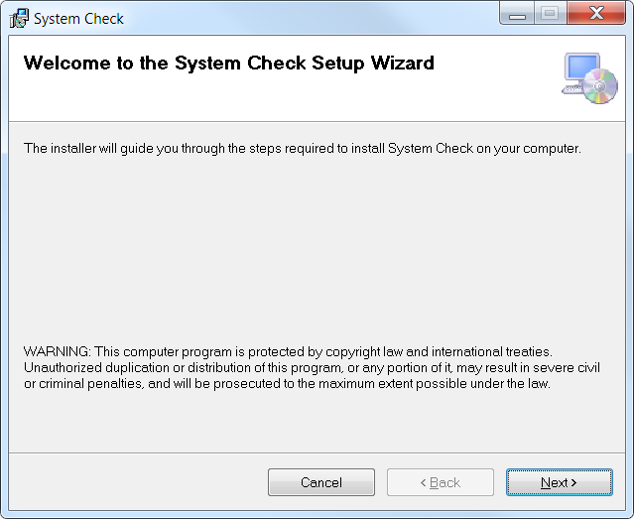
2. The installer will default the installation to just your Windows Profile, as shown in the next step and screenshot below. You may alter this if you choose for everyone on the machine.   
   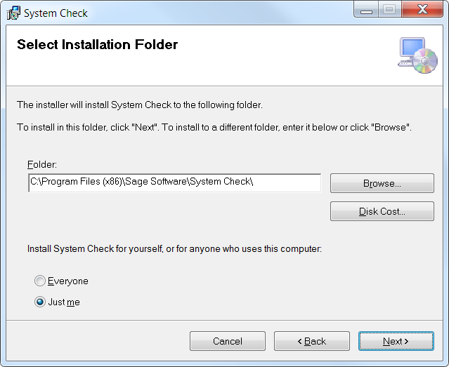
   1. Choose the path to install to or take the default.
3. Enough information has been gathered to install System Check, so press next at the prompt shown below  
   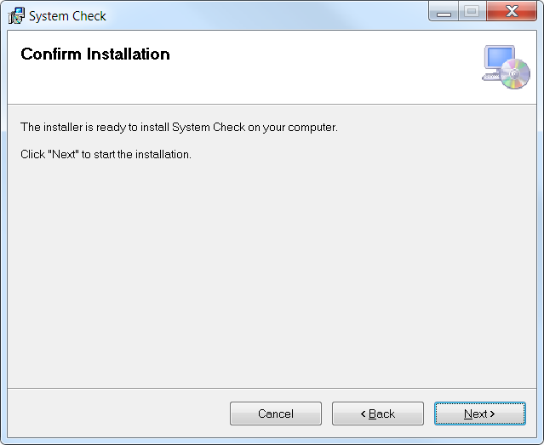
4. The installer will begin to distribute the required components  
   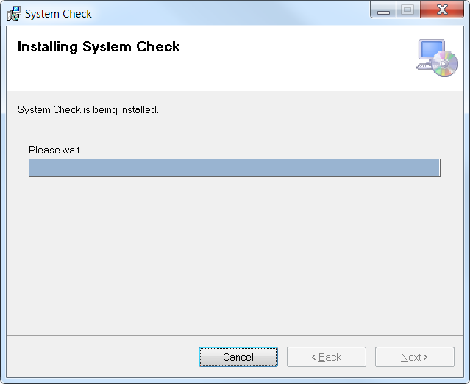
5. Finally, the installer has completed, so you may press the close button.   
   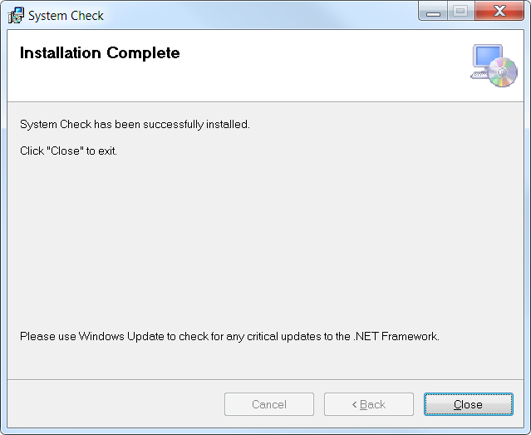

You may now find the System Check program off your programs menu:

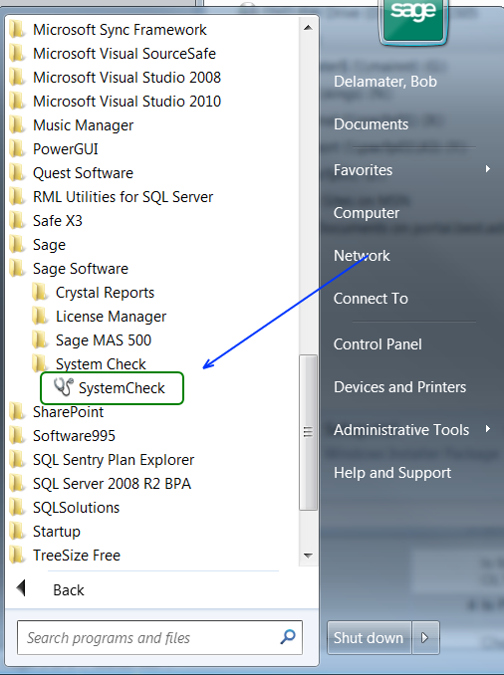

The installation directory will contain the following structure:

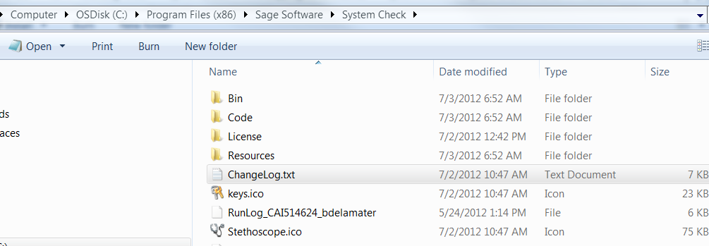

# Uninstalling

To uninstall the System Check program launch Program and Features and find the System Check program.

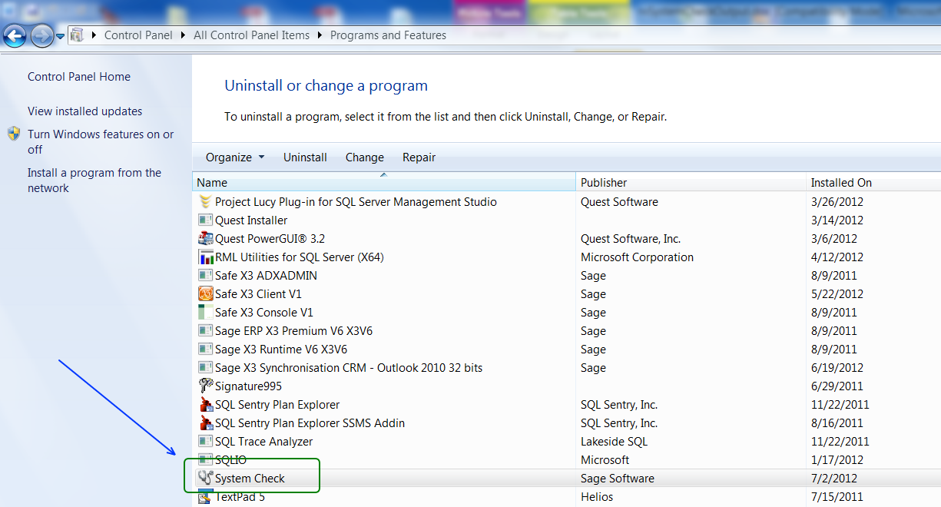

Right click on the System Check program and choose to uninstall. This will remove all the binaries of the program. However, the license file and any other files that may have been stored in the directory structure will be left. The default directory structure for the installation is listed here:

C:\Program Files (x86)\Sage Software\System Check\License

# Licensing

SystemCheck does leverage a licensing component. Upon initial launch you may receive one of a variety of license messages, all which have the same basic language. Below is an example of one of the license messages:

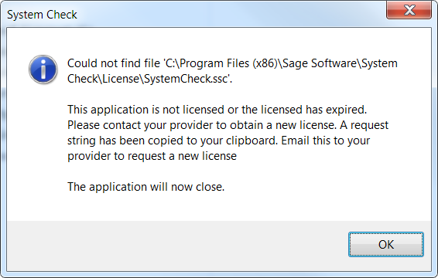

In order to license the product you must contact Bob Delamater ([bob.delamater@sage.com](mailto:bob.delamater@sage.com)) to request a license. Upon receipt of the email Bob will generate a license file based off an encrypted string you provide. When the screen above is displayed the encrypted message will be placed within the clipboard. You are too copy that encrypted sting into a text file using notepad, save it and send the file to Bob. He will respond with a return file. You are to place that file on your desktop, or anywhere on the computer and then double click it. Note, you may receive an error if the UAC is turned on. Turn the UAC off in order to fix the error. Alternatively you can place the file Bob provides you within the license directory of the SystemCheck program file path.

In summary, to license SystemCheck you must do the following:

1. Install SystemCheck
2. Launch SystemCheck once
3. Copy the encrypted string from your clipboard into a text file
4. Send that file to Bob
5. Bob will send you a file in return
6. Place that file on your desktop and double click it.
   1. You can also place the file in the **C:\Program Files (x86)\Sage Software\System Check\License** directory.

# Screens

SystemCheck has the following layout

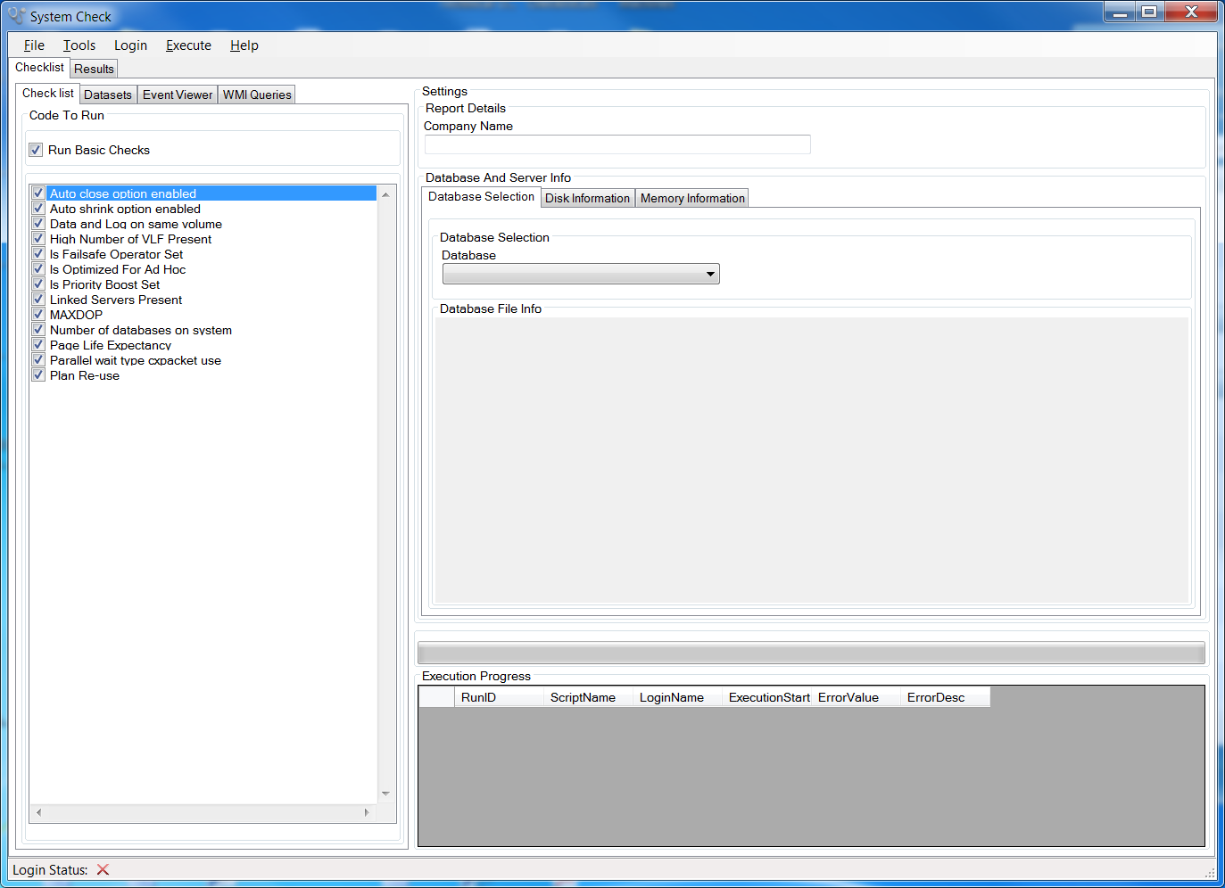

## Check list Super Tab

This tab houses four sub tabs:

1. Check list
2. Datasets
3. Event Viewer
4. WMI Queries

### Check List Sub Tab

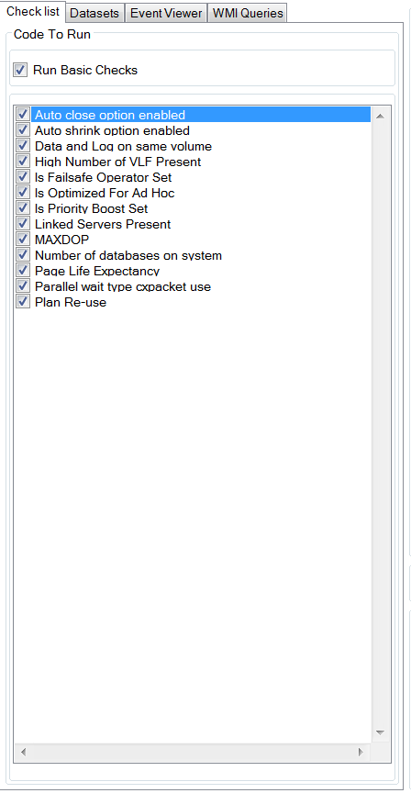

The Check List sub tab handles contains the basic checks for the SystemCheck program. All of these checks have known ranges for values and are configurable via an XML file. Each check within the Check List sub tab that is checked will be executed when the Execute button on the menu bar is clicked. The checks contained on this sub tab are documented in an additional documentation field that is accessible once the report is previewed or exported. The checks that are marked as true will be run at Execute time if the Run Basic Checks checkbox is set to true.

### Datasets Sub Tab

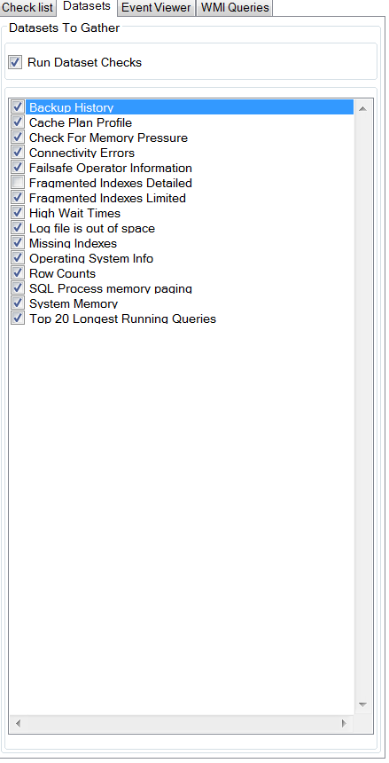

Each component on the Datasets sub tab is designed to gather sets of data for additional analysis by the user. These data sets are not considered on the basic health check report. This is considered a more advanced analysis technique and not often helpful if you are unfamiliar with SQL Server. The checks that are marked as true will be executed if the Run Datasets Checks checkbox is checked.

### Event Viewer Sub Tab

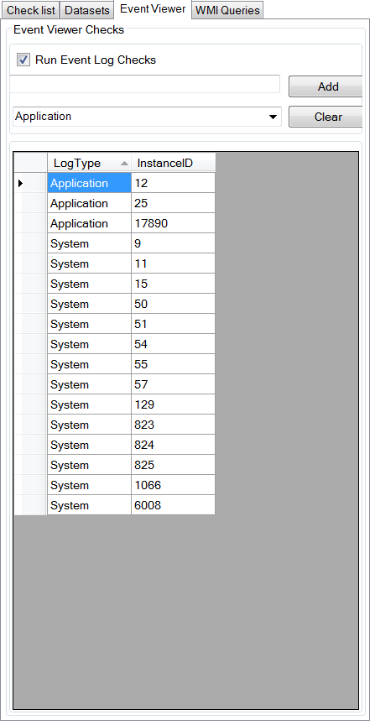

The Event Viewer sub tab contains a way to run queries against a machine. The values placed within the grid will be checked at Execute time if the Run Event Log Checks checkbox is set to true.

### WMI Queries Sub Tab

The WMI Queries sub tab contains WMI queries that will be executed at run time. At the time this documentation was written the following WMI queries exist:

* Win32_OperatingSystem
* Win32_Product
* Win32_LogicalDisk
* Win32_NetworkAdapterConfiguration
* Win32_DefragAnalysis
* Win32_PerfFormattedData_PerfOS_Memory

#### Win32_OperatingSystem

##### Description

The **Win32_OperatingSystem** [WMI class](http://msdn.microsoft.com/en-us/library/windows/desktop/aa393244(v=vs.85).aspx) represents a Windows-based operating system installed on a computer. Any operating system that can be installed on a computer that can run a Windows-based operating system is a descendent or member of this class

##### Additional Information

<http://msdn.microsoft.com/en-us/library/windows/desktop/aa394239(v=vs.85).aspx>

#### Win32_Product

##### Description

The **Win32_Product** [WMI class](http://msdn.microsoft.com/en-us/library/windows/desktop/aa393244(v=vs.85).aspx) represents products as they are installed by Windows Installer. A product generally correlates to one installation package

##### Additional Information:

<http://msdn.microsoft.com/en-us/library/windows/desktop/aa394378(v=vs.85).aspx>

#### Win32_LogicalDisk

##### Description

The **Win32_LogicalDisk** [WMI class](http://msdn.microsoft.com/en-us/library/windows/desktop/aa393244(v=vs.85).aspx) represents a data source that resolves to an actual local storage device on a computer system running Windows

##### Additional Information

<http://msdn.microsoft.com/en-us/library/windows/desktop/aa394173(v=vs.85).aspx>

#### Win32_NetworkAdapterConfiguration

##### Description

The **Win32_NetworkAdapterConfiguration** [WMI class](http://msdn.microsoft.com/en-us/library/windows/desktop/aa393244(v=vs.85).aspx) represents the attributes and behaviors of a network adapter. This class includes extra properties and methods that support the management of the TCP/IP and Internetwork Packet Exchange (IPX) protocols that are independent from the network adapter.

##### Additional Information

<http://msdn.microsoft.com/en-us/library/windows/desktop/aa394217(v=vs.85).aspx>

#### Win32_DefragAnalysis

##### Description

The **Win32_DefragAnalysis** class represents fragmentation values on a volume. An instance of the **Win32_DefragAnalysis** class is passed as an out parameter from the [**Win32_Volume**](http://msdn.microsoft.com/en-us/library/windows/desktop/aa394515(v=vs.85).aspx) methods **[DefragAnalysis](http://msdn.microsoft.com/en-us/library/windows/desktop/aa389827(v=vs.85).aspx)** and [**Defrag**](http://msdn.microsoft.com/en-us/library/windows/desktop/aa389832(v=vs.85).aspx).

##### Additional Information

<http://msdn.microsoft.com/en-us/library/windows/desktop/aa394119(v=vs.85).aspx>

#### Win32_PerfFormattedData_PerfOS_Memory

The **Win32_PerfFormattedData_PerfOS_Memory** formatted data class provides pre-calculated performance data from performance counters that monitor the physical and virtual memory on the computer. Physical memory is the amount of random access memory (RAM) on the computer. Virtual memory consists of space in physical memory and on disk. Many of the memory counters monitor paging, which is the movement of pages of code and data between disk and physical memory. Excessive paging, a symptom of a memory shortage, can cause delays which interfere with all system processes.

This class represents the Memory object in [System Monitor](http://msdn.microsoft.com/en-us/library/windows/desktop/aa390836(v=vs.85).aspx#wmi.gloss_system_monitor) and returns the same data you see in System Monitor. The original data source is the PerfOS performance library. The corresponding raw data class is [**Win32_PerfRawData_PerfOS_Memory**](http://msdn.microsoft.com/en-us/library/windows/desktop/aa394314(v=vs.85).aspx). Data is dynamically provided for this class from the performance library object by the [WmiPerfInst](http://msdn.microsoft.com/en-us/library/windows/desktop/aa394570(v=vs.85).aspx) provider.

##### Additional Information

<http://msdn.microsoft.com/en-us/library/windows/desktop/aa394268(v=vs.85).aspx>

## Graphs

There are three basic graphs.

1. Database Selection
2. Disk Information
3. Memory Information

Each graph listed below can be saved by right clicking and choosing “Save” or choose “Copy image To Clipboard”.

### Database Selection

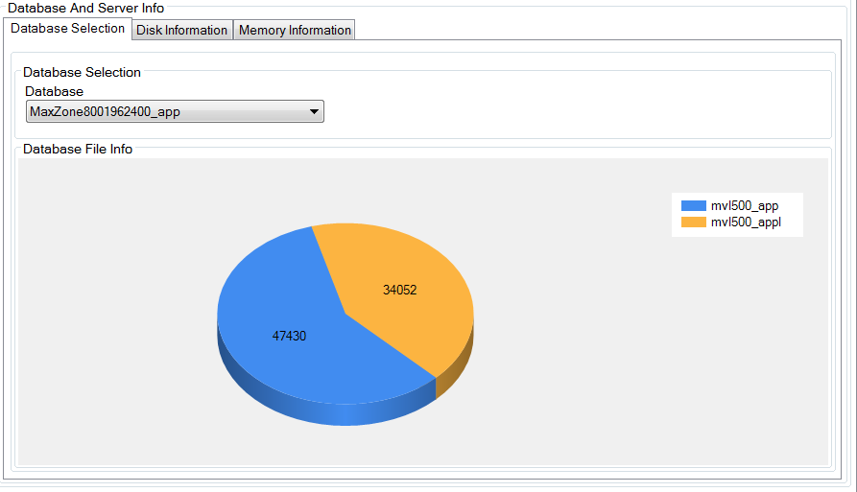

The database combo box drop down will allow you to get a visual reference of the size of each file within the database. This is useful for determining the how long certain queries will take to run, such as the index fragmentation query.

### Disk Information

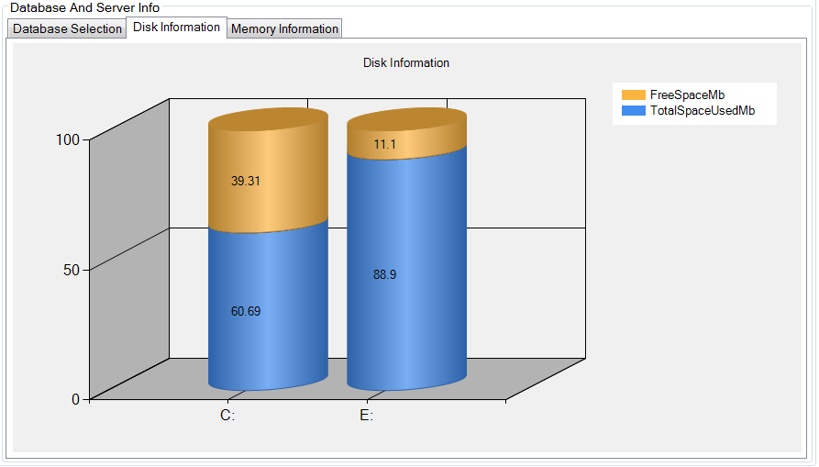

The Disk Information tab will show you a graph of each of the drives, as reported by Win32_LogicalDisk. Each drive will show a percentage of used and free space. At this time, it is known that the labels for each series denotes the unit of measure in megabytes. This is known to be wrong as the graph clearly expresses the data in percentages. The graph will be improved in the future to show the total size of the drive and adjust the each series label to express itself in percentage instead of megabytes.

### Memory Information

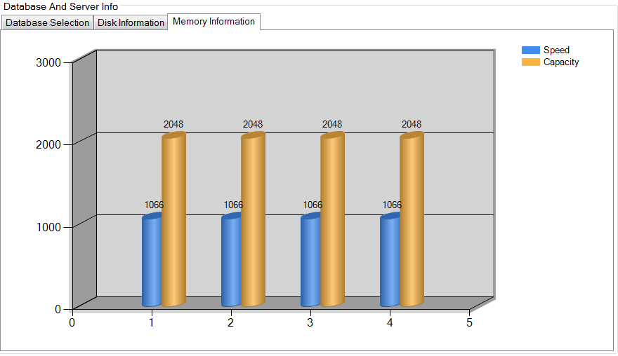

The memory information graph expresses the speed of each RAM chip in the computer along with the capacity of each chip. For example, the graph above shows four RAM chips each at a speed of 1066.

## Results Super Tab

The Results super tab houses a grid, a combo box and an expert to Excel button.

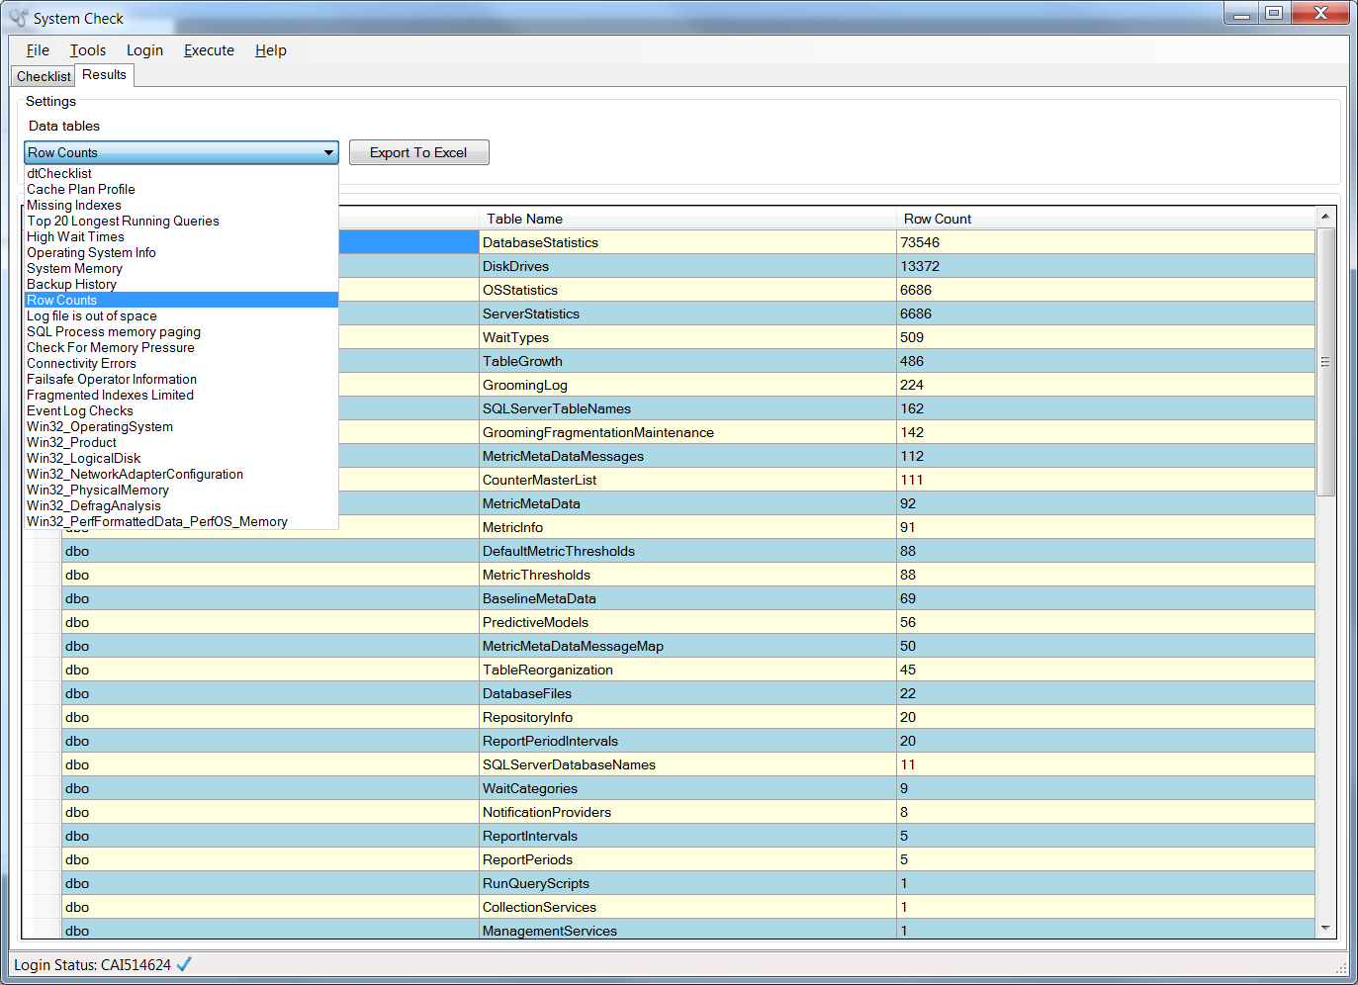

### Viewing your results

Once you’ve executed your queries and retrieved results the grid can be bound to each result set by adjusting the Data tables combo box.

### Exporting Your Results

Additionally, you can also export the results to Excel by pressing the Export To Excel button. When you press this button you will be prompted with a Save File dialog box, as seen here:

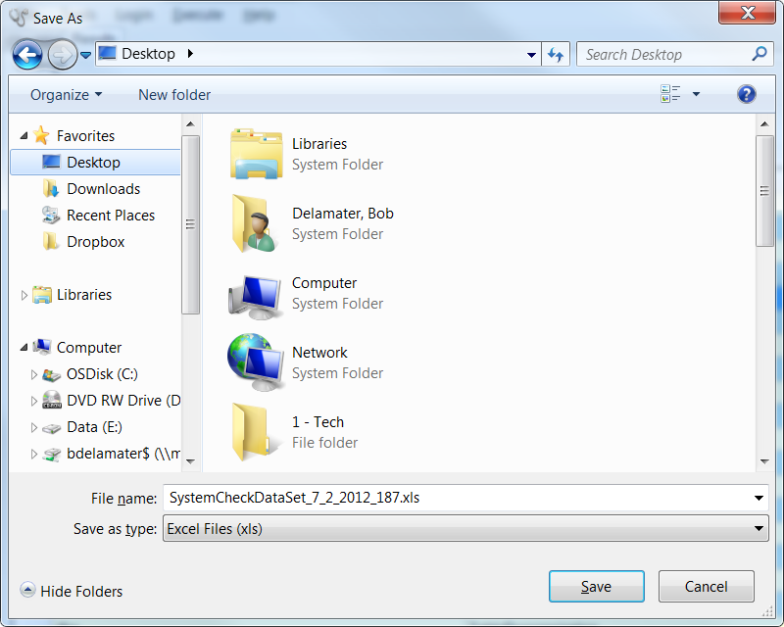

SystemCheck will generate a file name for you. Click save to save the file with this name in the location specified or adjust the location and name as desired. Once the Excel export finishes the file will be created for you. For every check that you decided to run a worksheet will be created within the Excel workbook. Below are example for each type of check that is exported to Excel.

### WMI Query Result Examples

#### Win32_PerfFormattedData_PerfOS_Memory



#### Win32_PhysicalMemory

This example shows four memory slots, each at 2 GB per slot, for a total of 8 GB of RAM.

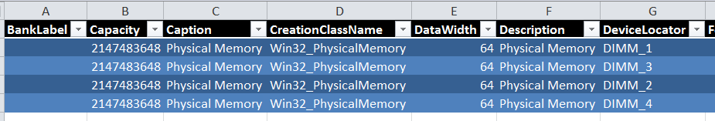

A look at the additional columns of Win32_PhysicalMemory exposes the speed of the RAM



#### Win32_NetworkAdapterConfiguration

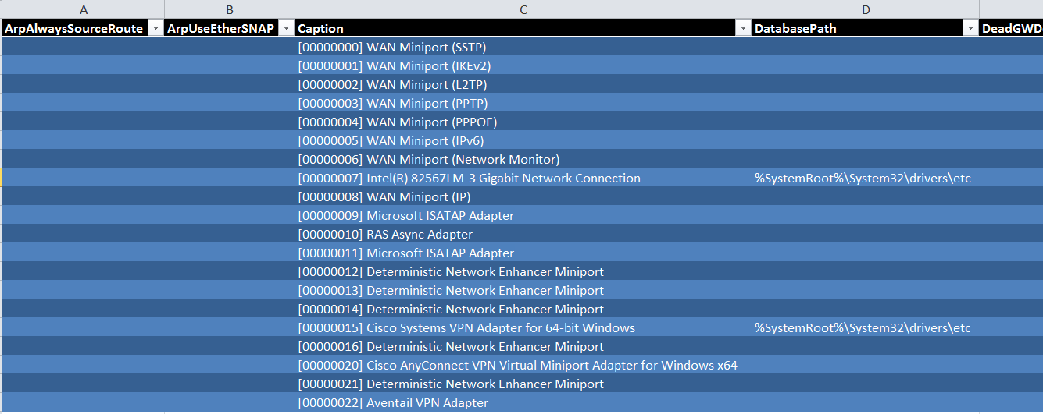

#### Win32_LogicalDisk



#### Win32_Product

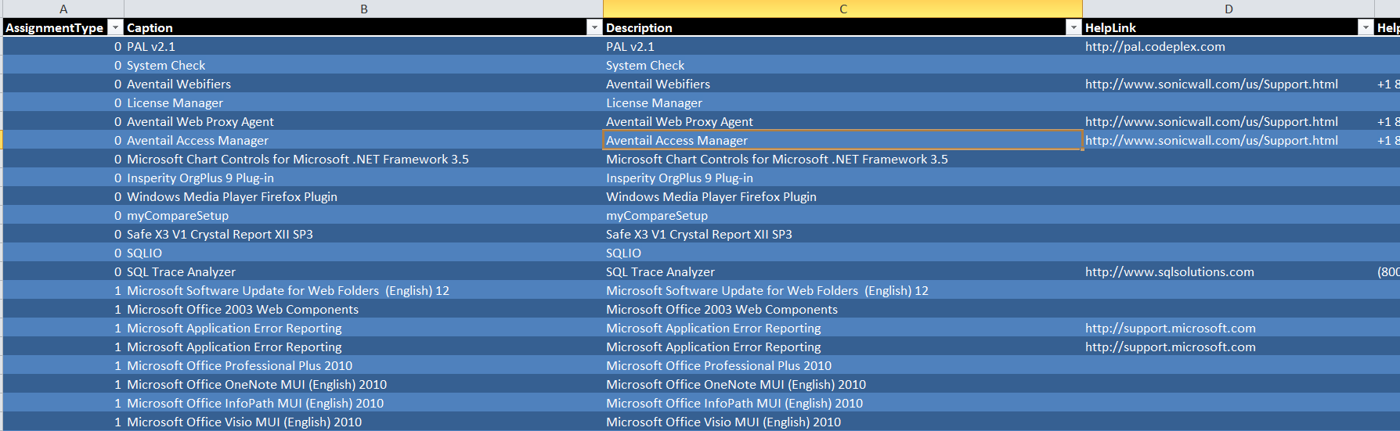

#### Win32_OperatingSystem



#### Event Log Checks

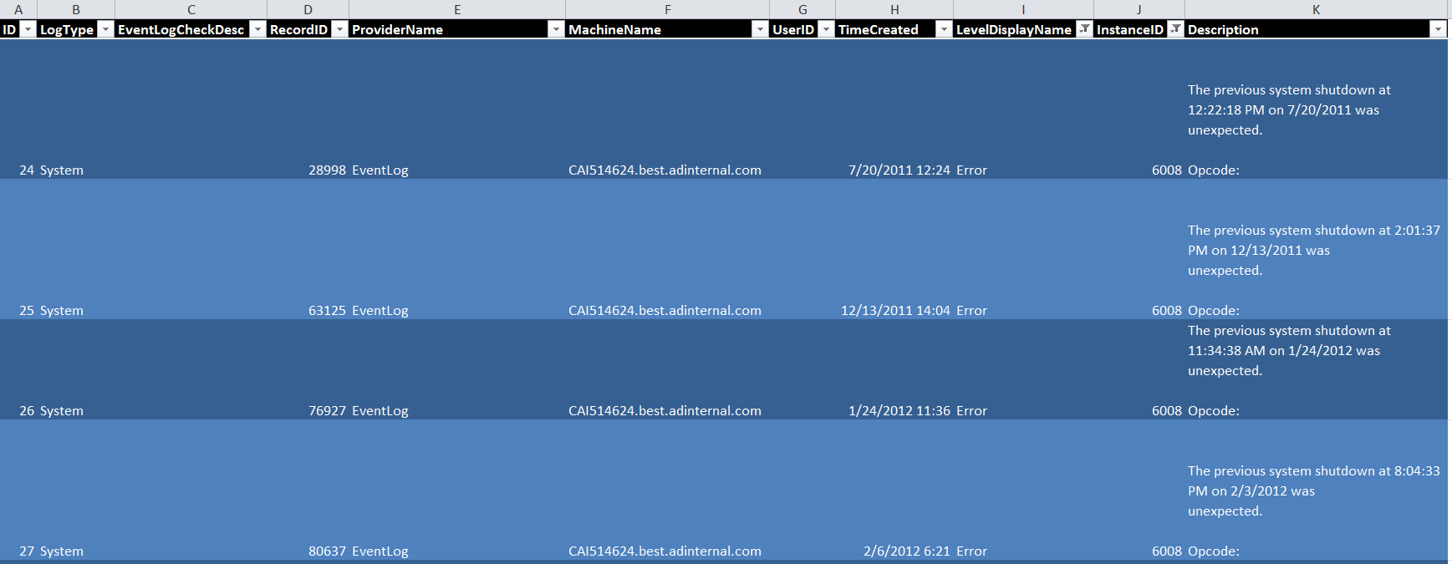

#### Failsafe Operator Information



#### Check For Memory Pressure



#### Row Counts

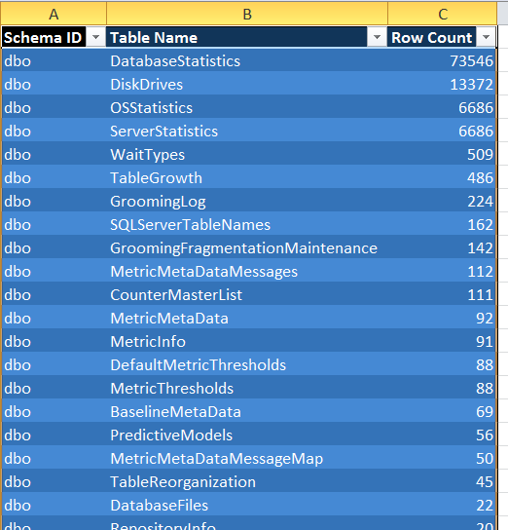

#### Backup History

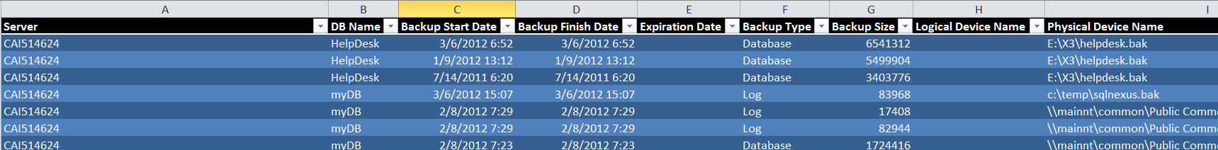

#### System Memory



#### Operating System Info



#### High Wait Times

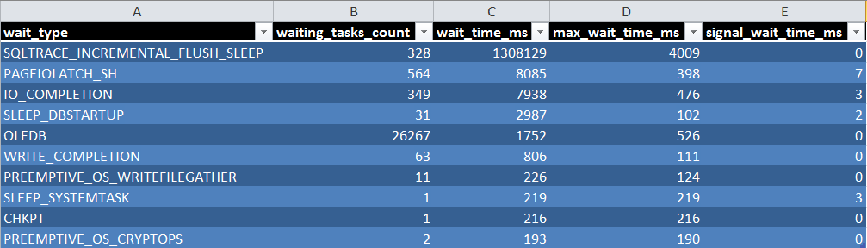

#### Top 20 Longest Running Queries

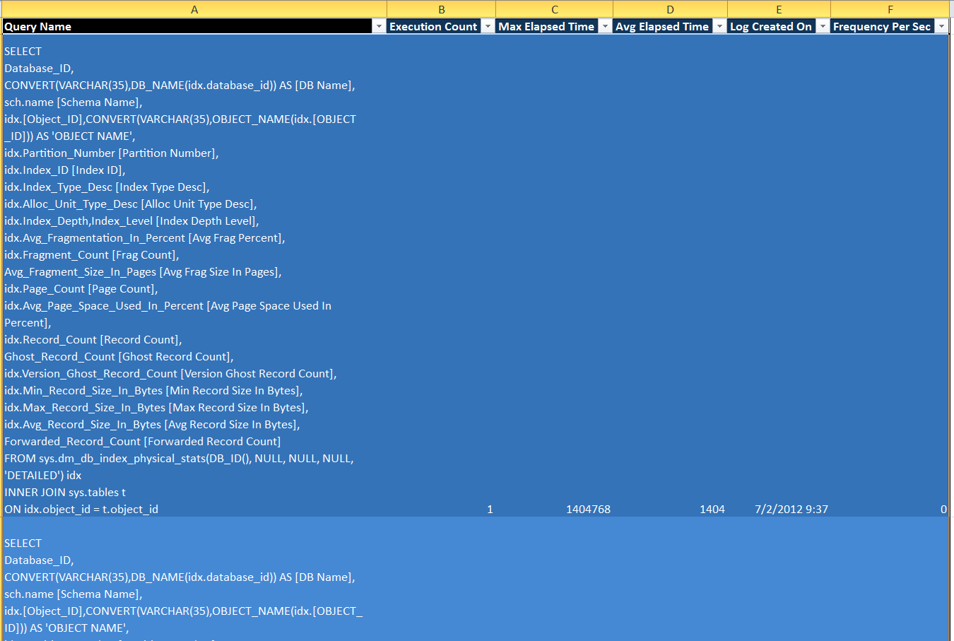

#### Cache Plan Profile

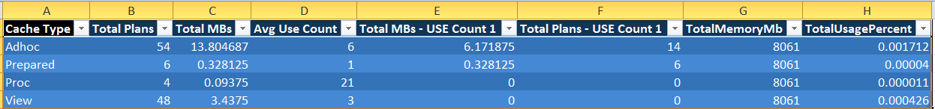

# System Health Check Report

An example of the System Health Check report can be found below. Of particular interest in the report are four contiguous columns listed below:

* Is Within Range Good
* Low Value
* Your Value
* High Value

## Is Within Range Good

The purpose of this column is to help you decide whether or not the range of the low and high values is deemed positive or negative in the affecting the health of the server.

## Low Value

For each particular query to the server there is a low value that is acceptable. This column represents the lowest possible value that is acceptable.

### Example 1: True False Queries

True / False queries

A low value of 1 means that only a true value is acceptable

### Example 2: Minimum range values

If the range cannot be lower than 300 and higher than some value, then the low value will be set to 300.

## Your Value

For each particular query to the server your actual value will be returned into this column. This value is to be measured against the low and high value range.

## Within Range

For each particular query to the server this column tells you if your actual value is placed within the low and high values of the range. This column does not take into account the first column within the four columns labled “Is Within Range Good”. If your actual value is between the low and high values (inclusive) then Within Range will be set to Yes, otherwise it will be set to No.

|  |  |  |  |  |  |  |
| --- | --- | --- | --- | --- | --- | --- |
|  | |  | | --- | | System Health Check | | |  |  |  |
|  |  |  |  |  |  |
|  |  | |  | | --- | | **Company**: CAI514624 | | | |  |
|  |  |  |  |  |  |
|  |  | |  | | --- | | **Run Time:** 7/3/2012 6:07:11 AM | | | |  |
|  |  |  |  |  |  |
|  |  |  |  |  |  |
|  |  |  |  |  |  |
|  | ..\bl.jpg | | |  |  |
|  |  |  |  |  |  |
|  | |  |  |  |  |  |  |  |  |  | | --- | --- | --- | --- | --- | --- | --- | --- | --- | | **Category** | **ID** | **Script Name** | **Is Within Range Good** | **Low Value** | **Your Value** | **High Value** | **Within Range?** |  | | Configuration | **1** | **Data and Log on same volume** | Yes | 0 | **1** | 0 | **No** |  | |  | Are the data file and the log file on the same volume? |  | Data Volume: C:\ Log Volume: C:\ | | | | <http://technet.microsoft.com/en-us/library/cc966534.aspx> | | **2** | **High Number of VLF Present** | Yes | 0 | **12** | 10000 | **Yes** |  | |  | High number of VLFs present indicates slow performance for all CRUD operations |  | --- | | | | <http://sqlblog.com/blogs/linchi_shea/archive/2009/02/09/performance-impact-a-large-number-of-virtual-log-files-part-i.aspx> | | **3** | **MAXDOP** | Yes | 1 | **0** | 1 | **No** |  | |  | Is MAXDOP set to 1 for this OLTP database? |  | maximum degree of parallelism | | | | <http://blogs.technet.com/b/mat_stephen/archive/2005/02/08/369120.aspx> | | **4** | **Is Failsafe Operator Set** | Yes | 1 | **1** | 1 | **Yes** |  | |  | Checks to see if a failsafe operator has been set. It does not check that the operator has a notification method set. You must do this manually. |  | There is a fail safe operater set | | | |  | | **5** | **Is Priority Boost Set** | Yes | 0 | **0** | 0 | **Yes** |  | |  | Is the priority boost switch set for SQL? |  | Priority boost is turned off. This is the recommended state. | | | | <http://technet.microsoft.com/en-us/library/cc966534.aspx> | | Operation | **6** | **Linked Servers Present** | Yes | 0 | **0** | 0 | **Yes** |  | |  | Linked servers cause additional drain on SQL, especially on a 32 bit system. |  | This server is a 64 bit machine. This check is not important on 64 bit systems | | | | <http://blogs.msdn.com/b/psssql/archive/2009/08/26/come-on-64bit-so-we-can-leave-the-mem.aspx> | | **7** | **Auto shrink option enabled** | Yes | 0 | **1** | 0 | **No** |  | |  | Database has auto shrink option enabled |  | --- | | | | <http://support.microsoft.com/kb/2160663> | | **8** | **Auto close option enabled** | Yes | 0 | **0** | 0 | **Yes** |  | |  | Database has auto close option enabled |  | --- | | | | <http://support.microsoft.com/kb/2160663> | | **9** | **Page Life Expectancy** | Yes | 300 | **829** | 99999999 | **Yes** |  | |  | Page life expectancy should be greater than 300. This is the number of seconds that a page will last in memory on SQL Server |  | SQLServer:Buffer Manager | Page life expectancy | | | | | <http://technet.microsoft.com/en-us/library/cc966401.aspx> | | **10** | **Is Optimized For Ad Hoc** | Yes | 1 | **0** | 1 | **No** |  | |  | Check to see if the server is optimized for Ad-Hoc queries |  | --- | | | | <http://sqlserverpedia.com/blog/sql-server-bloggers/optimizing-for-ad-hoc-workloads/> | | **11** | **Number of databases on system** | Yes | 1 | **8** | 3 | **No** |  | |  | How many databases exist on this system? |  | Number of databases on system | | | |  | | Performance | **12** | **Plan Re-use** | Yes | 0.90 | **0.227** | 1 | **No** |  | |  | Plan Re-use should be greater than 90%. Plan use is desirable for OKTP workloads because re-creating the same plan (for similar or identical transactions) is a waste of CPU resources and suggests a CPU bottleneck. |  | Batch Requests = 22.000 SQL Compilations: 17.000 | | | | <http://technet.microsoft.com/en-us/library/cc966401.aspx> | | **13** | **Parallel wait type cxpacket use** | Yes | 0 | **0.000** | 0.1 | **Yes** |  | |  | Parallel wait types are measured by cxpackets. If the total wait time for this counter is greater than 10% of total waits then you have CPU pressure as a result of the parallelization. This is not good for OLTP systems |  | Total Wait Time ms: 4176628 CXPACKET wait time ms: 0 | | | | <http://technet.microsoft.com/en-us/library/cc966401.aspx> | | | | | |