Greensboro-Winston Salem, NC
Ortho Tile Footprint
36° 15’
-80° 30’

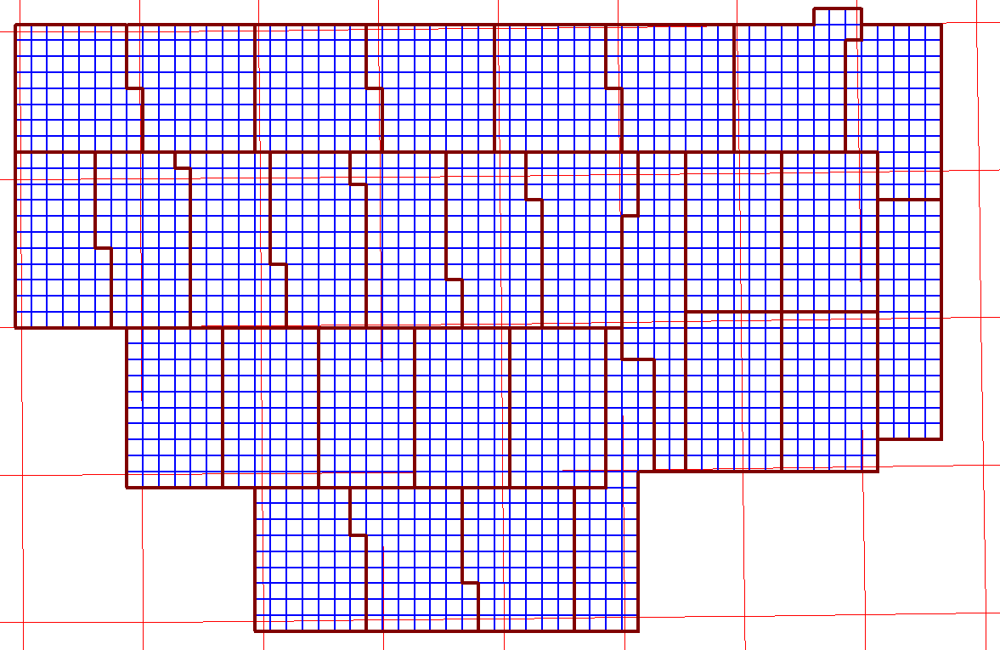
35° 45’
-79° 37’ 30”

Greensboro-Winston Salem, NC
Ortho Tile Footprint - DVD
36° 15’
-80° 30’

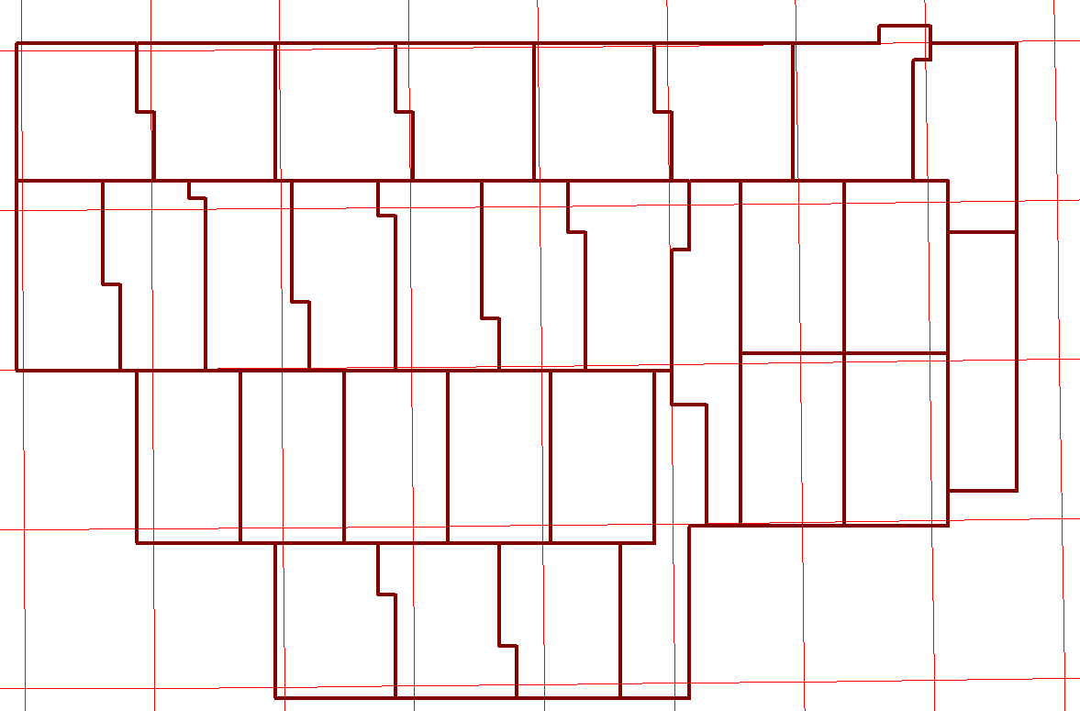
10
9
8
7
6
5
4
3
2
1
11
12
13
14
15
16
17
18
19
27
29
28
26
25
24
23
22
21
20
30
35° 45’
-79° 37’ 30”

Red lines – USGS quadrangle boundaries

Greensboro-Winston Salem, NC
Ortho Tile Footprint
36° 15’
-80° 30’

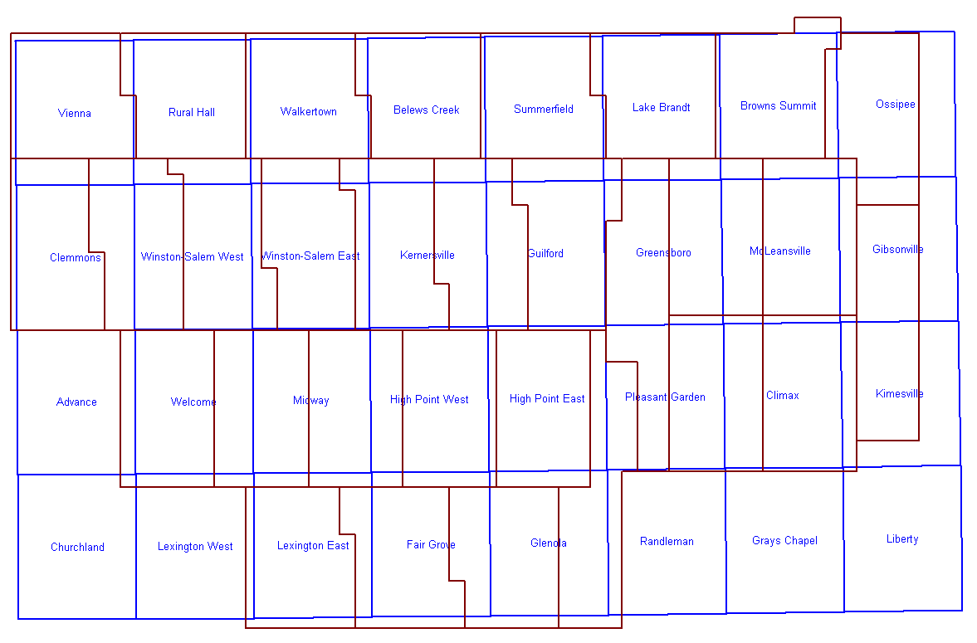
35° 45’
-79° 37’ 30”

Data in Ossipee, Gibsonville, Kimesville is extra data outside of the Urban Area requirement.

