Org-mode and Pandoc for Technical Writing

Tomáš Kruliš

21. 04. 2021

Table of Contents
1. Introduction
1.1. Tools I recommend and rationale why to use them
2. Basics of Version Control with Git
2.1. git in a nutshell
2.2. How to get git
2.3. Basic setup
2.4. First git repository
2.5. Working with git repository
2.6. Checking file status in git repository
2.7. Adding files to git tracking
2.8. Staging and committing modified files in git
2.9. Setting ignored files to git
2.10. File operations in git repository
2.11. Disclaimer
3. Export from org-mode to LaTeX – basics
3.1. Customizing export from org-mode to LaTeX
3.2. Resources

Introduction
Technical writing is an art in its own. When writing a manual, technical writer has to be the middle ground between software developers and users. As a technical writer you have to bring the subject matter, the software you are writing about, closer to its users. Very often you will have to cooperate directly with software developers and using version control tools such as git . I found it beneficial to use efficient tools that help you get the task done, and are also extensible to accommodate any need should arise from writing process.
That is why I have decided to make this basic blog, suitable for beginners trying to find good workflow setup for their writing.

Tools I recommend and rationale why to use them
As noted above, I prefer to use tools that are extensible and allow a lot of options to meet any requirements that I may be facing during writing. The con is, as you might have guessed from the blog title, that these tools are often very complex. Also, I prefer to use open source tools whenever possible.
What does a technical writer need to do his job? For starters, it would be an text editor. That is a program that allows you to write text. Simple as that.
I would advise against writing in binary formats like docx and odt (which are in fact archives of multiple files). The reason being is that it is actually more challenging to maintain consistent document structure and look with writing in those formats. From my experience, it is much more efficient to focus on content as a writer, and leave upholding the formatting and overall consistency on another application.
For choosing a text editor, well, the name of this blog is “Org-mode and Pandoc for Technical Writing,” and org-mode is a markup format native to program GNU/Emacs (further referred to simply as emacs). Because org-mode is just a markup format, you can actually use any text editor to write text in org-mode markup. However, emacs has the best support for it. If you insist on using different text editor than emacs, some alternatives would be vim or neovim , atom or notepad++ . In that case, you can skip chapters chapter references to chapters about emacs and doom emacs command shortcuts, which are focused on specifics of working with emacs. But for the full span of these blog posts, I will assume that you are using emacs as a text editor.
I have chosen org-mode as format for technical writing because it allows great workflow management and is tightly integrated into emacs. But it is a markup format that is best used for documentation source, not its “presentation” form.
Nowadays most documentation has to be accessible from web, or must be compatible with web-based applications, which means we need our documentation in html format. Often is very handy having access to offline documentation, for which is best choice the pdf format. I personally have been facing requirements to provide documentation also in .docx or .odt formats.

Basics of Version Control with Git
When you start a technical writing project, you can easily go by with an folder in your PC and thats it. But as the project grows, or you meet with more requirements from the client (maybe like to add another document format), you might wish to be able to test things out, or to comfortably revert from one state of things to another. That can be managed within folders, but sooner or later it will become clumsy and error prone. Other thing is, that client might straight from the beginning want you to contribute to some versioning system, to keep the manual in sync with current version of the software.
For those cases, you will have to use a version control system. Nowadays, the absolutely most used one is git. git is by definition “ distributed version control system (DVCS)” . How does it work? Software acting as version control is checking your files each time it is invoked, storing changes that have been made to those files in its own database. That way, you can revert to any previously recorded state of those files.
Now the “distributed” part means that the whole system does not have a central server (like it is with centralized version control system (CVCS)), but everything from the repository is mirrored to client local PC, even file history. This decentralized model brings more reliability, since if the server would went out of operation, the full repository can be revived from another clone. Also, these systems cope very well with multiple repository instances, so you can collaborate on your project easily with more people.
One of those DVCS is git. It is one of the most used DVCS today, maybe even THE most used DVCS. Especially in open source development.

git in a nutshell
Little contrary to previous description of the version control systems, git does not store changes to a file in time. Instead, git is taking snapshots of the whole repository filesystem in each commit. If there were no changes to an particular file compared to previous commit, git just stores reference to that file. git have uses hashes. Everything in git is checksummed with SHA-1 hash. SHA-1 hash is 40 character string consisting of hexadecimal characters (0 – 9 and a – f) and calculated based on the file contents. All of git actions only add data. It takes an effort to make git erase any data.
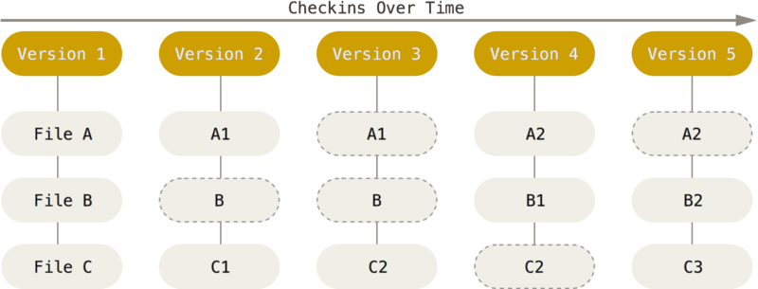 Figure 2.1.1: git storing data as snapshots of the project over time, source: Pro Git Book,
git recognizes three states of files: modified, staged and committed.
- modified means that you have changed the file but have not committed it to your database yet.
- staged means that you have marked a modified file in its current version to go into your next commit snapshot
- committed means that the data is safely stored in your local database
git representation of the project has three main parts:
- working directory (project files currently on local PC)
- staging area (file that stores information about staged files)
- .git directory (stores database of all the objects in your project)
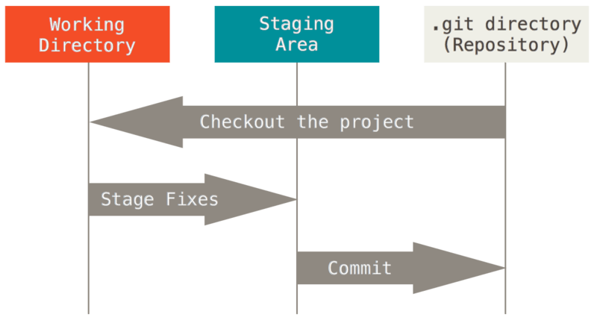 Figure 2.1.2: Main parts of git project repository, source: Pro Git Book,
Basic git workflow can be something like this:
- You modify files in your working directory (working tree)
- you selectively stage those changes that you want to be part of your next commit. Only those changes are added to the staging area
- you commit those changes
Committing clears the staging area and uses its content to create new snapshot of your working tree. This snapshot is stored in your .git directory.

How to get git
For getting git on GNU/Linux I would recommend using your distribution package manager. The package will be most probably named “git,” so for example with apt package manager on Ubuntu or other debian based GNU/Linux distribution the command would be:
sudo apt-get install git
The other installation option is compiling git from source code, but that could be for a little bit advanced users.
After the installation you can check whether git is working or not. As with most programs, you can use following command:
git --version
If you get git version info on the terminal without any error, you are good to go.

Basic setup
git has its own tool for configuring. You can execute it with command git config. git configuration is divided in three layers: system, global and local.
- system: located in /etc/gitconfig file, requires admin rights to allow any modification. It is accessed via command:
git config --system
- global: located in ~/.gitconfig or in ~/.config/git/config files is configuration for current user. It is accessed va command:
git config --global
- local: located in .git/config file in project repository. It is accessed via command:
git config --local
You can view your current settings with this command:
git config --list --show-origin
or you can view value of specific configuration variable with command:
git config <variable.name>
If you didn’t set any git configuration variables before, it might return nothing. You can set git configuration variables with those commands:
git config --global user.name "John Doe"
List of all git configuration variables can be accessed via --help flag:
git config --help

First git repository
You can get a git repository in two ways:
- clone an already existing repository using its web url address, for example like so:
přidat git clone odkaz na repositář projektu
which is actually the repository of this blog and full book releases of this blog.
- you can create one yourself on your local PC. To do that, go into your project folder and type command
git init
Using any of these options you get .git folder added to your project folder. This folder contains all of the git files necessary to maintain version control over your project. But only by initializing git repository doesn’t make anything tracked by git. There are more steps to achieve that.
First, you have to add files, that you want to have tracked, to the initialized repository. For example:
git add *.org
which adds to initialized git repository all .org files for version control. By issuing git add command, those files get only into staging area (as described in previous section). After adding the files, you have to commit them:
git commit -m "Initial commit."
That also means, that you can have in the project folder also files that are not tracked by git. git doesnt mind. Until you add them to git tracking that is.

Working with git repository
Basic workflow with git could be described as follows:
As you work with your project files, you modify them. If you have added them to git tracking, git sees them as modified, because you changed them from last commit. When you want to make another “version,” or project snapshot, you can selectively add each modified file with git add, or you can use --all flag to add all modified files to git staging area. git add command is multipurpose command, so you will definitely use it a lot. Finally, you commit all the staged files to git with git commit -m "Informative message." to create new snapshot of files tracked by git.
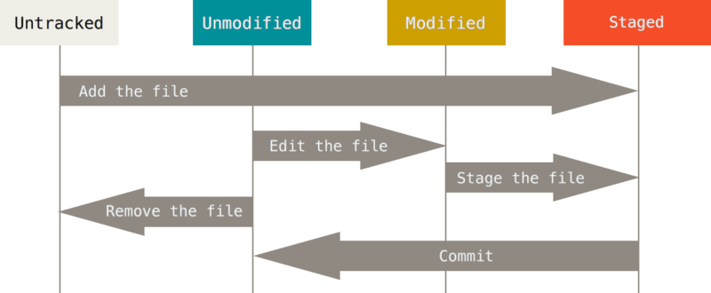 Figure 2.5.1: git workflow and file status changes as you work with them, source: Pro Git Book,

Checking file status in git repository
The main command to find out status of all the files in your repository, that means whether they are untracked, modified, staged, or in-sync with git repository snapshot; as defined above.
git status
Output message of this command should inform you which branch you are using, about its state compared to the default branch and about state of files in repository – whether there are any staged, or modified files that can be staged or untracked files that are not managed by git.
There is also short form of the git status report, that is invoked with command git status --short or git status -s that outputs abbreviated information about your git repository. In front of every file name is status identifier for staging area and current worktree. These identifiers have following meaning:
- ?? : signals that file is not tracked by git, therefore its state is unknown to git
- A : means tht file was added to the staging area
- M : file was modified
For example, identifier MM means that file was modified, staged and then modified again before committing previous changes.

Adding files to git tracking
In order to begin tracking new file you have to add it to git tracking list via git add command. For example, if you want t start tracking file test.org, you would issue following command in terminal:
git add test.org
If you run git status command again in the repository, you get information about new file being added to git tracking in output, section “Changes to be committed.” If you specify directory name to git add command all the files in thee directory are added recursively to git tracking.

Staging and committing modified files in git
Modify a file that is already tracked by git and check output of git status command output:
Nejlepší by bylo zde dát příklad.
git informs you that there is a modified file that is not staged for commit. Lets remedy that by putting it into staging area with command git add. As was stated already, git add command has multiple use cases. All of them lead to adding file in its current state to git staging area. If the file is untracked, after commit is part of next and following project snapshots, until removed. If added file is already tracked, git puts its contents again into staging area for next commit.
git add test.org
After adding file to the next future repository snapshot you have to create that snapshot with git commit command.

Setting ignored files to git
It might happen that you dont want to have some type of files tracked by git, for example some log files or files that are created during your build process and are not part of the final release. When we get to talking about LaTeX, you will notice that LaTeX generates pretty big number of build files that are needed to create resulting pdf, but that are not needed for reading it. For this occasion there is .gitignore file.
Záložka: str. 31

File operations in git repository

Disclaimer
This chapter was written with heavy support of Pro Git book, see

Export from org-mode to LaTeX – basics
– any text –

Customizing export from org-mode to LaTeX
– any introductive text –
I like to use KOMA-script classes, because they have a lot more customization features and very accessible documentation. However, exporting to KOMA-script classes from org-mode is not supported out of the box. To be able to use this document class you have to modify org-latex-classes defined in ox-latex.el. In standard Emacs, it would be done with this function napiš něco lepšího než tuhle větu:
(with-eval-after-load 'ox-latex
(add-to-list 'org-latex-classes
'("scrbook
"\\documentclass{scrbook}"
[NO-DEFAULT-PACKAGES]
[PACKAGES]
[EXTRA]"
("\\chapter{%s}" . "\\chapter*{%s}")
("\\section{%s}" . "\\section*{%s}")
("\\subsection{%s}" . "\\subsection*{%s}")
("\\subsubsection{%s}" . "\\subsubsection*{%s}")
("\\paragraph{%s}" . "\\paragraph*{%s}")
("\\subparagraph{%s}" . "\\subparagraph*{%s}"))))
Doom Emacs requires only slight modification to this by using after! ?macro? instead of with-eval-after-load function, so code in our personal ~/.doom.d/config.el will be:
(after! 'ox-latex
(add-to-list 'org-latex-classes
'("scrbook
"\\documentclass{scrbook}"
[NO-DEFAULT-PACKAGES]
[PACKAGES]
[EXTRA]"
("\\chapter{%s}" . "\\chapter*{%s}")
("\\section{%s}" . "\\section*{%s}")
("\\subsection{%s}" . "\\subsection*{%s}")
("\\subsubsection{%s}" . "\\subsubsection*{%s}")
("\\paragraph{%s}" . "\\paragraph*{%s}")
("\\subparagraph{%s}" . "\\subparagraph*{%s}"))))
– testing the function interactively –
Now, when we have working interactive export setup, we can move to incorporating that in our makefile. This will give us the opportunity to automate whole exporting process. Emacs has nice feature, that allows to run it in batch mode, that is non-interactively, just for evaluating some elisp:
emacs --batch --eval="(require 'foo)"
This can be used to evaluate exporting function defined in ox-latex.el that governs export from org-mode to LaTeX – org-latex-export-to-latex:
–upravit název org-mode souboru–
emacs test.org --batch -f org-latex-export-to-latex --kill
%%blíže vysvětlit -f a --kill flags%%
However, with Doom Emacs there is additional hoop to be overtaken, that is, Doom Emacs make it a little bit harder to run Emacs in batch mode, because in batch mode Doom Emacs doesnt load any user configuration. That means you have to load it manually:
emacs --batch -l ~/.doom.d/config.el -f org-latex-export-to-latex --kill
If you try to do this with your current ~/.doom.d/config.el, you probably end up with some kind of error about unknown function, in my case it was after! ?macro?. I have found that the easiest option is actually to put this “batch mode configuration” into separate file. Lets name it latexExportConfig.el and put it to our other Doom Emacs configuration files into ~/.doom.d folder.
Now we can simply load this file instead of our full Doom Emacs config:
emacs --batch -l ~/.doom.d/latexExportConfig.el -f org-latex-export-to-latex --kill
and %%it should work (TM) :)%%

Resources
- Emacs Wiki: odkaz na Batch mode na Emacs Wiki
- various Stack Exchange questions and answers: Odkaz na general Stack Exchange a na Emacs Stack Exchange

