Motivation

Greedy fat cyber-squirrels must protect their acorn base against the evil stylized pigeons/pigs/boars(“pata preta”) (other animal that craves the Acorns).

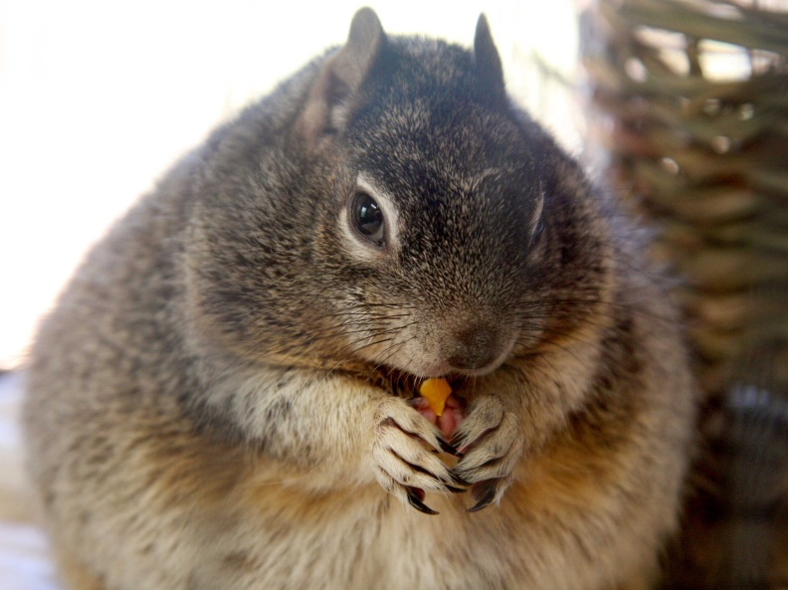VS.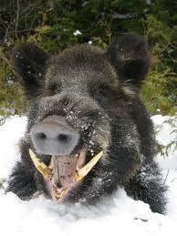

You play as the Master Squirrel: A fat highly intelligent rodent that oversees the acorn warehouse. He needs to manage a squad of flying squirrels (about 1-5) who keep the enemies at bay and gather MORE acorns.

The way the player controls the flying squad is indirect. The flying squads shoot enemies, while trying to avoid that they reach the base.

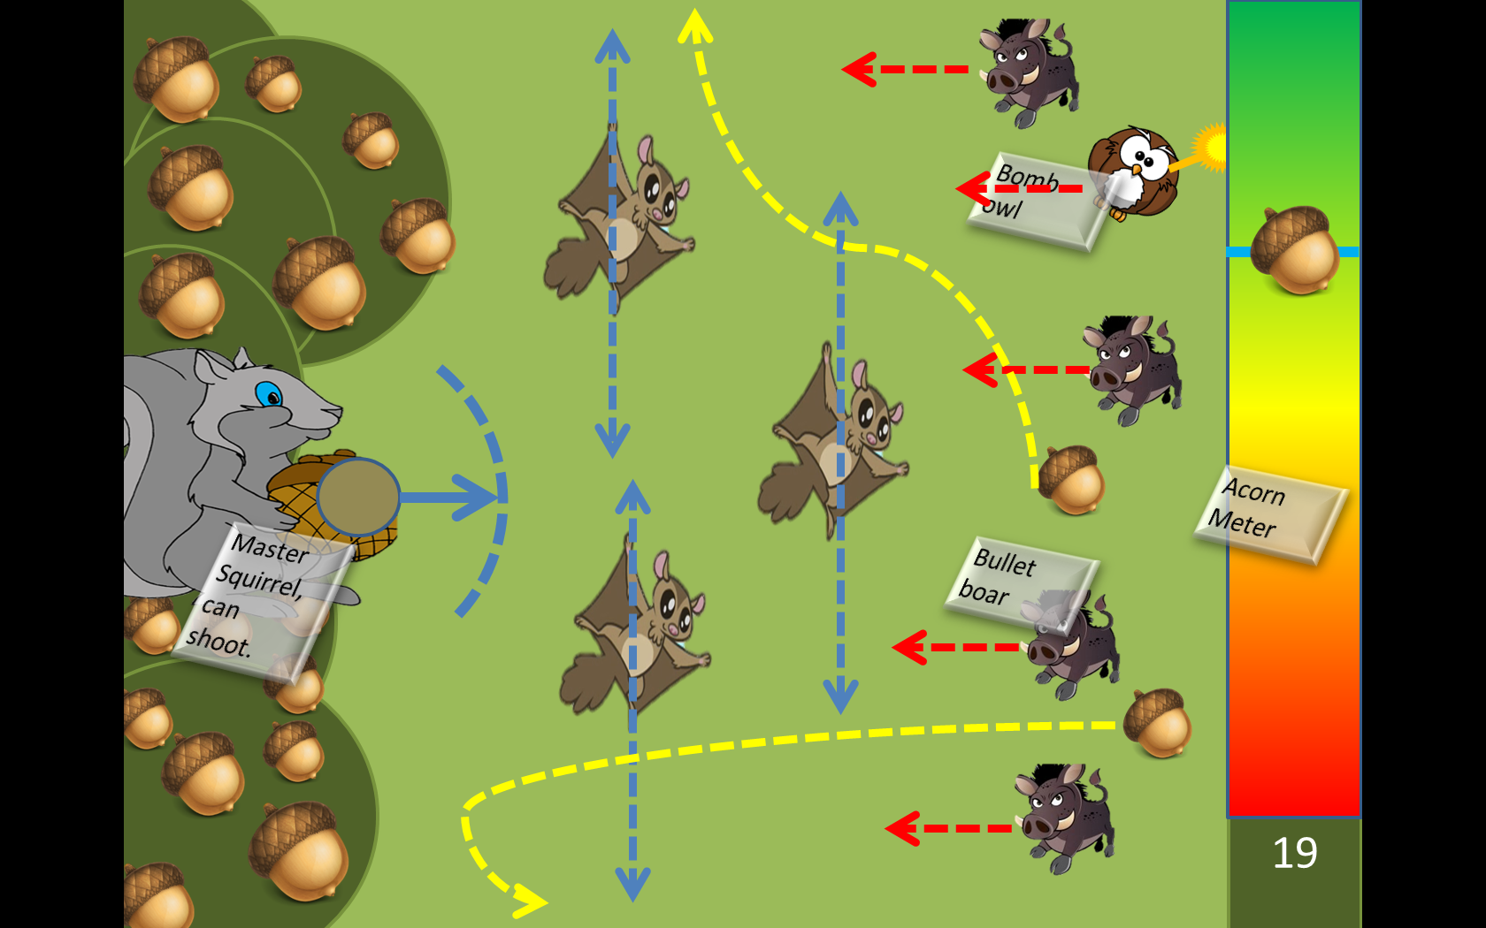

The flying squirrels can be augmented. To do so the Master Squirrels trades acorn for augmentations that can specialize the flying squad. Examples of these augmentations are:

* Collect + Acorns;
* Deal + Damage;
* Become a protective barrier;
* Laser Squirrels;

Hypothesis: To keep flying the squirrels consume X acorns /second. This way the master squirrel needs to shoot periodically acorns to keep the flying squad operational.

Exo-type Original idea

|  |
| --- |
| IDEA (maximum of 2 lines) |
| A colony of cyber-insects strives to survive its enemies. You are the queen and you can use your hive’s resources to create specialized soldiers to fight for you. |
| GAMEPLAY IDEA (maximum of 5 lines) |
| In this game you control a cyber-insect queen in a Side-Scrolling Shooter.  Your role is to manage your resources and select your young’s metamorphosis so they can collect power-ups, shield you, and shoot your enemies for you.  The morphing is done by shooting your brood to trigger the transformation.  The objective is to reach the end of the level alive while maximizing your score. |
| GAMEBOX IDEA (maximum of 10 lines) |
| * Be the mastermind in the fierce struggle for survival of the cyber-insect colony of Entomorphos. * Deploy your metamorphic insects. Morph them by shooting with the upgrade of your choice! * Let your subjects work for you, defend you, and fight for you. * A Side-Scrolling Shooter meets Real Time Strategy gameplay experience for a fast paced game. |