Ottawa COVID-19 Projections

*Last updated on 22 July, 2022, 12:42:33 PM.*

Pour le français cliquez [ici](https://613covid.ca/fr/).

This website has forecasts of hospitalization counts from COVID-19 and wastewater recovery of SARS-CoV-2.

Website is optimized for desktop use. For mobile users, it is recommended to view in landscape mode.

Click here to access the COVID-19 Daily Dashboard created by Ottawa Public Health. The Ottawa Public Health dashboard provides up to date COVID-19 metrics that inform projections presented on this website.

# Dashboard

Data to 2022-07-17

### Current

Case halving time: **6** days *

Rt: **0.61** *

**14** confirmed COVID-19 patients in hospital.

Including **12** acute care patients. **2** ICU patients.

* Based on health care worker absenteeism due to COVID-19.

## Observed cases & hospital use

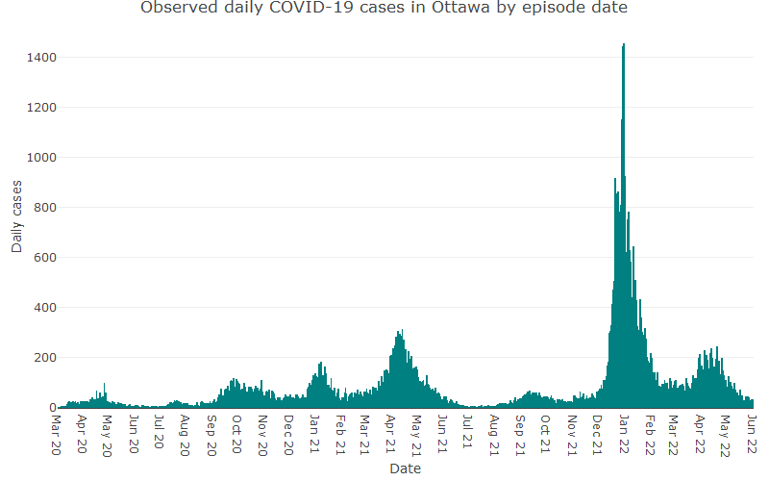

**Note:** New cases are based on approximate date of episode. Case data in the last 7 days should be considered preliminary as as public health investigators determine earliest onset date.

## Observed COVID-19 cases in health care workers in Ottawa by episode date

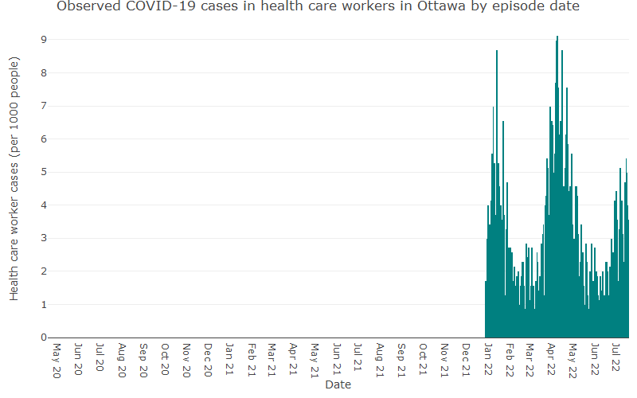

**Note:** The health care worker cases (per 1000 people) are the number of hospital staff who reported a positive PCR or RAT for selected hospitals and health care organizations. These are people who notified Occupational Health of their positive result. Observed COVID-19 cases are adjusted for under-reporting for staff working from home and not providing direct patient care.

## Cumulative incidence of COVID-19 positive staff

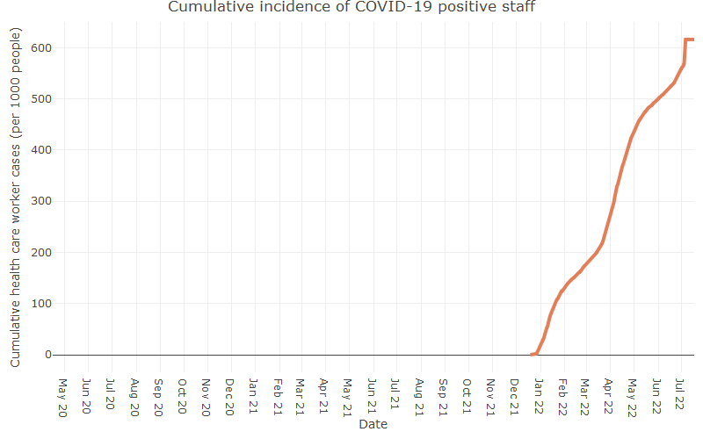

**Note:** The cumulative health care worker cases (per 1000 people) is the cumulative incidence or total proportion of health care workers who reported a positive PCR or RAT for selected hospitals and health care organizations since December 26, 2021. These are people who notified Occupational Health of their positive result. Observed COVID-19 cases are adjusted for under-reporting for staff working from home and not providing direct patient care.

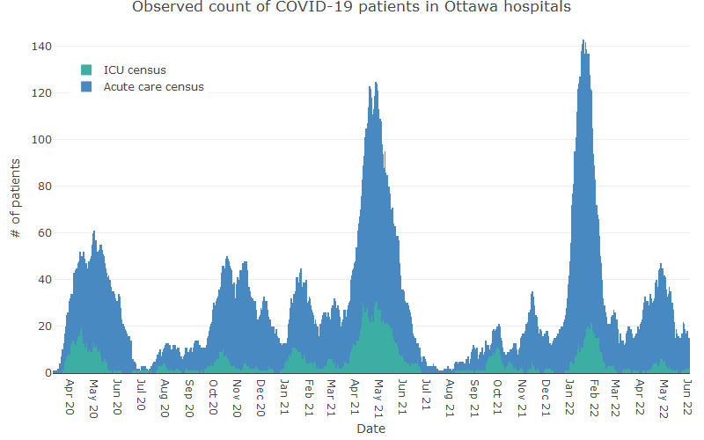

**Note:** As per Ottawa Public Health, hospital data reflecting the past 3-5 days should be considered preliminary as data is still being received and entered for this time period.

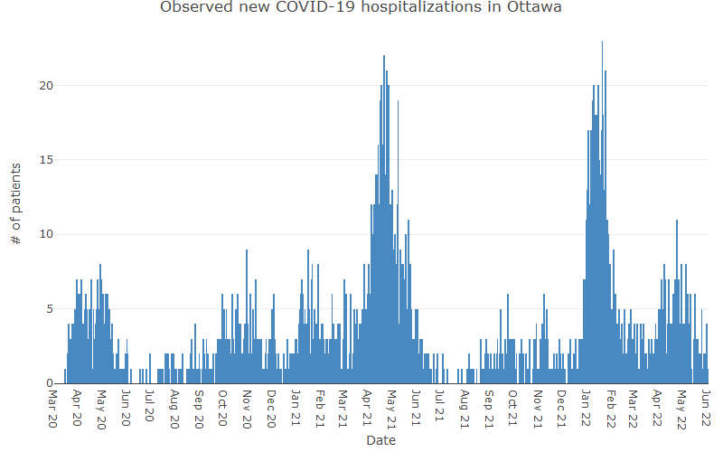

## Projection of hospital census in Ottawa

Projection of hospital census in Ottawa are presented below. See [Methods](/model) for how the projections where created. Short-term projections can trend in different directions when there are changing patterns of community COVID-19 transmission. For example, predicted hospital counts can be underestimated during periods of rapid re-opening.

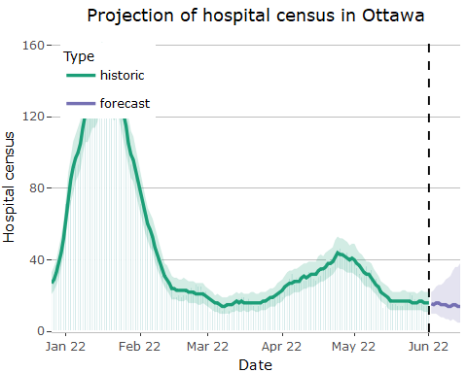

## Projection of COVID-19 positive health care workers in Ottawa

**Note:** The health care worker cases (per 1000 people) are the number of hospital staff who reported a positive PCR or RAT for selected hospitals and health care organizations. These are people who notified Occupational Health of their positive result. Observed COVID-19 cases are adjusted for under-reporting for staff working from home and not providing direct patient care.

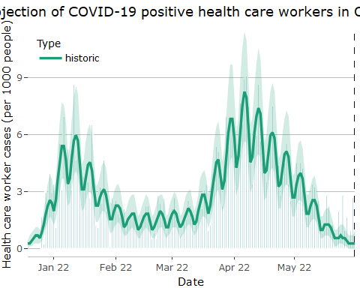

## Rt Projection of COVID-19 positive health care workers in Ottawa

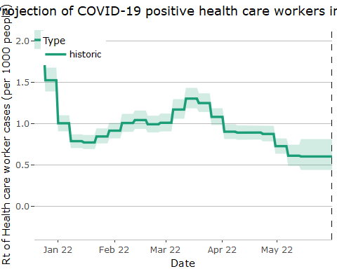

## Definitions

**Hospital count** is the count of patients in all Ottawa hospitals at midnight on the previous day. Ottawa Public Health counts and hospital counts reported from other sources may be different because:

* Hospital counts from other sources may include people who do not reside in Ottawa;
* Interpretation of clearance may vary between hospitals and Ottawa Public Health;
* Interpretation of treated for COVID-19 and being treated primarily for COVID-19 may vary slightly; and
* Ottawa Public Health workload may delay the clearance of hospitalizations in preference to reporting new ones by Ottawa Public Health when volumes are high.

**Transmission** is the risk that a person becomes infected when they come in contact with a person with COVID-19.

**Doubling time** refers to the time it takes for the number of hospitalized patients to double in number. Conversely, **halving time** refers to the time it takes for the number of hospitalized patients to halve in number.

**Daily growth** is the rate of change in the hospitalization from day-to-day.