TERRA WEB
Camera View
Seeing exactly what a camera captures, and zooming only between the reaches you set
The camera view shows the selected capture camera's picture at full size, standing where the rig stands and facing the master object. The only thing you can change in it is how far in the camera is — and only between the zooms configured in the camera's Zoom Distance control, which can now hold several saved zoom sets.
It replaces Camera Preview. The Preview tile is gone from the camera's bottom toolbar, along with its Top / Bottom picker and the fly-in that took over the editor's viewport. Every screenshot here was captured from the running editor.
 | Before — Camera Preview | Now — Camera view
Opened from | Preview tile in the bottom toolbar | Expand button on the camera's POV panel (or a click on the picture)
Where it shows | The editor's own viewport flew into the camera | A full-size view over the editor; the viewport is untouched
What you could do | Orbit, pan and zoom freely — views the capture never takes | Only zoom, and only to the reaches set in Zoom Distance
Which camera | Top / Bottom picker | Start / End switch in the view's header
Zoom | Free scroll zoom | Steps between 1x, each saved zoom set, and the current Zoom Distance

1. Opening the camera view
Select a camera. Its live POV panel sits above the Transform list, bottom right. The expand button (↗) in the panel's header opens the camera view; clicking anywhere on the picture does the same.
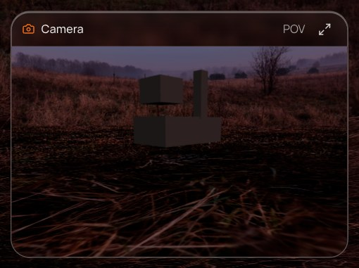  The POV panel with its expand button, top right. | 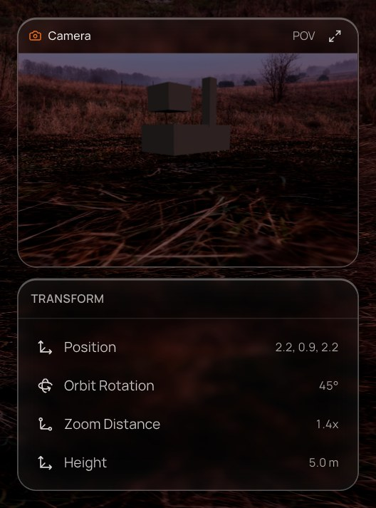  Where it sits: above the camera's Transform list.

The camera's bottom toolbar now has two tiles — Object and Capture. Looking through the camera is the POV panel's job.

2. The view
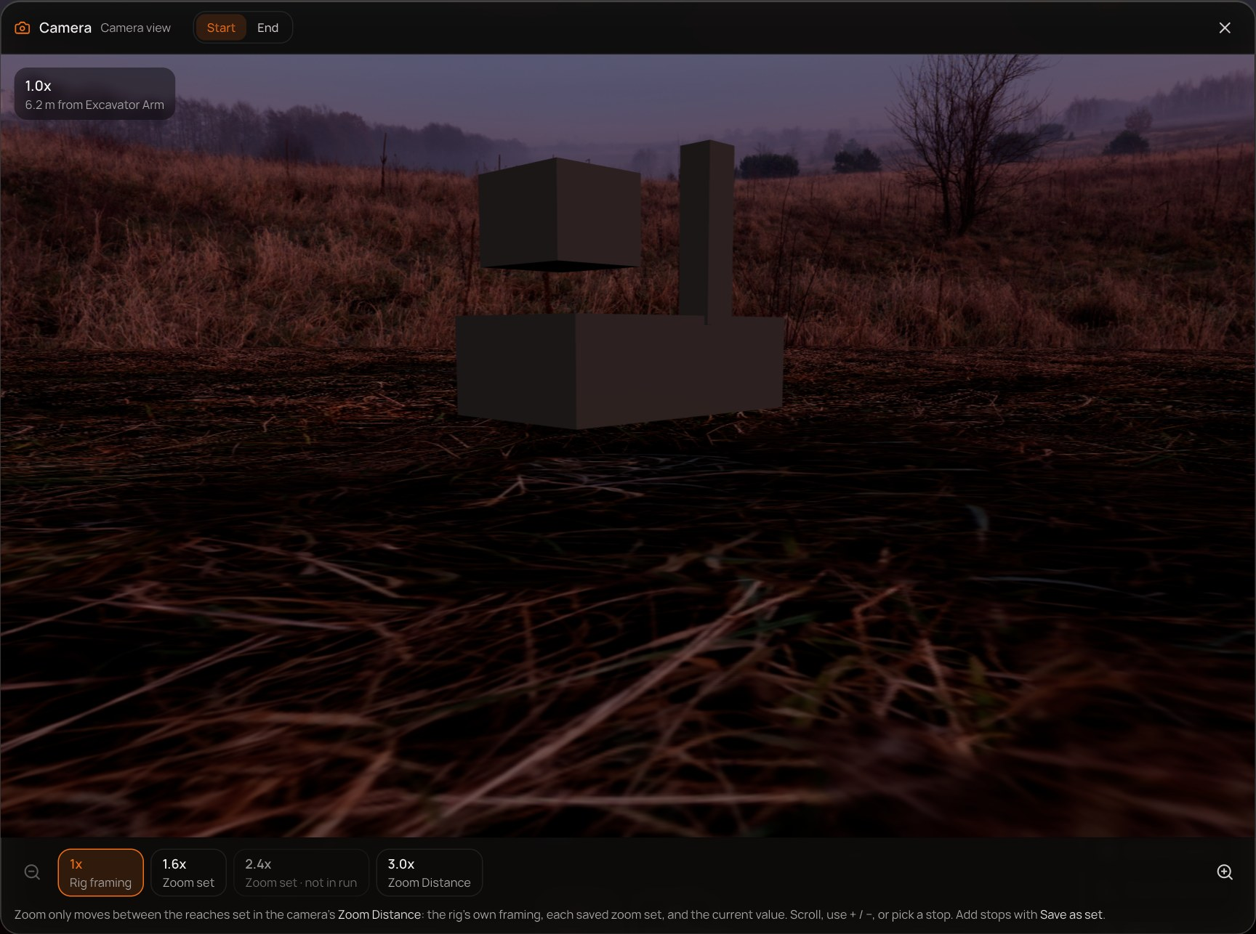
The camera view at 1x — the rig's own framing.
- Header — the camera's name, a Start / End switch for the two ends of the rig, and close (×, Esc, or a click outside the view).
- Picture — the scene from the camera, facing the master. The badge top-left gives the current zoom and the distance to the master, e.g. 3.0x · 2.1 m from Excavator Arm. Rig cameras themselves are hidden, as in a captured frame.
- Zoom rail — zoom out (−), one chip per stop, zoom in (+), and a line explaining where the stops come from.
While the view is open the editor is blocked: clicks don't reach it and its keyboard shortcuts are swallowed, so Delete can't remove the camera you are looking through. Selecting a different object closes the view.

3. Zooming between your reaches
The view can only stand at reaches the capture will actually shoot. These are the stops, farthest first:
Stop | Comes from | Notes
1x · Rig framing | Where the rig stands — the far end of the sweep | Always present while there is a master.
Zoom set | Each set saved under Zoom Distance (named by its zoom, e.g. 1.6x) | A set unticked from the run still appears, dimmed and marked not in run.
Zoom Distance | The control's current value | Only when it isn't already saved as a set — one chip per reach.

The zoom rail: 1x, two saved sets (2.4x is out of the run), and the current Zoom Distance, selected.

How to zoom
Action | Effect
+ / − buttons | One stop in / out. Disabled at the ends.
Scroll wheel / trackpad | One stop per scroll gesture — it steps, it doesn't slide.
+ = ↑ → | Zoom in one stop.
− ↓ ← | Zoom out one stop.
Click a chip | Jump straight to that stop.
Esc | Close the view.

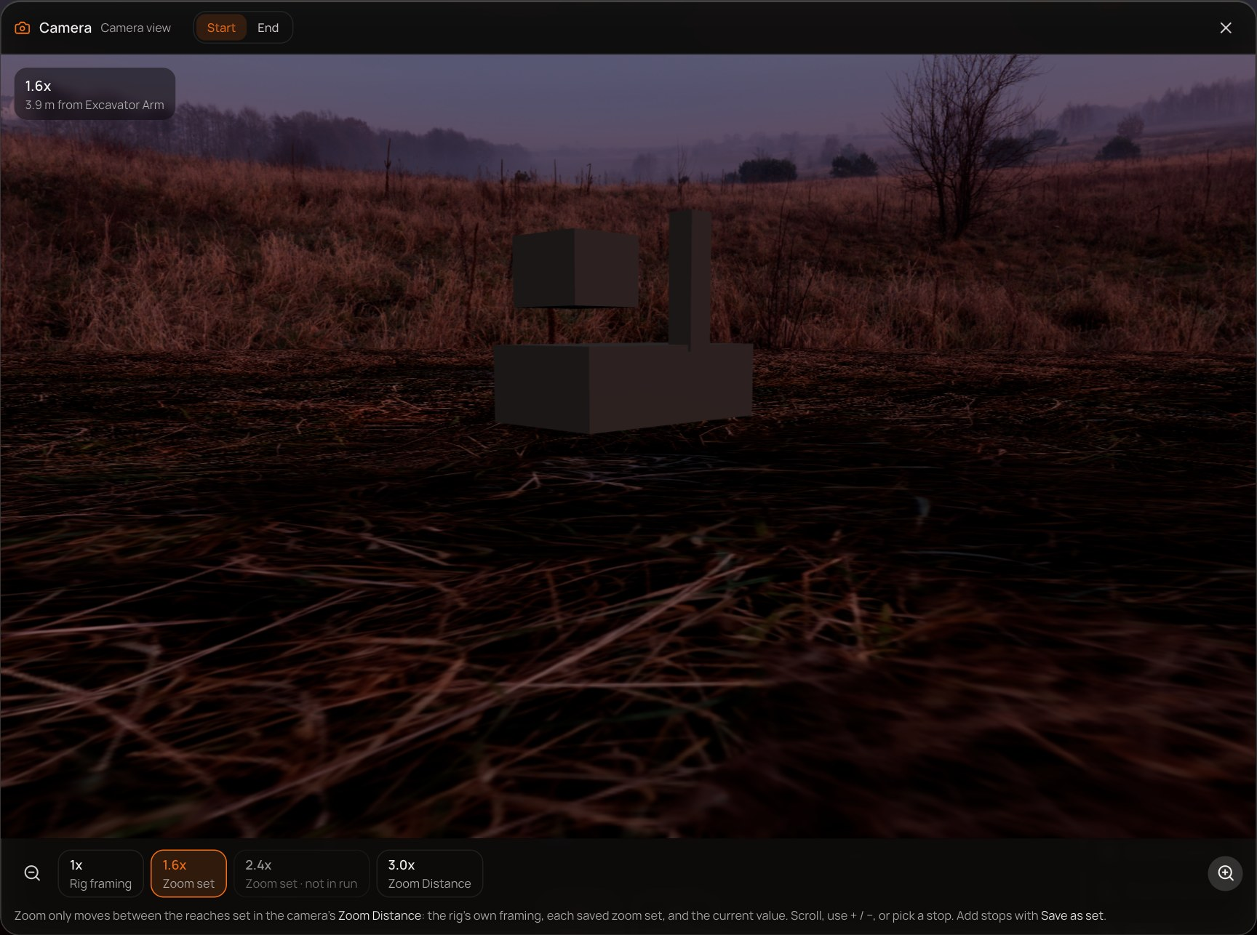  1.6x — a saved zoom set. | 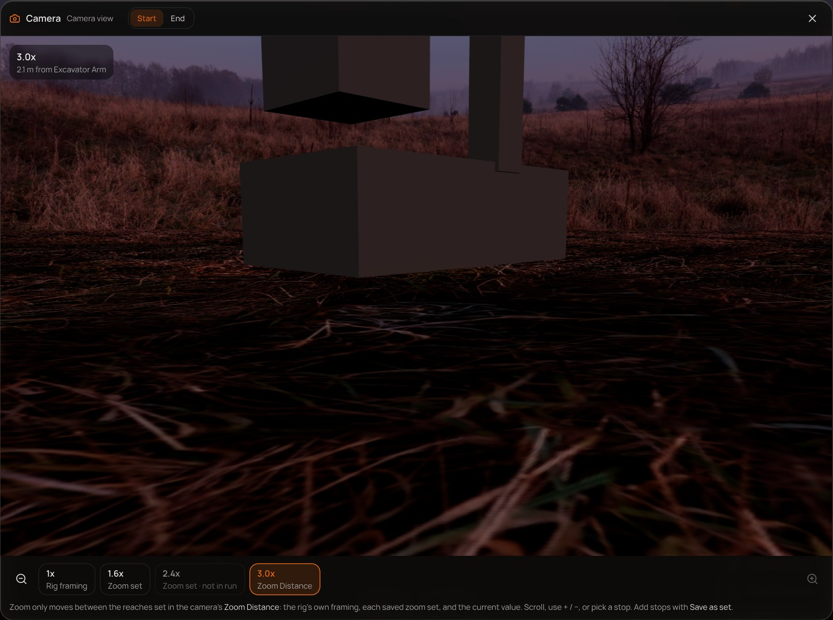  3.0x — the current Zoom Distance.

Zoom moves the camera in along its line to the master — the same travel the capture makes — rather than narrowing the lens. A narrower lens would show a picture that is not in the dataset.

Start and End
The switch in the header looks through the other end of the rig. The zoom stop is kept, so you can compare both cameras at the same reach.
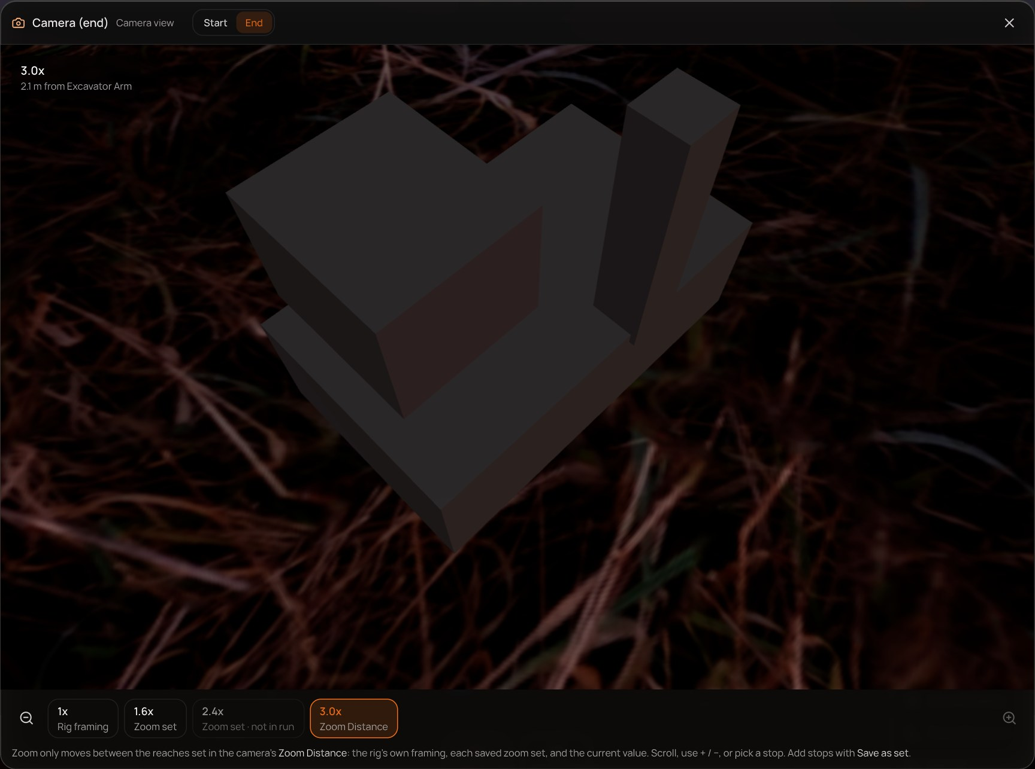
The End camera at the same 3.0x stop.

4. Setting up zooms — Zoom Distance and zoom sets
Zoom Distance (camera → Object tile → Zoom Distance) sets how far in the capture travels from the rig's framing. It can now keep several zooms, exactly like the Work Order's Camera Settings: set a value, press Save as set, repeat.
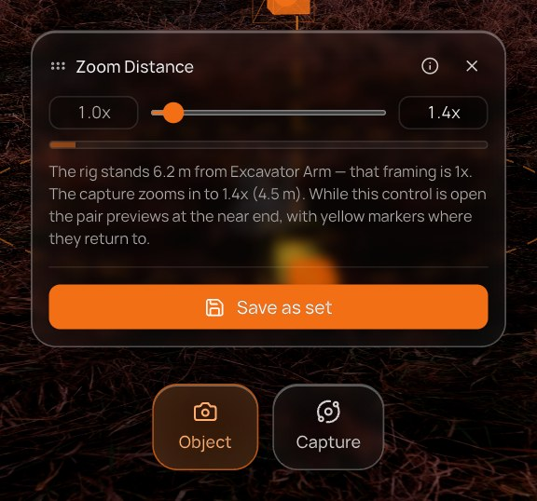  Zoom Distance with Save as set, before any sets. | 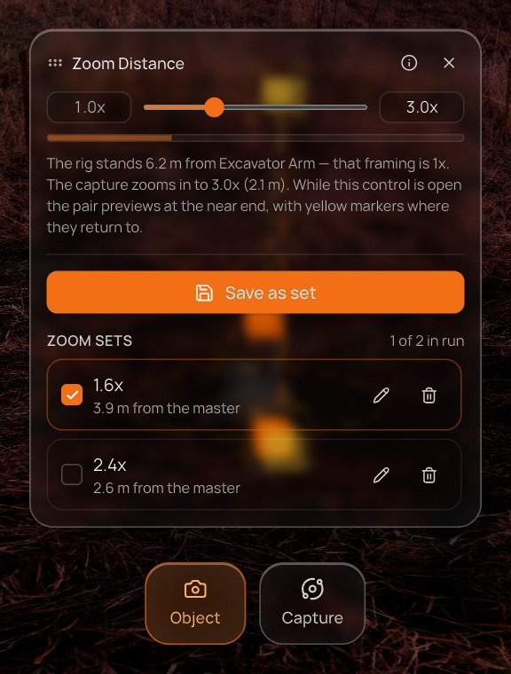  Two sets saved; 2.4x unticked, so 1 of 2 is in the run.

In the list | What it does
Checkbox | Whether the run captures this zoom. Every ticked set multiplies the run (each one is another pass over the sweep).
Name (e.g. 1.6x) | Loads that zoom onto the rig, and the viewport previews it.
Pencil | Loads the set for editing; adjust the slider, then Update set (or Done to leave it as it was).
Bin | Deletes the set.

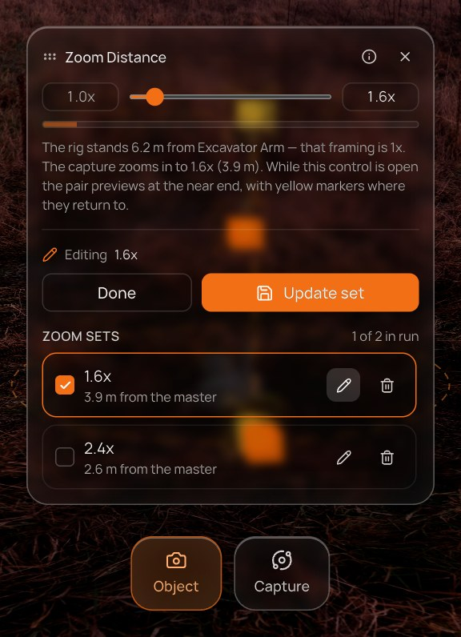  Editing the 1.6x set. | Editing a set  The pencil loads the set and shows Editing 1.6x with Done and Update set. Moving the slider then Update set rewrites that set rather than adding a new one.

One list, two places
The sets are stored on the scene, not in the panel: a set saved in the editor is already in the Work Order, and the other way round.
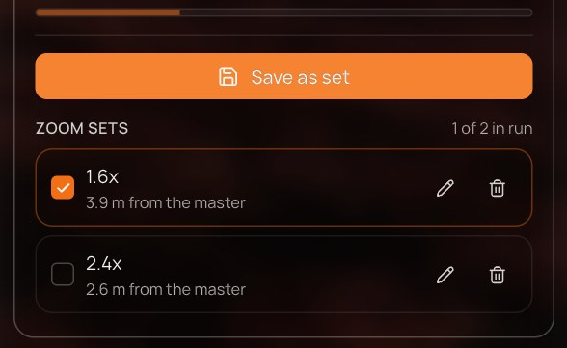
The same two sets in the Work Order's Camera Settings.

5. With no master object
Zoom is measured from the master object, so a camera in a scene without one has nothing to zoom between. The camera view still opens — the camera at its own framing — and says why the rail is empty. The Zoom Distance control lists the scene's objects so one can be made the master in place.
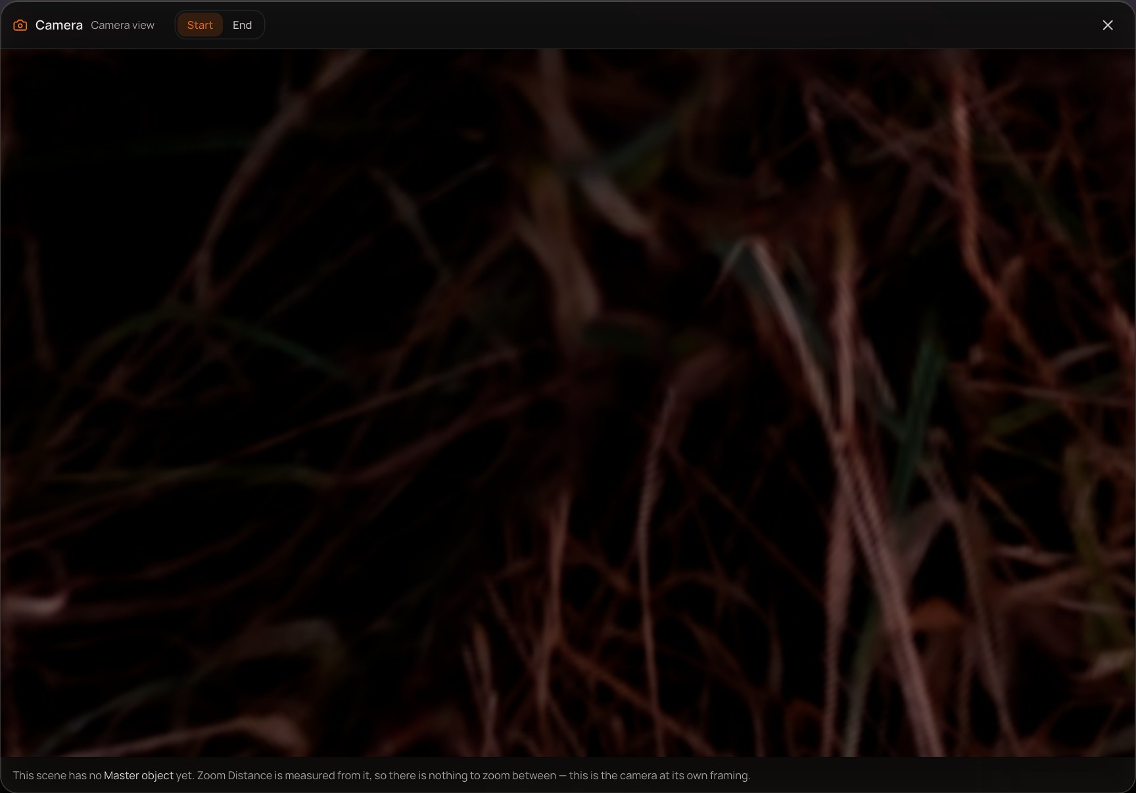
The camera view with no master: no stops, and the reason.
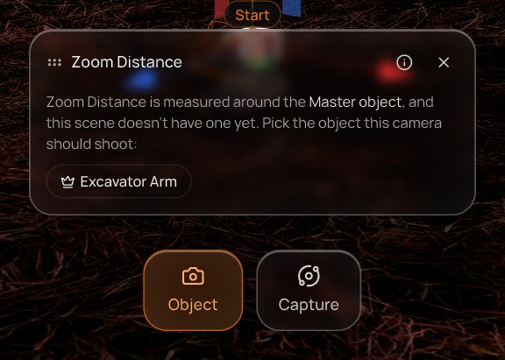
Zoom Distance with no master: pick the object the camera should shoot.

6. Rules at a glance
Rule | Detail
Only configured reaches | 1x, every saved zoom set (in or out of the run), and the current Zoom Distance when unsaved.
Camera moves, lens doesn't | Zoom slides the camera toward the master; the 50° lens matches the capture.
View-only | No orbit, pan or editing. Editor shortcuts are blocked while the view is open.
Belongs to the selection | Selecting another object closes it; the Start / End switch doesn't.
Shared sets | Zoom sets saved in the editor and in the Work Order are the same list.

