TERRA WEB
Generate Work Order
Every feature in the panel, with screenshots
The Generate Work Order panel turns a scene into an order for a synthetic dataset. You decide what the camera shoots, which conditions it shoots under, which parts of the scene vary between runs, and what comes back with every frame. The panel then shows the exact bill before anything is dispatched.
Every screenshot was captured from the running editor, using a demo scene: a Torus as the master object, three props (Street Lamp, Barrier, Fire Hydrant), and a drawn space behind the Torus for the arrangement solver.

The panel has… | What it is for
Four scene sections | Objects, Camera Settings, Weather & Lighting, Time of Day — they edit the scene itself: what is in it, how the rig shoots it, and the conditions it is shot under.
Two axes | Scene Environment and Arrangement — each one multiplies the run by rendering the scene several different ways.
Output | What TerraGen computes for every frame — type, resolution and annotations. It changes what comes back, not how many frames there are.
Footer | A live preflight strip and Review & dispatch, which opens the bill.

The one formula to remember: frames = subsets × frames per subset. The camera rig decides the frames per subset; everything that sweeps (environments, arrangements, saved sets, swap objects) multiplies the subsets. Section 12 has the full arithmetic.

1. Opening the panel
Press Generate at the right end of the editor's top bar. The editor switches to TerraGen mode: the panel docks on the right and the stage on the left shows the scene through the capture camera.
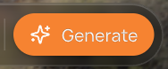
Figure 1 — The Generate button in the editor's top bar.
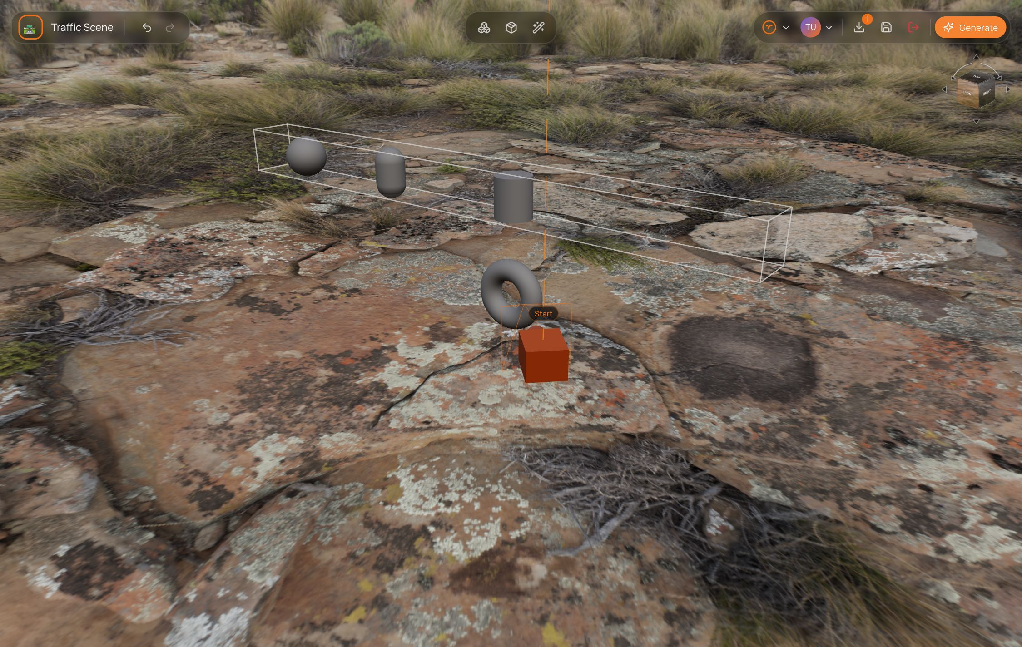
Figure 2 — The demo scene in the editor: the Torus (master), three props and the drawn space behind them.
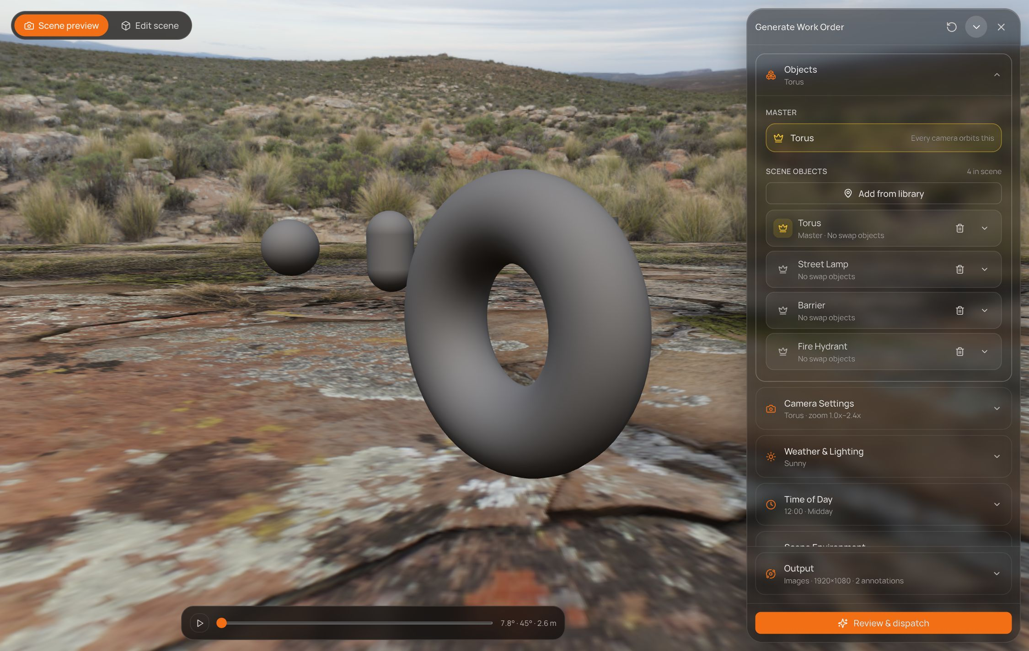
Figure 3 — The panel open. Objects is expanded; the stage shows frame 1 of the sweep.

Header
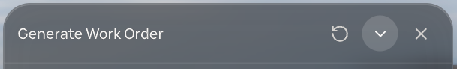
Figure 4 — The header: Re-read, Collapse and Close.
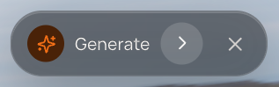
Figure 5 — Collapsed: the panel shrinks to this bar.
Button | What it does
↻ Re-read the scene | Throws the draft away and rebuilds it from the scene, with no confirmation. It resets every swap object list, the added environments, Arrangement (back to 1, with a new seed) and Output (back to the defaults). It does not touch anything stored on the scene — objects, the camera rig, weather, time of day, zoom and their saved sets are kept.
⌄ Collapse | Folds the panel down to a small Generate bar in the corner, so it is out of the way of the view. Everything you set is kept; the › button expands it again.
✕ Back to editor | Leaves TerraGen mode. The draft survives: reopening the panel picks up where you left off.

2. The stage — Scene preview and Edit scene
Two tabs at the top left switch what the big view on the left shows.
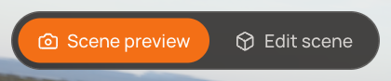
Figure 6 — The stage tabs.
Tab | What it shows
Scene preview | The scene through the capture camera, at one frame of the sweep. The camera bodies themselves are hidden. This is the tab the panel opens on.
Edit scene | The normal editing viewport, with the rig, gizmos and guides. Selecting an object here adds a Transform panel (position, rotation, scale) and a Done button.

The stage switches to Edit scene on its own when you open Camera Settings, change a camera control, preview a swap object, or open the library from any section. It never switches back by itself — press Scene preview when you want to look through the lens again.

Scrubbing the sweep
Under Scene preview there is a play button and a scrubber across the rig's whole sweep. Play steps through the frames in a loop; dragging the scrubber pauses it and jumps to that frame. Both are disabled when the sweep is a single frame (Fixed mode), and hidden when no camera is placed.
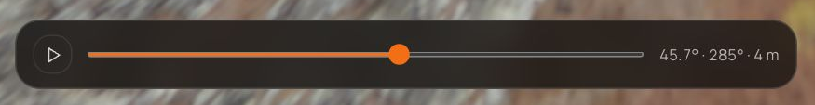
Figure 7 — The scrubber. The caption reads pitch · heading · distance.
Caption | Meaning
45.7° | Pitch — how far above the master the camera looks down from.
285° | Heading — the camera's bearing around the master, 0–359°.
2.6 m | Distance — straight-line distance from the camera to the master.
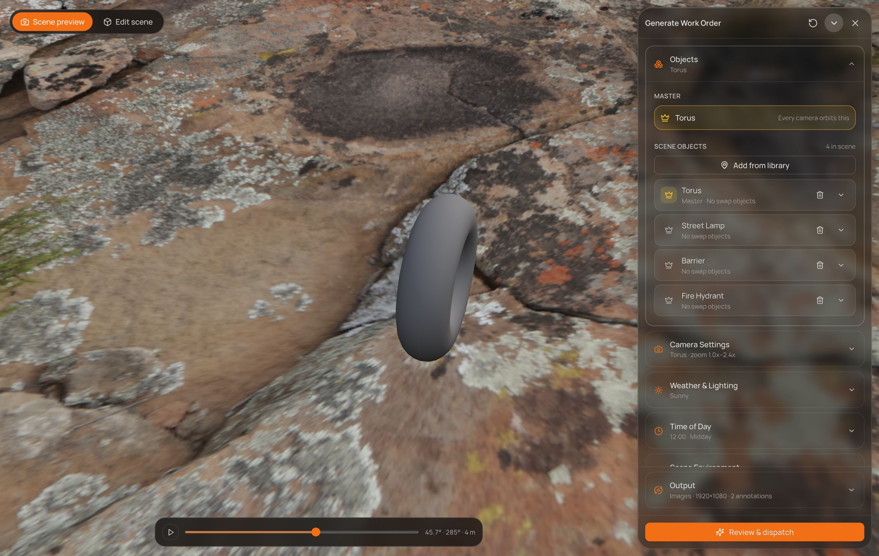
Figure 8 — The same scene scrubbed to a later frame: higher, further round, closer in.
The preview is camera-only. Weather, time of day, environments and swaps are part of the order but are not drawn in either stage — the preview shows where each frame is taken from, not the finished render.

3. Objects
Objects holds the whole cast of the scene. Its closed row reads the master's name, followed by how many background and distractor objects there are.
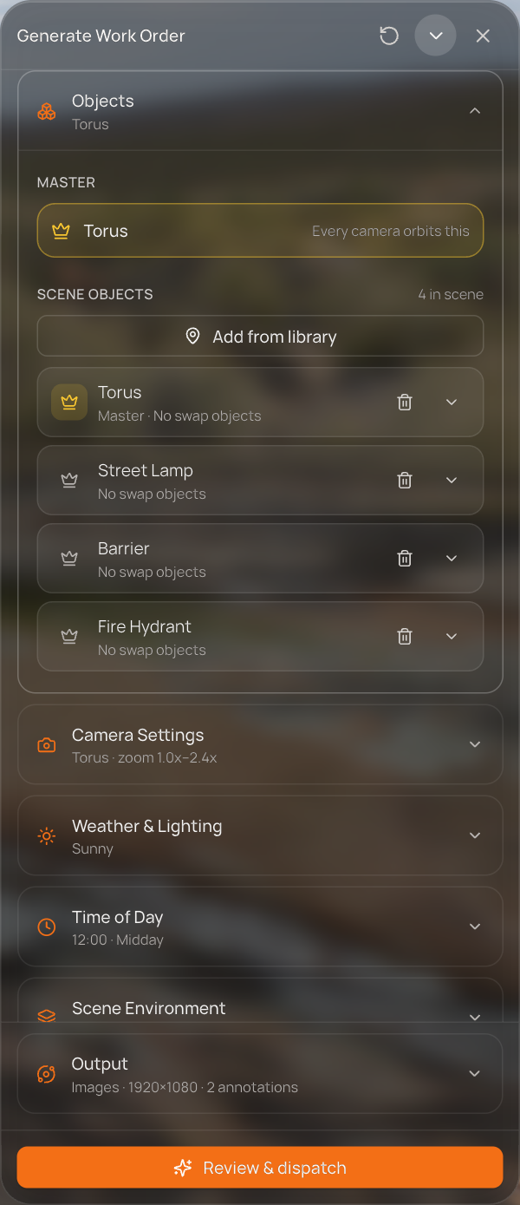  Figure 9 — Objects: the master, then every object in the scene. | Master  The master is the hero of the dataset — every camera orbits it, and the rig is measured against its size. The Master block shows it with a crown; click the name to select it in the scene. Without a master the run cannot be dispatched.  Scene objects  - Add from library opens the asset library on All Assets. Picking an asset places it in the scene, selects it and closes the library.  - Crown on a row — Make this the master object. The old master is demoted and the camera rig moves with the new one.  - Name — click to select the object in the scene. Underneath: its role, and how many swap objects it has.  - Bin — removes the object from the scene, together with its swap list.  - Chevron — opens that object's swap objects (below). One list is open at a time.

Swap objects — render one object several ways
A swap object is a stand-in rendered where the original stands. Give the Street Lamp two stand-ins and every subset renders three times: once with the Street Lamp, once with each stand-in. The scene itself does not change.
- Open an object's chevron and press Add swap objects. The library opens with its checkboxes armed and a Swap for Street Lamp button.
- Tick as many assets as you want and press the button. The library stays open so you can keep adding; close it when you are done.
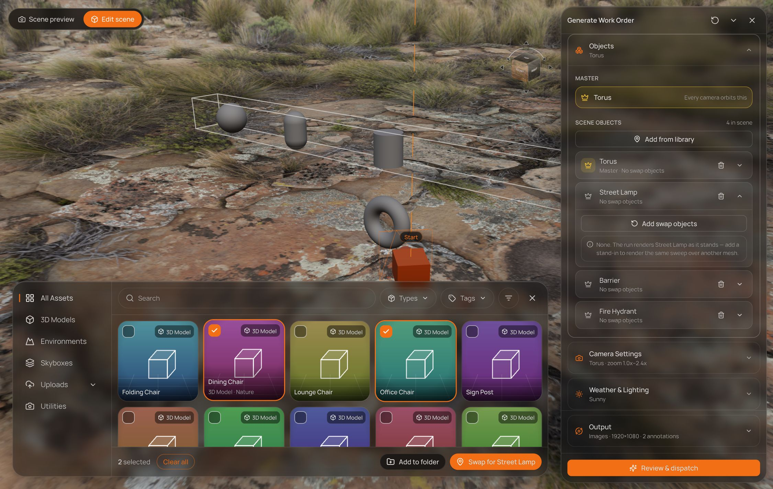
Figure 10 — Choosing stand-ins for the Street Lamp: Office Chair and Dining Chair ticked.
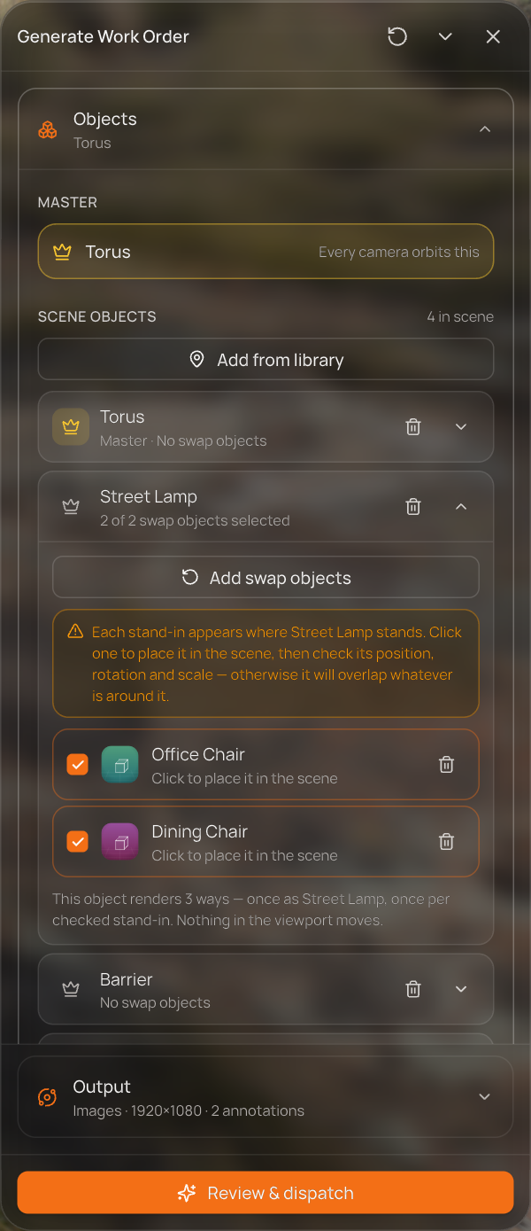  Figure 11 — The Street Lamp's swap list: 2 of 2 selected, renders 3 ways. | - Each stand-in appears in the list, checked into the run by default. Untick one to keep it in the list without rendering it; the bin removes it.  - Click a stand-in's name to place it in the scene and check its position, rotation and scale — the yellow note warns that otherwise it may overlap what is around it. Moving it with the gizmo only changes that stand-in's offset, never the original object.  The row caption follows the stand-in's state: Click to place it in the scene → Standing in — adjust it in the scene → Adjusted · click to review.

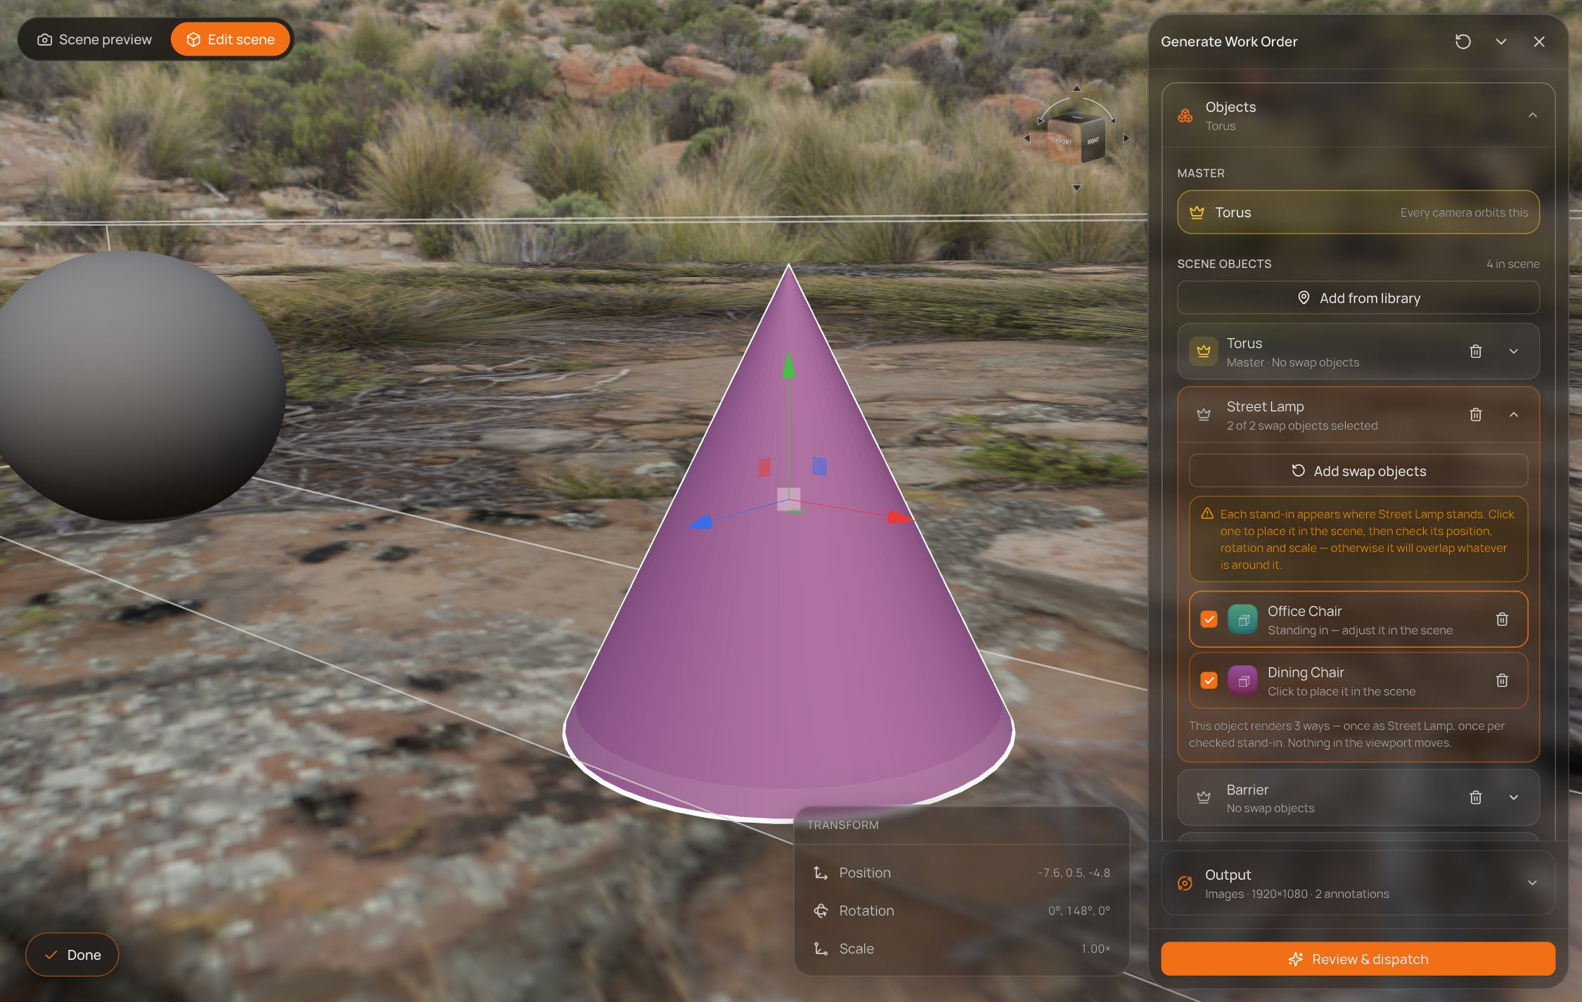
Figure 12 — Previewing the Office Chair stand-in (drawn as a placeholder cone) where the Street Lamp stands.
Roles. Objects carry a role — Master, Background ("scene dressing that sets context behind the hero") or Distractor ("foreground clutter the detector must learn to ignore"). In this panel only the master can be set; roles do not multiply the run, and the master is never moved by Arrangement.

4. Camera Settings
Camera Settings shapes the capture rig — the pair of cameras that sweeps around the master — and so decides the frames per subset. Opening the section switches the stage to Edit scene and frames the rig.
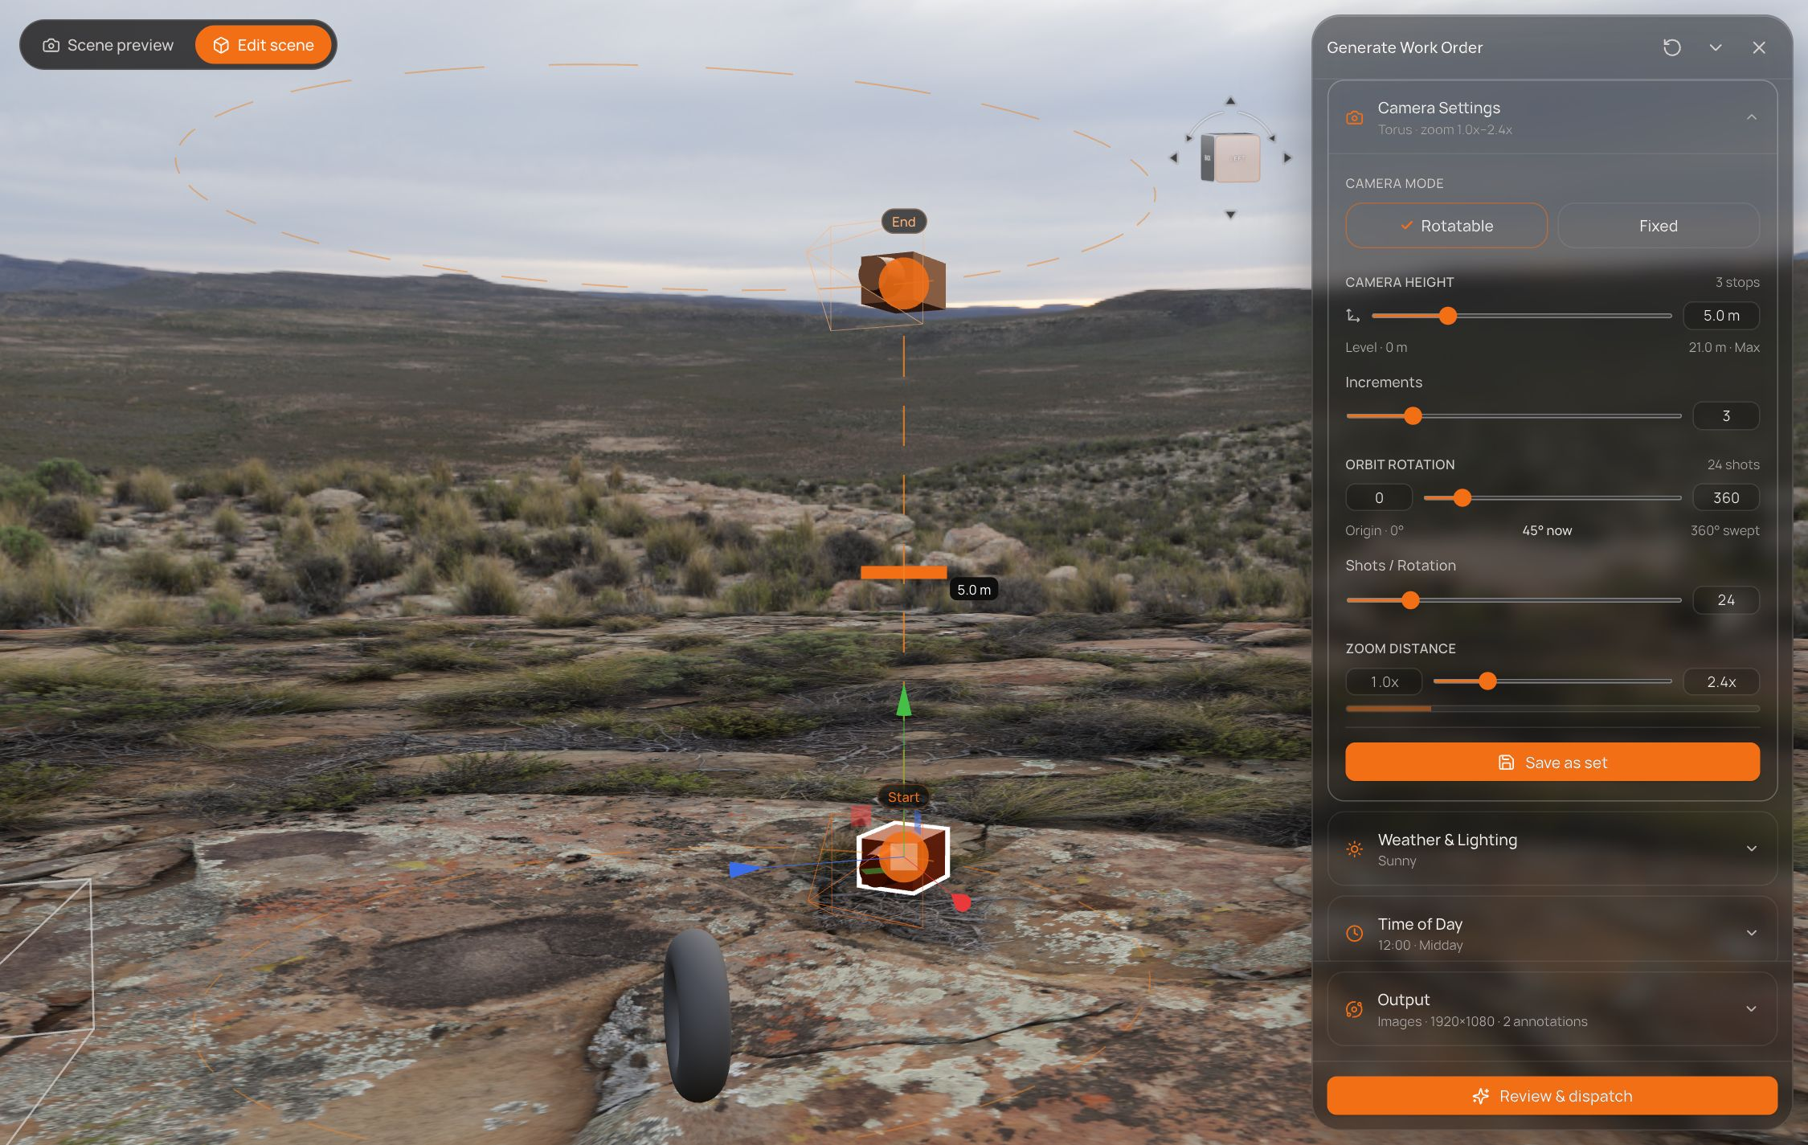
Figure 13 — Camera Settings open: the stage shows the rig, its orbit ring and the height guide.
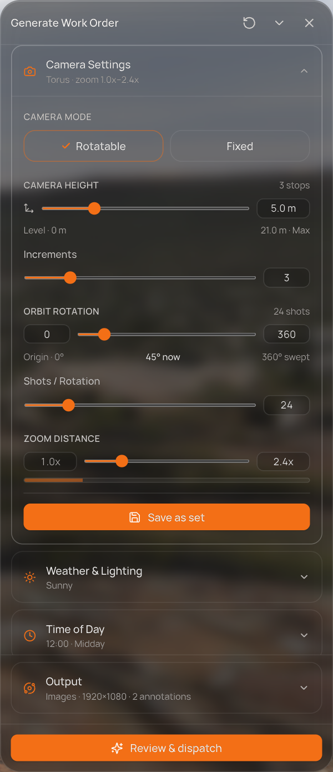  Figure 14 — The Camera Settings section.
  Control | What it does
  Camera mode | Rotatable (default) sweeps the rig around the master. Fixed shoots a single frame per subset from where the camera stands.
  Camera height | The height between the two cameras of the rig, from Level · 0 m up to a maximum set by the master's size, in 0.1 m steps. The quick buttons jump to either end.
  Increments | How many stops the rig makes between its two heights — default 3, from 1 to 12, capped so stops stay at least 0.25 m apart. The group's hint shows the stop count.
  Orbit rotation | The two fields are the start and end of the arc (default 0–360°). The slider swings the rig around the master; the labels read Origin, now and swept. Narrowing the arc changes where shots land, not how many there are.
  Shots / Rotation | How many frames the rig takes per revolution — default 24, from 4 to 120.
  Zoom distance | How far in the sweep zooms: from 1.0x, where the rig stands, up to a limit set by the master's size, in 0.1x steps. The demo rig starts at 2.4x.

Frames per subset = Increments × Shots / Rotation in Rotatable mode — 3 × 24 = 72 by default — or 1 in Fixed mode.

Zoom sets
Save as set stores the current zoom distance as a named set (for example 2.4x) and checks it into the run. Save a second zoom and every subset renders twice — once per checked zoom.
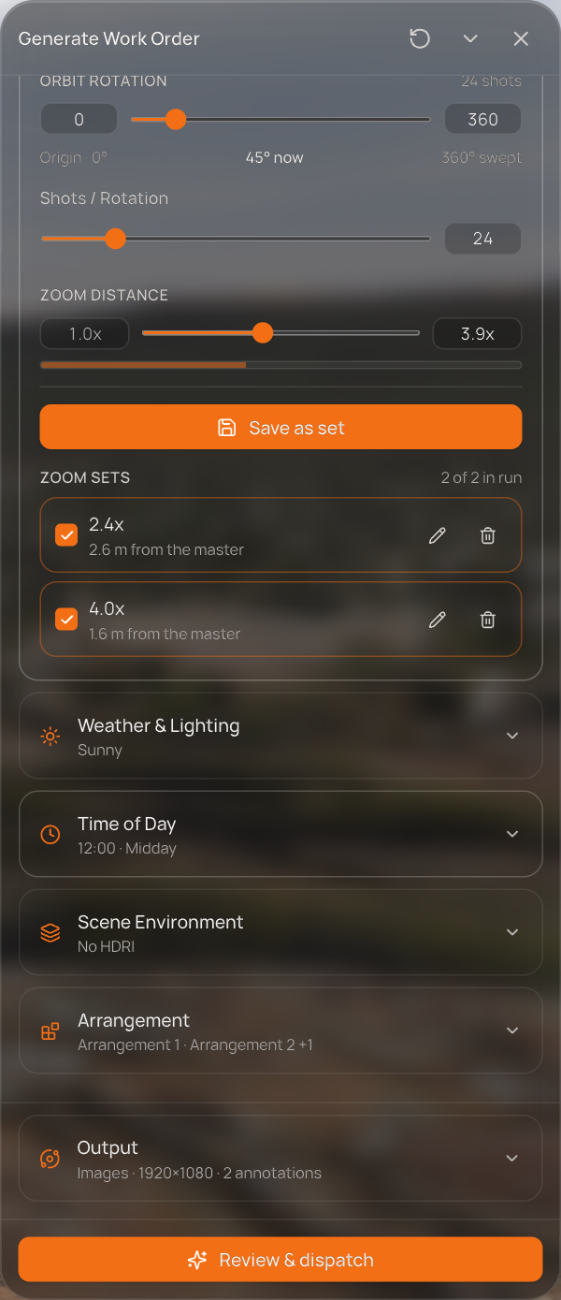  Figure 15 — Two zoom sets in the run: 2.4x (2.6 m from the master) and 4.0x (1.6 m). | One checked set counts as ×1 — sets only multiply once two or more are checked. The same is true of weather and time sets.
  On a set row | What it does
  Checkbox | Include the set in the run, or keep it without rendering it.
  Name | Jumps the rig to that zoom so you can look at it.
  Pencil | Edit mode — change the zoom, then Update set or Done.
  Bin | Deletes the set.

5. Weather & Lighting
Weather & Lighting sets the conditions the scene is rendered under. The closed row shows the active combination.

Conditions
The five tiles — Sunny, Cloudy, Rain, Dusty, Snow — can be combined (Combine any). The default is Sunny on its own, and the last condition that is on cannot be switched off. Each active condition adds its own dials:
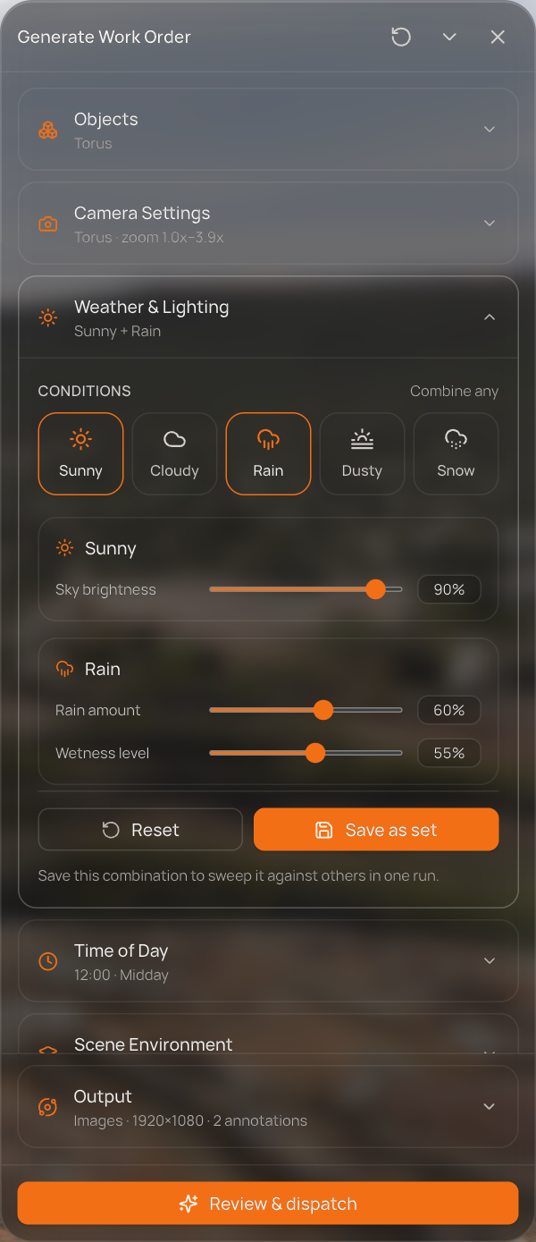  Figure 16 — Sunny + Rain: each condition brings its own dials. | Reset puts the active conditions' dials back to their defaults; it does not change which conditions are on.
  Condition | Dials (default)
  Sunny | Sky brightness (90%)
  Cloudy | Cloud coverage (75%)
  Rain | Rain amount (60%), Wetness level (55%)
  Dusty | Dust amount (50%)
  Snow | Snow amount (55%), Snow coverage (70%)

Weather sets
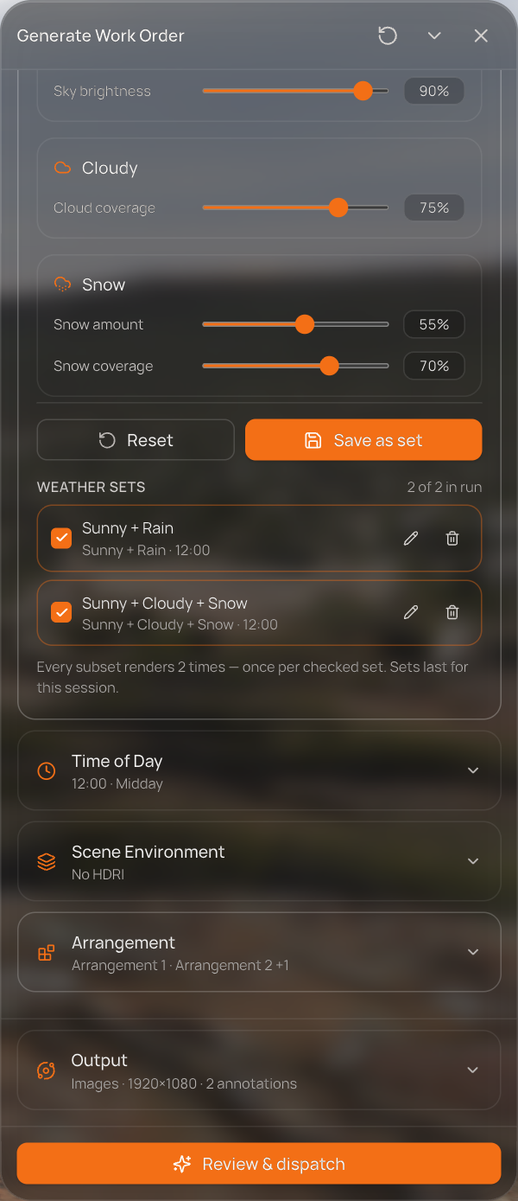  Figure 17 — Two weather sets in the run: Sunny + Rain, and Sunny + Cloudy + Snow. | Save as set stores the current combination under its name (for example Sunny + Rain) and checks it into the run. Save several and every subset renders once per checked set. Set rows work like zoom sets: checkbox, name (loads the set), pencil and bin.  A weather set also stores the time of day (shown on its row, e.g. · 12:00). Loading a weather set therefore moves the Time of Day clock too. Sets last for the current session.

6. Time of Day
Time of Day sets the sun's clock. The slider runs from 00:00 to 23:55 in 5-minute steps (default 12:00) over a colour strip that reads like the day itself — night at both ends, dawn around 06:00, midday light in the middle, golden hour and dusk towards 18:00. The 06:00 / 12:00 / 18:00 marks are labels, not stops.
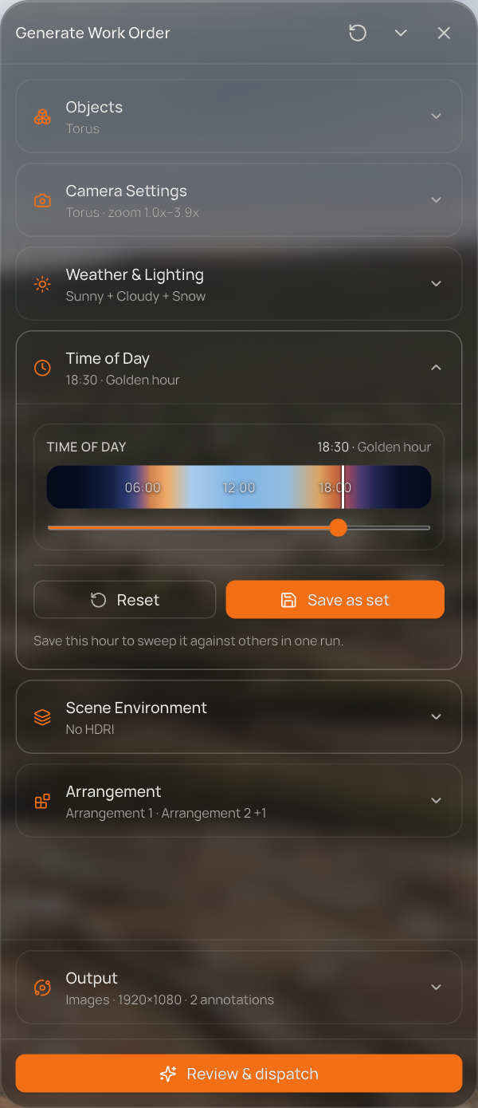  Figure 18 — Time of Day set to 18:30 · Golden hour. | The readout names the phase: Night, Dawn, Morning, Late morning, Midday, Afternoon, Golden hour, Dusk.  Reset returns the clock to 12:00.

Time sets
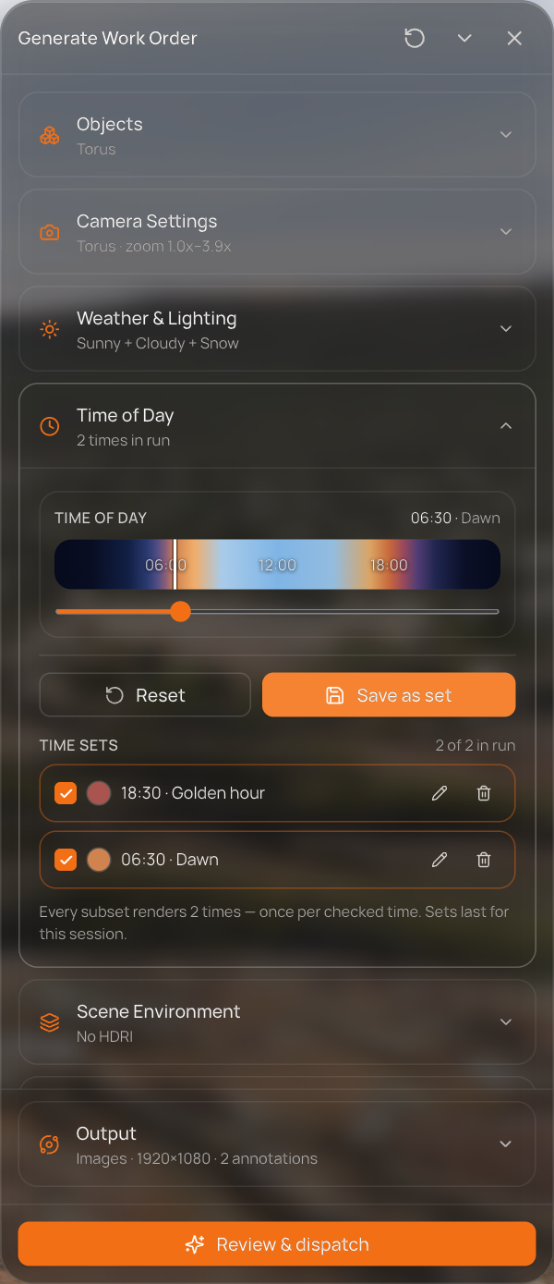  Figure 19 — Two times in the run: 18:30 Golden hour and 06:30 Dawn. | Save as set stores the hour (named like 18:30 · Golden hour) and checks it into the run. Once two or more are checked, every subset renders once per time, and the closed row reads N times in run.  It is kept separate from Weather because the two sweep independently — two times under two weather sets is four passes.

7. Scene Environment
Scene Environment is an axis: it renders the whole run under several skies (HDRIs).
- In scene — the HDRI already placed in the scene, which is always the first value. If none is placed, a yellow note says so: this axis varies the background, it cannot supply the first one.
- Added environments — Add from library opens the library on Environments with an Add to run button. Tick several and add them; the library stays open.
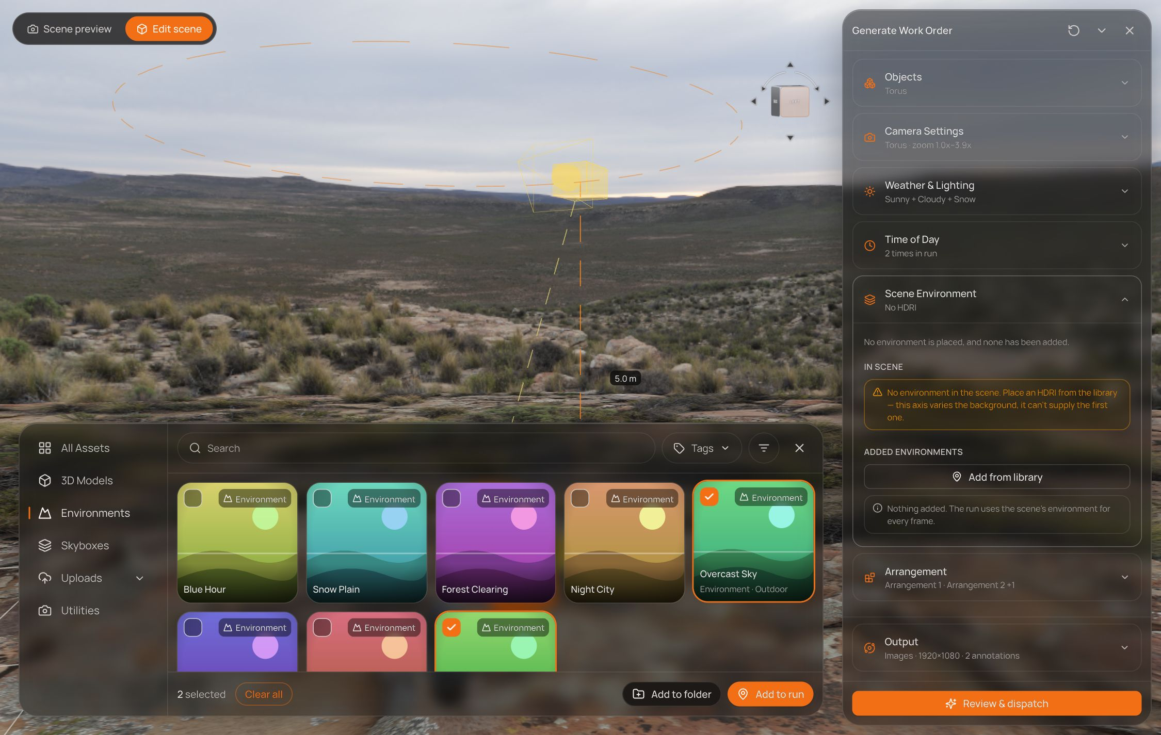
Figure 20 — Adding environments: Cloud Bank and Overcast Sky ticked.
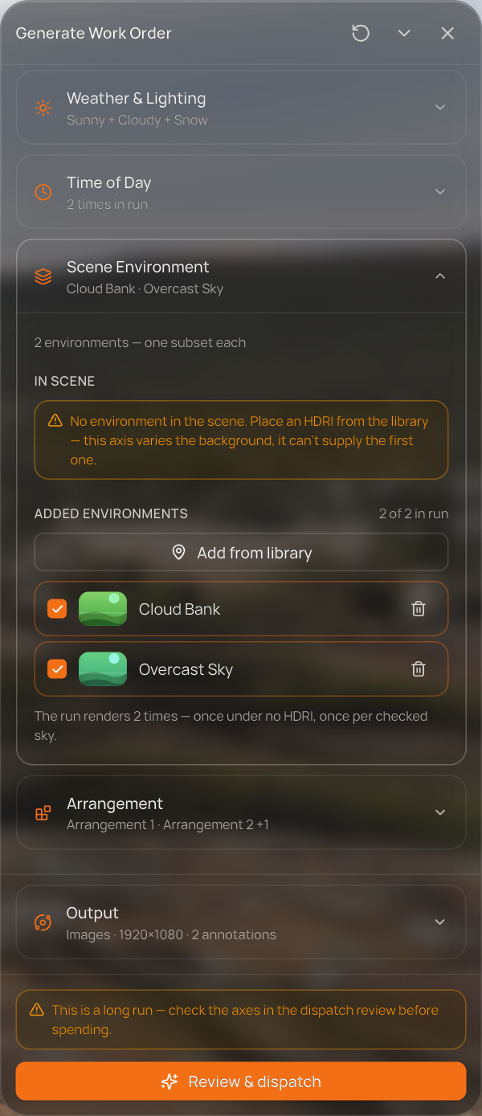  Figure 21 — Two environments added and checked. | - Each added environment has a checkbox (in the run or not) and a bin. The axis switches itself on as soon as one is checked — there is no separate switch.  How it multiplies: with an HDRI in the scene, the run renders once under it plus once per checked environment. With no HDRI in the scene (as in the demo), each checked environment is one subset — ×2 here.

8. Arrangement
Arrangement is the second axis: it rearranges the objects inside a space and renders each arrangement. Every arrangement is reproducible from its seed.
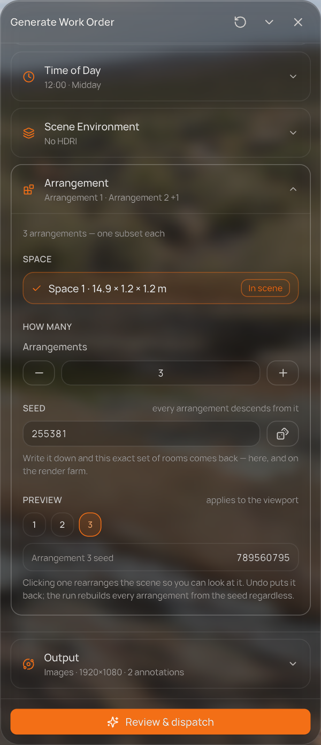  Figure 22 — Arrangement: the space, the count, the seed and the preview chips.
  Part | What it does
  Space | The space the solver arranges into. Spaces are drawn in the editor (library → Utilities → Space). Without one, the section says so and arranging is not possible.
  How many → Arrangements | A stepper from 1 to 10. At 1 the run renders the scene exactly as posed; 2 or more turns the axis on — one subset per arrangement.
  Seed | Every arrangement descends from this number (a random 6-digit seed per draft). Write it down and the exact same set of arrangements comes back. The button beside it draws a new seed.
  Preview | Chips 1 … N. Clicking one really rearranges the scene so you can look at it — Undo puts it back. The run rebuilds every arrangement from the seed regardless.

The solver moves only objects that are not the master, not locked and not hidden, and keeps a 0.2 m clearance between them. If something cannot fit, the section warns: couldn't be fitted — widen the space or lower the clearance.
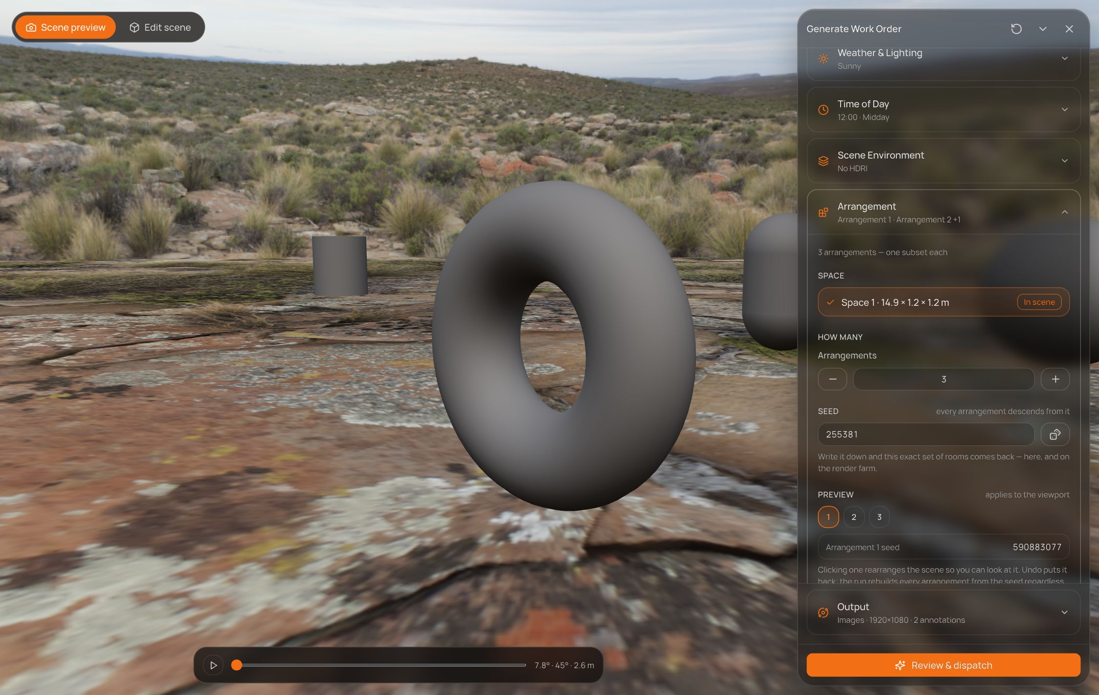
Figure 23 — Arrangement 1, seen through Scene preview.
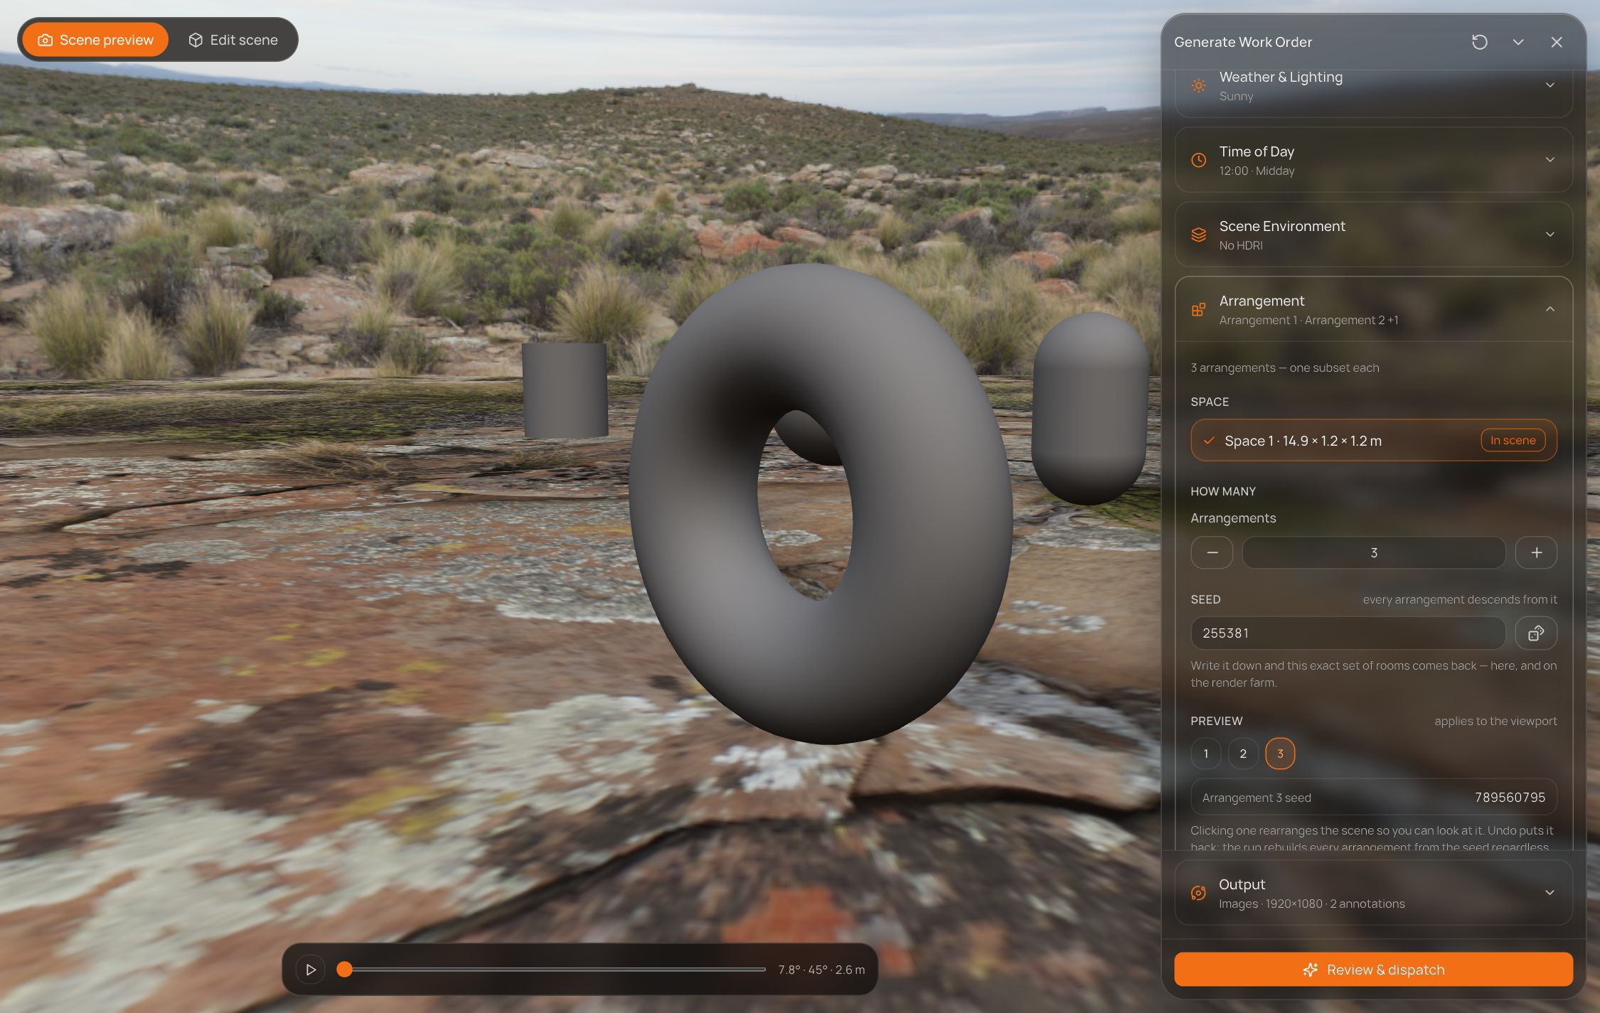
Figure 24 — Arrangement 3 from the same seed: the props behind the Torus have moved; the master has not.

9. Output
Output is pinned above the footer, so it is always one click away before you spend. It decides what comes back for every frame; it does not change the frame count.
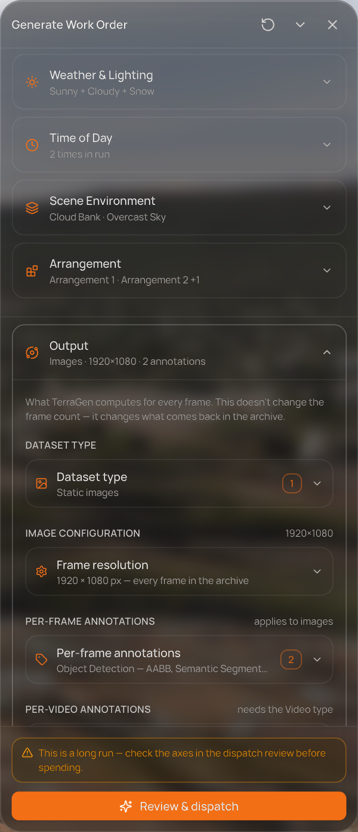  Figure 25 — Output: dataset type, frame resolution and annotations.
  Setting | Options
  Dataset type | Static images (on by default). Video is shown as coming soon.
  Frame resolution | Presets HD 1280×720, Full HD 1920×1080 (default), QHD 2560×1440, 4K UHD 3840×2160, or a custom width and height from 256 to 7680 px.
  Per-frame annotations | Object Detection — AABB (axis-aligned boxes, on by default), Semantic Segmentation (on by default), Pose Estimation, Polygonal Segmentation, Keypoint & Landmark. Object Detection — OBB (oriented boxes) is coming soon.
  Per-video annotations | Cosmos-compatible prompts — needs the Video type, coming soon.

MAT photorealism is applied to every frame after render — this is a statement of what happens, not a setting. The closed row summarises the section, e.g. Images · 1920×1080 · 2 annotations.

10. Preflight and the dispatch review

The preflight strip
Above the button, a live strip shows the most important problem with the order right now — blockers first, then warnings — with a +N pill when there are more. Review & dispatch stays disabled while anything blocks.
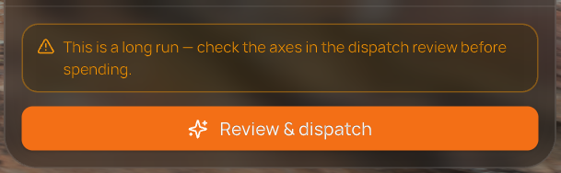
Figure 26 — A warning in the preflight strip: the demo order is over 10,000 frames.
Message | Level
Mark one object as Master — every camera orbits it. | Blocks
Place a Camera to define the sweep. | Blocks
Draw a space before sweeping arrangements — the solver needs bounds. | Blocks (only with 2+ arrangements)
Choose at least one dataset type. | Blocks
Choose at least one annotation type. | Blocks
N credits needed — you have M. | Blocks
This is a long run — check the axes in the dispatch review before spending. | Warns (over 10,000 frames)

Review & dispatch
Pressing Review & dispatch opens the bill before anything is spent.
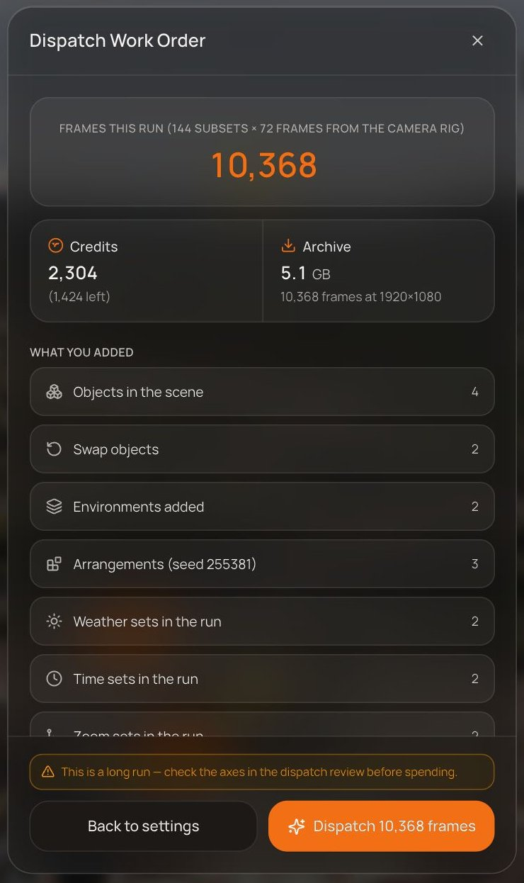
Figure 27 — The dispatch review for the demo order.
Part | What it shows
Frames this run | The headline: subsets × frames from the camera rig — 144 × 72 = 10,368 in the demo.
Credits | The cost of the run, and how many credits you will have left.
Archive | The estimated download size, and the frame count at the chosen resolution.
What you added | Only the things that apply to this order: objects, swap objects, environments, arrangements (with the seed), weather / time / zoom sets, annotation types and the frame resolution.
Why this many | Every multiplier as ×N, then the subset total. A folded list shows the first subsets by name.
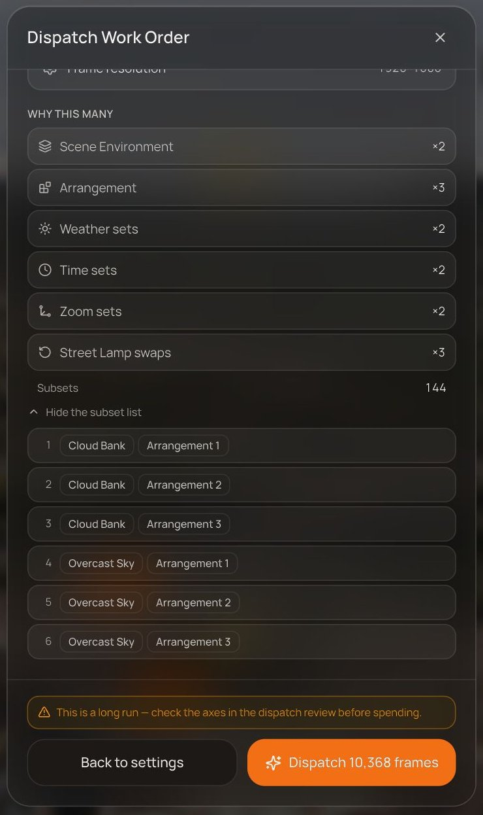
Figure 28 — Why this many: ×2 × 3 × 2 × 2 × 2 × 3 = 144 subsets, with the subset list opened.
Back to settings closes the review without spending. Dispatch N frames sends the order.

11. After dispatch
The footer confirms the order and offers Back to scene. The confirmation clears as soon as you change anything in the order.
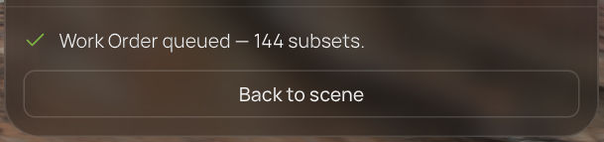
Figure 29 — The footer after dispatch.

Work Orders
Every dispatched run is listed in Work Orders — the download icon in the editor's top bar, which carries a badge while runs are in progress.
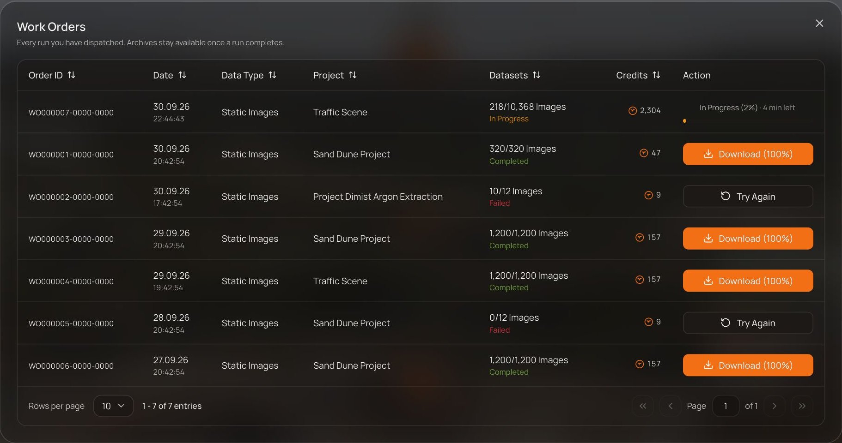
Figure 30 — Work Orders: the demo run at the top, In Progress.
Column / action | Meaning
Order ID, Date, Data Type, Project | Which order, when, what kind of data, from which project.
Datasets | Images done out of the total, and the status: In Progress, Completed, Failed or Cancelled.
Credits | What the run cost.
Action | In Progress (X%) · N min left while running, with a cancel ✕ on hover; Download (100%) when complete; Try Again for a failed or cancelled run, which restarts it from zero.

12. Reference — the arithmetic

Subsets
subsets = Scene Environment × Arrangement × weather sets × time sets × zoom sets × (for each object with checked swaps: checked swaps + 1)
- Weather, time and zoom sets only multiply once two or more are checked; one checked set is ×1.
- Swap lists on different objects multiply each other: two stand-ins on one object and one on another is 3 × 2 = ×6.
- Camera Settings, roles and Output never change the subset count.

Frames, credits and archive
Figure | How it is worked out
Frames per subset | Increments × Shots / Rotation (Rotatable), or 1 (Fixed)
Frames | subsets × frames per subset
Credits | frames × 0.125 + subsets × 7, rounded
Archive | frames × 0.5 MB, scaled by the resolution relative to 1920×1080

Worked example — the demo order
Subsets | Environment ×2 · Arrangement ×3 · Weather ×2 · Time ×2 · Zoom ×2 · Street Lamp swaps ×3 = 144
Frames | 144 × (3 increments × 24 shots) = 10,368
Credits | 10,368 × 0.125 + 144 × 7 = 1,296 + 1,008 = 2,304
Archive | 10,368 × 0.5 MB ≈ 5.1 GB at 1920×1080
These are the formulas as currently implemented in the prototype.

13. What is not wired yet
Things that are visible in the panel but do not yet do everything they suggest:
- Dispatch is simulated. Credits are not deducted from the balance, and progress in Work Orders is a timer. Download (100%) does nothing yet, and the list starts with sample history rows.
- Weather, time of day, environments and swaps are not previewed. They are part of the order, but neither stage draws them.
- Roles. Only the master can be set from this panel; there is no control here for Background or Distractor.
- Coming soon: the Video dataset type, Object Detection — OBB, and Cosmos-compatible per-video prompts.
- The subset list in the review names only Scene Environment × Arrangement combinations, not weather, time, zoom or swaps — the total is right, the list is partial.
- Two copy slips. With no HDRI in the scene, Scene Environment reads "once under no HDRI, once per checked sky", but the run renders only once per checked sky. Scene preview's empty state still says to pick a master "in the Camera section"; the master is now set in Objects.

