TERRA WEB · PRD
Getting-Started Guide
An in-editor walkthrough from an empty project to a dispatched Work Order
Feature | Editor guide (“Getting started”) + empty first-open scene
Status | Implemented in the prototype on branch feat/editor-terragen-camera-mat — not yet committed
Surface | Terra Web editor (#editor, #editor/<project>)
Code | src/features/editor/editor-guide.ts (steps & tips, as data) · EditorGuide.tsx (panel, bubble, engine) · EditorTopBar.tsx (info button)
Date | 6 October 2026

Every screenshot in this document was captured from the running editor at 1500 × 950. The bubble text quoted under each screenshot is read from the shipped guide definition, so it matches the product word for word.

1. Summary
A new Terra project now opens empty — no HDRI, no objects, no camera — and a small glass Getting started panel appears in the bottom-left corner. The panel lists six steps; the current one is explained by a coach mark: an orange ring on the control to use and a bubble beside it saying what it does. The guide watches what the user actually does and moves on by itself, so following it is the same as building a first scene: a world, a master object, a camera, then a tour of the Layers panel, the AI tools and the Work Order.
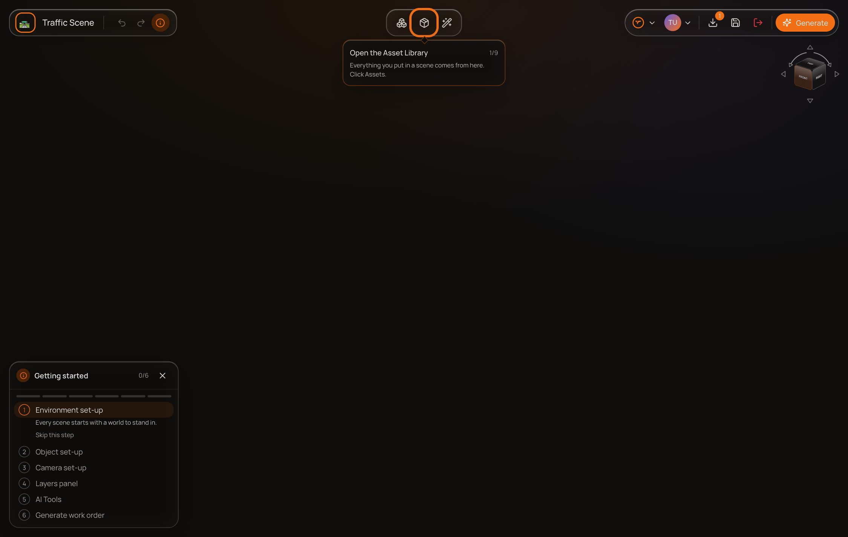
First open: an empty stage, the guide panel bottom-left, and the first coach mark on the Assets button.

2. Problem
- New projects used to open on a sample desert scene with an object and a camera already placed. Users started by deleting things they had not chosen, and never learned where those things come from.
- The editor has many controls that only appear in context — the bottom-centre toolbar, the focus title, the Master crown — so a first-time user can't discover them by looking around.
- A Work Order cannot be generated without a master object and a camera, but nothing told the user that, or why.
- Concepts that decide dataset cost and quality (master, increments × shots, Sky Influence vs Brightness) were undocumented in the UI.

3. Goals and non-goals

Goals
- Take a first-time user from an empty project to an open Work Order without outside help.
- Teach by doing: each placing step ends with a real object in the user's scene, not a demo.
- Explain every bottom-centre control for Environment, Object and Camera, plus rename, delete and Back.
- Make the master object's purpose explicit, and have the user set one.
- Stay out of the way: one small panel and one bubble at a time; closable at any moment from the top bar.

Non-goals (this release)
- Remembering progress across sessions or projects (see §10).
- Per-setting explanations inside the setting panels — covered by the separate Setting Info Panels PRD.
- Tours of the Material Preview, Scene Agent or 3D Generate tools themselves.

4. Users and stories
As a… | I want to… | So that…
First-time user | be shown where to start in an empty project | I don't stare at a blank stage
First-time user | have the guide notice when I've done a step | I'm not clicking Next on things I just did
Returning user | close the guide in one click and reopen it from the top bar | it never blocks my work
Any user | jump to any step or skip one | I can learn just the part I need
Dataset author | understand why a master object is required | I set it up correctly before generating

5. Experience overview

5.1 Empty first open
Opening the sample project (#editor) or a new one (#editor/<name>) starts with no objects, no camera rig and no sky. With no sky placed the viewport shows a plain dark stage, and objects are lit by a neutral studio light so anything placed is still visible.

5.2 The info button
An info (ⓘ) button sits in the top-left bar, directly after Undo and Redo. It toggles the guide. While the guide is open the button is tinted orange and pressed (aria-pressed); its tooltip reads Hide the guide / Show the guide.
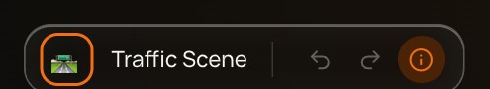  Guide open — info button lit. | 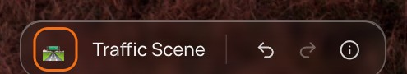  Guide closed — info button plain.

5.3 The guide panel
A 300 px glass panel floating bottom-left, styled like the editor's other floating panels with a darker ground (bg-canvas/90) so it stays readable over any sky. It moves up to sit above the Asset Library while that is open, because the library docks into the same corner.
- Header — info glyph, Getting started, a done/total count (e.g. 3/6) and a close button.
- Progress bar — one segment per step, filled orange when the step is complete.
- Step list — six numbered rows; completed rows show a tick. Any row can be clicked to jump to that step.
- Current step — expanded with a one-line blurb, an optional status box (shown when the bubble can't be, with a shortcut button such as Select it), and Skip this step.
- Finished — every row ticked, You're all set — the guide is here whenever you need it, and a Restart button.
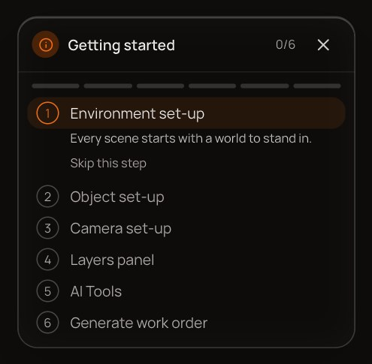  Start: step 1 expanded, 0/6. | 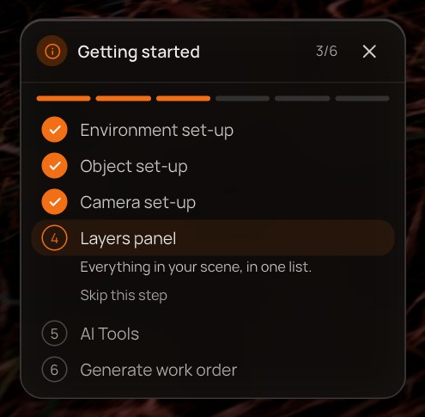  Mid-way: three steps ticked, Layers panel current.

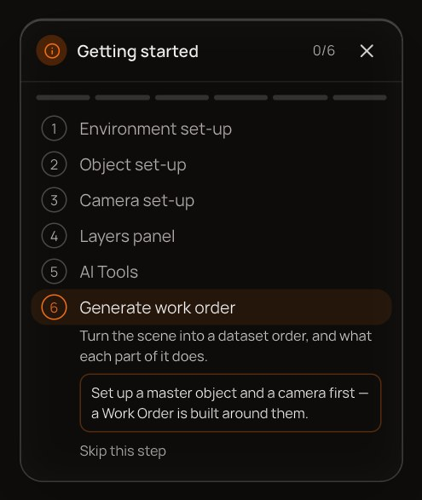  A blocked step explains what it needs. | 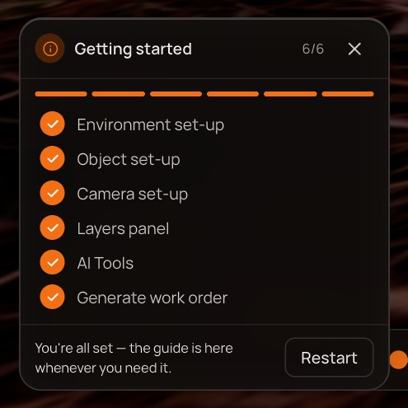  Finished, with Restart.

5.4 The coach mark
For the current tip, the guide draws a pulsing orange ring around the target control and a glass bubble beside it: the tip title, a n/N counter for the step, the explanation, and — only for tips that explain rather than ask for an action — a Next (or Done / Finish) button. The ring doesn't take clicks, so the control underneath stays usable. The bubble prefers the side named in the tip and flips to the opposite side when there isn't room.
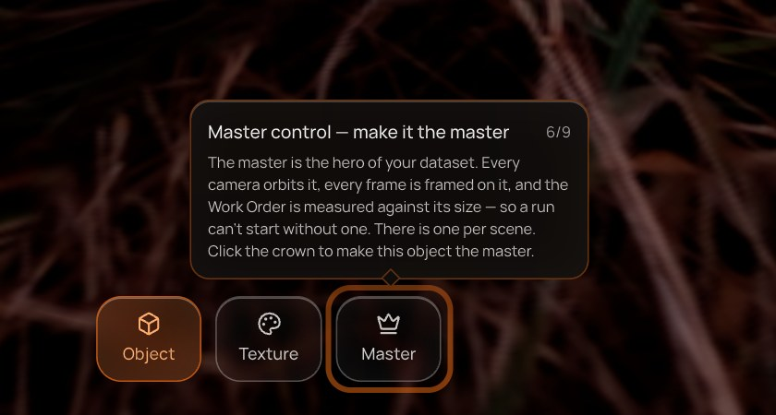
A coach mark: ring on the Master tile, bubble above it, no Next — this tip waits for the crown click.

5.5 How a tip completes
Kind | Completes when | Example
Action tip | The guide sees the result in the scene or the UI (checked four times a second). No button. | Open the Asset Library · Place your world · Master control
Explain tip | The user presses Next / Done / Finish. | Environment control · SAB · Output
Back tip | The user clicks Back in the focus title while the tip is showing. | Last tip of Environment, Object and Camera set-up
Action tips that are already true when reached pass straight through — for example, if a sky is already placed, the first four Environment tips are skipped.

6. The six steps, tip by tip
# | Step | Tips | Ends when
1 | Environment set-up | 9 | Back from the sky's focus view
2 | Object set-up | 9 | Back from the object's focus view
3 | Camera set-up | 7 | Back from the camera's focus view
4 | Layers panel | 2 | Done
5 | AI Tools | 4 | Done
6 | Generate work order | 10 | Finish

Step 1 — Environment set-up
Every scene starts with a world to stand in.
The user starts with an empty, dark stage. This step gets a world into it — an HDRI (which lights the scene) or a skybox (backdrop only) — and then walks the sky's focus view: both bottom-bar tiles, rename, delete, and Back.

1.1 Open the Asset Library
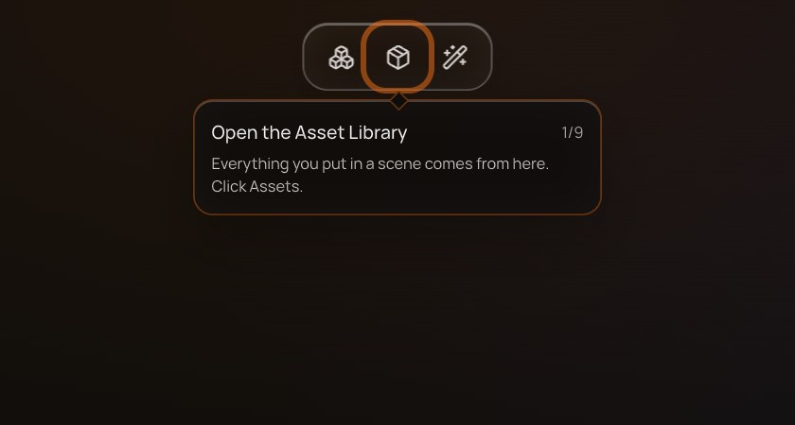
Step 1, tip 1 of 9 — Open the Asset Library
Points at | Assets button, top toolbar
Bubble copy | “Everything you put in a scene comes from here. Click Assets.”
Advances when | The Asset Library opens — or a sky is already in the scene.

1.2 Environments — HDRI maps
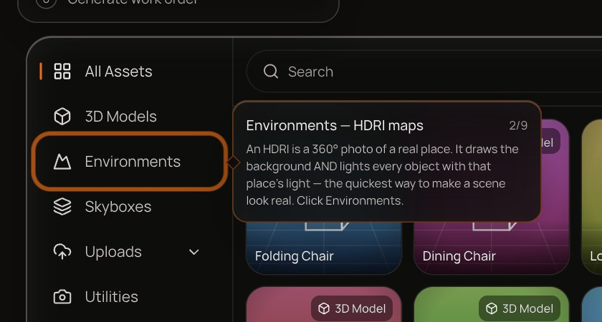
Step 1, tip 2 of 9 — Environments — HDRI maps
Points at | Environments category in the library
Bubble copy | “An HDRI is a 360° photo of a real place. It draws the background AND lights every object with that place's light — the quickest way to make a scene look real. Click Environments.”
Advances when | The Environments category becomes active — or a sky is already placed.
Control not on screen | Panel shows: “Open Assets again to continue.”

1.3 Skyboxes
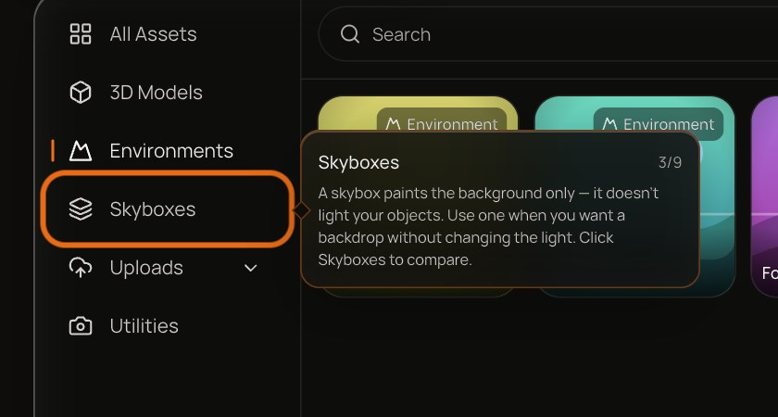
Step 1, tip 3 of 9 — Skyboxes
Points at | Skyboxes category in the library
Bubble copy | “A skybox paints the background only — it doesn't light your objects. Use one when you want a backdrop without changing the light. Click Skyboxes to compare.”
Advances when | The Skyboxes category becomes active — or a sky is already placed.
Control not on screen | Panel shows: “Open Assets again to continue.”

1.4 Place your world
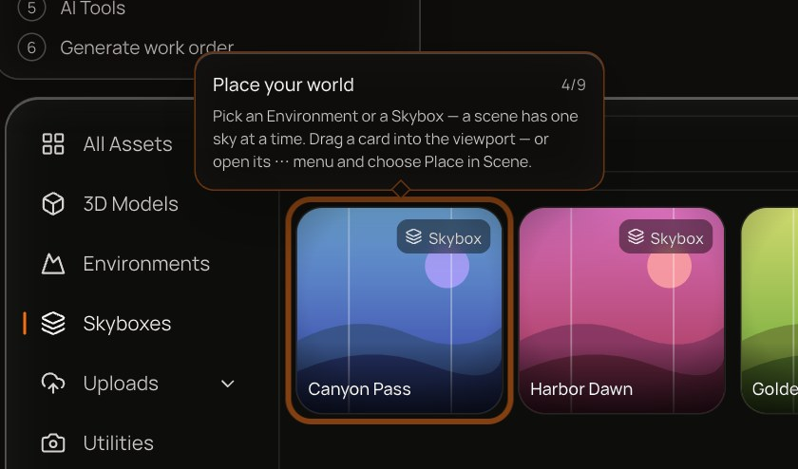
Step 1, tip 4 of 9 — Place your world
Points at | First visible Environment or Skybox card
Bubble copy | “Pick an Environment or a Skybox — a scene has one sky at a time. Drag a card into the viewport — or open its ⋯ menu and choose Place in Scene.”
Advances when | A sky (Environment or Skybox) exists in the scene.
Control not on screen | Panel shows: “Open Assets and pick an Environment or a Skybox.”

Placing does not select anything, so before the first focus-view tip the bubble has nothing to point at. The panel says so in its status box and offers Select it, which selects the sky for the user:
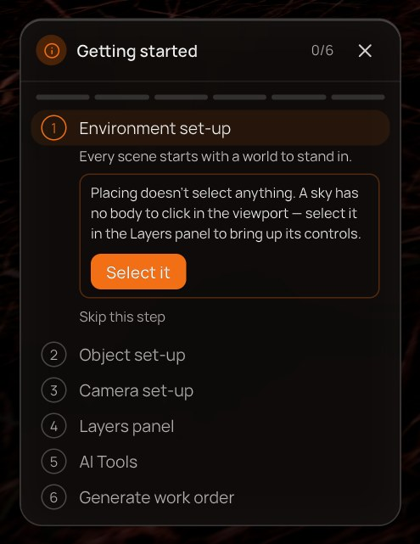
The status box after placing a sky: why there is no bubble, and the Select it shortcut.

1.5 Environment control
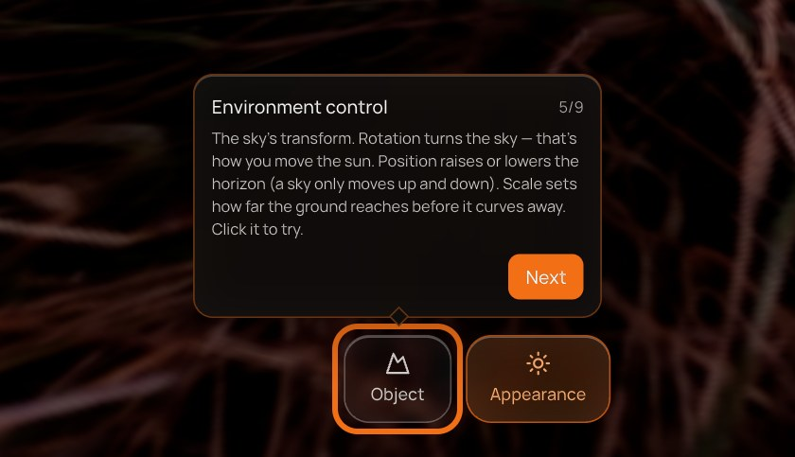
Step 1, tip 5 of 9 — Environment control
Points at | Object tile, bottom-centre toolbar
Bubble copy | “The sky's transform. Rotation turns the sky — that's how you move the sun. Position raises or lowers the horizon (a sky only moves up and down). Scale sets how far the ground reaches before it curves away. Click it to try.”
Advances when | The user presses Next in the bubble.
Control not on screen | Panel shows: “Placing doesn't select anything. A sky has no body to click in the viewport — select it in the Layers panel to bring up its controls.” — with a Select it button.

1.6 Appearance control
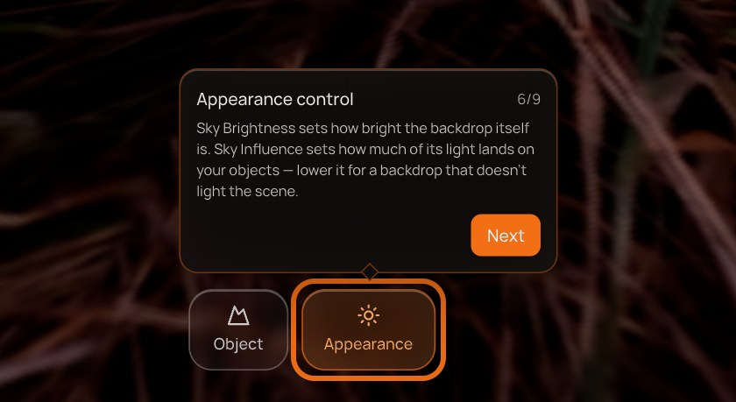
Step 1, tip 6 of 9 — Appearance control
Points at | Appearance tile, bottom-centre toolbar
Bubble copy | “Sky Brightness sets how bright the backdrop itself is. Sky Influence sets how much of its light lands on your objects — lower it for a backdrop that doesn't light the scene.”
Advances when | The user presses Next in the bubble.
Control not on screen | Panel shows: “Placing doesn't select anything. A sky has no body to click in the viewport — select it in the Layers panel to bring up its controls.” — with a Select it button.

1.7 Rename
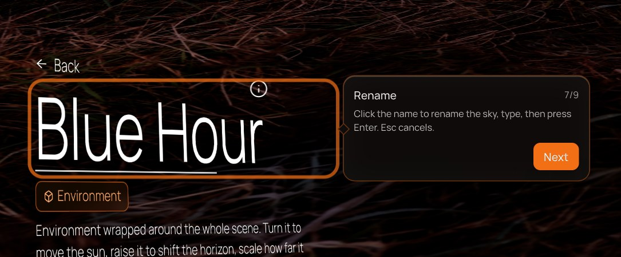
Step 1, tip 7 of 9 — Rename
Points at | The sky's name in the focus title
Bubble copy | “Click the name to rename the sky, type, then press Enter. Esc cancels.”
Advances when | The user presses Next in the bubble.
Control not on screen | Panel shows: “Placing doesn't select anything. A sky has no body to click in the viewport — select it in the Layers panel to bring up its controls.” — with a Select it button.

1.8 Delete
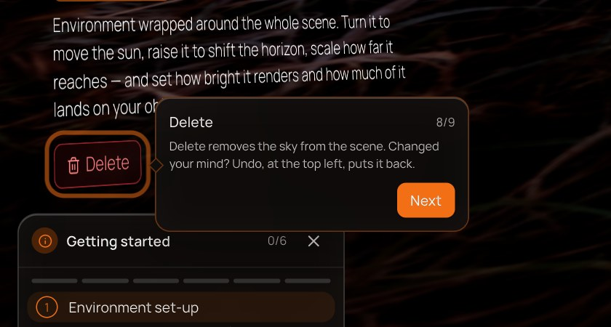
Step 1, tip 8 of 9 — Delete
Points at | Delete badge under the focus title
Bubble copy | “Delete removes the sky from the scene. Changed your mind? Undo, at the top left, puts it back.”
Advances when | The user presses Next in the bubble.
Control not on screen | Panel shows: “Placing doesn't select anything. A sky has no body to click in the viewport — select it in the Layers panel to bring up its controls.” — with a Select it button.

1.9 Back — finish this step
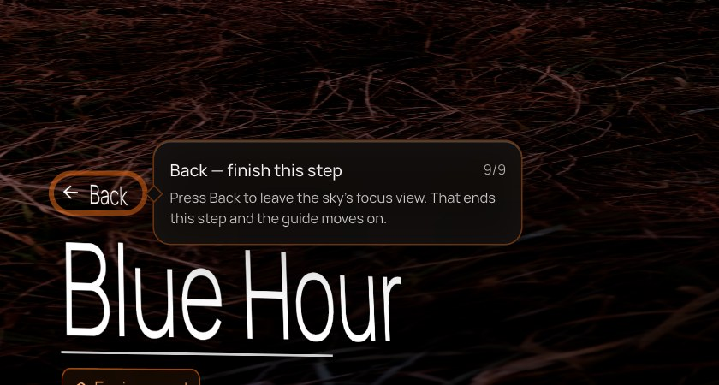
Step 1, tip 9 of 9 — Back — finish this step
Points at | Back link above the focus title
Bubble copy | “Press Back to leave the sky's focus view. That ends this step and the guide moves on.”
Advances when | The user clicks Back in the focus title while this tip is showing. Deselecting any other way does not count.
Control not on screen | Panel shows: “Placing doesn't select anything. A sky has no body to click in the viewport — select it in the Layers panel to bring up its controls.” — with a Select it button.

Step 2 — Object set-up
Add the object your dataset is about, and make it the master.
Adds the subject of the dataset and makes it the master — the object every camera orbits and the Work Order is measured against. The master tip is the only focus-view tip that waits for an action rather than Next.

2.1 Open the Asset Library
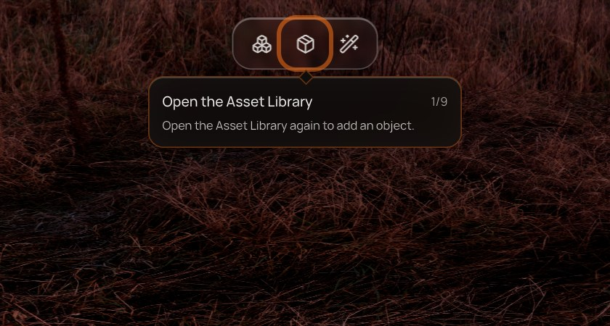
Step 2, tip 1 of 9 — Open the Asset Library
Points at | Assets button, top toolbar
Bubble copy | “Open the Asset Library again to add an object.”
Advances when | The Asset Library opens — or a 3D object is already in the scene.

2.2 All Assets
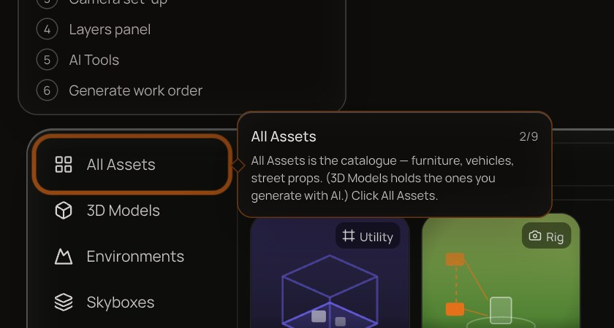
Step 2, tip 2 of 9 — All Assets
Points at | All Assets category
Bubble copy | “All Assets is the catalogue — furniture, vehicles, street props. (3D Models holds the ones you generate with AI.) Click All Assets.”
Advances when | All Assets becomes active — or an object is already placed. (Usually passes straight through, because the library reopens on All Assets.)
Control not on screen | Panel shows: “Open Assets again to continue.”

2.3 Place an object
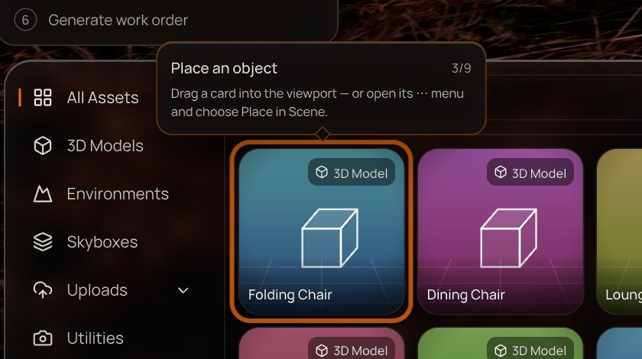
Step 2, tip 3 of 9 — Place an object
Points at | First visible 3D Model card
Bubble copy | “Drag a card into the viewport — or open its ⋯ menu and choose Place in Scene.”
Advances when | A 3D object (not a sky, camera or group) exists in the scene.
Control not on screen | Panel shows: “Open Assets and place a 3D model.”

The same hand-off appears for the object — click it in the viewport, or press Select it:
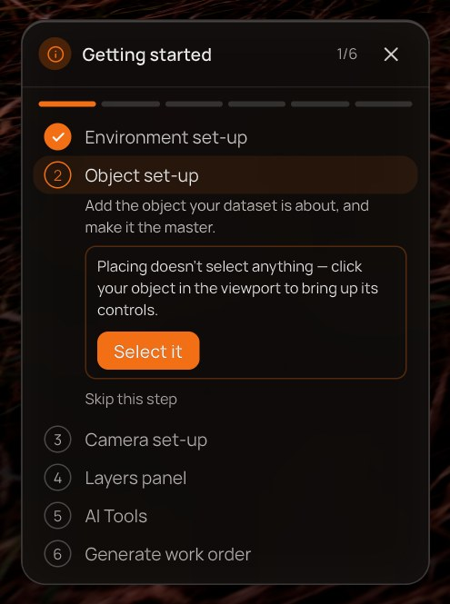
The Object set-up status box with Select it.

2.4 Object control
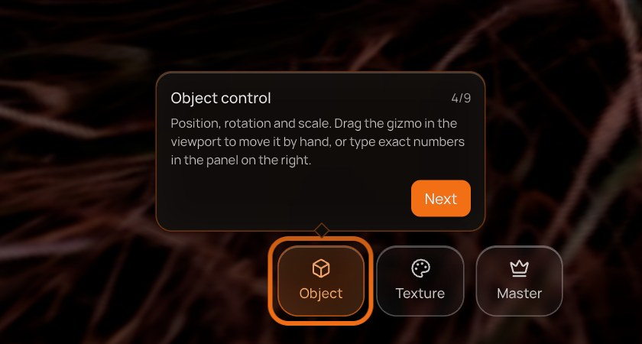
Step 2, tip 4 of 9 — Object control
Points at | Object tile
Bubble copy | “Position, rotation and scale. Drag the gizmo in the viewport to move it by hand, or type exact numbers in the panel on the right.”
Advances when | The user presses Next in the bubble.
Control not on screen | Panel shows: “Placing doesn't select anything — click your object in the viewport to bring up its controls.” — with a Select it button.

2.5 Texture control
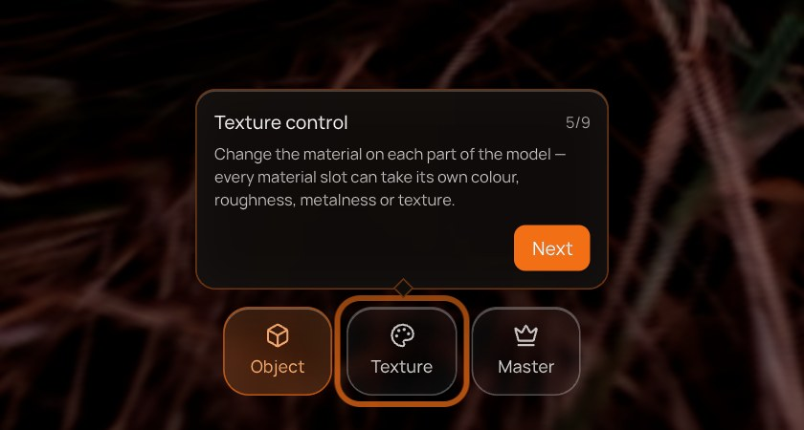
Step 2, tip 5 of 9 — Texture control
Points at | Texture tile
Bubble copy | “Change the material on each part of the model — every material slot can take its own colour, roughness, metalness or texture.”
Advances when | The user presses Next in the bubble.
Control not on screen | Panel shows: “Placing doesn't select anything — click your object in the viewport to bring up its controls.” — with a Select it button.

2.6 Master control — make it the master
Step 2, tip 6 of 9 — Master control — make it the master
Points at | Master (crown) tile
Bubble copy | “The master is the hero of your dataset. Every camera orbits it, every frame is framed on it, and the Work Order is measured against its size — so a run can't start without one. There is one per scene. Click the crown to make this object the master.”
Advances when | The scene has a master object — the user clicks the crown. There is no Next button on this tip.
Control not on screen | Panel shows: “Placing doesn't select anything — click your object in the viewport to bring up its controls.” — with a Select it button.

2.7 Rename
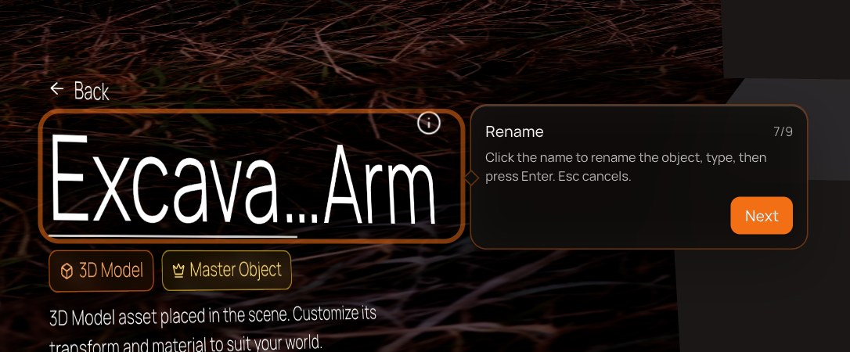
Step 2, tip 7 of 9 — Rename
Points at | The object's name in the focus title
Bubble copy | “Click the name to rename the object, type, then press Enter. Esc cancels.”
Advances when | The user presses Next in the bubble.
Control not on screen | Panel shows: “Placing doesn't select anything — click your object in the viewport to bring up its controls.” — with a Select it button.

2.8 Delete
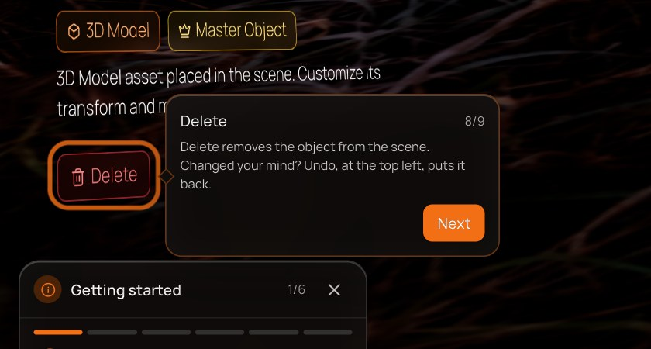
Step 2, tip 8 of 9 — Delete
Points at | Delete badge
Bubble copy | “Delete removes the object from the scene. Changed your mind? Undo, at the top left, puts it back.”
Advances when | The user presses Next in the bubble.
Control not on screen | Panel shows: “Placing doesn't select anything — click your object in the viewport to bring up its controls.” — with a Select it button.

2.9 Back — finish this step
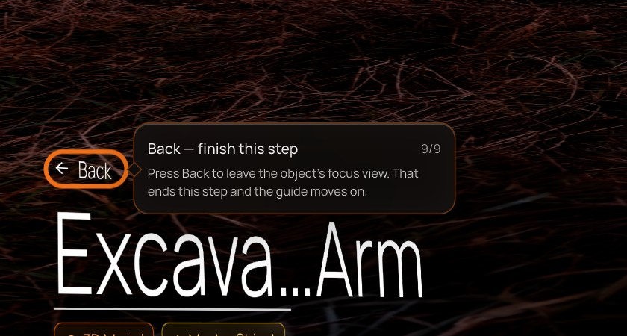
Step 2, tip 9 of 9 — Back — finish this step
Points at | Back link
Bubble copy | “Press Back to leave the object's focus view. That ends this step and the guide moves on.”
Advances when | The user clicks Back in the focus title while this tip is showing. Deselecting any other way does not count.
Control not on screen | Panel shows: “Placing doesn't select anything — click your object in the viewport to bring up its controls.” — with a Select it button.

Step 3 — Camera set-up
Place the capture rig that shoots your master.
Places the capture rig, explains its two bottom-bar tiles (Object and Capture) and the expand button on its POV panel, which opens the full-size camera view. The step ends on Back, like the two before it.

3.1 Open the Asset Library
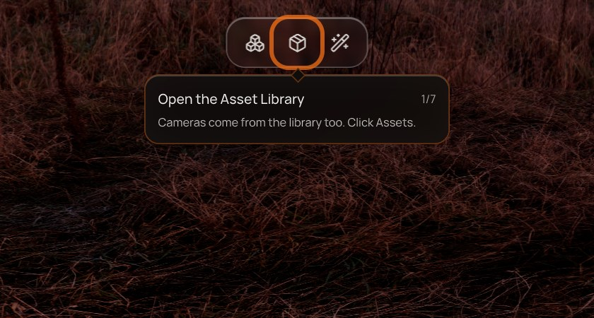
Step 3, tip 1 of 7 — Open the Asset Library
Points at | Assets button, top toolbar
Bubble copy | “Cameras come from the library too. Click Assets.”
Advances when | The Asset Library opens — or a camera rig already exists.

3.2 Utilities
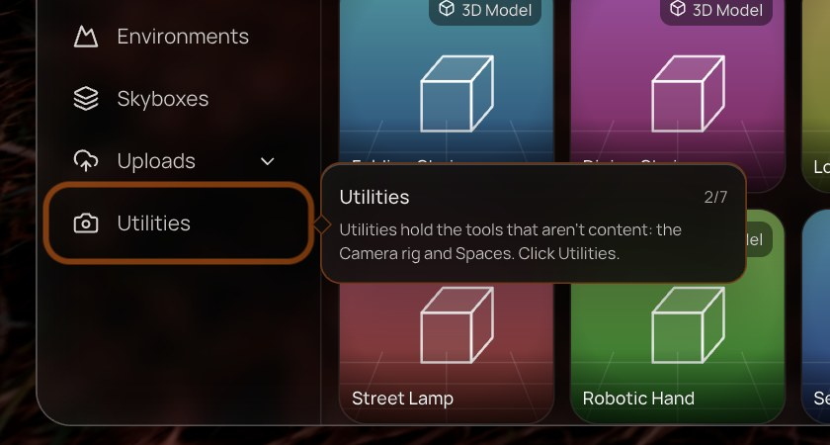
Step 3, tip 2 of 7 — Utilities
Points at | Utilities category
Bubble copy | “Utilities hold the tools that aren't content: the Camera rig and Spaces. Click Utilities.”
Advances when | Utilities becomes active — or a rig already exists.
Control not on screen | Panel shows: “Open Assets again to continue.”

3.3 Place the camera
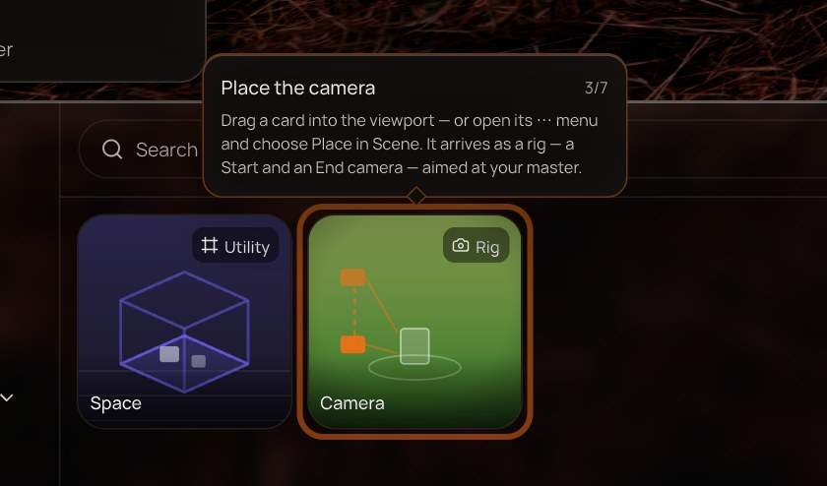
Step 3, tip 3 of 7 — Place the camera
Points at | The Camera card
Bubble copy | “Drag a card into the viewport — or open its ⋯ menu and choose Place in Scene. It arrives as a rig — a Start and an End camera — aimed at your master.”
Advances when | A camera rig exists in the scene.
Control not on screen | Panel shows: “Open Assets → Utilities and place the Camera.”

When a master exists, dropping a camera asks where the rig should begin. Yes, focus frames the rig on the master and selects it, so the next tip appears straight away:
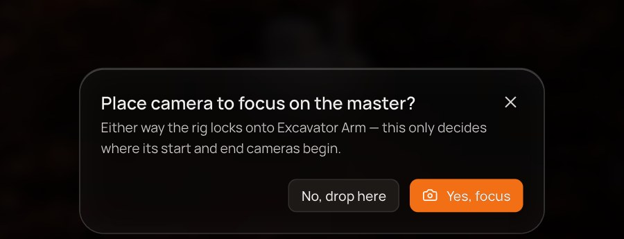
The camera placement dialog shown when a master is already set.

3.4 Object control
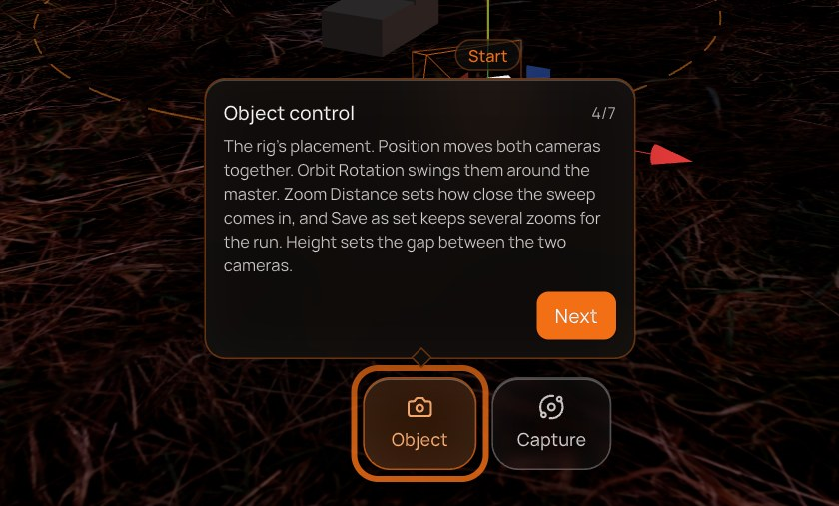
Step 3, tip 4 of 7 — Object control
Points at | Object tile (camera)
Bubble copy | “The rig's placement. Position moves both cameras together. Orbit Rotation swings them around the master. Zoom Distance sets how close the sweep comes in, and Save as set keeps several zooms for the run. Height sets the gap between the two cameras.”
Advances when | The user presses Next in the bubble.
Control not on screen | Panel shows: “Click one of the cameras in the viewport (or in Layers) to bring up its controls. If the camera view is open, close it with Esc first.” — with a Select it button.

3.5 Capture control
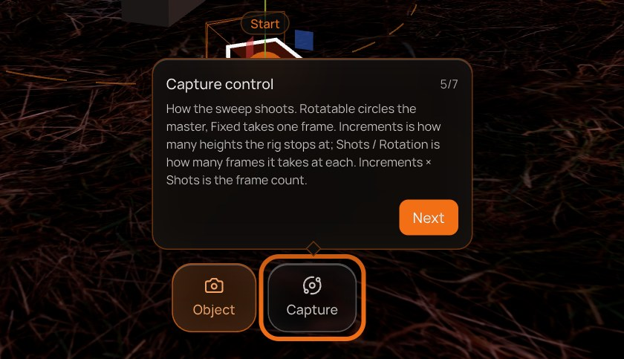
Step 3, tip 5 of 7 — Capture control
Points at | Capture tile
Bubble copy | “How the sweep shoots. Rotatable circles the master, Fixed takes one frame. Increments is how many heights the rig stops at; Shots / Rotation is how many frames it takes at each. Increments × Shots is the frame count.”
Advances when | The user presses Next in the bubble.
Control not on screen | Panel shows: “Click one of the cameras in the viewport (or in Layers) to bring up its controls. If the camera view is open, close it with Esc first.” — with a Select it button.

3.6 Camera view
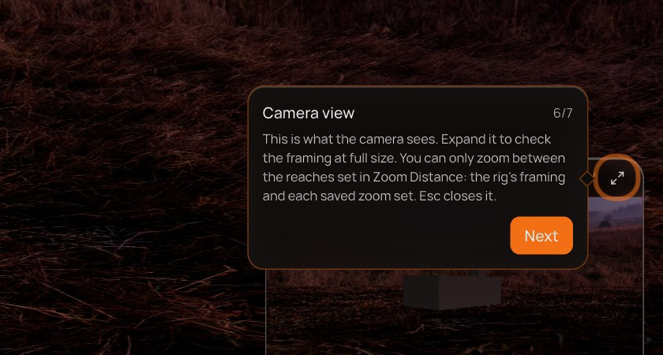
Step 3, tip 6 of 7 — Camera view
Points at | Expand button on the camera's POV panel (bottom right)
Bubble copy | “This is what the camera sees. Expand it to check the framing at full size. You can only zoom between the reaches set in Zoom Distance: the rig's framing and each saved zoom set. Esc closes it.”
Advances when | The user presses Next in the bubble.
Control not on screen | Panel shows: “Click one of the cameras in the viewport (or in Layers) to bring up its controls. If the camera view is open, close it with Esc first.” — with a Select it button.

3.7 Back — finish this step
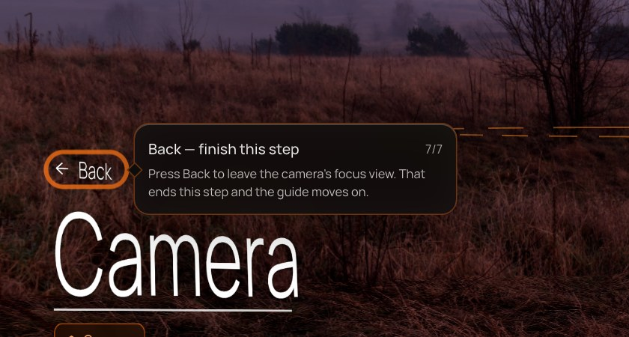
Step 3, tip 7 of 7 — Back — finish this step
Points at | Back link
Bubble copy | “Press Back to leave the camera's focus view. That ends this step and the guide moves on.”
Advances when | The user clicks Back in the focus title while this tip is showing. Deselecting any other way does not count.
Control not on screen | Panel shows: “Click one of the cameras in the viewport (or in Layers) to bring up its controls. If the camera view is open, close it with Esc first.” — with a Select it button.

Step 4 — Layers panel
Everything in your scene, in one list.
A two-tip tour of the Layers panel: open it, then what a row and its hover tools do.

4.1 Open Layers
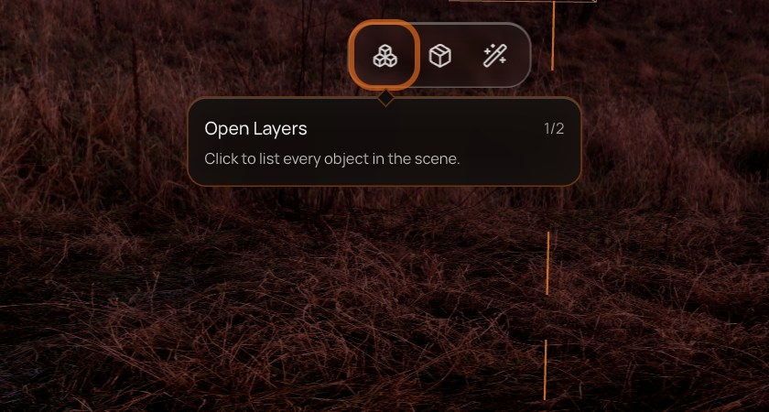
Step 4, tip 1 of 2 — Open Layers
Points at | Layers button, top toolbar
Bubble copy | “Click to list every object in the scene.”
Advances when | The Layers panel is open.

4.2 Manage your scene
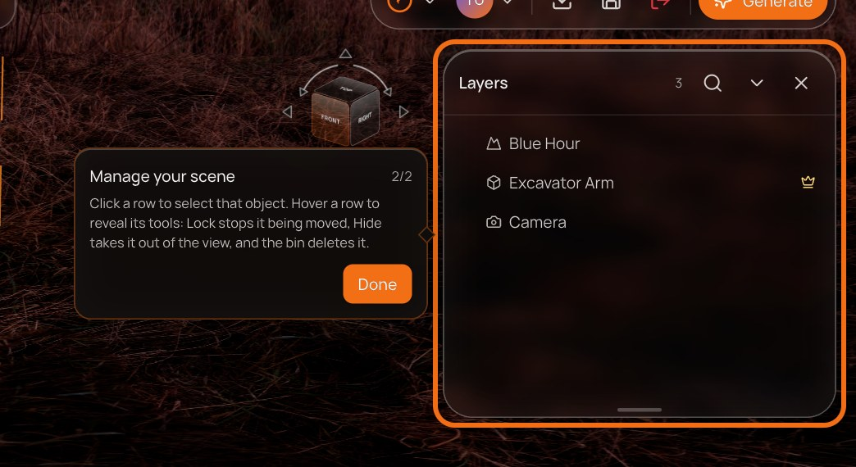
Step 4, tip 2 of 2 — Manage your scene
Points at | The Layers panel
Bubble copy | “Click a row to select that object. Hover a row to reveal its tools: Lock stops it being moved, Hide takes it out of the view, and the bin deletes it.”
Advances when | The user presses Done.
Control not on screen | Panel shows: “Open Layers from the toolbar to continue.”

Step 5 — AI Tools
Three assistants for building and finishing a scene.
Introduces Terra's three AI tools from the AI Tools menu. Explanatory only — nothing is generated.

5.1 AI Tools
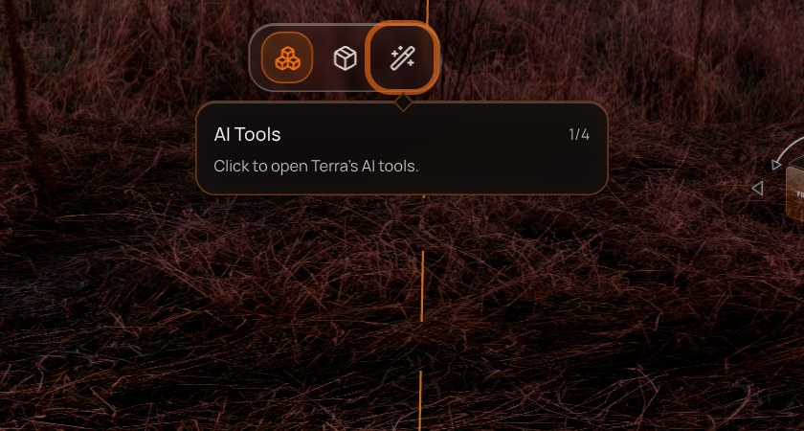
Step 5, tip 1 of 4 — AI Tools
Points at | AI Tools button, top toolbar
Bubble copy | “Click to open Terra's AI tools.”
Advances when | The AI Tools menu is open.

5.2 SAB — the scene agent
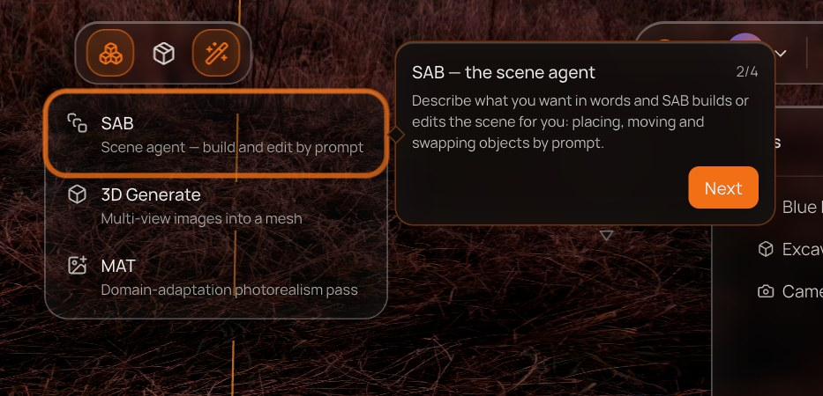
Step 5, tip 2 of 4 — SAB — the scene agent
Points at | SAB row in the AI Tools menu
Bubble copy | “Describe what you want in words and SAB builds or edits the scene for you: placing, moving and swapping objects by prompt.”
Advances when | The user presses Next in the bubble.
Control not on screen | Panel shows: “Open AI Tools from the toolbar to continue.”

5.3 3D Generate
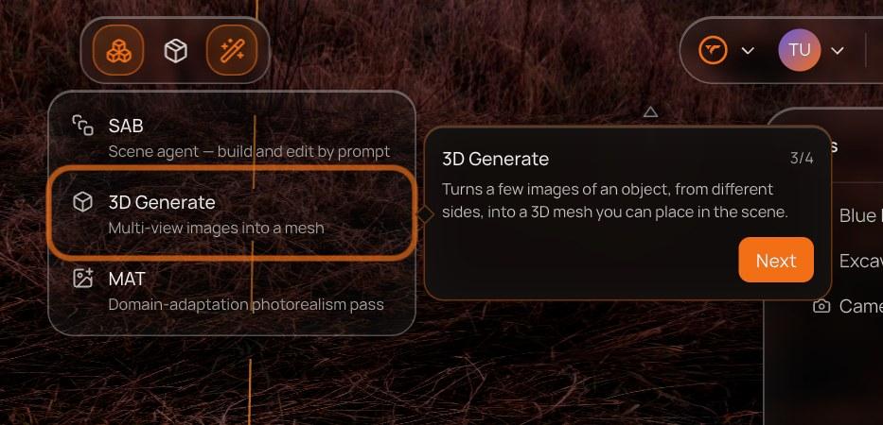
Step 5, tip 3 of 4 — 3D Generate
Points at | 3D Generate row
Bubble copy | “Turns a few images of an object, from different sides, into a 3D mesh you can place in the scene.”
Advances when | The user presses Next in the bubble.
Control not on screen | Panel shows: “Open AI Tools from the toolbar to continue.”

5.4 MAT
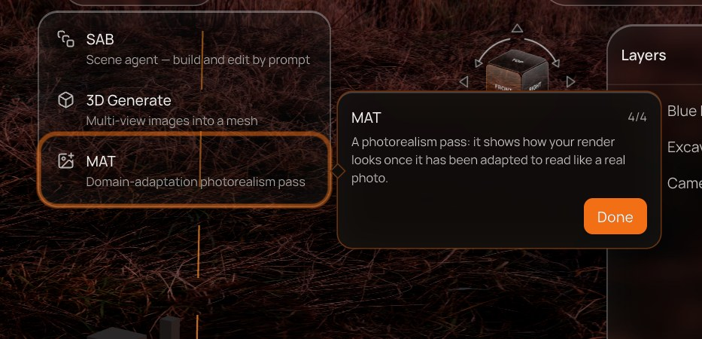
Step 5, tip 4 of 4 — MAT
Points at | MAT row
Bubble copy | “A photorealism pass: it shows how your render looks once it has been adapted to read like a real photo.”
Advances when | The user presses Done.
Control not on screen | Panel shows: “Open AI Tools from the toolbar to continue.”

Step 6 — Generate work order
Turn the scene into a dataset order, and what each part of it does.
Opens the Work Order (TerraGen) panel and tours each section, ending on Review & dispatch. This step is blocked until the scene has both a master object and a camera; until then the panel explains why instead of showing a bubble.
Blocked until | The scene has a master object and a camera rig.
Panel says | “Set up a master object and a camera first — a Work Order is built around them.”

6.1 Generate a Work Order
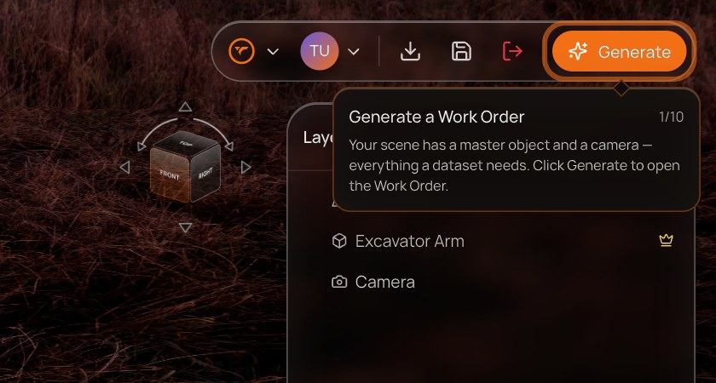
Step 6, tip 1 of 10 — Generate a Work Order
Points at | Generate button, top right
Bubble copy | “Your scene has a master object and a camera — everything a dataset needs. Click Generate to open the Work Order.”
Advances when | The Work Order panel is open.

6.2 Scene preview & Edit scene
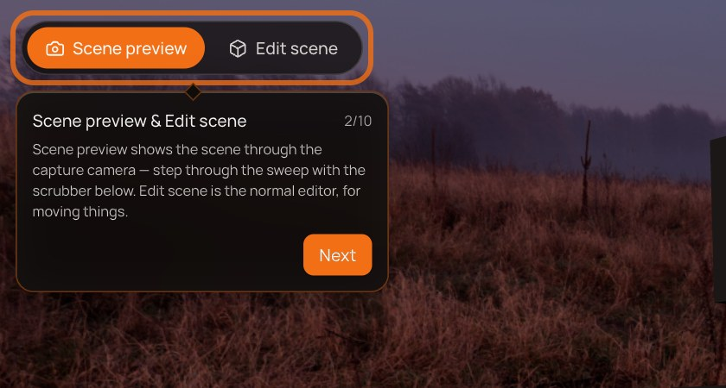
Step 6, tip 2 of 10 — Scene preview & Edit scene
Points at | Scene preview / Edit scene tabs
Bubble copy | “Scene preview shows the scene through the capture camera — step through the sweep with the scrubber below. Edit scene is the normal editor, for moving things.”
Advances when | The user presses Next in the bubble.
Control not on screen | Panel shows: “Click Generate to open the Work Order.”

6.3 Objects
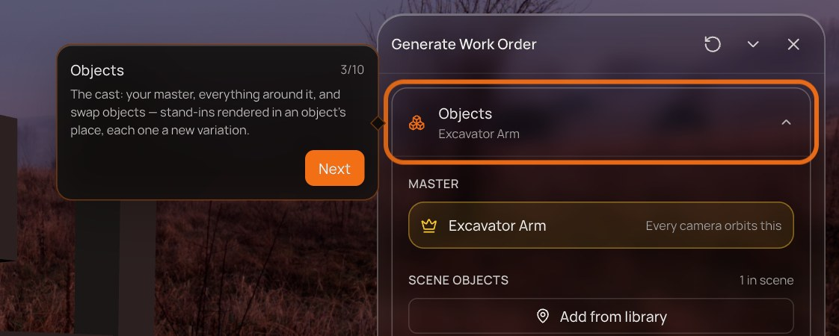
Step 6, tip 3 of 10 — Objects
Points at | Objects section
Bubble copy | “The cast: your master, everything around it, and swap objects — stand-ins rendered in an object's place, each one a new variation.”
Advances when | The user presses Next in the bubble.
Control not on screen | Panel shows: “Click Generate to open the Work Order.”

6.4 Camera Settings
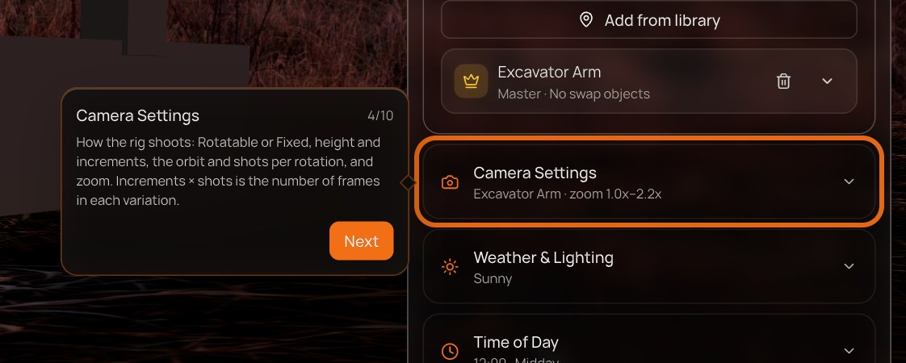
Step 6, tip 4 of 10 — Camera Settings
Points at | Camera Settings section
Bubble copy | “How the rig shoots: Rotatable or Fixed, height and increments, the orbit and shots per rotation, and zoom. Increments × shots is the number of frames in each variation.”
Advances when | The user presses Next in the bubble.
Control not on screen | Panel shows: “Click Generate to open the Work Order.”

6.5 Weather & Lighting
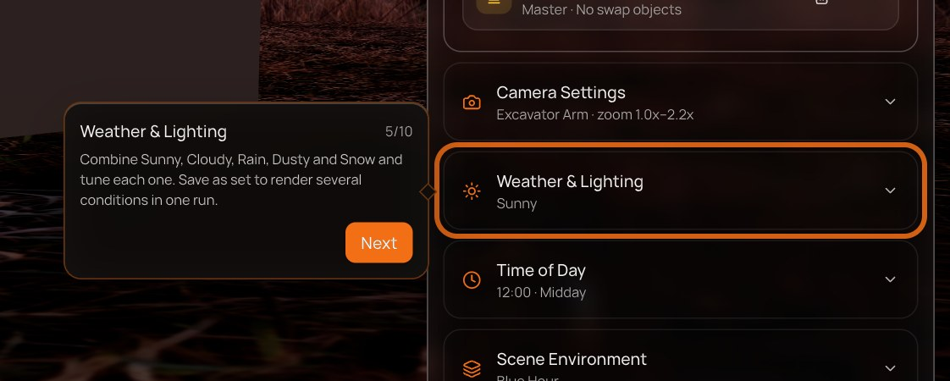
Step 6, tip 5 of 10 — Weather & Lighting
Points at | Weather & Lighting section
Bubble copy | “Combine Sunny, Cloudy, Rain, Dusty and Snow and tune each one. Save as set to render several conditions in one run.”
Advances when | The user presses Next in the bubble.
Control not on screen | Panel shows: “Click Generate to open the Work Order.”

6.6 Time of Day
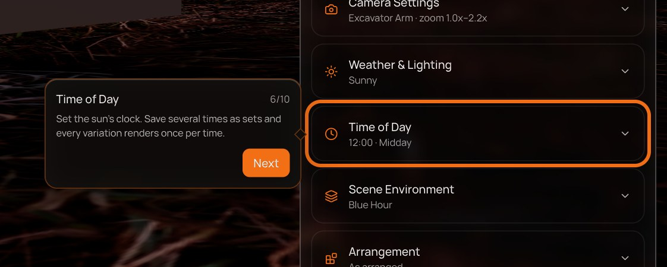
Step 6, tip 6 of 10 — Time of Day
Points at | Time of Day section
Bubble copy | “Set the sun's clock. Save several times as sets and every variation renders once per time.”
Advances when | The user presses Next in the bubble.
Control not on screen | Panel shows: “Click Generate to open the Work Order.”

6.7 Scene Environment
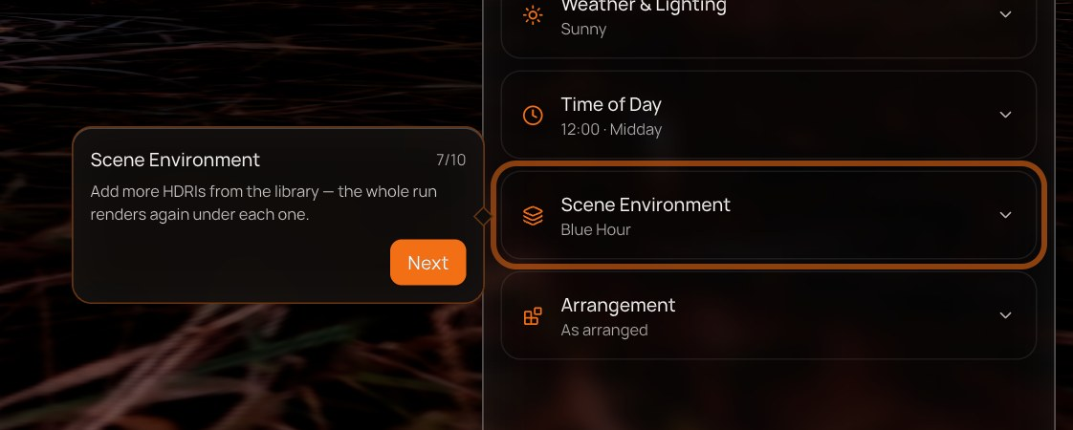
Step 6, tip 7 of 10 — Scene Environment
Points at | Scene Environment section
Bubble copy | “Add more HDRIs from the library — the whole run renders again under each one.”
Advances when | The user presses Next in the bubble.
Control not on screen | Panel shows: “Click Generate to open the Work Order.”

6.8 Arrangement
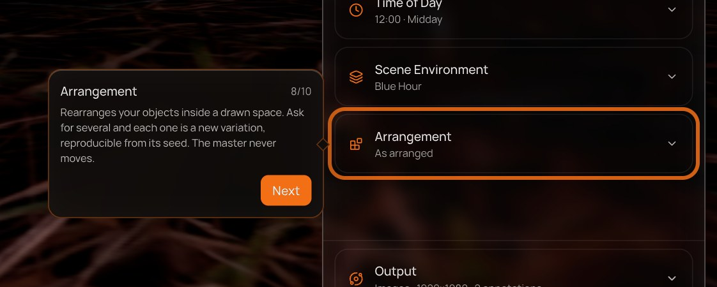
Step 6, tip 8 of 10 — Arrangement
Points at | Arrangement section
Bubble copy | “Rearranges your objects inside a drawn space. Ask for several and each one is a new variation, reproducible from its seed. The master never moves.”
Advances when | The user presses Next in the bubble.
Control not on screen | Panel shows: “Click Generate to open the Work Order.”

6.9 Output
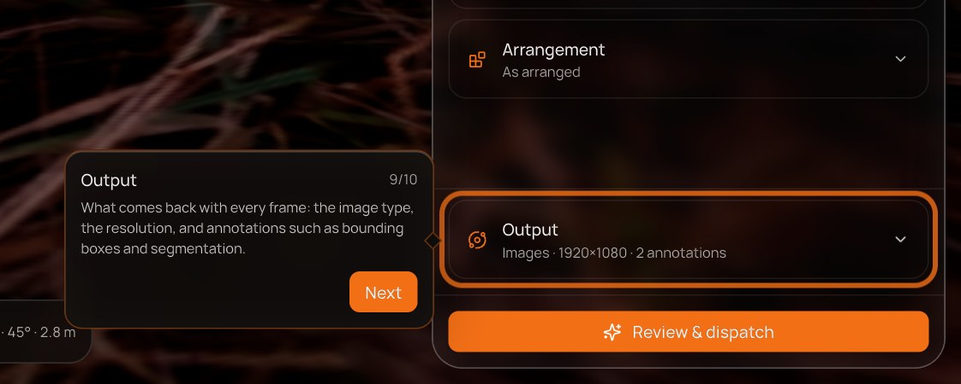
Step 6, tip 9 of 10 — Output
Points at | Output section
Bubble copy | “What comes back with every frame: the image type, the resolution, and annotations such as bounding boxes and segmentation.”
Advances when | The user presses Next in the bubble.
Control not on screen | Panel shows: “Click Generate to open the Work Order.”

6.10 Review & dispatch
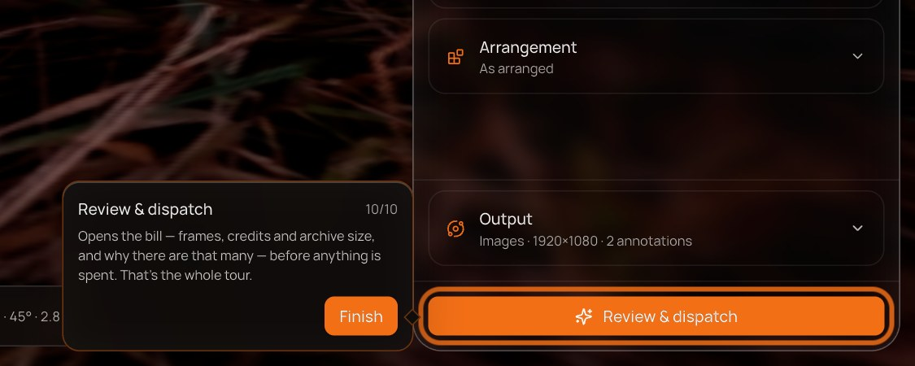
Step 6, tip 10 of 10 — Review & dispatch
Points at | Review & dispatch button
Bubble copy | “Opens the bill — frames, credits and archive size, and why there are that many — before anything is spent. That's the whole tour.”
Advances when | The user presses Finish. The guide is complete.
Control not on screen | Panel shows: “Click Generate to open the Work Order.”

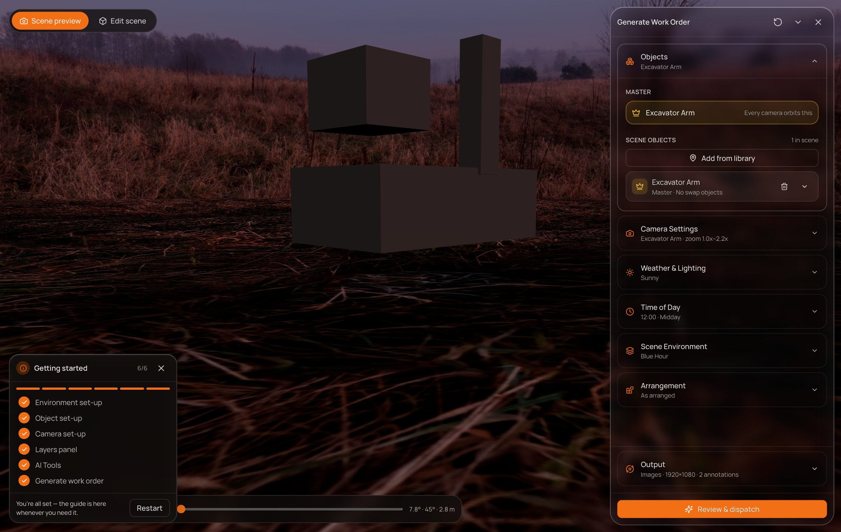
After Finish: every step ticked; the Work Order stays open for the user to continue.

7. Functional requirements
ID | Requirement
GD-01 | Opening any project (#editor or #editor/<name>) starts with an empty scene: no objects, no camera rig, no HDRI or skybox.
GD-02 | With no sky placed, the viewport shows a dark stage and lights objects with a neutral studio light.
GD-03 | The guide opens automatically every time a project is opened, starting at Environment set-up.
GD-04 | An info button after Undo/Redo toggles the guide; its pressed state and tooltip reflect whether the guide is open.
GD-05 | The guide panel floats bottom-left, above the Asset Library while the library is open, and never covers the top bar.
GD-06 | The panel shows a done/total count, a per-step progress bar, the six steps, and the current step's blurb.
GD-07 | Clicking a step row jumps to that step's first tip; Skip this step marks the step complete and moves to the next incomplete step.
GD-08 | Each tip draws a ring on its target and a bubble with title, n/N counter and copy. Explain tips add a Next/Done/Finish button.
GD-09 | Action tips complete automatically when their condition is met, polled every 250 ms and on resize.
GD-10 | If a tip's target is not on screen (hidden, covered, or not rendered), no bubble is shown; the panel shows the tip's missing line instead, plus a shortcut when one exists.
GD-11 | Focus-view tips offer Select it, which selects the newest sky / object / camera so its controls appear.
GD-12 | Environment, Object and Camera set-up each end only when Back is clicked while the Back tip is showing. A click on empty space, or a Back click during an earlier tip, does not end the step.
GD-13 | The Master tip explains why a master is needed and completes only when the scene has a master.
GD-14 | Generate work order is blocked until a master and a camera exist; while blocked the panel states the requirement.
GD-15 | Generate and the Work Order settings tour are one step (10 tips), ending on Review & dispatch with Finish.
GD-16 | When every step is complete, the panel shows a finished state with Restart; Restart clears progress and returns to step 1.
GD-17 | Closing the guide (× or the info button) hides it without losing progress for the current session.
GD-18 | The guide sits above the Work Order panel (z-index 70/71 vs 50) so it stays visible during step 6.
GD-19 | Clicks inside the guide never count as user actions for completion checks.

8. Edge cases
Situation | Behaviour
User places things before the guide asks | Matching action tips pass straight through; the step starts at the first tip that isn't already true.
User deletes the sky / object mid-step | Focus-view tips lose their target; the panel shows the missing line and Select it (which finds nothing until the user places a new one).
Camera view is open when a camera tip appears | The full-size camera view covers the editor, so the tip's control is not on screen; the panel's missing line asks the user to close it with Esc first.
User jumps to Generate work order early | The step shows its blocked message until a master and a camera exist.
Bubble would leave the viewport | It flips to the opposite side, then clamps to a 12 px margin; the arrow keeps pointing at the target.
Bright skies | Panel and bubble use a darker glass ground so text stays readable over white skyboxes.

9. Success measures (proposed)
- Share of new projects that reach an open Work Order in the first session.
- Completion rate per step, and where users skip or close the guide.
- Share of first Work Orders that have a master set (target: 100% for guided sessions).
- Time from project open to first placed object.
The prototype doesn't log analytics yet; these would need instrumentation.

10. Open questions and future work
- Persistence. Progress lives in memory only: reloading or reopening a project starts the guide again at step 1. Should completed users be able to opt out (“don't show again”), or should progress be saved per user?
- Empty first open for the sample project. #editor now opens empty too. Should the sample keep its demo scene for people who want to look before building?
- Localisation. All copy lives in editor-guide.ts as plain strings, ready to be extracted.
- Small screens. Designed and tested at desktop sizes; tablet and narrow layouts need review.

