TERRA WEB · PRD
Setting Info Panels
An explanation behind every control in the Environment, Object and Camera panels
Feature | Info (ⓘ) button on every setting panel + the camera master picker
Status | Implemented in the prototype on branch feat/editor-terragen-camera-mat — not yet committed
Surface | Terra Web editor — the floating setting panel above the bottom-centre toolbar
Code | SettingControl.tsx (panel, info button, master picker) · SettingExplainer.tsx (copy + diagrams) · CaptureExplainer.tsx (capture topics) · ObjectPropertiesPanel.tsx (settingKeysFor)
Date | 6 October 2026

Screenshots were captured from the running editor at 1500 × 950 with the info explanation open. The explanation text quoted beside each panel is read from the shipped source, word for word; [master name] stands for the master object's actual name, which the app fills in.

1. Summary
Every glass setting panel that opens from the bottom-centre controls — for a sky, a 3D object and a camera — now has an info (ⓘ) button in its header, the same pattern the camera's Shots per Rotation panel already used. Pressing it opens a short card under the control: what the setting does on this kind of thing, and for the spatial camera settings a small moving diagram drawn from the rig's own numbers.
The same release fixes the camera panels that opened empty. Orbit Rotation, Zoom Distance, Camera Height and Shots per Distance are measured around the master object; in a project with no master they now explain that and let the user pick one, instead of showing nothing (or, for Rotation, the per-object X/Y/Z sliders a camera can't use).
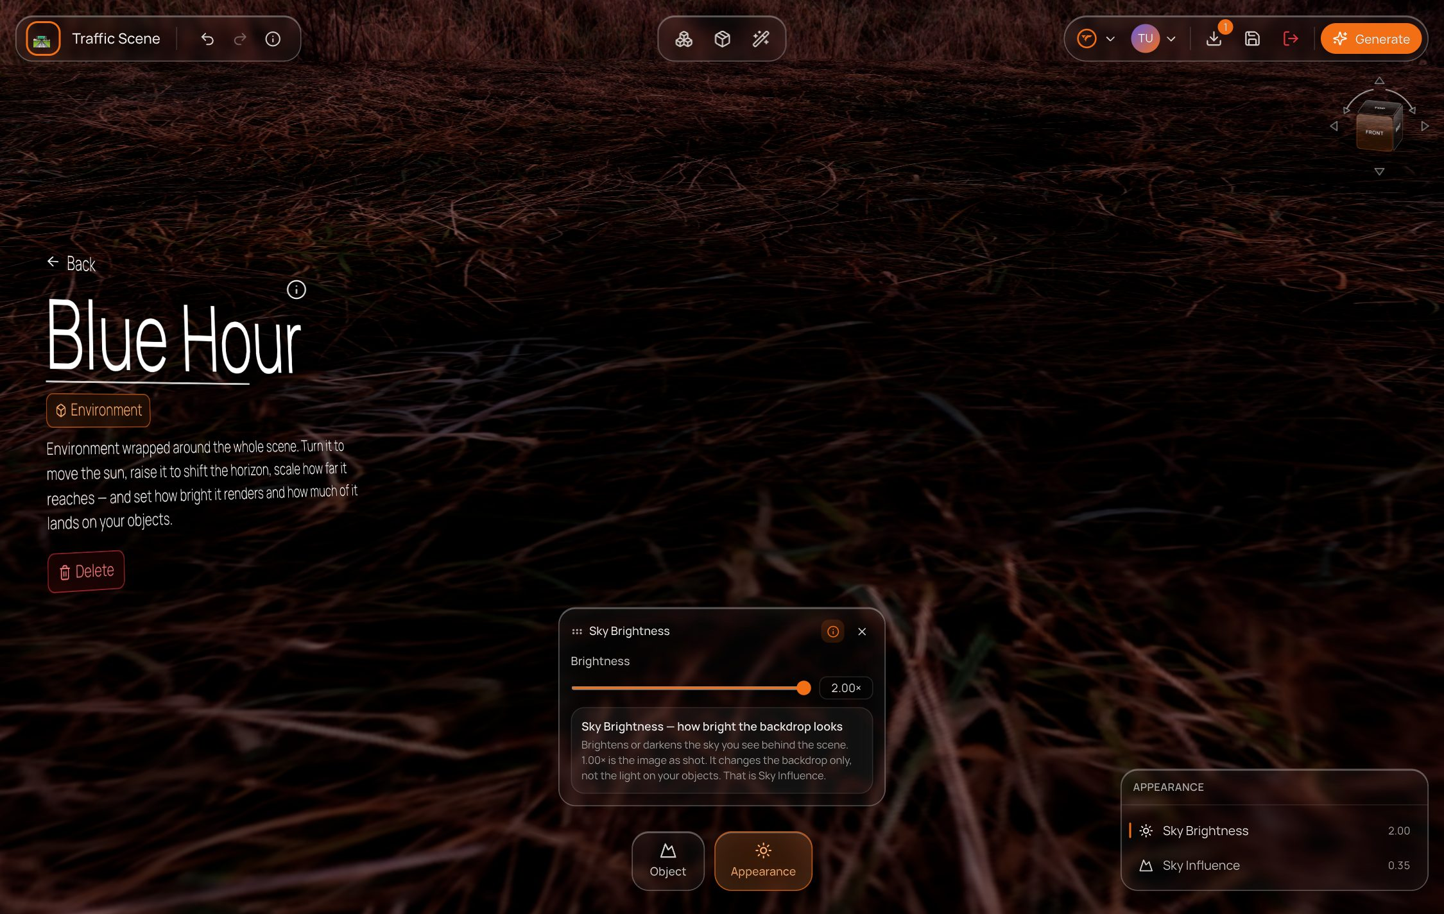
The Sky Brightness panel with its info card open, above the sky's Object / Appearance toolbar.

2. Problem
- Setting names don't say what they change. Specular vs Roughness, Sky Brightness vs Sky Influence, and Zoom Distance measured as 1x–4x are easy to misread.
- The same name means different things on different objects: Rotation turns a chair, moves the sun for a sky, and swings a camera rig around the master.
- Only the three capture settings had an explanation; everything else was unexplained.
- Projects now open empty. A camera placed before a master existed showed blank Zoom Distance, Camera Height and Shots per Distance panels, and Rotation fell back to X/Y/Z sliders — users reported these controls as missing.
- A setting left open on one object carried over to the next selection — e.g. a sky's Scale panel stayed open over a camera, which has no scale.

3. Goals and non-goals

Goals
- One consistent way to ask what does this do? on every setting panel, for every asset type.
- Copy specific to the selected source (sky, object, splat, camera), not one generic sentence per setting name.
- Never show a camera control that has nothing to measure from; offer the fix in place.
- Zero cost when not wanted: closed by default, one click to open, no change to the control's position.

Non-goals
- Tooltips on individual sliders or fields.
- Explanations inside the Work Order (TerraGen) panel.
- Remembering the open/closed preference between sessions.

4. Experience

4.1 Where setting panels come from
Selecting an object opens its bottom-centre toolbar (Object / Appearance for a sky; Object / Texture / Master for a 3D object; Object / Capture for a camera). Each tile opens a properties list on the right; picking a row opens that one setting as a small glass panel above the toolbar. That panel is where the info button lives.
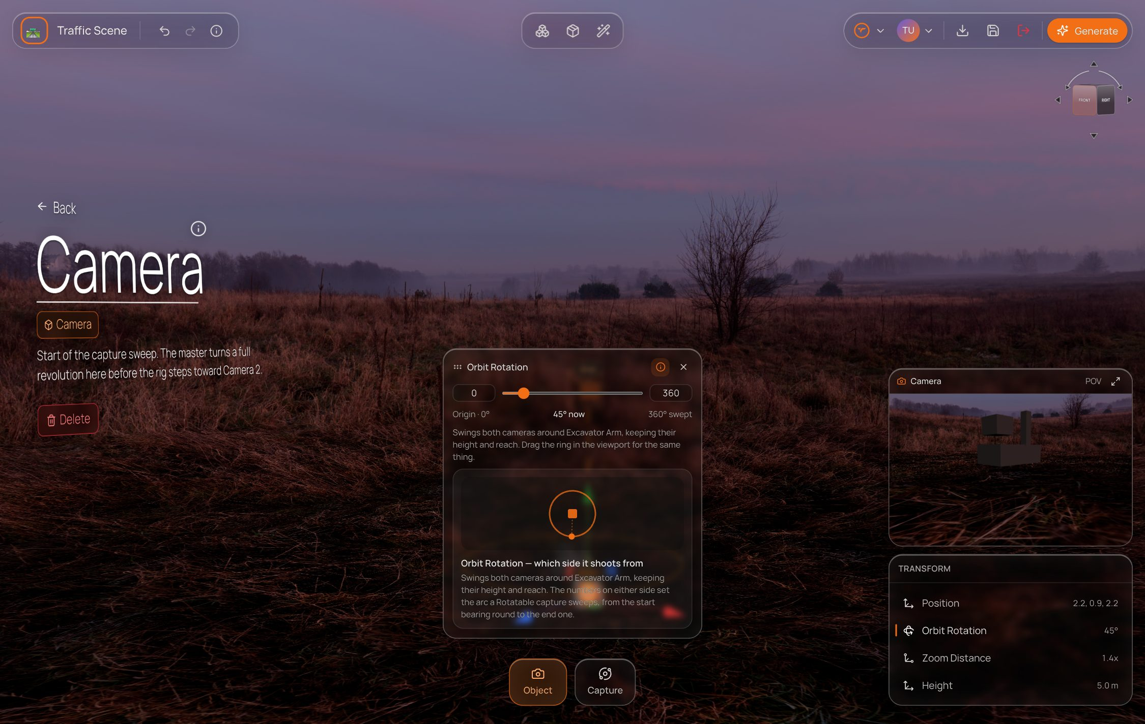
A camera's Orbit Rotation panel with its info card and orbit diagram; the properties list is bottom-right.

4.2 The info button
A 24 px ⓘ button sits in the panel header between the title (and the Uniform switch, on Scale) and the close button. It is a toggle (aria-pressed), tinted orange while the card is open. Its tooltip and accessible name are What this setting does.
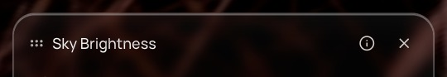  Info closed. | 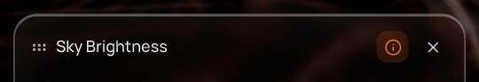  Info open — button tinted.

4.3 The info card
- Opens under the control, inside the same panel, so the control itself doesn't move.
- A bold title naming the setting and its job (e.g. Roughness — glossy to matte), then one or two plain sentences.
- Camera geometry settings (Orbit Rotation, Zoom Distance, Camera Height) add a small animated diagram drawn from the rig's real values: its arc, its zoom multiple, its climb.
- Capture settings (Mode, Increments, Shots / Rotation) keep their existing explainer, which includes the frame sum — e.g. 3 increments × 24 shots = 72 frames.
- Stays open as the user steps from setting to setting while the panel is open; closes with the panel.

4.4 Coverage
Asset | Tile | Settings with an info card
Environment / Skybox | Appearance | Sky Brightness · Sky Influence
Environment / Skybox | Object | Position (height) · Rotation · Scale
3D object | Object | Position · Rotation · Scale
3D object | Texture | Color · Metallic · Roughness · Specular · Normal Intensity
Gaussian splat | Appearance | Brightness · Sky Influence (Object tile uses the 3D-object copy). No splat ships in the catalogue today.
Camera | Object | Position · Orbit Rotation · Zoom Distance · Camera Height
Camera | Capture | Mode · Increments (Shots per Distance) · Shots / Rotation
22 info cards across four asset types — sky 5, 3D object 8, camera 7, splat 2 — and the same setting name has its own copy per type.

5. Environment (sky) panels
A sky is a 360° image wrapped around the world. It has no body, so its Transform is what the projected dome can express — and Appearance holds the two sky parameters.
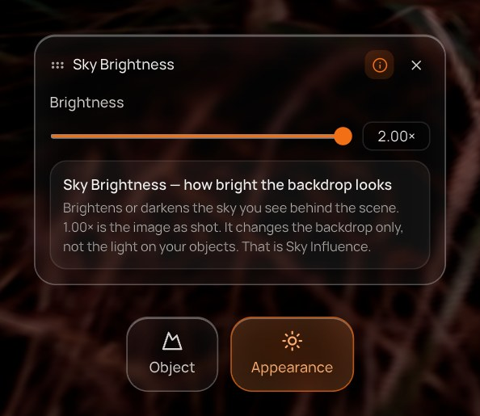  Sky Brightness — info open | Sky Brightness
  Opens from | Appearance tile
  Control | Slider 0–2×, 1.00× = as shot
  Explainer | Sky Brightness — how bright the backdrop looks
  Says | “Brightens or darkens the sky you see behind the scene. 1.00× is the image as shot. It changes the backdrop only, not the light on your objects. That is Sky Influence.”

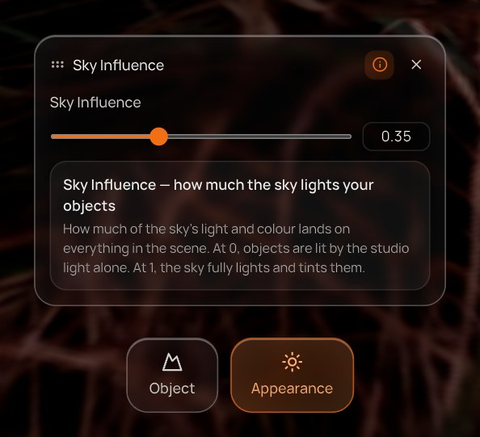  Sky Influence — info open | Sky Influence
  Opens from | Appearance tile
  Control | Slider 0–1, default 0.35
  Explainer | Sky Influence — how much the sky lights your objects
  Says | “How much of the sky's light and colour lands on everything in the scene. At 0, objects are lit by the studio light alone. At 1, the sky fully lights and tints them.”

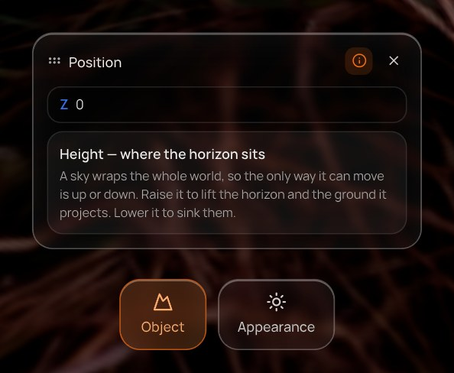  Position (height) — info open | Position (height)
  Opens from | Object tile
  Control | One field — Z only
  Explainer | Height — where the horizon sits
  Says | “A sky wraps the whole world, so the only way it can move is up or down. Raise it to lift the horizon and the ground it projects. Lower it to sink them.”

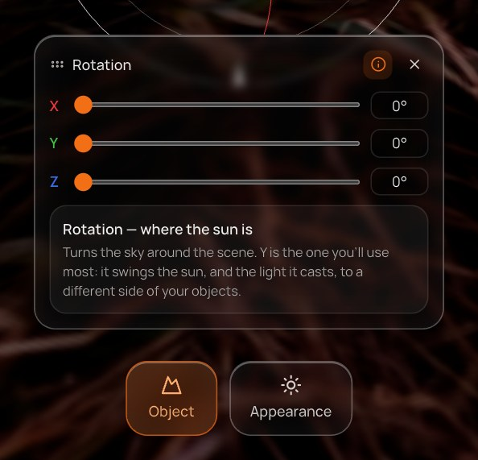  Rotation — info open | Rotation
  Opens from | Object tile
  Control | X / Y / Z sliders, 0–360°
  Explainer | Rotation — where the sun is
  Says | “Turns the sky around the scene. Y is the one you'll use most: it swings the sun, and the light it casts, to a different side of your objects.”

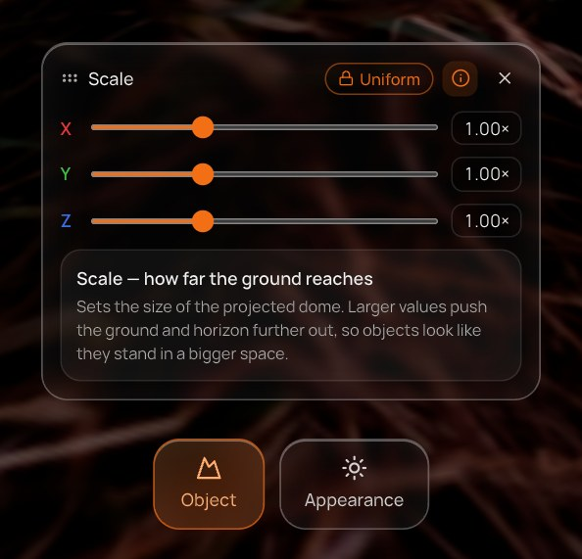  Scale — info open | Scale
  Opens from | Object tile
  Control | X / Y / Z sliders with Uniform lock
  Explainer | Scale — how far the ground reaches
  Says | “Sets the size of the projected dome. Larger values push the ground and horizon further out, so objects look like they stand in a bigger space.”

6. Object panels
A placed 3D model. Texture factors act on the material slot chosen in the properties list — the Element N chip in the header says which.
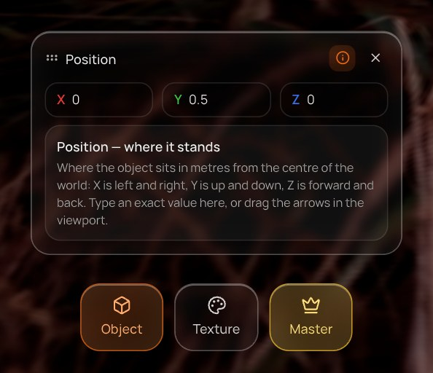  Position — info open | Position
  Opens from | Object tile
  Control | X / Y / Z number fields (metres)
  Explainer | Position — where it stands
  Says | “Where the object sits in metres from the centre of the world: X is left and right, Y is up and down, Z is forward and back. Type an exact value here, or drag the arrows in the viewport.”

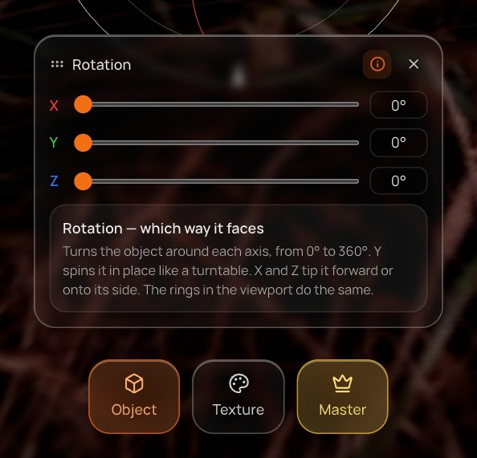  Rotation — info open | Rotation
  Opens from | Object tile
  Control | X / Y / Z sliders, 0–360°
  Explainer | Rotation — which way it faces
  Says | “Turns the object around each axis, from 0° to 360°. Y spins it in place like a turntable. X and Z tip it forward or onto its side. The rings in the viewport do the same.”

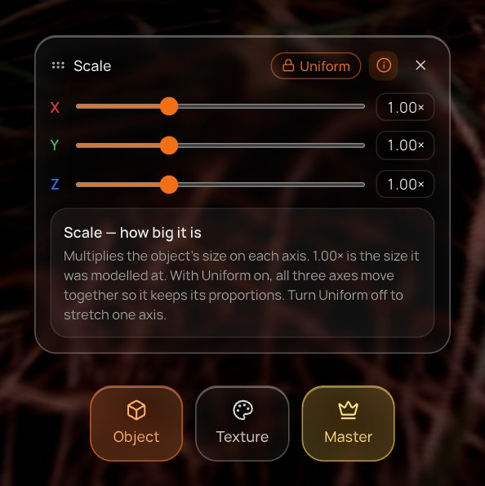  Scale — info open | Scale
  Opens from | Object tile
  Control | X / Y / Z sliders 0.1–3× with Uniform lock
  Explainer | Scale — how big it is
  Says | “Multiplies the object's size on each axis. 1.00× is the size it was modelled at. With Uniform on, all three axes move together so it keeps its proportions. Turn Uniform off to stretch one axis.”

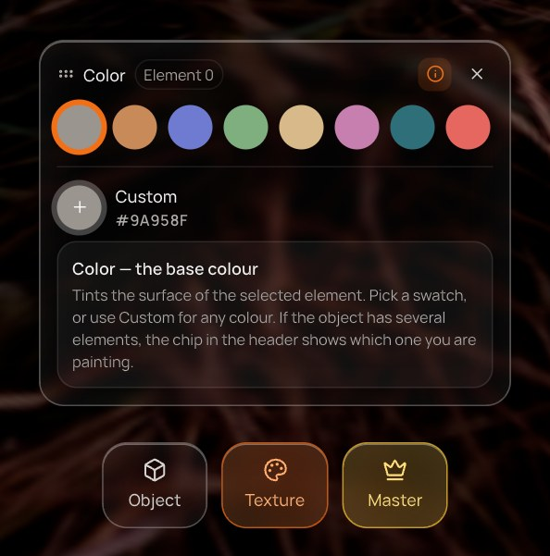  Color — info open | Color
  Opens from | Texture tile
  Control | Eight swatches + Custom picker
  Explainer | Color — the base colour
  Says | “Tints the surface of the selected element. Pick a swatch, or use Custom for any colour. If the object has several elements, the chip in the header shows which one you are painting.”

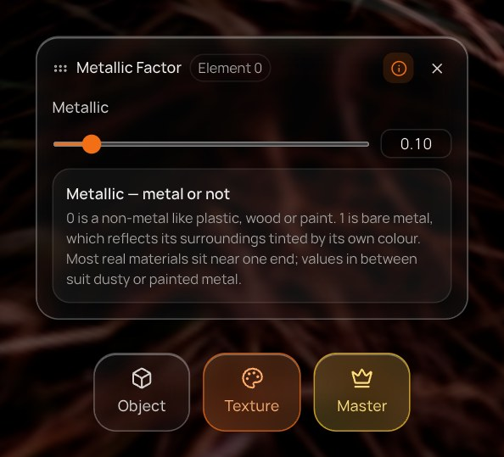  Metallic — info open | Metallic
  Opens from | Texture tile
  Control | Slider 0–1
  Explainer | Metallic — metal or not
  Says | “0 is a non-metal like plastic, wood or paint. 1 is bare metal, which reflects its surroundings tinted by its own colour. Most real materials sit near one end; values in between suit dusty or painted metal.”

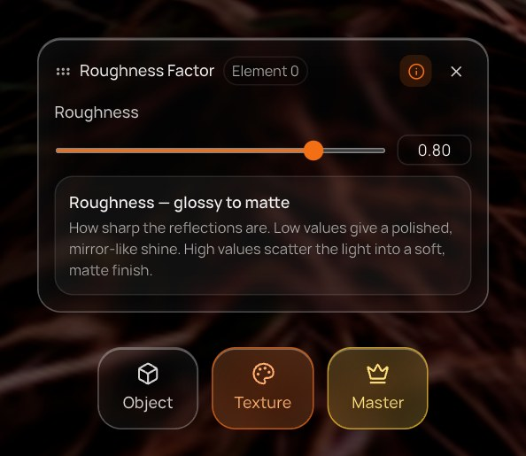  Roughness — info open | Roughness
  Opens from | Texture tile
  Control | Slider 0–1
  Explainer | Roughness — glossy to matte
  Says | “How sharp the reflections are. Low values give a polished, mirror-like shine. High values scatter the light into a soft, matte finish.”

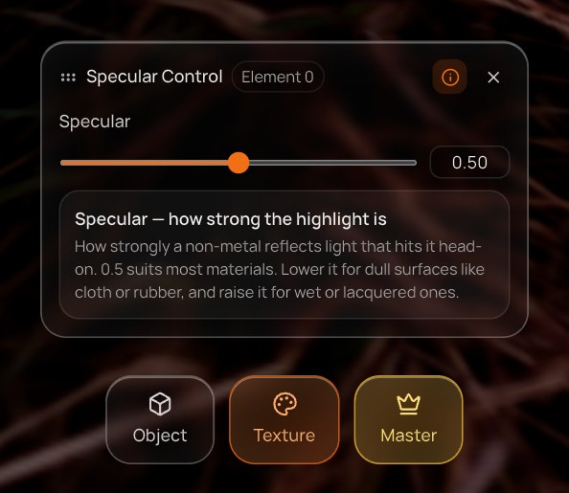  Specular — info open | Specular
  Opens from | Texture tile
  Control | Slider 0–1, 0.5 default
  Explainer | Specular — how strong the highlight is
  Says | “How strongly a non-metal reflects light that hits it head-on. 0.5 suits most materials. Lower it for dull surfaces like cloth or rubber, and raise it for wet or lacquered ones.”

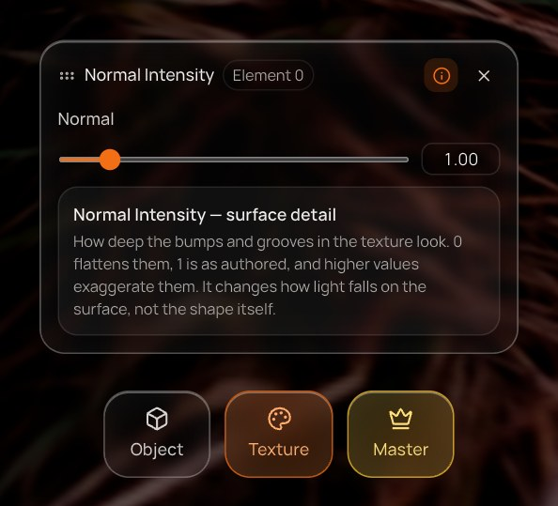  Normal Intensity — info open | Normal Intensity
  Opens from | Texture tile
  Control | Slider 0–8, 1 = as authored
  Explainer | Normal Intensity — surface detail
  Says | “How deep the bumps and grooves in the texture look. 0 flattens them, 1 is as authored, and higher values exaggerate them. It changes how light falls on the surface, not the shape itself.”

7. Camera panels
A camera is a rig of two cameras locked on the master. Its Object tile edits where the rig stands relative to the master; Capture edits how the sweep shoots.

7.1 Object tile
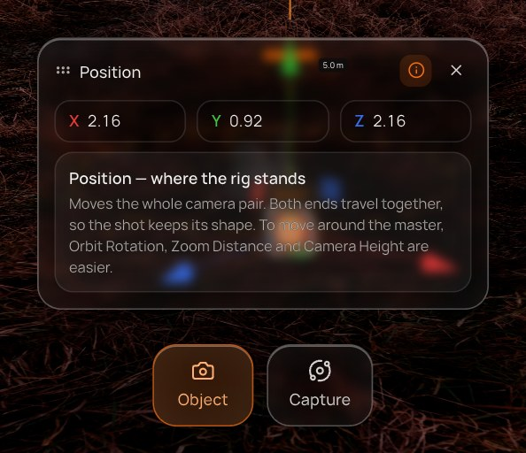  Position — info open | Position
  Opens from | Object tile
  Control | X / Y / Z — moves both cameras
  Explainer | Position — where the rig stands
  Says | “Moves the whole camera pair. Both ends travel together, so the shot keeps its shape. To move around the master, Orbit Rotation, Zoom Distance and Camera Height are easier.”

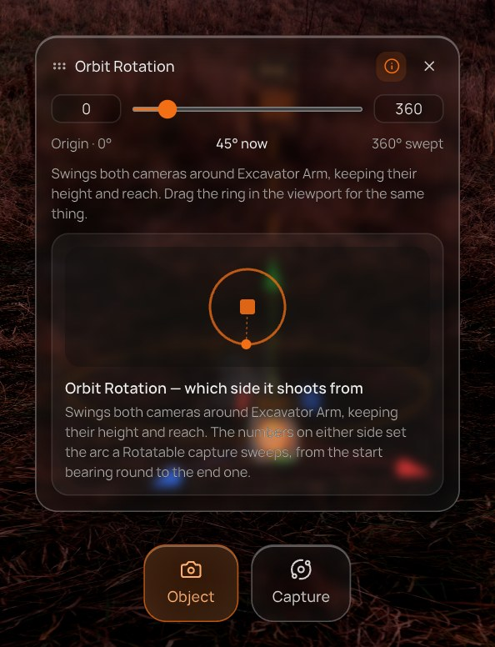  Orbit Rotation — info open | Orbit Rotation
  Opens from | Object tile
  Control | Arc start · orbit slider · arc end
  Explainer | Orbit Rotation — which side it shoots from
  Says | “Swings both cameras around [master name], keeping their height and reach. The numbers on either side set the arc a Rotatable capture sweeps, from the start bearing round to the end one.”
  Visual | Top-down ring: the arc highlighted, the camera sweeping it.

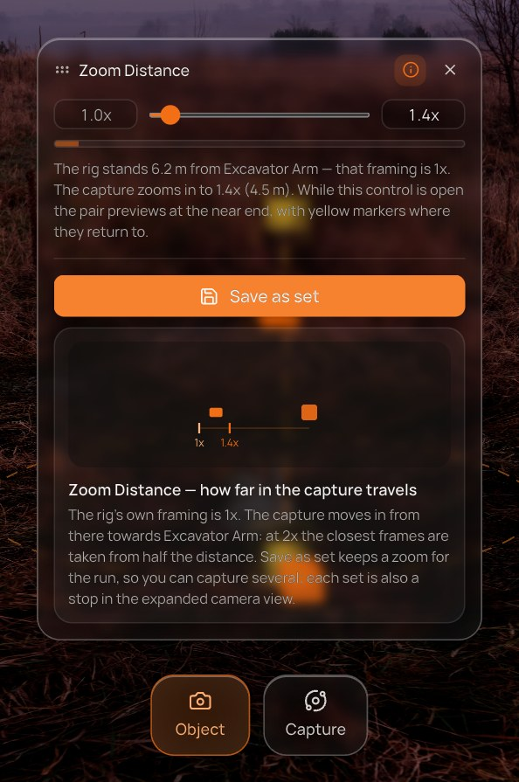  Zoom Distance — info open | Zoom Distance
  Opens from | Object tile
  Control | 1x anchor · zoom slider · current zoom, then Save as set and the zoom-set list
  Explainer | Zoom Distance — how far in the capture travels
  Says | “The rig's own framing is 1x. The capture moves in from there towards [master name]: at 2x the closest frames are taken from half the distance. Save as set keeps a zoom for the run, so you can capture several; each set is also a stop in the expanded camera view.”
  Visual | Side view: camera travelling from 1x in to the set zoom.

Zoom Distance now holds several zooms. Save as set keeps the current value; the list under it is the same one the Work Order's Camera Settings shows (tick = in the run, pencil = load and update, bin = delete). Each set is also a stop in the expanded camera view opened from the POV panel.
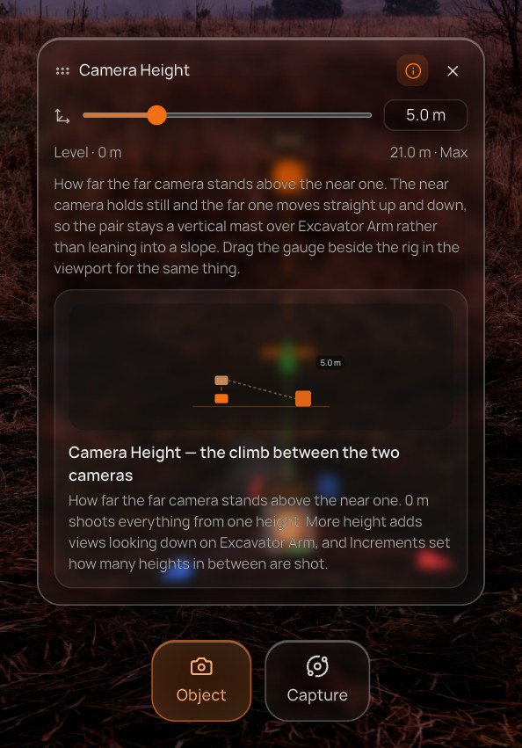  Camera Height — info open | Camera Height
  Opens from | Object tile
  Control | Climb slider, Level 0 m ↔ Max
  Explainer | Camera Height — the climb between the two cameras
  Says | “How far the far camera stands above the near one. 0 m shoots everything from one height. More height adds views looking down on [master name], and Increments set how many heights in between are shot.”
  Visual | Side view: the far camera above the near one, looking down.

7.2 Capture tile
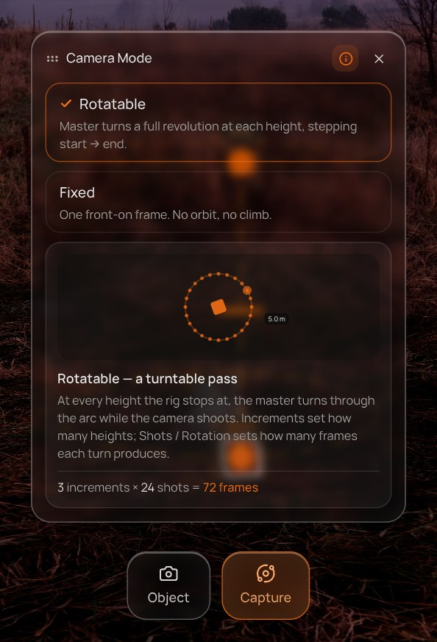  Mode — info open | Mode
  Opens from | Capture tile
  Control | Rotatable / Fixed
  Explainer | Rotatable — a turntable pass
  Says | “At every height the rig stops at, the master turns through the arc while the camera shoots. Increments set how many heights; Shots / Rotation sets how many frames each turn produces.”
  Visual | Turntable pass (or a single frame for Fixed), plus the frame sum.

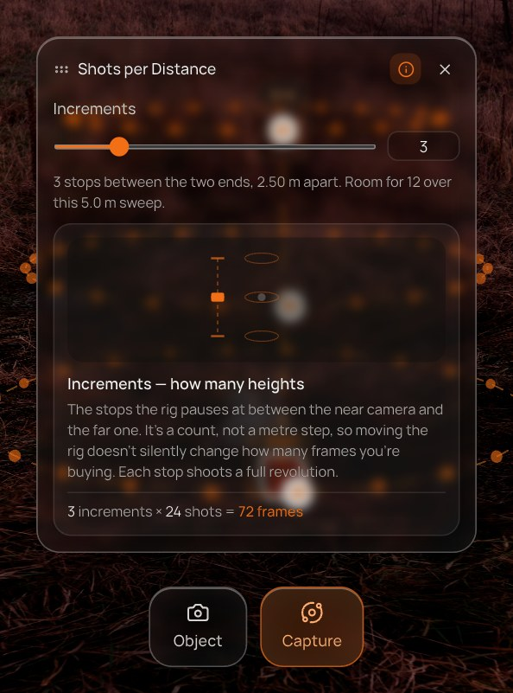  Increments — info open | Increments
  Opens from | Capture tile
  Control | Count, capped by what the sweep can hold
  Explainer | Increments — how many heights
  Says | “The stops the rig pauses at between the near camera and the far one. It's a count, not a metre step, so moving the rig doesn't silently change how many frames you're buying. Each stop shoots a full revolution.”
  Visual | Stops along the mast, a revolution at each.

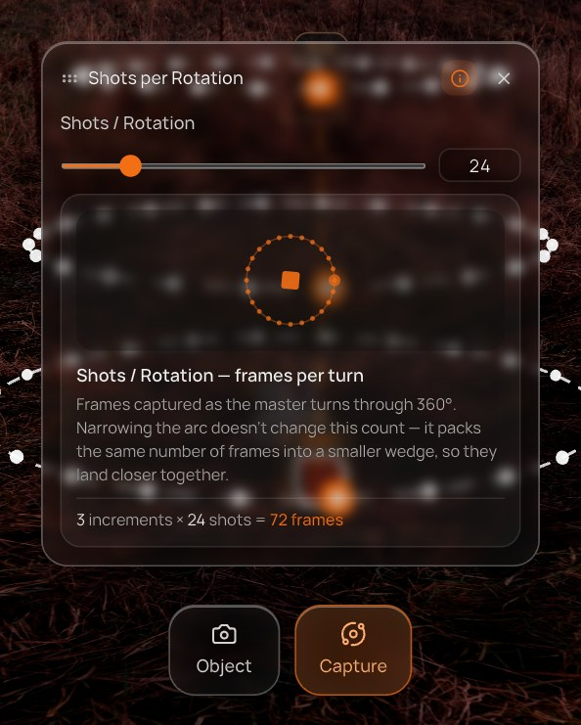  Shots / Rotation — info open | Shots / Rotation
  Opens from | Capture tile
  Control | Count 4–120
  Explainer | Shots / Rotation — frames per turn
  Says | “Frames captured as the master turns through [arc]°. Narrowing the arc doesn't change this count — it packs the same number of frames into a smaller wedge, so they land closer together.”
  Visual | Shot marks around the arc; the master turning.

8. Camera controls with no master
Orbit Rotation, Zoom Distance, Camera Height and Shots per Distance are all measured from the master object. Because projects now open empty, a user can place a camera before any master exists. Previously those panels rendered empty, and Rotation showed the per-object X/Y/Z sliders. Now each says what it needs and offers the fix:
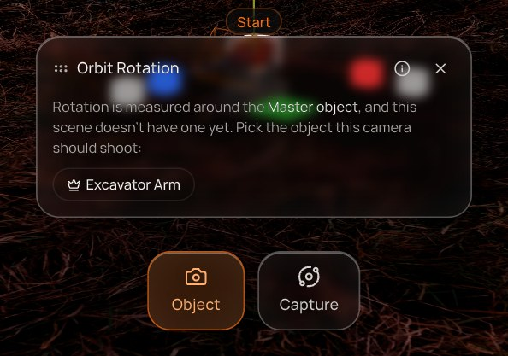  Objects exist: one chip per object that can be the master. | 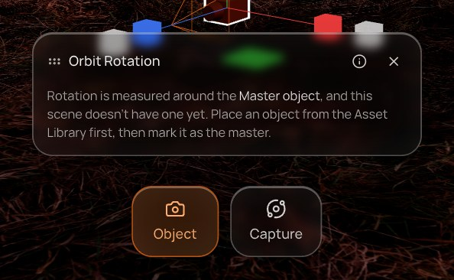  Nothing to pick: place an object first.

- The message names the setting: “Zoom Distance is measured around the Master object, and this scene doesn't have one yet.”
- Each chip is an object that can take the role (not a sky, camera or group child). Clicking one makes it the master and frames the rig on it — the same framing as Yes, focus when dropping a camera — and the real control appears in the same panel.
- The info button still works in this state, so the user can read what the setting will do before choosing.
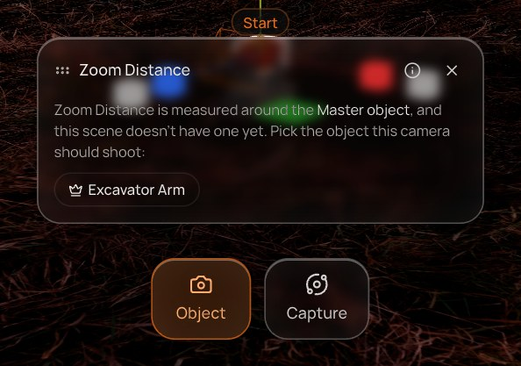  Zoom Distance before a master is picked. | 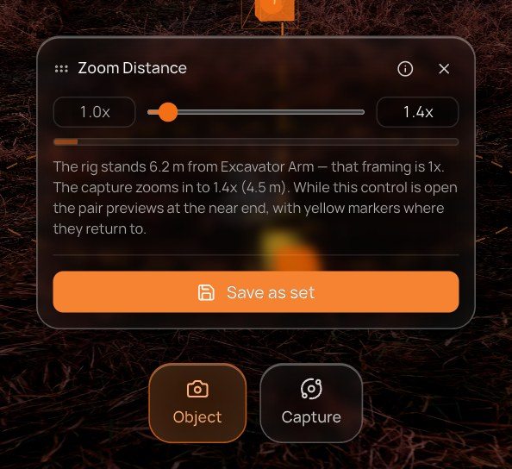  The same panel after clicking the chip.

8.1 Related fix — a setting no longer leaks between objects
When the selection changes, the open setting now stays open only if the new object has that setting (settingKeysFor(source, group)). Position stays open when moving from one chair to another; a sky's Scale closes when a camera is selected instead of showing a scale control the camera doesn't have.

9. Functional requirements
ID | Requirement
IP-01 | Every setting panel opened from the bottom-centre toolbar shows an info button in its header, for skies, 3D objects, splats and cameras.
IP-02 | The button toggles an info card under the control; it is off by default and exposes aria-pressed and the label What this setting does.
IP-03 | Copy is chosen by setting and source: sky, splat, camera, or ordinary object.
IP-04 | Mode, Increments and Shots / Rotation use the capture explainer, including the increments × shots = frames line (not shown in Fixed mode).
IP-05 | Orbit Rotation, Zoom Distance and Camera Height show an animated diagram drawn from the rig's current arc, zoom and climb.
IP-06 | The card's open state persists while the user switches settings in the same panel and resets when the panel closes.
IP-07 | For a camera with no master, Orbit Rotation, Zoom Distance, Camera Height and Shots per Distance show the needs-master message instead of an empty or wrong control.
IP-08 | The needs-master message lists every top-level object that can take the master role as a chip; with none, it tells the user to place an object first.
IP-09 | Clicking a chip sets that object as master and reframes the rig on it; the requested control then renders in the same panel.
IP-10 | A camera's Rotation is always titled Orbit Rotation and never falls back to per-object X/Y/Z sliders.
IP-11 | On selection change, the open setting is kept only if the new object offers it under the tab it opens on; otherwise the panel closes.

10. Acceptance checks (verified)
Run headlessly against the dev server before this document was written:
- All 20 settings on a sky, a 3D object and a camera open an info card with the expected title (sky ×5, object ×8, camera ×7 — Mode, Increments and Shots / Rotation via the capture explainer).
- Camera with no objects: Orbit Rotation shows Place an object from the Asset Library first.
- Camera with an object but no master: Rotation, Zoom Distance, Height and Shots per Distance show the picker; clicking the chip renders Increments with its stop count.
- Sky with Scale open → select the camera: the setting panel closes; the camera's rows are Position, Rotation, Zoom Distance, Height.
- TypeScript build: no new errors.

11. Open questions
- Should the info card remember that a user opened it once and start open next time, or stay off by default for everyone?
- The splat Brightness and Sky Influence copy exists but hasn't been seen in a capture: no Gaussian splat ships in the catalogue, so it needs an uploaded .ply / .splat to check.
- Copy is English only and lives in SettingExplainer.tsx; it should move to the localisation pipeline with the guide copy.
- Should the needs-master picker also appear in the Work Order's Camera Settings section?

