**ENSF614 Fall 2022**

**Final Project**

**Design Report**

December 3, 2022

Group 8

|  |  |
| --- | --- |
| **Ryan Ahlstrom** | **Andrew Bright** |
| **Dhruvi Dave** | **Dele Oyelese** |

**Table of Contents**

Systems Use Case Diagram 3

Systems Activity Diagram 4

Use Case Scenarios 5

Select Theater 5

View All Movies 5

Select Movie 5

View Show Times 5

Browse Available Seats 5

Purchase Ticket 5

Cancel Ticket 5

Receive Email Receipt 6

Register User 6

Pay Annual Account Fee 6

Login 6

Modify Database Contents 6

View Announcements 6

List of Candidate Objects 7

State Transition Diagrams 8

Ticket Object 8

Payment Object 9

Use Case – Login 10

Use Case – Pay Annual Fees 10

System Interaction Diagrams 11

Use Case – Login 11

Use Case – Purchase Ticket 12

Use Case – Cancel Ticket 13

Use Case – Browse Seats 14

Design Level Class Specification – Relationships 15

Design Level Class Specification – Attributes 16

Package Diagram 17

Deployment Diagram 18

# Diagram Description automatically generatedSystems Use Case Diagram

# Diagram Description automatically generatedSystems Activity Diagram

# Use Case Scenarios

## Select Theater

After the user selects the option to begin ticket purchase, a list of all available movie theaters is displayed on the page.

User selects a movie theater from the list.

## View All Movies

After selecting a theater, a new page is shown to the user with a list of movies being played at the selected theater.

The user views all movies in an alphabetical list. The user decides they want to find their desired movie, so they enter a title into the search bar.

After entering the title into the search bar, only the movies which match the title are displayed to the user.

## Select Movie

With the list of movies shown on the page, the user clicks on the movie they want to watch.

## View Show Times

After selecting the movie, a new page is shown to the user.

The user views all available show times for the selected movie at the selected theater, and they select a showtime by clicking on it.

## Browse Available Seats

After selecting a show time, the user views a colored map of all available seats for the selected show time. The seats are displayed by number and availability.

The user clicks on the seat they want, and the application verifies that the seat is available.

The user decides they want to buy a seat for their friend, so they click on another seat. The application verifies that the user’s seats will not exceed the limit of 10% capacity for a reserved showing.

After the user has selected all of the seats they want, they click on a payment button.

## Purchase Ticket

After the user clicks on the payment button, a new page is displayed with several fields for the user to enter information into.

The input fields displayed are “Card number”, “Expiration date”, “CSV”, and “email address”.

If the user is currently logged in as a registered user, these fields are retrieved from the server and filled automatically.

At the bottom of the page is a button labeled “Pay for tickets”

The user presses the button, and the application contacts the billing system to determine if the payment is valid.

If the payment is invalid, an error message is shown.

## Cancel Ticket

After pressing the cancel ticket button, a new page is shown with several fields for the user to enter.

The displayed input fields are “Movie title”, “Movie time”, and “Email address”.

The user enters all information into these fields, and clicks a button on the bottom of the page labelled “confirm cancellation”

The application contacts the server to determine if the ticket exists and the movie show time is greater than 72 hours from the current time.

If the ticket cancellation is not possible, an error message is shown.

The application contacts the billing system if the ticket cancellation is possible, and distributes a refund to the user depending on the user type. 85% for nonregistered users, and 100% for registered users.

If the refund is unsuccessful, an error message is shown.

## Receive Email Receipt

After the application confirms the validity of a purchase or refund, a new page is shown.

This page lists the payment amount and the email address of the user.

The user is able to press a button labelled “email receipt” to receive an emailed copy of the receipt.

## Register User

After clicking on the “register” button, the user is shown a new registration page

This page has several listed input fields “First name”, “Last name”, “Address”, “Email address” and “Credit card information”.

## Pay Annual Account Fee

After registering for the first time or logging in as a registered user with overdue annual fees, the payment page for annual fees is shown.

Since the user has their credit card details on file, they do not need to enter the credit card details.

There are two buttons displayed on the screen “Charge credit card” or “Continue as guest”.

Since the user wants to remain a registered user, they press the button to charge their credit card.

## Login

The user types in the movie website address into their web browser, and they are redirected to a login page.

The login page displays two input fields “Username” and “Password”

Several buttons are shown on the page “Log in”, “Register”, and “Continue as a guest”

If the user is a registered user or an administrator, they enter their login details into the two input fields and press the “Log in” button. The application validates the information.

The user is able to select any of the 3 options. Since the user is a guest, they click the “Continue as a guest” option.

After selecting the guest option, the user is given an option to purchase or cancel a ticket.

## Modify Database Contents

If the user pressed the “Log in” button with valid administrator credentials, a new page is shown.

This is an administrator console where the admin user can enter API calls to modify database contents.

## View Announcements

After logging in or paying annual fees, a registered user is sent to a new page.

On the new page are movie announcements not available to the public.

At the bottom of the page are two buttons, “Purchase a ticket” or “Cancel a ticket”.

## List of Candidate Objects

|  |  |
| --- | --- |
| Noun | Filtering Decision |
| User | Candidate object |
| Theater | Candidate object |
| Movie | Candidate object |
| Showtime | Candidate object |
| Ticket | Candidate object |
| Seat | Candidate object |
| Registered User | Candidate object |
| Administrator | Candidate object |
| Guest | Filtered (not stored) |
| Application | Filtered (out of scope) |
| Server | Filtered (out of scope) |
| Billing System | Filtered (out of scope) |
| Card number, Expiration, CSV, email address | Filtered (attributes of object) |
| Movie time, Movie title, email address | Filtered (attributes of object) |
| Refund | Candidate object |
| Purchase | Candidate object |
| Payment | Candidate object |
| Receipt | Candidate object |
| Emailed copy | Filtered (duplicate of receipt) |
| First name, last name, address, email address, credit card information | Filtered (attributes of object) |
| Annual fees | Filtered (attribute or method) |
| Credit card details | Filtered (attribute of object) |
| Website address | Filtered (out of scope) |
| Username, password | Filtered (attributes of object) |
| Movie announcements | Candidate object |
| API calls | Filtered (out of scope) |

# State Transition Diagrams

Name: Dhruvi Dave

## Ticket Object

## Payment Object

Name: Dele Oyelese

## Use Case – Login

Name: Ryan Ahlstrom

## Use Case – Pay Annual Fees

Name: Andrew Bright

# System Interaction Diagrams

## Use Case – Login

Name: Ryan Ahlstrom

## Use Case – Purchase Ticket

Name: Dele Oyelese

## Use Case – Cancel Ticket

Name: Dhruvi Dave

## Use Case – Browse Seats

Name: Andrew Bright

# Design Level Class Specification – Relationships

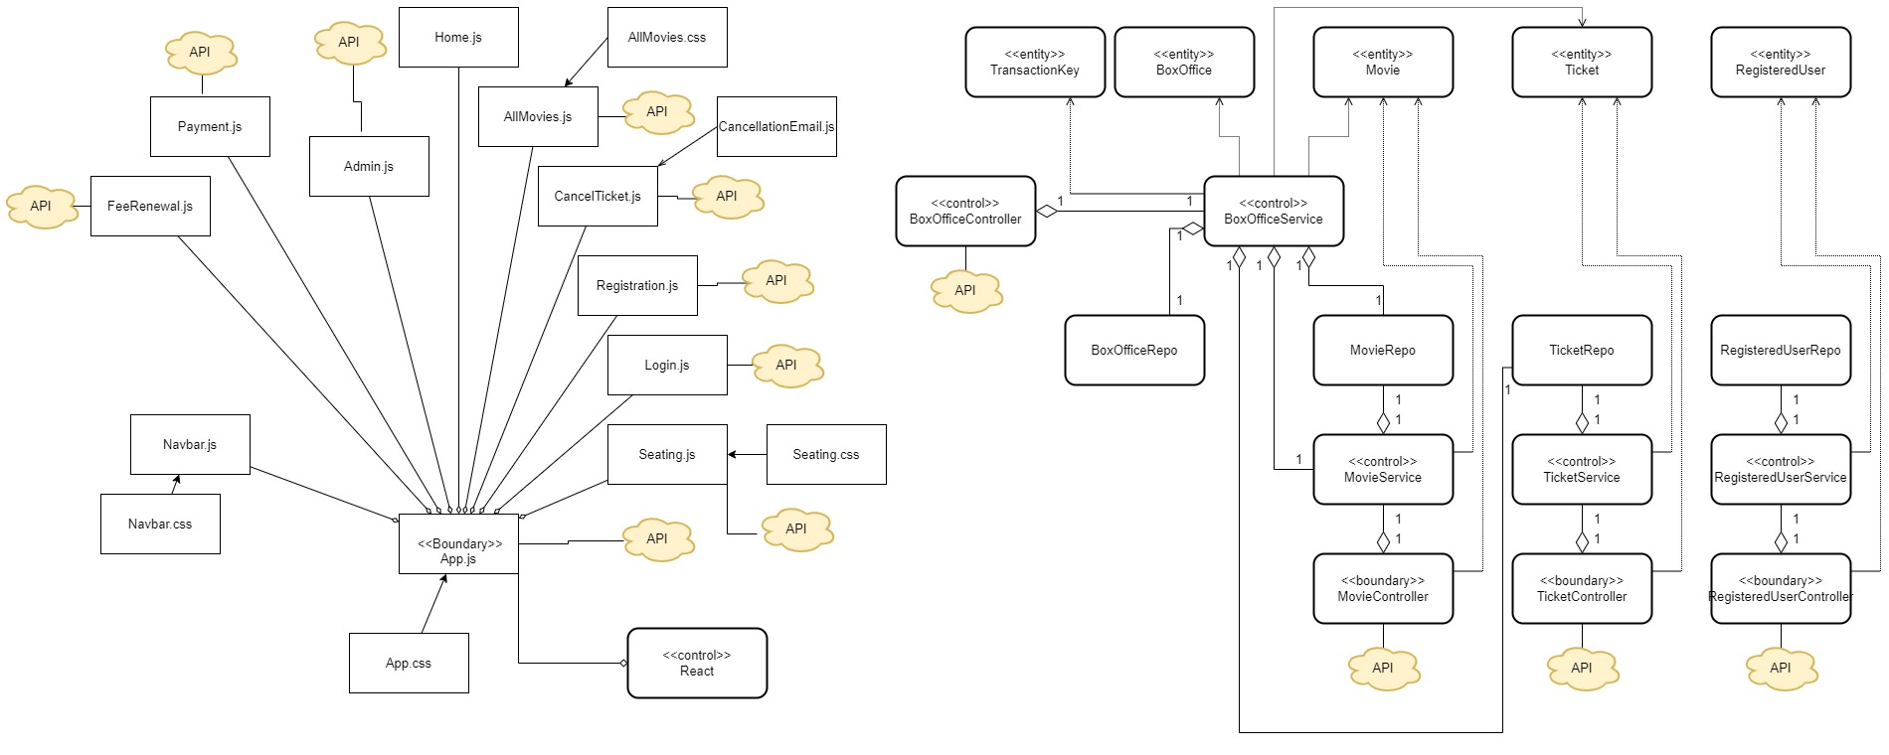

# Design Level Class Specification – Attributes

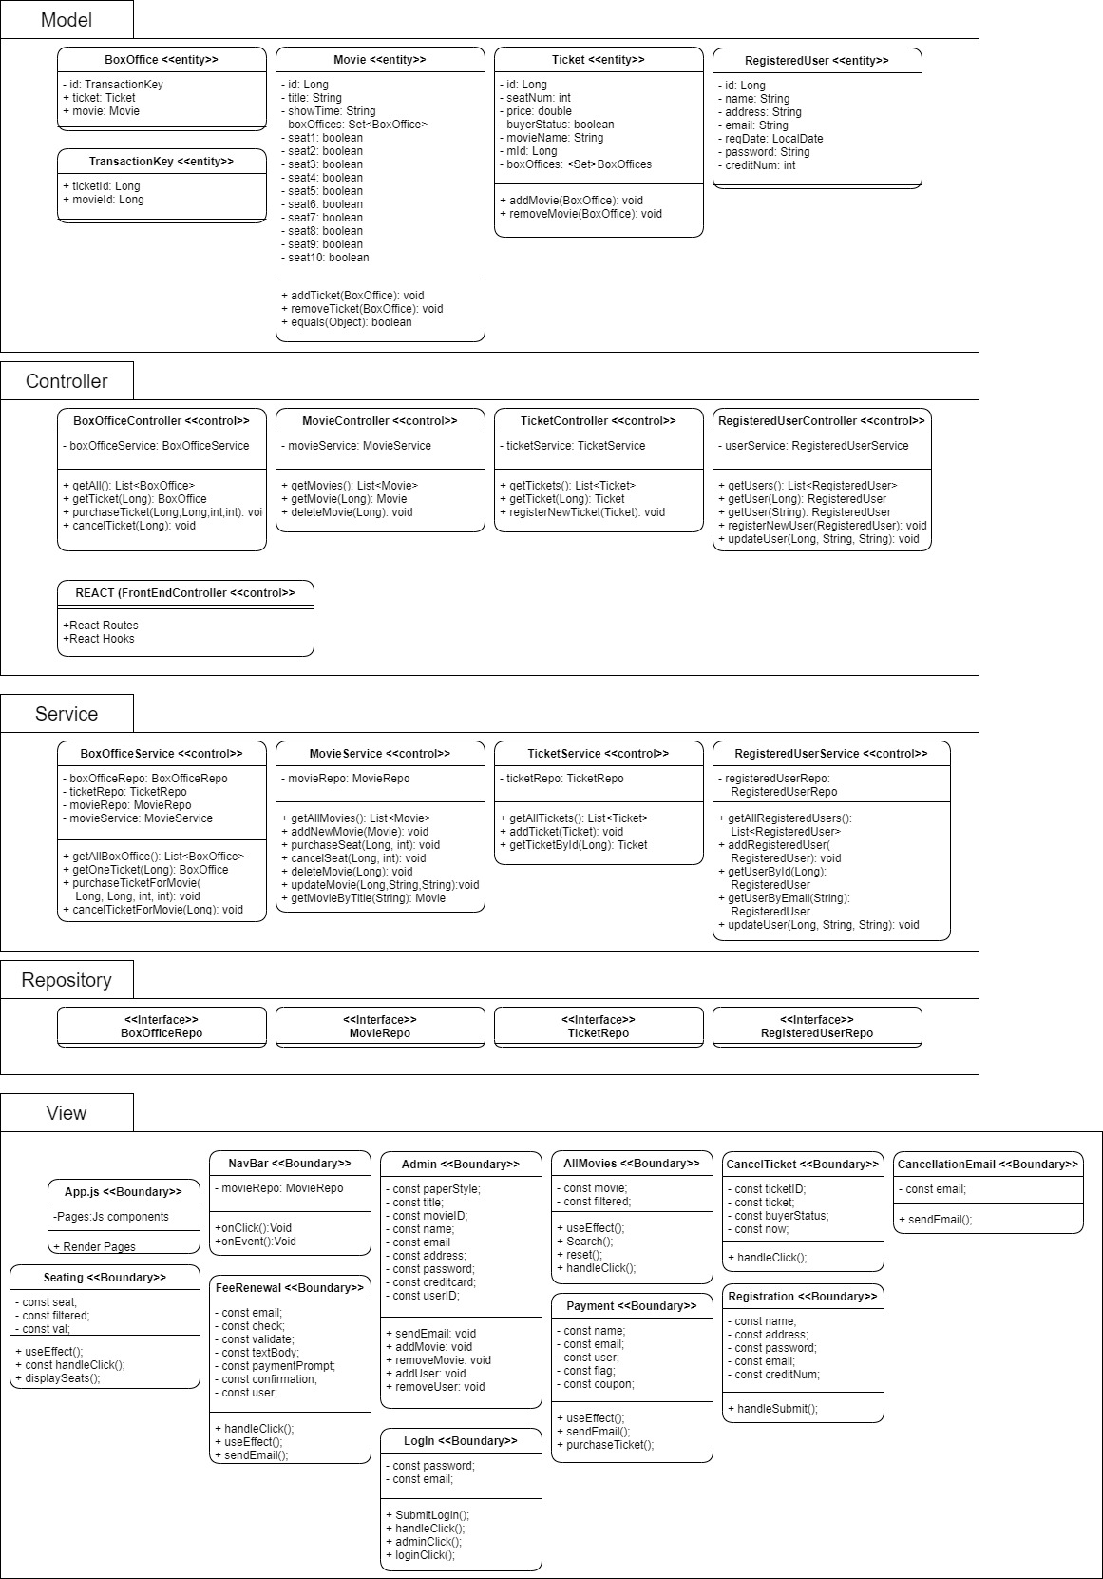

# Diagram Description automatically generatedPackage Diagram

# Deployment Diagram

