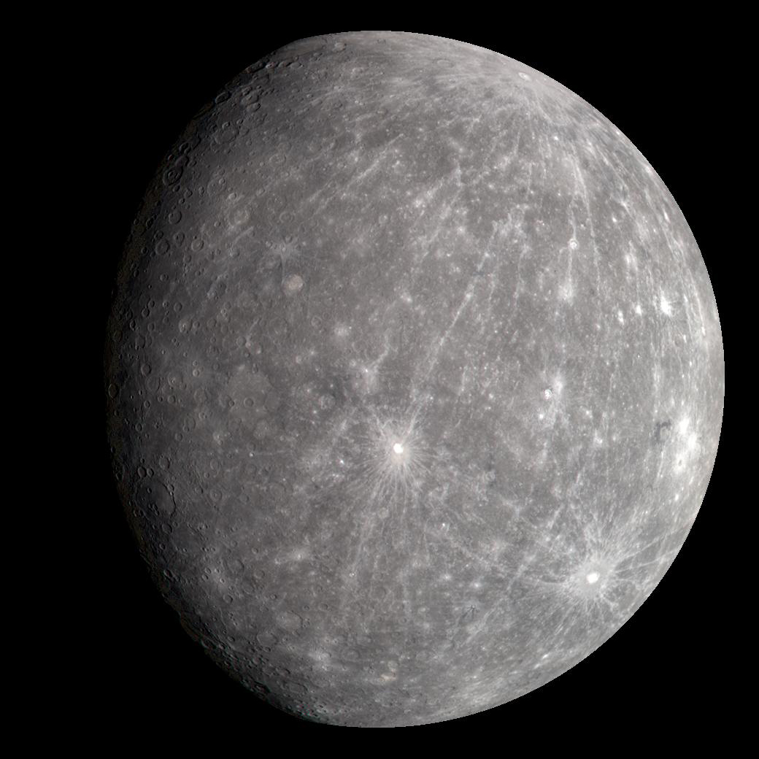
Size of this preview: 960 × 960 pixels. Other resolutions: 250 × 250 pixels | 500 × 500 pixels | 1,040 × 1,040 pixels.
This file has annotations. Move the mouse pointer over the image to see them.
Original file (1,040 × 1,040 pixels, file size: 408 KB, MIME type: image/jpeg)
Open in Media Viewer
File information
Structured data
Captions
English
Mercury in true color. Photographed by Messenger in 2008.
Summary
Description
English: This is a cropped bottom right image from the original four image mosaic PIA11364: Mercury's "True" Color is in the Eye of the Beholder.
Original Caption Released with Image:

Given the WAC’s ability to take images through 11 narrow-band color filters, it is natural to wonder what does Mercury look like in “true” color such as would be seen by the human eye. However, creating such a natural color view is not as simple as it may seem. Shown here are four images of Mercury. The image in the top left is the previously released grayscale monochrome single WAC filter (430-nanometer) image (PIA11245); the remaining three images are three-color composites, produced by placing the same three WAC filter images with peak sensitivities at 480, 560, and 630 nanometers in the blue, green, and red channels, respectively. The differences between the color representations result from how the brightness and contrast of each individual WAC filter image was adjusted before it was combined into a color picture. In the top right view, all of the three filter images were stretched using the same brightness and contrast settings. In the bottom left picture, the brightness and contrast of each of the three filter images were determined independent of the others. In the bottom right, the brightness and contrast settings used in the upper right version were slightly adjusted to make each of the three filter images span a similar range of brightness and contrast values.
So which color representation is “correct” for Mercury? The answer to that would indeed depend on the eye of the beholder. Every individual sees color differently; the human eye has a range of sensitivities that vary from person to person, resulting in different perceptions of “true” color. In addition, the three MDIS filter bands are narrow, and light at wavelengths between their peaks is not detected, unlike the human eye. In general, in light visible to the human eye, Mercury’s surface shows only very subtle color variations, as seen in the three images here. However, when images from all 11 WAC filters are statistically compared and contrasted, these subtle color variations can be greatly enhanced, resulting in extremely colorful representations of Mercury’s surface, such as seen in a high-resolution image of Thākur crater (PIA11365).
Date Acquired: October 6, 2008
Image Mission Elapsed Time (MET): 131775256, 131775260, 131775264, 131775268
Instrument: Wide Angle Camera (WAC) of the Mercury Dual Imaging System (MDIS)
Resolution: 5 kilometers/pixel (3 miles/pixel)
Scale: Mercury’s diameter is 4880 kilometers (3030 miles)
Spacecraft Altitude: 27,000 kilometers (17,000 miles)
Date 6 October 2008
Source https://photojournal.jpl.nasa.gov/catalog/PIA11364
Author NASA/Johns Hopkins University Applied Physics Laboratory/Arizona State University/Carnegie Institution of Washington
Wikipedia

This is a featured picture on the Hebrew language Wikipedia (תמונות מומלצות) and is considered one of the finest images. See its nomination here.
If you think this file should be featured on Wikimedia Commons as well, feel free to nominate it.
If you have an image of similar quality that can be published under a suitable copyright license, be sure to upload it, tag it, and nominate it.

Licensing
Public domain This file is in the public domain in the United States because it was solely created by NASA. NASA copyright policy states that "NASA material is not protected by copyright unless noted". (See Template:PD-USGov, NASA copyright policy page or JPL Image Use Policy.)
Warnings:
Use of NASA logos, insignia and emblems is restricted per U.S. law 14 CFR 1221.
The NASA website hosts a large number of images from the Soviet/Russian space agency, and other non-American space agencies. These are not necessarily in the public domain.
Materials based on Hubble Space Telescope data may be copyrighted if they are not explicitly produced by the STScI.[1] See also {{PD-Hubble}} and {{Cc-Hubble}}.
The SOHO (ESA & NASA) joint project implies that all materials created by its probe are copyrighted and require permission for commercial non-educational use. [2]
Images featured on the Astronomy Picture of the Day (APOD) web site may be copyrighted. [3]
The National Space Science Data Center (NSSDC) site has been known to host copyrighted content. Its photo gallery FAQ states that all of the images in the photo gallery are in the public domain "Unless otherwise noted."
File history
Click on a date/time to view the file as it appeared at that time.

Date/Time Thumbnail Dimensions User Comment
current 08:16, 15 May 2023 Thumbnail for version as of 08:16, 15 May 2023 1,040 × 1,040 (408 KB) CactiStaccingCrane (talk | contribs) Reverted to version as of 10:42, 24 July 2022 (UTC)
08:01, 15 May 2023 Thumbnail for version as of 08:01, 15 May 2023 1,024 × 1,024 (837 KB) CactiStaccingCrane (talk | contribs) Manually merge the original monochrome image with the calibrated color image to eek out more resolution
10:42, 24 July 2022 Thumbnail for version as of 10:42, 24 July 2022 1,040 × 1,040 (408 KB) JCP-JohnCarlo (talk | contribs) Make this planet image center
10:25, 24 July 2022 Thumbnail for version as of 10:25, 24 July 2022 1,040 × 1,040 (710 KB) JCP-JohnCarlo (talk | contribs) Canvas image
09:00, 3 November 2019 Thumbnail for version as of 09:00, 3 November 2019 960 × 1,040 (865 KB) Mirecki (talk | contribs) User created page with UploadWizard
You cannot overwrite this file.

File usage on Commons
The following 4 pages use this file:

User:Hypersilly/Solar System Objects
User:Nicole Sharp/InstantCommons
Commons:WikiProject Aviation/recent uploads/2019 November 3
File:Qaamu daalacha.png (file redirect)
File usage on other wikis

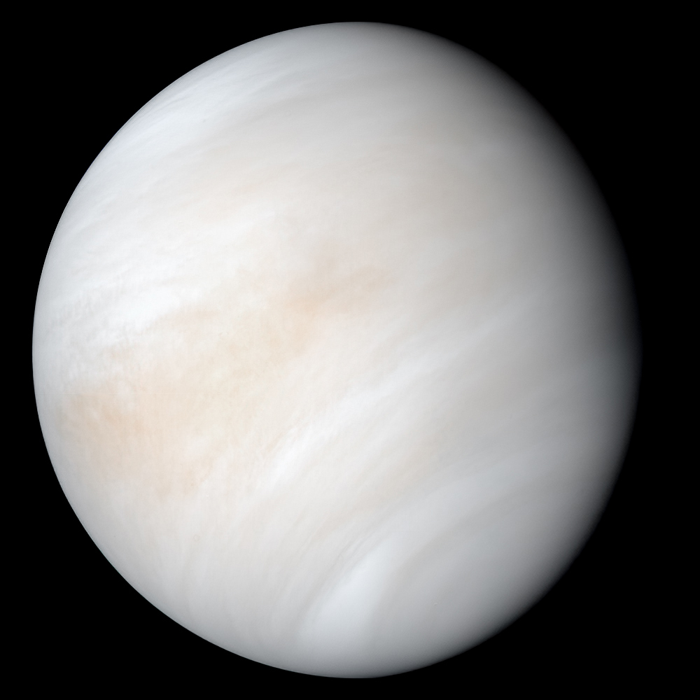
Venus taken by Mariner 10 on its way to Mercury
Summary
Description
English: As it sped away from Venus, NASA's Mariner 10 spacecraft captured this seemingly peaceful view of a planet the size of Earth, wrapped in a dense, global cloud layer. But, contrary to its serene appearance, the clouded globe of Venus is a world of intense heat, crushing atmospheric pressure and clouds of corrosive acid.
Date 7 February 1974
Source https://solarsystem.nasa.gov/resources/2524/newly-processed-views-of-venus-from-mariner-10/
Author NASA/JPL-Caltech
Licensing
Public domain This file is in the public domain in the United States because it was solely created by NASA. NASA copyright policy states that "NASA material is not protected by copyright unless noted". (See Template:PD-USGov, NASA copyright policy page or JPL Image Use Policy.)
Warnings:
Use of NASA logos, insignia and emblems is restricted per U.S. law 14 CFR 1221.
The NASA website hosts a large number of images from the Soviet/Russian space agency, and other non-American space agencies. These are not necessarily in the public domain.
Materials based on Hubble Space Telescope data may be copyrighted if they are not explicitly produced by the STScI.[1] See also {{PD-Hubble}} and {{Cc-Hubble}}.
The SOHO (ESA & NASA) joint project implies that all materials created by its probe are copyrighted and require permission for commercial non-educational use. [2]
Images featured on the Astronomy Picture of the Day (APOD) web site may be copyrighted. [3]
The National Space Science Data Center (NSSDC) site has been known to host copyrighted content. Its photo gallery FAQ states that all of the images in the photo gallery are in the public domain "Unless otherwise noted."
This file, which was originally posted to https://solarsystem.nasa.gov/resources/2524/newly-processed-views-of-venus-from-mariner-10/, was reviewed on 29 September 2021 by reviewer Taivo, who confirmed that it was available there under the stated license on that date.
File history
Click on a date/time to view the file as it appeared at that time.

Date/Time Thumbnail Dimensions User Comment
current 10:33, 24 July 2022 Thumbnail for version as of 10:33, 24 July 2022 1,000 × 1,000 (269 KB) JCP-JohnCarlo (talk | contribs) Re-crop source from https://solarsystem.nasa.gov/system/downloadable_items/3277_PIA23791.tif
18:53, 24 May 2021 Thumbnail for version as of 18:53, 24 May 2021 948 × 1,007 (248 KB) PlanetsForLife (talk | contribs) Uploaded a work by NASA/JPL-Caltech from https://solarsystem.nasa.gov/resources/2524/newly-processed-views-of-venus-from-mariner-10/ with UploadWizard
You cannot overwrite this file.

File usage on Commons
The following 2 pages use this file:

User:Nicole Sharp/InstantCommons
File:Venus in natural color.jpg (file redirect)
File usage on other wikis
The following other wikis use this file:

Usage on ab.wikipedia.org
Венера
Usage on ckb.wiktionary.org
ڤینۆس
Usage on de.wikipedia.org
Benutzer:Eandré/JPG
Usage on el.wiktionary.org
Αφροδίτη
Usage on en.wikipedia.org
Venus
The Planets
Venera program
Pioneer Venus project
Vega program
Magellan (spacecraft)
List of montes on Venus
Talk:Venus
Timeline of discovery of Solar System planets and their moons
Sedna Planitia
Venera 11
Venera 9
Transit of Venus
2004 transit of Venus
2012 transit of Venus
Hesperus
List of Venus-crossing minor planets
Phosphorus (morning star)
List of craters on Venus
List of artificial objects on Venus
Arachnoid (astrogeology)
Venus in fiction
Ishtar Terra
Maat Mons
Maxwell Montes
Phases of Venus
Geology of Venus
Abeona Mons
Aphrodite Terra
Observations and explorations of Venus
Lakshmi Planum
Anala Mons
Neith (hypothetical moon)
524522 Zoozve
Meitner (Venusian crater)
Danilova (crater)
De Lalande (crater)
Cleopatra (crater)
Addams (crater)
Alcott (crater)
Yablochkina (crater)
Mead (crater)
Golubkina (crater)
Guilbert (crater)
Adivar (crater)
Ruth (Venusian crater)
View more global usage of this file.

Metadata
This file contains additional information such as Exif metadata which may have been added by the digital camera, scanner, or software program used to create or digitize it. If the file has been modified from its original state, some details such as the timestamp may not fully reflect those of the original file. The timestamp is only as accurate as the clock in the camera, and it may be completely wrong.

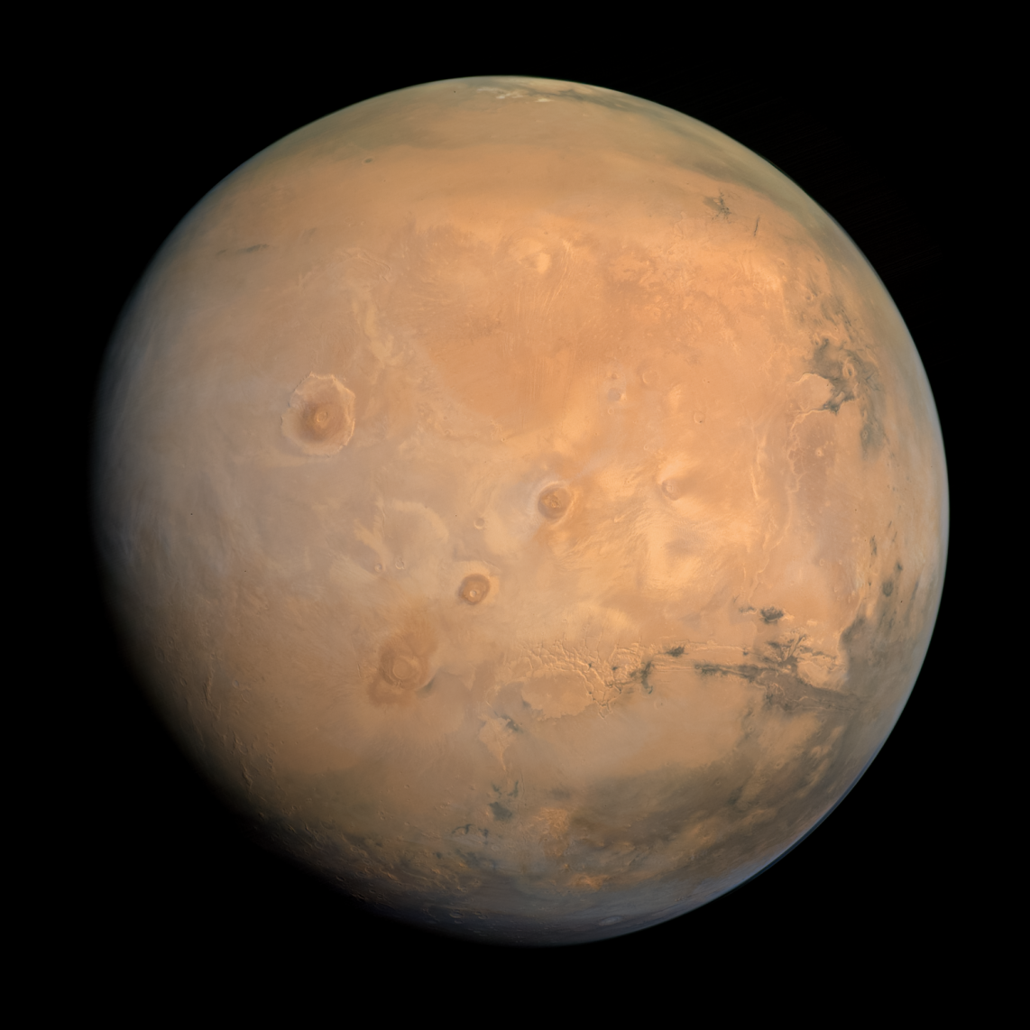
Original file (1,558 × 1,558 pixels, file size: 6.74 MB, MIME type: image/png)
Open in Media Viewer
File information
Structured data
Captions
English
Mars as seen by Hope
Summary
Description
Filters: f635, f546, f437

CU/LASP EMM/EXI ITF/Kevin M. Gill
Date Taken on 3 January 2022, 13:23
Source Mars - August 30 2021
Author Kevin Gill from Los Angeles, CA, United States
Flickr tags mars, emm, exi
Wikipedia

This is a featured picture on the Hebrew language Wikipedia (תמונות מומלצות) and is considered one of the finest images. See its nomination here.
If you think this file should be featured on Wikimedia Commons as well, feel free to nominate it.
If you have an image of similar quality that can be published under a suitable copyright license, be sure to upload it, tag it, and nominate it.

Licensing
w:en:Creative Commons
attribution
This file is licensed under the Creative Commons Attribution 2.0 Generic license.
You are free:
to share – to copy, distribute and transmit the work
to remix – to adapt the work
Under the following conditions:
attribution – You must give appropriate credit, provide a link to the license, and indicate if changes were made. You may do so in any reasonable manner, but not in any way that suggests the licensor endorses you or your use.
This image was originally posted to Flickr by Kevin M. Gill at https://flickr.com/photos/53460575@N03/51831155718. It was reviewed on 24 January 2022 by FlickreviewR 2 and was confirmed to be licensed under the terms of the cc-by-2.0.

File history
Click on a date/time to view the file as it appeared at that time.

Date/Time Thumbnail Dimensions User Comment
current 01:45, 24 January 2022 Thumbnail for version as of 01:45, 24 January 2022 1,558 × 1,558 (6.74 MB) Red panda bot (talk | contribs) In Flickr Explore: 2022-01-20
You cannot overwrite this file.

File usage on Commons
The following 10 pages use this file:

Mars
User:Hypersilly/Solar System Objects
User:Nicole Sharp/InstantCommons
Commons:Featured picture candidates/File:Mars - August 30 2021 - Flickr - Kevin M. Gill.png
Commons:Featured picture candidates/Log/June 2023
File:Mars - August 30 2021 (51831155718).png (file redirect)
Category:Maps of Mars
Category:Mars (planet)
Category:Martian deities
Category:Views from Mars
File usage on other wikis
The following other wikis use this file:

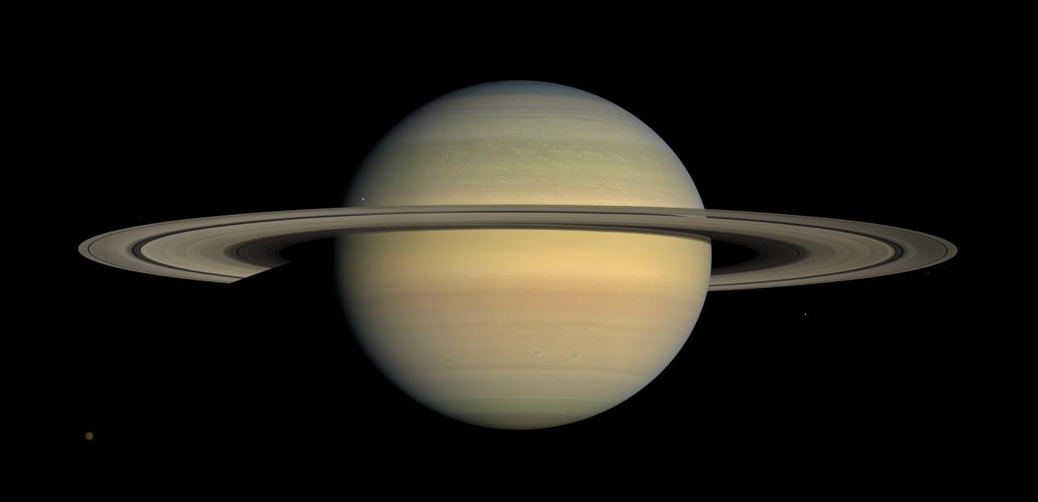
Description
العربية: هذه الصُورة الآسرة ذات الألوان الطبيعيَّة لِكوكب زُحل صُنعت عبر دمج عدَّة صُور التُقطت بعد فترةٍ قصيرةٍ من بدء مسبار كاسيني بِمُهمَّته الطويلة القاضية بِمُراقبة الاعتدال الشمسي، في شهر تمُّوز (يوليو) 2008م. (في الواقع بلغ زُحل اعتدالهُ الشمسي يوم 11 آب (أغسطس) 2009م.)
English: This natural color view of the planet Saturn was created from images collected shortly after Cassini began its extended Equinox Mission in July 2008. (Saturn actually reached equinox on August 11, 2009.)
Español: Esta foto de color natural del planeta Saturno fue creada de las fotos tomadas por Cassini durante su misión extendida del equinoccio en julio de 2008.
Tiếng Việt: Ảnh màu thực tế của Sao Thổ được chụp và thu thập ngay sau khi Cassini bắt đầu Sứ mệnh Phân điểm Cassini vào tháng 7 năm 2008. (Sao Thổ thực sự đạt đến điểm phân vào ngày 11 tháng 8 năm 2009)
Français : Vue en couleurs naturelles de la planète Saturne, créée d'après des images recueillies par la sonde spatiale Cassini peu de temps avant qu'elle commence sa mission « équinoxe » en juillet 2009. Six lunes sont aussi visibles: Titan (5150 kilomètres de diamètre), Janus (179 kilomètres), Mimas (396 km), Pandore (81 km), Épiméthée (113 km) et Encelade (504 km).
Original Caption Released with Image:

As Saturn advances in its orbit toward equinox and the sun gradually moves northward on the planet, the motion of Saturn's ring shadows and the changing colors of its atmosphere continue to transform the face of Saturn as seen by Cassini.
Natural color view created from images collected shortly after Cassini began its extended Equinox Mission in July 2008. It can be contrasted with earlier images from the spacecraft's four-year prime mission that show the shadow of Saturn's rings first draped high over the planet's northern hemisphere, then shifting southward as northern summer changed to spring (see PIA06606 and PIA09793). During this time, the colors of the northern hemisphere have evolved from azure blue to a multitude of muted-colored bands.
This mosaic combines 30 images—10 each of red, green and blue light—taken over the course of approximately two hours as Cassini panned its wide-angle camera across the entire planet and ring system on July 23, 2008, from a southerly elevation of 6 degrees.
Six moons complete this constructed panorama: Titan (5,150 kilometers, or 3,200 miles, across), Janus (179 kilometers, or 111 miles, across), Mimas (396 kilometers, or 246 miles, across), Pandora (81 kilometers, or 50 miles, across), Epimetheus (113 kilometers, or 70 miles, across) and Enceladus (504 kilometers, or 313 miles, across).
NASA's Cassini spacecraft captured these images at a distance of approximately 1.1 million kilometers (690,000 miles) from Saturn and at a sun-Saturn-spacecraft, or phase, angle of 20 degrees. Image scale is 70 kilometers (43.6 miles) per pixel.
The Cassini-Huygens mission is a cooperative project of NASA, the European Space Agency and the Italian Space Agency. The Jet Propulsion Laboratory, a division of the California Institute of Technology in Pasadena, manages the mission for NASA's Science Mission Directorate, Washington, D.C. The Cassini orbiter and its two onboard cameras were designed, developed and assembled at JPL. The imaging operations center is based at the Space Science Institute in Boulder, Colo.
For more information about the Cassini-Huygens mission visit http://saturn.jpl.nasa.gov/. The Cassini imaging team homepage is at http://ciclops.org.
Date 23 July 2008
Source http://www.ciclops.org/view/5155/Saturn-Four-Years-On http://www.nasa.gov/images/content/365640main_PIA11141_full.jpg http://photojournal.jpl.nasa.gov/catalog/PIA11141
Author NASA / JPL / Space Science Institute
Other versions
Image extraction process
This image has multiple extracted files:

Saturn during Equinox (without moons).jpg

Saturn during Equinox (cropped).jpg

Saturn closeup.jpg
Assessment
Picture of the day
Featured picture
Valued image
Wikimedia CommonsWikipedia

This file was the picture of the day on October 6, 2009.
This is a featured picture on Wikimedia Commons (Featured pictures) and is considered one of the finest images. See its nomination here.
This image has been assessed under the valued image criteria and is considered the most valued image on Commons within the scope Saturn. See its nomination here.
Wikipedia
If you have an image of similar quality that can be published under a suitable copyright license, be sure to upload it, tag it, and nominate it.

Licensing
This image or video was catalogued by Jet Propulsion Laboratory of the United States National Aeronautics and Space Administration (NASA) under Photo ID: PIA11141.
This tag does not indicate the copyright status of the attached work. A normal copyright tag is still required. See Commons:Licensing.
Public domain This file is in the public domain in the United States because it was solely created by NASA. NASA copyright policy states that "NASA material is not protected by copyright unless noted". (See Template:PD-USGov, NASA copyright policy page or JPL Image Use Policy.)
Warnings:
Use of NASA logos, insignia and emblems is restricted per U.S. law 14 CFR 1221.
The NASA website hosts a large number of images from the Soviet/Russian space agency, and other non-American space agencies. These are not necessarily in the public domain.
Materials based on Hubble Space Telescope data may be copyrighted if they are not explicitly produced by the STScI.[1] See also {{PD-Hubble}} and {{Cc-Hubble}}.
The SOHO (ESA & NASA) joint project implies that all materials created by its probe are copyrighted and require permission for commercial non-educational use. [2]
Images featured on the Astronomy Picture of the Day (APOD) web site may be copyrighted. [3]
The National Space Science Data Center (NSSDC) site has been known to host copyrighted content. Its photo gallery FAQ states that all of the images in the photo gallery are in the public domain "Unless otherwise noted."
File history
Click on a date/time to view the file as it appeared at that time.

Date/Time Thumbnail Dimensions User Comment
current 02:01, 20 May 2022 Thumbnail for version as of 02:01, 20 May 2022 4,613 × 2,233 (2.2 MB) Pi.1415926535 (talk | contribs) Reverted to version as of 08:12, 11 September 2018 (UTC)
01:55, 20 May 2022 Thumbnail for version as of 01:55, 20 May 2022 4,611 × 2,230 (487 KB) Italyoz484 (talk | contribs) Make Titan Brighter

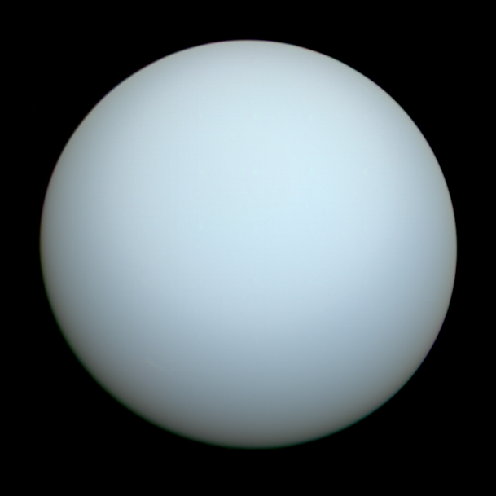
Size of this preview: 830 × 830 pixels. Other resolutions: 250 × 250 pixels | 500 × 500 pixels.
Original file (830 × 830 pixels, file size: 1.79 MB, MIME type: image/png)
Open in Media Viewer
File information
Structured data
Captions
English
Uranus on 1986-01-23 formula NASA's Voyager 2 probe.
Summary
Description
English: Uranus on 1986-01-23, taken by NASA's Voyager 2 probe. This color image was composed of three frames, orange, green, and blue, taken by Voyager 2's imaging system. This color image has been calibrated to best represent Uranus's true color and appearance. Based on: (in English) Irwin, Patrick G J (2023-12-23). "Modelling the seasonal cycle of Uranus’s colour and magnitude, and comparison with Neptune". Monthly Notices of the Royal Astronomical Society 527 (4): 11521–11538. DOI:10.1093/mnras/stad3761. ISSN 0035-8711.
Date 7 January 2024
Source Own work
also published on Flickr: https://www.flickr.com/photos/197038812@N04/53449450202/
Author Ardenau4
Licensing
I, the copyright holder of this work, hereby publish it under the following license:
Creative Commons CC-Zero This file is made available under the Creative Commons CC0 1.0 Universal Public Domain Dedication.
The person who associated a work with this deed has dedicated the work to the public domain by waiving all of their rights to the work worldwide under copyright law, including all related and neighboring rights, to the extent allowed by law. You can copy, modify, distribute and perform the work, even for commercial purposes, all without asking permission.

File history
Click on a date/time to view the file as it appeared at that time.

Date/Time Thumbnail Dimensions User Comment
current 07:41, 8 January 2024 Thumbnail for version as of 07:41, 8 January 2024 830 × 830 (1.79 MB) Ardenau4 (talk | contribs) Uploaded own work with UploadWizard
You cannot overwrite this file.

File usage on Commons
The following 8 pages use this file:

Uranus
User:Hypersilly/Solar System Objects
Commons:Valued image candidates/Uranus Voyager2 color calibrated.png
File:Sao Thiên Vương, được phát hiện bởi Herschel năm 1781.png (file redirect)
File:Uranus2.jpg
File:Uranus as seen by NASA's Voyager 2 (remastered).png
File:Uranus as seen by NASA's Voyager 2 (remastered) - JPEG converted.jpg
Category:Uranus (planet)
File usage on other wikis
The following other wikis use this file:

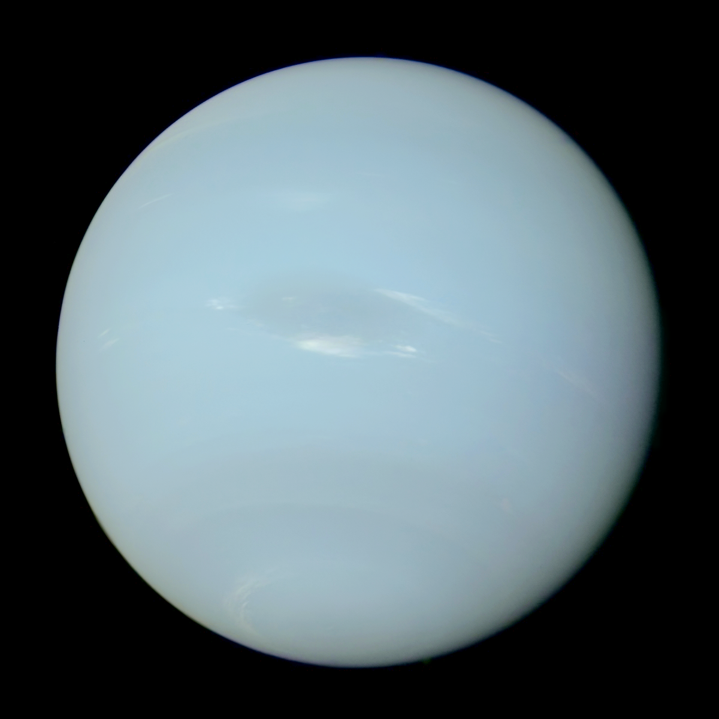
English: Neptune on 1989-08-17, taken by NASA's Voyager 2 probe. This color image was composed of three frames, orange, green, and blue, taken by Voyager 2's imaging system. This color image has been calibrated to best represent Neptune's true color and appearance. Based on: (in English) Irwin, Patrick G J (2023-12-23). "Modelling the seasonal cycle of Uranus’s colour and magnitude, and comparison with Neptune". Monthly Notices of the Royal Astronomical Society 527 (4): 11521–11538. DOI:10.1093/mnras/stad3761. ISSN 0035-8711.
Date 1989-08-17
2024-01-06
Source Own work
also published on Flickr: https://www.flickr.com/photos/197038812@N04/53446862462/
Author NASA / Voyager 2 / PDS / OPUS / Ardenau4
Other versions
Neptune Voyager2 color calibrated, brightened.png
Neptune Voyager2 color calibrated, brightened.png
Licensing
I, the copyright holder of this work, hereby publish it under the following license:
Creative Commons CC-Zero This file is made available under the Creative Commons CC0 1.0 Universal Public Domain Dedication.
The person who associated a work with this deed has dedicated the work to the public domain by waiving all of their rights to the work worldwide under copyright law, including all related and neighboring rights, to the extent allowed by law. You can copy, modify, distribute and perform the work, even for commercial purposes, all without asking permission.

