Delenthia M. Harrison

Harrisond1528@forsythtech.edu

ELEVATE RETAIL:

CAPSTONE PROJECT NOTEBOOK

Program: Data Analytics and Reporting

Institution: Forsyth Technical Community College

Instructor: T. Holleman

Course: DBA 289

Date: May 1, 2025

# Introduction

The Elevate Retail Capstone Project is a business intelligence solution designed using Power BI to help a fictional retail company make data-informed decisions. The project was structured around the System Development Life Cycle (SDLC), a methodology that ensures the development process is organized, traceable, and goal-oriented. By applying SDLC principles across planning, analysis, design, implementation, and maintenance stages, this project was able to produce a multi-page interactive dashboard suite tailored to different stakeholder roles within the company.

The importance of using SDLC lies in its ability to break complex development work into manageable and measurable phases. For a project like this—where data modeling, stakeholder needs, visual storytelling, and performance must align—SDLC ensured that each component was not only designed with purpose, but also tested and refined with usability in mind.

# Planning Phase

Problem Statement:

Elevate Retail lacked a centralized, interactive system to track sales, product performance, and customer retention. Decision-makers relied on static reports, limiting their ability to respond quickly to trends.

Goals and Objectives:

- Create a multi-page Power BI dashboard suite  
- Address the needs of executives, managers, and analysts  
- Enable interactive filtering, KPI visibility, and trend analysis

Feasibility Study Summary:

- Technical: Tools like Power BI, Excel, and DAX are accessible and well-supported  
- Economic: Free licenses and no new infrastructure needed  
- Operational: Easy to use; aligns with stakeholder workflows

# Analysis Phase

Requirements Gathering Summary:

Conducted simulated stakeholder interviews, team planning discussions, and role-based need analysis. Considered customer, product, and sales-related KPIs and usability expectations.

Functional Requirements:

- KPI calculation  
- Interactivity  
- Visual breakdowns

Non-Functional Requirements:

- Responsive layout  
- Fast load  
- Clean design

CSV Files (Data Sources)

↓

Power BI Query Editor

↓

DAX Model & Measures

↓

Interactive Dashboards

↓

Business Stakeholders

Figure 1: Context diagram representing data flow through the system.

Start

↓

Import CSV Files

↓

Clean & Transform (Power Query)

↓

Create Measures (DAX)

↓

Build Dashboards

↓

Export/Publish

↓

End

Figure 2: System flowchart showing Power BI development steps.

# Design Phase

The following section outlines the database and user interface structure for Elevate Retail's reporting system. 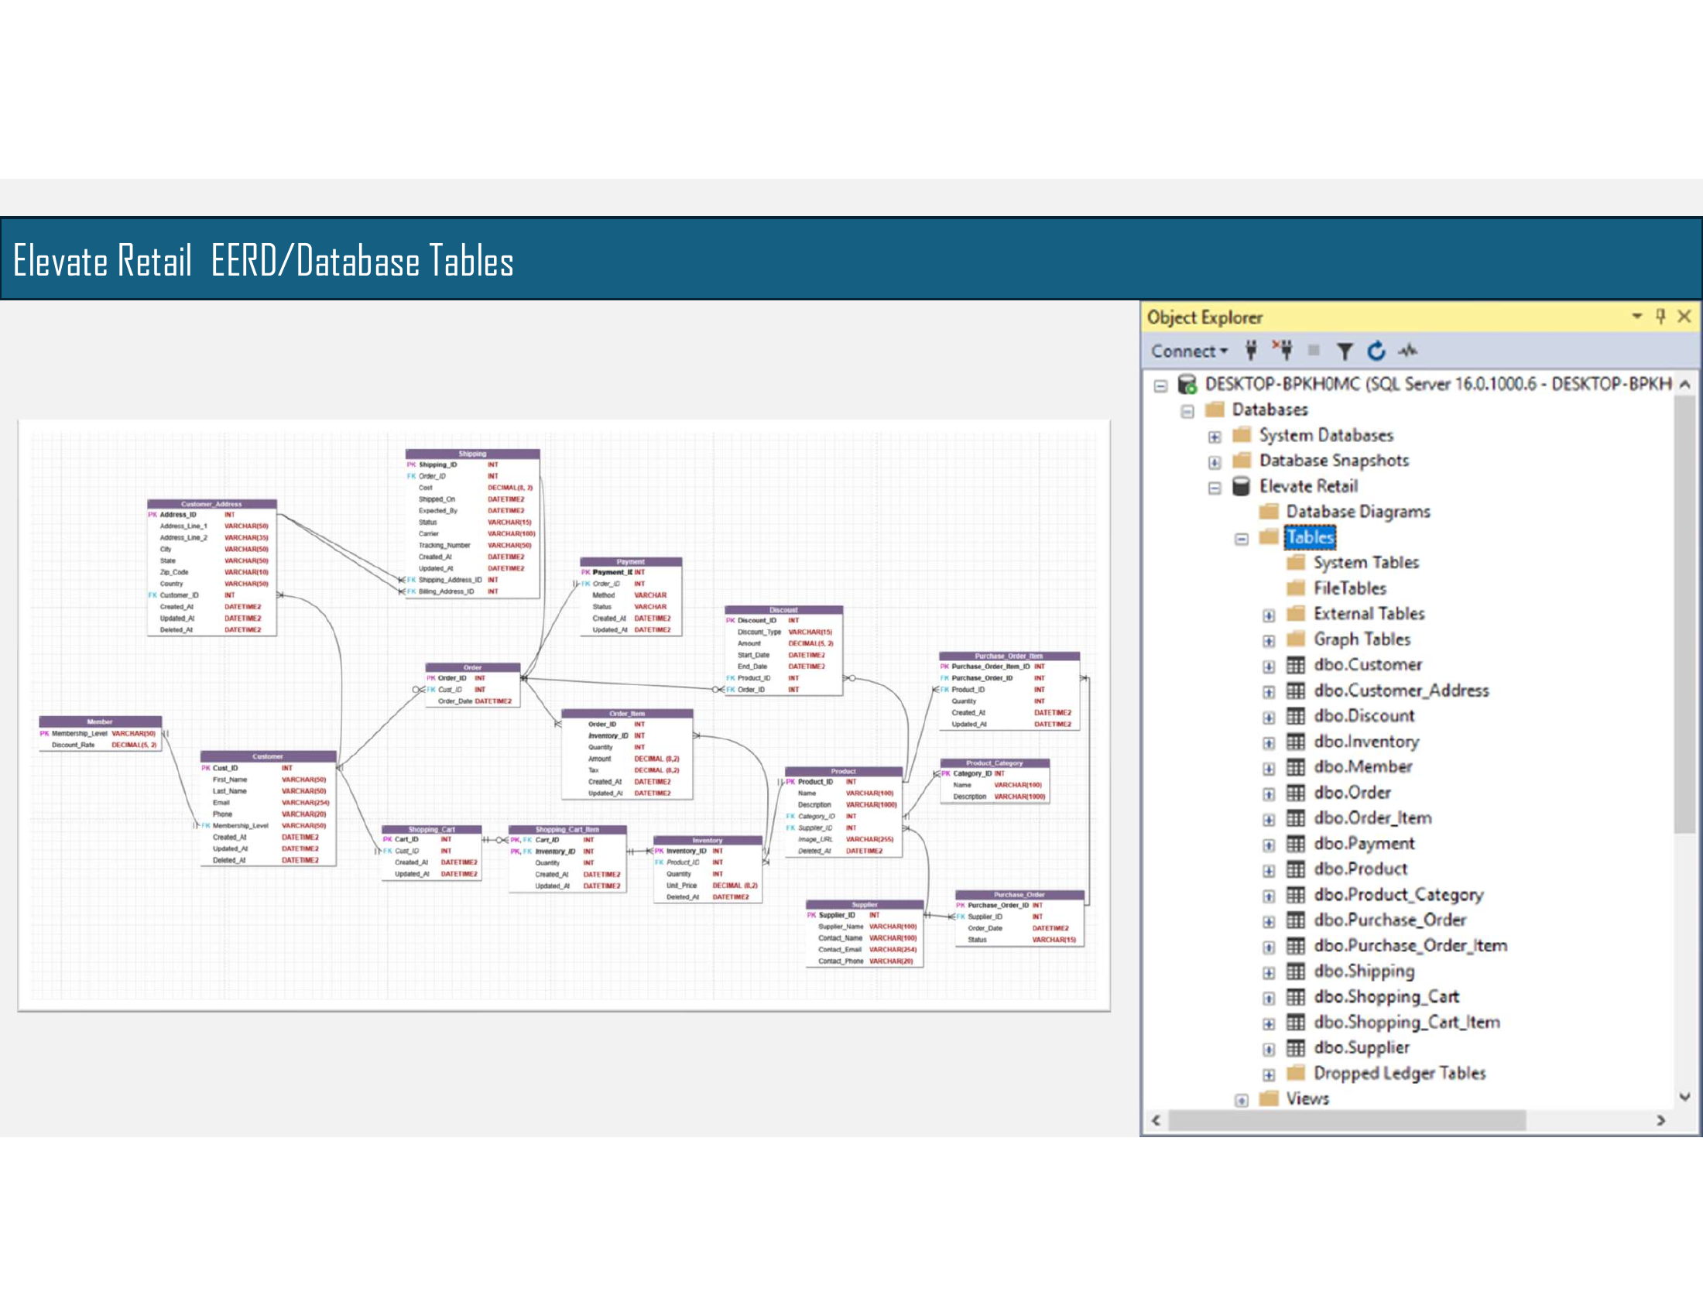Figure 3: Final Enhanced Entity Relationship Diagram (EERD) for Elevate Retail.

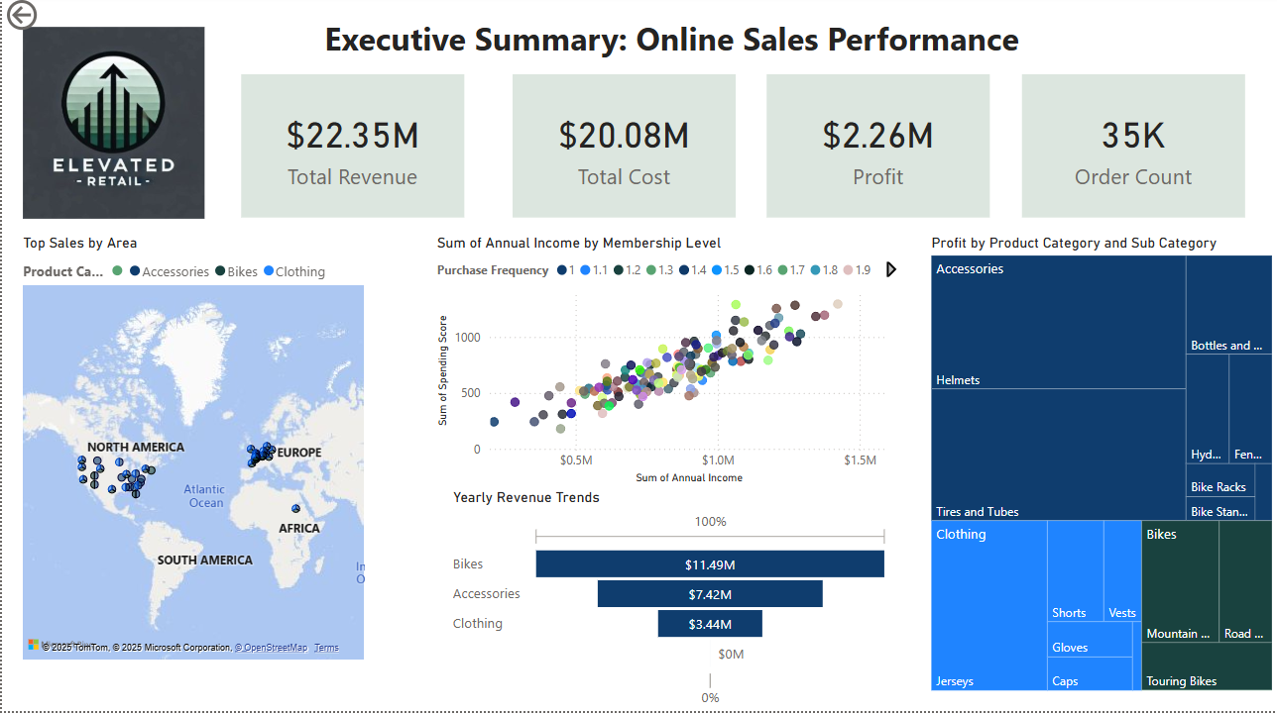

Figure 4: Executive Summary – Online Sales Performance Dashboard

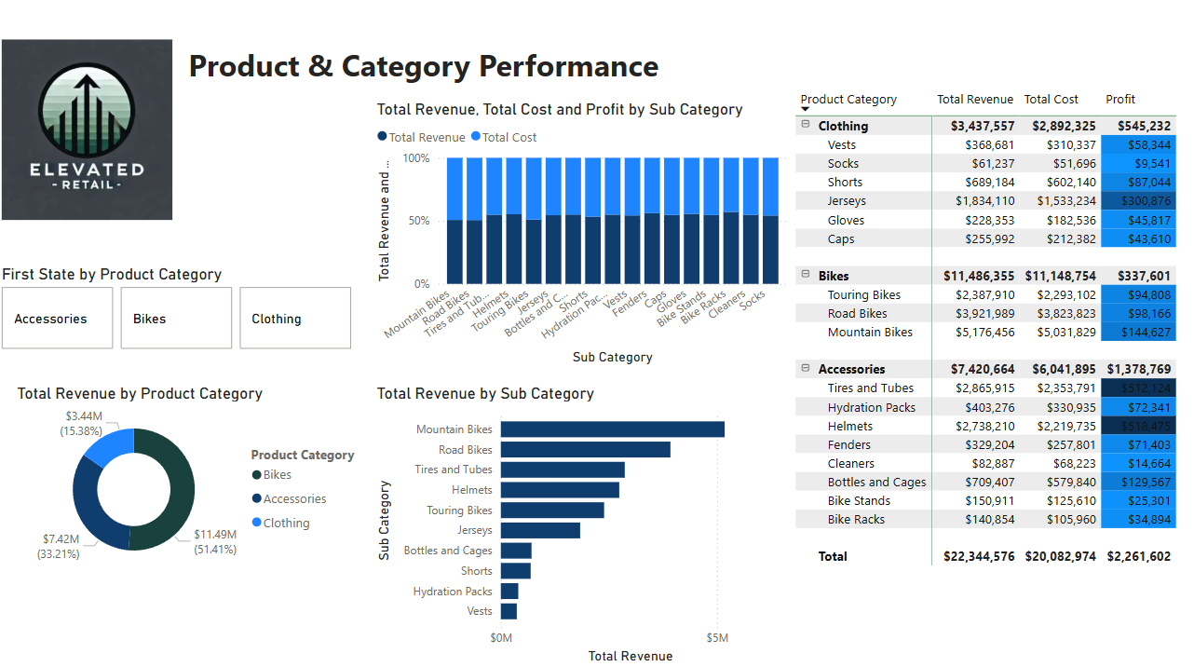

Figure 5: Product & Category Performance Dashboard

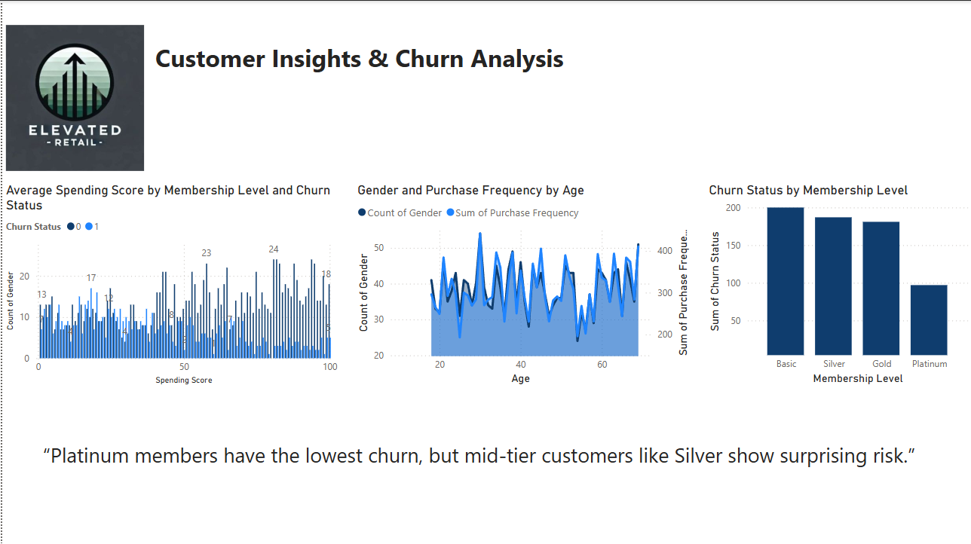

Figure 6: Customer Insights & Churn Analysis Dashboard

# Implementation Phase

Sample DAX Code:  
Total Revenue = SUM(Sales_Data[Revenue])  
Profit = [Total Revenue] - [Total Cost]  
Churn Rate = DIVIDE(CALCULATE(COUNTROWS(Customer_Data), Customer_Data[Churn_Status] = 1), COUNTROWS(Customer_Data))

## Testing Plan Summary

The following items were tested during implementation:  
- Accuracy of DAX measures for revenue, cost, profit, and churn  
- Functionality of slicers across all pages  
- Visual consistency and formatting  
- Filter and drill-down interactivity  
- Page load performance in Power BI Desktop

# Maintenance Phase

Update Plans:  
- Weekly data refresh through Power BI service  
- Documentation of refresh and publishing steps

Future Recommendations:  
- Add forecasting visuals  
- Embed in mobile app or web platform  
- Include natural language Q&A visual

Risk Mitigation Strategies:  
- Backup datasets  
- Document data logic  
- Lock filters and slicers where necessary

# Conclusion

Overall, the Elevate Retail dashboard project was a success. It addressed the organization’s problem by creating an interactive, role-specific dashboard suite that helps visualize performance metrics, identify customer trends, and inform strategic planning.  
  
Applying the SDLC provided a clear roadmap for the project. It helped ensure that the dashboard was not only visually polished but grounded in meaningful business objectives. From requirement gathering to testing and delivery, each phase contributed to a final product that is functional, user-friendly, and portfolio-worthy.  
  
If repeated, future improvements would include adding more automation to data ingestion and expanding user testing to ensure clarity across different roles. The SDLC framework was instrumental in helping me stay focused, manage complexity, and produce a solution that mirrors real-world business intelligence practices.