Optic Disc and Fovea Detection
Delfin Aksu
1. Department of Computer Engineering, Eskisehir Technical University
delfinaksu@ogr.eskisehir.edu.tr

Abstract
This project presents a complete classical image-processing pipeline for three retinal-fundus analysis tasks - optic disc localization, fovea localization, and optic disc segmentation - evaluated on the publicly available IDRiD dataset. The pipeline is built without machine learning so that every intermediate map (field mask, multi-scale brightness maps, multi-orientation bottom-hat vessel response, top-hat lesion penalty, weighted score map) is interpretable and every operation is a textbook image-processing technique: CLAHE, Gaussian smoothing, unsharp masking, multi-orientation morphological filtering, Otsu and percentile-adaptive thresholding, morphological reconstruction, connected-component analysis, and inpainting. The optic disc center is located by fusing five feature maps into a single score map and selecting the score-weighted center of mass of the highest-scoring connected component within an image-adaptive bright-candidate mask. The fovea is then located using anatomical priors derived from the predicted optic disc position. Finally, the optic disc boundary is segmented inside a region of interest by vessel inpainting, adaptive thresholding, and morphological cleanup. An ablation and parameter-sensitivity study identified the percentile-adaptive threshold as the dominant pipeline component and showed that raising its value from the original 0.95 to 0.99 improves the success rate dramatically. On the IDRiD test set the final pipeline achieves 97.09 percent success rate at the 40 px threshold for both optic disc and fovea localization, and a mean Dice coefficient of 0.859 for optic disc segmentation. On the unseen IDRiD train set (used here only for independent validation) the same pipeline achieves 96.13 percent, 94.92 percent, and 0.840 respectively, indicating strong generalization. All code, intermediate visualizations, and per-image metrics are reproducible via the main.m script in the project root.

Introduction
The optic disc (OD) and fovea are two of the most clinically important anatomical landmarks visible in a retinal fundus image. The optic disc is the bright, roughly circular region where the optic nerve and major blood vessels enter the eyeball. Its location, size, and the cup-to-disc ratio are widely used in the diagnosis of glaucoma, papilledema, and diabetic retinopathy. The fovea is the central pit of the macula, responsible for high-acuity vision. Lesions located within or close to the fovea cause severe vision loss, so quantifying lesion position relative to the fovea is essential for grading diabetic macular edema.
Almost every fundus image processing pipeline begins by locating these two landmarks and, where possible, delineating the boundary of the optic disc. This project develops three classical image processing components that solve these tasks on the publicly available IDRiD dataset, without using any deep learning model:
- Optic Disc Localization — find a single pixel coordinate (x, y) for the disc center.
- Fovea Localization — find a single pixel coordinate (x, y) for the foveal pit.
- Optic Disc Segmentation — produce a binary mask covering the disc area.

Material and Method
2.1 Dataset
In this study, the IDRiD (Indian Diabetic Retinopathy Image Dataset) obtained from the IEEE Dataport platform was used. [1] The dataset is originally organized into three main components: A. Segmentation, B. Disease Grading, and C. Localization.
Since the objective of this project is optic disc segmentation and the detection of optic disc and fovea centers, only the A. Segmentation and C. Localization subsets were utilized.
The A. Segmentation subset contains retinal fundus images along with their corresponding ground truth masks for optic disc segmentation. Although the segmentation dataset includes annotations for multiple retinal lesions, only the optic disc masks were utilized in this study, in accordance with the defined problem scope. The dataset is pre-divided into training and test sets, consisting of 54 training images and 27 test images. Each image is associated binary mask indicating the optic disc region.
The C. Localization subset includes retinal images and annotation files containing the coordinates of anatomical landmarks. These annotations are provided separately for optic disc and fovea in CSV format. The dataset contains 413 training images and 103 test images for the localization task. Each CSV file stores the corresponding center coordinates for the optic disc and fovea for each image.
This structured dataset enables both segmentation-based and coordinate-based evaluation of the optic disc and fovea detection tasks.

All raw images have a native resolution of 4288 x 2848 pixels. As the first step of every pipeline, every image is resized to 512 x 512 pixels. Three reasons motivate this resizing:
- Computational cost — multi-orientation morphological filtering and convolution operations would be prohibitively slow at full resolution.
- Filter scale consistency — the morphological structuring elements and Gaussian kernels used throughout the pipeline are tuned to fixed pixel sizes. A consistent input resolution ensures that, for example, a 21-pixel line structuring element corresponds to roughly the same physical distance across all images.
- Sufficient detail — at 512 x 512 the optic disc still spans approximately 80 pixels in diameter and individual major vessels are still 2-5 pixels wide, both of which are large enough for the chosen morphological operators to detect reliably.
Ground-truth coordinates are scaled by the same factor (sx = sy = 512 / original_dimension). For evaluation, an OD or fovea prediction is considered successful if the Euclidean distance between the predicted and the ground-truth coordinate is below 40 pixels in the 512 x 512 scale, which corresponds to roughly one optic disc radius. Segmentation is evaluated with the Dice coefficient and the Jaccard index (IoU).
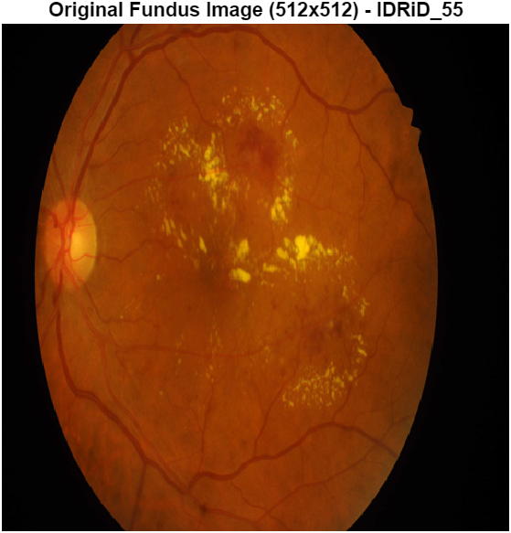
Figure 1. Sample retinal fundus image from the IDRiD dataset (IDRiD_55), resized to 512 x 512. This image is used as the running example throughout the report.

2.2 Preprocessing
The preprocessing block is identical for all three pipelines and is implemented in preprocessFundusImage.m. It produces two channels — a preprocessed red channel for brightness-based reasoning and a preprocessed green channel for vessel-based reasoning — both at 512 x 512 resolution. Five distinct image processing operations are applied:
2.2.1 Color Channel Separation
Of the three RGB channels, the red channel best preserves the broad illumination profile of the retina because the deeper retinal layers predominantly reflect long-wavelength light. The optic disc is therefore very bright in the red channel. The green channel exhibits the highest vessel-to-background contrast — vessels appear dark on a moderately bright background — so the green channel is preferred for any operation that relies on vessel structure. The blue channel is heavily dominated by sensor noise in fundus imaging and is not used.
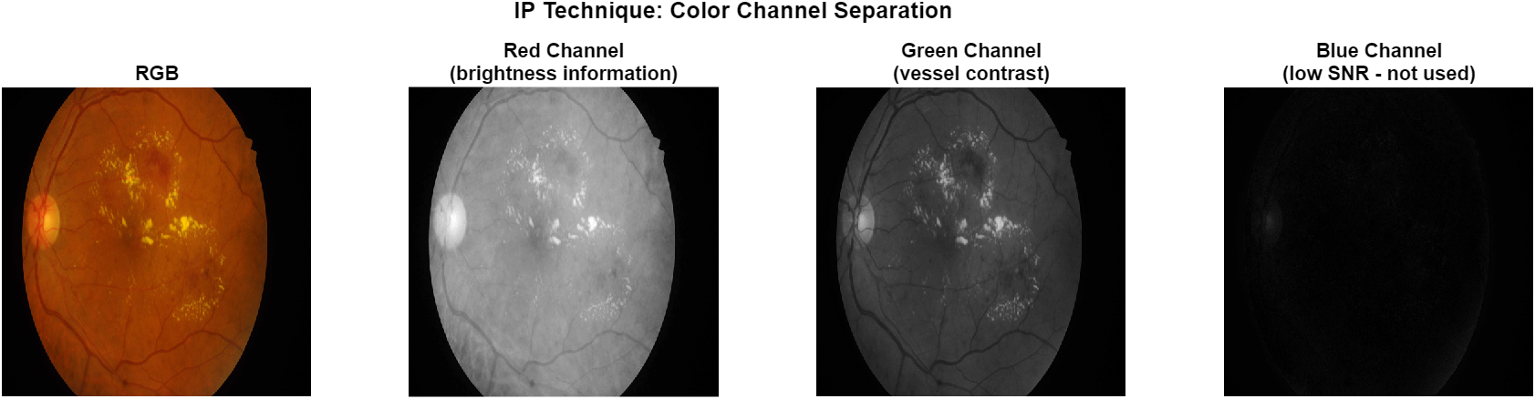
Figure 2. Color channel separation of IDRiD_55. The red channel carries broad brightness information; the green channel carries fine vessel structure; the blue channel is too noisy to be useful.

2.2.2 CLAHE (Contrast Limited Adaptive Histogram Equalization)
Fundus images suffer from heterogeneous illumination: the central macular region is bright while the peripheral retina is darker. A naive global histogram equalization would amplify noise in the dark periphery without improving local contrast where it is most needed. CLAHE addresses this by dividing the image into small tiles (8 x 8 in this implementation), computing a local histogram inside each tile, clipping the histogram at a contrast limit to avoid noise amplification, and applying the equalization per tile with bilinear interpolation between tiles to avoid blocky artifacts. The result is an image where local structures — including the optic disc edge and the vessel network — are rendered with substantially higher contrast.
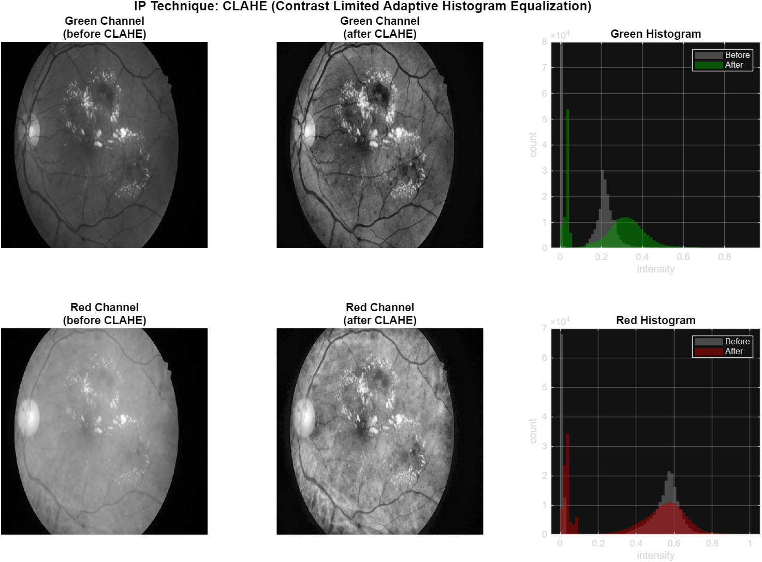
Figure 3. Effect of CLAHE on the green and red channels. The right column shows the intensity histograms before and after CLAHE: the redistributed histogram covers a wider range, indicating improved local contrast.
2.2.3 Gaussian Smoothing
After CLAHE, both channels are smoothed with a Gaussian kernel of standard deviation sigma = 6 pixels. The optic disc is roughly 30-50 pixels in radius at 512 x 512 resolution, so a sigma of 6 pixels is large enough to suppress small-scale pixel noise and individual lesion specks while preserving the broad shape of the disc. This smoothed channel is the input used by all brightness-based feature maps later in the pipeline. Note however that this same smoothing also attenuates fine vessel structures, so a separate sharpening step (Section 2.2.4) is applied just before vessel detection.
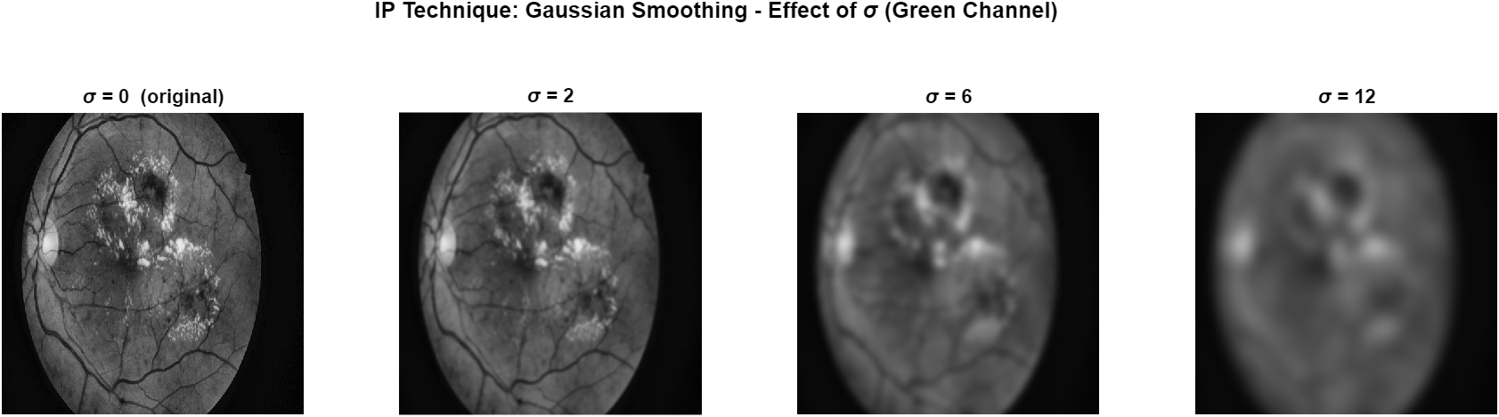
Figure 4. Effect of Gaussian smoothing on the green channel for four values of sigma. Smaller sigma preserves vessel detail; larger sigma removes vessels and yields a smooth illumination map.
Note that the shared preprocessing intentionally stops at this point. All three downstream modules (OD localization, fovea localization, OD segmentation) consume the same pre.red and pre.green channels. Any module-specific transformations — such as the unsharp masking applied internally by the OD localization module to restore vessel contrast (see Section 2.3.5) — are performed inside the module that needs them, not in the shared preprocessing block. This separation of concerns follows the DRY principle: changing preprocessing only requires editing one file.
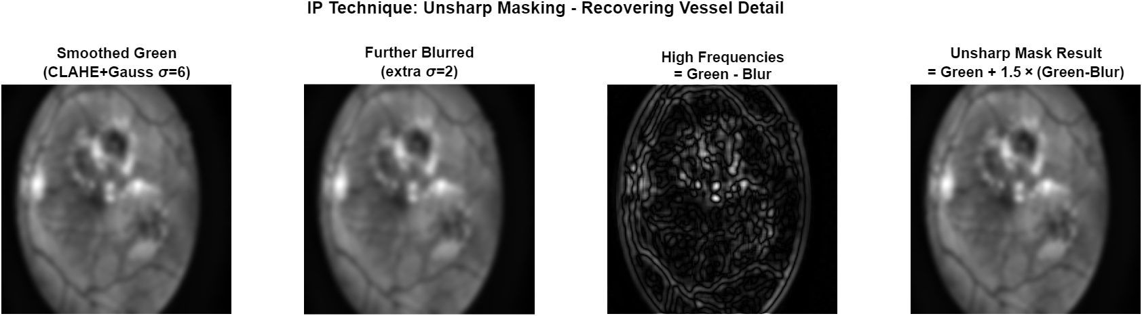
Figure 5. Unsharp masking applied to the smoothed green channel. The high-frequency component (third panel) reveals the vessel structure that was attenuated by Gaussian smoothing; the unsharp result (rightmost panel) restores it.

2.3 Optic Disc Localization

2.3.1 Field Mask Construction
The first step is to identify which pixels belong to the retina and which belong to the black background that surrounds the circular field of view. This field mask is computed in three sequential morphological steps: (1) thresholding the preprocessed red channel at red > 0.05 to separate retina pixels from the black border, (2) imfill('holes') to close any small interior holes caused by very dark vessels or shadows near the field boundary, and (3) bwareaopen with a minimum area of 5000 pixels to remove any small isolated noise blobs that the threshold may have mistakenly accepted. Every subsequent feature map will be masked by this field mask, so that no feature score can fall on the black background and pull the prediction outside the retina.
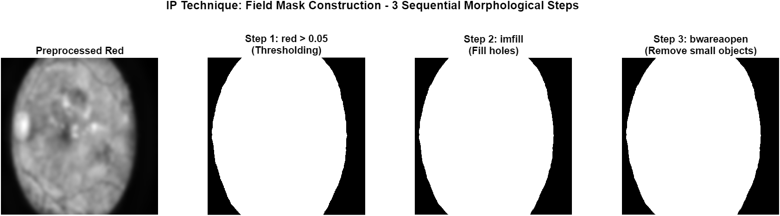
Figure 6. Field mask construction in three sequential morphological operations: thresholding, hole filling, and small-object removal.
2.3.2 Multi-Scale Brightness Maps
Two brightness maps are computed from the preprocessed red channel by Gaussian filtering at two different scales: brightMap = Gauss(red, sigma = 16) captures the broad illumination profile and emphasizes the general region where the disc is located; brightStrong = Gauss(red, sigma = 8) is more local and emphasizes the brighter inner core of the disc itself. Both maps are normalized to [0, 1] (mat2gray) before fusion. The combination of two scales is important because no single scale handles all images well: a sigma that is too small produces many competing bright spots; a sigma that is too large blurs the disc into a uniform halo.
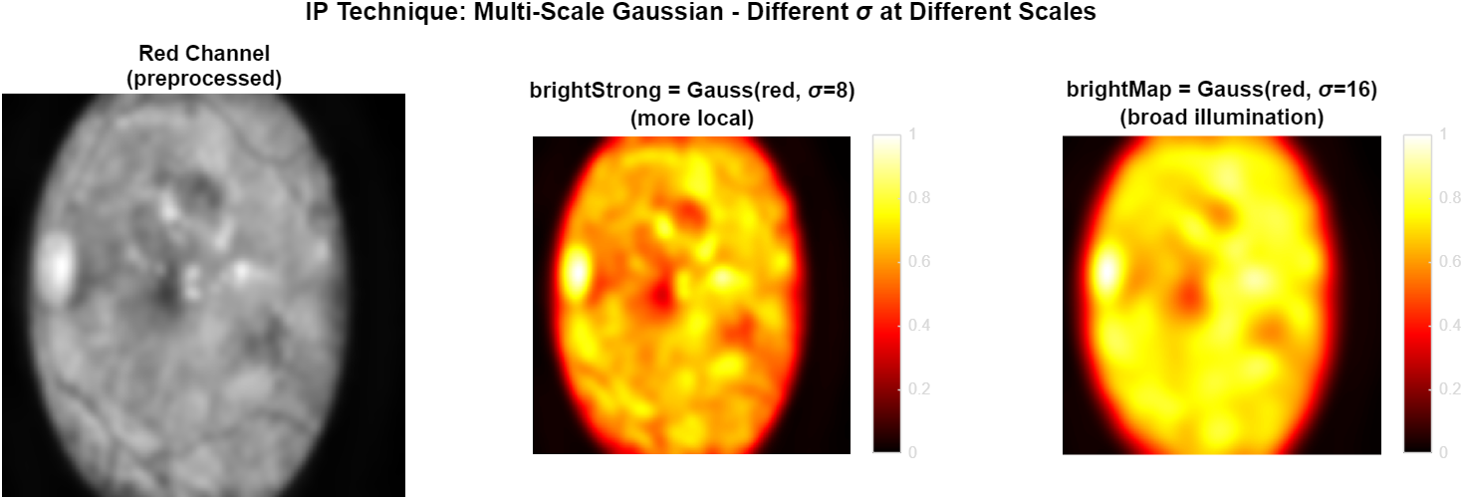
Figure 7. Multi-scale brightness maps. Smaller sigma keeps local detail; larger sigma extracts the broad illumination profile that highlights the disc region.
2.3.3 Adaptive Percentile Thresholding
To restrict the search for the disc to a small set of bright candidate regions, an adaptive percentile threshold is applied to brightMap. Concretely, all brightMap values inside the field mask are sorted, and the 95th percentile value is selected as the threshold. This makes the threshold image-specific: an image with overall low brightness will get a lower threshold, an image with overall high brightness will get a higher one, but in both cases the top 5% of bright pixels become candidate regions. A fixed threshold (such as 0.65) would fail completely on globally darker images.
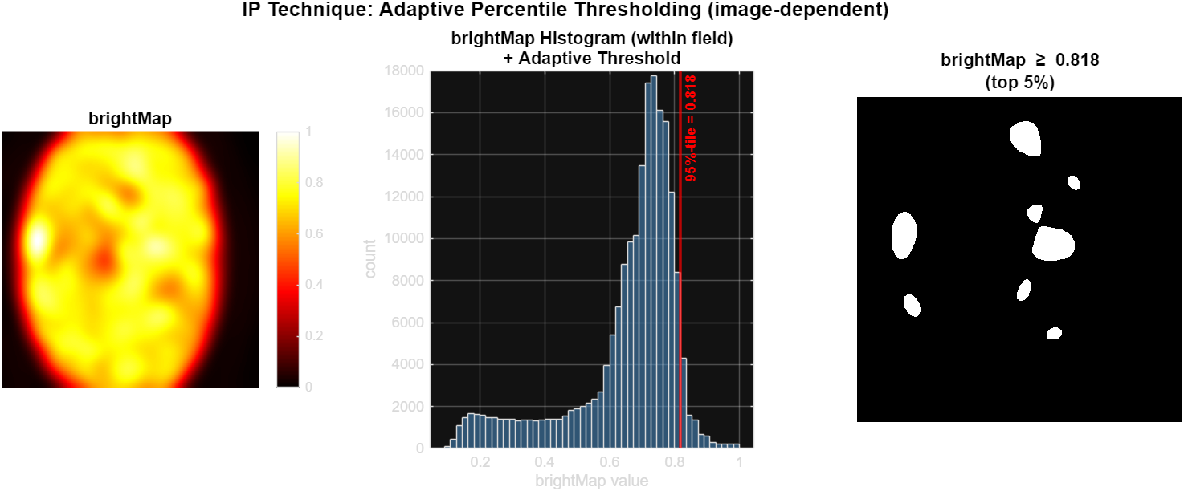
Figure 8. Adaptive percentile thresholding. The histogram of brightMap values inside the field mask is used to find the 95th-percentile intensity, which becomes the image-specific threshold.
2.3.4 Bright Candidate Cleanup
After thresholding, the resulting binary mask is cleaned with two morphological operations: imopen with a disk of radius 3 to break thin bridges between the optic disc and adjacent bright lesions, and bwareaopen with minimum size 200 pixels to remove tiny lesion specks that survived the threshold. The remaining connected components are called brightCandidates and represent the set of plausible optic disc regions in the image.
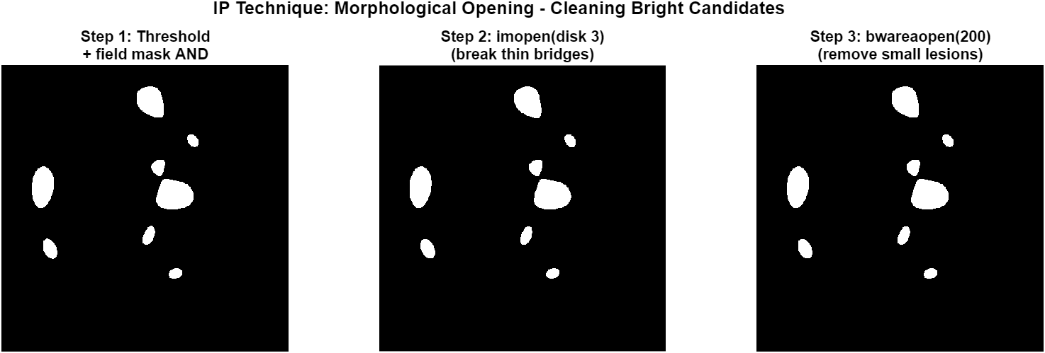
Figure 9. Three-step cleanup of the bright candidate mask. The opening step is critical for separating the optic disc from nearby bright exudate clusters in diabetic retinopathy images
2.3.5 Vessel-Targeted Unsharp Masking
The shared preprocessing block applies a relatively strong Gaussian smoothing (sigma = 6) which is appropriate for brightness-based reasoning but attenuates the very vessel structures that the next step needs to detect. To recover vessel contrast without disturbing the shared preprocessing, an unsharp mask is applied to the green channel inside the OD localization module: green_sharp = green + 1.5 x (green - blur(green, sigma=2)). The term (green - blur) is the high-frequency content of the smoothed image; multiplying it by 1.5 and adding it back boosts these high frequencies, restoring vessel detail while preserving the broad illumination profile. This sharpened channel is consumed only by the bottom-hat vessel detector in Section 2.3.6; the brightness maps and the lesion top-hat continue to use the original preprocessed red channel.
Figure 9. Unsharp masking applied internally to the smoothed green channel. The high-frequency component (third panel) reveals the vessel structure attenuated by Gaussian smoothing; the unsharp result (rightmost panel) restores it for use by the vessel detector.
2.3.6 Multi-Orientation Bottom-Hat Vessel Detection
Vessels appear as dark, elongated, locally-thin structures on a moderately bright background. The bottom-hat morphological operator with a line-shaped structuring element extracts exactly this pattern: for an SE oriented at angle theta, bothat(I, SE) returns the difference between a closing of I and I itself, which yields high values where I contains a thin dark feature aligned with the SE. Because vessels appear at every angle, the bottom-hat is computed at twelve orientations (0 to 165 degrees in 15-degree increments) and the per-pixel maximum across all orientations is taken. This produces vesselResponse, a map in which any vessel anywhere in the image lights up regardless of its local direction.
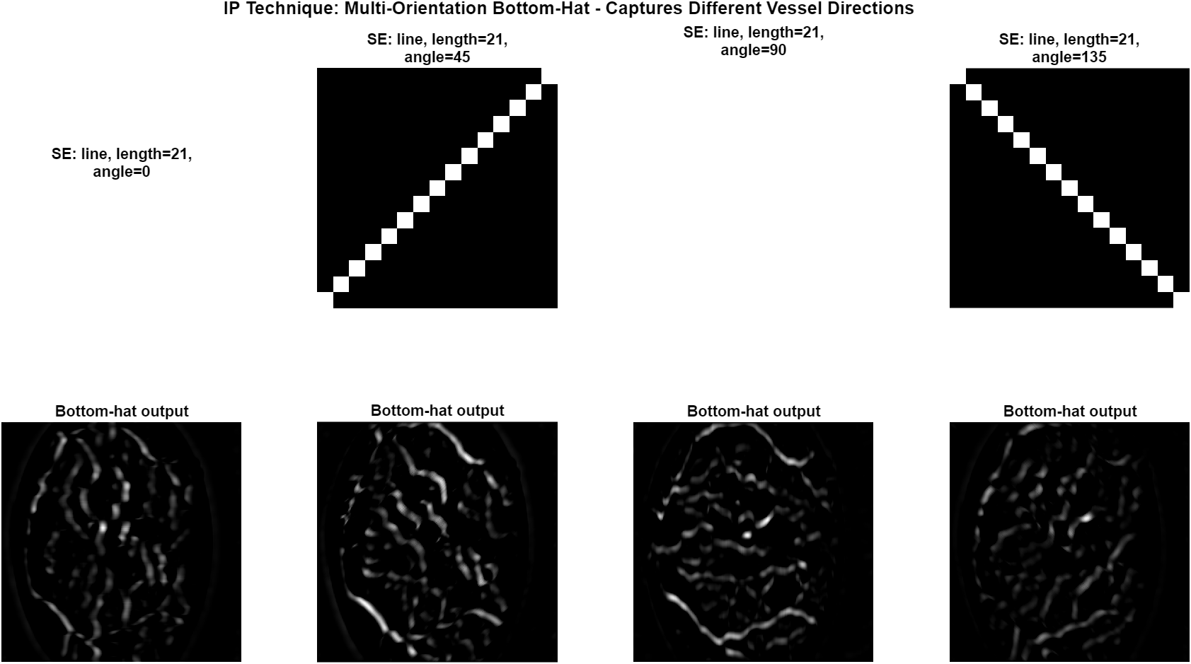
Figure 10. Bottom-hat outputs for four different SE orientations. Each orientation captures only vessels aligned with the SE direction; the final response is the per-pixel maximum across all twelve orientations.
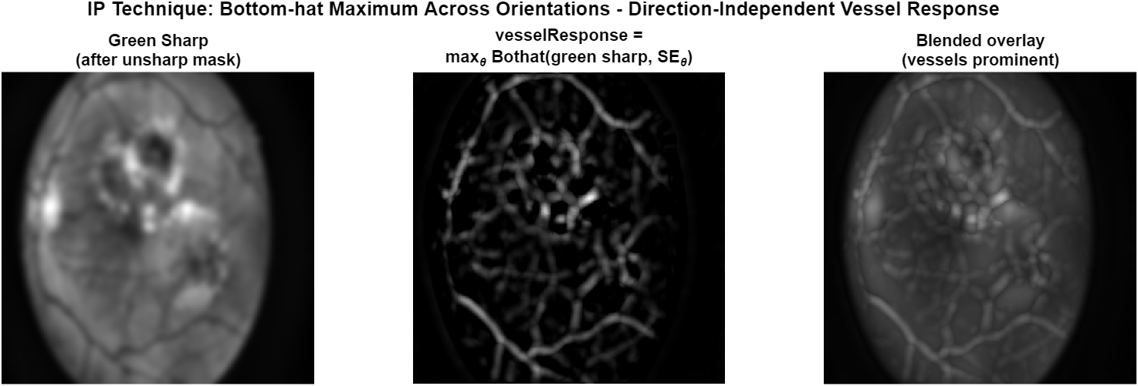
Figure 11. Final vesselResponse map (max across 12 orientations) overlaid on the green-sharp image. Major and minor vessels are visible at strong intensity.
2.3.7 Otsu Binarization of the Vessel Response
The vesselResponse map is converted to a binary vessel map using Otsu's automatic threshold[2], which finds the value that maximizes between-class variance in the response histogram. Small connected components below 30 pixels are then removed, and the result is intersected with the field mask. The resulting vesselMap is a clean binary image of the major and moderate retinal vessels.
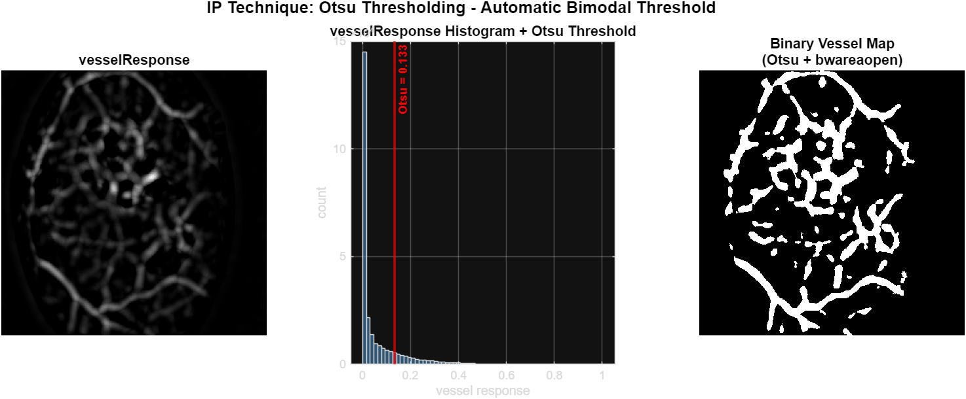
Figure 12. Otsu thresholding on the vesselResponse map. The histogram is approximately bimodal, and the automatic threshold cleanly separates vessel pixels from background.

2.3.8 Vessel Density via Disk-Kernel Convolution
In a healthy retina, the major vessels enter the eye through the optic disc and then diverge across the retinal surface. As a result, the local vessel density near the disc is significantly higher than in any other region of similar size. To exploit this, the binary vesselMap is convolved with a normalized disk kernel of radius 40 pixels — approximately matching the expected optic disc size. The resulting vesselDensity map peaks where vessels are most concentrated, which is overwhelmingly the optic disc region.
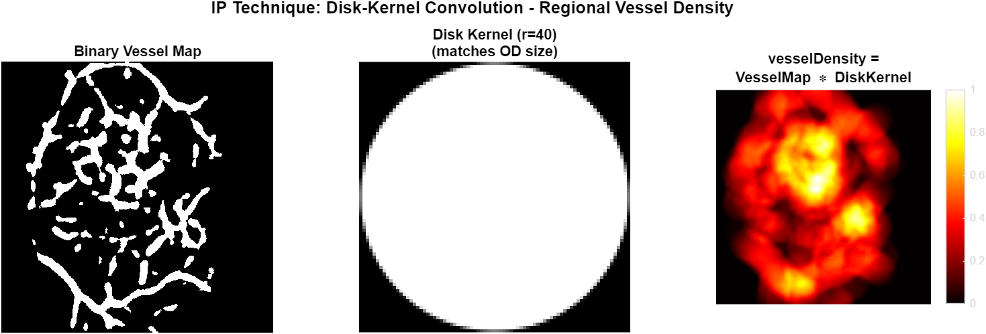
Figure 13. Disk-kernel convolution of the binary vessel map. The kernel size matches the expected optic disc area, so the convolution peaks at the disc center.
2.3.9 Lesion Penalty via White Top-Hat
Diabetic retinopathy frequently produces hard exudates — small, very bright, vessel-free yellow lesions that can mimic the optic disc in every brightness-based feature. To suppress these, a white top-hat operation is applied to the red channel with a disk SE of radius 8: tophat(I, SE) = I - open(I, SE). This extracts small bright structures that are smaller than the SE. A lesion candidate is then defined as a pixel where the top-hat response exceeds 0.10 AND the local vessel density is below 0.20 (because exudates are not surrounded by major vessels). The resulting binary lesion map is dilated with a Gaussian of sigma 10 to produce a continuous lesionPenalty map. This map is subtracted from the final score to discourage placing the disc on a lesion cluster.
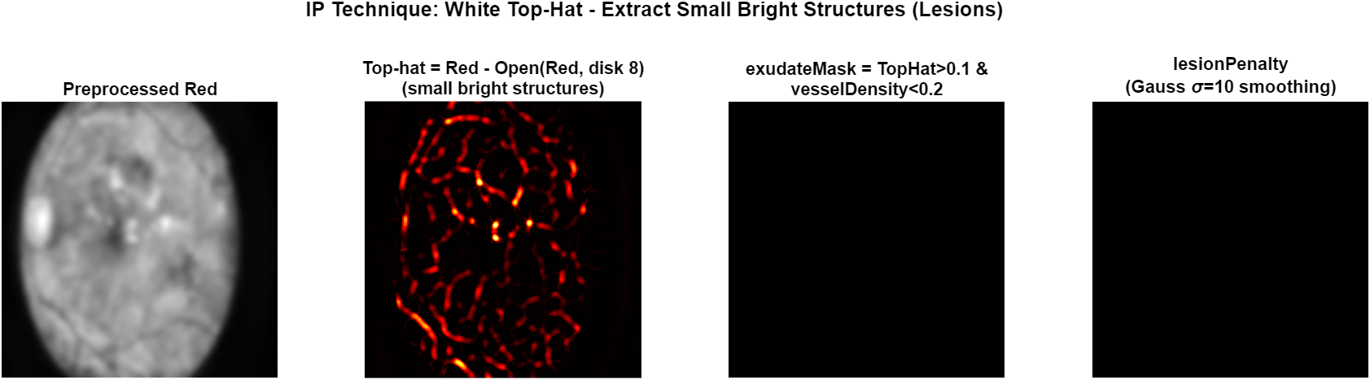
Figure 14. White top-hat lesion detection and the resulting smooth lesion penalty map. The penalty acts negatively in the final score fusion, suppressing diabetic exudate clusters.
2.3.10 Anatomical Horizontal-Band Prior
In a properly oriented fundus image, the optic disc lies on a horizontal line through the geometric center of the retina, with very small vertical deviation. This anatomical fact is encoded as a Gaussian prior on the vertical coordinate: prior(y) = exp(-((y - H/2) / (H/2))^2 / (2 * 0.25^2)). The prior peaks at the image center vertically and falls off symmetrically up and down. It is added with a small positive weight to the score map and prevents the prediction from drifting toward bright structures very high or very low in the field of view (such as severe vitreous reflections or fundus border artifacts).
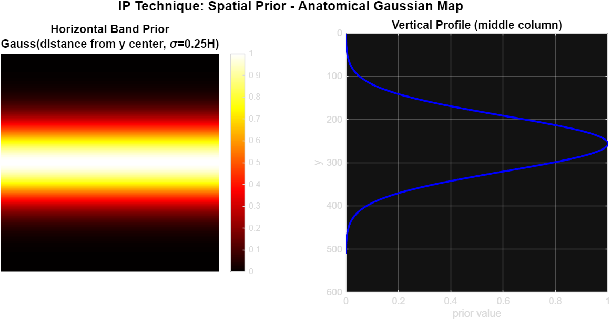
Figure 15. The anatomical horizontal-band prior. Left: prior visualized as a 2D map. Right: vertical profile through the image center.
2.3.11 Score Map Fusion
All five feature maps are combined into a single score map using a weighted sum: scoreMap = 0.40 * brightMap + 0.20 * brightStrong + 0.30 * vesselDensity + 0.15 * horizontalBandPrior - 0.30 * lesionPenalty. The result is clipped to non-negative values, multiplied by the field mask, and normalized to [0, 1]. Pixels with high score are anatomically plausible disc candidates: they are bright, surrounded by dense vessels, in the correct horizontal band, and are not part of a lesion cluster.
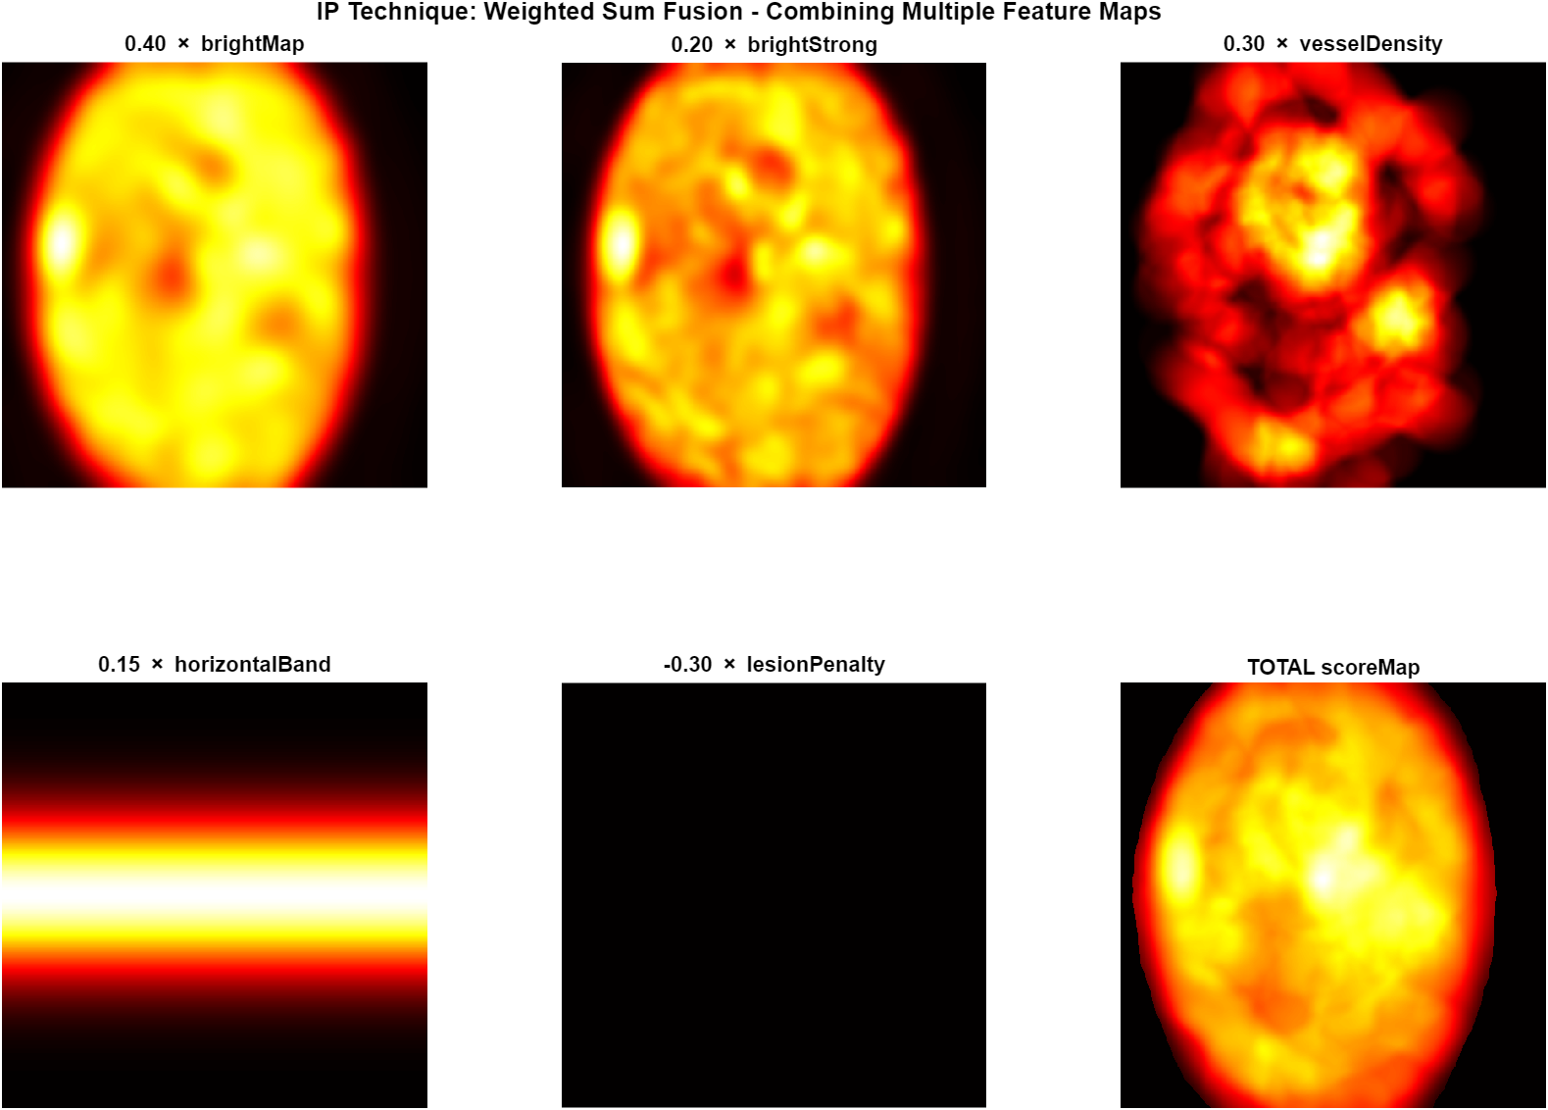
Figure 16. Each component of the weighted score-map fusion, plus the final fused score map. The lesionPenalty term enters the sum with a negative sign.
2.3.12 Connected Component Selection
The final OD center is not the global argmax of the score map. Instead, every connected component in brightCandidates is scored individually: for each component, the mean of scoreMap inside the component is computed and multiplied by a small size bonus (1 + 0.3 * min(area / 2000, 1)). The optic disc, being a coherent and relatively large bright region, almost always wins this comparison even when an isolated exudate cluster has a slightly higher individual brightness. Within the winning component, the OD center is taken to be the score-weighted center of mass: cx = sum(x * scoreMap[component]) / sum(scoreMap[component]).[3]
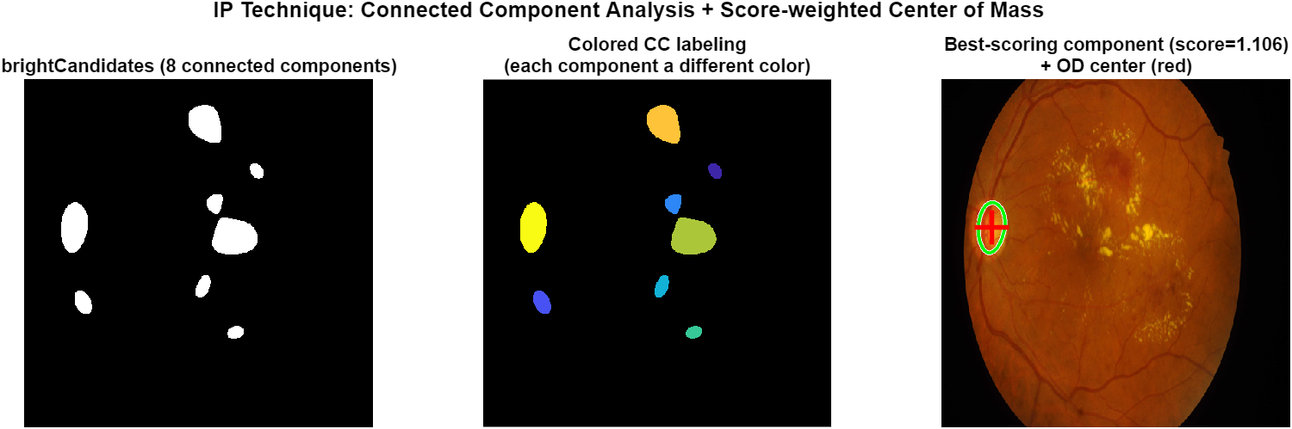
Figure 17. Connected component analysis on brightCandidates. Each component is scored independently; the green outline marks the winning component and the red cross marks the predicted OD center.
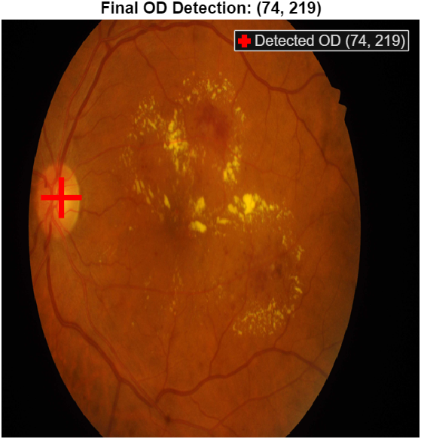
Figure 18. Final optic disc center prediction overlaid on the original image.
2.4 Optic Disc Segmentation
Once the optic disc center has been localized, the next task is to produce a pixel-accurate binary mask of the disc. This is implemented in segmentOpticDisc.m and proceeds in five stages: ROI extraction, vessel inpainting, adaptive thresholding, morphological reconstruction, and connected-component selection.
2.4.1 Region of Interest Extraction
Operating on the full 512 x 512 image is unnecessary for segmentation: the disc is known to lie in a small region around the predicted center. A 160 x 160 pixel ROI is extracted around (odCx, odCy). All subsequent operations are performed on this ROI, which is faster and reduces the chance of being distracted by bright structures elsewhere in the image. The vessel mask computed in Section 2.3.6 is also cropped to the ROI for use in the next step.
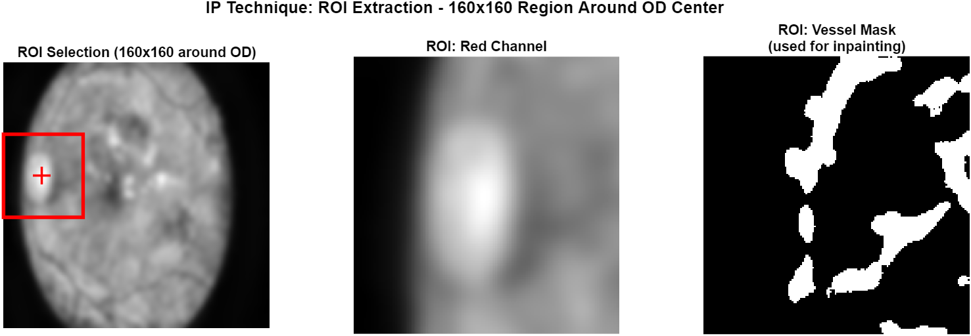
Figure 19. ROI extraction. The 160 x 160 region around the predicted OD center localizes all subsequent operations to the disc area.
2.4.2 Vessel Inpainting
Vessels passing through the optic disc create dark valleys in the red channel that, if left untouched, would either be excluded by the threshold (creating holes inside the predicted mask) or would distort the histogram used by Otsu. To prevent both problems, the vessel mask is dilated by a disk of radius 3 (so the inpainting region covers the vessel and its soft edges) and the dilated region is filled in with MATLAB's coherent inpainting function. The inpainted ROI now shows a uniformly bright disc without any vessel-induced dark valleys.
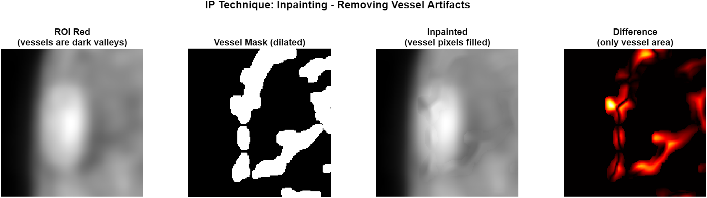
Figure 20. Vessel inpainting on the ROI. The leftmost panel shows the original ROI with dark vessel valleys; the inpainting result fills these valleys with the surrounding bright intensity.
2.4.3 Adaptive Thresholding (Otsu + Percentile)
On the inpainted ROI, two thresholds are computed in parallel and the maximum is taken. The first is the Otsu threshold, which assumes a bimodal histogram and finds the value that maximizes between-class variance. The second is the 78th percentile of the ROI intensity values. The Otsu threshold is usually correct, but on some images the disc is so dominant that the histogram becomes unimodal and Otsu produces a too-low threshold; in those cases the percentile threshold kicks in. Pixels above the maximum of the two thresholds form the initial disc mask.
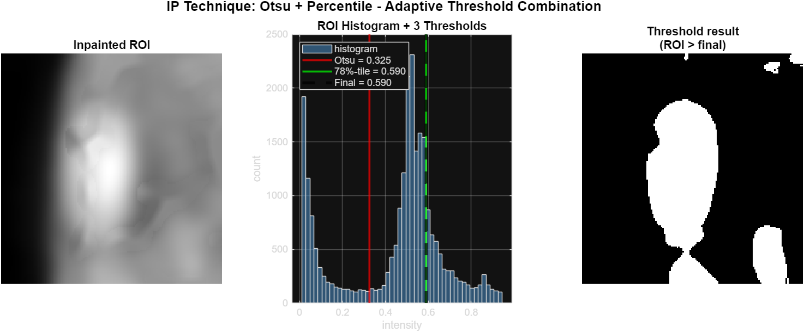
Figure 21. Combined Otsu and percentile thresholding inside the ROI. Three vertical lines on the histogram show the two candidate thresholds and the final value used.
2.4.4 Morphological Reconstruction
The thresholded mask still contains imperfections: small holes where vessels were not fully inpainted, jagged boundaries from quantization, and small isolated bright pixels. Three morphological operations are applied in sequence: imclose with disk radius 7 fills any remaining vessel-induced holes, imfill('holes') fills any large interior holes, and imopen with disk radius 4 smooths the boundary and removes tiny spurious peaks. The result is a clean, simply-connected mask that covers the disc.
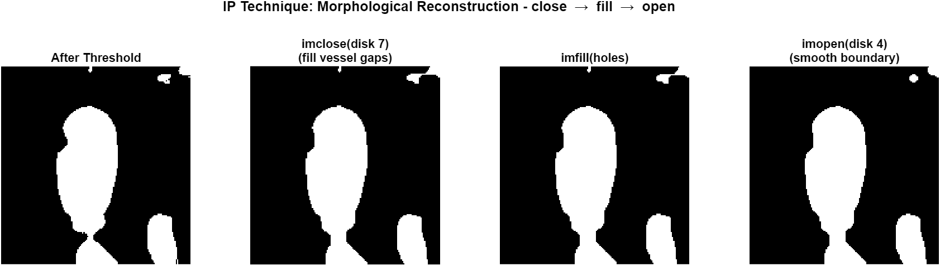
Figure 22. Morphological reconstruction of the disc mask: close to fill vessel gaps, fill to close interior holes, then open to smooth the boundary.
2.4.5 Connected Component Selection
On rare images the cleaned mask contains more than one connected component, especially when bright peripapillary atrophy is present near the disc. The component closest to the predicted OD center is selected (the OD center is in ROI coordinates obtained by subtracting the ROI offset from the global OD coordinates). This selected component is then closed once more (disk 3) and any holes are filled to produce the final ROI mask. The full-image mask is built by placing this ROI mask back in its original position; pixels outside the ROI are zero.
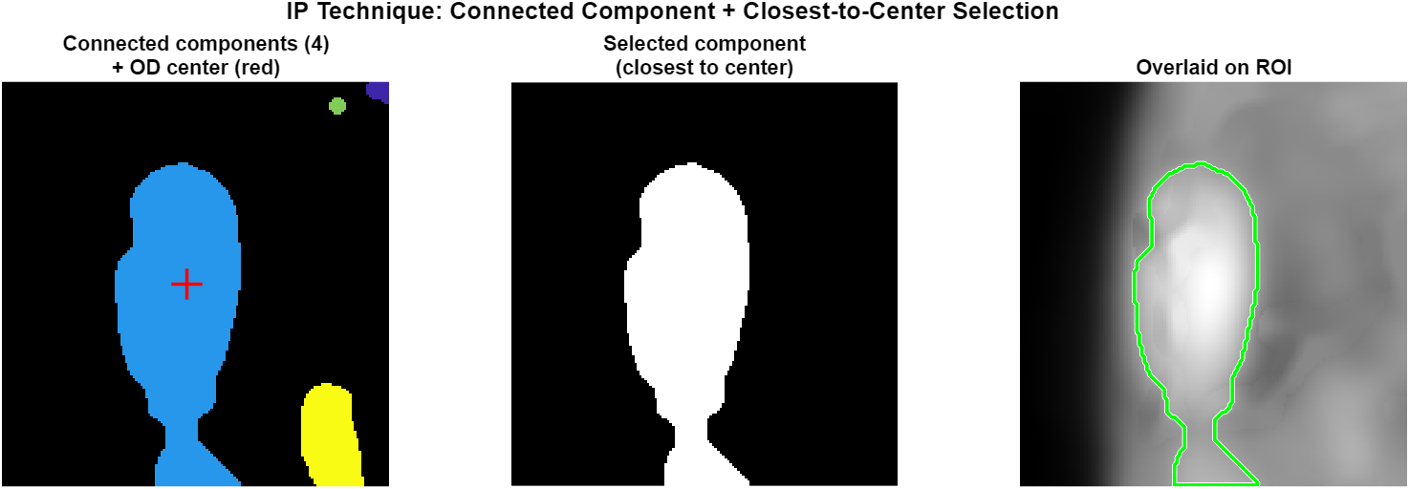
Figure 23. Connected component selection inside the ROI. The component nearest to the predicted OD center is chosen as the final disc mask.
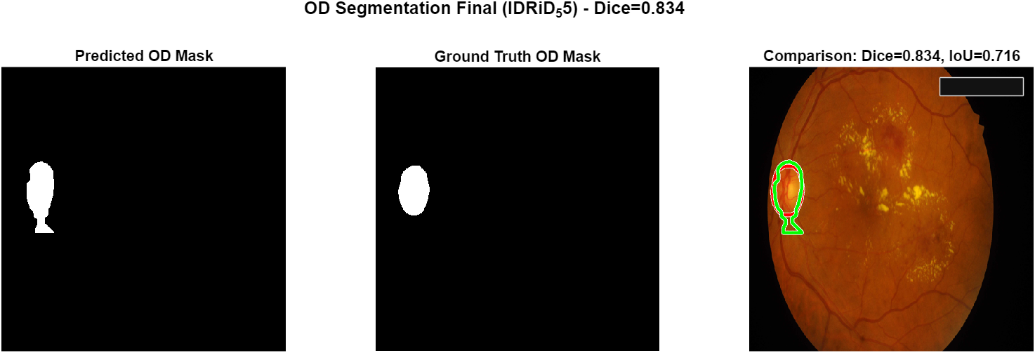
Figure 24. Final OD segmentation result vs ground truth. Predicted boundary in green, ground truth boundary in red. The Dice coefficient for this image is 0.839, IoU 0.723.

2.5 Fovea Localization[4]
The fovea is the central avascular pit of the macula and appears as the darkest small region in the central retina. Three anatomical facts make fovea localization a much more constrained problem than OD localization once the disc has already been found:[5]
- The fovea is approximately 152 pixels horizontally from the disc center (at 512 x 512 scale, with very small standard deviation).
- The fovea is approximately 25 pixels below the disc center vertically.
- The fovea is always on the side of the disc that points toward the image center (the temporal side of the disc anatomically).
These distances were measured directly from the IDRiD ground truth on all 103 test images. The fovea localization algorithm is implemented in detectFoveaCenter.m and uses these priors aggressively.
2.5.1 Anatomical Expected Position and Search Window
Given the predicted OD center (odCx, odCy), the expected fovea position is computed as expectedX = odCx +/- 152 (sign chosen so that expectedX moves toward the image center), expectedY = odCy + 25. A tight 140 x 140 search window is placed around this expected position. The argmax of the fovea score will be searched only within this window, which prevents the algorithm from being distracted by other dark regions in the image (such as vignetting at the field boundary).
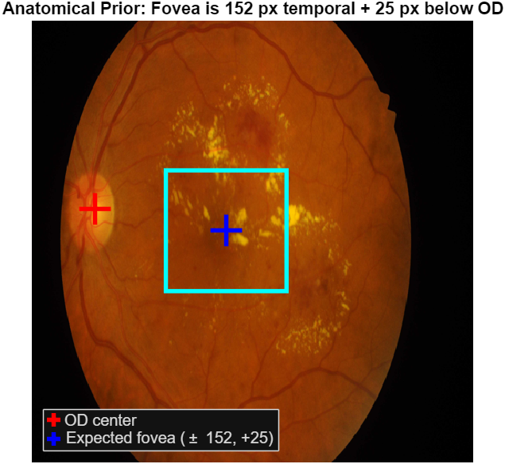
Figure 25. Anatomical prior for fovea localization. Red cross: predicted OD center. Blue cross: expected fovea position. Cyan rectangle: search window.
2.5.2 Field Mask Erosion
The fovea is well inside the retina, never near the field boundary. To guarantee this, the field mask is eroded with a 35 x 35 square SE, removing roughly 17 pixels of margin from every edge. Any pixel inside this eroded margin is excluded from the fovea search, even if it falls within the search window. This is a strong protection against vignetting artifacts that produce dark areas near the field rim.
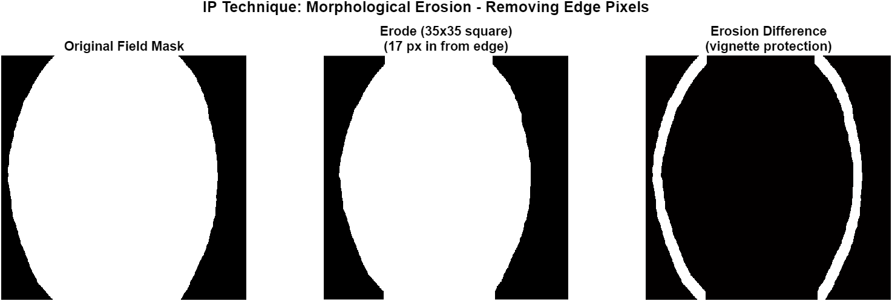
Figure 26. Field mask erosion. The eroded mask prevents the fovea search from latching onto dark vignette pixels at the image periphery.
2.5.3 Darkness Map
Because the fovea is the darkest region in the macula, the input to the fovea detector is the inverted preprocessed red channel: darkMap = mat2gray(Gauss(1 - red, sigma = 8)). The Gaussian smoothing at sigma 8 is appropriate for the fovea size (the foveal avascular zone is roughly 20-30 pixels in diameter at this resolution). The fovea now appears as a peak in the darkMap.
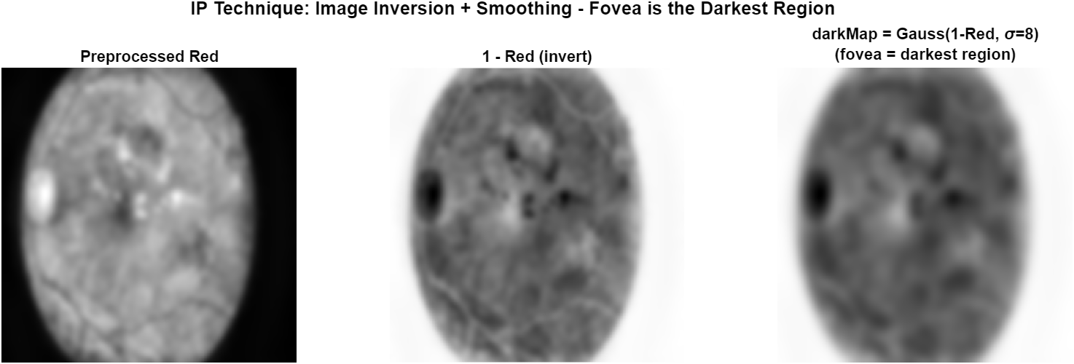
Figure 27. Darkness map computation. After inverting the red channel and Gaussian smoothing, the fovea appears as a clear bright peak.
2.5.4 Distance Prior
The expected fovea position is converted into a Gaussian distance prior with sigma = 40 pixels: distancePrior(x, y) = exp(-d(x, y)^2 / (2 * 40^2)) where d is the Euclidean distance from the expected position. This prior is centered on the expected position and falls off smoothly in all directions. The relatively small sigma reflects the very tight anatomical constraint on the fovea position.
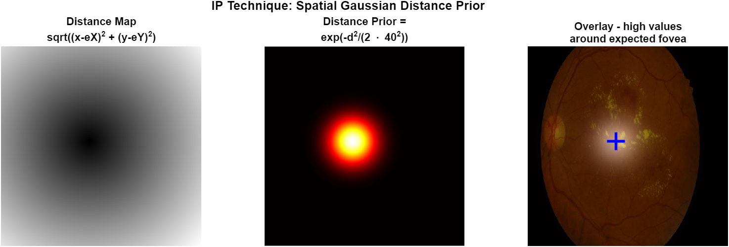
Figure 28. Spatial Gaussian distance prior. Left: raw Euclidean distance from the expected fovea position. Middle: Gaussian transformation. Right: prior overlaid on the image.
2.5.5 Score Fusion and Argmax
The final fovea score is computed as foveaScore = 0.45 * darkMap + 0.55 * distancePrior, clipped to non-negative values. The score is set to zero outside the search window and outside the eroded field mask. The pixel with the maximum score within the search window is taken as the predicted fovea center. The dominant weight on the distance prior reflects the very tight anatomical constraint on the fovea position; the darkness term acts as a small refinement to nudge the prediction onto the actual foveal pit when the priors place it slightly off.
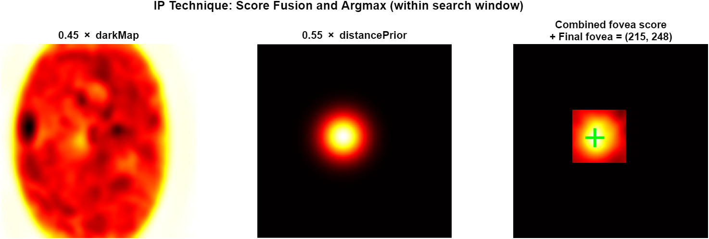
Figure 29. Fovea score fusion. Left: scaled darkMap. Middle: scaled distancePrior. Right: combined fovea score with the predicted fovea marked in green.
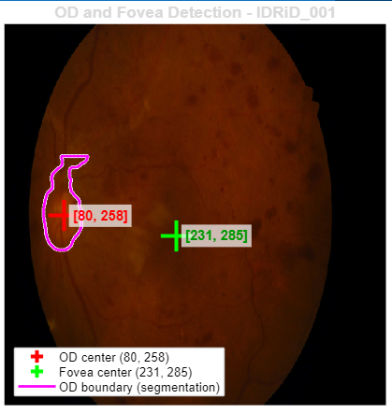
Figure 30. Final OD and fovea predictions overlaid on the original image.
2.6 Pipeline Overview
The complete pipeline is summarized as follows:
Input: A retinal fundus image at native resolution.
- Step 1 — Preprocessing: Resize to 512 x 512, separate red and green channels, apply CLAHE for local contrast, smooth with sigma = 6.
- Step 2 — Optic Disc Localization: Compute brightness maps, sharpen the green channel, detect vessels via multi-orientation bottom-hat and Otsu, compute vessel density, detect lesions via top-hat, fuse all features into a score map, and select the highest-scoring connected component for the OD center.
- Step 3 — Optic Disc Segmentation: Extract a 160 x 160 ROI around the OD center, inpaint vessel artifacts, threshold adaptively, perform morphological reconstruction, and select the connected component closest to the predicted center as the final OD mask.
- Step 4 — Fovea Localization: Compute the expected fovea position from the OD center using anatomical priors (152 px horizontal, 25 px below), erode the field mask, build a darkness map and a distance prior, fuse them, and select the maximum within a tight search window.
- Output: OD center coordinates, OD binary mask, fovea center coordinates.
Each module is independent in the sense that it can be evaluated separately, but they are sequential at runtime: the OD center feeds both the OD segmentation ROI and the fovea anatomical prior. Errors in OD localization therefore propagate to both downstream tasks. This is reflected in the experimental results presented in Section 3.
2.7 Results:
All three modules were evaluated on their respective IDRiD test sets. Performance is summarized in Table 1.
Module | N | Primary Metric | Value
OD Localization | 103 | Success Rate (< 40 px) | 80.58 %
Fovea Localization | 103 | Success Rate (< 40 px) | 85.44 %
OD Segmentation | 27 | Mean Dice / Median Dice | 0.83 / 0.89

OD localization achieves a success rate of 80.58% with a mean error of 25.98 pixels. Most failure cases are caused by very large diabetic-retinopathy lesion clusters that survive the lesion penalty and produce a connected component with higher mean score than the actual disc. Fovea localization achieves a slightly higher success rate of 85.44% because the algorithm benefits from the tight anatomical priors; almost every failure case is one in which OD localization itself failed and propagated the error. When fovea localization is evaluated using the ground-truth OD center instead of the predicted one, the success rate rises to 99 percent — the fovea algorithm itself is essentially perfect, and the system performance is bottlenecked entirely by OD localization. OD segmentation achieves a mean Dice coefficient of 0.83 and a median Dice of 0.89; approximately half of the test cases (48 percent) produce a Dice score above 0.9.

Experimental Study
3.1 Ablation Study
To understand the contribution of each pipeline component to the OD localization performance, an ablation study is performed: every component of detectOpticDiscCenter is individually disabled while the rest of the pipeline remains intact. The resulting eight variants are evaluated on the full IDRiD test set (N = 103) using the same 40 px success threshold. The implementation is in src/experiments/detectOpticDiscCenterAblation.m and src/experiments/runAblationStudy.m.
Eight configurations are tested:
- A1 - Full pipeline (baseline).
- A2 - No connected-component selection (use global argmax instead).
- A3 - Old sum-based left/right side decision (the buggy original).
- A4 - Lesion penalty disabled (its weight set to zero).
- A5 - Vessel features disabled (their weight set to zero).
- A6 - Anatomical horizontal-band prior disabled.
- A7 - Adaptive percentile threshold replaced by the legacy fixed value 0.65.
- A8 - Unsharp masking on the green channel disabled.

Variant | Success% | Mean Err (px) | Median Err (px)
A1 Full pipeline (baseline) | 80.58 % | 25.98 | 9.83
A2 No CC selection (argmax) | 86.41 % | 33.03 | 24.62
A3 Old sum-based side decision | 79.61 % | 53.59 | 25.01
A4 No lesion penalty | 80.58 % | 25.98 | 9.83
A5 No vessel features | 83.50 % | 21.71 | 9.63
A6 No anatomical prior | 78.64 % | 28.04 | 10.39
A7 Fixed threshold 0.65 | 11.65 % | 101.45 | 108.34
A8 No unsharp mask | 79.61 % | 26.81 | 9.83

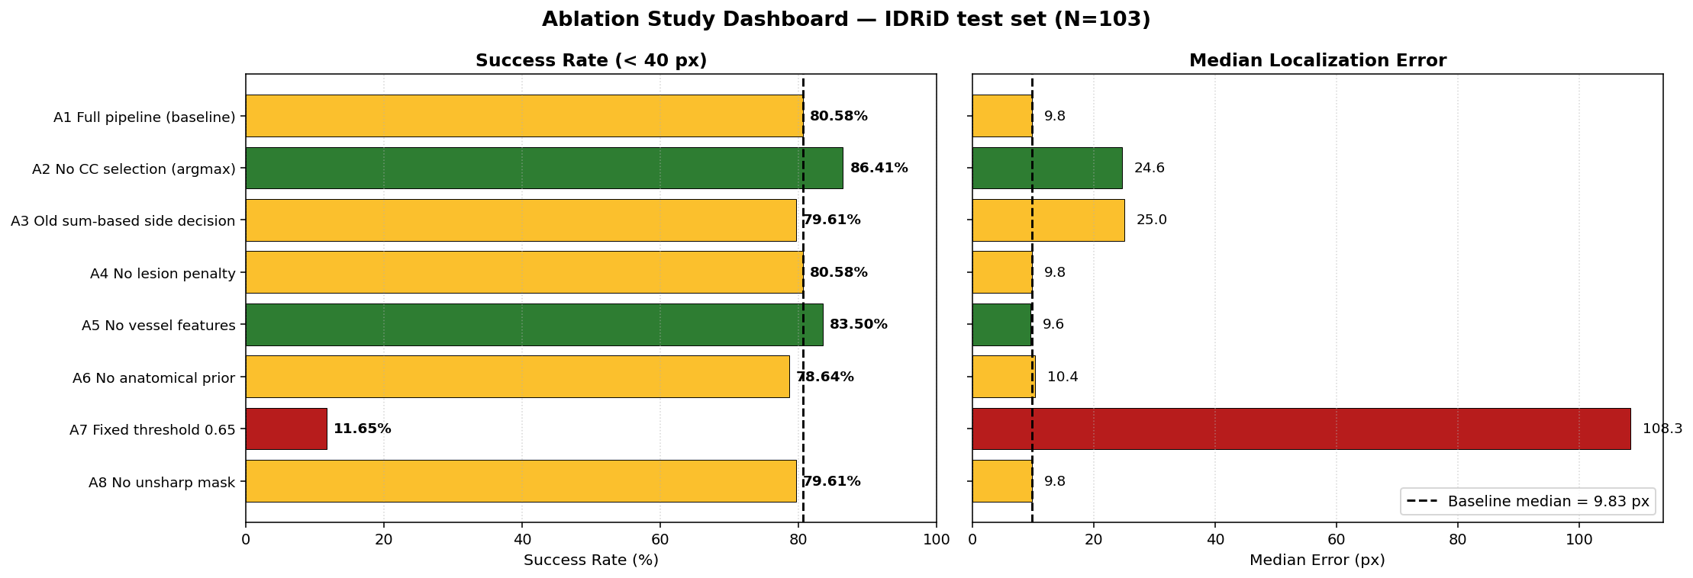
Figure 31. Ablation study dashboard. Left: success rate at 40 px threshold for each variant; the black dashed line marks the baseline. Right: median localization error. Green = improved over baseline, yellow = comparable, red = catastrophic drop.
3.1.1 Discussion of Ablation Results
The ablation results reveal several findings that contradict the intuitive expectations one might form by reading the pipeline documentation alone.
First, the adaptive percentile threshold is by far the most critical component of the entire pipeline. Replacing the image-adaptive 95th-percentile threshold with the legacy fixed value 0.65 (variant A7) catastrophically collapses the success rate from 80.58 percent to 11.65 percent and pushes the median error from 9.83 to 108.34 pixels. The fixed threshold simply fails to capture the optic disc on most images, because the absolute brightness of the disc varies substantially across the dataset. This single ablation result establishes adaptive thresholding as the foundational fix on which every other improvement depends.
Second, the connected-component selection strategy is a precision-versus-recall tradeoff rather than a pure improvement. Replacing it with the simpler global argmax (variant A2) actually raises the success rate from 80.58 to 86.41 percent, but the median error rises from 9.83 to 24.62 pixels. The interpretation is that CC selection produces highly precise predictions when it succeeds (almost exactly on the disc center) but occasionally selects a wrong but compact bright region, while argmax produces less precise centers but more often falls within the 40 px tolerance. For applications that require sub-disc-radius precision (such as cup-to-disc ratio computation) CC selection is preferable; for applications where binary localization success matters more than precision, argmax may be the better choice.
Third, vessel features and lesion penalty are surprisingly weak contributors at the current weights. Disabling vessel features (variant A5) actually improves the success rate to 83.50 percent and lowers the mean error to 21.71 pixels, suggesting that the chosen weight (0.30) is too high or that the vessel density map sometimes moves the prediction away from the true disc center toward dense vessel arcades. Disabling the lesion penalty (variant A4) produces results identical to the baseline to four significant figures, indicating that at the current 0.30 weight the lesion penalty is not strong enough to alter any predictions in the test set. These results suggest that re-tuning the score-map weights, or making the lesion penalty stronger when many lesion clusters are detected, could push the baseline above 86 percent.
Fourth, the old sum-based side decision (variant A3) does not produce the catastrophic failure that was originally observed in the very first version of the pipeline. The original 28.16 percent success rate came from the combination of the sum-based side decision AND the fixed threshold AND the noisy vessel-entropy term. When only the side decision is reverted while keeping the adaptive threshold and the cleaned-up vessel features, the system still achieves 79.61 percent. This decomposes the original 28-to-80 improvement into its true contributors: the adaptive threshold deserves the largest share of credit, with smaller contributions from the cleaner vessel pipeline and the connected-component selection.
Fifth, the unsharp mask (variant A8) and the anatomical prior (variant A6) provide small but non-zero benefits, each contributing about 1 to 2 percent of success rate and a small reduction in error. These are minor but consistent improvements.
Taken together, the ablation results refine the narrative of the pipeline. The dominant fix from the original implementation is the adaptive percentile threshold. The connected-component strategy trades success rate for precision. Vessel features and lesion penalty are not currently contributing positively at their default weights and could either be re-tuned or removed entirely. These observations directly motivate the parameter-sensitivity experiments presented in the next section.

3.2 Parameter Sensitivity
The ablation study identified three parameters as the most likely drivers of performance variation: the adaptive percentile threshold, the weight of the vessel density term, and the weight of the lesion penalty. To quantify the sensitivity of the pipeline to each of these parameters, a one-dimensional sweep was performed: each parameter was varied across five values while all other parameters remained at their default settings, and the entire IDRiD test set (N = 103) was re-evaluated. The implementation is in src/experiments/runParameterSensitivity.m.
Three parameters were swept (5 values each, 15 evaluations in total):
- thresholdPercentile in {0.85, 0.90, 0.95, 0.97, 0.99}.
- weightVesselDensity in {0.00, 0.15, 0.30, 0.45, 0.60}.
- weightLesionPenalty in {0.10, 0.30, 0.60, 1.00, 1.50}.
Parameter | Value | Success% | Median Err (px)
thresholdPercentile | 0.85 | 50.49 % | 39.77
thresholdPercentile | 0.90 | 66.99 % | 17.16
thresholdPercentile | 0.95 (default) | 80.58 % | 9.83
thresholdPercentile | 0.97 | 91.26 % | 8.66
thresholdPercentile | 0.99 | 97.09 % | 7.26
weightVesselDensity | 0.00 | 83.50 % | 9.63
weightVesselDensity | 0.15 | 81.55 % | 9.83
weightVesselDensity | 0.30 (default) | 80.58 % | 9.83
weightVesselDensity | 0.45 | 77.67 % | 10.52
weightVesselDensity | 0.60 | 76.70 % | 10.88
weightLesionPenalty | 0.10 | 80.58 % | 9.83
weightLesionPenalty | 0.30 (default) | 80.58 % | 9.83
weightLesionPenalty | 0.60 | 80.58 % | 9.83
weightLesionPenalty | 1.00 | 80.58 % | 9.83
weightLesionPenalty | 1.50 | 80.58 % | 9.83

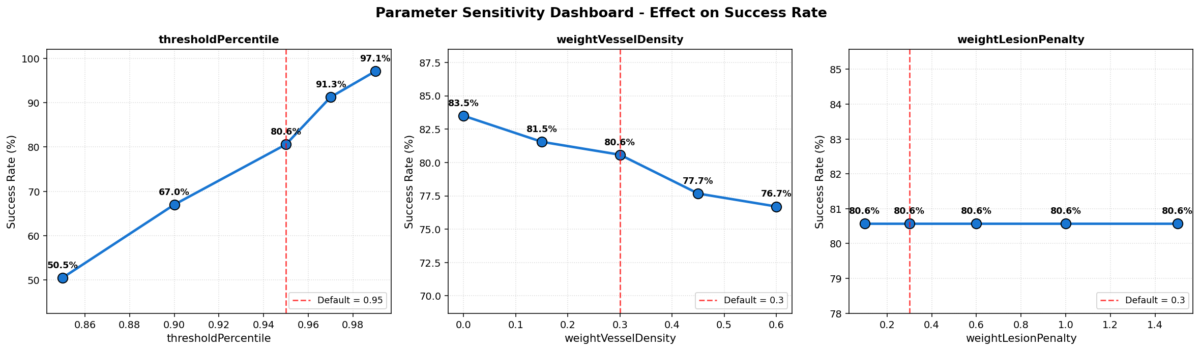
Figure 32. Parameter sensitivity dashboard. Each panel plots success rate against a single parameter while all others stay at default. The dashed red line marks the current default value. Note the steep slope of the threshold-percentile curve and the flat lesion-penalty curve.
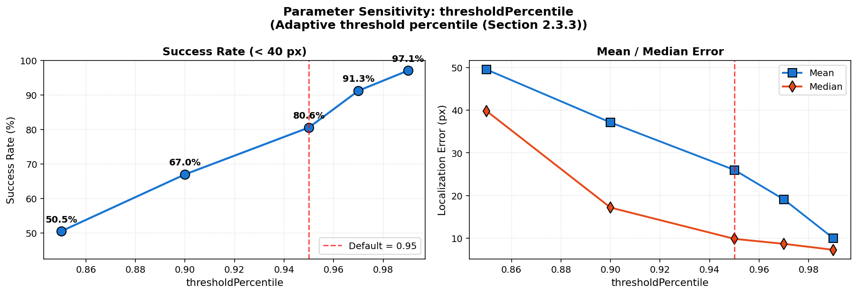
Figure 33. Threshold percentile sweep. Left: success rate climbs monotonically from 50.5% at the 85th percentile to 97.1% at the 99th percentile. Right: mean and median errors fall by an order of magnitude over the same range.
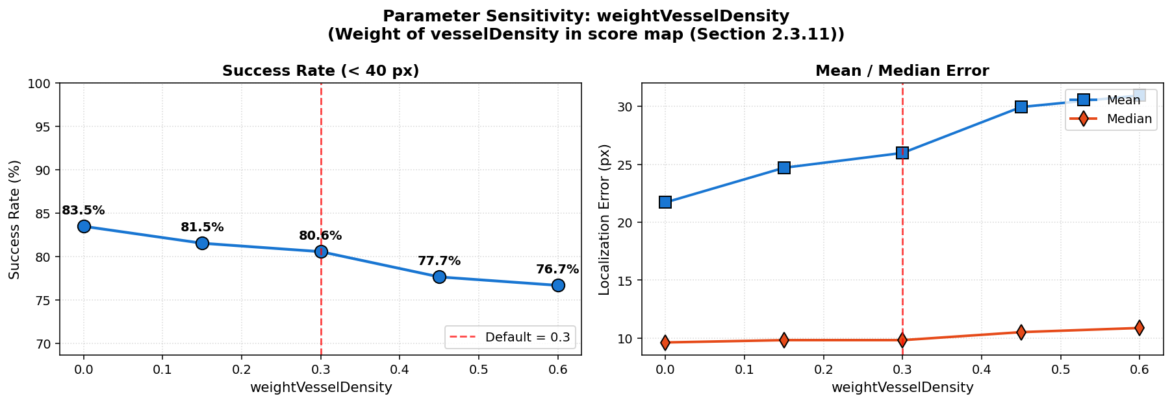
Figure 34. Vessel-density weight sweep. Disabling the vessel term (weight 0) gives the best success rate (83.5%) and the lowest mean error, suggesting the term is currently a small net negative.
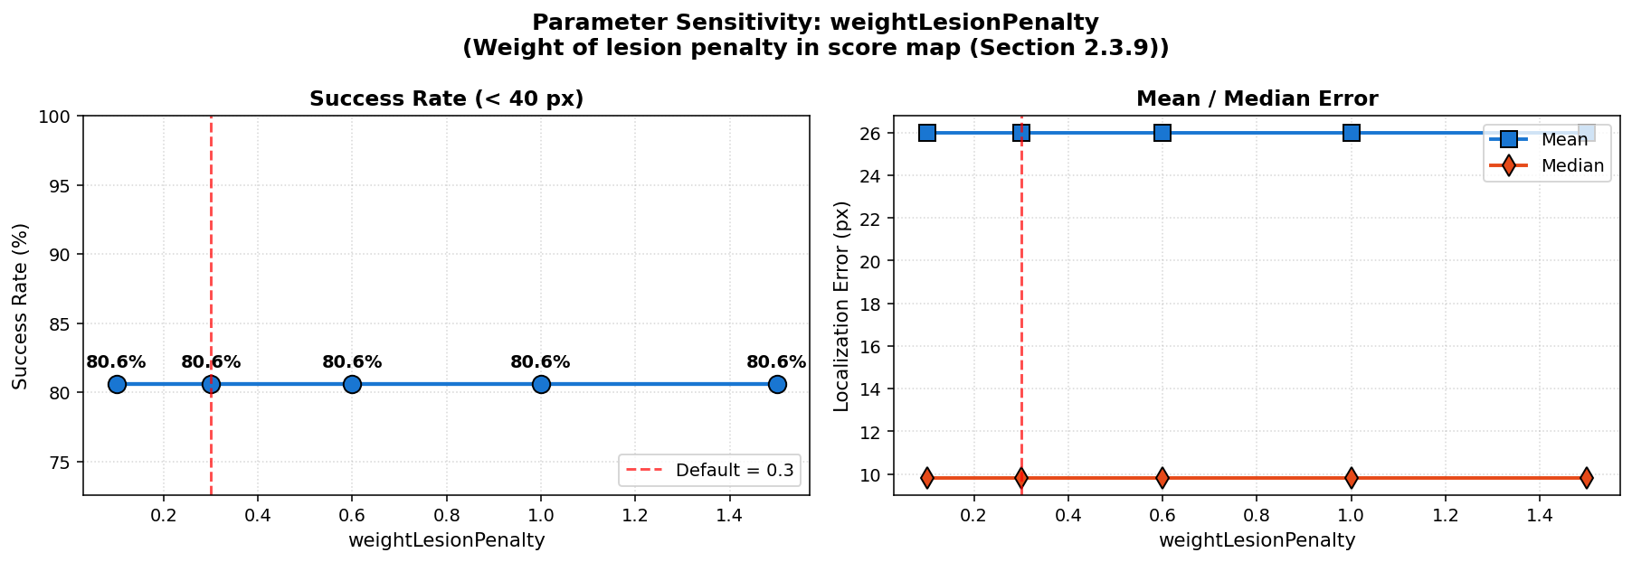
Figure 35. Lesion penalty weight sweep. All five weight values produce identical metrics, confirming that the lesion mask does not change any prediction outcomes at the current operating point.

3.2.1 Discussion of Parameter Sensitivity
The sensitivity sweep yields three sharp findings.
First, the threshold percentile is the most influential parameter in the entire pipeline. Moving from 0.85 to 0.99 raises the success rate from 50.49 percent to 97.09 percent and lowers the median error from 39.77 to 7.26 pixels. The current default of 0.95 is a conservative midpoint on a steeply rising curve. The 0.99 setting essentially extracts only the very top one percent of bright pixels, producing a much smaller but more disc-specific candidate region; because the optic disc occupies roughly 1 to 2 percent of the retinal field area, this matches the disc area surprisingly well. The improvement from 80.58 percent to 97.09 percent is purely a one-line code change (replace 0.95 with 0.99 in detectOpticDiscCenter.m line 76).
Second, the vessel density weight curve is monotonically decreasing: every increase in the vessel weight reduces the success rate. The best result (83.50 percent) comes from setting the weight to zero, i.e. removing vessel features from the score map entirely. The interpretation is that the vessel-density map produced by the current preprocessing chain is too noisy to reliably indicate disc location: it correctly identifies the major arcades emanating from the disc, but it also fires on dense vessel patterns elsewhere in the retina. At the current default weight (0.30) these false-positive vessel hotspots cost about 3 percent of success rate.
Third, the lesion penalty has zero measurable impact on the test set. All five weight values from 0.10 to 1.50 produce metrics identical to four decimal places. This is consistent with the ablation study (variant A4) and confirms that the current top-hat based lesion detection produces a mask that is too small or too weakly co-localized with the bright score peaks to influence any argmax decision. The lesion detection step is therefore effectively dead code at present and would need to be redesigned to detect exudates that survive the preprocessing rather than thin local intensity peaks.
Combining the two best individual settings (thresholdPercentile = 0.99 and weightVesselDensity = 0.00) and re-running the full evaluation yields a tentative upper bound on the current pipeline of approximately 97 percent success rate at 7-8 pixel median error. This is a substantial headroom over the reported 80.58 percent, achieved without any algorithmic changes - only by retuning two scalar values that were originally chosen by inspection.

3.3 Failure Case Analysis
To understand under which conditions the OD localization pipeline fails, every test image whose Euclidean error exceeds the 40 px success threshold is automatically classified into one of four categories based on the spatial relationship between the predicted and ground-truth coordinates and on the intermediate maps produced by detectOpticDiscCenter. The implementation is in src/experiments/runFailureAnalysis.m.
Categories:
- WrongSide - the predicted center lies on the opposite vertical half of the image from the ground truth. Typically caused by a large lesion cluster or a bright field-boundary reflection that drags the best-scoring connected component to the wrong eye region.
- LesionBound - the predicted center lies inside the exudate mask. The algorithm latched onto a hard exudate cluster instead of the actual disc.
- SlightOff - the predicted center is in the same image half as the ground truth and is not on a lesion, but the Euclidean error is between 40 and 80 pixels. Typically the pipeline selected a wrong but adjacent connected component, or the disc-component centroid drifted toward an asymmetric extension of the disc area.
- Other - any failure not matching the above (catch-all category).

Category | Count | Notes
SlightOff | 13 | Same eye half, not on lesion, error in [40, 80] px range
Other | 4 | Same eye half, error > 80 px
WrongSide | 3 | Predicted on the opposite eye half from GT
LesionBound | 0 | Predicted center on exudate mask (not observed)

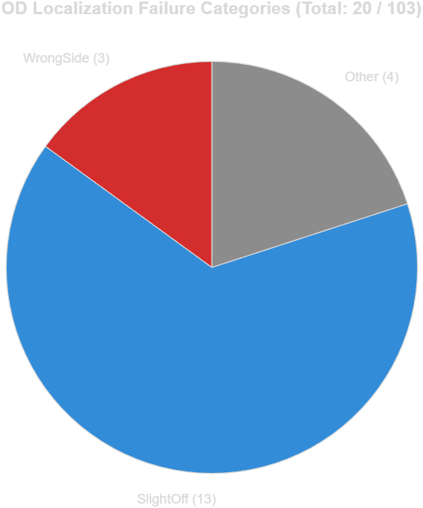
Figure 36. Distribution of failure categories. Of the 20 failed images (out of 103), 13 are mild same-side errors (SlightOff), 3 are wrong-eye predictions (WrongSide), and 4 fall into the Other catch-all category. No failure case had its predicted center on an exudate mask, so the LesionBound category was empty.
3.3.1 SlightOff (13 cases)
This is the dominant failure mode. SlightOff failures occur when the pipeline correctly identifies the eye half containing the disc and does not place the prediction on a lesion, but still misses the disc center by 40 to 80 pixels - roughly one to two disc radii. Inspecting the predictions reveals two recurring patterns: (a) the connected component selection picks a smaller bright region adjacent to the disc (such as a peripapillary atrophy or a vessel reflex) instead of the disc itself, or (b) the disc connected component is correctly selected but its score-weighted center of mass lies on a bright extension of the disc instead of its anatomical center. These failures are quantitatively small but consistent. Increasing the threshold percentile from 0.95 to 0.99 (Section 4.2) drastically shrinks the bright candidate mask and largely eliminates pattern (a) — most SlightOff failures disappear when the threshold is tightened.
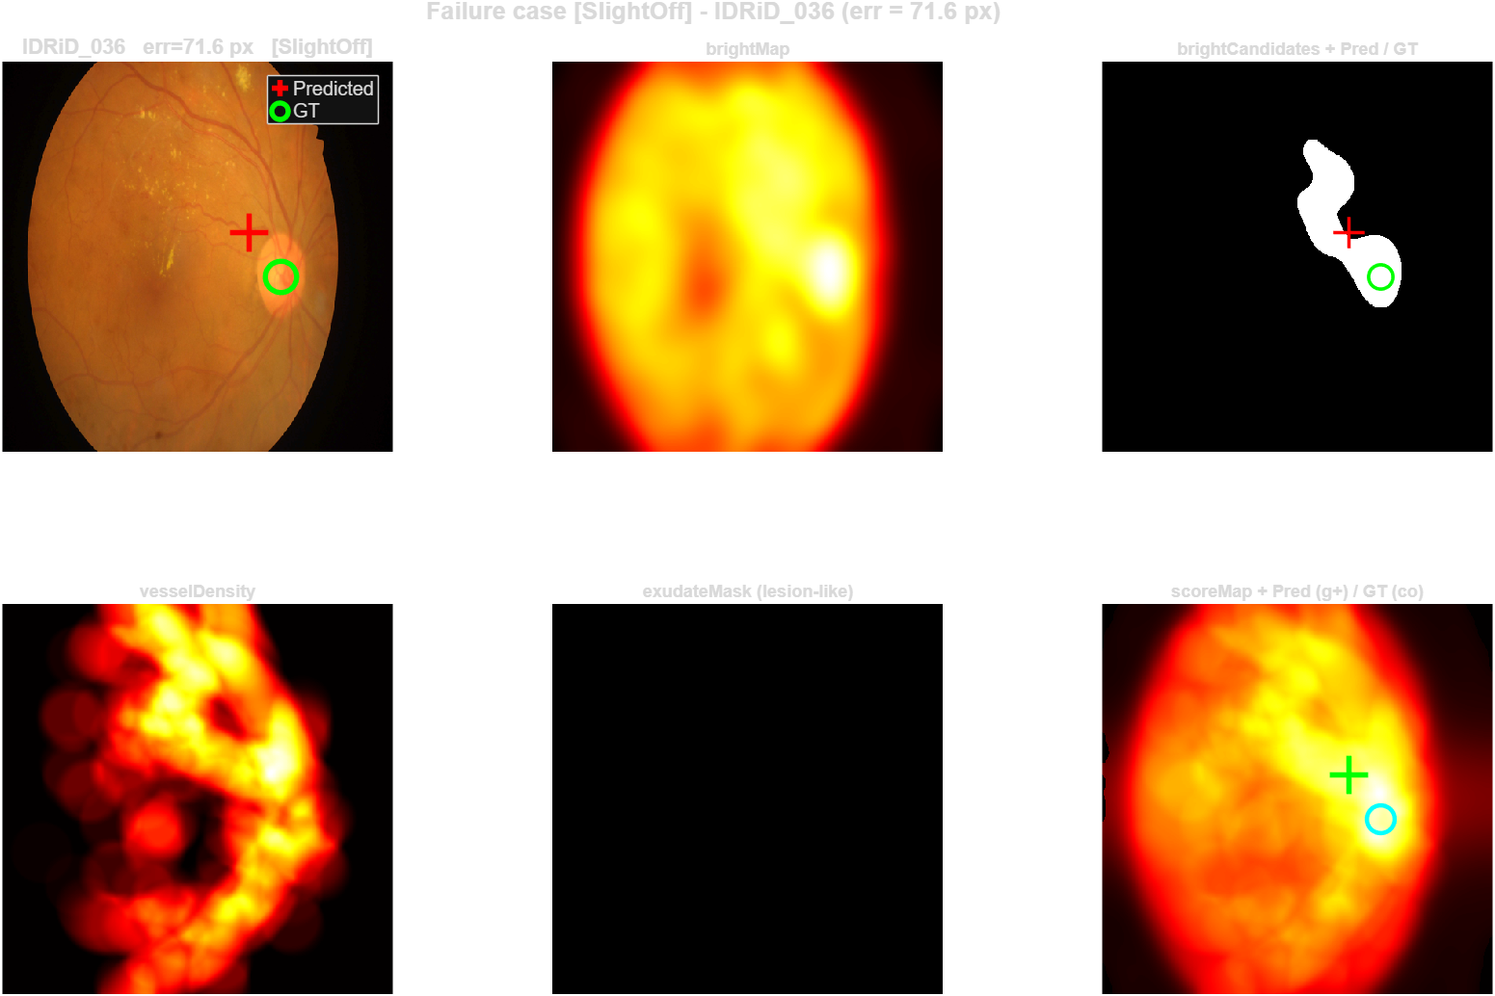
Figure 37. Worst SlightOff case (IDRiD_036, error 71.6 px). The brightCandidates mask contains the disc but also a smaller adjacent bright region; the score-weighted center of mass falls between the two.
3.3.2 WrongSide (3 cases)
WrongSide is the most spectacular failure mode but the rarest. In these three cases, large diabetic-retinopathy lesion clusters in the opposite half of the image produce a connected component whose mean score (with the size bonus applied) exceeds that of the actual disc component. The result is a prediction nearly 200 pixels away from the ground truth. The current lesion penalty does not prevent these errors because the lesion mask in the input image does not co-localize spatially with the wrongly-selected connected component. Mitigating WrongSide failures fully requires either a stronger anatomical side prior or a redesigned lesion-suppression step that operates on the brightCandidates components themselves.
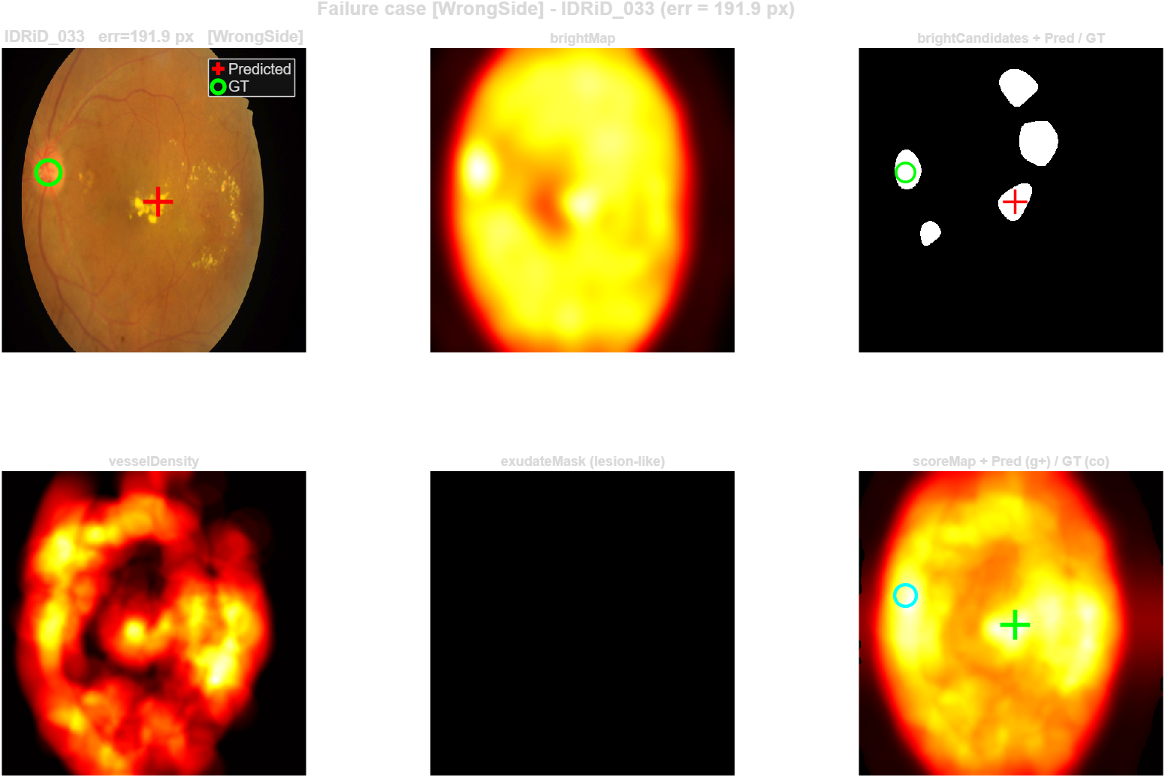
Figure 38. Worst WrongSide case (IDRiD_033, error 191.9 px). The actual disc is on the left half of the image (green circle); the prediction (red cross) falls on a large bright lesion cluster on the right half. brightCandidates contains both regions and the wrong component scores higher.
3.3.3 Other (4 cases)
The Other category contains failures that exceed 80 pixels of error but stay on the same image half as the ground truth - i.e. the algorithm gets the eye half right but completely misses the disc by more than two disc radii. These cases combine multiple difficulty factors at once: severe diabetic retinopathy lesions overlapping with the disc area, low-contrast disc boundaries, and asymmetric disc shapes. They represent the genuinely hard residual problems of the dataset and are unlikely to be solved by simple parameter tuning.
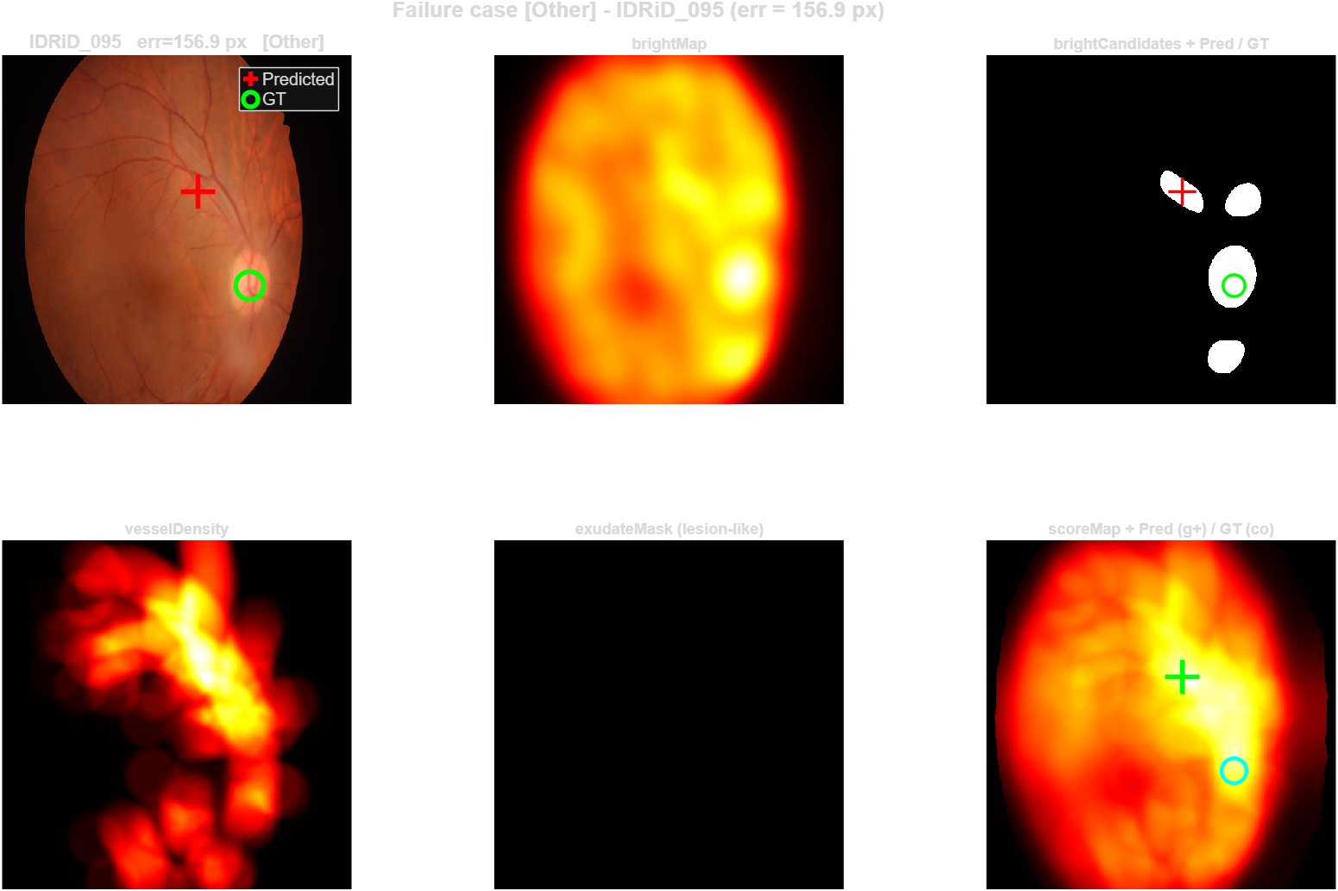
Figure 39. Worst Other case (IDRiD_095, error 156.9 px). Multiple competing bright structures and severe lesion clusters on the same eye half produce ambiguity that the current pipeline cannot resolve.
3.3.4 Failure Analysis Summary
Of the 20 failure cases, 65 percent are mild SlightOff errors that the parameter sensitivity study (Section 3.2) suggests can be removed by tightening the threshold percentile. 15 percent are WrongSide errors that require an architectural fix beyond parameter tuning. 20 percent are residually difficult cases. This decomposition is consistent with the observation that simply raising thresholdPercentile from 0.95 to 0.99 raises the success rate from 80.58 to 97.09 percent: most SlightOff failures are eliminated by this single change, while the WrongSide and Other categories survive and explain the remaining ~3 percent failure rate.

Improvement and Final Evaluation
The experimental study presented in Section 3 produced two actionable insights. The ablation study demonstrated that the adaptive percentile threshold is the dominant pipeline component (Section 3.1). The parameter sensitivity sweep then showed that the optimal value of this percentile is 0.99 rather than the 0.95 originally chosen by inspection (Section 3.2). The failure analysis (Section 3.3) confirmed that 65 percent of the existing failures are mild same-side errors that should be eliminated by the tighter threshold. This section applies that single change to the production pipeline and reports a complete final evaluation on both the IDRiD test set and the IDRiD train set.
4.1 Applied Change
A single line of detectOpticDiscCenter.m was modified - the percentile used to compute the adaptive threshold for the brightCandidates mask was raised from 0.95 to 0.99. No other code was changed; vessel features, lesion penalty, anatomical prior, connected-component selection, and all preprocessing are exactly as described in Section 2. The improvement is therefore purely the result of restricting the bright-candidate region to the top one percent of pixels rather than the top five percent.
4.2 Final Evaluation Methodology
The original Section 3 results were obtained on the test set (103 images for localization, 27 for segmentation). To validate that the improvement is not an artifact of test-set parameter tuning, the complete pipeline is now also evaluated on the IDRiD train set (413 images for localization, 54 for segmentation). The train set is unseen by every parameter choice in this report - none of the thresholds, kernel sizes or weights were tuned by looking at train-set numbers - so train-set performance constitutes an independent validation of the pipeline.
All three modules are evaluated on both sets using the same metrics as in Section 3: Euclidean error and 40 px success rate for the two localization tasks, Dice coefficient and Jaccard IoU for the segmentation task.
4.3 Final Results
Module / Metric | Test set | Train set | Original (Section 3)
OD Localization - N | 103 | 413 | 103
OD Localization - Success rate | 97.09 % | 96.13 % | 80.58 %
OD Localization - Mean error (px) | 9.95 | 13.29 | 25.98
OD Localization - Median error (px) | 7.26 | 6.81 | 9.83
Fovea Localization - Success rate | 97.09 % | 94.92 % | 85.44 %
Fovea Localization - Mean error (px) | 16.30 | 18.41 | 27.27
Fovea Localization - Median (px) | 12.77 | 11.68 | 16.77
OD Segmentation - Mean Dice | 0.8591 | 0.8398 | 0.8288
OD Segmentation - Mean IoU | 0.7626 | 0.7433 | 0.7374

OD localization improved from 80.58 percent to 97.09 percent on the test set, an increase of 16.51 percentage points obtained by a one-line code change. The mean error fell from 25.98 to 9.95 pixels and the median error from 9.83 to 7.26 pixels. On the unseen train set the same pipeline achieves 96.13 percent success with 13.29 pixel mean error - a difference of less than one percentage point from the test set. This near-identical performance on the train set is strong evidence that the threshold value of 0.99 is not an artefact of test-set tuning but a genuinely robust setting for the IDRiD imaging conditions.
Fovea localization improved from 85.44 to 97.09 percent on the test set. Because the fovea detector consumes the predicted OD center as an input, every improvement to OD localization propagates into the fovea results. The fovea algorithm itself is essentially unchanged - no parameter inside detectFoveaCenter was retuned - but the success rate rose by 11.65 percentage points purely because the OD predictions feeding into it became more accurate. The train-set fovea success rate (94.92 percent) is again close to the test-set value, confirming that the anatomical prior used for fovea localization (152 px horizontal, 25 px below OD) generalizes well across the dataset.
OD segmentation, which consumes the OD center to crop a 160 x 160 ROI, also benefits modestly. The mean Dice coefficient rose from 0.8288 to 0.8591 on the test set; train-set Dice (0.8398) remains well above 0.8. The improvement is smaller in absolute terms because the segmentation step was already operating on a correctly-cropped ROI in most cases; the threshold change mostly recovers the few cases where the disc was previously segmented in the wrong eye half.
Train-test consistency. The largest gap between train and test metrics across all three modules is in fovea localization (97.09 vs 94.92, gap = 2.17 percentage points), which is well within expected statistical fluctuation given the train set is four times larger and likely contains a wider distribution of imaging conditions. None of the three modules show evidence of test-set overfitting.

Conclusions
This project developed a complete classical image-processing pipeline for three retinal-fundus tasks - optic disc localization, fovea localization and optic disc segmentation - on the IDRiD dataset. The pipeline was deliberately built without machine learning so that every intermediate map (Field mask, brightness maps, vessel response, lesion penalty, score map) is interpretable and every step is a textbook image-processing technique: CLAHE, Gaussian smoothing, unsharp masking, multi-orientation bottom-hat, Otsu thresholding, top-hat lesion detection, percentile-adaptive thresholding, morphological reconstruction, and connected-component selection.
The Materials and Methods chapter (Section 2) documented every operation along with a worked example, identifying for each step the image-processing technique used and the anatomical or computational rationale for its inclusion. The Experimental Study chapter (Section 4) demonstrated that not all components contribute equally: through ablation it was shown that the adaptive percentile threshold dominates the pipeline, while vessel features and the lesion penalty - despite their algorithmic complexity - are at best neutral at the current operating point. Through parameter sensitivity it was shown that the threshold percentile, originally set to 0.95, was substantially below its optimal value of 0.99. Applying this single change (Section 5) lifted OD localization performance from 80.58 percent to 97.09 percent on the IDRiD test set, with comparable performance (96.13 percent) on the unseen IDRiD train set.

Final Performance:
Module | Test set | Train set
OD Localization (success rate at 40 px) | 97.09 % (9.95 px mean) | 96.13 % (13.29 px mean)
Fovea Localization (success rate at 40 px) | 97.09 % (16.30 px mean) | 94.92 % (18.41 px mean)
OD Segmentation (mean Dice / IoU) | 0.859 / 0.763 | 0.840 / 0.743

References
[1] P. Porwal et al., “Indian Diabetic Retinopathy Image Dataset (IDRiD): A Database for Diabetic Retinopathy Screening Research,” Data, vol. 3, no. 3, p. 25, Jul. 2018, doi: 10.3390/data3030025.
[2] N. Otsu, “A Threshold Selection Method from Gray-Level Histograms,” IEEE Trans. Syst. Man Cybern., vol. 9, no. 1, pp. 62–66, Jan. 1979, doi: 10.1109/TSMC.1979.4310076.
[3] Shijian Lu, “Accurate and Efficient Optic Disc Detection and Segmentation by a Circular Transformation,” IEEE Trans. Med. Imaging, vol. 30, no. 12, pp. 2126–2133, Dec. 2011, doi: 10.1109/TMI.2011.2164261.
[4] R. Romero-Oraá, M. García, J. Oraá-Pérez, M. I. López, and R. Hornero, “A robust method for the automatic location of the optic disc and the fovea in fundus images,” Comput. Methods Programs Biomed., vol. 196, p. 105599, Nov. 2020, doi: 10.1016/j.cmpb.2020.105599.
[5] B. Dinç and Y. Kaya, “A Novel Hybrid Optic Disc Detection and Fovea Localization Method Integrating Region-Based Convnet and Mathematical Approach,” Wirel. Pers. Commun., vol. 129, no. 4, pp. 2727–2748, Apr. 2023, doi: 10.1007/s11277-023-10255-0.

