ADVANCED DATABASE ASSIGNMENT TWO

ADDB7311

Sbongkwanda Simelane

2024

**QUESTION 1**

Below is the SQL/PL code for creating the Customer table:

Below is the insertation of data into the Customers table and the output being displayed:

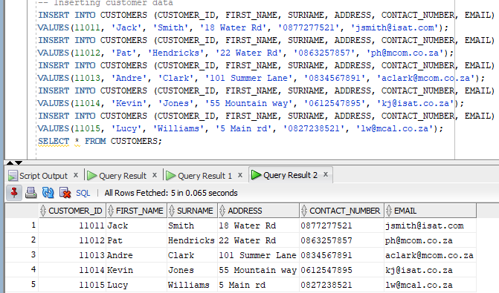

Below is the SQL/PL code for creating the Employee table:

Below is the insertation of data into the Employee table and the output being displayed:

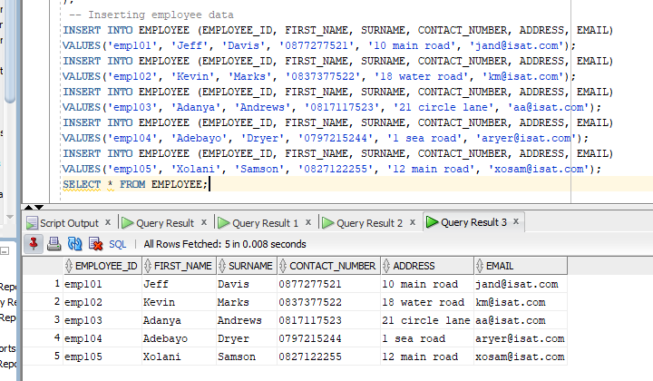

Below is the SQL/PL code for creating the Donator table:

Below is the insertation of data into the Donator table and the output being displayed:

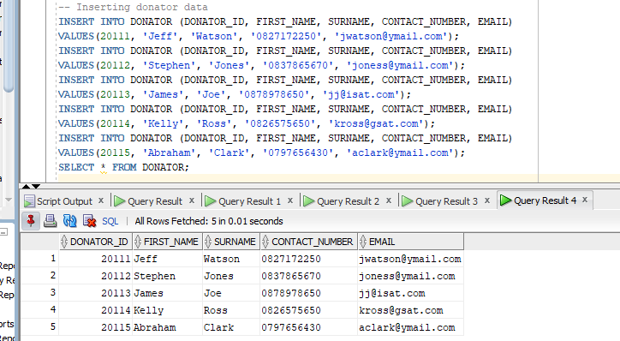

Below is the SQL/PL code for creating the Donation table:

Below is the insertation of data into the Donation table and the output being displayed:

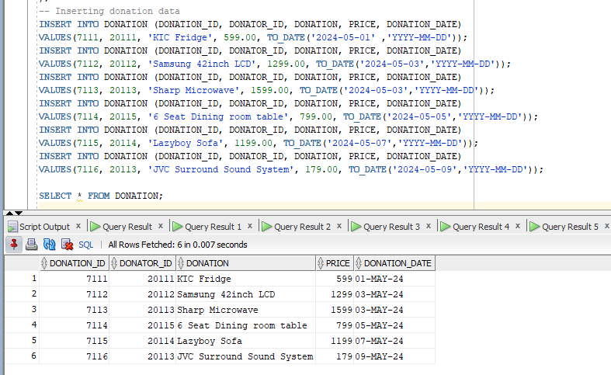

Below is the SQL/PL code for creating the Delivery table:

Below is the insertation of data into the Delivery table and the output being displayed:

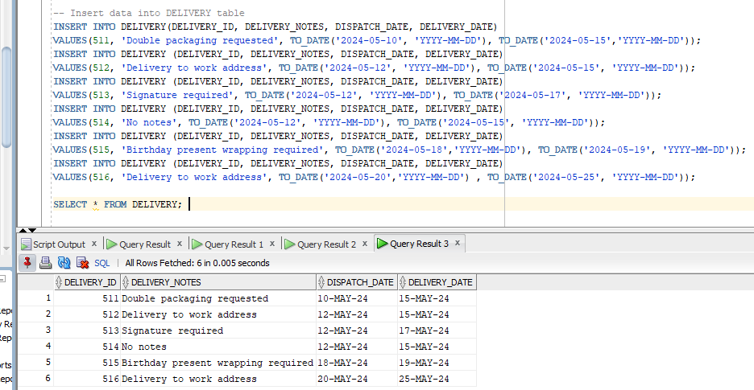

Below is the SQL/PL code for creating the Returns table:

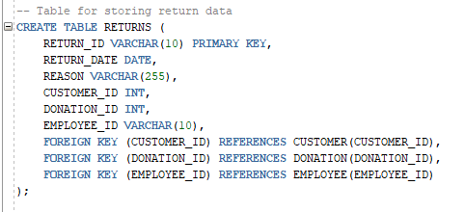

Below is the insertation of data into the Returns table and the output being displayed:

Below is the SQL/PL code for creating the Invoice table:

Below is the insertation of data into the Invoice table and the output being displayed:

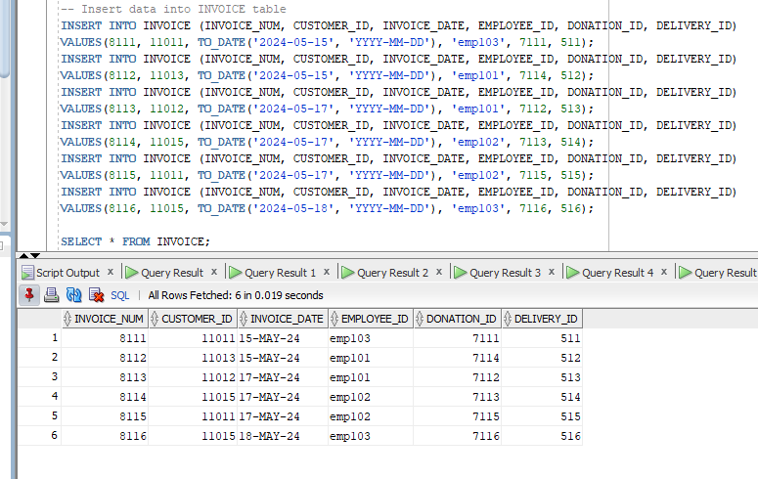

Below is the output source that shows all the tables have been created successfully using the above SQL/PL code above given above:

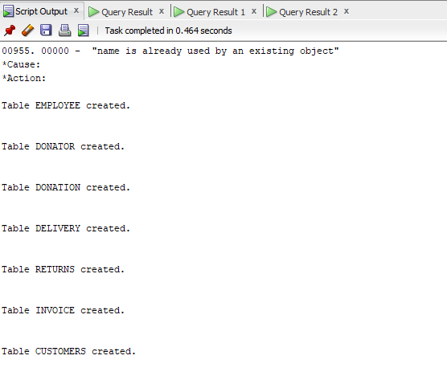

**QUESTION 2**

Below is the SQL query that generate the required report with the results being dispalyed:

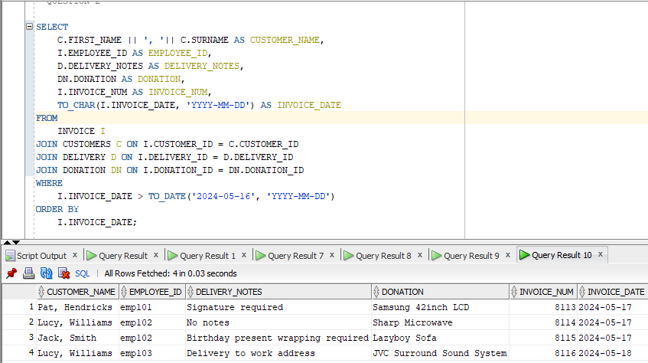

**QUESTION 3**

Below is the SQL query that creates tb_Funding table which will generate a unique id every time a record is inserted into the new table:

**QUESTION 4**

Below is a PL/SQL query to display the combined customer name, donation purchased, donation price and the reason why the donation was returned:

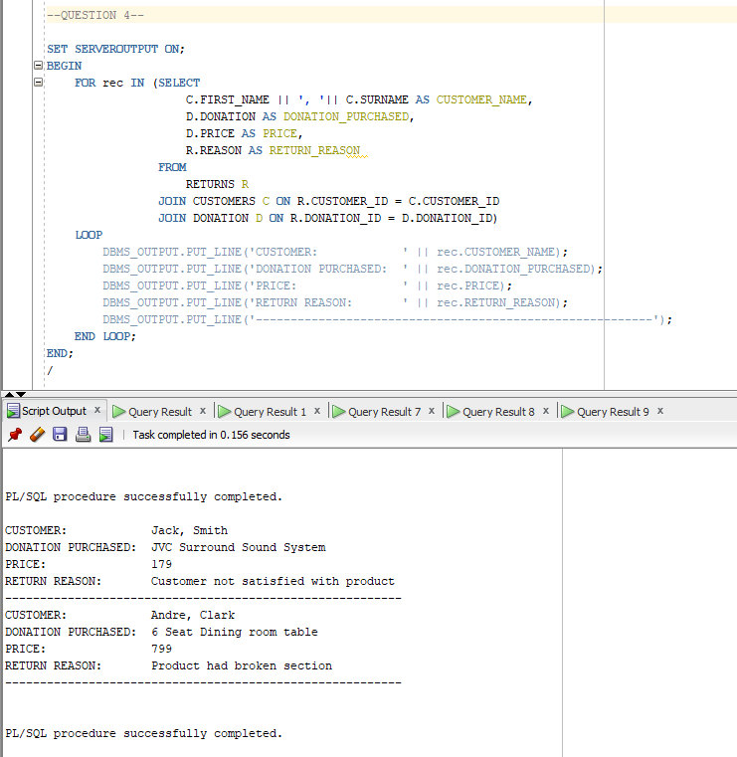

**QUESTION 5**

Below is a SQL query to display the customer’s name, employee name, donation, dispatch date and the delivery date with the display of number of days between the dispatch date and the delivery date in days for customer 110111:

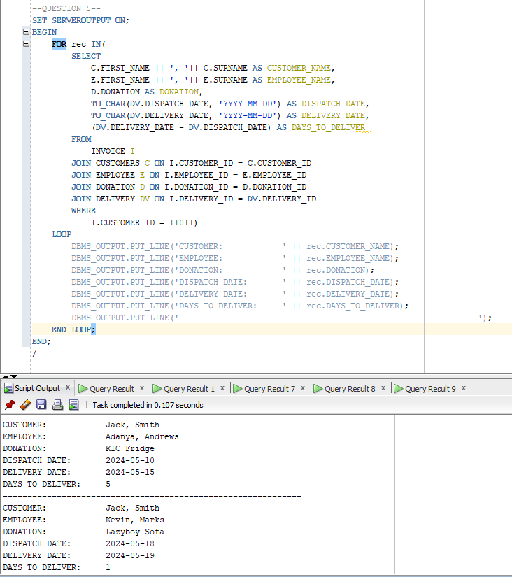

**QUESTION 6**

Below is a SQL query to create a report to display the combined customer name and total amount spent by each customer on the purchases:

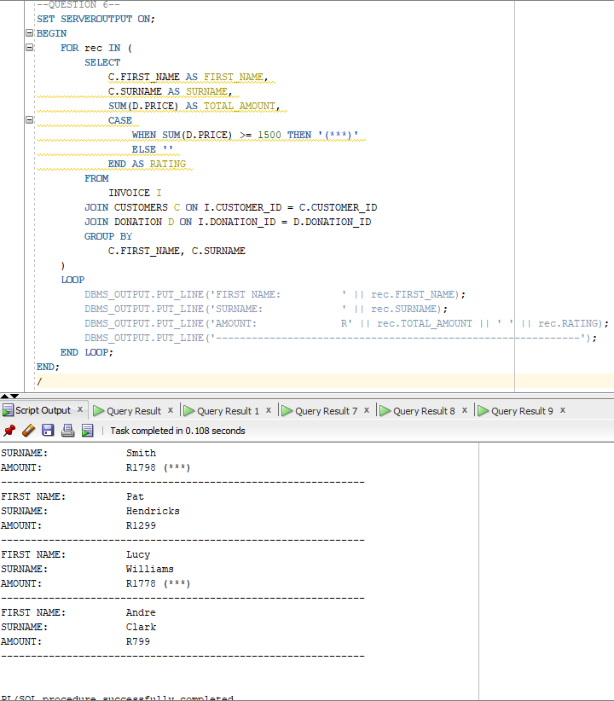

**QUESTION 7**

**Q.7.1** %TYPE attribute:

Below is the SQL query with the example for the %TYPE attribute:

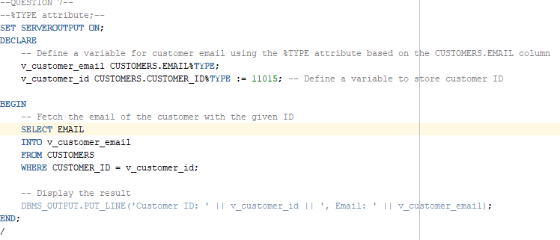

Below is the output the shows that the query has been successfully completed:

Q.7.2 % ROWTYPE attribute:

Below is the SQL query with the example for the %ROWTYPE attribute:

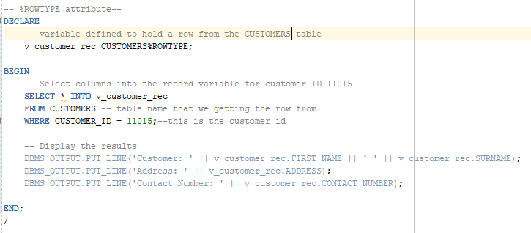

Below is the output the shows the %ROWTYPE attribute:

Q.7.3 User defined exception:

Below is the SQL query with the example for the User defined exception:

Below is the output that shows the User defined execption:

**Question 8**

Below is the SQL query to determine customer ratings to display the combined customer name and total amount spent by each customer on the purchases:

