**RENAME PACKAGE GUIDE**

1. **Required tool**

Download Notepad++ and install it into your machine.

Notepad++ homepage: <https://notepad-plus-plus.org/>

1. **Rename package guide**

* Close Katalon (if opened). Open project folder, delete “**bin**”, “**Libs**” folders.

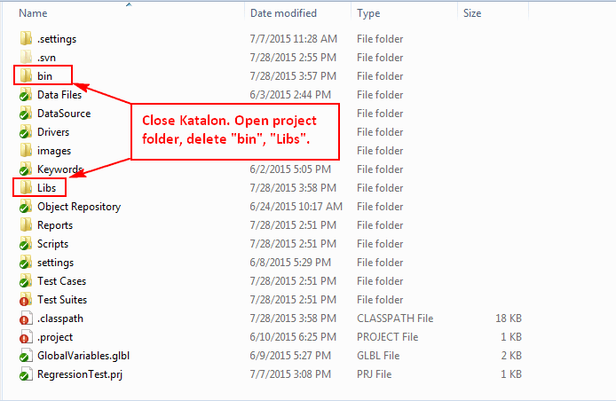

* Open Notepad++. Go to **Search** menu, select **File in Files…**

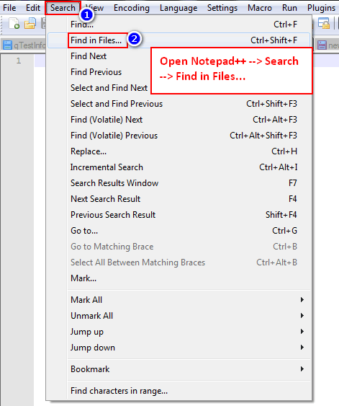

At **Find what**, enter: com.kms.qautomate

At **Replace with**, enter: com.kms.katalon

At **Filters**, enter: *.classpath *.groovy

At **Directory**, navigate to project folder

Check **Match case**, **In all sub-folders**, **Search Mode Normal**

Click **Replace in Files**

