**How to use test data in Data Files**

**Create Data File**

There are two ways to create Test Data:

* Right click on **Data Files** > **New** > **Folder**, then in **New Folder** > **New** > **Test Data**

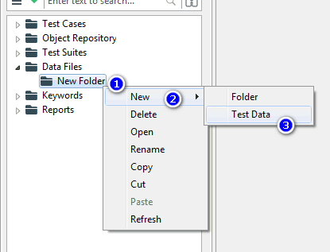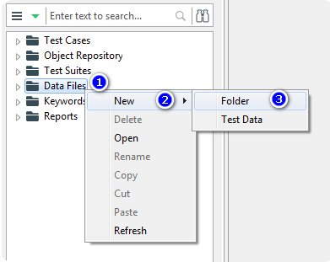

* Click **New Test Data** in Toolbar

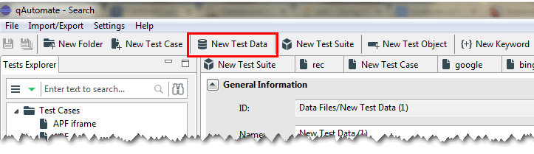

⮩Show Test Data dialog

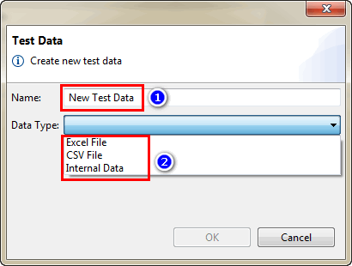

❶ Change data name

❷ There are 3 options to choose from Data Type

**Excel File**

After show **Test Data** dialog, click **Excel File** in the combobox of **Data Type** > click **OK** button

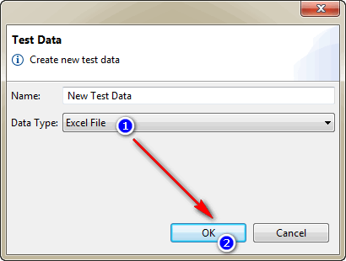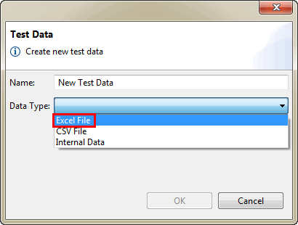

Default interface from excel data

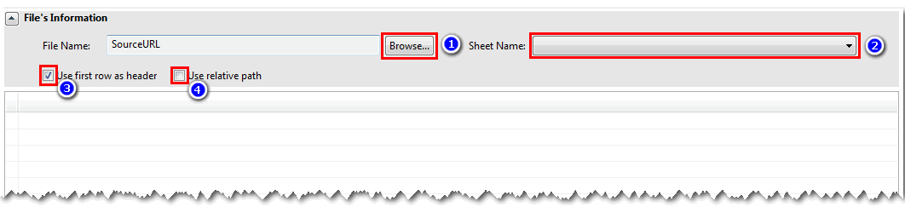

❶ Open Folder contains excel file

❷ Click and choose sheet in excel file you want to use in test data

❸ Users want to use the first row in the data as header

❹ Show the root path

⮑ Example data from excel file

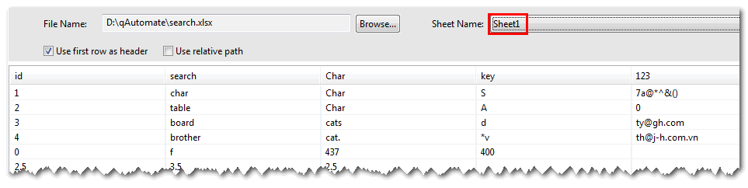

✍Notes🖎

* Data in Data File change if user edit file csv and save data, then refresh data by right click **Test Data** > **Refresh**
* Column name don’t use excel function and only read (char/number + char) + @ +…

**CSV File**

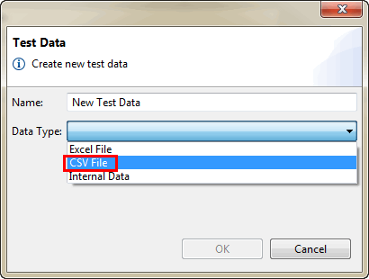After show **Test Data** dialog, click **CSV File** in the combobox of **Data Type** > click **OK** button

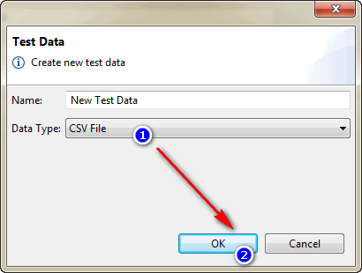

Interface default from CSV data 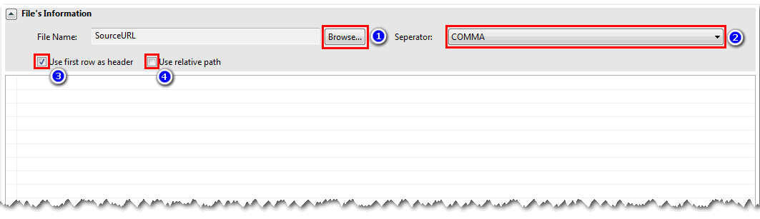

❶ Open Folder contains excel file

❷ There are 3 options to choose from a Separator when you want to view data different

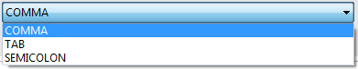

❸ Users want to use the first row in the data as header

❹ Show the root path

⮑ Example data from CSV file

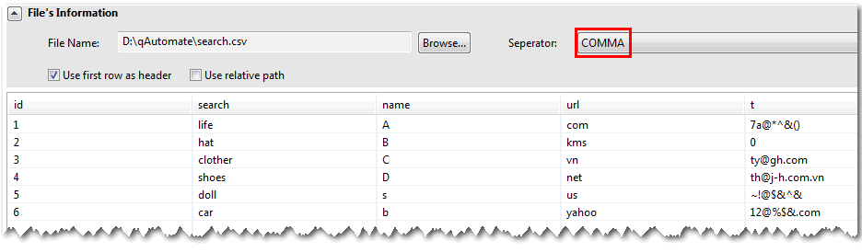

✍Notes🖎

* Data in Data File changes if user edit file csv and save data, then refresh data by right click **Test Data** > **Refresh**

**Internal Data**

After show **Test Data** dialog, click **Internal Data File** in the combobox of Data Type > click **OK** button

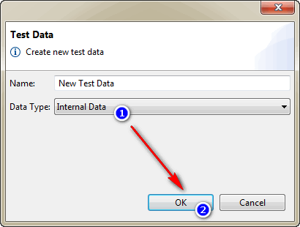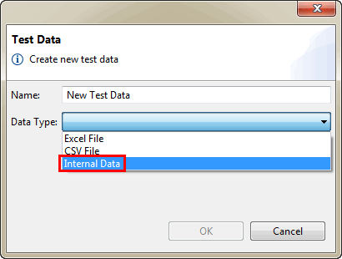

Interface default from Internal Data

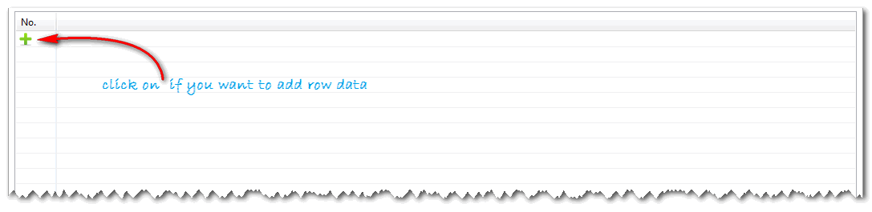

Create data in Internal, user right click Editor and choose **Insert column to the right**, then show **Data Column Definition** dialog

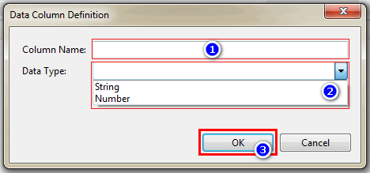

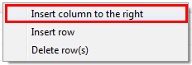

❶ Users input column name

❷ There are 2 options to choose from Data Type

❸ Click OK button

⮑ Example about Internal data

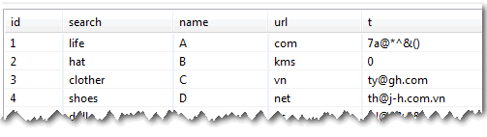

✍Notes🖎

* User can input/edit any char/cell in the Editor

**Use Test Data in Test Suites**

Interface default in Test Suites

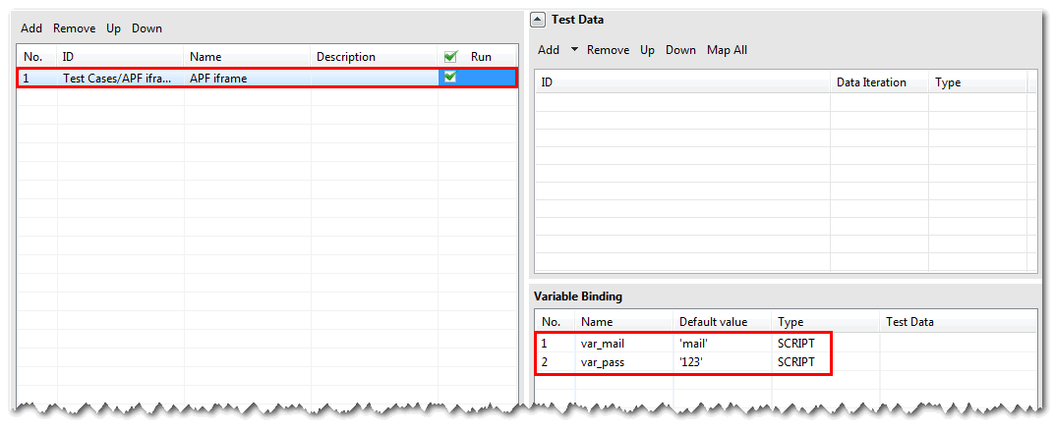

This is the interface default after users add Test Case into Test Suites, if the users click test case, then the data in Test Case show in Variable Binding. Users can run Test Suites with data default in Test Case.

Add data into Test Data tab

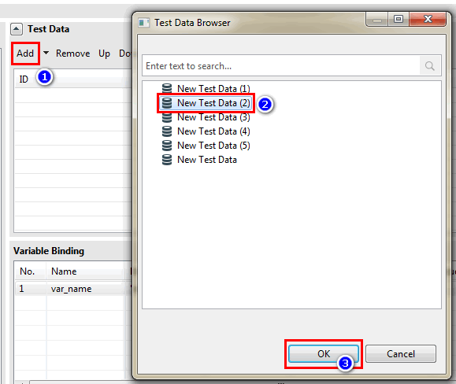

Use data in **Data Iteration**

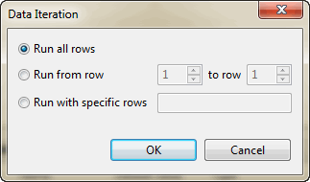



* Run all rows: use all data to test
* Run from row: users can choose from 1 to row n with n ≤ m (n: row number user want to run, m: total row in data file)
* Run with specific rows: users can input any row at will

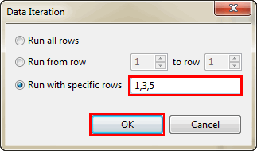

Users could type row number at will in the text box of **Run with specific rows**, then click OK button to complete.

Using data in Type of Test Data

ONE ONE  
a1 b1  
a2 b2 2  
a3

🢚 Min (ONE x ONE) -> 2

MANY MANY  
a1 b1   
a2   
a3 b2

🢚 MANY x MANY -> 3 x 2 = 6

ONE MANY  
a1 b1  
a2 b2 2  
a3  
a4 4

🢚 ONE x MANY -> 4 x 2 = 8

Add data into Variable Binding tab

