Executive Summary 2
Introduction 3
Data Understanding and Preparation 5
Overview of Dataset 5
Data Cleaning and Preparation 5
Descriptive Summary and Key Findings 6
Ethical and Governance Considerations 6
Dashboard 1 - Course Director View: Progress & Retention 7
Dashboard Overview 7
Dashboard Design and Key Features 8
Insights from the four key charts 9
Recommendations and Implications for Course Directors 11
Dashboard 2 - Institutional Retention and Progress Insights 12
Overall Institutional Retention 13
Faculty-level Retention 13
Faculty Size vs Completion Outcomes 14
Academic Performance (WAM) 15
Key Takeaways 16
Predictive Analytics & Insights 17
Purpose of the Predictive Model 17
Methodology and Modelling Approach 17
Key Drivers of Attrition Risk 19
Insights for Personas 20
For Course Directors: 20
For University Executives: 20
Strategic Recommendations 21
Conclusion & Project Reflection 21
Dashboard Links 23

Executive Summary
This business advisory report has been prepared for Macquarie University’s Business Intelligence and Reporting (BIR) team as part of the BUSA8031 – Business Analytics Project. It uses de-identified enrollment and retention data from 2020–2025 to understand student progression, academic performance and retention, and to recommend targeted actions that improve student success at both course and institutional levels.
Two core datasets Enrolment Data (284,818 unit-level records) and Retention Data (52,434 course-level records) were cleaned, standardised and merged via the shared key hub_course_admission_key. A derived retention_status variable (Retained, Completed, Not Retained) created a consistent outcome measure, enabling integrated analysis of demographics, academic results and continuation patterns. Data were handled in accordance with Macquarie’s Education Data Governance framework.
Dashboard 1 – Course Director: Progress & Retention shows that, across 2020–2025, around 71.4% of students are retained, 41.3% complete, and 46.3% do not re-enrol, with an average WAM of 63.2 (Credit). It highlights high-risk units such as ECON1020 and confirms a strong association between low WAM (<60) and non-continuation, supporting the need for early academic intervention and unit redesign.
Dashboard 2 – Institutional Retention & Progress Insights (Executive View) aggregates results at faculty and institutional level. Retention rises steadily from 2020 to 2024 and then stabilises in 2025, with Business and Science & Engineering performing more strongly than Arts. Equity student retention improves from about 68% to 74%, narrowing the gap with non-equity students and indicating progress on inclusion.
A predictive model (XGBoost) was developed to identify students at greatest risk of attrition, achieving a PR-AUC of 0.465, a 5.6× uplift over random targeting. Prioritising the top 20% highest-risk students would capture roughly 66% of future attrition, enabling focused Week-3/4 outreach and support.

Introduction
This report has been prepared as part of the BUSA8031 Business Analytics Project for Macquarie University’s Business Intelligence and Reporting (BIR) team. The project applies data analytics and visualisation techniques to evaluate student progression, academic performance, and retention trends between 2020 and 2025, with the goal of supporting evidence-based decision-making for improved student success and institutional planning.
Macquarie University’s strategic framework emphasises data-informed continuous improvement, and student retention is one of its most critical performance indicators. High retention and completion rates signify both academic quality and institutional stability, while attrition reflects underlying challenges in student engagement, curriculum structure, and equity of access. Recognising these interconnections, this project integrates multiple datasets to generate insights that can directly inform academic and operational interventions.
The analysis is structured around two key user personas, reflecting the multi-level governance model of the University:
- Course Directors, who require detailed program- and unit-level insights to identify progression bottlenecks, academic risk factors, and areas for pedagogical improvement.
- University Executives, who need a consolidated, institution-wide perspective to assess retention, performance, and equity outcomes across faculties and cohorts.
Two de-identified datasets - Enrolment Data and Retention Data were provided by the BIR team. After cleaning, standardising, and merging via the common key hub_course_admission_key, a unified dataset was created that connects demographic, academic, and retention information. This merged file forms the foundation for all subsequent analyses, dashboards, and predictive modelling.
Three major deliverables were developed:
- Dashboard 1 (Course Director – Progress & Retention): A course-level tool that visualises trends in retention, completion, and academic performance to support local program management.
- Dashboard 2 (Institutional Retention & Progress Insights – Executive View): An executive dashboard presenting faculty-level and equity comparisons to guide strategic policy and resource allocation.
- Predictive Analytics Model: A time-aware, leakage-safe machine learning model that identifies students most at risk of non-retention, enabling early and efficient intervention.
Together, these outputs demonstrate how data integration and advanced analytics can enhance institutional decision-making. The insights derived support Macquarie University’s ongoing commitment to fostering inclusive, high-quality, and sustainable educational outcomes through data-driven innovation.
Dashboard 1 (Course Director – Progress & Retention) provides course-level visibility of progression. It shows that, on average, 71.4% of students are retained, 41.3% complete, and 46.3% are not retained in the following year, with an overall average WAM of 63.2 (Credit). The dashboard highlights high-risk units such as ECON1020 and confirms a strong link between low WAM (<60) and non-continuation.
Dashboard 2 (Institutional Retention & Progress Insights – Executive View) extends the analysis to the institutional level. Retention improves steadily from 2020 to 2023, then softens slightly in 2025. The Faculties of Business and Medicine, Health and Human Sciences outperform others, while Arts shows more volatility. Equity student retention improves from around 68% to 74%, narrowing the gap with non-equity students.
A predictive model (XGBoost) was then developed to identify students most at risk of attrition, achieving a PR-AUC of 0.465 a 5.6× uplift over random targeting. Targeting just the top 20% of highest-risk students would capture about 66% of future attrition, enabling efficient, proactive intervention.
Together, these components provide a robust analytical foundation to support data-driven policy, curriculum redesign and student-support initiatives at Macquarie University.

Data Understanding and Preparation

Overview of Dataset
Two primary datasets were used for this analysis: Enrolment Data and Retention Data, covering academic years 2020 to 2025. The enrolment dataset contained 284,818 rows and 43 columns, with each record representing a student’s enrolment in a specific unit within a given academic year. It included demographic information such as gender, citizenship, and equity status, along with academic performance variables including grade, unit status, and weighted average mark (WAM). Additional fields captured course and faculty details, study mode, and credit points earned.
The retention dataset consisted of 52,434 rows and 13 columns, with each record corresponding to a student’s course enrollment in a particular year. It contained indicators for whether the student continued, completed, or transferred courses at the course, faculty, or university level. Both datasets shared a common linking variable, hub_course_admission_key, which allowed them to be merged to create a single integrated dataset.

Data Cleaning and Preparation
The data cleaning process began with an assessment of structure and quality. Both datasets were well-structured with no duplicate entries. A missing value analysis showed that most missing data occurred in variables related to course completion or credit transfers, which are naturally incomplete for students who have not yet graduated or transferred credits. For example, advanced_standing_credit_points was missing in approximately 84 percent of records, credited_credit_points in 55 percent, and course_completion_date in 46 percent. These gaps were expected and not treated as errors, so imputation was not applied.
Variable names were standardized to lowercase and spaces were replaced with underscores to ensure compatibility across tools such as Python and Qlik Sense. Date fields were converted to a uniform datetime format, and categorical variables such as unit_status and grade were checked for consistency in naming. Numeric fields were confirmed to have correct data types.
After cleaning, the two datasets were merged on hub_course_admission_key. This created a unified dataset linking student demographics, academic performance, and retention outcomes. The merged dataset now allows direct analysis of how academic results and demographic characteristics relate to student retention across multiple years and faculties.

Descriptive Summary and Key Findings
Summary statistics showed that the average weighted average mark (WAM) was approximately 63.6 with a standard deviation of 12.9, indicating that the overall student performance lies within the Credit range. The average completed credit points value was 199, consistent with typical undergraduate program progression. Most students achieved grades of Pass or Credit, while smaller proportions earned Distinction or High Distinction. The distribution of unit_status revealed that about 85 percent of unit enrolments were passed, 12 percent failed, and 2 percent were withdrawn.
All students in the dataset were enrolled in Bachelor-level courses. Gender distribution was slightly skewed towards males, who accounted for about 59 percent of enrolments, while domestic students formed approximately 76 percent of the total population. Around 15 percent of students had an equity flag, indicating participation in equity or support programs.
In the retention dataset, 54 percent of students were retained into the next academic year, 19 percent had completed their studies, and 21 percent were not retained. To streamline analysis, a new variable named retention_status was derived from the original code_tag field. The multiple granular categories were grouped into three broad outcomes: Retained, Completed, and Not Retained. This transformation simplifies analysis and allows consistent filtering and aggregation during dashboard development and reporting.

Ethical and Governance Considerations
All data provided for this project were de-identified and handled in accordance with Macquarie University’s Education Data Governance (EDG) framework. The datasets contained no personal identifiers and were used solely for analytical purposes. The work complied with confidentiality and ethical research standards, ensuring that no individual student could be identified from the analysis or subsequent visualisations.
The data preparation process resulted in a clean, standardised, and integrated dataset suitable for both statistical analysis and visualisation. The merged file connects demographic, academic, and retention information in a structured form that supports deeper investigation of student progression, performance, and attrition patterns. This dataset will serve as the foundation for the dashboard team to visualise retention trends, explore relationships between student performance and demographics, and identify key factors influencing course completion and continuation.

Dashboard 1 - Course Director View: Progress & Retention

Dashboard Overview
The Course Director dashboard is designed to track student progress and retention using merged enrolment and retention data, combining enrolment records, academic results, and continuation outcomes for each student.
Filters let you drill down by academic year, course, study mode, outcome group, domestic or international status, and equity background so that you can zoom in on specific cohorts quickly.
At the top, four key metrics give you the headline picture: retention rate, completion rate, non-retention rate, and average WAM. Below that, you'll see breakdowns by year and course, plus unit-level results and WAM trends over time. The goal is to help the course director spot and understand whether students are on track or if they might need intervention.
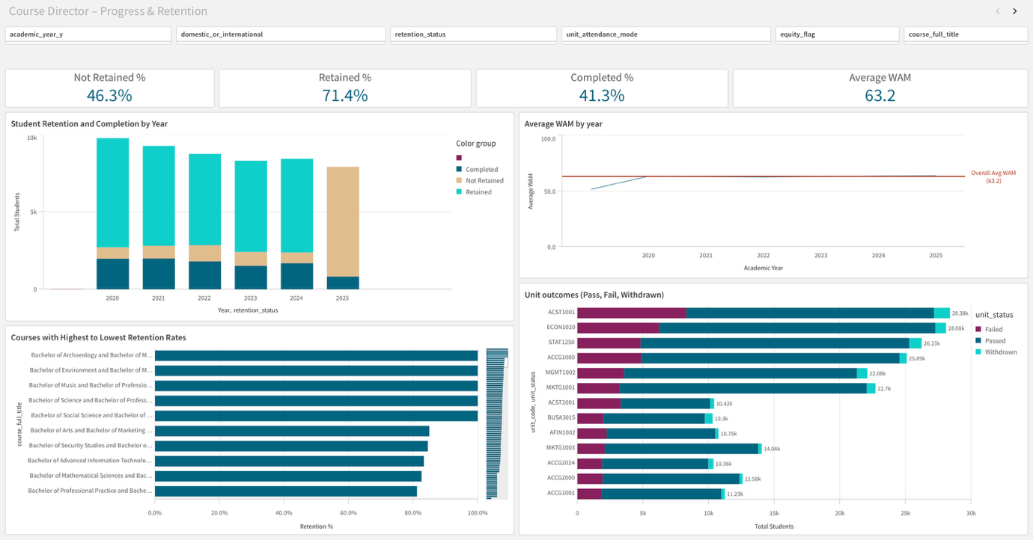

Dashboard Design and Key Features

This dashboard is built for Course Directors and uses the merged enrolment and retention dataset. A compact row at the top shows four metrics: retained, completed, not retained, and average WAM. These numbers change the moment you adjust a filter.
A set of clear visuals sits below. One chart shows the share of outcomes by year. Another shows the share of outcomes by course. A line chart tracks average WAM across years. A unit outcomes chart lists passes, fails, and withdrawals. It shows the top fifteen units so the view stays readable.
Filters appear along the top. You can focus by academic year, course, study mode, domestic or international status, and equity background. Colours stay the same across every view: teal for retained, orange for not retained, and blue for completed.
Hovering on any bar or line shows the exact student count and the percentage. All visuals update together when you make a selection.

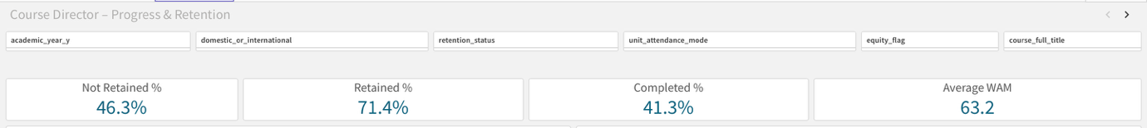

Insights from the four key charts

The dashboard presents four main insights that help Course Directors identify where students are progressing well and where interventions may be needed. Each chart works with the filters, allowing targeted exploration by course, year, or cohort.
Chart 1 shows: How many students continued, completed, or did not continue each year
Between 2020 and 2024, retention remained steady, with most students continuing their studies each year. However, 2025 shows a visible decline in the retained category and a sharp rise in students marked “not retained.” This suggests a recent shift that may be linked to course delivery or external factors such as post-pandemic adjustments. Course Directors can use this view to identify when performance trends begin to drop and align interventions in time.

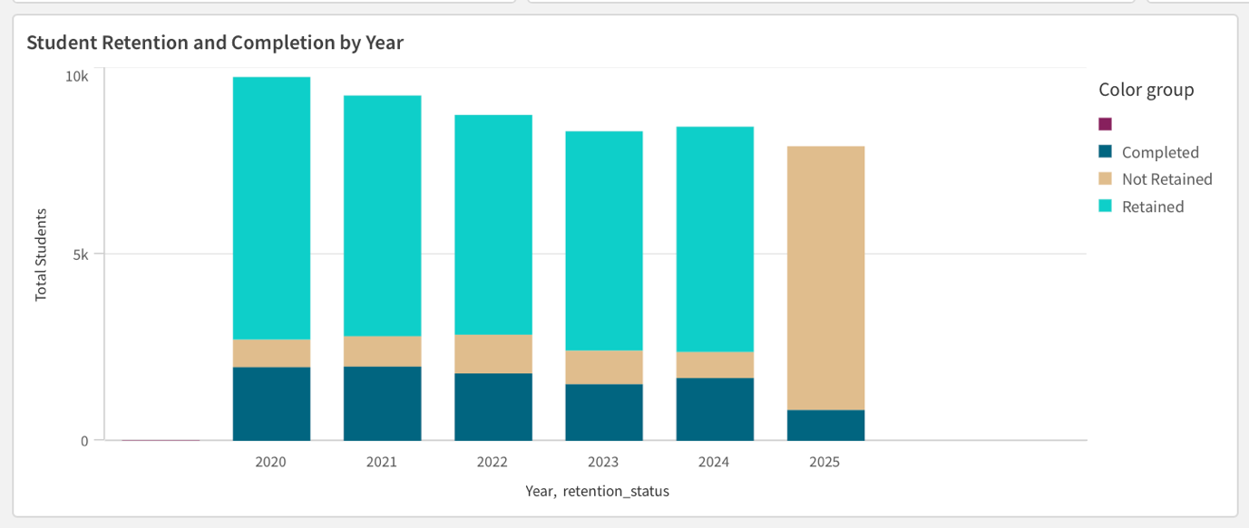

Chart 2 shows: Which courses have the highest and lowest retention
The course comparison view highlights significant variation across programs. Accounting and Finance courses record the highest retention rates, while Marketing and Information Technology show weaker continuation. This pattern indicates potential issues in student engagement or assessment structure in those areas. By filtering by year or study mode, Course Directors can explore whether these differences are consistent or improving over time
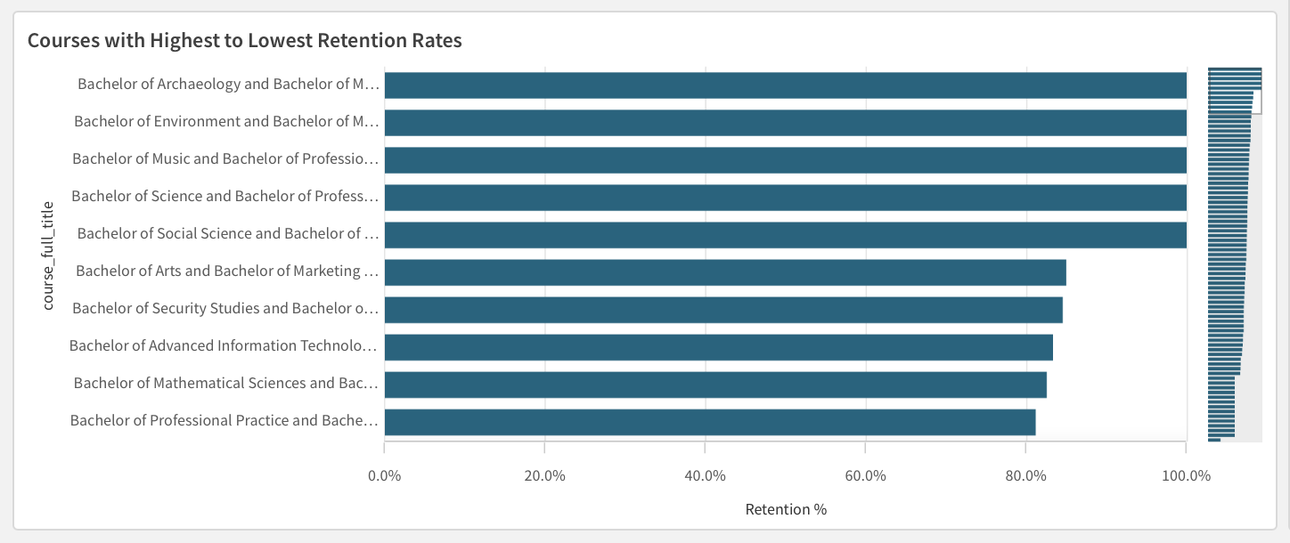

Chart 3 shows: How does the average WAM change over time
The WAM trend remains almost flat, maintaining an overall average of about 63. This stability implies that academic performance standards are consistent across cohorts, and fluctuations in retention are not caused by declining marks. Course Directors can therefore focus on improving student support and engagement rather than revising grading or difficulty levels.

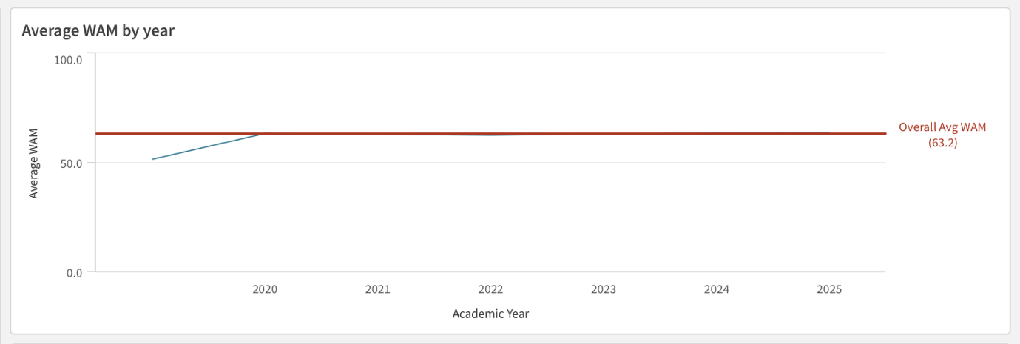

Chart 4 shows: Which units show many failures or withdrawals
The unit-level analysis highlights ACST1001 and ECON1020 as having the highest fail and withdrawal counts, followed by STAT1250 and ACGG1000. These are large first-year or foundation units, suggesting that early transition and study adjustment challenges may play a key role. Monitoring these units helps Course Directors and unit convenors pinpoint where academic support or redesign may be needed to reduce early drop-offs.
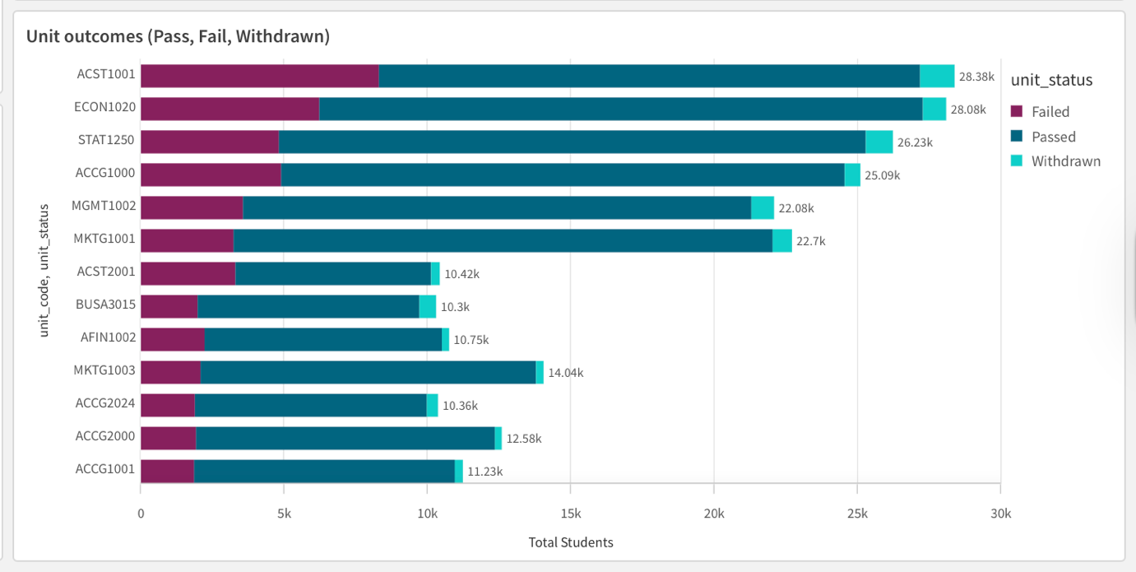

Recommendations and Implications for Course Directors
The dashboard shows where Course Directors can focus and take action to improve retention and performance outcomes.
First, early identification of at-risk students should be a priority. The retention and unit-level charts show where non-continuation and high failure patterns appear, allowing Course Directors to collaborate with advisors and support teams to intervene early.
Second, checking retention across courses each year can help track which programs, such as Marketing or IT, continue to show the lowest engagement. Continuous monitoring will support resource planning and ensure accountability across faculties.
Third, the flat WAM trend suggests academic standards are consistent, so the focus should shift to improving learning experiences and progression support rather than assessment redesign.
Lastly, Course Directors should use the dashboard collaboratively, sharing insights with faculty teams each semester to track progress and measure improvement in student outcomes.

Dashboard 2 - Institutional Retention and Progress Insights
While Dashboard 1 focuses on course-level patterns and provides detailed insights for Course Directors, Dashboard 2 takes a broader, institutional view. It offers an Executive View of overall student retention, faculty performance, and academic progress across the university. This perspective helps senior leaders connect course-level outcomes to university-wide performance, ensuring that decisions on resources, policies, and student support are grounded in reliable data.
Dashboard 2 brings together key metrics such as retention, completion, and academic performance, giving executives a clear, interactive view of progress across faculties and student groups. Filters for Faculty, Academic Year, Attendance Mode, and Student Type enable flexible exploration, while colour-coded visuals and concise labelling make insights easy to interpret.
Overall, the dashboard shows that retention and academic performance have steadily improved since 2020, though results vary by faculty, highlighting where additional support or resorces may be needed to sustain progress.
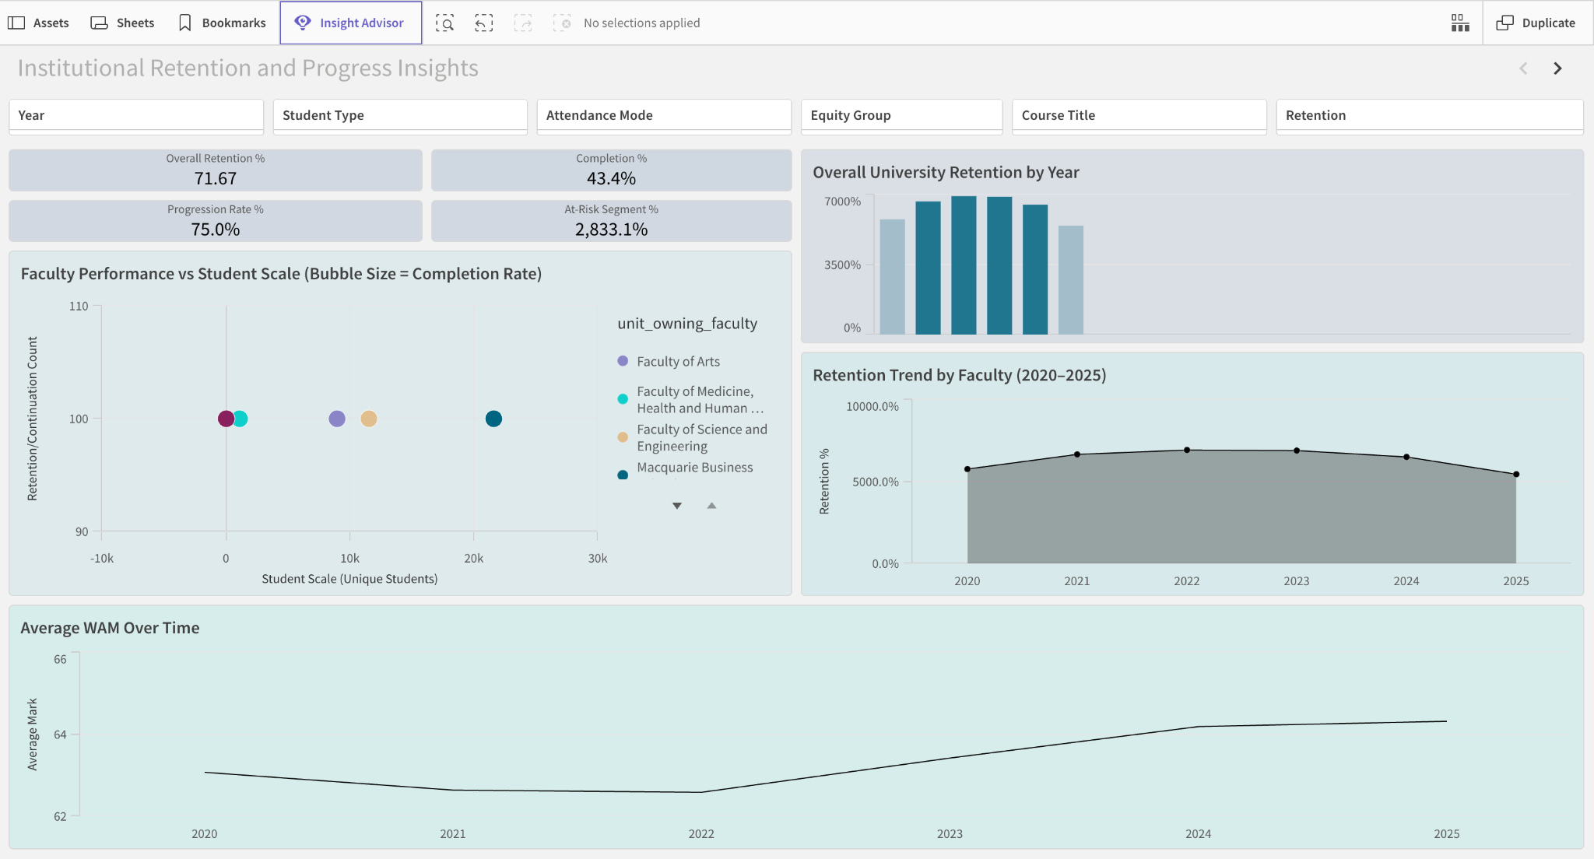Figure 2.1 Institutional Retention and Progress Insights Dashboard (Executive View – Full Layout with Interactive Filters).

Overall Institutional Retention
University-wide retention rose steadily from 2020 to 2024 before levelling off in 2025. This growth reflects the success of post-pandemic initiatives such as flexible delivery and expanded student support. The plateau suggests these strategies have matured, and further progress may depend on early-alert or predictive analytics systems to identify at-risk students sooner. Completion trends mirror retention, showing that most continuing students finish on time. Overall, retention improved each year before stabilising, confirming that existing support initiatives are effective but reaching maturity.
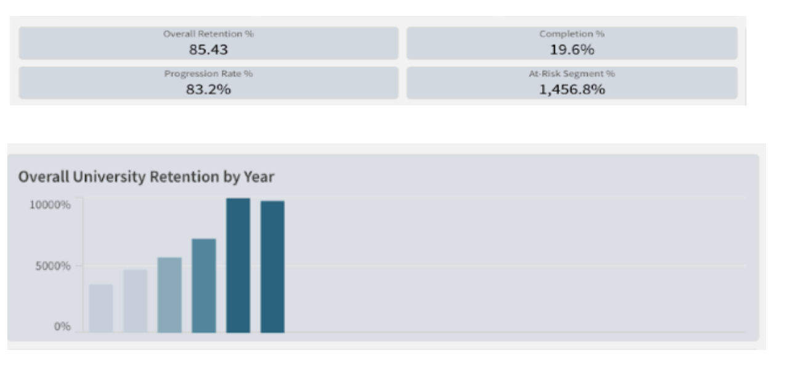Figure 2.2 Institutional Retention Trend (2020–2025) – Filtered by Academic Year.

Faculty-level Retention
Faculty-level results vary across the university. The Business School and Science & Engineering maintained continuation and completion rates above the institutional average from 2021 to 2024, while Arts showed steady but lower outcomes. Differences in class size, course mix, and student profile may explain this gap. Sharing proven strategies from high-performing faculties, such as mentoring programs, blended learning, and early academic advice, could help improve retention in smaller faculties with minimal added cost. Collectively Business and Science & Engineering outperformed other faculties, highlighting opportunities for shared practices and cross-faculty learning.
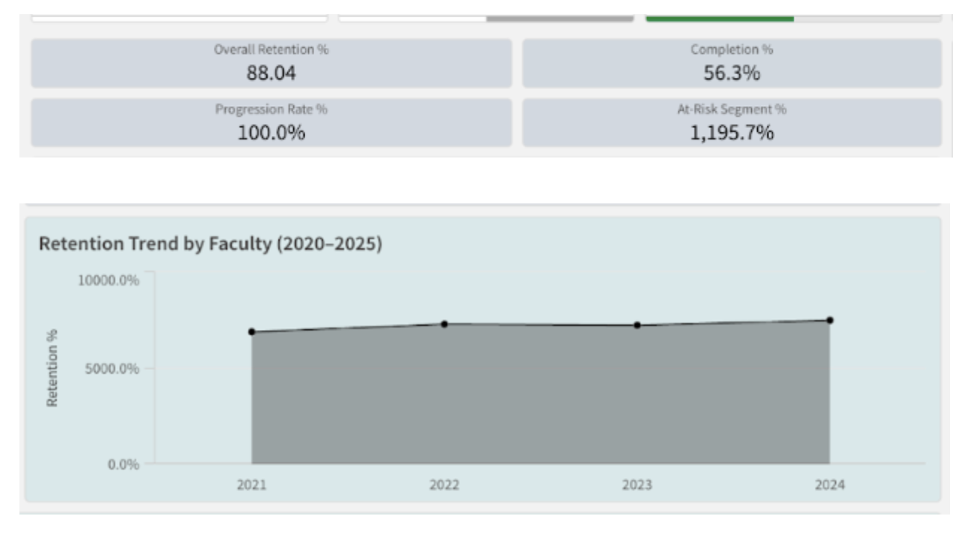
Figure 2.3 Retention by Faculty (2020–2025) – Filtered by Faculty.

Faculty Size vs Completion Outcomes
Comparing faculty size with continuation and completion rates shows that larger faculties perform slightly better, likely due to stronger administrative support, peer networks, and shared resources. Smaller faculties may lack these advantages, suggesting a need for fairer resource distribution. Providing them access to common systems and student-success programs could lift completion outcomes and close performance gaps across the university. In summary, larger faculties achieved stronger results, highlighting how scale and shared resources contribute to student success.
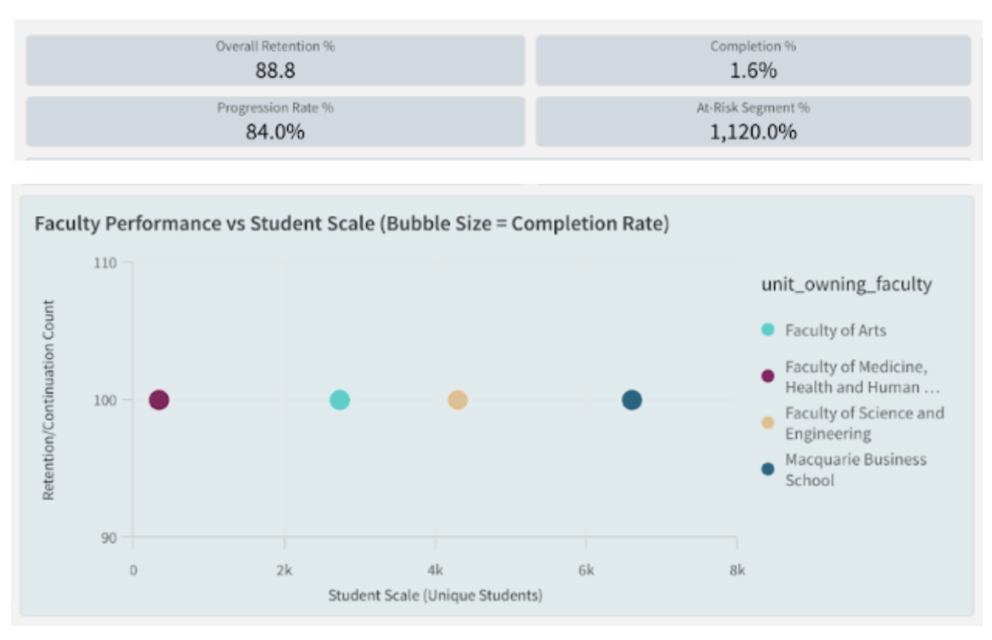
Figure 2.4 Faculty Size, Retention and Completion rates – Filtered by Year.

Academic Performance (WAM)
Average WAM rose steadily from 2020 to 2024 before leveling off in 2025, showing improved learning outcomes and engagement. This reflects the success of consistent assessment design and quality feedback. The plateau suggests performance may have reached its limit under current settings, highlighting the need for personalised feedback, stronger academic-skills programs, and further investment in digital learning tools. Overall, WAM improved consistently before stabilising, confirming steady progress in student performance and engagement.
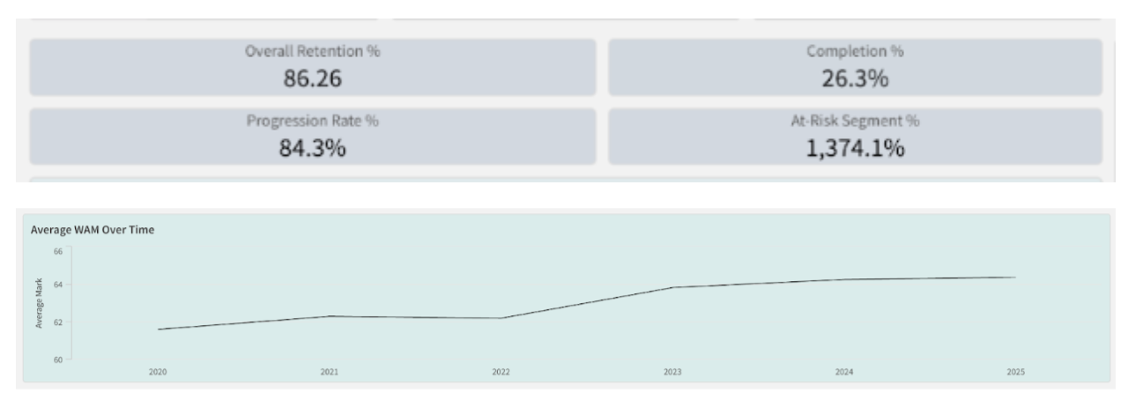
Figure 2.5 Average WAM Trend (2020–2025) – Filtered by Academic Year.

Key Takeaways
Overall, institutional retention and academic performance have improved since 2020, confirming the value of the university’s student-experience strategy. Differences between faculties, however, show that progress is uneven and partly shaped by resource levels and delivery modes. To sustain improvement, senior leaders should:
• Monitor retention and completion annually to detect shifts early.
• Encourage collaboration across faculties to share successful support models.
• Strengthen inclusion initiatives to close performance gaps among demographic groups.
• Review resource distribution to ensure smaller faculties have access to equivalent support systems.
Dashboard 2 turns complex enrollment data into clear, evidence-based insight. It enables executives to connect policy and funding decisions with measurable outcomes, supporting a balanced and data-informed approach to improving student retention, completion, and overall institutional performance.

Predictive Analytics & Insights
Student retention is a strategic priority for Macquarie University, directly influencing institutional performance, funding sustainability, student outcomes, and reputation. While descriptive dashboards provide valuable visibility of historical trends, executives and academic leaders increasingly require foresight to intervene before disengagement occurs. To address this need, we developed a predictive model that identifies students most at risk of not being retained in the following academic year. This enables early, targeted, and resource-efficient support that strengthens student success outcomes at scale.

Purpose of the Predictive Model
The predictive model shifts the University’s retention approach from reactive to proactive. Instead of relying solely on historical patterns and end-of-year outcomes, the model generates an individual-level early-warning signal, estimating the probability that each student will fall into the “Not Retained” category in the subsequent academic year. This provides Course Directors with an actionable mechanism to prioritise interventions within programs and equips University Executives with a strategic view of risk concentration across faculties, equity groups, and academic cohorts. In doing so, predictive analytics becomes a strategic decision-support tool that enhances MQ’s ability to deliver high-impact retention initiatives aligned with institutional priorities and student success goals.

Methodology and Modelling Approach
A robust, leakage-safe modelling framework was adopted to reflect real operational deployment conditions. Features were engineered using only information available up to the student’s current academic year (t), while the target variable represented the retention outcome in year t+1. A time-aware data split was applied to prevent information leakage: data from 2020–2022 was used for model training, 2023 for validation, and 2024 for final hold-out testing. Missing values were imputed using training-set medians to ensure fairness and consistency across cohorts.

Two supervised machine learning models were evaluated to balance transparency and predictive power:
Model | Rationale
Logistic Regression (Balanced) | Serves as a transparent, policy-friendly baseline suitable for executive communication and fairness auditing
XGBoost Classifier | Captures non-linear interactions in student progression and is widely used in education analytics due to its strong real-world performance
Given the low attrition prevalence, optimising for Precision–Recall AUC (PR-AUC) was prioritised over accuracy or ROC-AUC, as PR-AUC more accurately reflects the model’s usefulness in small-target scenarios.
Model Performance and Value Demonstration
Split | Prevalence | ROC-AUC | PR-AUC
Validation 2023 – Logistic Regression | 0.110 | 0.898 | 0.614
Validation 2023 – XGBoost | 0.110 | 0.884 | 0.612
Test 2024 – Logistic Regression | 0.083 | 0.843 | 0.454
Test 2024 – XGBoost | 0.083 | 0.826 | 0.465

XGBoost achieved the highest PR-AUC on the 2024 hold-out dataset, outperforming the baseline PR-AUC of 0.083 by more than 5.6×. This demonstrates substantial uplift in the University’s ability to correctly identify students who will disengage. Logistic Regression remains valuable as a transparent benchmark and would be suitable for governance or stakeholder-friendly explanations; however, XGBoost provides superior real-world intervention value and was therefore selected as the recommended model.
Strategic Early-Intervention Efficiency: “Return on Support Capacity”
To evaluate practical impact, we analysed the proportion of future attrition that can be captured when only a limited share of students can receive proactive support:
% of Students Flagged | % of All Attrition Captured | Count
Top 10% | 50.4% | 347 of 689
Top 20% | 66.0% | 455 of 689
Top 30% | 74.6% | 514 of 689

This demonstrates significant operational efficiency: by targeting only the top 20% highest-risk students, MQ can reach two-thirds of those who will disengage. Even a light-touch pilot targeting the top 10% would still support half of all future attrition cases. This positions predictive modelling as a high-ROI lever for Student Success, Faculty leadership, and the PVC Education portfolio.

Key Drivers of Attrition Risk
Analysis highlights four systemic drivers that materially influence risk:
1. Academic friction during the year – Multiple fails and withdrawals strongly predict next-year disengagement, signalling academic or wellbeing barriers.
2. Inefficient academic progress – Low pass rate and low credits-earned-to-attempted ratio indicate course misalignment, study load imbalance, or lack of academic readiness.
3. Core unit sequencing pressure – Concentrated enrolment in 2000-level core units drives elevated risk, suggesting structural course-design pinch points.
4. Program-level effects – Certain courses show consistently higher predicted risk, implying differences in academic load, support access, cohort composition, or curriculum design.
These drivers translate into specific, controllable levers for both Course Directors and Executives.

Insights for Personas

For Course Directors:
- Prioritise early outreach for students exhibiting academic friction and low pass-rate efficiency.
- Use risk signals to refine program sequencing, reduce clustering of core pressure-point units, and support course progression pathways.
- Embed early diagnostics (Week 3–4) to detect and redirect emerging risk before disengagement becomes irreversible.

For University Executives:
- Use risk concentration patterns across faculties and student groups to inform targeted resourcing, policy shifts, and student success initiatives.
- Monitor high-risk programs and cohorts as part of institutional performance reporting.
- Integrate risk analytics into retention governance to ensure support distribution is equitable and strategically aligned to MQ’s priorities.

Strategic Recommendations
We recommend that MQ:
1. Implements a top-20% early-warning risk flag to operationalise proactive support with measurable impact.
2. Launches a Week-3/4 Student Success Outreach Program for flagged students, including load-balancing guidance and referral pathways.
3. Reviews high-pressure course sequencing to reduce structural academic bottlenecks contributing to disengagement.
4. Monitors equity in intervention outcomes to ensure fair access to support across domestic/international, equity-flag, and diverse cohorts.
5. Embeds annual model refresh and governance to maintain ethical, transparent, and high-performance predictive capability.

Conclusion & Project Reflection
This project illustrates how rigorous data preparation, visual analytics and predictive modelling can be combined to support strategic decision-making in higher education. By cleaning and merging the enrolment and retention datasets, the team created a single, reliable analytical asset linking demographics, academic performance and retention outcomes across six academic years. This integrated view is essential for understanding not only what is happening to students, but why.
Dashboard 1 translates this data into an operational tool for Course Directors. It reveals that although overall retention (71.4%) is relatively strong, only 41.3% of students complete on schedule and specific units notably ECON1020 and some large quantitative subjects act as progression bottlenecks. The clear association between low WAM and non-continuation underlines the importance of early academic support, workload review and targeted tutoring in high-risk units.
Dashboard 2 provides an institutional lens for Executives. It shows that Macquarie has largely recovered from the pandemic, with retention improving through 2023, and that larger faculties such as Business and Science convert scale into higher completion and retention. At the same time, the more variable performance of the Faculty of Arts and smaller programs signals areas where curriculum design and student support need closer attention. Encouragingly, equity retention has improved, narrowing the gap with non-equity students and demonstrating progress against inclusion goals.
The predictive analytics component moves the university from reactive reporting to proactive management. By using a time-aware, leakage-safe design, the XGBoost model can identify a relatively small group of students who account for a large share of future attrition. This makes it realistic to operationalise interventions such as a Week-3/4 outreach program, load-balancing advice, and referrals to support services, without overwhelming staff capacity.
From a learning perspective, the project strengthened the team’s skills in Python-based data cleaning, Qlik Sense dashboard design, and applied machine learning, as well as teamwork, documentation and ethical handling of de-identified data under the Education Data Governance framework.
Overall, the project demonstrates that when data is integrated, visualised and modelled thoughtfully, it becomes a powerful lever for improving student progression, informing resource allocation, and supporting Macquarie University’s commitment to high-quality, equitable student outcomes.

Dashboard Links

Dashboard 1 : https://23cen6dozz61syg.ap.qlikcloud.com/sense/app/4d7a37d0-88d7-4fb3-b1f4-448246c39658

Dashboard 2 : https://23cen6dozz61syg.ap.qlikcloud.com/sense/app/9b261911-3aea-4951-99d3-3e603903742e

