**In order to setup braintree subscription plugin in your Reaction Commerce, follows the given steps:-**

1> Create an account on <https://www.braintreepayments.com/>. After creating an account, you get some credential like

Merchant ID: xxxxxxxxxxxx

Public Key: xxxxxxxxxxxxx

Private Key: xxxxxxxxxxxxxxxxxx

2> Login in Braintree <https://www.braintreepayments.com/>. and create a plan in Braintree.

3>Download the braintree subscription plugin from GitHub and put it in

your reaction commerce

imports->plugins->custom

and run the command

reaction reset

on your terminal.

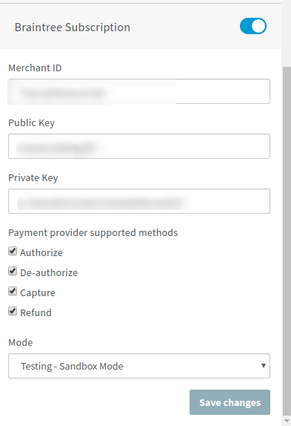4>Login in Reaction Commerce as a admin and click payment from dashboard

and enter the above details and now you are ready to use this plugin.

5> This plugin is developed for both normal and subscription based payment.

I have written this code in

imports->plugins->custom->payments-braintree-subscription->client->checkout->braintreeSubscription.js

const oneTime = "oneTime";

const subscription = "subscription";

const paymentType = subscription;

if the product is for one time based payment then

const paymentType = oneTime;

if the product is for subscription baesd payment then

const paymentType = subscription;

6> There are some further development needed :-

a> Cancel of subscription based payment.

b> Refund of subscription based payment

c> Different report of one time and subscription based payment.