***提高开头段***

Day 1---- 顾1 & 2

Day 2 ---顾3&6

Day 3 ----顾 7& 8

Day 4 ---顾9 & 10

Day 5----写蓝色书146.3 & 150.2 开头段

### Day1

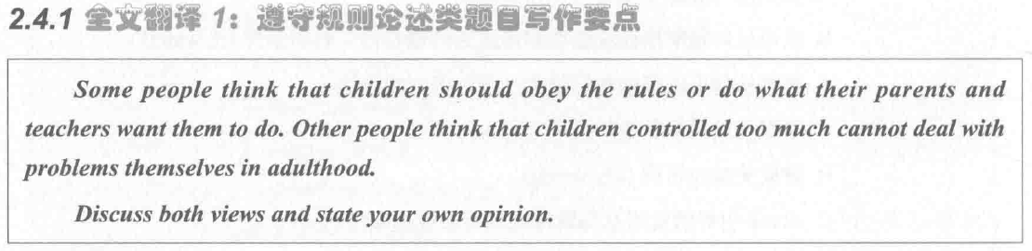

个人分析：

Discuss讨论类，没有background info，使用定义法：

$定义对象 has has been recognized as .... , because reason1 and reason2

Parenting has been recognized as playing an important role in children education, because children are able to shape a positive world view and distinguish right from wrong.

表明观点：

although + 不支持的观点改写，I personally believe that + 不支持的观点改写

Although children should follow rules or do what their parents and teachers expect them to do，I personally believe that problems cannot be dealt with by children themselves in adulthood，if they are controlled too much.

开头段：

Parenting has been recognized as playing an important role in children education, because they are able to shape a positive world view and distinguish right from wrong. Although children should follow rules or do what their parents and teachers expect them to do，I personally believe that strict discipline has an adverse impact on children’s problem-solving abilities.

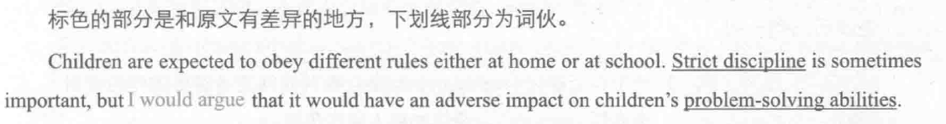

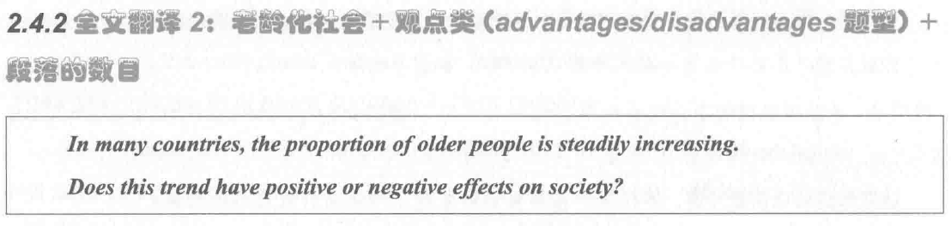

ad / disad 观点类，有背景，可以用同义替换法。

背景句：

同义替换后的背景句，possibly because （of） + reason1 and reason2

The ratio of the elderly has been growing steadily possible because of improvements in technology and the personal wealth.

观点句：

although + 不支持的观点改写，I personally believe that + 不支持的观点改写

Although the senior citizens are able to achieve social value，I personally believe that this demographic change leads to some problems.

开头段：

The ratio of the elderly has been growing steadily possibly because of improvements in technology and the increase in personal wealth. Although the senior citizens are able to achieve social value，I personally believe that this demographic change leads to some social problems.

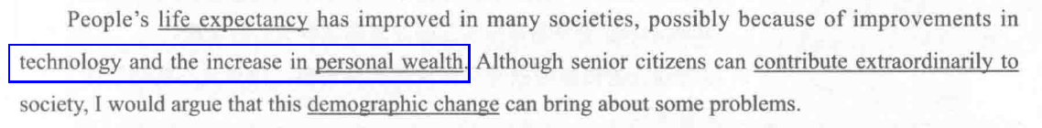

### Day2

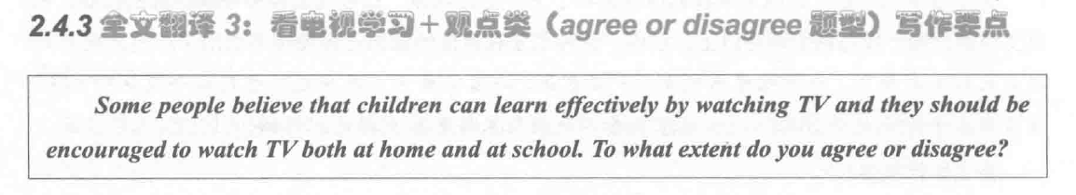

观点类，有背景，用替换法。

Watching television has been recognised as an effective method of children’s learning, because audio-visual information can attract children’s attention and engage their interest. Although many TV programmes has educational value, I personaly believe that increasing screen time is not a good idea.

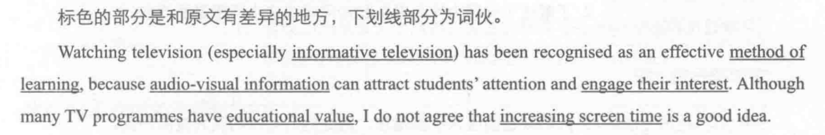

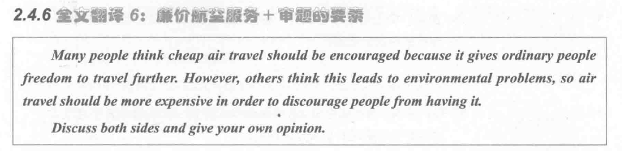话题类作文，没有背景句，使用定义法。

Air travel has been recognized as a routine method possibly because of improvements in technology and the increase in personal wealth. Although low-cost air travel might cause air pollution, I personaly believe that cheap flights can benefit the masses.

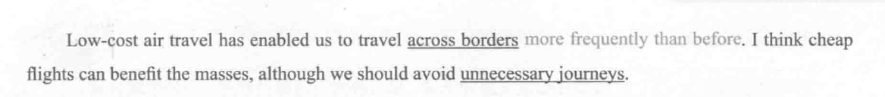

### Day3

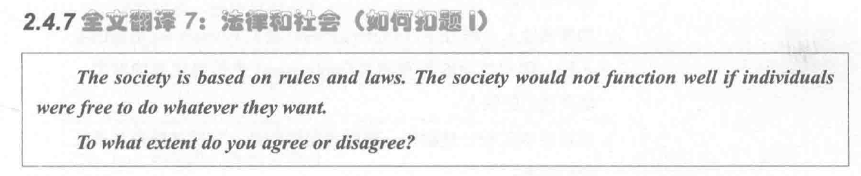

agree or dis— 观点类，无背景句（背景句不完善），使用定义法：

Law and rules has been recognized as a stable basis of human being, possibly because of they maintain the right and benefits of citizens. Although laws play an important role in regulating people’s behaviour, I personally believe that strict laws can also restrict their freedom.



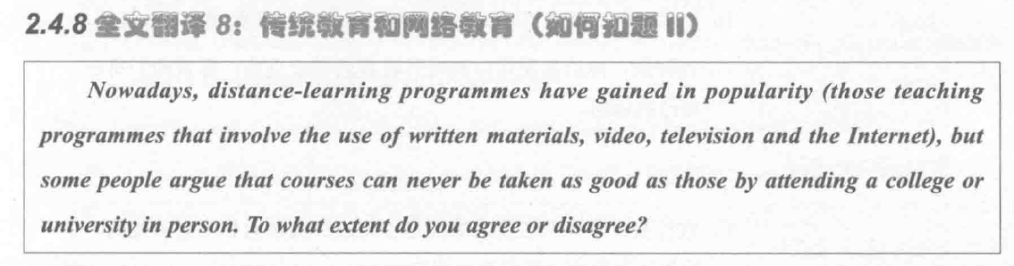

观点类，有背景句，使用同义替换：

The proportion of distance-education is steadily growing possibly because of improvements in technology and the increase in personal wealth. Although distance-learning differs from traditional university education in some aspects, I personally believe that students are able to acquire knowledge from online course more conveniently.

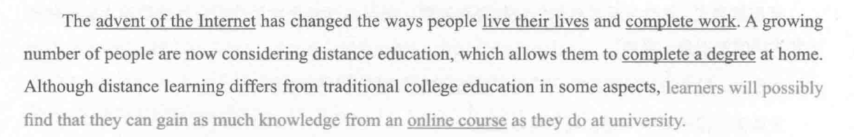

### Day4

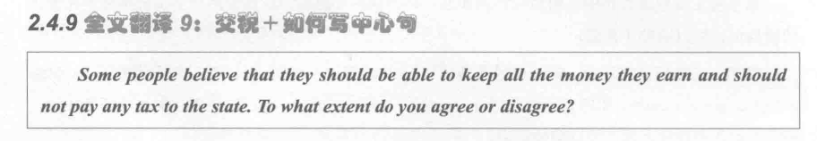

disagree or disagree 观点类，无背景，定义Tax，同意表达有Duty

Paying Tax has been recognized as a basic duty, possibly because the state uses taxes to maintain social stability and complete infrastructure. Although duty is regard as a burden, I personally believe that the society cannot function appropriately without it.

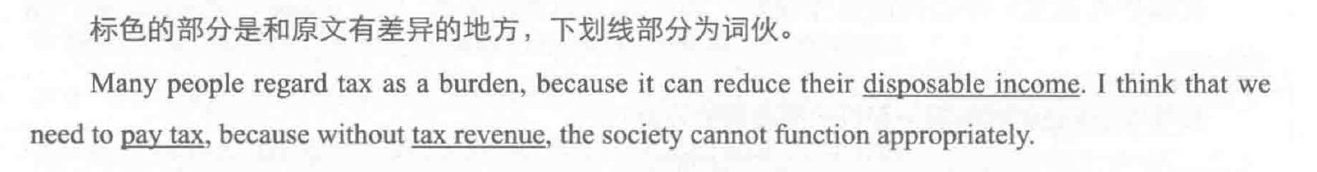

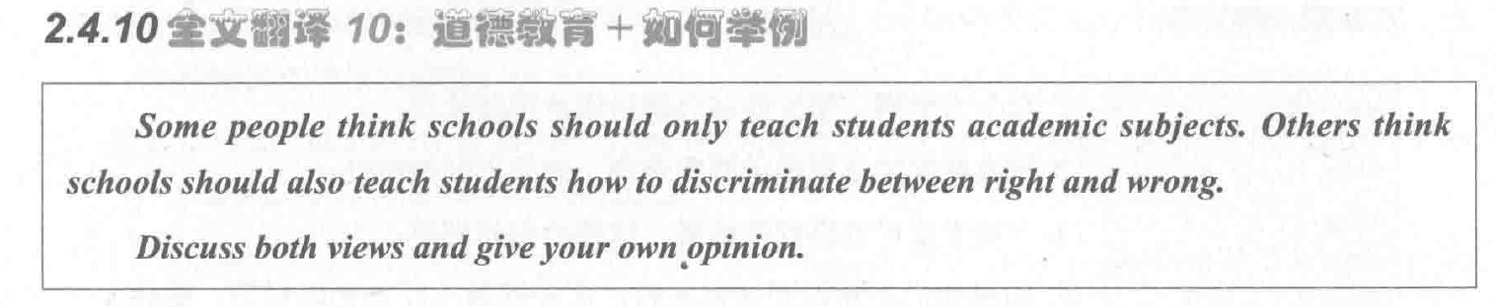

讨论类，无背景，定义 School education

School plays an indispensable role in people’s life, possibly because students acquire knowledge and shape a positive world view in campus. 书上的更好定义school你这个背景句的话就不会出现后面那个争议了，你这句话就成了都要教。 Although academic subjects are important to one’s career achievement, I personally believe that students who do not learn the difference between right and wrong cannot succeed in their working lives.

