### *Day6*

#### *翻译 [ 20 ]*

1. 越来越糟糕，直接翻译成：has become worse （不用more and more worse）
2. 让他们，可以翻译成enable them.... to ....
3. 传染病的蔓延一直没有被遏制：the spread of infectious diseases has not been curbed
4. 环境友好的：environmentally-friendly
5. because （大众或谈话对象不清楚的事实），as / since（大众或谈话对象了解的事实），for（推断结果）
6. 经济援助：financial aids
7. use 可做名词，不要翻译成the using of
8. 精通金融方面的知识：master the konwledge as to finace
9. 节能设备：energy-efficient equipment
10. 低估underestimate

#### *作文开头段*

*11.05.19 /07.12.15 [ 重写 ]*

The government should control the amount of violence in films and on television in order

to decrease the violent crimes in society. To what extent do you agree or disagree?

注意审题，这个题目问的是政府控制媒体暴力能不能达到减少暴力犯罪

你的观点应该是，尽管·····能减少····， 我个人觉得暴力犯罪还 跟其他的因素相关

agree / disagree 观点类作文，无背景，定义媒体中的行为

Misconducts in media has been imitated proverbially, possibly because audio-visual information can attract people’s attention and provide them entertainment. Although the proportion of violent crimes will reduce because of the decreasing violence in media, I personaly believe that it also relate to apposite laws and civic education.

*[ 疑问 ]*

跟其他的因素相关这里需不需要具体到某一两个其他因素？

回答：这里比较适合背景，什么样的情况会产生这个争议？比如你可以写随着媒体的spread，人们，特别是年轻人，可以通过各种网络或者电视去获取各种信息including 负面的，这样对他们的后果是什么？再去写你的第二句

#### *思维*

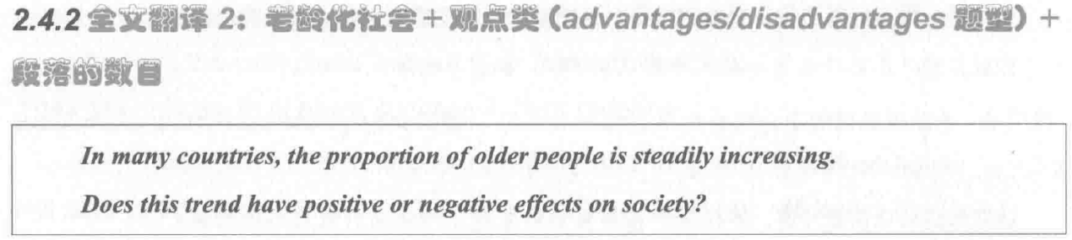

1. *positive：*

A. 老年人的经验和智慧对社会来说是一笔宝贵的财富( valuables asset ) 。*[ topic sentences ]*

B. 因为老年人的经历可以教会年轻人许多理论知( theoretical knowledge) and 综合技能(comprehensive skills) *[ supporting sentences 解释论证 ]*

C. For example, 从事计算机岗位的年轻人从退休的前辈借鉴编程经验和计算机设计方法。*[ supporting sentences 举例论证 ]*

D. This 会极大加快企业的发展，since 将经验知识应用到实践(applying the experience knowledge into practice )能够提高生产力(increase productivity) and 创造社会价值 (achieve social value) *[ concluding sentences 举例论证] 这里是inducing words*

1. *negative：*
2. 人口老龄化会给政府带来沉重的经济负担 (increase the financial burden of the government) and 导致资源分配不均(uneven distribution of resources) *[ topic sentences ]*
3. 因为政府需要支付大量的健康医疗费用，养老金 and other 社会福利 *[ supporting sentences 解释论证 ]*
4. When政府过多的投资(pour more money in doing sth) 照顾老年人，其他更重要的方面例如教育就会去缺乏资金（will be underfunded）。*[ supporting sentences 举例论证，加时间状语扩展 ] 这里是对比*
5. As a result，不平衡的资源分配这里最好不要跟第一句话重复导致很多贫困地区的年轻人会因为缺乏政府的资助而不能接受高等教育(receive higher education) *[ concluding sentences 使用including words ]*

#### 段落翻译

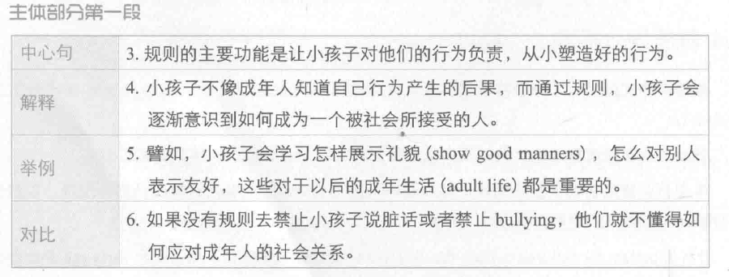

1. The main function of rules is to hold children accountable for their behaviour and to help them develop good behaviour patterns from a young age.
2. Unlike adults, children are normally not aware of the consequences of bad behaviour, and setting rules can help them realise how to behave in a socially acceptable way.
3. For example, children can learn how to show good manners and get along with others, which would be important skills in adult life.
4. If no rules forbid them to use bad language or bully others, they will not know how to deal with social relationships in adulthood.