### *Day7*

#### *思维*

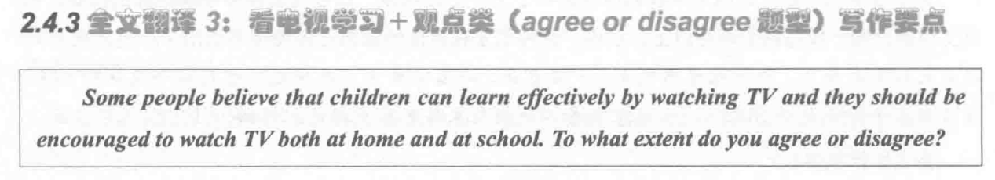

[ *positive* ]

A. 电视中的信息可以扩展小孩的视野 (Expand the horizon of knowledge) and 激发学习兴趣 (stimulate learning interests) *[ topic sentences, 拓展名词 ]*

B. numerous教育类节目(educational programmes)都是面向孩子的，帮助他们增加对不同科目的了解。 *[ supporting sentences 解释论证，教育类是修饰词]*

C. For example, 文化纪录片可以让小孩见识很多文化遗产(cultural heritage) and 环境频道可以提高他们的环境保护意识(raise awareness of conserving environment)。*[ supporting sentences 举例论证 ]*

D. 这些课外知识是对课堂学习的补充。 *[ concluding sentences 对比论证，也可以without反面论证]*

[ *negative* ]

1. 长时间看电视会降低小孩的获取知识的兴趣(the interest of acquiring knowledge) and 影响小孩的学习 *[ topic sentences ]*

B. 电视中的声像信息（audio-visual information）例如动画，会让小孩沉浸(be addicated to)其中。*[ supporting sentences 解释论证 ]*

C. If 小孩经常看电视会导致他们上课无法集中注意力(Focus on study) and 课后无法及时完成作业。 *[ supporting sentences 举例论证 ] 应该是对比论证*

D. As a result, 小孩的学习成绩就会落后于(was in retard of )同班级同学。 *[ concluding sentences 对比论证 ] 这是inducing . 这句话写的并不好，参考书*

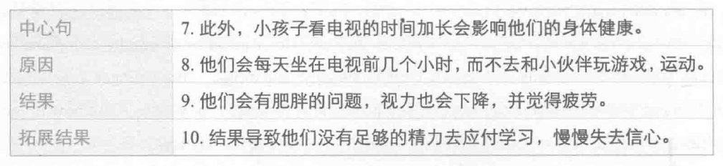

#### *翻译*

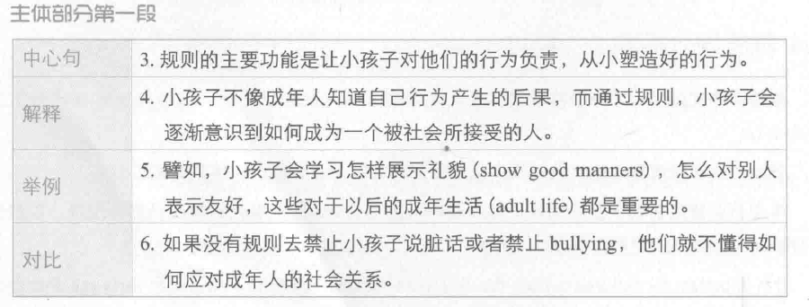

1. The main function of rules is to hold children accountable for their behaviour and to help them develop good behaviour patterns from a young age.
2. Unlike adults, children are normally not aware of the consequences of bad behaviour, and setting rules can help them realise how to behave in a socially acceptable way.
3. For example, children can learn how to show good manners and get along with others, which would be important skills in adult life.
4. If no rules forbid them to use bad language or bully others, they will not know how to deal with social relationships in adulthood.

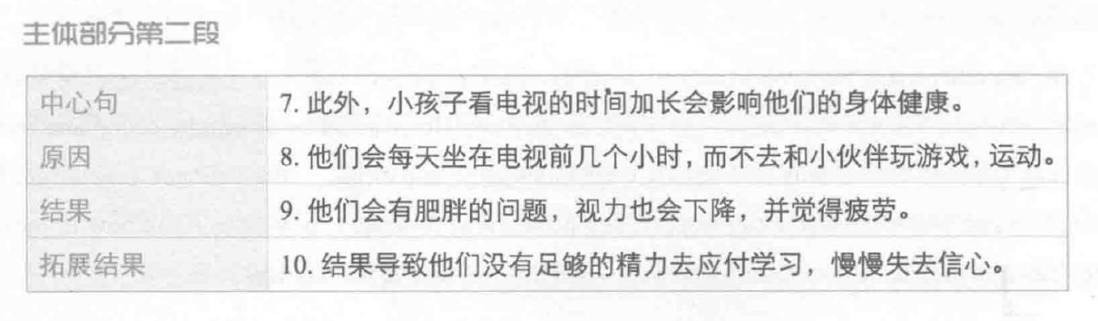

1. Another problem is that *excessive* （过多的）screen time will affect children's health.
2. They sit in front of a *screen* / television for many hours every day, *instead of* playing games and doing sports with *peers* / friends.
3. They also *suffer obesity,poor eyesight and fatigue*. 患肥胖症，视力降低，乏力
4. As a result / Because of this, they do not have energy to cope with the demands of schooling and lose self-confidence over time [ 我用的slowly ].

My problem：

A B C D 四个句子，我们是不是用的太多and了？

*作业：*

*1. 每天一个思维 （一正，一反 顾2.3.7.8.9）*

*2.每天做一个段落的翻译*

*顾家北第一篇*

*Day 1----主体段1 -----90% -----没有就重新翻译（修改的范文）*

*Day2 ----重翻译主1 + 主2*

*Day 3 ---- 重翻 主1.2 + 主3*

*Day 4------ 1.2.3*

*Day 5----- 1.2.3*

*3.下节课上课前一晚 把顾家北第九篇用英文写出来*